1. Introduction 2
2. How SG Govt is currently using social media 2
3. How SG Govt Organize themselves to use social media 3
4. Data Collection – Social Media 4
5. Survey 6
6. How successful is SG govt in using social media. 7
7. Conclusion 8
7. References/Citation 9

1. Introduction
- What is social media

- Social media presence in Singapore

- How social media has changed the social environment and what possible impact it can bring about

- SG govt’s social media initative

2. How SG Govt is currently using social media

- Engage and communication to its Citizen on national issues: This comes as Prime Minister Lee Hsien Loong said the government "can do better" in harnessing cyberspace to "explain issues, shape opinions and rally support".

- To understand its citizens better: The Singapore government is looking at using social media Business Analytics tools to get a better understanding of how Singaporeans feel about its policies. The tools will enable public services to be better tailored to individuals by “listening” to views expressed in social media

- To disseminate information

  - Reporting weather condition in live feeds (twitter), https://twitter.com/NEAsg

- Appointed in Jan 2009 as the key online platform for e-engagement on Government policies and issues, REACH aggregates the views and concerns of citizens on national policies and issues, using a wide variety of traditional and online consultation channels. These include e-Consultation and e-Participation via blogs, online discussion forums, e-townhall web chats, and new media platforms such as Facebook and Twitter.

3. How SG Govt Organize themselves to use social media

http://www.channelnewsasia.com/stories/singaporelocalnews/view/1151874/1/.html

- Training: Singapore's government agencies are set to get more structured training in the use of social media.The ministry told Channel NewsAsia it is working with the Civil Service College to come up with a more structured social media training programme for civil servants. This means a more systematic way of identifying new media competencies needed by public officers, and providing suitable courses.

- Dedicated resource to setup new media teams taking care of a ministry's website, revamped with social media platforms

- Rather than a one-size-fits-all approach, observers say each ministry should look into how social media platforms could be deployed for their own purposes.

- Observers added the government also needs to look at engaging communities in non-mainstream websites, such as independent socio-political websites and blogs.

- MICA had provided guidelines to ministries on a coherent online strategy, rules of engagement and implementation. MICA recognises the value and power of social media and encourages all ministries to consider using social technologies

http://www.channelnewsasia.com/stories/singaporelocalnews/view/1237463/1/.html

- With the rise of social media, many teachers find it difficult to know where to draw the boundary when interacting with their students. As such, the Ministry of Education (MOE) has announced the development of a Code of Professional Conduct for Educators. The consolidated guidelines will provide educators clearer guidelines on how to use social media.

http://blog.dk.sg/2012/08/01/singapore-set-up-a-media-literacy-council/

- Singapore set up a Media Literacy Council

- Media Development Authority (MDA) announced the setting up of the Media Literacy Council (MLC) to spearhead public education on media literacy and cyber wellness, and advise the government on the appropriate policy response to an increasingly complex and borderless world of media, technology, consumer expectations and participation.What other countries government is doing

4. Data Collection – Social Media

Influence Level of Each Platform Rated by Singapore PR Professionals
Media and PR professionals from Singapore also rated how much they think the platforms are influential. In general, Singapore professionals prefer to use traditional media over online and social media.

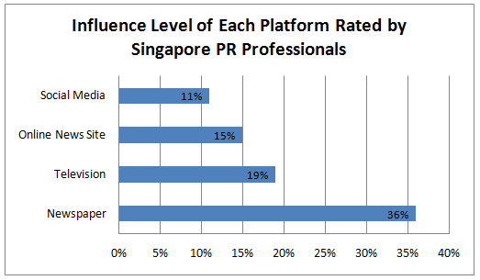

Moreover, media and PR professionals from Singapore think that traditional media offers
- better quality of analysis and opinion (64% rated ‘better than’ social media)
- perceived to be more balanced and unbiased (57% said ‘better than’ social media)
Therefore, they concluded that Singapore respondents currently hold a mixed view about the watch-dog role of social media.

Percentage of Singapore and Malaysia Media Professionals Using the Platform
From the survey, it is found that most media professionals from Singapore and Malaysia are working across multiple platforms with the average of 2 platforms per professional. Print and online are the two most commonly used platforms.

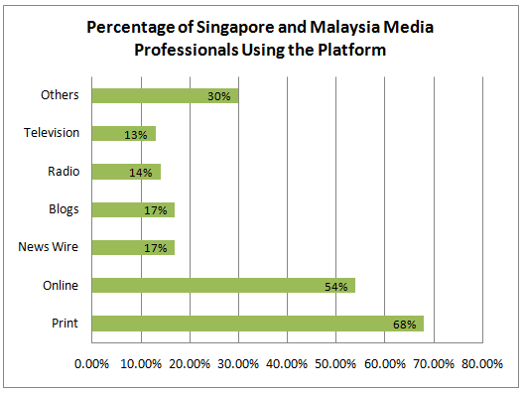

5. Survey

We can conduct a online survey to substantiate our data collection. Below is some of the questions I can think of

- Age

- Have you provided and comments/feedback to SG govt social media website such as facebook page, twitter, forums

- Have you subscribed to govt social media content. E.g. twitter, facebook live feeds

- Do you feel that the government policies are more transparent now with the social media

- Do you feel that you could voice your concern to the gov easier now with the prevalence of social media

- What other govt social media initiative you would like to see in future

6. How successful is SG govt in using social media.

Based on our data collection, we will then assess

- Assess current situation and describe if the current initiative by SG govt is successfully based on the evaluation matrix we will be using (joseph)

Refer to this link for statistics: http://www.socialbakers.com/facebook-pages/singapore/

Statistics of Social Media in Singapore: https://wiki.smu.edu.sg/digitalmediaasia/Digital_Media_in_Singapore

http://www.theathenanetwork.com.sg/2013/03/01/social-media-week-singapore-2013-planwathena-the-stats/

- Number of initiatives introduced

- Type of number and type social media used by the government. Number of blogs, twitters and facebook account managed officially by the gov

- Citizens participation rate

  - Number of twitter subscribers
  - Number of liked, shares
  - Number of download for mobile apps and apps rating
  - Page view rate

- Number of social media that provide interactivity between govt and citizen

- Survey on increase transparency

- Response turn around time

- Number of negative / positive comment

What is the potential of SG Govt using social media. Crowdsource
7. Conclusion

- what has already been done (which is good)

- describe what can be done better, how the govt can capitalize on the potential benefits that social media can bring to the public

- whether the government should continue on the existing pace, faster but watch out for repercussion effect

8. References/Citation

* We will use the below’s format for references and citiation

[1] Hallmark Website, Hallmark History & Timeline. Retrieved on 10 Sep 2012 http://corporate.hallmark.com/Company/Company-History

[2] Hallmark Website, Consumer Created Cards. Retrieved on 10 Sep 2012 http://corporate.hallmark.com/Product/Consumer-Created-Cards

[3] Stephanie Reese, (2011), Hallmark’s Customer-Created Cards Grow Engagement. Retrieved on 15 Sep 2012 from http://www.emarketer.com/blog/index.php/case-study-hallmarks-customercreated-cards-grow-engagement/

[4] Toni Hilton, (2008), Co-production and co-creation using self service technology: The application of service-dominant. Retrieved 17 Sep 2012, from http://www.business.otago.ac.nz/marketing/events/OtagoForum/Final%20forum%20papers/Otago%20Forum%20Paper%204_Hilton.pdf
Points taken from articles

http://www.computerworld.com.sg/resource/applications/desktop-apps/singapores-hdb-takes-initial-steps-into-social-media-and-mobile-apps/?page=2

- Yes, we do rely on statistical indicators such as viewership, hits, etc but these do not tell the whole picture.

- We have received encouraging responses and feedback on Mobile@HDB. Since its launch in April 2011, the iPhone app for Mobile@HDB has been downloaded more than 320,000 times and has also received an average rating of four stars. This is definitely not a small feat considering that many of our customers are e-savvy and are very direct with their feedback.

- Additionally, we are looking into enhancing the recently launched "Car Park Info" service to allow our customers to access information on car park space availability while on the go.

