1. Course Title: Sourcing Strategy & Planning Initiatives

  - Basic Outsourcing

Outsource

Let's say that as a Project Manager, you are given an IT project. What would be the options available to handle the project? Well, here are three possible options:
- buy an off-the-shelf package
- build your own
- outsource
We will focus on the third option in this lesson. Outsourcing is not a new concept. You may be familiar with the concept already but are not aware that it is called outsourcing. Can you guess what other terms refer to outsourcing as well?

Benefits of Outsourcing

Taking Advantage of Future Technologies
As new technologies emerge, most companies cannot immediately take advantage of them because of the cost and learning curve associated with these technologies. Since one of the strategic initiatives for an outsourcing firm is to stay current with new technologies, they would be responsible for maintaining a high competency level in current, as well as new technologies. The technology benefit is significant for companies who are on a fast pace and who realise significant growth.

Cost Savings
While outsourcing firms can provide savings in many areas, the primary reason for these savings is their ability to take advantage of economies of scale. Since outsourcing firms are providing the same type of service for many customers, they are able to consolidate data centre operations to provide lower overhead costs on a per-customer basis. They are also in the position to receive deep discounts from hardware and software suppliers because of their annual volume of business.

Centre of Expertise
Since an outsourcing firm's primary business is to manage technology for clients, it is appropriate to assume they have experience with current, as well as new technologies. Larger outsourcing firms embrace the "center of expertise" concept, in which a group of research and development technology engineers are dedicated to evaluating new products and their applicability throughout the industry.

Resource Availability
The requirements for IT resources fluctuate according to the changes in business needs and customer demands. Outsourcing firms can provide additional professional resources on an as-needed basis. This reduces the cost of customer organisations of retaining permanent employees and/or utilising industry consultants for short term engagements.

Reduction of Risk
A properly structured outsourcing agreement will ensure the outsourcer assumes the appropriate risk. The outsourcer will have to be responsible for ensuring that the systems, among other things, are meeting the reliability and performance criteria, and that properly skilled personnel are available at the right time.

Improved IT Customer Service
Having a great customer service relationship is as important as the quality and cost effectiveness of the products being produced and maintained. As with most professions, the systems developed for IT are becoming more and more complex day by day. On the other hand, the knowledge level of the user is increasing but not at the same rate. Therefore, it is imperative to establish and maintain an excellent help desk or support centre to provide a point of contact for the user. A properly structured contract will insist that the outsourcing firm provides a state-of-the-art help desk function.
IT Professional Growth
The constant challenge that each company faces is the need to challenge the internal IT staff continuously. Many industries are in business to produce goods and services that are not IT-related. Thus, it is not the priority of these industries to train their IT staff regularly, nor to keep them abreast of new technologies in their profession. On the other hand, an outsourcing firm's revenue is heavily dependent on the quality of service their personnel provides. As such, outsourcers will typically invest a great deal more in the training and education of their IT staff.

In sourcing

An alternate approach to outsourcing is insourcing. Insourcing basically involves a contract that calls for the market to provide resources to be deployed under the client's management and control.
For example, let's say that a client is required to boost its own in-house IT capability. The client brings in specialised skills from a contractor. Having done so, the client will need to manage the resources, which could include people, facilities, technology and other assets, and of course, at the end of the day, manage the results.
In other words, insourcing is buying-in a vendor's resources and managing them internally. To further understand the concept of insourcing, take a look at the animation below.

Offshore outsourcing

Another approach to outsourcing is offshore outsourcing. Offshore outsourcing refers to the situation where the buyer's company, with offices sited in one country (e.g.Singapore) agrees to a contract with a contractor's company where the bulk of the outsourcing work is to be performed in another country (e.g. India).

  - Outsourcing Trend

Navigating opportunities and risks

Companies interested in investigating offshore opportunities must be able to tackle challenges in three areas: cultural, geographical and political. They must be willing to invest time and money in building processes to ensure proper project management , effectively evaluating and training personnel , and establishing meaningful metrics to make sure projects stay on track.
But when offshore projects go astray, frequently the reasons are poor communication or cultural miscues. To prevent your offshore projects from bobbing aimlessly on the high seas, or sinking in stormy weather, follow the golden rule of any outsourcing project: Don't assume anything, ever . Specifically, companies must have 2 Ss and 2 Cs .

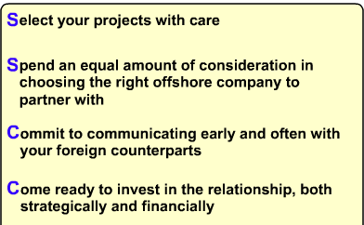

Considerations for offshore outsourcing

Companies considering offshore outsourcing should examine:
- Outsourcing firm qualifications, such as technical certifications, resource maturity, and viability
- Communication mechanisms, including two-way, Web-based capability; and on-site/offshore coordination abilities
- Location, together with operational/geopolitical risk assessments and business process/industry knowledge

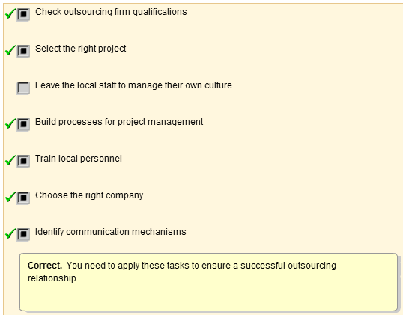
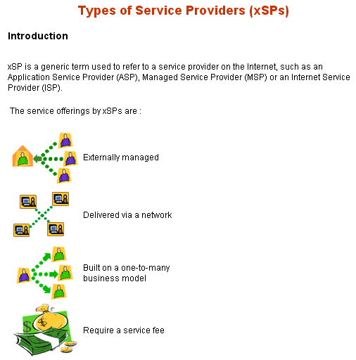
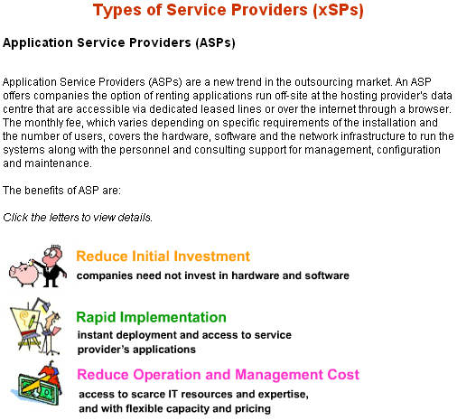
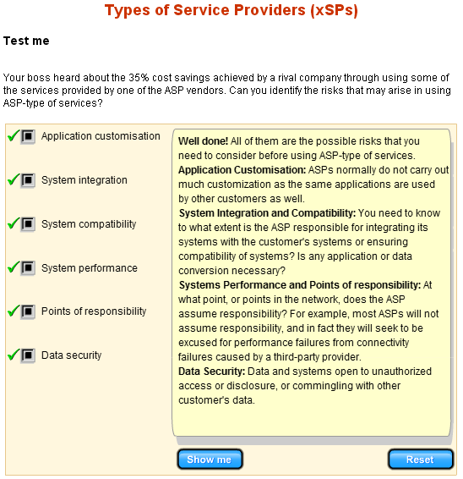
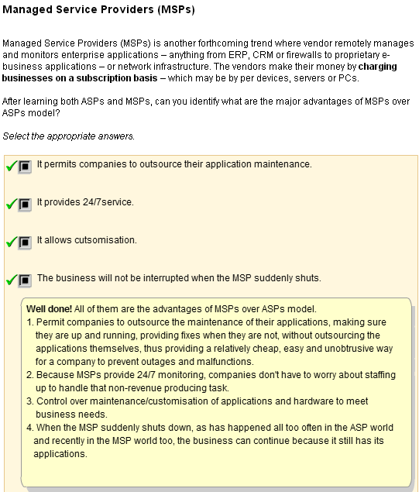
Beside ASPs and MSPs, there are a few more of other types of service providers.

Storage Service Providers (SSPs)
Storage Service Providers, such as Storage Networks, provide and manage the storage capacity either at customer’s data centre, in a co-location facility that hosts the customer’s website or in the providers own data center.

Managed Security Service Providers (MSSP)
Managed Security Service Providers offer security services such as managing firewalls, virtual private networks and securing internet applications. MSSP offerings vary considerably, from no-frills technology oversight to complete service, including software, hardware and staffing. Yankee group has estimated that organizations will spend US$2.6 billion with MSSPs by 2005.

Internet Service Providers (ISPs)
Internet Service Providers deliver internet access to organisations and individuals.

Utility computing
Utility computing is another grand concept endorsed by some big tech company. Instead of paying a fixed price, the client can pay for usage. A provider of IT services, such as outsourcing and systems integration, will in turn be able to price its services using this same consumption-based model. This concept is termed "utility computing," because it resembles the way in which people pay for their water and electricity.

"Utility Computing" is used as an envelope around a number of other concepts such as ASPs (Application Service Providers) and xSPs. It has pushed the concept of saving money on infrastructural costs by sharing computing resources. The vendors believe that clients like this payment model because it prevents them from overpaying for an underused IT product. Likewise, it protects them from finding themselves overwhelmed by a sudden computing demand that their systems can't handle. These pay-per-use arrangements are also attractive because clients don't have to buy the products and put the capital expenditure on their balance sheets.

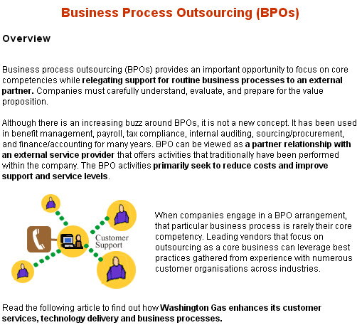

Good candidates for BPOs

BPO generally requires a company to accept vanilla business processes, and hence, the business process should not be the company's core competency or critical process to the company's strategic initiatives.

According to a Forrester report, four business segments are excellent candidates for successful and effective BPOs:
Straightforward bulk transactions
Straightforward bulk transactions, includes credit cards and stock transactions.
Broad shared-services outsourcing
Broad shared-services outsourcing, includes finance, administration, human resources, and indirect procurement.
High-volume vertical processes
High-volume vertical processes, includes policy administration, claims and loan applications.
More complex and specialised vertical applications
More complex and specialised vertical applications, includes monitoring chemical control processes and environmental data reporting.

BPOs outsourcing success factors

Clear Business Process
Understanding the outsourcing business processes means being able to:
- negotiate a contract with measurable objectives
- set clear metrics to manage the outsourcing relationship
Once BPO is in place, it is only the beginning of an ongoing process of measuring and managing the relationship. If possible, organisations should negotiate a pay-per-performance arrangement with the outsourcer.

Managing Transition
Managing the outsourcing transition well without significant loss of functionality. A project office that leads a transition task force made up of people from each specific business area affected by the project (IT, human resources, legal), as well as resources from the outsourcing partner, can help ensure success.
The client company should carefully select a project leader who is politically connected within the organisation – the manager who will serve as the regular liaison with the outsourcing provider.

Initiating Parallel Run
Considering (if possible) running legacy internal processes in parallel with the outsourced processes as a check and validation until all bugs are corrected.
Effective Communication
Ensuring effective communication (justification for BPO, how it will work) and managing people issues (training, "stay" bonuses to support legacy processes when required) as they arise.
Managing Change
Implementing an ongoing change management process with the client organization and outsourcer to ensure continuous business improvement.

  - Key Success Factors of Outsourcing
Key Success Factors of Oursourcing

Key success factors
While IT outsourcing is becoming more pervasive, clients' expectations of outsourcing are often not aligned with realistic benefits. Users may be too ambitious or optimistic in their appraisal of what an outsourcing arrangement can accomplish. Incorrect expectations are the primary reason for outsourcing arrangements being perceived as failures. Also, many organisations commit themselves to outsourcing without clearly defining their internal objectives.

Some key factors in successful outsourcing:  - Commit to outsourcing engagements with correct and realistic expectations  - Identify the primary objectives of outsourcing and risks associated with it  - Select an outsourcing vendor who is capable and motivated to meet primary objectives  - Establish well-defined contracts  - Form an experienced team to manage the outsourcing vendor throughout the contract | 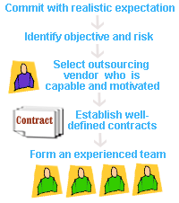

  - Define the Outsourcing Objectives and Goals

Determine the Driving Force to Outsource

So, why do you think many companies are turning to outsourcing in droves? As a Project Manager, it is essential to know the main driving force to outsource and the possible benefits of outsourcing. With this knowledge, you will be able to make a wise decision on whether to outsource your project or not. It will also be helpful to know how outsourcing supports your business goals and objectives.

The reasons for outsourcing can be categorised as:
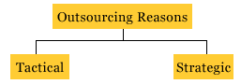
Strategic Reasons
Let's first look at the strategic reasons to outsource. The following are reasons why companies outsource their business activities:

Improve Business Focus
Outsourcing allows a company to focus on its core business by having operational functions assumed by an outside expert. The company is also relaxed from devoting energy to areas that are not in its expertise, and can focus its resources on meeting its customer's needs. this will improve its business focus and hence increase its business operations.
Gain Access to World-Class Capabilities
By the very nature of the contractors' specialisation, outsourcing providers bring extensive world - class resources to meet the needs of their customers. The outsourcing company makes extensive investments in technology, methodologies and people. This combination of specialisation and expertise gives customers the competitive advantage and in turn helps them avoid the cost of chasing technology and training. Hence steep learning curve and training on the use of new tools can be avoided.
Accelerate Business Benefits
Outsourcing is a by-product of another management tool know as the Business Process Re-engineering. It allows an organisation to immediately realise the anticipated benefits of re- engineering by letting an external organisation, one that had re-engineered to world-class standards, take over the process.

Share Risks
Another reason for outsourcing is to share the risks of the business. This can be done through building business relationships in the form of strategic alliance. The strategic alliance partners will approach the relationship as if it owns a part of your business. They will participate in strategic planning and share instrategic decisions. Companies are looking for such partnership with service providers especially in outsourcing areas that have a strategic impact to their businesses. Partnerships also come with shared risks. As new technologies emerge, the outsourcing firm will be responsible for maintaining high level of competency in both current and new technologies. Companies that outsource will be able to access the critical computer technology in lesser time, effort and incur lesser risks in implementing them.

Redirect Resources to more Strategic Activities
Every organisation has limited resources available. Outsourcing permits the redirection of resources from non-core activities towards activities that provide greater return in serving the customers. Three simple questions to test the understanding of the organisation's real competencies are:
1. If you are starting today, would you do it yourself or contract out?
2. Are you so good at an activity that others would hire you to do it for them?
3. Will tomorrow's CEO come from that skill set?

If the answer is not 'Yes' to all three, and the activities are being performed within the company out of habit, then new strategic thinking is demanded.

Tactical Reasons
Some companies outsource their business activities based on tactical reasons.

Reduce or Control Operating Costs
The single most important tactical reason for outsourcing is the reduction or control of operating costs. One way is to turn fixed costs into variable costs. Outsourcing firms can provide additional professional resources on an as-needed basis. This reduces costs of retaining permanent employees and/or utilising industry consultants for short-term engagements. There are no fixed overheads in maintaing the systems. You only pay the contractor if you use his services. This scheme reduces operating costs, and is known as the "pay-as-you-use" scheme.
Make Capital Funds Available
There is tremendous competition within most organisations for capital funds. Outsourcing can reduce the need to invest capital funds in non-core business functions, hence making capital funds readily available for core areas. Instead of acquiring the resources through capital expenditures, they are contracted for on a "as used" operational expenses basis. Outsourcing can improve certain financial measurements by eliminating the need to show return on equity from capital investments in non-core areas.
Generate a Cash Infusion
Outsourcing often involves the transfer of assets from the customer to the provider. Equipment, facilities, vehicles and licences used in current operations have value and can be sold to the contractors as part of the transaction. The contractor can then use these assests to provide service back to the client. Depending on the value of the assets involved, this sale may involve significant cash returns to the customer.
Secure Resources
Companies outsource because they do not have access to the required resources within the organisation. For example, in a new geographic region, outsourcing is a viable and important alternative to building the needed capability from ground up.
Gain Control
Gain Control Outsourcing is one way to handle backlogs in IT companies.

Chris Pickering's 1998 Survey of Advanced Technology found that 75% of organisations surveyed have backlogs running from seven months to over two years. IT companies are not able to keep up with the pace of change which continues to exceed the speed at which they can produce.

Identify Potential Risks
After determining the driving force to outsource, it is also essential to identify potential risks that are involved in outsourcing. There are generally 5 types of risks involved in outsourcing.

Irreversibility of outsourcing
It is normally difficult to reverse outsourcing decisions, when both parties have made a decision to go ahead with it. Reversing the outsourcing decision means bringing the outsourced activities back in-house. This can be done but it is difficult. Some of the questions we may ask ourselves when we want to reverse the decision are:
1. Do we have the skill set?
2. Do we have the infrastructure to run those applications?
3. How long does it take to rebuild the infrastructure and the skill set required?
4. What are the implications to the business operations?
Leakage in confidential information
Confidential information may leak to inappropriate personnel through outsourcing.
1. Disclosure to contractors without appropriate contractual safeguards may negate the requisite element of secrecy.
2. The vendor or its employees may make unauthorised disclosures.
3. Other customers of the outsourcers may gain unauthorised access to your trade secrets.
For example, the contractor will have access to all the data pulsing through your outsourced computer applications. An outsourcing user must be particularly cautious and concerned with a contractor who also provides services for a competitor. So, it is very important to address confidentiality requirements in the contract.
Dependence on specific vendor
The reason some organisations outsource projects to vendors may be because of the lack of certain skill set or expertise in their existing staff. The risk involved when this is the main reason would be that the dependence of the customers may lie only on a specific vendor. This would not be good in terms of business relationship because the vendor is at an advantage while the customer is at the mercy of the vendor.
Breach of contract by vendors
There are cases when the contractor breaches the agreement, thereby allowing you to terminate his service. Substandard contractor's performance and missed service level agreements are some examples where the contractor could breach the contract. The risk of an interruption of service or an actual breach of the provider's duties is, of course, an unavoidable risk at some level. This must be evaluated as a part of the business decisions to outsource. Of grave importance is the implications to the business once the contractors breach the contract. Of course we can sue, but the time and management effort, loss in the project and losing out to competition could be a very serious matter.
Loss of control over resources
From a management point of view, outsourcing may represent a degree of loss of control for an organisation. Although many outsourcing arrangements are reserved to the customer, matters such as strategic planning, process control, resource procurement, overall technology policy, undergo a dramatic change in control, that the organisation is able to exercise over the outsourced functions. It may also represent a significant loss of flexibility to the extent that organisation wishes to maintain a fixed scope and a fixed pricing structure over the term of contract.

Determine the Applicability of Outsourcing
After determining the driving force to outsource and also the risks involved, you can then determine the applicability of outsourcing. This simply means that you will decide how applicable it is for your organisation to outsource the project.

There are basically three key reasons to outsource:
- To reduce IT costs by offloading nonstrategic functions
- To acquire new skills in more strategic activities (new technologies)
- To re-engineer the IT and/or the business function(s)
Based on these reasons, you can then decide on the applicability of outsourcing. An algorithm has been developed to help us determine the applicability of outsourcing.

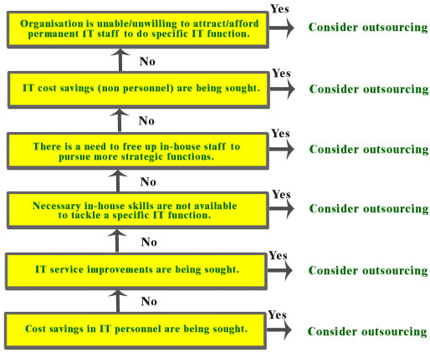
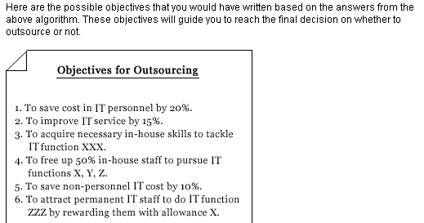

  - Sourcing Options
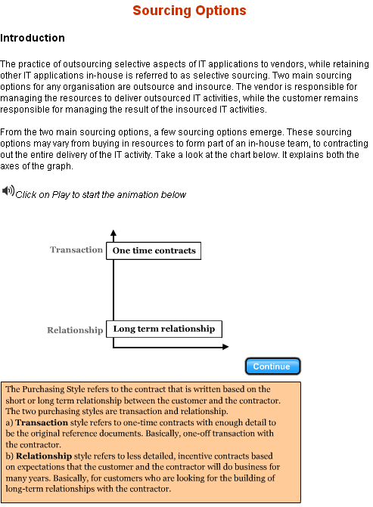
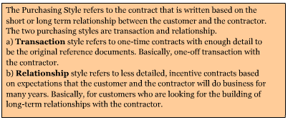

Buy-In
From the chart, Buy-In involves the transaction style with the resources option. The transaction style shows that the customer and contractor do not intend to have a long term relationship. Therefore, the customer buys the contractor's resources to meet a temporary need, such as programmers for the latter stages of a new development project. Customer organisations are often not sure of the exact hours need to complete the coding, so they sign contracts that specify the skills required and the cost per person.
Contract Out
From the chart, Contract Out involves the transaction style with the result option. Here, the contractor is responsible for delivering the result of the activity. This strategy is most successful when the companies can clearly define their needs in an airtight contract. The contract must be clear and complete in order for it to be used as a reference to manage the work done by the contractor.
Preferred Suppliers
From the chart, Preferred Supplier involves the relationship style with the resource option. With the relationship style, the customer and contractor intend to do business for many years. Therefore, the customer organisation develops a close relationship with a contractor in order to access resources for ongoing IT activities. An incentive-based contract defines complementary goals.
Preferred Contractor
From the chart, Preferred Contractor involves the relationship style with the result option. Companies contract with a particular contractor to help mitigate risk. The contractor is responsible for the management and delivery of the IT activity, that is the final deliverable. To ensure the contractor's performance, the company constructs an incentive-based contract that ensures shared goals.

What you should have learned:
- Two main sourcing options for any organisation are outsource and insource. From the two main sourcing options, a few other sourcing options emerge:
  - Outsourcing
    - Contract out
    - Preferred contractor
  - Insourcing
    - Buy-in
    - Preferred supplier
    - In-house
- Contracts can be categorized into
  - Purchasing style
    - Transaction driven or short term relationship
    - Relationship driven or long term relationship
  - Purchasing focus
    - Resource focus
    - Result focus
- Buy-in, which involves the transaction style with the resources option, is an insourcing option because in-house management retains full visibility and control of the IT activity.
- Preferred supplier, which involves the relationship style with the resources option, is an insourcing option because in-house management retains full visibility and control of the IT activity.
- Contract out, which involves the transaction style with the result option, is an outsourcing option because in-house management passes control of the IT activity to the contractor.
- Preferred contractor, which involves the relationship style with the result option, is an outsourcing option because in-house management passes control of the IT activity to the contractor.

  - Select Possible Candidates to Outsource

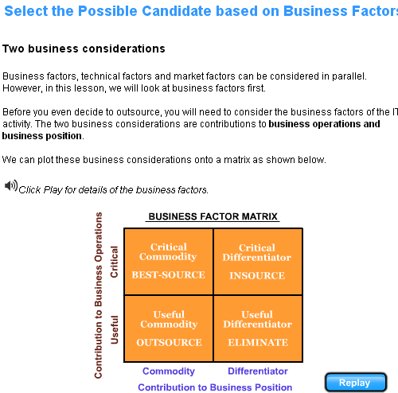

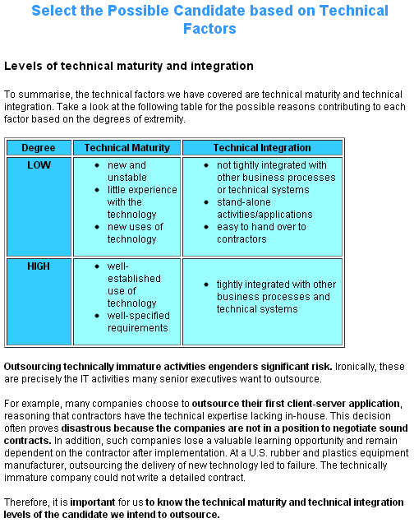
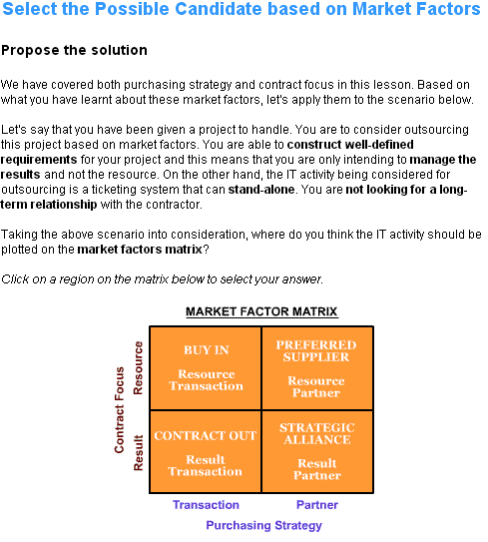
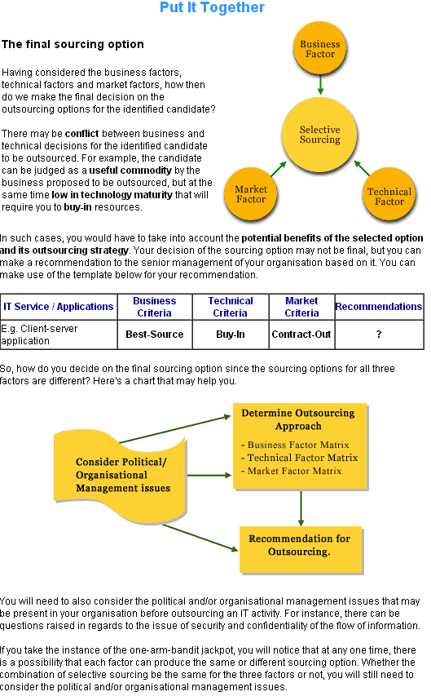

  - Types of sourcing relationship

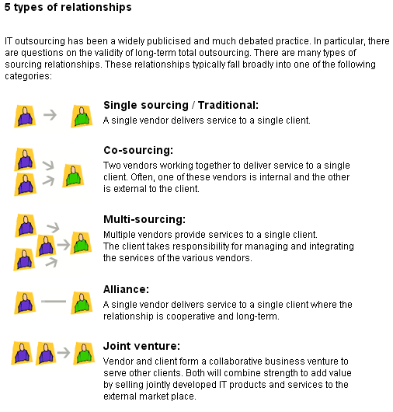
Benefits and risks
After learning the different types of sourcing relationships,now you will learn the benefits and risks of each type of relationship.

Type of relationship | Benefit | Risk
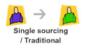 | Easier to manage as compared to multiple vendor management where one have to coordinate various issues. | Heavy dependence on a single vendor.
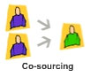 | With the internal IT providing the services together with the external vendor, transfer of knowledge will be easier. | Heavy dependence on a single vendor.
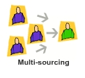 | Reduce the risk of depending on one vendor. Risks spread over multiple vendors. | The task of managing multiple vendors can be very demanding on the clients.
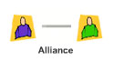 | Trust and mutual benefit for both client and vendor. This helps in sustaining long-term relationship that result in having successful projects. | As years pass, dependence on that one vendor would mean losing all those necessary skills when the day come for the alliances to be terminated.
 | Both are in as business partners and would like the business to succeed. | Products or services not well-delivered and cost incurred by commercialisation would have no returns.

2. RFP Development

2.1 RFP Process
A RFP is a formal request for vendor proposals, and such proposals often become the basis for the contract. The RFP becomes the statement of work for the contract and is an important historical document if the project begins to experience problems.

The primary purpose of a RFP is to transmit your understanding of the requirements for a project to vendors whom you believe can provide solutions.

The advantages of using a RFP are:
- A RFP forces out the potential problems of dealing directly with vendors.
- A RFP ensures a formal set of requirements to work from.
- A RFP requires the RFP team to examine the problems and issues concerning the project in greater detail than would normally occur.
- A RFP forces the vendors to create competitive solutions that not only respond to the RFP requirements but may even go beyond them, thus providing additional value for a given price.
- A RFP does not favor one vendor over another, but allows all to compete fairly based on the same set of rules and requirements.

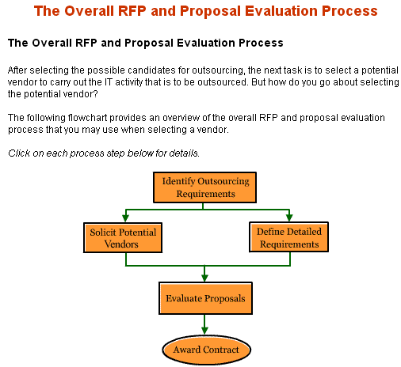
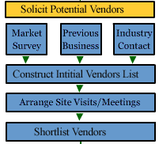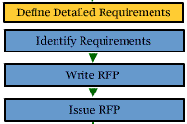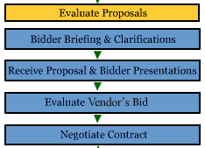
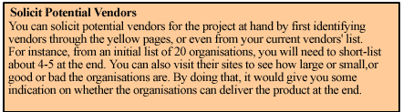
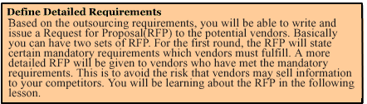
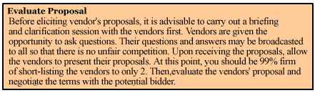

RFP Planning and Preparation

1. Set up the Project organisation
This involve setting up the Steering Committee as well as the RFP Project Team.
2. Develop project schedule
This involves developing a preliminary schedule for the whole RFP or tender process from start right up to the award of the contract.
3. Education on the available technology and the potential vendors
This involves identifying the potential vendors and suitable solutions, as well as the technologies involved.
4. Estimate project budget
This includes the budget for the RFP phase and also for the completed project.
5. Perform cost and benefit analysis
Like any other projects, you need to do a cost and benefit analysis. If this is not done before writing the RFP, at least an in-principal agreement from the senior management is required before proceeding with the project.
6. Develop evaluation criteria
You need to look at the requirements and develop the evaluation criteria so as to ensure an objective evaluation.
7. Develop the RFP
Based on the information gathered from the above steps, write the RFP for distribution to the potential vendors.
8. Review and approve the RFP for release to the vendors
You need to ensure proper and sufficient reviews by the various stakeholders are carried out before releasing to the vendors.

Sample project schedule

The sample project schedule shown here is only an example of the type of schedule and planning that needs to take place. You can use it as a guide.

Item | Activity
1 | Pre-RFP Activities
2 | Identify need
3 | Perform initial study
4 | Write project justification
5 | Estimate budget for project
6 | Approve RFP project
7 | RFP Activities
8 | Identify RFP team
9 | Identify project schedule and key dates
10 | Identify high-level requirements
11 | Start vendor and/or technology education
12 | Identify and interview users
13 | Develop technical requirements
14 | Review requirements with users
15 | Review requirements against corporate standards and constraints
16 | Finalise technical requirements
17 | Develop management requirements
18 | Review requirements with users
19 | Review against corporate standards
20 | Finalise technical requirements
21 | Write RFP
22 | Develop evaluation criteria
23 | Develop RFP schedule
24 | Review finished RFP
25 | Send RFP to suppliers
26 | Post-RFP Activities
27 | Allow question-and-answer period
28 | Receive proposals
29 | Evaluate proposals
30 | Ask suppliers’ questions if needed
31 | Select shortlist
32 | Hold supplier presentations, site visits, demonstrations, and reference checks
33 | Select winning supplier
34 | Negotiate contract
35 | Provide supplier debriefings for losing proposals
36 | Review, clean up and store losing proposal
37 | Start project implementation

The area addressed in the development of RFP

Refinement of scope and description of services
The scope of services to be outsourced needs to be confirmed and may need to be defined in more detail. Where there is to be shared responsibility for the provision of certain services, the responsibilities of each party need to be defined. For example, if staff are retained for functions such as security administration, table maintenance and user support, the transition point of responsibility needs to be spelled out. The same clarification is required if more than one vendor will be contracted to provide services. This will become a critical component of the RFP and the contract. Disputes may arise if this description is not thorough.

Human Resource Plan
Once the scope of the outsourcing has been confirmed, we need to define the process for transition of staff to the vendor, and to promote retention of staff through the transition where possible.

Vendor Characteristics and Minimum qualifications
Establishing the desired characteristics of the vendor and the minimum qualifications will have a significant effect on the nature of the contractual relationship, the structure of the service offering and the potential for competition in the process. This is a strategic business decision that will be based on the objectives for the outsourcing. For example, if an objective is to plan and implement a major technology change or to support a complex business initiative, the vendor will require different skills than it would under a more stable technology environment. If there is a decision to consider more than a single vendor, a consortium structure with a primary contractor may be required to promote accountability and cooperation between vendors.

Contract Term
The choice of a term for the contract will also be driven by the objectives for the outsourcing. For example, if there is no significant capital investment to be amortized, and no significant technology migration requiring an extended window, a relatively shorter term may be viable. The general trend has been toward terms of five to seven years. These terms are intended to avoid costs associated with termination or renewal, and to facilitate the implementation of major initiatives. However, these longer terms may increase the risk that the contract pricing becomes non-competitive over time, unless there are provisions for adjustments to the pricing to be triggered by "benchmarking" provisions.

Evaluation Process
Decisions are required on the major steps to be followed in the issuance and evaluation process. These may include:
- A vendor briefing sessions, followed by the issuance of supplementary information.
- An initial review of responses to confirm that they meet minimum requirements.
- Short-listing of superior proposals.
- Presentations and references, which may be followed by a further short-listing.
- Due diligence.
- A best and final offer stage.
- Selection to enter contract negotiations.

The optimum approach will be determined by factors such as the complexity of the service offering and the probable number of respondents. The RFP must describe the process to be followed.
Evaluation Criteria
The criteria for evaluating responses should be developed before the RFP is issued. The main principles for rating should be incorporated in the RFP itself. The development of the evaluation criteria at this point will assist in ensuring that the objectives for the outsourcing and the important characteristics of the outsourcer will be accurately reflected in the RFP. Different approaches can be taken to scoring and to weighting item scores. For example, pricing could account for 20% of the overall score. The business objectives for the outsourcing are key factors in selecting an approach.

Business Environment and Direction
The current business environment and business direction needs to be documented in the RFP. Much of this material may be available in the current business plan of the organization, but this may need to be supplemented with additional information on new initiatives and how IT is expected to support these. Any known re-structuring or re-engineering initiatives need to be identified along with the potential implications for IT. The bidders will rely heavily on this information to outline the skills and supporting technical solutions that they can bring to the business.

Technical Overview
A comprehensive description of the technology environment and how it supports the business processes is required. Even if the outsourcing affects only part of the technical environment, the bidders may need to see a bigger picture. A listing of significant assets and a summary of other assets is required. Detailed documentation may be provided in a reference library accessible to the bidders, if it is too lengthy to include in the RFP. Bidders should be required to enter into a non-disclosure agreement to protect proprietary information and to safeguard security. Any organizational-wide standards for system architecture should be outlined in this section.

Service Levels and Reporting
Baseline service levels need to be set for each service component to be outsourced, based on historical performance data and business requirements. This usually includes target and minimum service levels. Reporting expectations also need to be developed as part of this process. The maximum reporting period should be one month to facilitate the timely identification of performance issues and to ensure that serious loss of service events have an appropriate impact on the overall performance measure for the time period. Simple average measures are generally not sensitive enough for this purpose and need to be supplemented by other measures. For example, 98% average availability for a month can be achieved in spite of a single loss of service of a duration that would be unacceptable to the business users. Historical performance levels may be unsatisfactory, in which case a new target may be set with the recognition that this may increase costs. Penalties may be outlined for not meeting the established minimum service levels. These should reflect the impact of loss of service to the business users. They should be significant enough to ensure that performance issues are dealt with in a timely way, and provide for an escalation process. This would be covered in greater detail in the following lessons.

Security and Data Integrity
Minimum expectations need to be established for maintaining the security and integrity of the technical environment. This includes separation of duties in database administration, separation of test and production environments, backup processes, firewall and encryption standards, physical security, and user I.D. and password administration. In regard to the physical site for processing and storage of data, specify the mandatory condition where data will be processed and stored. Expectations need to be defined for the development, maintenance and testing of a disaster recovery plan.

Transition
The RFP should require the bidders to provide a detailed plan for the transition of staff, assets and services, along with a schedule. However, there may be business requirements that need to be stipulated in the RFP, for example a maximum time period for the transition, and a maximum period of loss of service in the case of a physical migration of application programs or assets.

Approval of key personnel
One of the critical factors for the success of an outsourcing contract is the quality of the vendor's staff, particularly those in key positions such as project manager, senior architect, senior analyst and account manager. Continuity in staffing is extremely important to ensure familiarity with the technical and business environment and to build on effective working relationships. The RFP should require the vendor to provide resumes and references for the individuals who will fill the key positions. The RFP should indicate that the contract will require that these resources stay in place for a prescribed time period and that the approval of the customer organization is required for substitutions after that time.

Risk Assessment
The term "risk assessment" is used in different contexts within these guidelines. At this point in the process, the potential costs resulting from loss of data or an extended loss of service need to be determined so that insurance, liability and performance security requirements can be established and outlined in the RFP and in the contract.

Disposition of Assets
Decisions are required concerning the disposition of significant assets that are to be operated or maintained within the scope of services. A business case needs to be developed for the assets in each service area. A number of factors will need to be considered, including the term of the agreement, the currency of the technology and need for upgrading and the transferability of software licenses. For example, if the intent is to upgrade technology in the short-term, it may be advantageous to have the vendor acquire ownership and make the upgrade immediately.

Pricing
By completing a performance review of the existing services and defining the objectives for outsourcing, the organization will have a clear idea of whether its current costs are reasonable and whether cost reduction is a key objective for outsourcing. If the RFP is designed to select a partner to provide a new strategy for IT service delivery, pricing details for the continuation of the existing services may not be the right focus. In most cases, pricing will be central to the selection decision.

It is generally better to stipulate the desired results, including service levels, rather than indicate the available budget. However, if there are expectations for major cost reductions, the RFP should indicate this relative to the base budget. The RFP should require the bidders to provide a detailed breakdown of prices for each service area to permit effective comparison between bids and an analysis of how cost reductions are going to be achieved.

Some outsourcing contracts include "benchmarking" provisions that require a periodic analysis of the vendor's prices for specific services and a comparison with industry standards to ensure that the pricing continues to be competitive. If the price is not within a specified distance from the industry optimum standard, there is an adjustment in the pricing for the subsequent measurement period. This analysis is generally conducted by a mutually acceptable independent consultant. This process can work to the advantage of both parties by ensuring against overpayment on the one hand, or service problems resulting from cost pressures on the other hand.

2.2 Establish an outsourcing project team

The RFP project team

The RFP project team should be balanced equally with skills from various business and IT departments. The team should consist of the following basic groups:

Business Operations, which is the user group, who will be using the system or services and hence providing the business requirements.

This is usually the department that conducts the business for which this technology will apply. Business operation staff understands the current workflow and challenges. When new technology or system is being planned, they should be consulted on how the new systems could be exploited to improve or replace the current work processes.
Business operations staff typically provides the following types of information:
- Describe the current work process within the department and across department and organisations.
- Identify the current operational problems that limit the amount of work processed.
- Identify those operational processes that can be changed or eliminated and those that cannot be changed.
- Provide information on volumes and throughput requirements anticipating growth.
- Determine the number of internal and external users (customers, vendors) and the current resources that is available.
- Determine if such operations would be outsourced.

Information Technology (IT) Department who is responsible for technologies that are needed to accomplish the organisation’s business objectives.

This department is generally responsible for supporting corporate hardware and software needs, including the network and other communications facilities. Before the RFP is written, which is during the vendor identification period, the IT department is responsible for reviewing potential vendors’ technology to determine whether they are appropriate for the project’s application.
In terms of contributing to the RFP, IT department would be responsible for areas such as the following:
- Develop the technical requirements based on the functional work description provided by the business operations staff.
- Provide a complete description of the current technology and equipment used and identify those that the new system must co-exist or communicate.
- Describe the standards to be followed, such as programming and development standards or the communication’s network standards.
- List the minimum technical qualifications of potential vendor.
- Consolidate and develop the RFP project requirements.

Financial and Legal Advisors, who will provide legal and financial advise.

The financial advisor is in charge of developing the payment schedules and the financial standing of the vendors.

The legal advisor will look at the terms and conditions stated in the RFP, which will become the basis of the contract.
Human Resource Advisor who will assist in planning for staff retention or recruitment.

Once the scope of the outsourcing has been confirmed, the human resource advisor will help in defining the process for transition of staff to the vendor and also to promote retention of staff through the transition.

The tactics of building a team

Without question, developing a RFP is a team effort, where group dynamics play an important role. Building a team with the right mix of technical and managerial know-how can be tricky. To make the most of your team, deploy the following tactics:
Appoint a leader early
You'll need one focal point for the project - a principal contact for all staff involved and a first point of contact for all potential vendors . Make sure the leadership is established up front. The leader must have good communication and soft skills to manage the team, and preferably, have some years of experience in managing project of similar complexity.

Keep the team together for the entire process
Make sure everyone on your team understands the RFP process and the commitment required. The staff that prepares the RFP must be the same staff that evaluates vendor proposals and listens to vendor presentations. Continuity and consistency is key to the success of the project. Hence, the team members selected must be able to work with each other.

Solve internal problems before you begin
Make sure you understand which division or department is leading the project that is authorised to make decisions, and ensure that funding has been approved. An unclear chain of command or departments in a turf war make your company look less than professional, and that can affect the quality of the results you receive. Therefore, at least one staff from the division or department must be represented in the team.

2.3 Strategies for information gathering

Pre-RFP request for information

When more information is needed than is publicly available, the RFP team may use a “pre-RFP” request for information (RFI). RFI is a way for clients to determine what is available from the vendors who respond to their requirements. It is also a way for the buyer to determine whether the requested requirements are reasonable and whether appropriate technology is available.
Vendors are encouraged to respond to the requirements and also spell out where there may be potential problem, areas where technology may not exist, or unrealistic goals and schedules. The information gleaned from the RFI may help guide the subsequent RFP or cause it to be cancelled if no vendors respond.

A RFI is not a mandatory prerequisite to writing a RFP. When will you consider to use RFI?
- The goals of the project are in question
- The technology for this project is new
- A variety of potential solution needs to be explored

Responses to the RFI

Responses to the RFI may show the following:
- The technology mandated by the requirements is not available or matured
- The technology is available but far more costly than originally anticipated
- Vendors do not understand the requirements
If suppliers are not responsive, it could mean either going back to the requirements analysis phase or stopping further work on the project.
It is important to make it clear to vendor that the purpose of the RFI is to gain understanding of a specific technology.

2.4 Define the required products and Services

Service level
One important component of the RFP is the Service Level Agreement (SLA). Before we even look at what a SLA is, let's first understand the definition of service levels. Service levels are primarily used to clearly define the level of service or service performance that is expected from the outsourcing service provider.

The SLA is a document that clearly defines the service performance of the vendor in delivering the project. In the outsourcing contract, the SLA can be part of the technical description of the actual work to be performed.

It is important that you include the SLA in the contract to the vendor so that the vendor is aware of the performance that is expected from his company. It acts as a guideline for the vendor.

The SLA is a powerful communication tool between the vendor and the client. Only by using the SLA will you be able to verify the actual work to be performed by the vendor.

Define the Required Products
Introduction

Now you will take a step further to define the products that you want or the services to be provided by the vendors. As much as possible, such detail should be in the RFP.
You need to define in details the products expected to be produced by the vendor and the services to be rendered by them. It should be as detailed as possible to manage expectations. The greater the detail, the better it will be in selecting the right fit.
The table below summarises what you need to define and what document to record.
What to define | Example | What document  to record
The products to be produced by the vendor | Applications,hardware  and software | User requirement specification
The services to be  rendered by the vendor | Network and operational services | Service level  agreement

Characteristics of well-written requirements

A well-written user requirement specification will help the vendors know what you expect from them, so they will be able to propose the solution to meet your need.
The WUMAN is a list of the characteristics of well-written requirements.

What: In the requirement, you should specify what you want the product to do, not how the product should do it.
Unambiguous: In the requirement, the description of the expected products should be clear, not ambiguous.
Measurable: It should be verifiable. In the requirement, you should be able to state the criteria required for verification. So, the product can be confirmed through tests or demonstration to meet the requirements.
Attainable: Anything is possible with IT. You are only constrained by time and money. Therefore, in the requirement, you should ensure that it is technically feasible/realistic and also falls within your budget and schedule.
Necessary: In the requirement, you need to distinguish between needs and wants. Ask yourself, “What is the worst thing that could happen if this requirement were not included?” If the answer is “nothing of consequence”, then you do not need this requirement.
A requirement that is not necessary is just “gold-plating” requirement that contributes more to cost of the product than functionality or usefulness.
Introduction to functional and none-functional requirements

You need to define functional and non-functional requirements for a product/system expected from the vendor. Functional requirements define what you want the system or product to do. Non-functional requirements define how well in term of quality and service the system does it.

Functional requirements

Functional requirements capture what you want the system/product to do. When defining the functional requirements, you need to
- Describe what the users want from the system: It refers to identify what users need to do their job.
- Describe what the system must do: It refers to the tasks the system must perform and the inputs and outputs it must process.
- Specify scope or boundaries of the system: It is important to define the scope that is not currently available.
Introduction to non-functional requirements

Non-functional requirements define how well in terms of quality and service of the system. The requirements include performance, reliability and usability.
For non-functional requirements, you need to ask question like how well you would expect the system to perform in order to meet the business needs and demands. Here is a list that you may want to use as a guide in defining the non-functional requirement
- Performance requirements
- Operational requirements
- Maintainability requirements
- Portability requirements
- Security requirements
- Usability requirements
- Look and feel requirements
- Cultural/political requirements
- Legal requirements
- Additional requirements
Performance requirements include the following components:
- Speed: Response time (end-to-end).
- Volume/throughput: Number of transactions per unit time.
- Precision: The capability of the service/system to provide the right or agreed results or effects with the needed degree of precision; round-up or down.
- Capacity: Ability of handling required tasks.
- Scalability: As your business grows, your product must be able to cope with increased volume.
Operational requirements include the following components:
- Expected physical environment: Specify the physical environment in which the product will operate as this may entail certain special physical interfaces
- Expected technological environment: Specify the hardware and other devices that comprise the operating environment for the new system.
- Collaborating applications: Specify other applications that your product must interface with.
- Support: Specify the level of support for the product and what forms it might take. For instance, if you are going to have your helpdesk help "troubleshoot" product problems, then what sort of audit trail information should the product generate to facilitate such troubleshooting? Don’t just specify the quality support you want, but what kind, such as 24X7 or 9X5.
- Logistics: How will you be distributing your product?
Maintainability requirements
In maintainability requirements, you need to identify the special requirements for maintainability. For example, Will the product be maintained by end-users or will you be taking over maintenance from the outsourcer? This may affect the way the product is developed and may require more documentation.

Portability requirements
In portability requirements, you need to identify whether there are any other platforms or environments which the product must be ported. For example:
- The product is expected to run on Linux® and Windows® XP.
- The product shall be translated into various foreign languages. As yet, the languages are unknown.
In the second example, the requirement will affect the way the product is designed. Interfaces must be designed in such a way as to make it easy to add new languages.
Security Requirements table

Component | Explanation | Example
Confidentiality | Data stored by the product is protected from unauthorised access and disclosure. | - The system must keep the PIN confidential at all times while being processed, in storage or in transit.  - Symmetric encryption must use key lengths of at least 128 bits.  - RSA public key cryptography employed in the system must use key lengths of at least 1024 bits.  - All users must be authenticated before being allowed to access any data in the system.
Integrity | Integrity usually measured with respect to database updates. The capability of the software service or product to re-establish a specified level of performance and recover the data directly affect in the case of a failure. | - Data held by the product corresponds to data as it was delivered to the product from an adjacent system.  - Data must be protected from modification while being stored in the product, while being processed by the product or while in transit.
Availability | Define availability, such as 99% or 99.99%. | - Data is accessible to authorised users whenever they want it, in whatever form they want it.  - The system shall be available for 99% of the time between 8a.m. and 8p.m.
Audit | Some sort of audit trails are typically required. Consult your organisation’s auditors for precise audit requirements. | - The system should provide audit trail for any addition or deletion of ids.

Usbaility requirements, you need to specify how:
Easy to use: Is initial training or learners kit required?
For example:
- New users should be able to add, change and delete new customers within 30 minutes of their first attempt at using the product.
- The product shall provide a preferred way of working for financial personnel. At least 75% of them shall regularly used the product after a 6-week familiarisation period.
Easy to learn: Is it intuitive enough to understand?
For example:
- The product shall be usable by a member of the public without training. They may have seen the advertising campaign.
- A clerk shall be able to produce x certificates per hour after receiving y hours of training.
Look & feel requirements

In look and feel requirements, they specify the user interface or the style of the product. The look and feel of the product has to be appealing to its targeted users.
Can you identify the following examples that best describe look and feel requirements?
Cultural, political and legal requirements
Cultural and political requirements are specific to the sociological and political factors that affect the acceptability of the product. Some possible cultural or political requirements could be “The product shall use British English.” or “The product must not use terminology or icons that someone, somewhere on the planet might possibly take offence to.”
On the other hand, legal and regulatory requirements are specific to the legal and standard factors that affect the acceptability of the product. For example, for Internet banking, all on-line bank should follow MAS Internet banking security guidelines.
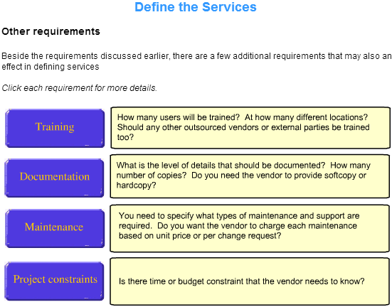
2.5 Develop the evaluation criteria
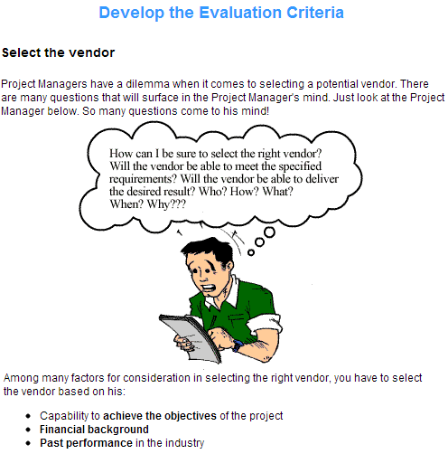
Define the Objectives of Outsourcing your IT Operations
Before we decide to outsource, we need to define the following criteria. They would determine the success or failure of the outsourced project. In the Evaluation Criteria, this section covers the following questions:
- What are the objectives of outsourcing this IT activity?
- What functions are to be outsourced?
- Is the reason to outsource due to performance and quality improvement?
- Will the services available reduce your costs?
Define the Outputs expected from the Vendor
This section of the Evaluation Criteria lists the criteria for the vendor to deliver the
output. The expected output from the vendor include:
- operational systems
- documentation (according to milestones of the project)
- management (resources and results, minutes of meeting and progress
- reports)
- training (by the vendor to the customer to use the end product)
- communication links (e.g. number of lease lines, speed)
- support (e.g. 24-hour hotline to call up for technical help)
- transfer of expertise and passing of knowledge from vendor to
customer
- assets (ownership of hardware and software that are used in the project)
Define the Acceptance Criteria for these Outputs
Based on the identified outputs, you will define and list down the acceptance criteria. Your list of criteria should include:
- the quality of service in terms of functionality, performance, usability, reliability and availability of the services
- the implementation and operation plan to note how quickly the vendor responds to any queries and how often can the vendor upgrades the system or fix bugs.
- the capability for future enhancements in line with business expansion.
- the cost of delivering the output.
Define the Qualifications of the Vendor
- Technical capability. Does the vendor show ability to meetobjectives of the project?
- Financial stability. If your project is a 5-year project, would the vendor still be around then?
- Quality standards. Is he an ISO Certified Vendor?

Sample Vendor Evaluation Criteria Checklist
Background/History
- Who started the company, when and why? What were the initial products?
- Who were the initial clients?
- Describe growth in products, staff, and so forth.
- What were the changes in business focus and client base?
- What were the significant accomplishments?
Vision/Core Values
- What is the vision of the company? What are the core principles, i.e., the three to six statements that define the company, that will stay the same regardless of internal and external change?
Company Financial Position
- Is the company publicly or privately held? Is information available to the public?
- Does the company voluntarily disclose debt structure, current financial situation, financial projections, and planning?
Products and Services
- What are the key products, basic architecture, hardware platforms, or languages?
- What is the product orientation - i.e., toward what computing environment, solving what business problems?
- What are the types of products -- extent of customisation vs. turnkey installation?
- Is there an overview of the development process, testing and evaluation procedures, release schedules?
- Are projects always or usually completed on time?
- Are deadlines met?
- How are budgets established?
- What are the life cycles of products?
- Is the market niche(s) changing?
- What are the projections?
- How is the need for upgrades, or new products assessed?
Facilities and Staff
- Describe the status and security of the facilities. Are there any plans for new facilities?
- How many original employees were there?
- How many of the originals remained?
- Describe the ideal employee.
- Describe the typical employee, e.g., education, experience, etc.
- How are employees hired?
- What is the rate of staff turnover?
- Describe the general morale of the employees.
- Are the open positions filled relatively quickly?
- Is there competitive compensation?
- Describe employee benefits.
- Describe staff training, cross training.
- Describe employee evaluation.
- Who is promoted and why?
- Who are the leaders in the company?
- What is the functional expertise of the staff?
- Do staff skills match client needs?
Policies and Procedures
- What are the written procedures for product development?
- Are products always developed the same way?
- How are problems tracked?
- What are the legal procedures and policies, e.g., contracting standards?
- Are there any existing legal complications?
Organisational and External Relationships
- Are formal organisation charts available and up to date?
- Describe staff coordination, communication.
- What are policies and traditions on ethics, security, integrity?
- What is the management style?
- Who are the user groups?
- What are the advisory groups?
- How are user expectations and satisfactions surveyed, assessed, and/or measured?
Innovation and Planning
- How are good ideas encouraged, recognised, evaluated and incorporated?
- Is there any formal planning and plans (e.g., operational, multi-year, disaster)?
- For project planning with goals, objectives, deliverables, budgets, responsibilities, staffing levels, and deadlines -- how are changes to these plans accommodated (Change order process)?
- How does the client participate in planning?
Self-assessment and Quality Control
- How is quality assured?
- How is customer/client satisfaction measured?
- What is the method of self-assessment/benchmarking with management, employees, and clients?
- Is there credibility with clients, competitors, and the professional community?
- Who are major competitors, and how is competition monitored?
2.6 Develop RFP
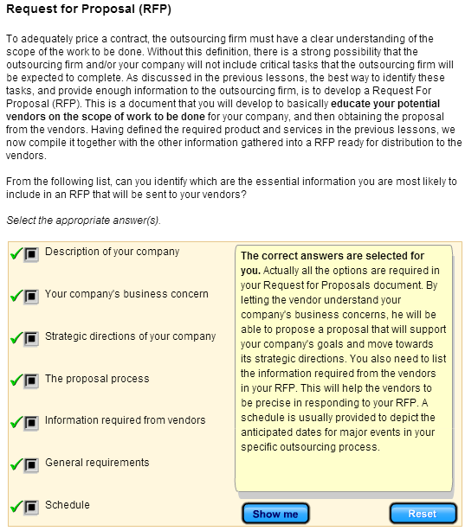

The categories in the RFP
There is a lot of information that you want your potential vendors to know before they send in their proposals to bid for your contract. In a RFP, you can categorise the information into four distinct parts. When you develop your RFP, be sure to include the following:

General Information of the Outsourcing Function
In this section, provide general instructions to the vendors, telling them how to prepare and respond to the RFP. Some of the information provided are:
- description of the vendors responsibilities
- criteria for selection
- project milestones
- independent price determination
- contract payment schedule
- cost liability
Company Background Information
In this section, provide brief background information about your company to the vendors. Since the project is in the initial phases, providing detailed information might pose a risk, as there may be chances of your competitors gaining access to the information.
General Requirements of the Project
In this section, provide an overview, and define the objectives and scope of the project. Specify the expected services of the vendor. By providing the vendor with this information, you are enabling him to meet project goals with his innovative ideas.
Information Required from the Vendors
In this section, list a set of information which the vendors should provide while responding to the RFP. To name a few, the information should include proposed approach, business organisation, vendor support, maintenance and service, project plan and cost.

Sample RFP
A typical RFP would consists of the following main sections with a cover letter accompanying it:
1.Cover Letter
It summarises the scope of the project and the RFP rules and the law of precedence with regard to the information provided. For example, if a particular document is identified as a common point of reference for precedence regarding terms that may have been expressed in an inconsistent manner across several documents. This is important for ensuring that data does not get misinterpreted.
2.Project Overview
This section provides an overview of your company and a statement of the problem that you hope to resolve through this RFP. There should be enough details for the vendor to grasp both the business issues that are driving the RFP and the technical issues that have precipitated the problem.
3. RFP Administration
This section contains all the administrative requirements and information with which a vendor must comply in order to submit an acceptable proposal. It should also provide the ground rules for the procurement, from receiving the RFP to awarding the contract. It should include information such as
- Where and when to submit the proposal
- Where and when the vendor briefing will be held
- Relevant dates for the procurement
- Requirements for preparing the proposal
- How proposal will be evaluated
- RFP contact names and addresses and the acceptable manner of communication
- Any other information that is required for a vendor to be responsive
4. Technical Requirements
It should contain an overview of the current business application and the technical environment including any relevant hardware, software, and communication equipment. The rest of the section should defines the scope of work and the functionalities or requirements desired to which a vendor must respond in the proposal. For example it should include
- description of the vendors responsibilities
- criteria for selection
- project milestones
- independent price determination
- contract payment schedule
- cost liability
The specification must be complete and all requirements should be stated clearly, concisely, logically and unambiguously. It should only contain the essential features or characteristics of the requirement.
5. Management Requirements
This section provides the information for the vendor to develop a project plan for the whole project covering design, implementation, installation, training maintenance and other aspects of the project. The plan should give assurance that the vendor has the resources and the management process required to perform the contract successfully. The project plan typically contains the following information:
- Staffing requirements
- Site preparation responsibilities
- Delivery and installation schedule and plan
- System acceptance test requirements
- System maintenance requirements
- System training requirements
- Documentation requirements
6. Vendor Qualification and References
This section details the information the vendor has to provide in proposal with regard to their company, financial status and the customers who will serve as references for their proposal effort. Typical information required include:
- A brief history of the vendor’s organisation
- The vendor’s installation and maintenance offerings and capabilities
- Evidence that the supplier has the necessary technical skills, management skills, relevant staff and financial resources to perform the contract
- A list of the currently installed systems
- Names of customers with similar configurations who can provide references, including contact names and telephone numbers
7. Vendor Section
This section reserves a place in the RFP for vendors to provide information that they feel is necessary but not requested. Vendors can also discuss potential issues that are relevant to the RFP and their proposal. For example, a vendor may comment on requirements that they feel are missing from the RFP, or present a unique solution that was not anticipated by the client.
8. Pricing Section
This section provides a detailed format for suppliers to follow in developing their price proposals. Clear Instructions should be given with regard to the format to ensure that price proposals from different vendors can be compared on an equal basis. A sample spreadsheet could be provided that breaks the proposed system into the following components:
- Hardware
- System Software
- Application development software
- Installation
- Maintenance
- Training
- Documentation
- Project management
- License fees (could be on-going)
9. Contracts and License Agreements Section
This section provides basic guidance to the supplier on how to respond to contracts and agreements. Contracts are provided to vendors, who can begin to study them along with the RFP requirements. If contract provisions are such that vendors cannot comply with, vendors may either choose not to bid on the RFP or take exception to the contract provision in their proposal. Typical contracts include the following:
- Purchase agreement
- Maintenance contract
- Warranty period
- Software license agreement
- Performance bonds
- Payment bonds
- Non disclosure agreements
10. Appendices
This section is for detailed information that might be too lengthy for the body of the RFP. Some examples:
- Workflow diagrams and studies
- Spreadsheets with statistical information
- Communications network drawings and plans
- List of current equipment
- Standards used within the company
- Tentative project plan with dates

3. Vendor Selection
This module discusses the fundamentals of developing a vendor selection strategy. It applies the selection criteria to evaluate and select the most suitable vendor. It also provides a cautionary guide to decode the vendor claims.

3.1 Requests for Vendor Proposal

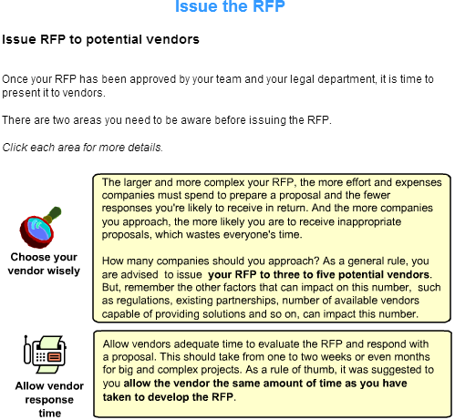
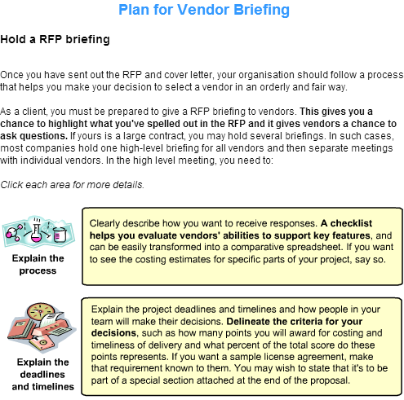
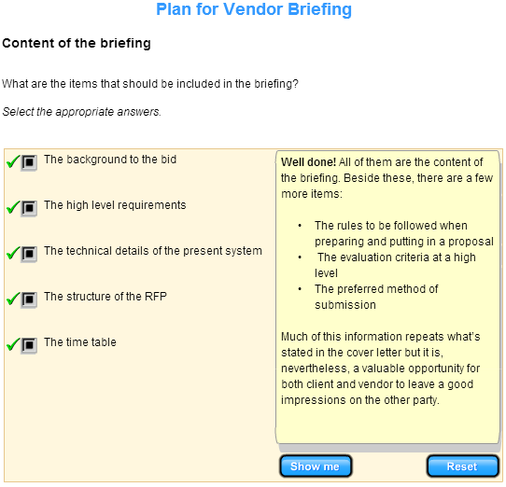
When explaining the RFP terms, you should be specific about terms in the RFP that describe qualities that you will look for in the vendor proposal. You might emphasise “consistency of service”, “customer satisfaction”, or “cutting edge” as being important to you, but you must also specify what you mean by these.

If you have not been clear about these terms in the RFP, expect the vendors to ask you for their meanings in the RFP briefing. They need to do this because they have to find out what they must do to achieve the qualities that you require.

Deal with Vendor's Questions

Have a plan for answering questions promptly

During the RFP process, potential vendors will undoubtedly have question, how would you propose to handle those questions?
- Identify the contact personnel
- Establish the lines of communication

No matter how much care you put into writing the RFP, it will be open to different interpretations. To handle this, make your contacts available at all times . If separate contacts are necessary, you might need a technical contact, as well as a business contact. It should include person's complete information, such as name, address, e-mail, telephone, fax in the RFP. Make sure all contacts are always available during regular business hours to your potential vendors during the RFP process. If a contact is out of the office, make sure someone is screening his/her calls and e-mails. For a potential vendor and for everyone on your team, every day is critical during the RFP process.

Handle proprietary information

If questions contain proprietary information, you may wish to edit the questions, but do so carefully. Tell vendors that proprietary information must be so marked. Your answers may be posted on your web site, e-mailed to each potential vendor or other means of distribution. The key point is to keep everyone in the loop, and keep the playing field lev

Types of vendor's questions
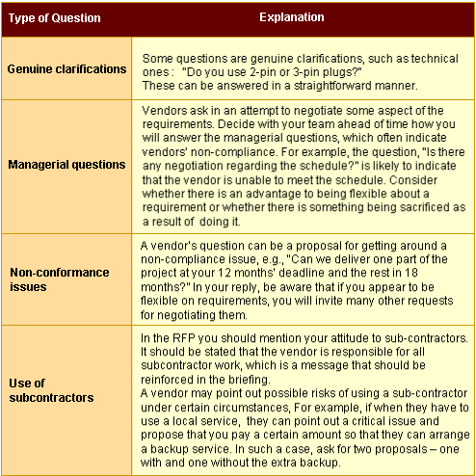
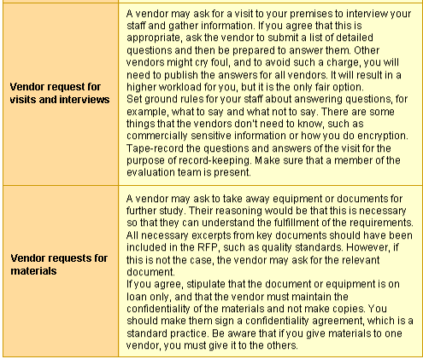

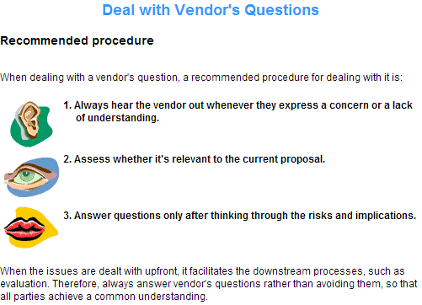

3.2 Assess Vendor Proposal Presentation

Elicit Vendor Information
Introduction

Having short-listed those vendors who are able to meet your requirements, the next thing on your agenda is to arrange for the vendors to present their proposals . In these sessions, you should take the opportunity to clarify their proposals and to validate all the important points. This is the time to test their capabilities, commitments & honesty.

In fact, this stage you may want to assess the confidence level of each company in handling your project's requirements.

It is possible for an outsourcing firm to meet all your requirements and fare well in your previous analysis. But,
- You may still have a hunch that their capabilities may not meet your expectations or
- You may feel as though the chemistry isn't right between your company and the outsourcing firm even though there are no hard facts to support the suspicion.
Documenting these concerns allows you to compare across multiple outsourcing firms.

Questions for vendors – management questions

The three categories of questions which clients tend to ask vendors are - management, technical and financial.
Management questions are intended to find out to what extent vendors are compliant with the RFP requirements. It is also an opportunity for you to test their credibility, so vendors should offer a convincing answer. Below is an example of a typical managerial question concerning about schedule.

Client PM – Can your schedule be compliant with ours
Vendor says
Yes – can you provide evidences to prove how you will meet the schedule ?
No – why cant it be complaint

Other types of management questions

Other types of questions which concern project resources are:
- What is your commitment regarding project staffing?
- What will you do if the PM leaves the company?
- Who are the staff assigned to us?
- Can you guarantee that we can use them when we need?
Questions for vendors – technical questions

Now we need to find out their technical capability. Typical technical questions are:
- We've stated our growth rate as 5% in the RFP. How would you respond if our growth rate were even bigger, say, 10%? Would your system still be able to handle it? How scalable is it?
- Each day you deal with xx KBs per day. What would it be if it was 100MB a day? How would your system respond to excessive treatment?
- How inter-operable is your system?
- How often do you intend to do a technical upgrade?
  - E.g., components
- How do you handle encryption and security?
- How do you intend to handle disaster situations?
- How will you demonstrate that you are going to meet the targets which you have set?
  - If the vendor has benchmarking or field testing, this may be answered.
- Will you have acceptance testing after the system is in place? What will be the nature of it?
  - You may want to test something before it's installed, as part of benchmarking.

Questions for vendors – financial questions

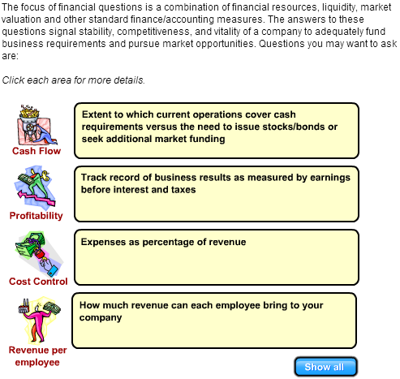

Assess the vendor references

It is standard practice to be able to get five prior client references from each vendor. In these references, look for companies that are of a similar size as yours. This is because with an environment similar to yours they can act as evidence supporting success of the outsourcing relationship with the vendor.

You should be able to meet one of the referees in confidence to discuss their experience with the vendor.
Assess Vendors' Presentation

The proposal presentation

You should organise a proposal presentation by each vendor. This provides you the opportunity to ask the vendor questions. The presentation should be attended by the evaluation committee and the evaluation team.

Agree ahead of time who should ask questions from the client side. All committee and team members should be able to ask any questions to clarify doubts or confirm understanding. Also decide who will keep a record of the presentation proceedings.

The chairman of the evaluation committee should control the questions. It's good practice to have pre-prepared questions. Give the team 1-2 weeks to read the proposals in order to give them enough time to formulate questions.
Proposal presentation questions

During the proposal presentation you will be asking the vendors questions. These should be genuine questions meant to elicit critical information. Your questions should not be disguised criticisms, which could de-motivate the vendor. An example could be,"Your proposal is very poor".

You should evaluate the quality of their answers using the following framework:

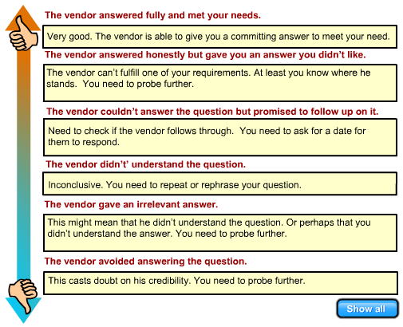
Typical vendor responses

No protracted negotiation should take place in the presentation but you may ask pointed questions about key aspects of the proposal, such as pricing. For example, you might ask, “That's a lot of money, is it flexible?” Would you be able to identify some typical vendor responses when you enquire about their pricing?

  - Sorry. But we feel that we offer value for money
  - We can talk about it at the end of the presentation
  - Let set a date for negotiation right away
  - I can come up with ways to make your package more attractive to you

You should be hard and firm about what you feel is a fair price to pay, by saying, for example, “I'm prepared to pay this and nothing more.” Private company clients almost always ask if the price is negotiable.

Ideally, the vendor team member doing the presentation must be sufficiently empowered to take a position on this. He should at least give the impression that the company will be able to do something about the price later. Otherwise, an indecisive response would leave you, as a client, with a bad impression of the vendor.

Evaluating a proposal presentation

A good way to gauge the caliber of the vendor is to see who's doing their proposal presentation.
- Is it a senior director or junior member of staff?
- Do the presenters dress and behave professionally, i.e., with appropriate business attire and etiquette to match? For a million dollar contract vendors should dress appropriately, especially if they are presenting to senior management.
- How professional was their presentation? How complete was it?
Mark vendor down for poor performance in these three areas:
- Content
- Topic
- Style

Visit vendor sites

You may also arrange to visit vendor sites to verify the claims from the vendor. When visiting the vendors, you may want to ask for visits to vendors' reference sites to access customer feedback, assemble equipment to demonstrate and test it or benchmark it.

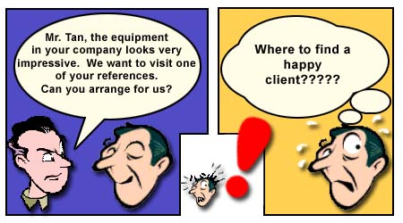
3.3 Interview Vendor Project Manager

Roles and Responsibilities of a Vendor PM
Vendor project manager

A successful project team normally starts with the project manager. Looking at the typical project management tasks, we have the usual responsibilities of planning, organising, integrating, controlling, leading, decision-making, communicating and building a supportive climate for the project.

Vendor project manager

Like any project managers, a vendor project manager must be able to:
- Manage client expectations
- Establish well-defined contracts
- Monitor and control activities that consistently meet the service delivery commitments
- Manage relationships, both with the client and other third party interfaces
- Monitor and manage clients and end-users satisfaction
More importantly, the vendor PM must be able to work closely with client PM for the successful completion of the project.

Assess the Vendor PM

Assess the vendor PM's background and capability

You need to home in on the capability of the members of the vendor staff, so you may want to interview them. The most important person to interview is the PM, upon whom much of the project success will rest. Before the interview, look at the PM's certifications, qualification, and experience. What kind and how much relevant experience is in the evidence?
During the interview make sure that you know the fundamentals about the PM's background and capability.
What are the questions you should ask the vendor project manager in the interview?

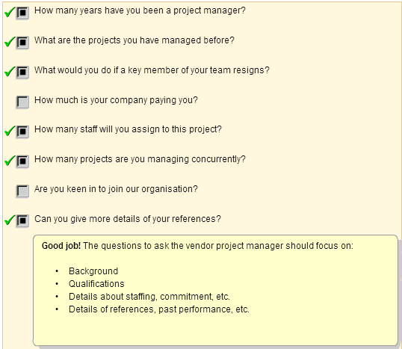
During the interview

Concentrate more on questions that touch upon client and vendor relationship than questions about technical capability. Good questions do not focus not on what the PM can do himself, but on how he would have to get his organisation to serve the client. Make the question address a specific issue so that it can't be waffled.

If possible, interview all the short-listed vendor's project managers. You can deduce what kind of manager they are from their answers. An example of a challenging managerial question is “What would you do if a member of your team wasn't performing?”

Another example is “ How would you deal with an unreasonable request from us? Supposing I ask for a manager to report by Monday, 9am when it's now Friday, 5pm. Or have a change of request. Or adding a new location within a day? "

In a large project, it may also be useful to interview the senior engineer.
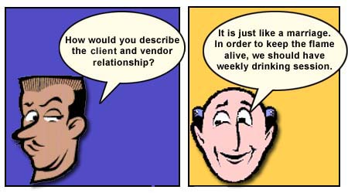
Evaluation criteria

After the interview, you can then summarise using a table like this:
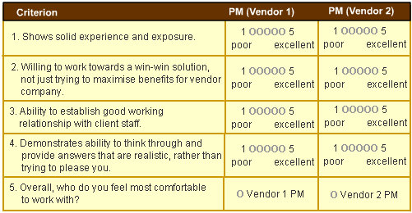

It is difficult to give a right or wrong answer to this, as many of the criteria used by individual interviewers can be subjective. However, it may still be possible to make a clear decision based on the criteria you have identified earlier, i.e.
- The individual PM capability
- The individual PM experience
- The ability of the PM to create and maintain a relationship with you as a client
3.4 Select Vendor
Perform Detailed Proposal Evaluation
Introduction
Your request for proposal (RFP) will result in response from many potential vendors. Now is the time for you to assess the vendors' proposal in detail before making the final decision.
How should you go about assessing a vendor's proposal?
Consider the scenario of selecting a building contractor, who will be constructing your home.

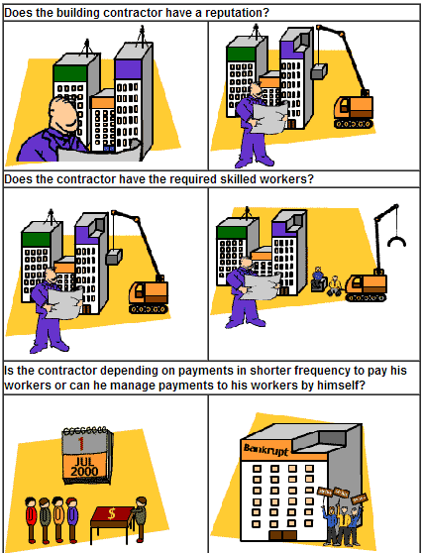

The process of selecting the potential IT vendor is similar to the above scenario.
The four factors that you should consider to assess the vendor are:
- The managerial proposal
- The terms and conditions
- The technical proposal
- The financial proposal
In the next few pages, we will look at each of the above in detail.
Assess the managerial proposal
The first factor when assessing the vendor's proposal is to assess the Managerial Proposal. In assessing the Managerial Proposal, you need to verify and confirm the acceptance of the following details:

The plan
Check whether the vendor has developed a complete plan that covers implementation, development and the turn-back process.
The desired working relationship
Does the vendor require a formal or informal relationship during the term of the contract? Is the working relationship an acceptable arrangement?
The depth and frequency of liaison
Has the vendor proposed a progress meeting on a monthly or weekly basis? If the project is complex or critical, then the meetings shall be held more frequently to minimise the risk of miscommunication. It also helps to manage quality and schedule.
The location of offices and services
Based on the the outsourcing terms and conditions, does the vendor need to work on site or at his own location? Are the services provided locally or subcontracted to other countries?
The confidentiality of the project
If confidentiality of the project is of vital importance, what are the measures that will be taken by the vendor to maintain strict confidentiality?
The resources and commitment required of client
The proposal should also include the vendor's expectation of your involvement in the project, in terms of expected time and frequency.

Management Evaluation Questionnaire

Outsourcing Management
- Are the senior management of the vendor organisation committed to the success of this project?
  - Are they actively involved?
  - Are communication procedures established at this level?
- Have contingency plans been developed?
- Can the vendor continue providing the IT function if excessive turnover occurs?
- Have problem identification and resolution procedures been developed?
- Have problem escalation procedures been developed?
- Have critical skills been identified and allocated?
Individual Tasks
- Have appropriate resources been assigned to this task?
  - Adequate experience?
  - Adequate time/effort?
- Are appropriate quality controls established?
- Has the vendor identified any weakness in his capability to accomplish this task?
  - Has he identified a way to overcome these weaknesses?
Source: "Managing your Vendors" by Florian A. Mikulski, Prentice Hall

Assess the terms and conditions
Another important aspect in the vendor's proposal that you should assess are the terms and conditions specified. Make sure that they contain the answers to the following:

Ownership of Hardware and Software
- Is the vendor willing to acquire the hardware and software required for the project? Or would there
be any transfer of ownership for current assets that you might have?
- Who holds the rights to own the hardware and software of the project, especially at the end of the
contract?
Maintenance of Client Supplied Equipment
If you are supplying the hardware to the vendor, who is responsible for the cost and maintenance of the equipment?

Protection of Client and Vendor Proprietary Information
- How has the vendor responded to the request for protection of confidentiality and trust between you
and the vendor?
- Who owns the Intellectual Property Rights of the deliverables?

Warranty Period
- How much time is proposed to rectify any defects after completion of the project?
- Does the warranty period begin sfter delivery by the vendor or after the acceptance of the product
by the client?
- Is the warranty period reasonable for your type of project?

Escrow Arrangements
Does the contract require an Escrow Arrangement? That is, to have rights to the source code when the vendor goes bust? This type of arrangement can be illustrated as follows:
Based on the milestones of a project, the vendor will deliver the operational system to the client. Normally, the vendor would deliver object codes. An arrangement can be made with a mutually-agreed company where a copy of the source codes will be kept. If in case the vendor runs
into trouble, the client need not spend additional time and effort to re-create the source codes.

Assess the technical capability
The next step is to assess the technical capability of the vendor. The response to the RFP by the vendor should provide answers to the following

Completeness of Proposal
You should check if the vendors have responded to all the requirements stated in the RFP. Some vendors miss out some sections due to oversight or lack of expertise.

Demonstration of Capabilities or Products
The vendor should be able to prove his technical capabilities by providing samples of his works previously developed. If the vendor cannot provide proof of earlier projects for certain reasons like copyright issues, then he must be able to show some demo products that prove his technical capability.
You should also check if the documents' standards and product development procedures are followed by the vendor.

Compliance to Requirements
The vendor should also clearly define whether or not he can deliver the project with the expected performance and quality.
Demonstration of Degree of Understanding
The vendor should be able to provide sufficient evidence to prove his understanding of your project. This includes understanding the problems and applicability of the solutions proposed. If required, the vendor should provide better solutions in developing the project compared to the plan proposed by you.

Technical Strategy
From the Request for Proposal (RFP),the vendor should be able to demonstrate or prove his technical maturity in regards with the IT activity that you are outsourcing. He should also demonstrate an understanding of the applicability and compatibility of your IT activity and future strategy.

Assess the financial proposal

Besides the Managerial Proposal, the Terms and Conditions, and the Technical Proposal, you are also required to assess the Financial Proposal. The method or mode of payment to the vendor should be described in the Financial Proposal.
As the Project Manager, you need to do two things when you assess the financial proposal:
- Identify total costs
- Assess the methods of payment
Cost Payment Schedule
When you identify the total costs of the project, you can use the cost payment schedule. This schedule presents the breakdown of the payment in installments that will be made to the vendor.
To avoid any dispute, the schedule should specify the exact amount that will be paid at an agreed period to the vendor. It should also define any event that will change the payment schedule. For example, if the vendor delays in providing the results at the specified intervals, then the payment schedule will be affected.
Proposed Methods of Payment
Four common proposed methods of payment are shown below

Fixed Price
The price is determined for a certain number of years of contract. For example, a fixed price is decided for the services to be provided by the vendor over a period of 3 years.

Usage of Resources
With this method of payment, the price varies, and is calculated on the usage of the resources. The price may again vary based on the type of resource, whether hardware or manpower. It works in the way that is termed as "pay as you use". For instance, many companies do not purchase photocopy machines. Instead, they are charged based on the number of photocopies made.

Shared Savings
Sometimes outsourcing vendors share in the reduction of the client's IS costs instead of charging a fee. For instance, if your organisation's IS cost has been a million dollars a month, some outsourcing vendors might propose this: Your outsourcing cost will not be more than a million per month; the vendor will charge you its actual cost; and the vendor expects to get 30% of any savings that you enjoy. This kind of structure is very attractive to many clients because it controls their data processing costs, offers at least the possibility of lowered costs, and builds in an incentive for the vendor to reduce costs.

Shared Revenue
Shared revenue is another means by which a client may compensate a vendor. For instance, a system that processes traffic tickets and collects fines for those tickets could be structured such that the vendor shares some of the revenue of the fines from the tickets. Some property tax collection
engagements work in such a manner.

Assess the vendor's proposal
Now that you have assessed the Managerial Proposal, the Terms and Conditions, the Technical Proposal and the Financial Proposal, there is one final part to assessing the vendor's proposal. It is to check on the basic strength and capability of the vendor. In particular, you should check the potential vendor on the following:
- The company's industry specialisation and track record
- Length of time in similar business
- Length of time with local presence
- Standards qualification (ISO9000, etc)
- Size, Ownership, Financial position
- Staff assigned
- References from other customers
- Previous experience with vendor
- Sincerity and credibility of the vendor
- Interest in your business
While looking into the company and its background, you may come across companies of various sizes. Both small and large companies have their advantages and disadvantages. For instance, small companies may react quickly to the change requirements from customers because they are very focused and responsible for change. Larger companies are usually financially strong and may not mind losing the contract.

In terms of the staff assigned, they must be qualified and experienced to work on the project. Generally, you should request the vendor to provide CVs of all the staff assigned for the project, so that you can assess their competency for the job.

It is also important that the vendor is open and honest about his experience in the required work.

Quantify Evaluation Criteria
Scoring method
The final step you need to carry out in evaluating the potential vendor is to select one of the many who have responded to your request for proposal (RFP). You will recall that you have developed the Evaluation Criteria and the RFP followed by assessing each vendor's proposal.
You will find that the vendors who have responded to the RFP have qualities both positive and negative. For example, one vendor might have worked on large projects successfully, but at present he is short of qualified manpower as most of the experienced employees have left. So how do you evaluate the vendor?
One suggested method is the scoring method. For this method, you should carry out the following steps:

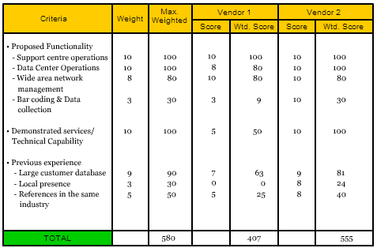
The purpose of the scoring method is to assist you in determining which objective is more important than others. This list of "must haves" should be clearly defined. The goal is to generate the absolute requirements that a vendor must meet.
With the final results, you should be able to rate the potential vendors. Therefore you will be able to recommend the potential vendor to the senior management. If required by the management, you will have to justify your scoring method and the basis of selecting the final vendor. The management will make the final decision in selecting the vendor.

Assess Overall Risk

After completing the individual section evaluations, some final analysis must be completed. All the various technical, managerial and financial issues must be considered together here as the variety of risks and strengths/weaknesses may stretch over more than one particular area. Specifically, we must:
- Evaluate the risks associated with accepting each proposal
- Construct “strengths and weaknesses” of each vendor
The PM and the business analyst will apply a risk questionnaire to each of the vendor proposals. This risk questionnaire will consist of several sections with each section corresponding to some feature of the vendor proposal. The procedures are
- The questionnaire will ask specific questions regarding the vendors technical and managerial approach.
- Then it will assign scores as a result of applying these questions.
The output from the questionnaire will be an overall score, which will give a measure of the overall level of the risk. It will allow different vendor proposals to be compared and also indicate in what particular areas vendor's proposals may be risky.
Select the Right Vendor
Introduction

Having completed the proposal evaluations, it is time to select the right vendor to award the contract. Making the decision as to which vendor to choose involves a combination of mechanical decision processes and more judgmental ones. The mechanical processinvolves interviewing everyone before filling in a ranking table.
Parallel to this, you can continue with the more judgmental process of continuing to ask questions of the vendor, usually through email. Read and evaluate the vendor's responses to help you build up a picture of their capability and credibility.
The proposal evaluation process is key to the success of an outsourcing agreement.Take your time and enlist support from industry experts and internal personnel to do a thorough review of the proposals.
