Contents
1. Introduction to software testing 3
1.1 Purpose of testing 3
1.2 Common misconception of about testing 3
1.3 Testing principles 3
1.4 Software Quality Assurance 3
1.5 Major types of tests in life cycle 4
1.6 Test Case & Scaffolding 4
2. Test Case Design Technique 5
2.1 Objective 5
1.2 Test Approach 5
1.3 Test Design Methods 5
3. Testing in the Life Cycle 7
3.1 Objective 7
3.2 Unit Testing 7
3.3 Integration Testing 7
3.4 Interface Testing 7
3.5 Specification Integration Testing 8
3.6 Integration strategy 8
3.7 System strategy 9
3.8 Usability Testing 10
3.9 Security Testing 10
3.10 Stress Testing 10
3.11 Testing Robustness 10
3.12 Additional Testing after System Testing 11
3.13 Beta Testing 11
3.14 Field Testing 11
3.15 Acceptance Testing 11
3.15 Regression Testing 13
3.16 Other types of testing 14
3.17 Summary 14
4. Test Automation & Tools 15
4.1 Objective 15
4.2 Deployment Pipeline 15
4.3 Key practices in Deployment Pipeline 15
4.4 Why do we Test 16
4.5 Traditional vs Agile Testing 16
4.6 Test Quadrants 16
4.7 Test Automation 19
4.8 Benefits of Test Automation (value proposition) 20
4.9 Test Automation Process 20
4.10 Test Automation Framework 20
4.11 Agile Testing Practices 21
4.12 Types of Testing 21
4.13 Agile Testing Principles 21
5. Test Planning & Execution 22
5.1 Objective 22
5.2 The Test Plan 22
5.3 Basic Elements of a Test Plan 22
5.4 How much testing is enough 23
5.5 Factors Affecting Estimating Test Effort 23
5.6 Quality Metrics 24
5.7 Test Execution & Problem 24

1. Introduction to software testing
1.1 Purpose of testing
1.2 Common misconception of about testing

1.3 Testing principles
- Testing is the process of executing a program with the intent of findings errors
- Test for invalid and unexpected input conditions as well as valid and expected condition
- Testing should not be planned under the tacit assumption that no errors will be found
- Software should be kept status during testing
- Expected results must be defined
- Results of each test must be thoroughly inspected
- Testing cannot tell us anything about the code style, because ugly or spaghetti code can still be correct – but this may result in performance issue or hard to maintain
- Testing cannot reveal poor code structure
  - We need technique such as system architecture review
  - Code walkthrough etc
1.4 Software Quality Assurance
- General approach to quality assurance
  - Test preparation starts early
  - Testers have time to plan for testing
  - Quality of testing is increased
- Testing in context
  - The first, and most important point about testing is it cannot be relied upon alone to ensure correct function and high quality
  - Is must be used in combination with other verification processes
    - Reviews
    - Design and code walkthrough
    - Formal inspections

1.5 Major types of tests in life cycle
Test | Purpose
Unit testing | - Individual code module  - Can be done as soon as the component is built. Usually done by programmer with script to automate testing
Integration test | - Code component work correctly with each other  - Usually done in sequence, as the components are built tested and combined  - Interface test (part of integration test).  - Data and control flow between code component  - Can be done when the interface is defined, and we have real or dummy components to use it
System Test | - The entire systems and hardware and software, functions as specified  - Done at the end of the development on an integrated product
Acceptance Test | - Whatever the customer or user does to confirm the vendor delivered the right product  - Done on a complete baselined product

1.6 Test Case & Scaffolding
- Test case is a description of a test to be executed to exercise a particular program path or to verify compliance with a specific requirement
- Test script is a automatically executable test case
  - It is typically a unix shell script, job control script, macro, or other machine readable document
    - Mechanically verifiable
    - Automatically executable
    - Repeatable at will

- Test procedure is a description of series of steps required to execute test case
- Scaffolding
  - Is what you put up while you are building, and take down when you are done
  - In software development, scaffolding is everything you need to build and test the product, that is not part of the product
  - Including building
    - Test drivers
      - A programs that calls the program under test
    - Test stubs
      - Substitutes a program called by program under test

2. Test Case Design Technique

2.1 Objective
- To understand how to decide a efficient and effective test strategy
  - Predict what needs to be tested
  - Derive test cases based on test condition
  - Formulate overall test strategy

1.2 Test Approach
- Structured Testing Approach
  - Blackbox – testing done based on specification, not cost effective
  - Whitebox – test based on internal program logic

1.3 Test Design Methods
- Functional Analysis
  - Test the system based on external specification
  - Based on simple concepts
    - What is the system expected to do
    - How do we determine that it is “doing it”
  - Requires for a detailed analysis
    - Understanding of the system objectives
    - Business processes
    - System users
  - Develop Test Cases for
    - Value input conditions
    - Invalid and unexpected conditions

- Equivalent Partitioning
  - Divides the input domain of a program into equivalence classes of data from which test cases can be derived
  - An equivalence class represents a set of valid and invalid input values
  - Guidelines
    - Specific Range: 1 valid (within range), 2 invalid (below or above range)
    - Specific value: 1 valid (value correct), 2 invalid (absent or incorrect)
    - Spefific member set: 1 valid (within set), 1 invalid (outside set)

- Boundary Value Analysis
  - Test at the extreme boundaries of both input and output equivalence classes
  - Guideline for boundary value analysis
- Decision Table
  - A decision table identifies a set of actions corresponding to a set of decision. Each column in the decision table is a testable condition
  - Decision table are appropriate when
    - The requirements are represented in a form that can easily be mapped to decision table
    - The resulting decision table are not very big
    - Each column in the table is a unique condition independent of the other column
  - Ensure all permutations are covered
    - If only Y/N decisions, then on way is to treat each combination as a binary number from zero up to max for the number of conditions – e.g. if 2 condistions, then 00,01,10,11
  - Steps to create a decision table
    - List all causes in the decision table
    - Calculate the number of possible combinations
    - Fill columns with all possible combinations
    - Reduce test combinations
    - Check covered combinations
    - Add effects to the table

- Cause Effect Graphing
- Loop Testing
- Variable Coverable Testing
- Exploratory Testing User Scenario Testing

3. Testing in the Life Cycle

3.1 Objective
- To understand the different types of testing in the software life cycle
- Appreciate the objective of each type of test
- Execute the different types of test
- Definition

  - - Software test stubs are programs which simulate the behaviors of software components (or modules) that are the dependent modules of a under test module.

  - - Software test drivers are programs which simulate the behaviors of software components (or modules) that are the control modules of a under test module.

3.2 Unit Testing
- First life of defenses
- Program logic performs according to program specs
- Key foundation for all later phases of testing
- Checks each coded module for the presence of bugs
- Ensures that each as-built module behaves according its specification defined during detailed design

- Automating unit tests
  - Unit tests test individual functions within a single. They have the least dependencies, and the most stable environment.
  - Unit tests are the easiest and most cost effective tests to automate.
  - Unit test cases can be derived using the white and black box methods we have examined.
  - Automating unit tests can be done through an ad-hoc test harness (as in the assignment), but it is better to use a test manager that can be integrated into an IDE.

3.3 Integration Testing
- A sub-assembly test
- Interconnects sets of previously tested modules to ensure that the sets behave as well as they did as independently tested modules.
- Ensures that each as-built component behaves according to its specification defined during preliminary design
  - Components link and work together

3.4 Interface Testing
- A type of integration testing which involves testing a new component or system on one side of an interface can interact correctly with an existing component or system on the other side of the interface
- Example 1:
  - You’re building an e-commence system.
  - It will accept payment by credit cards
  - At some point, you must test that the system correctly communicates with the credit card company , through their existing B2B interface
    - Perform credit check
    - Charge credit card
    - Cancel charge on credit card

3.5 Specification Integration Testing
- Connectivity
  - Test that control or data flow properly between them
- Communication
  - Test that data are interpreted correctly by both components
- Function
  - Test that the requested operations are performed on the data – function testing
- Result
  - Test that the returned result or status is correctly interpreted
- Use of test data for integration testing
  - As far as possible, reuse the same test data and situations throughout the integration process
    - Easier to trace the data to demonstrate correct data flow
    - Easier to run regression test
    - Focuses on errors lurking in interfaces
  - At this stage, it is not our purpose to introduce new tests on specific components, but to demonstrate that the components work together

3.6 Integration strategy
- There are several integration strategies
  - Incremental
    - Top-down
    - Bottom-up
    - Sandwich
  - Non incremental
    - Left-right
    - Big bang
      - hard to debugging, not easy to isolate errors
      - not easy to validate test results
      - impossible to form an integrated system

- A good integration strategy has 2 goals
  - Minimize the amount of scaffolding
  - Integrate in such a way that defects can be easily isolated to the offending component

- Two powerful strategies that do this are
  - Bottom-up integration
  - Left-right integration

- Top down Integration
  - Explanation 1:
    - Testing the topmost module first
    - Then integrating the next lower level, and so on
    - This method is advantages if major flaw occur as towards the top modules
    - It is easier to build up the skeletal system
    - However test conditions may be difficult or impossible to create at early stages of the integration
  - Explanation 2
    - Idea:-Modules are integrated by moving downward through the control structure.
    - Modules subordinate to the main control module are incorporated into the system in either a depth-first or breadth-first manner.
    - Integration process (five steps):
      - 1. the main control module is used as a test driver, and the stubs are substituted for all modules directly subordinate to the main control module.
      - 2. subordinate stubs are replaced one at a time with actual modules.
      - 3. tests are conducted as each module is integrated.
      - 4. On completion of each set of tests, another stub is replaced with the real module.
      - 5. regression testing may conducted.
    - Pros and cons top-down integration:
      - - stub construction cost
      - - major control function can be tested early.
    - 2 Types
      - Depth first or breath first
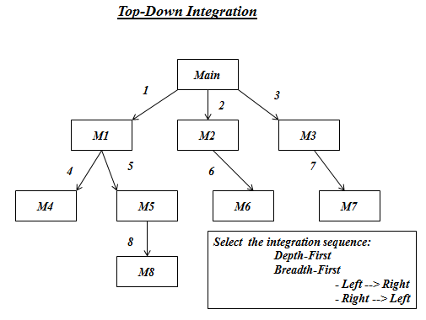
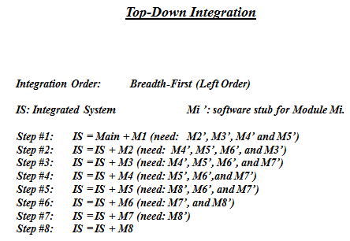

- Bottom Up Integration
  - Explanation 1:
    - Consists of
      - Testing the lowest level first
      - Then integrating the next higher level, and so on to the top
    - Test conditions are easier to create and observation of test results is easier
      - The lower level programs do not see higher level programs and so can be tested without them
      - Higher level call tested code, so any defect most probably lies in the higher level
Explanation 2

- Idea:- Modules at the lowest levels are integrated at first, then by moving upward through the control structure.
- Integration process (five steps):

1. Low-level modules are combined into clusters that perform a specific software sub-function.
2. A driver is written to coordinate test case input and output.
3. Test cluster is tested.
4. Drivers are removed and clusters are combined moving upward in the program structure
- Pros and cons of bottom-up integration:
  - - no stubs cost
  - - need test drivers
  - - no controllable system until the last step
Example
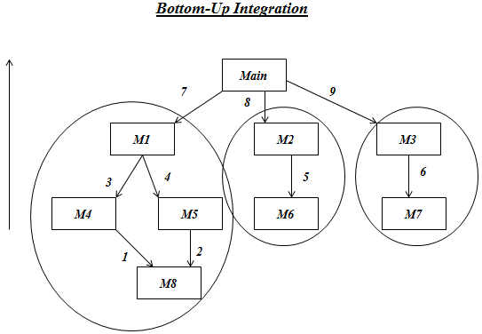
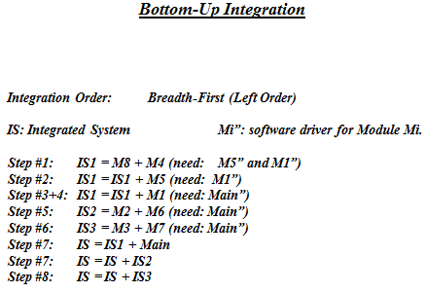

- Sandwhich Integration
  - Combines top-down strategy with bottom-up strategy
  - The system is view as having three layers
    - A target layer in the middle
    - A layer above the target
    - A layer below the target
    - Testing converges at the target layer
  - How do you select the target layer if there are more than 3 layers?
    - Heuristic: Try to minimize the number of stubs and drivers
  - Pros and Cons
    - Top and Bottom Layer Tests can be done in parallel
    - Does not test the individual subsystems thoroughly before integration
    - Solution: Modified sandwich testing strategy

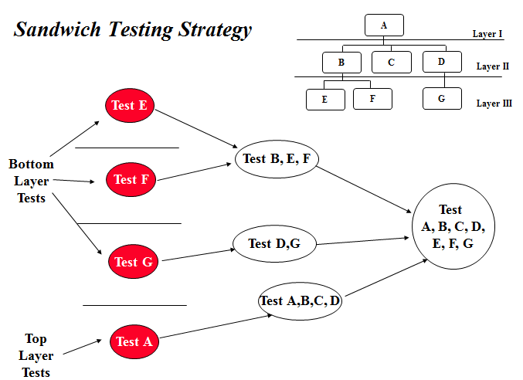

- Left Right Integration
  - This is especially applicable to message intensive systems, such as web applications
    - Test the message source first
    - Then integrate the next component along transaction path, and so on to the sink
  - The rationale is
    - Producers do not see consumers, so may be tested without them
    - If all upstream components have been tested, the defect is very probably in the downstream component
  - Testing a client-server system
    - Right left integration approach
      - Integration request handling functions left-right from client to server
      - Test the turn around component for correct response to requests
      - Integrate response handling components right-left from server to client
    - The entire system can now be tested transaction by transaction end to end, with reasonable confidence

3.7 System strategy

- Highest level of testing
- Checks that the entire software system embedded in its actual hardware environment behaves according to the requirements document
- Tests
  - System functionality
  - System technical issues
- Testing Quality Attributes
  - Usability
  - Security
  - Response to stress
  - Robustness
- Challenge/Problem with the quality attributes is that they cannot always be isolated to specific components and so cannot be tested until after integration
3.8 Usability Testing

- Usability Testing – Without testing, user is able to perform a complex task easily and fast
- The usability of a system depends heavily on the user interface
  - Navigation – ease of access to data and functions
  - Efficiency – fast, clean transactions
  - Understandability – clear data entry and display pages, formats and styles
  - Robustness – good error detection and reporting
  - Helpfulness – good explanations of functions and invocation rules
- The usability testing consists in testing all the above aspects to ensure that the system is easy to use and user friendly

3.9 Security Testing

- Testing if appropriate controls are in place and working correctly
- The approach would be to attempt to devise test cases that subvert the system’s security controls
  - Look for non-compliance rather than compliance

3.10 Stress Testing

- Stress testing is a test that the system continues to function under extreme conditions
  - Very large email message
  - An enormous number of database records
  - Hundreds of simultaneous users
- Construct a set of test cases that create extreme situations and test to demonstrate
  - The system handles all the transactions
  - The system functions correctly on each
  - After being stressed, the system continues to function normally

3.11 Testing Robustness

- To test if the system is able to recover form errors and failures
  - Programming errors
  - Hardware failures
  - Data errors
  - System overload
3.12 Additional Testing after System Testing

- 2 additional techniques can increase our confidence before final implementation
  - Beta testing – third party testing
  - Field testing

3.13 Beta Testing

- Usually conducted by vendors prior to official release of a product
- Test is done by independent teams external to the developer, not within the same organization
- Independent team construct a set of system tests from the specification alone
- Extremely helpful when testing is required on large and diverse platforms and configuration

3.14 Field Testing

- Test the entire system in the field live data in the real environment
- Live data in the real environment
  - At certain selected (pilot) sites only
- This is desirable because
  - The field test concentrates on the most common transactions and data, whjich are the most important to get right

3.15 Acceptance Testing

- Independent test by users
- System readiness for installation
  - Formal testing conducted to determine whether or not a system satisfies its acceptance criteria
    - Enable a customer to determine whether to or not to accept the system
  - Ensures comprehensive testing of the system against the requirement specification as agree on by the customer and the developer
    - Oriented to business fit issues

- Major issues in Acceptance Testing
  - Even when built according to specification, an application might still not deliver full value
    - Does not dovetail precisely with business processes
    - Make processes more difficult to execute
    - Causes processes to take longer
    - Makes additional processes necessary
  - The main goal of acceptance testing is to ensure that the above does not happen

- Key principles
  - The purpose of the acceptance tests is to
    - Exercise the system in its real context of use
    - Test all the roles that its users will adopt
    - Measure the degree of support provided for all the processes the various roles must execute
    - Check for gaps, errors, annoyances, and other problems that subtract value
    - Finally accept, defer, or reject the system

- Systematic Approach
  - The systematic approach to test construction can be divided into three main stages
    - Develop test strategies top-down from business goals and processes
    - Develop specific test left right along process and transaction paths
    - Monitor and map test coverage locating and filling in any gaps

  - During the first two stages, we look at both functional and quality testing; the third stage usually finds gaps in functional testing

- Roles and Responsibilities
  - For an acceptance to be successful, both customer and vendor will have to fulfill their roles and responsibilities
  - Both parties need to be clear on
    - Vendor actions & customer actions
      - Pre-test actions
      - During-test actions
      - Post-test actions

- Vendor actions & customer actions
  - Vendor pre-test actions,
    - before the test the vendor is responsible for
      - Full system testing
      - Delivery of all training materials and system documentation
      - Training of selected users and surrogate users
      - Advising on installation planning and system checkout
    - These actions are usually closed by a joint test readiness review
  - Customer pre-test actions
    - Similarly, the customer is responsible for
      - Developing the acceptance tests cases
      - Selecting the users to perform the tests
      - Reviewing and accepting the training and other system documentation
      - Scheduling the pre-test training
      - Scheduling and implementing the system installation and check out

  - Customer during test actions
    - The customer is not responsible for
      - Performing the testing as planned and scheduled
      - Documenting the results of each test
      - Reporting any “show stoppers”
      - Retesting as appropriate after repair
      - Incrementally completing the test coverage analysis
    - These activities are closed by a test completion review

  - Vendor during test actions
    - The Vendor similarly, is responsible for
      - Providing specific help and guidance to the testers on request
      - Repairing any “show stopper” defects as quickly as possible
      - Providing help on measuring test coverage at the functional and behavioral level
      - Providing actual functional tests when appropriate
    - The vendor also participates in the test completion review

  - Customer post-test actions
    - After testing is complete, the customer is responsible for
      - Conducting a comprehensive post-test review with all participants
      - Reporting the overall test results to all other users and stakeholders
      - Documenting and prioritizing any defects discovered
      - Finally: recommending acceptance, deferral, or rejection of the systems with reasons

3.15 Regression Testing

- Done after modification has been made to an existing system
- All-important feature are re-tested
- Requires regression test bed
- Test bed must be maintained effort to build regression test facility is minimal if done during system development
- Full regression testing should be performed for major changes
- Issues
  - How much investment required to build facility
  - How to keep the facility current?
  - Whether to use live data/generated date
  - How is the trace test cases to specific features
  - How much overage required
  - Where to apply automation and to what extent
  - What is the role of the test librarian
  - How to sequence the testing

3.16 Other types of testing

- Performance testing
  - Testing conducted to evaluate the compliance of a system or component with specified performance requirements
- Installation testing
  - Testing to ensure that the system has been installed correctly and ready to cut over to live operations
- Parallel testing
  - Ensuring the operational correctness of new system with an existing system

3.17 Summary
- Testing by itself does not improve the software quality. Test results are an indivator of quality, but in and of themselves, they done improve it.
- Unit testing ensures that a given unit or component behaves according to its specification
- Integration testing combines unit tested components systematically into a complete software product
  - Integrate component symmetrically so as to minimize extra work and maximize the ability to isolate any found defects
- System testing happens at 100% integration
  - Is in-house
  - Maybe be complemented by good third-party or field testing.
- Acceptance helps to ensure that the system not only performs its intended functions, but does so in its true organization context and in the manner its intended users expect.
  - Acceptance testing is a joint effort with responsibilities shared by vendor and customer, that should be planned and executed jointly

4. Test Automation & Tools

4.1 Objective
- Describe the fundamental concepts involved in deployment pipeline, software test automation
- Explore the needs, risks and challenges involved in test automation
- Identify strategies test automation architecture
  - Show how to design test automation architecture
- Explore automated testing techniques and frameworks
  - Demonstrate the essential steps in selecting tools
  - Explore related popular open case studies
- Advantages of automated
  - Repeatable, reliable, faster release process
  - Disciplined version control
  - Automate the deployment pipeline
  - Continuous (frequent) integration & testing
  - Cross disciplinary skill set
  - Shared responsibility
  - Continuous feedback & improvement

4.2 Deployment Pipeline
- Build
  - Compile
  - Unit test
  - Static analysis
  - Create installer
- Deploy
  - Automated
  - QA, Staging & Production
  - Environment
- Test
  - Automation
  - Functional Testing
  - Non-Functional Testing
- Release
  - Snapshots
  - Repository
  - Management

4.3 Key practices in Deployment Pipeline
- Faster Feedback
  - Team needs to know of defects as quick as possible
  - Frequent customer validation is necessary
  - Automating verification tests creates a robust regression test suite
- Transparency and flexibility
  - Deployment process has to be transparent
  - Empowering teams to have complete transparency

4.4 Why do we Test
- Reveal defects based on specification
- Ensure system is reliable
- Make sure that the system will be usable by target users
- Improve the system by feedback
- Verify completeness
- Manage technical debt
  - Deferred work; improve design via refactoring
  - Hacks, untidy work framework migrations
  - Teams handovers

4.5 Traditional vs Agile Testing

4.6 Test Quadrants

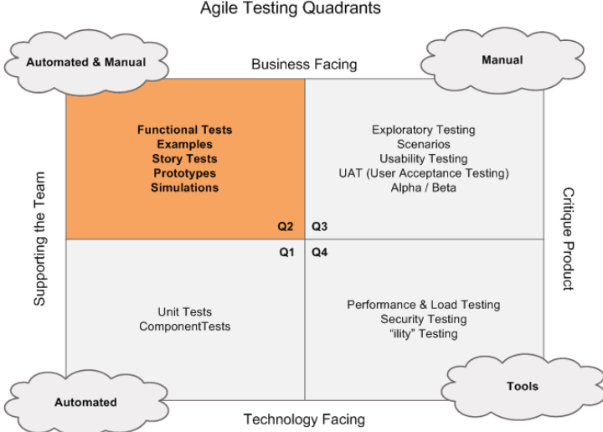

Quadrant 1 Test
- Types of test
  - unit and component testing
- Purpose
  - Test database access, updates
  - Business logic and presentation separated
  - Isolate tests ,allows isolating problems
  - Focus on Internal code quality
  - Allow continual refactoring
- Benefit
  - Unit Test provide safety net
  - Refactoring support
    - Improve design and maintainability without changing functionality
  - Faster; productivity; builds quality inside
  - TDD increases confidence in design
  - Forms basis for automated regression suite
  - Builds testability inside code
- Toolkits
  - Unit Test tools
  - Integrated development environment (e.g. eclipse, intelliJ etc)
  - Build/CI tools, source code management

Quadrant 2 Test
- Types of test
  - Functional Test, examples/ story tests/prototype/simulation
- Purpose
  - Drive development with business facing tests
  - Focus on external quality
  - Elicit requirements; explain business
- Benefit
  - Help customer to achieve advance clarity, clarify requirements
  - Capture example, express as executable test
- Toolkits
  - Checklist, mindmaps, mockups, prototypes, flowcharts
  - Story test template (test case)

Quadrant 3 Test
- Types of test
  - Exploratory, scenarios/usability testing/user acceptance testing/alpha/beta
- Purpose
  - Evaluate the product
  - Recreate user experience
  - Realistic use
  - Learn as you test
- Benefit
  - Build confident, quick feedbac
  - Capture example, express as executable test
- Toolkits
  - Simulators and Emulators
  - Logging toolkit (log and analyze user behavior)

Quadrant 4 Test
- Types of test
  - Performance, load testing, security tetsing
- Purpose
  - To cover non-functional or para-functional tests
  - Performance, stability, realibility, scalability, maintainability, compatability, installability
  - Memory management, data migration, recovery and failover test, baseline
  - Realistic use
  - Learn as you test
- Benefit
  - Build confident (make assurance for complete product)
- Toolkits
  - Native database tool
  - Jprofiler etc
  - Commercial load test tools

Planning Your Test Strategy
- Plan you test strategy;
  - Consider factors such as priorities, resource, risks, time scope and other constraints
- Choose the right Tools that solve the problem
- Involve Customers, collaborate with them
- Improve using the lesson learnt each time, findings
- Document only what is useful
- Consider all four quadrants
- Elaborate all quadrants to team and come to consensus on what is applicable to the project

4.7 Test Automation
- Challenges in TA (numerous factor)
  - System Environment
    - Third party products
    - Deployment condig
    - Database, OS, Browser
  - System Under Test
    - Bug fixes, minor modification
    - New functionality, integration
    - Service packs
    - Patches, data patch ?
    - Interfaces
- Advantages of Test Automation
  - Avoid errors which humans can make when things become repetitive
  - Unlike humans, cannot skip any test case by mistake
  - Records results accurately and on top of it always in a decided format
  - Results can be pushed into a test case management system
  - Cost effective method of achieving the desired results
  - Makes the regression process quite simple and dast
    - The off time(nights) can be utilized
  - Helps in reducing the surplus man power
- When Should a test be automated
  - Testing is done through an external interface (black box testing)
  - Design the test first and then decide if it needs to be automated
  - Consider time and life cycle factors before modeling
  - The organization has fixed maturity level of automation support and libraries
  - Complete automated testing to complete manual testing is a spectrum
    - A choice is usually governed by requirements of the test case
    - Both automation and manual testing are plausible

- What can we automate
  - Continous integration, builds and deploys
  - Unit and component tests
  - API or Webservice Testing
  - Business Logic/API testing
  - GUI testing, load testing, repetitive tasks testing
  - Data creation& Setup
- What we shouldn’t automate
  - Usability testing
  - Trivial tests that don’t fail
  - Exploratory testing
  - One off testing
  - Scenario based testing

- Criteria for Automating a Test Case
  - Criticality
    - Test cases that are business-critical and.or high risk
  - Receptiveness
    - Test cases that has to be performed repeatedly
  - Tedious
    - Test cases that are tedious to perform manually
  - Time consuming
    - Test cases that require considerable amount of time to perform manually

4.8 Benefits of Test Automation (value proposition)
- Reduction in testing cost
  - Un-attended, repeatability, less machines & improved machine utilization
  - QA engineers can focus on kernel test activities
- Shortened test lead time
  - Manual test reduction
  - Better speed in executing tests
  - Re-usable test ware
- Monitoring “Quality”: Health of the product
  - Insight about the risks quicklu
  - Consistency across test runs
  - Test frequently and thoroughly

4.9 Test Automation Process
- Plan software test automation
- Design test automation strategies & solution
- In parallel
  - Select and evaluate available testing tools
  - Develop & implement test automation solutions
- Introduce and deploy test automation solution
- Review and evaluate software test automation

4.10 Test Automation Framework
- Test Automation framework is a set of assumptions, concepts and tools that provide support for automated software testing
- Correctly implemented test automation framework can further improve ROI by reducing the development and maintenance cost
- Framework routine calls from designed tests
  - Modularity and reuse of components
  - Hide design evolution of UI or tool command partial salvation from the custom control problem
  - Independence of application (the test case) from user interface details
- Types
  - Data drive testing
    - Test input and output values are read from data files and are loaded into variables in captured or manually coded scripts
  - Keyword-driven or table driven testing
    - Requires the development of data tables and keywords, independent of the test automation tool
  - Hybrid test automation
    - Combination of all the above techniques
- Benefits of Test Automation
  - Bugs found late are more expensive to fix than bugs found early
  - Return on Investment
    - En = Aa / Am = (Va + n * Da) / (Vm + n * Dm)

4.11 Agile Testing Practices
- Provide continuous feedback
- Deliver value to the customer
- Enable face-to-face communication
- Practice continuous improvement
- Respond to change, self-organize
- Focus on people, enjoy

4.12 Types of Testing
- Functional Testing
  - GUI Software testing
  - Usability Testing
  - Performance testing
  - Compatibility testing
  - Error handling testing
  - Load, volume, stress security scalability, sanity, smoke, exploratory, adhoc, regression testing
  - Reliability, installation, maintenance, recover, failover, accessibility testing
- Non-Functional Testing
  - Baseline testing
  - Compliance testing
  - Documentation testing
  - Localization testing
  - Performance testing
  - Recovery testing
  - Resilience testing

4.13 Agile Testing Principles
- Agile testing foster “whole team approach”
- Business and IT need to think testing strategically
- Testing should address: business and IT needs
- Testing is a multi-skill activity: testing needs collaboration and innovation
- Bring automation early in the development

5. Test Planning & Execution
5.1 Objective
- Test Planning
  - How to write a test plan
  - Discuss the issues of test planning
  - Estimate test planning effort
  - Outline
    - Basic elements of a test plan
    - How much testing is enough
    - Estimating test effort
    - Quality metrics
- Test Execution & Reporting
  - Understand how to manage test execution
  - Evaluate test result
  - Outline
    - Major issues of test execution
    - Criteria to start testing
    - Test documentation
    - Managing the test environment
    - Handling test failure
    - Problem reporting
    - Criteria for test completion. E.g. entry and exit criteria

5.2 The Test Plan
- Defines the overall testing approach
  - Estimate schedules & effort & resource demands
  - Ensure coverage and reliability
  - Access system’s readiness to deliver
  - Ensure customers requirements are met
- Identifies
  - What, who, when, where

5.3 Basic Elements of a Test Plan
- Objective
  - A goal statement stating what is expected to be accomplished
- Description of system to be tested
  - Functions to be tested
  - Functions not to be tested
- Risks, assumption & contingencies
  - Identified risks and mitigation approach
- Approvals and Sign-Offs
  - User Management
  - QA
- Strategy and Approach
  - Test environment
  - Scope of testing
    - Application functionality
    - Usability
    - Security
- Roles and responsibilities
  - Core group
  - Support group
  - Relationship among groups
- Test Schedule & resource
- Communication Approach
- Plan for test execution
  - Criteria to start
  - Suspension & resumption criteria
  - Test completion criteria
- Test procedure
  - Test project management
  - Status reporting
  - Mechanism for change
  - Regulatory compliance

5.4 How much testing is enough
- Depends on the following factor
  - Desired functional coverage
  - ‘degree of quality and reliability required
  - Anticipated quality in the system
  - Consequences of defects constraints on test resource

5.5 Factors Affecting Estimating Test Effort
- Factors that affect estimation are
  - Product complexity and size
  - Product stability vs volatility
  - Inherent risk
  - Efficiency of support infrastructure and test execution process
  - Tester skill and resource availability

5.6 Quality Metrics
- How good is “Good Enough”
- The project manager must establish in advance the key quality metrics that will be used during testing
  - Acceptable severity of defects
  - Acceptable cost of defect detection and repair
  - Acceptable elapsed time to repair defects
- Some test metrics.
  - Test coverage
    - Percentage of feature & requirements tested
    - Number of test case per feature that has been
      - Planned
      - Executed
  - Test Status
    - Total tests planned VS total executed
  - Test Density
    - Ratio of failed test to total executed
  - Defect removal efficiency
    - Fix time per defect
    - Elapsed time between defect detection and fix
  - Ratio of defect founds to defect fixed

5.7 Test Execution & Problem
- Test Execution Process
  - Retrieve Test -> Understand Test case -> Setup test -> Retrieve data
  - Execute Test -> Monitor Interim Result -> Capture Test Result
  - Evaluate Test Result -> Document Test Result -> Failure ?
  - Yes -> write problem report-> Retrieve next test
  - No -> Retrieve next test

- Major Issues of Test Execution
  - Criteria to start Testing
    - Eg. The system is delivered to the test group
    - Testers are ready e.g. properly trained and briefed
    - The test environment is ready, test script is ready
  - Replication of problems
  - Assignment of severity levels
  - Problem reporting
  - Control of test environment
  - Control of test schedule
  - Retesting after defect fix
  - Completion criteria for testing
- Criteria to start Testing
  - Eg. The system is delivered to the test group
  - Testers are ready e.g. properly trained and briefed
  - The test environment is ready, test script is ready

- Test Documentation
  - Typical test documentation consists of
    - Test plans
    - Test specification/test case
    - Test logs
    - Test status report
    - Error/problem reports
  - Typical test Case consists of
    - Test case id,Test case description,Pre-condition required for test
    - Test input data,Expected result
    - Test procedure/test script
      - Steps to execute a test case
  - Typical test Log
      - Test Case ID, Test Date and Time
      - Test Run #, Tested by, actual result observed
      - Test result evaluated by , severity level
      - Test time & date
- Managing Test Environment
  - Includes managing necessary infrastructure needed for testing
    - Hardware, software, tools, test data, test documents

- Test Configuration Management
  - All test artifacts must be placed under configuration management before testing begins
    - Test planning documents
    - Test harnesses and scripts
    - Test data
    - Test reference results
    - Placeholders for test logs and actual results
    - Test results and coverage analyzes

- Management of other Test Items
  - The various tools for test execution management must also be baselined
    - Computer and network platform, OS, application code
    - Test data
    - Instructions to testers, test observers operations, management team
    - Procedures for test results review, defect management, and statistical analyze

- Using Live Data in Testing: Advantage
  - Acceptance occur more readily
  - Test of unusual situation
  - Save effort of data creation
  - Easy to perform volume testing
  - Under representation of negative cases
  - All scenarios not tested
  - Maybe difficult to comprehend expected result
  - Excessive use of resources
  - May violates confidentiality
  - Repeatability of tests not possible

- Test Suspension & Resumption Criteria
  - Suspension criteria specifies the circumstance under which any further testing is paused
    - Too many defects
    - Environment not reliable
    - Severe failure
  - Resumption criteria specifies when testing may resume after a suspension

- Handling Test Failures
  - Why is the behavior not acceptable
  - Can this be replicated
  - Was the test case correct
  - Under what condition does it occur
  - What are the other affected cases
  - Any additional information
  - What is the severity of the problem
  - Should further testing be continued

- Assignment of Severity Levels
  - Severity levels help
    - Assign priorities for fixing defects
    - Monitor project status
  - Each defect would ideally have the following defects associated with it
    - Severe failures where entire system is not available or very little functionality is available
  - Major failures where high-priority features are not available or data integrity is in doubt
  - Minor failures where some functions not available but work-around are available
  - Cosmetic failures are errors which are present but not significant

- Problem reporting
  - Log and deliver quickly
  - Provide a summary of the problem
    - Specify the condition under which the failure occurs
    - Explain steps to reproduce the problem
    - Describe actual vs expected problem
    - Assign level of severity
  - Problem with reporting issue
    - Report description not clear
      - Problem cannot be replicated/cannot be reproduced
      - Not clear why the failure is unacceptable
    - Report not timely
    - Overlapping problem in 1 report
      - Multiple problems reported under one problem
    - Duplicate problem reports
      - Variation of the same theme across several problem reports

- Test Status Reporting
  - Usually applicable for bigger and complicated projects where
    - Test status is not evident
    - Several stakeholders involved
    - Formal project tracking/reporting required
  - Determine reporting frequency during planning
    - Daily, weekly, monthly
  - Reporting information depends on requirement of the project/organization
    - Quality/Test Metrics
    - Other information as dictated by the stakeholders

- Criteria for Test Completion
  - Passes have been logged for all test cases
    - If some cases have not passed the consequence of failing is insignificant
  - The important defects have been fixed and re-test has passed
  - A comprehensive regression test has been executed successfully
  - Test productivity falls off with further testing
    - No or very few errors found on testing further

- Summary
  - Good Test planning and management is an integral part of project management
  - Testware must be adequately reviewed and kept under proper configuration control
  - Problem reporting must be clear and precise
    - Must be able to replicate failures
  - Criteria to start testing and for test completion should be defined and agreed to by all parties involved

Assertion
An assertion is code that’s used during development—usually a routine or macro—that allows a program to check itself as it runs. When an assertion is true, that means everything is operating as expected. When it’s false, that means it has detected an unexpected error in the code. For example, if the system assumes that a customer-information file will never have more than 50,000 records, the program might contain an assertion that the number of records is lessthan or equal to 50,000. As long as the number of records is less than or equal to 50,000, the assertion will be silent. If it encounters more than 50,000 records, however, it will loudly “assert” that there is an error in the program.
Assertions are especially useful in large, complicated programs and in high reliability programs. They enable programmers to more quickly flush out mismatched interface assumptions, errors that creep in when code is modified, and so on.
An assertion usually takes two arguments: a boolean expression that describes the assumption that’s supposed to be true and a message to display if it isn’t.
Normally, you don’t want users to see assertion messages in production code; assertions are primarily for use during development and maintenance. Assertions are normally compiled into the code at development time and compiled out of the code for production. During development, assertions flush out contradictory assumptions, unexpected conditions, bad values passed to routines, and so on. During production, they are compiled out of the code so that the assertions don’t degrade system performance.

