
Service Innovation - CA 1
(Individual)
Name: Lee Zhong De Rollei
Student ID: A0079953L

Report Title:
Table of Contents

1. Introduction 3
2. Background 3
3. How the Service Works 3
4. Service Co-Production and Value Co-Creation 4
CoAssessment, winner define by judges and public votes 7
5. Conclusion 8
6. References 9

1. Introduction

This short report seeks to discuss how Hallmark had used Service Co-Production and Value Co-creation concept in their Greeting Cards business to successfully create competitive advantages against their competitors.

2. Background

Hallmark is one of the largest manufacturers of greeting cards around the world. Hallmark's creative staff consists of around 800 artists, designers, stylists, writers, editors and photographers. Together they generate more than 19,000 new and redesigned greeting cards and related products per year. The company offers more than 48,000 products in its model line at any one time. ^{[1]}
In 2007, Hallmark launched its first greeting card design competition “Your Greeting Card Competition” encouraging their customers to create a greeting card based on a specific theme (provided by hallmark). Customers will be rewarded with cash prizes if the card they submitted were chosen by hallmark judges as the top 5 best designed cards for that theme. The chosen cards will also be made available for public purchases with the designer name printed at the back of the card. ^{[2]}
Today, greeting card contests has become part of Hallmark’s card production process. Each contest draws an average of 1,600 entries ^{[2]}. In fact, the sales of customer-created cards tend to do well or even better than company-created cards. ^{[3]}
This program has allowed Hallmark to continuously engage their customers and create greater awareness among their consumers

3. How the Service Works

- Hallmark will periodically come out with various card design themes contests

- Customers will design the card using Hallmark card design software(http://www.hallmarksoftware.com/) or using their own design software

- Customer will submit their design to hallmarkContests.com along with some sentiment that fits with the theme

- A team of Hallmark judges chooses the winners, and those cards chosen will be sold on Hallmark.com. Winner will receive $250 cash

- At a later date, Hallmark will based on the sales results of customer’s card and decide which card will be sold in stores. Customers whom have their cards chosen to be sold in stored will receive another $250 cash.

4. Service Co-Production and Value Co-Creation

Co-creation encompasses both service co-production and value co-creation where customers participate during any or all of the ideation, design, production, consumption phases of a product/service
The difference in service co-production and value co-creation is that, value co-creation relates to the value received by the customer through usage, consumption or experience. Co-production is a component of co-creation relating to specific tasks undertaken by customers that usually occur prior to usage, consumption or experience. ^{[4]} Hence, it can be seen that the customer is always a value co-creator but may not be a service co-producer

Hallmark first few indirect “Service Co-Production” ideas could be seen from their greeting cards voting contest. Initially, before their greeting cards were sold in stores, Hallmark will get their consumer to vote for the best designed greeting cards produced by their own designer. This contest has now evolved into a direct service co-production idea where customers will be directly involved in designing some of the Hallmark greeting cards and the selected cards designed by customers will be printed and sold by Hallmark
Below is a diagram to illustrate how Hallmark engages their customer to co-produce service (in this case, their greeting cards) and co-create value for their customer.

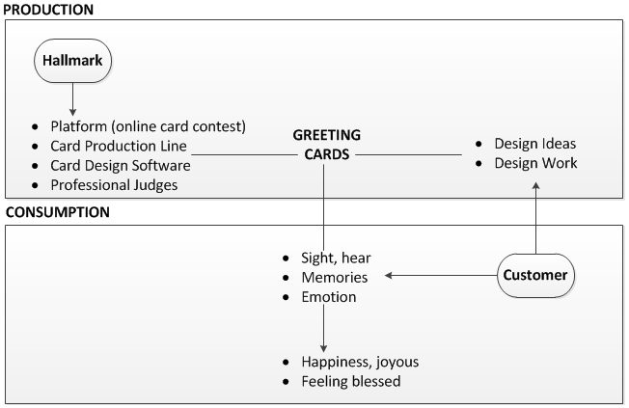
Diagram A: Hallmark’s Service Co-Production and Value Co-Creation Model

The diagram shows the resources (e.g. platform, software) and competencies (e.g. professional judges, design work) put into by Hallmark and their customers during the service production phase has been put together to produce the end product (greeting cards). This can be seen as a service co-production where the customers participate (by contributing design ideas and work) during the card production phase.

The product produced will then be consumed by customer through reading and digesting the content of the card to produce intangible values – happiness.

However, in order to create value from the card, customer must provide the capabilities (e.g. sight, hear, memories etc) during the consumption phase to transform the value proposition in the greeting card into intangible values (e.g. Happiness, joyous). Customer participation during the service consumption phase to produce values can be seen as value co-creation.

Some of the reasons why Hallmark had successfully adopted the co-production:

Hallmark has a very strong brand name in America with huge customer base in America; hence getting enough customers to participate in co-designing of greeting cards was not a problem for them.

To motivate for quantity and quality card design submission, Hallmark not only gives out monetary rewards to the winners, it also gives recognition to winners whom their cards have been selected to be sold in Hallmark. The recognition comes in a form of printing the customer name at the back of the card with hallmark’s logo and publicly announcing customers who have repeatedly win the contests – Hallmark “Repeat Card Stars”

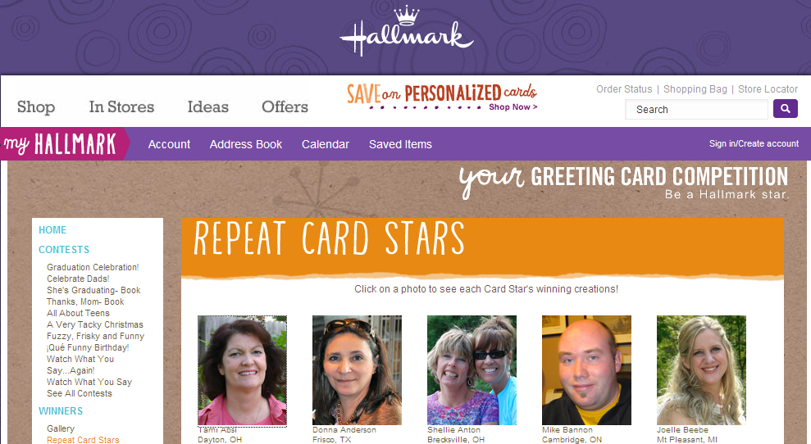

To engage their customer to give the personal touch, hallmark also created a Facebook page for the contest, separate from its corporate fan page. The Facebook contest page is where fans share their contest entries and talk about them. Hallmark judges will also personally comment on in the facebook wall to connect with their fans. This helps to create more awareness for the contest and make the contest more popular than before.

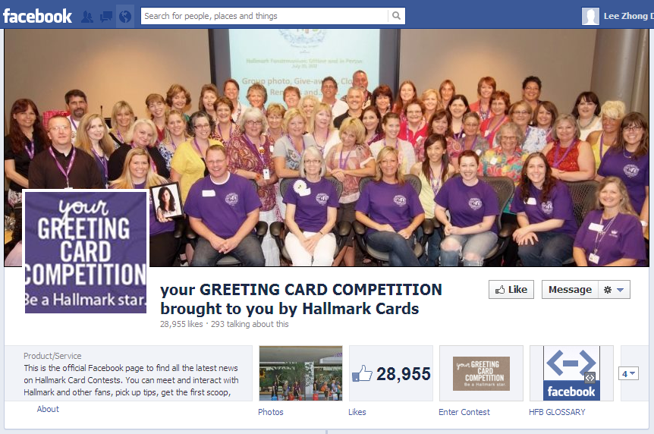

Hallmark effort in organizing the contests has not only provided them with continuous stream of design ideas, it also allows them to tap on the creativity of millions of consumers around the world at a relatively lower cost compared to hiring numerous full time card designers to produce comparable load of desgigns

Moving forward, Hallmark could innovate, allow card designer to also submit the fragrance that comes with the card and the music produced when the card is opened.

CoAssessment, winner define by judges and public votes

5. Conclusion

In the past, the process of service production was driven almost exclusively within the business, customer hardly participate in the design of the product.
However, as the consumers are getting more sophisticated and competent, and with the advancement of technologies where it has enabled companies to engage their consumer more effectively; service co-production seems more plausible than before.
Today, service co-production is more of a competitive necessity than a competitive advantage. Almost all companies will attempt to directly or in-directly involve their customers during product/service production phase, whether through getting feedbacks from customers or empower customers to design their own service or product (through self-service technology e.g. design your own nike shoes), all companies are moving into providing services/products that are more customer oriented than product oriented. This allows companies to produce maximum value to their customer and hence improve the overall service/product experience the customer received.
Service co-production will also allow service/product providers to gain an insight on consumers needs so the providers could attune their service/product to meet their consumers’ requirements.
It is also important for companies to understand how their consumers participate in service consumption to co-create values. It helps companies to identify potential value proposition which could help to enhance their service/products

6. References

[1] Hallmark Website, Hallmark History & Timeline. Retrieved on 10 Sep 2012 http://corporate.hallmark.com/Company/Company-History

[2] Hallmark Website, Consumer Created Cards. Retrieved on 10 Sep 2012 http://corporate.hallmark.com/Product/Consumer-Created-Cards

[3] Stephanie Reese, (2011), Hallmark’s Customer-Created Cards Grow Engagement. Retrieved on 15 Sep 2012 from http://www.emarketer.com/blog/index.php/case-study-hallmarks-customercreated-cards-grow-engagement/

[4] Toni Hilton, (2008), Co-production and co-creation using self service technology: The application of service-dominant. Retrieved 17 Sep 2012, from http://www.business.otago.ac.nz/marketing/events/OtagoForum/Final%20forum%20papers/Otago%20Forum%20Paper%204_Hilton.pdf

[5] Dr Irene Ang, Professor in Uni. Of Warrick (2010),Value Co-Creation. Retrieved 17 Sep 2012, http://value-basedservicesystem.blogspot.sg/2010/01/value-co-creation.html

