
Service Innovation
CA – Service Concept
(Group)

Report Title:
Table of Contents

1. Introduction 3
2. Background Error! Bookmark not defined.
3. How the Service Works Error! Bookmark not defined.
4. Service Co-Production and Value Co-Creation Error! Bookmark not defined.
5. Conclusion Error! Bookmark not defined.
6. References Error! Bookmark not defined.

0. Introduction

Predicting weather can be a tricky business. Existing weather forecast are usually unreliable especially in predicting the current weather of a specific location. As a result, one may have less confidence when planning for ad-hoc outdoor activity (e.g. BBQ, Soccer etc) or may contemplate whether it is necessary to bring an umbrella out.

With the ever increase number of smart phone users in Singapore, predicting accurate weather status of a specific location through crowd sourcing seems more plausible than before.

However, there still exists a challenge to form the right crowd that will actively participate and contribute in reporting the current weather status.

1. Design Challenge

How can we encourage our users to actively contribute to weather updates and stay engaged with us?

2. Concept Description

2.1 Service System

1) Service Attributes & Selection and Benefits
Idea/Offering
Provide mobile application with real-time weather information
Provide open data to the businesses for commercial use
Provide api to embed in other apps
Attributes
-Helps to decide when to do outdoor activities
-Provide api

Benefits/Outcomes
Assurance that the user will not be affected by the weather
Peace of mind

2) Classification of offering according to the KANO model
Basic
Linear
Delighters

3) Quality Function Development Matrix
3) Use trade-off techniques to decide on a set of service offerings which will form your service package

2.2 Concept Map

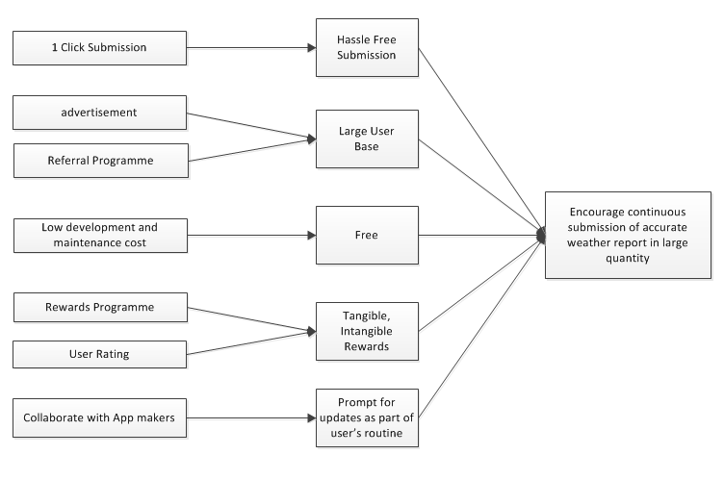
2.3 Story Board
Retrieving the updated weather information

1) User Open Weather App
User can start the Weather App at anytime. No matter what device and mode they’re using. They can start-up individual Weather App directly or access Weather App from the third-party plugin (E.g. Facebook, Forum...) using SmartPhone or computer.
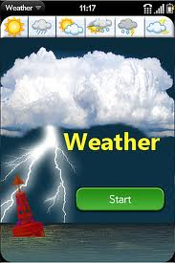
2) Selecting the Place
User can type in the place name, road name or postal code which they want to retrieve. System will display one or more places based on the similarity to sort.
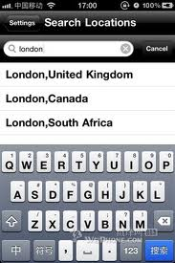
3) Activate GPS to Auto-detect Current Location
For the smartphone or mobile device user, they can enable GPS to auto-detect their current location.
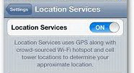
4) Retrieving Weather Info
Upon selected place, system will retrieve the related weather information based on the publishing time and rating to sort.

(pic)

5) View the Published Weather Info
User can view the weather information, comments and suggestions. So it’s easier to know what the weather is for that place.

(pic)

6) Comparing Weather Info
Based on the selected place, system will also provide a most updated official weather information from NEA. User may compare with other people shared weather information.

(pic)

7) Report the Updated Weather Info
User is possible to report the current weather information if they found the published weather is not updated.

(pic)

8) Finalize the Weather Info
Finally, user can get the accurate weather information. So they can do the corresponding preparation.

(pic)

3. Stake Holder Map and Description

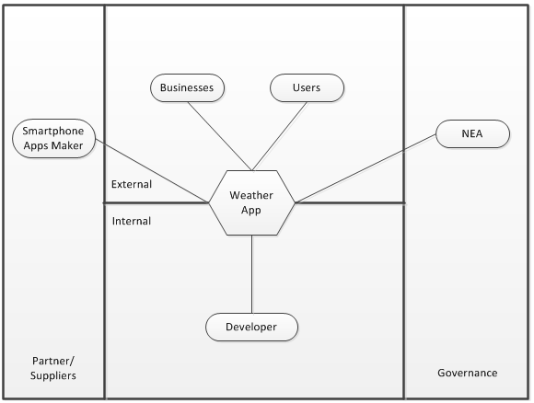
# | Stake Holders | Description
1 | Developer | Group that will develop the weather application for users to check/report weather status
2 | Users | Users that will use the weather app to check/report weather status
3 | Business | Businesses that will use the weather app open data for commercial use. Such as taxi companies may use to direct their taxis to places that is raining heavily where taxis maybe in demand
4 | Smartphone Apps Maker | Companies that weather app can collaborate with to encourage the submission of weather report. E.g. collaborate with facebook or foursquare to embed weather report submission as part of the location check in process.
5 | NEA | Weather app can tap on NEA open data to allow users to compare weather forecast predicted by NEA with weather forecast reported by users

4. Key Insights and learnt opportunities

5. Value Proposition
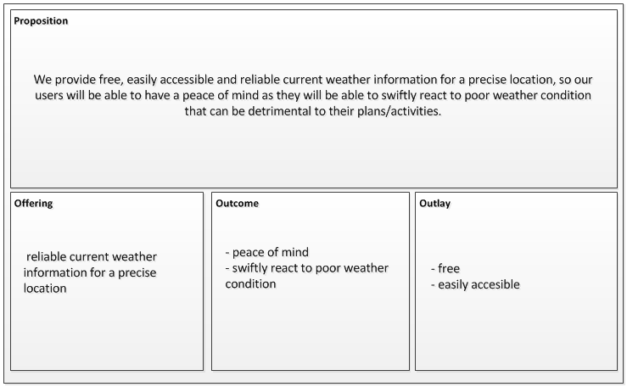

Value Proposition
We provide up to date weather information at any place in Singapore so that you can be sure you get to do what you plan to do without any costs by simply sharing your current weather status.
Offering - Up to date weather information, location service
Outcome - Get to do what is planned
Outlay - Sharing your current weather status

6. Recommendation

