MasterCard Personal Expense Management System (MPEMS)
End of Project Report
Filing Reference : | MPEMS_PM_1.2.6
Document Title : | End of Project Reports
Version : | v0.1a
Prepared By : | Lee Zhong De Rollei
Date Created : | 11 Dec 2012
Team Advisor : | Mr Russon, Howard G
©1993 ISS.  The information contained in this document is the property of ISS. The contents must not be reproduced, wholly or in part, for purposes other than for which it has been supplied, without the prior permission of ISS, or, if it has been furnished under contract to another party, as expressly authorized under that contract. ISS shall not be liable for any errors or omissions. | ISS

Abstract

This document is a project report that summarizes the overall project work undertaken by students (of Team 2S, ISS-NUS) and the issues encountered by the team during the course of delivering the project. The goal of the project is to design and produce a personal expenses tracking system that will help any credit/debit card holders to manage their card expenses through consolidating and tracking transactions of different cards issued by different banks. MasterCard Singapore is the client of this project.

The report starts by providing the background, scope and high-level requirements of this project; it will then move on to discuss the approaches and methodologies that were adopted to execute the project tasks and the issues encountered during the project.

The report will then end by providing an overall evaluation of the project and the conclusion drawn from the output produced from the project.

TABLE OF CONTENTS
13. AMENDMENT HISTORY 5

Revision History:

Version | Date | Author | Remarks
v0.1a | 01 Feb 2012 | Lee Zhong De Rollei | Initial Draft

Distribution:
Name | Department | Organization
Huang Donghao | Master Card | Master Card
Dao Xuan Dung | S2 | ISS
Lee Zhong De Rollei | S2 | ISS
Alvin Lee | S2 | ISS
Guo Yu | S2 | ISS
Zhou ZiFeng | S2 | ISS
Jiang Hao Min | S2 | ISS

1. INTRODUCTION

This project is industry cum academic project supported by Institute of System Science (ISS, NUS) and MasterCard Singapore (the project client). The project team consists of 6 students undertaking the MTECH degree programme offered by ISS, NUS. The project was set to be completed within a period of 12 months with an estimated effort of 369.5 man-days.

The project seeks to develop a web application system - MasterCard Personal Expense Management System (MPEMS) that could provide expense management services to MasterCard customers. The services provided by the new system will enhance customer’s experience with MasterCard and prompt the customers to choose MasterCard as their preferred card. The system also comes with back-end administration modules which will allow MasterCard staff to manage online members and post MasterCard exclusive deals for members to enjoy etc.

The system developed has been successfully tested and is able to integrate with MasterCard UAT database to simulate an end-to-end transaction data flow from a simulated merchant to the new system (MPEMS)’s database using Near Field Communication (NFC) device to trigger the card transaction.

The system was able to meet the client’s requirement of sending out SMS/Email notification to remind customer when they are about to exceed or has already exceeded their spending budget that they have pre-defined in MPEMS.

For maximum outreach of user’s usage, the system also adopted responsive web design ^{[2]} so the application can be viewed and used comfortably by customers using different screen resolution devices. E.g. desktop, tablet and smartphone etc.

The system has now been tested and accepted by MasterCard - Singapore and has now been deployed to MasterCard Research Lab UAT environment for further assessment and refinement before it will be planned for release to the market.

Overall, the project was completed successfully within the planned schedule of 12 months but has exceeded the initial estimated man-effort by 15% - Planned 369.5 man days, Actual: 430 man days

The rest of the report will be providing a more in-depth background of this project and will also discuss the approach and methodology adopted to complete the project.
2. BACKGROUND

2.1 Business Context

The project client – MasterCard is an American multinational financial services coporation. It’s principal business is to process credit/debit payments. MasterCard plays a critical role in processing, or switching, transactions payments—connecting merchants, financial institutions and cardholders together to facilitate fast, reliable and secure payments. ^{[1]}

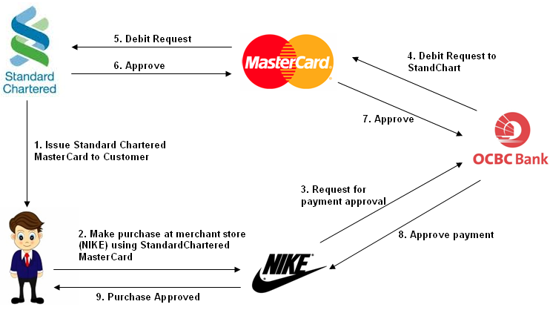

In a recent survey conducted by HSBC, Singapore cardholders owned the most number of credit cards across the region, with an average of 3.3 cards per individual ^{[2].} Currently if a customer holds multiple credit/debit from the same or different banks, individual card expenses can only be tracked by per card basis when the banks on a monthly basis, issue out card bills for each credit card holds by the customer. This can be very inconvenient for customers who need to track their total expenses from all their cards on an ad-hoc and timely basis, as it will be very time-consuming for them to collate bills from different cards from different banks with different billing cycle and then to do the expense computation in totality.

There is certainly a need for a service that will provide customer with consolidated view of their card bills and expenses from different banks. MasterCard who holds the card transaction records from different banks could provision such service to their customers.

The project team has collaborated with MasterCard – Singapore and has developed a system that could help to address the issue that the customer will face when tracking multiple card expenses. In addition, the system that has been developed could also provide supplementary functions such as budget planning and viewing of spending patterns in chart and graphs format to the users.

The system - MasterCard Personal Expense Management System (MPEMS) has the following major functions:

Member Module
- Single point for user to check all their credit/debit cards transactions that are tie to MasterCard Payment Network
- Expense Tracker, allow user to track and analyze their expenses via diagrams, charts etcs.
- Budget Assistance, allow users to organize their budgets and set reminder when their spending is about OR has exceeded their pre-defined budget
- Exclusive MasterCard Deals, allow users to receive exclusive deals only for MasterCard users
- Rewards Program, allow users to earn reward points by spending on their MasterCard. The reward points can be used to exchange vouchers.

Administration Module

- Manage members (such as deactivating account)
- Manage merchant (CRUD)
- Manage Exclusive Deals (CRUD)
2.2 Project Management Context

There were 2 sides of requirements that need to be managed in this project, the academic requirements and project client requirements. It was clear from the start that this project timeline cannot be delayed else it will not only result in poor customer satisfactory, it will also not meet the academic requirements, hence the project was carefully planned

Project Organization Chart

The project team was made up of six team members, each team member assume different primary and secondary roles and different stage of the project. The person assuming the secondary role is the back up for the person assuming the primary role. (i.e. a member’s secondary role can be project manager, hence s/he will take over as a project manager when main project manager is not available). The project Organization chart is as follow.

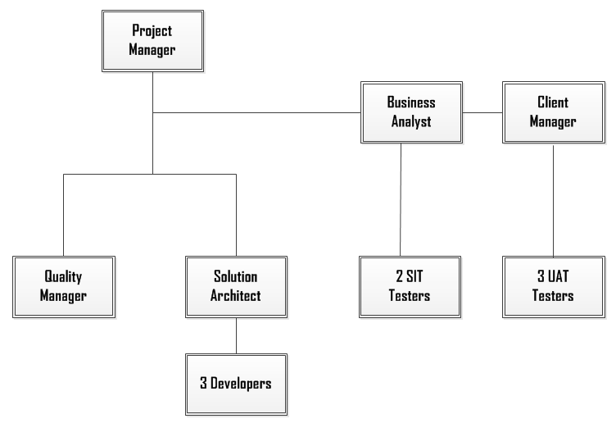

Refer to project plan xxx.xxxx for roles and responsibility

Project SDLC

To meet the rigid deliverables timeline, Waterfall SDLC was used as the requirements were reasonably clear and the familiarity with the technology was considerably high (all team members have previous experience in successful implementation of Java web application). The project was divided into 3 main phases as follow:

Phase 1  Requirements & Project Planning  (Jan to Mar) | Phase 2  Analysis and Design  (Apr to Aug) | Phase 3  Implementation  (Sep to Jan 2014)
The major activities in this phase is  - Gather and baseline user’s requirements and based on user requirements  - Produce a initial project plan (schedule and effort etc)  - Produce project quality plan (quality control etc)  - Risk assessment and measurements to mitigate the risk identified. | Phase 2 of the project was to  - Analyze user requirements and produce the functional specifications and high level design.  - Produce and baseline User Interface Specification  - Prototype high-level design and user interface specification to test design feasibility and user’s acceptance to interface design | The last phase of the project was to  - produce a detailed design specification  - Implement the system (coding & unit test) the system based on detailed design specification  - Conduct 2 round of System Integration Testing  - Conduct 2 round of User Acceptance Testing  - Handover project configuration items to project client

Quality Management

To ensure that the project can be delivered with good quality given the rigid timely, the waterfall model adopted was extended to V-Model where test plan and test activities was done in parallel with the development activities. This will help to ensure that verification and testing can be done as early as possible to discover defects in the early stage of the project before it causes more complications and effort to rectify.

Requirements Traceibility matrix

2.2 Technology Context

Presentation
Browser Side, Responsive Web

Server side
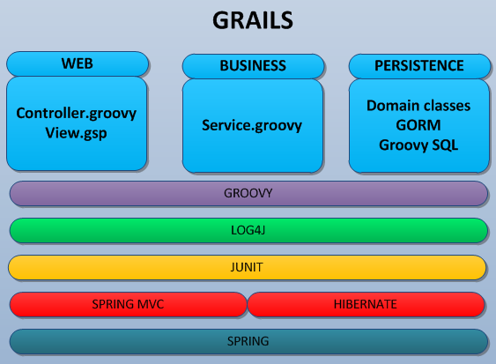

Database Side

During the course of delivering the project, the client required the team to use a relatively new framework – Grails, that has only been around for 2 - 3 years. Grails is an open source, full stack, web application framework for JVM. It takes advantage of the Groovy programming language and convention over configuration to provide a productive and stream-lined development experience ^{[3].} The solution architect has successfully led the team to design and build the system based on this framework.

To ensure the proposed system could outreach to maximum users, it was decided that the system should be developed as a web application as oppose to thick client application (e.g. as windows app, iphone app etc). This will ensure that the system will be able to run in all devices that has internet browser installed.
The system was also designed to be displayed in devices with different resolution sizes through the adoption of responsive web design^{[2]}. To ensure the system will have the same responsiveness as thick client application, client request to and responds from server were communicated via AJAX to minimize large data transmission which can be detrimental to system’s usability due to the longer waiting time to transmit large payload.
In addition, the project client required the system to be developed using Grails (Java Based Framework) and the database to be used is MySQL.

Security
As the data been displayed and transferred are sensitive financial information, to ensure user’s privacy, MPEMS will encrypt data exchange between server and client via TLS/SSL.

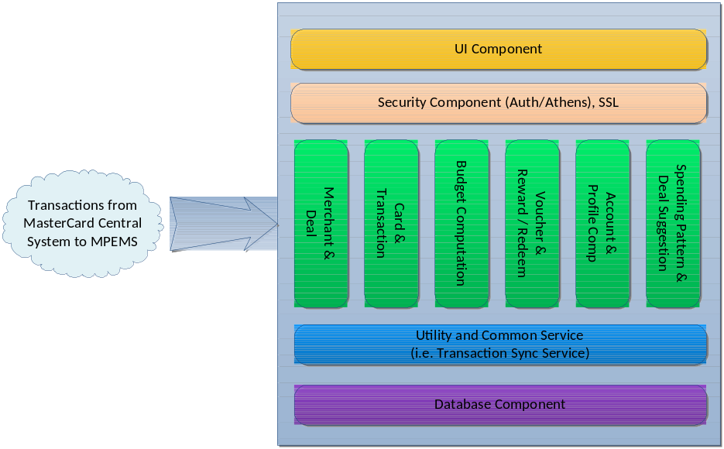
- 3. Project Development
3.1 Requirements and Project Planning Phase
The project started with a kick off meeting with the client to discuss the overall high-level project plan and timeline. Several interviews were then conducted by the business analyst to captured user’s requirements. User requirements was then reviewed, baseline and sign-off by client.
A more detailed project plan was then produced, the efforts was first estimated by using a bottom up effort estimation approach. Each lowest-level work package defined in WBS was assigned with man-days determined by the project manager and solution architect’s expert judgment. The combined total man days of (346 man-days) for the work packages was then used as the project effort estimates. To verify the estimates derived from the bottom up approach, an independent effort estimation was performed using COCOMO (functional point count) algorithm. The effort estimates produced by COCOMO was 8% more (@ 374 man-days) than the estimates produced from WBS work packages, the man-effort for each work package was then reviewed again by the project manager and solution architect. The initial efforts were then finalized at 369.5 man-days.
Project risk assessment was also performed in this phase, a total of 7 management and technical risks were identified. The risks were analyzed and the mitigation and high-level contingency plan for each risk were also defined and assigned to project manager and solution architect for monitoring and control.
A project quality plan was produced. The quality plan described the quality controls that needs to be practiced in this project. The quality plan provides detailed information such as change control procedure, incident report procedure, document control procedure, peer review, task assignment etc.
At the end of phase 1 the following documents were produced.
- Requirement Specifications (reviewed and sign-off by client)
- Project Plan (reviewed and sign-off by client)
- Quality Plan (reviewed and communicated to client and project stakeholders)
- Risk Plan (reviewed and communicated to client and project stakeholders)

Issues and Challenges
Phase 1 of the project was rather smooth sailing as the project client did not have complex/complicated and large scale requirements. All work items were completed and baselined within the planned timeline and effort.
However there still exists an issue with customer’s requirements. Initially, customer only require a few basic functions such as member registration, functions for members to manage their consolidated card transactions from different banks and providing summary view of their consolidated card spending in various diagrams and charts for customer’s analysis.
After analyzing these requirements, as was clear that the requirements could hardly meet the MTECH project requirements of 360 man-days (with 60 man-effort per team member). The team then brainstormed and proposed several ideas such as budget reminder notification via SMS, earn reward points as you spend and exclusive deals for MPEMS member etc. These ideas were well-received by the client and later translated into detailed business requirements
Also, one of the challenges was the collaboration between team members. As each team member will undertake the project tasks at their individual time outside their full-time job, it was initially proposed to use Microsoft Sharepoint Project Workspaces as a common digital ground for members to collaborate in the project, however Assembla was later chosen over Sharepoint because
- Sharepoint workflow is less flexible and may require substantial customization to cater for Change Request / Incident Report procedures defined in the quality plan.
- Assembla is a free online tool and can be used immediately , while some effort is required for the team to install and configure sharepoint services in the project server.

3.2 Analysis and Design Phase
The initial activity in phase 2 was to translate the baseline requirements in phase 1 into high-level functional requirements e.g. UDMS, UCRR etc, and based on the functional requirements define a transition strategy and produce a high-level system architecture. Concurrently, a user interface specification was also produced, reviewed and sign-off by the client. The system architecture design and user interface design were then ptrototyped. The purpose of prototying was to
- Test the overall architecture design and each architecture component (security, logging, exception handling, javascript package, database connection etc)
- Elicit for user’s feedback on System User Inteface design
- Allow the programmers to learn and familiarize with architecture components/

Issues and Challenges

To ensure maximum outreach of user’s usage, MPEMS must be able to run smoothly and viewed comfortably by customers using different screen resolution devices. Initially, it was proposed to the client that MPEMS can also be developed in mobile application e.g. iphone, android etc.

However, after much discussions with the client it was decided that MPEMS to be developed as web application due to the following considerations

- Client do not have an existing team to maintain mobile application

- With the use of correct techniques (e.g. CSS, AJAX etc), web application could also provide equally rich and responsive web user interface

- Could reach more customers, not restricted to only specific customers using the targeted platform

- No true meaning to keep offline data that is not updated.

- Web application can be easily wrapped in mobile application to run like a mobile application on the targeted platform or to be uploaded to app stores like Apple store or Andriod play store etc.
After the decision to build MPEMS as a web application, the team needs to come out with a method to display the page based on different screen resolution in different device. 2 techniques were been discussed. The first technique was through XSL Transformation where client browser will retrieve the data (in XML format) and the layout (in XSL format) and transform into HTML. The second technique was to adopt Responsive web design through the extensive use of fluid layout, dynamic margin/width (in percentage) etc, retrieve data in JSON format and manipulate HTML DOM through Javascript. It was later decided by the solution architect that responsive web design is a better choice because
- Data in JSON format has a lighter payload than XML
- Browser takes longer to render XML into HTML through XSLT
- Same page to be displayed in different resolution may require the creation of multiple XSL files which can be hard to maintain
- Responsive design is a more straight forward technique
Need to have a responsive and interactive chart.

g: user click on chart area, it shows animation...
it's responsive to browser
e.g resize and its size change automatically
it's doesn't use iFrame
so it's much easier to interact
z
- Prototype Study
During the prototype, the team has successfully simulated the end to end process integration with Mastercard UAT servers.
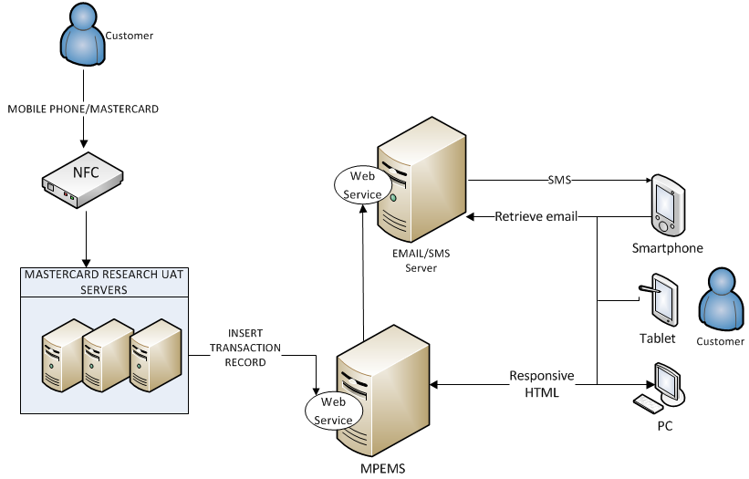
Architecture
Audit Trail, Security, Database
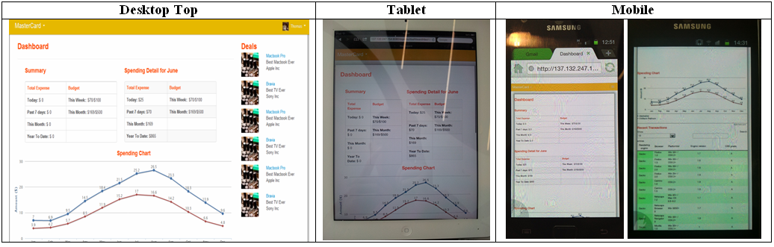

Challenges
Initially, paper task assignment, hard to track, later use assembla to better collaborate and assign tasks to track individual member work done.
Steep learning curve as its still a relatively new framework with not much resources and study online.

3.3 Implementation

Tools used for unit testing GRAILS framework

Challenges
Server provided
Request customer to provide UAT test cases as agreed previously, but customer explained that they do not have time and they suggest to use SIT test cases,
5. EVALUATION
5.1 Project Evaluation

Should have done survey to collect requirements
Prototype should also be done involving public users also used as a means to collect detailed requirements

The project has an initial estimation of 369.5 man days over the period of 1 year. But the actual man days taken to complete the project has exceeded the initial estimation by 15%, i.e. the project took 425 man days to complete. The additional effort arises from scope creep, rework and change requests.
Provide high level planned and actual work.

5.2 Product Evaluation

Provide change request statistic
Provide SIT and UAT defects, average turn around time etc

6. Future work
Everyday MasterCard receive close to 100,000 transaction records, to ensure MPEMS could continuously receive inflow of transaction data without any disruption, MPEMS should be deployed to multiple servers for scalability, recovery and performance. Below is one possible way
Stress testing
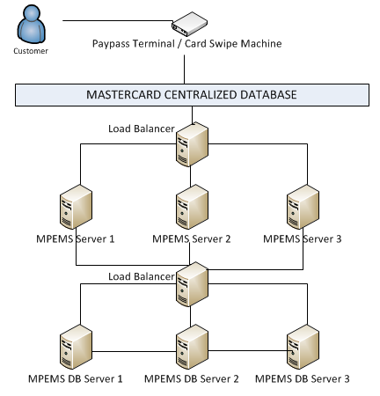
- 13. References
[1] MasterCard, Processing: Behind a MasterCard Transaction – How it Works, Retrieved on 12 Dec 2012.http://www.mastercard.com/us/company/en/whatwedo/processing_behind_transaction .html

[1] Yahoo Finance News, Singapore top in Asia in credit cards owned per person: survey. Retrieved on 12 Dec 2012. http://sg.finance.yahoo.com/news/singapore-top-asia-credit-cards-105414790.html

[2] Design Modo, Responsive Web Design: 50 Examples and Best Practices. Retrieved on 12 Dec 2012. http://designmodo.com/responsive-design-examples

[3] Grails, Learning Grails. Retrieved on 13 Dec 2012. http://grails.org/learn

http://www.mastercard.com/us/company/en/whatwedo/processing_behind_transaction.html
http://designmodo.com/responsive-design-examples/
- 13. AMENDMENT HISTORY
Version | Section | Notes of Amendments or Changes
0.1 | - | Initial Draft

