

Life Cycle Activities
Assignment

SG5103 – CA 1
Software Quality Management
Team 2
- A0079973 : Dao Xuan Dung
- A0079995 : Guo Yu
- A0079949 : Jiang Hao Min
- A0079976 : Lee Mingjian Alvin
- A0079953 : Lee Zhong De Rollei
- A0080037 : Zhou Zifeng

Table of Contents

4 QUALITY SYSTEM FOR LIFE CYCLE ACTIVITIES 3
4.1 INTRODUCTION 3
4.2 PRE-CONTRACT 6
4.3 CONTRACT REVIEW 11
4.4 PROJECT INITIATION & PLANNING 14
4.5 REQUIREMENTS CONTROL 18
4.6 DESIGN CONTROL 21
4.7 PROGRAMMING AND USER DOCUMENTATION 23
4.8 TESTING AND VALIDATION 25
4.9 ACCEPTANCE 27
4.10 DELIVERY AND INSTALLATION 29
4.11 MAINTENANCE 31

QUALITY SYSTEM FOR LIFE CYCLE ACTIVITIES

INTRODUCTION
The main business of Xpress Systems Pte Ltd is to undertake software contracts for Customers. These can be either be new development, enhancements to existing systems, or partial developments (undertaking only part of the life cycle, such as project to produce a requirements specification and a functional specification). From the point view of the QMS, all projects are treated the same – they all involve delivering the requirements specified by the Customer. To achieve the successful delivery of Customer requirement, the project must be organized around a life cycle model featuring the basic activities shown as below.
Pre-Contract Phase
- File Tender Specification into Company Project Shared Repository
- Study Tender Specification
- Produce RFP(Request for Proposal) work plan
- Conduct Initial Requirements Gathering and Documentation of requirements
- Requirements Feasibility Study and produce proposal
- Review proposal and initial user requirement specifications

Contract Review Phase
- Review contract
- Contract negotiation meeting
- Update contract
- Contract Sign Off

Project Initiation & Planning
- Project Initiation
- Setup project filing system
- Project start up meeting
- Produce project plan and quality plan
- Review project plan and quality plan
- Project team formation
- Send project team for training (if required)
- Engage subcontractors (if required)
- Engage hardware/software supplier (if required)s

Requirements Control
- User requirements gathering
- Study and Documentation of user requirement specification
- Review user requirement specification (Internal)
- Review user requirement specification (Customer)
- Sign Off user requirement specification

Design Control
- Conduct preliminary design
- Produce user interface design specifications (optional)
- Build and study prototype
- Prototype walk-through with customer
- Formulate system design strategy
- Change Request (if required)

Programming and User Documentation
- Development Environment Setup
- Coding
- Design and Review Unit Test Plan (Test Case/Test Script)
- Perform Unit Test & Document Test Results
- Peer Review/Code Walkthrough

Testing and Validation
- SIT environment setup
- Produce test plan (strategy, test case, script)
- Review test plan
- Perform SIT and document SIT results
- Review SIT results
- Coding (Fix Defects)
- Create SIT Test Report
- Review SIT Test Report

Acceptance
- UAT environment setup
- Conduct user training
- Produce Test Plan (Strategy, Test Case, Script)
- Review and Accept Test Plan
- Perform UAT & Document UAT Results
- Review UAT Results
- Coding (Fix Defects)
- Change Request (if required)
- Create UAT Test Report
- Review & Accept UAT Test Report

Delivery and Installation
- Review and accept delivered product
- Produce and review installation plan
- Installation
- Post installation check
- Troubleshoot and fix installation issue
- Handover and user sign off

Maintenance
- Produce maintenance documentation
- Review maintenance documentation (internal)
- Review maintenance documentation (customer)
- Troubleshoot and analyze production issue
- Perform corrective action
- Regression testing in UAT
- Deploy fix to production

PRE-CONTRACT
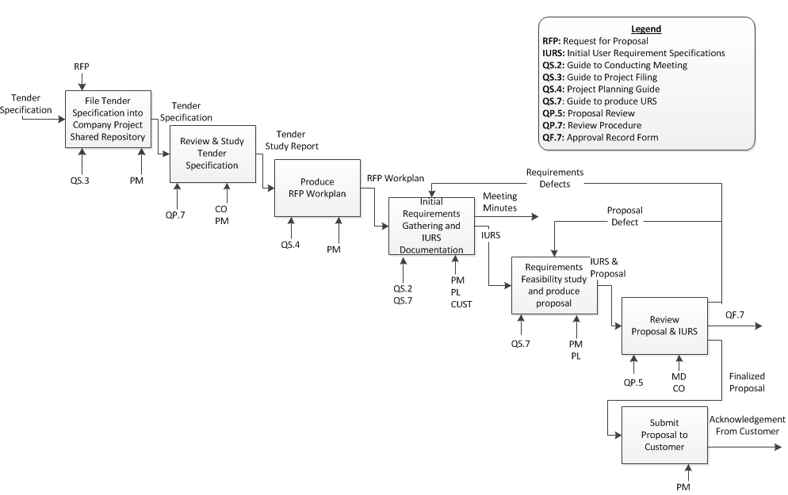
PRE-CONTRACT
PURPOSE | : | - To ensure the RFP process start off in a controlled manner  - To ensure customer initial requirements are captured and properly process  - To feasibility of the requirements
OBJECTIVE | : | To produce an exceptionally good proposal to obtain approval from MD and subsequently secure the project contract from customer
STANDARDS | : | Product Standard  - Proposal  - Initial User Requirement Specification  Process Standard  - Review Tender Specification in details  - Produce a RFP work plan  - Conduct User Requirements Gathering  - Obtain approval of proposal from MD
INPUT | : | - Tender Study Report
OUTPUT | : | - Tender Study Report  - RFP Work plan  - Meeting minutes  - Approved Proposal  - Initial User Requirement Specification
PROJECT FLOW | : | The pre-contract phase starts when the formal request for proposal and tender specification is received

STEPS | TOOL/REFRENCE
File Tender Specification into Company Project Shared Repository  All potential projects’ pre-contract information such as tender specifications and business specifications must be filed into company’s project document shared repository | QS.3: Guide to project filing
Review and Study Tender Specification  PM and CO will need to review and study the tender specification to understand the high-level requirements fully and subsequently determine the suitability of the project. | QP.7: Review Procedure
Produce RFP Work plan  To ensure the RFP process is conducted in a controlled manner. The project manager will need to come out with a strategy and a high level work plan to increase the chance of securing the project  PM also need to assign a project leader to assist him in the RFP process  PM should also reference the project planning guide when producing the high level work plan. | QS.4: Project Planning Guide
Initial Requirements Gathering and IURS Documentation  PM must first obtain the high level project requirements from customer. The project requirements should also cover the legal perspective of the project. The project requirements collected during the requirements gathering will have to be documented into an initial user requirement specification. | QS.2: Guide to Conducting Meeting  QS.7: Guide to produce URS
Requirements Feasibility Study and Produce Proposal  PM and the assigned PL will need to conduct a feasibility study on the technical challenges and the risks involved in the project based on the high level requirements.  If the feasibility study shown that the company may not have the technical expertise or resources to meet the project requirements or if the risk is too high, PM may recommend stoppage to the project and the MD will approve/reject PM’s recommendation  If the feasibility study shows that the project is potential, PM & PL will produce a project proposal. The proposal should describe the high level solutions that will help to meet customer’s business requirements | QS.7: Guide to produce URS
Review Proposal and IURS  After receiving the proposal from the PM, MD review the proposal with reference to the IURS to ensure the proposal is feasible in terms of timescale and financially viability.  CO will also review the proposal to ensure the proposal does not conflict with company policies  CO and MD will both sign off the approval record form to indicate that they have reviewed and approved the proposal | QP.5: Proposal Review  QF.7: Approval Record Form
Submit Proposal to Customer
Finally, upon receiving the approval from the MD and CO, PM will submit the proposal to customer

CONFIGURATION ITEMS | : | - Tender Study Report  - RFP Work plan  - Meeting minutes  - Approved Proposal  - Initial User Requirement Specification
DOCUMENT CONTROL ITEMS | : | - Approved Proposal  - Initial User Requirement Specification
QUALITY RECORDS | : | - Proposal Review Records  - Proposal Approval Record Form  - Minutes from requirements gathering

CONTRACT REVIEW
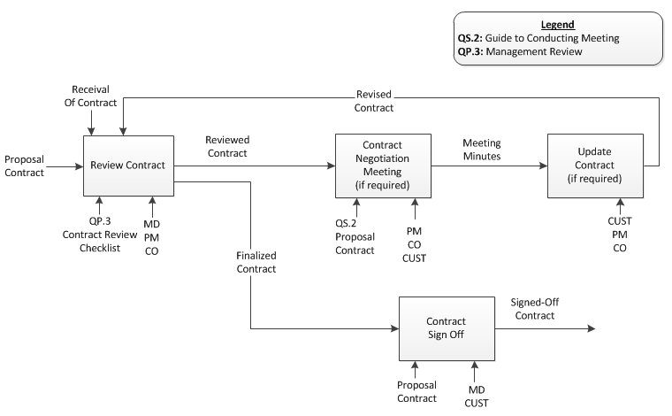
CONTRACT REVIEW
PURPOSE | : | To ensure proper contract review is conducted and company will only enter into the contract if the project are technically feasible within a justifiable timescale and the project is financial viable
OBJECTIVE | : | To get the contract reviewed and sign-off with reasonable agreement and cost
STANDARDS | : | Product Standard  - -  Process Standard  - Review of Contract  - Contract Negotiation  - Contract Sign-off
INPUT | : | - Proposal  - Contract
OUTPUT | : | Signed-Off Contract
PROJECT FLOW | : | The pre-contract phase starts when the formal request for proposal and tender specification is received

STEPS | TOOL/REFRENCE
Review Contract  Upon receiving the contract from the customer. MD, PM and CO will review the contract to ensure that the contract adhere to the company policies for project work. | QP.3 Management Review  Contract Review Checklist
Contract Negotiation (if required)  If required, after the contract has been reviewed, PM will arrange for a contract negotiation meeting with the customer. The negotiation meeting will allow both parties to validate and clarify any issues regarding the contract.  All discussion must be documented in the minutes. | QS.2: Guide to conducting meeting  Proposal  Contract
Customer Update Contract (if required)
If the contract needs to be updated after the contract negotiation meeting, customer will do the update and resend it to the company for review.
Contract Sign Off
Once both party is agreeable with the finalized contract. The contract will be signed off by both party

CONFIGURATION ITEMS | : | Signed-Off Contract
DOCUMENT CONTROL ITEMS | : | -
QUALITY RECORDS | : | - Review records for contract review  - Minutes for contract negotiation meeting

PROJECT INITIATION & PLANNING

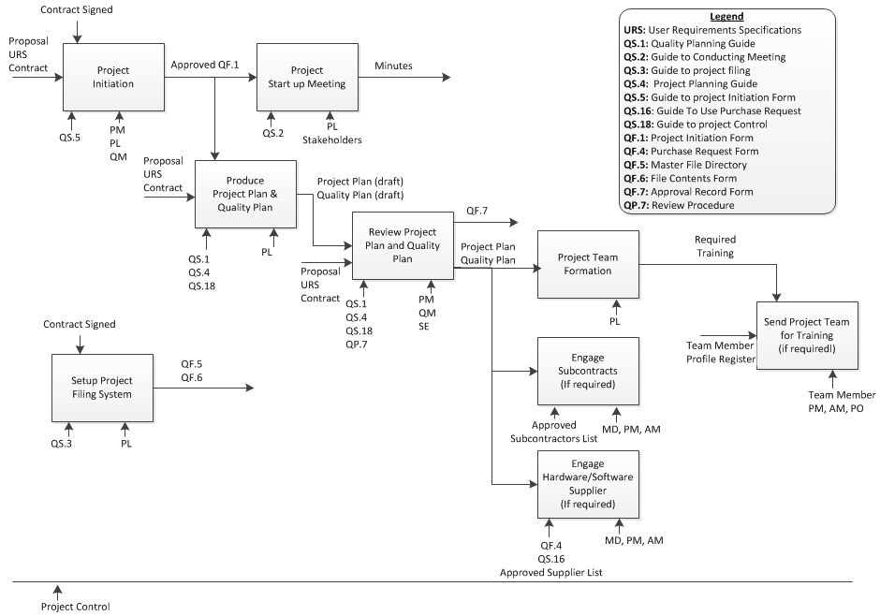
Project Initiation & Planning
PURPOSE | : | - To formally initiate the project  - To formulate project strategy  - To estimates project schedule, cost and resources  - To analyze the risk and produce a risk plan to manage any potential risks
OBJECTIVE | : | To produce an overall project plan and obtain management, stake holders commitment to the plan
STANDARDS | : | Product Standard  - Project Plan  - Quality Plan  Process Standard  - Project initiation  - Project start up meeting  - Project Planning  - Quality Planning  - Project team formation  - Team member training (if required)  - Engage sub contractors (if required)  - Engage suppliers (if required)
INPUT | : | - Proposal  - Contract  - User requirement Specification
OUTPUT | : | - Project Plan  - Project strategy  - Work breakdown structure  - Estimated resources required  - Estimated cost  - Estimated project schedule  - Risk Plan  - Quality Plan  - Change control procedure (specified to this project)  - Document review procedure (specified to this project)  - Document register  - QF.5: Master file directory  - QF.6: File contents form
PROJECT FLOW | : | The project initiation and planning phase starts when the contract has been signed

STEPS | TOOL/REFRENCE
Project Initiation  During the project initiation process:  QM will have to register the project details into the project register for tracking purpose  The PL (assigned by PM during pre-contract phase) will initiate the project but completing the project initiation form. PM will review and approve the initiation form created by PL | QF.1 Project Initiation
Setup Project Filing System  Concurrently, the project PL will also be responsible to setup a project filing system to ensure all project related documents are stored under a controlled environment. A master file directory list and file contents form must also be produced. | QS.3: Guide to project filing  QF.5: Master file directory  QF.6: File contents form
Project Setup Meeting  Upon receiving the approval of the project initial form, PL will initial a project start up meeting (project kick-off meeting). PL will have to give a short presentation to introduce the project to all project stakeholders and hence get their commitment to the project | -
Produce Project Plan & Quality Plan  It is also the PL’s job to produce the project and quality plan. | -
Review Project Plan & Quality Plan  Upon receiving the contract from the customer. MD, PM and CO will | -
Form Project Team  Upon receiving the contract from the customer. MD, PM and CO will | -
Engage Subcontracts (Optional)  Upon receiving the contract from the customer. MD, PM and CO will | -
Engage Suppliers (Optional)  Upon receiving the contract from the customer. MD, PM and CO will | -

CONFIGURATION ITEMS | : | Signed-Off Contract
DOCUMENT CONTROL ITEMS | : | -
QUALITY RECORDS | : | - Review records for contract  - Minutes for contract negotiation meeting

REQUIREMENTS CONTROL

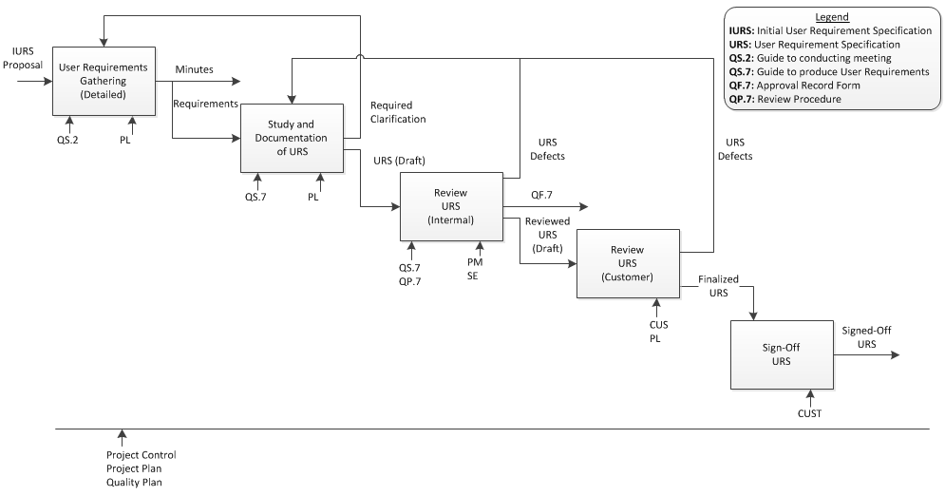
REQUIREMENTS CONTROL
PURPOSE | : | To understand customer’s business requirements and translate it to functional requirements. To ensure the translated functional requirements are reviewed repeatedly to prevent any potential scope creep.
OBJECTIVE | : | Obtain user requirement specification sign-off from users
STANDARDS | : | Product Standard  - Signed-Off URS (User Requirement Specification)  Process Standard  - User Requirements Gathering  - Study and Documentation of URS (User Requirement Specification)  - Review URS (Internal)  - Review URS (Customer)  - Sign-Off URS
INPUT | : | - Initial User Requirement Specification  - Proposal  - Project Plan  - Quality Plan
OUTPUT | : | Signed Off User Requirement Specification
PROJECT FLOW | : | The requirements control phase starts when the contract has been formally signed by both party

STEPS | TOOL/REFRENCE
User Requirements Gathering  Based on the project requirements, requirements can be gathered via interviews, focus group, and observation from existing system or survey. The project leader will determine the appropriate method to conduct the requirements gathering meeting. At the end of every meeting, a meeting minutes will have to be produced for audit purpose. The minutes will have to be disseminated out to various stakeholders and also be filed into the project filing system. | QS.2: Guide to conducting meeting
Study and Documentation of URS  After collecting the requirements from requirements gathering meeting, PL will have to study the requirements and fully understand the requirements. If clarification is required, PL and Customer will attempt to clarify the requirements gap via emails or phone calls, if required PL or Customer could request for a formal requirements meeting.  After fully understanding users’ requirements, PL will have to translate the requirements into a user requirements specification. | QS.7: Guide to produce user requirement specifications
Review URS (Internal)  The requirement specification documented by the PL will have to be reviewed by the PM to ensure the clarity and completeness of the requirements. PM will have to follow the standard review process (QP.7) Upon completing the review, PM will approve the URS. PL can then proceed to send the URS for customer’s review | QP.7: Review Procedure  QF.7: Approval Record Form
Review URS (Customer)
Customer will be given sometime to do the review
Sign Off URS
Once the customer has completed reviewing the URS, the customer will have to sign-off the URS.

CONFIGURATION ITEMS | : | Signed-Off User Requirement Specification
DOCUMENT CONTROL ITEMS | :
QUALITY RECORDS | : | - URS review (internal) records  - URS approval records  - Minutes for user requirements gathering

DESIGN CONTROL

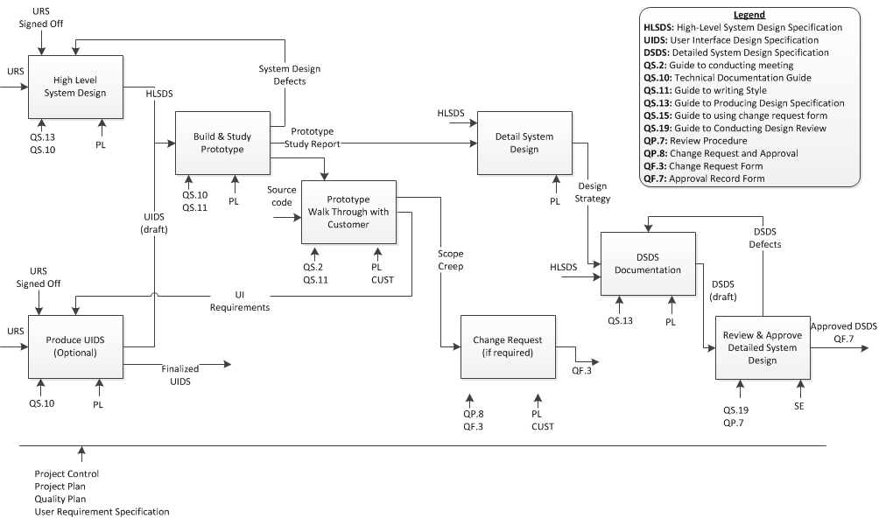

DESIGN CONTROL
PURPOSE | : | - To produce a high level system design to define the system architecture, platform, components, services  - To build a prototype to ascertain the feasibility of the high level design  - To produce screen design mock ups and walkthrough the system prototype with user to continuously validate the requirements
OBJECTIVE | : | To produce a holistic system design
STANDARDS | : | Product Standard  - Detailed Design Specification  - Design Strategy  - Architecture Design  - Component and Service Design  - Database Design  - Design Pattern  - Coding Standard  Product Standard  - Build and review prototype  - Prototype walkthrough with customer  - Review and obtain detailed design approval from SE  - Review user interface specification design (if any) with user
INPUT | : | - Decision to proceed with preliminary system design  - Signed-off user requirement specification
OUTPUT | : | - Detailed System Design Specification to describe the internal design of the new system  - Prototype Study Report (if any) to describe the findings and justification of decision made to the design  - User Interface Design Specification (if any) to describe the mock up screens of the new system  - Change Request (if any) to document down any requirements not documented in user requirements
PROJECT FLOW | : | The design control phase starts when the user requirements have been signed off by the user.

STEPS | TOOL/REFRENCE
High Level System Design  After the user requirement specification has been signed-off, the PL will proceed to do a high level system design. The design should cover the design strategy (translating analysis to design), system architecture, components, services | QS.13 Guide to producing design specification  QS.10: Technical documentation guide
Produce UIDS (User Interface Design Specification) - Optional  If the new system is operated via graphic user interface, PL will have to do a screen mock up for the new system. The screen mock up produced will be prototyped | QS.10: Technical documentation guide
Build & Study Prototype  The high level design will have to be prototyped to ensure it is feasible to be implemented. A prototype study report must be documented to justify the design decision made. It can also be used by future project as a reference for system design | QS.10: Technical documentation guide  QS.11: Guide to writing style
Prototype Walk through with customer  After building and studying the prototype, PL will have to walk through the prototype with the customer. The purpose is to revalidate some of the critical high-level functions with the customer. | QS.2: Guide to conducting meeting
Change Request (if required)  During the prototype walkthrough if customer discovers some of the critical functions are missing from the prototype and was not documented in the user requirement specification. The customer will have to raise a Change Request Form. The form will be subjected to the PL for review. The PL will not recommend to the PM the effort required and the PM will decide if the CR will be chargeable | QP.8: Change request and approval  QF.8 Change Request Form
Detailed System Design
After studying the prototype, PL will have to proceed to conduct a detailed system design. The detailed design should cover the database design, coding standard, UML diagrams and design patterns to be used.
DSDS (Detailed System Design Specs) Documentation  The detailed design will have to be documented based on the QS.13 guideline. | QS.13 Guide to producing design specification
Review and Approve DSDS (Detailed System Design Specs)  Upon completing the detailed design specification, the document will be sent to SE for review. | QS.19: Guide to conducting design review  QP.7: Review procedure

CONFIGURATION ITEMS | : | - Prototype Study Report  - User Interface Design Specification  - High Level System Design  - Detailed System Design Specification
DOCUMENT CONTROL ITEMS | : | - User Interface Design Specification  - High Level System Design  - Detailed System Design Specification
QUALITY RECORDS | : | - Minutes from prototype walkthrough  - Detailed design specification review records  - Detailed design specification approval record

PROGRAMMING AND USER DOCUMENTATION
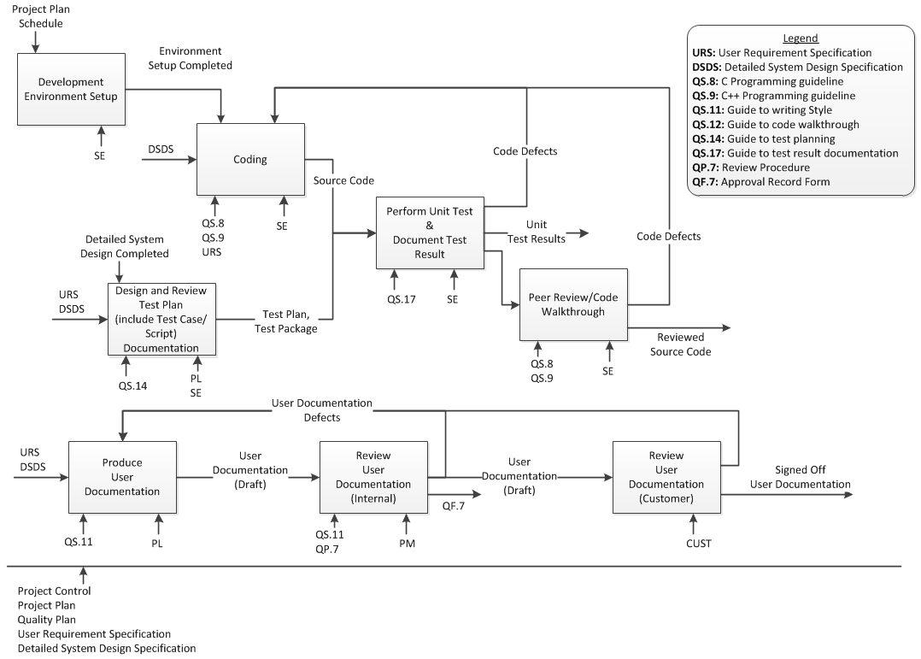
PROGRAMMING AND USER DOCUMENTATION
PURPOSE | : | - To produce the source code of the new system and ensure that he source code produced adhere to coding standard and meet the system requirements  - To produce user documentation and obtain sign off from customer
OBJECTIVE | : | - To produce the source code of the new system  - To obtain user documentation sign off
STANDARDS | : | Product Standard  - Reviewed Source Code  - Unit Test Results  - Signed-Off User Documentation  Process Standard  - Coding  - Peer Review/Code Walkthrough  - Review of user documentation
INPUT | : | - Detailed System Design Specification  - User requirements
OUTPUT | : | - Reviewed Source Code  - Unit Test Results  - Signed-Off User Documentation
PROJECT FLOW | : | The phase starts when the SE has formally reviewed and approved the detailed design specification

STEPS | TOOL/REFRENCE
Development Environment Setup
SE will have to setup the development environment before the coding commerce. All coding will have to be done in a controlled manner using source code controlling tool such as SVN, Source Safe etc
Coding  The programmer study the detailed system design specification and proceed to code the system based on the detailed system design specification | QS.8: C Programming Guideline  QS.9 C++ Programming Guide
Design and Review Test Plan  SE could proceed to produce the unit test plan after the detailed system design specification has been baseline. | QS.14: Guide to test planning
Perform Unit Test & Document Test Result | QS.17: Guide to test result documentation
Peer Review/Code Walkthrough | QS.8: C Programming Guideline  QS.9 C++ Programming Guide
Produce User Documentation | QS.11: Guide to writing style
Review User Documentation (Internal) | QS.11: Guide to writing style  QP.7: Review procedure  QF.7: Approval Record form
Review User Documentation (Customer)

CONFIGURATION ITEMS | : | - Source Code  - Test Package/Script  - Unit Test Plan
DOCUMENT CONTROL ITEMS | : | - User Documentation  - Unit Test Plan  - Source Code
QUALITY RECORDS | : | - Unit Test Results  - User documentation review (internal) records  - Peer review/code walkthrough findings

TESTING AND VALIDATION
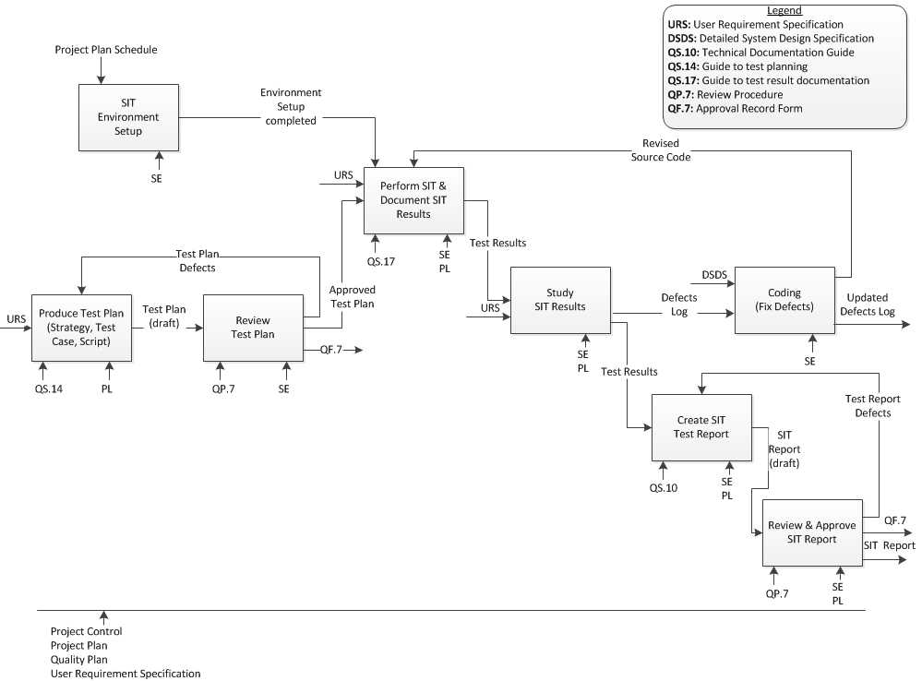
TESTING AND VALIDATION
PURPOSE | : | To ensure the new system is tested thoroughly before user testing to boost user’s confidence in the system
OBJECTIVE | : | To test and validated the entire system to ensure its bugs free
STANDARDS | : | Product Standard  - Approved Test Plan and Test Script  - SIT Test Report  Process Standard  - SIT  - Review of SIT results  - Coding to fix defects (if any)  - Review of SIT Report
INPUT | : | User requirements Specification
OUTPUT | : | - Approved Test Plan and Test Script  - SIT Test Report
PROJECT FLOW | : | This phase will start after all the modules code are completed,

STEPS | TOOL/REFRENCE
SIT Environment Setup
Produce Test Plan (Strategy, Test Case, Script) | QS.14: Guide to test planning
Review Test Plan | QS.14: Guide to test planning  QP.7: Review procedure  QF.7 Approval Record Form
Perform SIT & Document SIT Results | QS.17: Guide to test result documentation
Study SIT Results
Coding (fix defects)
Create SIT Test Report
Review SIT Report | QP.7: Review procedure  QF.7 Approval Record Form

CONFIGURATION ITEMS | : | - Test Results  - SIT Plan  - SIT Report
DOCUMENT CONTROL ITEMS | : | - SIT Plan
QUALITY RECORDS | : | - Test Results  - Approval records of test plan and SIT report  - Review records of test plan and SIT report

ACCEPTANCE
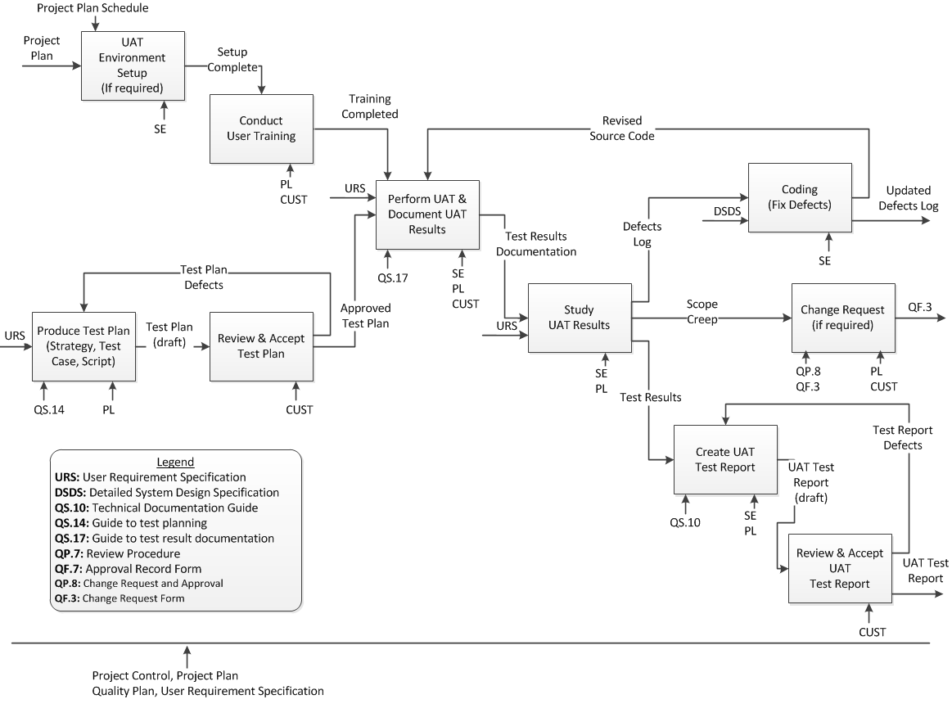
ACCEPTANCE
PURPOSE | : | To ensure
OBJECTIVE | :
STANDARDS | :
INPUT | :
OUTPUT | :
PROJECT FLOW | :

STEPS | TOOL/REFRENCE
UAT Environment Setup
Conduct User Training
Produce Test Plan | QS.14: Guide to test planning
Review & Accept Test Plan
Perform UAT & Document UAT Results | Test cases found in Test Plan  QS.17: Guide to test result documentation
Study UAT Results
Coding (defects) | Coding standards defined in detailed system design specification
Change Request (if required) | Qp.8: Change Request and Approval  QF.3: Change Request Form
Create UAT Test Report | QS.10: Technical documentation guide
Review & Accept UAT Test Report

CONFIGURATION ITEMS | : | - UAT Plan  - UAT Report
DOCUMENT CONTROL ITEMS | : | - UAT Plan  - UAT Report
QUALITY RECORDS | : | - Test results  - UAT Results  - UAT Defects

DELIVERY AND INSTALLATION
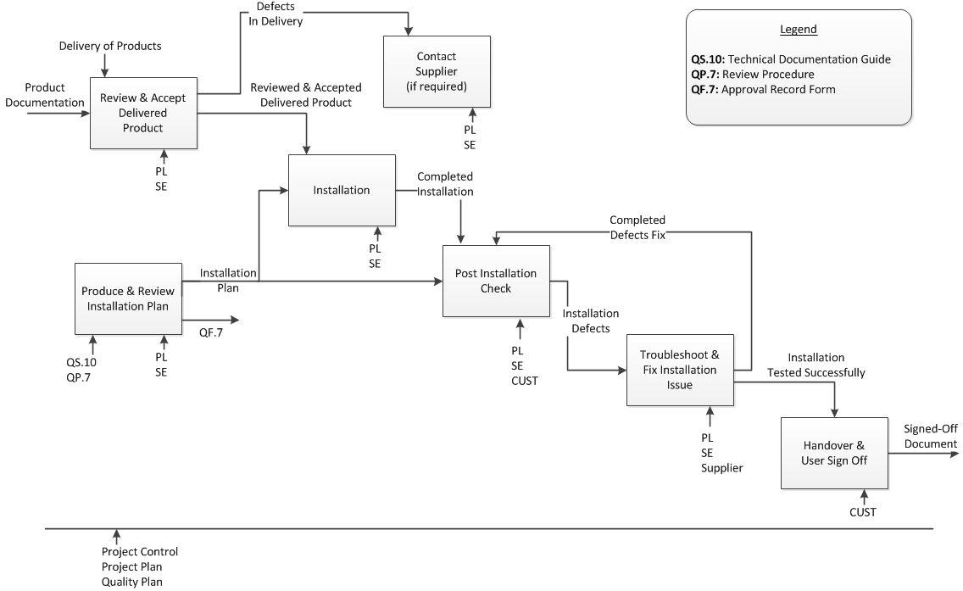
DELIVERY AND INSTALLATION
PURPOSE | :
OBJECTIVE | :
STANDARDS | :
INPUT | :
OUTPUT | :
PROJECT FLOW | :

STEPS | TOOL/REFRENCE

CONFIGURATION ITEMS | :
DOCUMENT CONTROL ITEMS | :
QUALITY RECORDS | :

MAINTENANCE
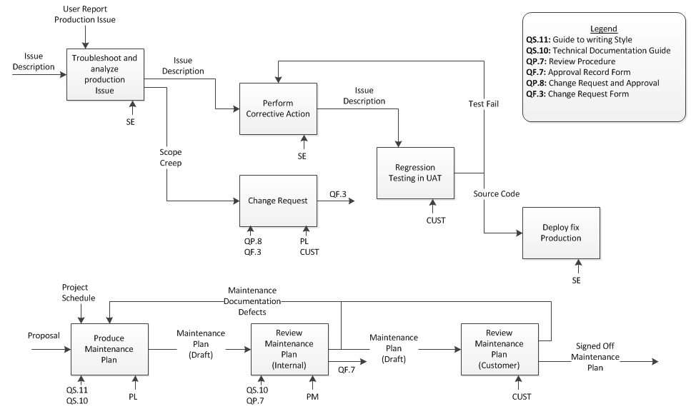
MAINTENANCE
PURPOSE | : | To ensure the customer
OBJECTIVE | :
STANDARDS | : | Product Standard  - Maintenance Plan  Process Standard  - Maintenance planning  - Review of maintenance plan (internal)  - Maintenance plan sign off by customer
INPUT | : | Proposal
OUTPUT | : | Signed-Off Maintenance Plan
PROJECT FLOW | : | The maintenance phase will start immediately after the customer took over the system.

STEPS | TOOL/REFRENCE
Troubleshoot and analyze production issue
Perform Corrective Request
Change Request | QS.8: Change Request and Approval  QF.3: Change Request Form
Regression Testing in UAT
Deploy fix production
Produce maintenance plan | QS.11: Guide to writing style  QS.10: Technical Documentation Guide
Review maintenance plan (internal)
Review maintenance plan (customer)

CONFIGURATION ITEMS | : | Signed-Off Contract
DOCUMENT CONTROL ITEMS | : | -
QUALITY RECORDS | : | - Review records for contract  - Minutes for contract negotiation meeting

