
Software Entrepreneur
SG5013

TEAM MEMEBRS:

A0079953 – LEE ZHONG DE ROLLEI
A0079949 – JIANG HAO MIN
A0080053 – CHONG CHEE YONG
A0006487 – KHINE PHYU PHYU THAN
A0079971 – TAN PIC CHENG

SKYPE: Revolutionized Cross-Border Real-time Communication through
Peer-to-Peer technologies

TABLE OF CONTENTS

1. Executive Summary 3
2. Skype Service 4
3. Technology 6
4. Business Model 8
5. Profitability 11
6. Conclusion 13
7. References 14

1. Executive Summary
Skype Technologies commonly known as Skype is a computer software that uses Voice over IP (VoIP) and internet connectivity to provide real time communication between 2 or more parties. It has been widely used for cross border real time communication as it is relatively cheaper than using traditional land line communication.

Skype was originally founded by Janus Friis from Denmark and Niklas Zennstrom from Sweden in 2003. On 13th October 2011, Skype was eventually acquired by Microsoft Corporation.

As of 28th September 2012, the Skype Statistics released by Skype Journal, Skype Numerology reported that there are in total 31 million global skype users in use of this service. This figure is accurate as of January 2012. ^{[1]}

The enormous number of users reported has evidently proven that Skype is widely popular and had increasingly gained global acceptance as an alternative to traditional land line communication. Skype success was not merely due to the advancement of internet connectivity but also its adoption to service dominant mindset. The belief that “communication” is the service they aim to sell, not the phone (hardware). Hence, Skype had since focused on how to improve their customers’ “communication” experience rather than focusing on how to improve its hardware product. The software product has successfully catered to user’s utilitarian (cross-border real time communication at 0 cost) and hedonic needs (the intelligent and techno features that comes with it) This product is designed for People and since the creation of mankind, human beings have an innate desire to communicate and bond with each other. That’s why there is an old age saying that stands the test of time: “No man is an island”.

Skype uses peer-to-peer internet telephony (VoIP) network to enable real time communications over the internet. This network is provided by all combined users using the free Skype application known as the peer-to-peer network. The Skype user directory is decentralised and distributed amongst the nodes in the network. The advantage of this peer-to-peer network is that it can easily scale to very large sizes without the need for a complex and centralised infrastructure. Further to this, the peer-to-peer network combines the bandwidths of all current users which implies a faster download bandwidth for the average user (example: file sharing service in Skype)

Skype successful exploration of using the right technology to present a product to deliver real time communication services to its users at zero or little costs has enabled human beings to communicate freely with anyone, anywhere and anytime on any chosen device platform such as computer, mobile and tablet.

As of Year 2010, Skype generated a revenue of 402.6 million from its business model and its sources of revenue are mainly from their Skype Credits and Subscription plans by paying Skype users and from the sales of Skype Hardware to facilitate Skype services for users.[1]
2. Skype Service

Skype provides many wonderful services that attract many people. Also, many of these services are free to use, the rest just charge lower price than traditional telecom provided services. Let’s take a look at the services.

- Online Voice/Video Communication: Communication with peers by voice using a microphone and by video using a webcam over the internet. To use Skype, the devices at both ends of the call must have the software installed, and the users each must have created a free Skype account to login. It’s free of charge to call other users within Skype service. Right now, Skype allows to install the client-side software on computer, mobile and tablet. It’s convenient to communicate with friends anytime or do the business with customers.

- Online Messaging and File Sharing: Skype provides free instant messaging and file sharing with each other over the internet. After user logon the Skype clients on computer, mobile or tablet, they can make the sharing with each other. There’s no limitation on the file size with quickly and easily transferring. Can share it with friends or colleagues.

- Voicemail: Free voicemail service to indisposed skype users. So user can know who has made a call. For busy men, they cannot answer some calls during the busy time. So they can return any calls according to the messages.

- SMS messaging: Skype clients can send SMS text messages to the mobile phone numbers. Costs are generally lower than standard SMS charges. If your friend is living in different country, then this service has great value to contact them.

- Skype To Go Number: Skype users can set up a Skype To Go Number which allows them to reach international phones numbers dialled from any landline or mobile. Skype provides a local number that then connects using Skype Credit to the number in another country. It’s convenient for those people who is in the trip and enjoy the lower price.

- Outgoing Call: Allow skype users to make international calls to landlines or mobile phones at low costs. (This fee is as low as US$0.021 per minute for most developed countries, and as high as US$2.142 per minute for calls to the island Diego Garcia.) Phone calls may be placed to recipients on the traditional telephone networks. This service is very cheap for people to make an international call. E.g. Sales person need contact their customers very frequent in different countries. Using this service, can help company to save money.

- Forward Call: Just like the regular forward call on mobile or landline. Skype get the incoming calls and forward to any phone at lower rate. So user will never miss any important calls. If people go for travelling, then they can enable this service and forward any calls to their local mobile. It’s much cheaper than roaming fee.

- Caller ID: Skype will let user know who is calling with free caller information. User can always know the caller before answer the call. If friends lose the mobile and your contact info, then they still can see your information when you call them. It’s automatically update to their phone.

- Skype WiFi: Skype users can use their Skype Credits to pay for per minute charge of internet access at commercial wireless hotspots. No need to buy the expensive network day passes. This service is quite convenient for travelling people or businessmen who need the network urgently.

- Screen Sharing: Free sharing computer screen with a friend or colleague who is on skype. It’s similar to Remote Assistant. The friend can see user’s current screen without any delays. For business, it’s possible to demo your product online to your customer instead of meeting them.

- Skype Number: Skype provides a unique phone number that other people from mobile/landlines can dial the Skype clients on computer, mobile or tablet. For the caller, they just need remember one phone number even though you’re in different country.

- Video Conferencing: Skype allow up to 10 users in different locations to communicate by simultaneous two-way video transmissions. It’s great for regular family catch ups using this service. For corporation, they may hold online business meeting with anyone worldwide.

3. Technology
The service infrastructure is the world wide web. Skype is said to be the first peer-to-peer Voice Over Internet Protocol (VoIP) service, and the main enabling technology is a proprietary peer-to-peer VoIP protocol. The details of the protocol are not publicly available, but both User Datagram Protocol (UDP) and Transmission Control Protocol (TCP) are used, with UDP preferred for stream data. Personal computers, or mobile phones are needed to access the Skype service.

To use the Skype service, users install and run a Skype client on their personal computers or mobile phones. The Skype client provides the Internet Messaging (IM), voice and video functions. The installers are typically distributed over Skype’s website. Popular desktop and mobile operating systems are supported.

To identify themselves, users need to create an account, typically via the Skype website, or alternatively, they could use a Microsoft or a Facebook account. That means users with existing Microsoft or Facebook account do not need to remember a separate account just to use Skype. To go online, users authenticate via the Skype client to one of the many Skype login servers. These login servers are the main centralized part of the protocol.
After authentication, users are able to search for contacts and establish calls. The Skype user directory is decentralized and distributed among the clients known as supernodes in the Skype network. A very small percentage of Skype clients could possibly become such supernodes by themselves. When a user searches for a contact, the request possibly does not involve servers own by Skype.

When contacts are found, users can establish calls. For such calls, the voice or video data between the caller and the receiver is directly routed without going through a central server. Proprietary codecs are used for both voice and video. It is possible to transit in high definition (HD). A good performance would require 40 kbps and 1 Mbps symmetric bandwidth respectively for voice and video; customers who want HD features would need broadband speeds. To have privacy, the data are encrypted end-to-end with the Advanced Encryption Standard (AES).

In some cases, users are behind a firewall or Network Address Translation (NAT), which does not allow the ordinary Skype protocol to pass through. Skype uses at least three methods to perform NAT traversal automatically. This reliefs network administrators from doing much configuration work on their firewalls or NAT devices. To complete the NAT traversal, some Skype clients outside the private network meeting some performance conditions, may become relay nodes (in the same way they may become supernodes). These nodes relay data, including voice and video, between Skype clients behind firewall or NAT, that otherwise could not connect to each other.

Add up together, the growth of the user peer-to-peer traffic does not place a proportional strain on the centralized login servers. That is, Skype does not need to invest a lot more backend infrastructure to support user growth as most of the computation would run on user’s hardware. The service is therefore highly scalable.

It is possible call and send SMS to phones in the public switched telephone network (PSTN), and receive calls from the PSTN in return; users of Skype is not limited to only Internet users. Calling PSTN phones requires Skype credit, which customers could pay for using credit card facilities and others such as Pay Pal. Receiving calls from PSTN requires a Skype Number for phones to dial, and could also be displayed as caller ID when the Skype user calls PSTN phones.
For business users, Skype offers a self-service web-based tool to manage business accounts and allocate Skype credits to employees. Business users could also view reports on their existing usage. For businesses with SIP-enabled PBX, Skype offers a Skype for SIP service to allow businesses to connect their existing SIP-enabled PBX to Skype. This allows Skype users to call them, and also allows the business to call PSTN phones using Skype’s call rates.

To allow developers to write applications for Skype, an Application Programming Interface (API) is provided. This API allows applications to connect to Skype servers via a Skype protocol over the Internet.

4. Business Model
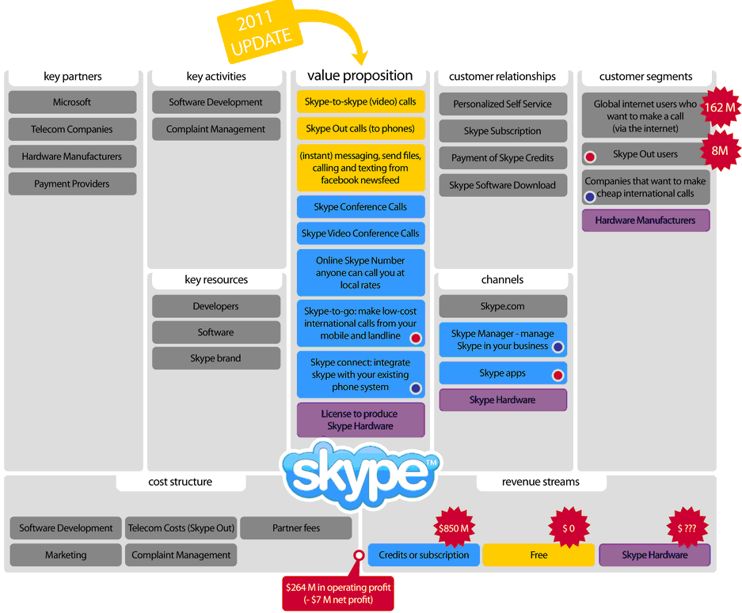
Skype’s business model as of 2011. Extracted from www.businessmodegeneration.com
1. Customer Segments

The following are the target customer segments.
- web users who wants to do video conferencing
- people who wants to make free phone call around the world

2. Value Proposition(s)

The value proposition is to provide the free/ cheap communication media among people on their laptops, mobiles and even landline phones using the latest internet, wifi technology.

3. Channels

The main distribution channel to Skype is via website skype.com for users to download. Skype also make partnership with the accessories companies like headsets (Plantronics), webcams (Logitech), and home phone adapters (Freetalk). These can be purchased from the Skype website or through other channels.

4. Customer Relations

Skype provides a user friendly UI and every customer can set up very easily. Moreover it support for paid customers and enterprise whenever there is a necessary.

5. Revenue Streams

About 90% of Skype usage is free and the rest 10% are Prepaid (Skype Credit) or subscription for premium users. Moreover, they have hardware sales revenue through partnerships.

6. Key Resources

The key resources for skype is the software that they provides and the software developers of skype system.

7. Key Activities
Developing, maintaining and enhancing the system is the core activities of business model.

8. Key Partners
Payment providers like paypal, enets are the core partners for skype to process credit card payments etc. Skype also has Distribution partners which make the software available for download on websites other than skype.com. for example. download.cnet.com and those whose allow for platform compatibility of OS e.g. Skype for Mac OSX, Skype for Windows, And lastly are telecommunications industry partners which is impossible to make calls from Skype on a computer to landlines around the world with cheap price.

9. Cost Structure

The cost of skype depends on the two factors of Software development cost and Customer Support cost.

5. Profitability
Skype main services such as voice calls, video calls and conference calls are generally free. However, Skype also have a whole lot of other value added services that is chargeable. This is where their main revenue comes from.

Some of the payable service may include:

- Purchasing Skype Credit or subscribing skype plan to make calls to landline or mobile phones using

- Buying a skype number so your friends can call you from anywhere and you can pick up their call from skype

- subscribe to Skype Premium to access advance features such as group video call

Skype has also pro-created other revenue stream from

- Licensing revenues. (E.g. Skype-Nokia and Skype-MySpace). Skype charges a small amount of license fee to allow external party to install Skype into their application.

- Sales of Skypephone (hardware phone) produced by Skype in collaboration with Hutchison 3G

- Advertisement, Skype charges advertisement fee to allow external party to subtly advertise in Skype application and website. Free users will be the main audience of the advertisement.

Skype’s total revenues for the company reached USD 859.8 million in 2010, up from USD 718.9 million in 2009 [1]. The reasons why Skype business is considerably successfully and profitable can be due to

- Negligible customer acquisition costs (Mainly through word-of-mouth). The product is so popular that existing users are continuously bringing new users so both parties could communicate through skype.

- Negligible capital expenditures and network maintenance costs (being peer-to-peer, the purchase of hardware and network connectivity cost is been transferred to the customer themselves)

- Pre-funded accounts which result in negative working capital where subscriptions and Skype credits are paid in advance.

As of today 2013, Skype’s only account for 8% of the world’s international calls, as the technologies infrastructure continue to spread and mature across continents the communication paradigm may potentially shift from basic hardwired networks and devices to software based networks and intelligent devices. VoIP may eventually become the mainstream communication channel for international calls. Therefore, there is a huge potential that Skype’s business and profitability will continue to grow

Moving forward Skype’s may continue to focus on its core businesses to continue to increase its revenue.

Sype may consider incorporating the following approaches into the existing business model to ensure their business remain highly profitable

- Continually driving up their customer base. Leveraging on social network to reach out for more potential customers. Introduce “Refer a friend” programme to get more users and at the same time reward its existing customer with calling credits to retain them

- Continue to innovate to ensure they could continue to provide efficient and effective local/cross border communication with little or no cost at all

- Introduce more new paid services that are value for money. E.g. Expand from being a product to being a solution that fits with other PBX and software solutions the business users are already working with

- Monetize free users via advertising. However, this have to be done elegantly without annoying the free users, else if the user is annoyed they may stop using the service.

- Integrate Skype to other platform e.g. intelligent TV sets, car dashboards and intelligent public access terminals such as bank ATM’s, billing paying machines that are all tied to same common network.

- Diversifying their business focus through introducing a more intelligent Skype smartphone. The smartphone will be capable to assess user’s current location internet signal strength and decide which connection to take, whether using the tradition connection or internet connection.

- Continue to invest in R&D on how data packets can be shrinked while as the same time ensure communication clarity between 2 parties

6. Conclusion

As internet connectivity continue to develop and spread across the world, it is not impossible for VoIP to fully replace traditional land line communication. Clearly, there is a great potential for Skype to continue to expand their businesses. However, in order to remain as the market leader they need to continue to innovate to ensure their software application remain highly relevant to the changing lifestyle of each individuals.

Skype should also continue to collaborate with more key partners to have their software installed in more devices, not just computers and phones, but may TV, Car etc

Through the expansion of its customer base, extension of services to other platforms and its continual innovation to be the best communication software, Skype will continue to grow its business and hence result in higher profitability
7. References

[1] http://www.statisticbrain.com/skype-statistics/

[2]https://support.skype.com/resources/sites/SKYPE/content/live/DOCUMENTS/0/DO5/en_US/skype-it-administrators-guide.pdf

[3]https://support.skype.com/resources/sites/SKYPE/content/live/DOCUMENTS/0/DO5/en_US/skype-it-administrators-guide.pdf

[4] http://www.skype.com/en/offers/skype-credit/

[5] http://www.skype.com/en/features/skype-connect/

[6]http://www.telecompaper.com/news/skype-grows-fy-revenues-20-reaches-663-mln-users--790254

[7]http://voiceontheweb.biz/skype-world/skype-llc/skype-news-skype-llc-skype-world-2/skype-business-model-revealed-at-ebay-analyst-event/

[8] http://tekedia.com/30422/skypes-business-model/
http://www.skype.com/en/features/skype-connect/

[9] - Skype API references: https://support.skype.com/en/faq/FA214/what-is-the-skype-public-api

