Date | Start Time | End Time | Activity | Remarks
6 Dec 2012 | 1400 | 1400 | Meet Up at Changi Airpot Terminal 1 | - Remember to bring passport
6 Dec 2012 | 1400 | 1410 | Check-In | - no have no luggage check in
6 Dec 2012 | 1410 | 1500 | Lunch
6 Dec 2012 | 1500 | 1520 | Departure | 3K543, Flight Duration: 3hr 30min
6 Dec 2012 | 1520 | 1750 | Arrival | 3K543, Flight Duration: 3hr 30min
6 Dec 2012 | 1750 | 1830 | Immigration (ard 40mins) | Hanoi Noi Bai International Airport  - Buy SIM Card  - Take Map
6 Dec 2012 | 1830 | 1910 | Journey to Hotel (40 mins) | Hanoi Elegance Ruby Hotel  - 3 Yen Thai Street, Hoan Kiem District, Hanoi  - Take– Around 15 SGD, 306,000 VND, Remember to check if toll fee is included  - Use only Mai Linh or CP taxi (Taxigroup) to avoid getting ripped off by taxi guys setting faster meters although twice we even got slightly ripped off by them.
6 Dec 2012 | 1910 | 1930 | Hotel Check | - Check Bus back to Airport and Cost  - Check tour  - If 1 night and 1 day stay is around the same price then take 1 night stay in halong bay
6 Dec 2012 | 1930 | 2200 |  | Go to Chợ Đêm (Night market for dinner)
6 Dec 2012 | 2200 | 2400 | Wash up, pack bags for Tml Halong bay trip.
1 SGD = 17, 043 VN
15 SGD = 250, 000 VN

7 Dec 2012 |  |  |  | OPTION 1: RED DRAGON CRUISES (2days/ 1night)  Bai Tu Long is still an uncharted bay in Ha Long, offering a chance to get “off the beaten track”, visit the fishing villages, and discover the secrets of the sea.  Small groups in luxury junks, staff dedicated to personal service and your comfort will not only make our offer unique but your trip unforgettable!  Day 1: Welcome on board:  Embark at noon, a slow cruise to the famous islands of Halong Bay and onto Bai Tu Long Bay, aside from the cave visit “Thien Canh Son” and swimming, we will explore this beautiful area by kayak in 45 minutes. All meals and sleep aboard the vessel

8 Dec 2012 |  |  |  | Day 2: Cruise, fishing village, return to Ha Long.  Wake up at sunrise before breakfast, cruise Bai Tu Long, a visit to the floating fishing village of Vung Vieng - learn about daily life here, arrive in Ha Long aroundnoon.
8 Dec 2012 | 1500 |  | Massage | * dunno what time will be back to hotel

9 Dec 2012 | 0900 | 1000 | Wake up and Wash up
9 Dec 2012 | 1000 | 1200 | Have breakfast (in hotel or outside)
9 Dec 2012 | 1200 | 1200 | Check out hotel and leave luggage in hotel | Get hotel staff to book taxi to airport
9 Dec 2012 | 1200 | 1600 | Last min shopping or massage
9 Dec 2012 | 1600 | 1700 | Journey to Airport
9 Dec 2012 | 1700 | 1700 | Reach Airport and Check In
9 Dec 2012 | 1700 | 1800 | Have Dinner
9 Dec 2012 | 1800 | 1830 | Get ready to board the plane
9 Dec 2012 | 2310 | 2310 | Home Sweet Home
To Huong Sen Sauna and Spa (Yen Phu)
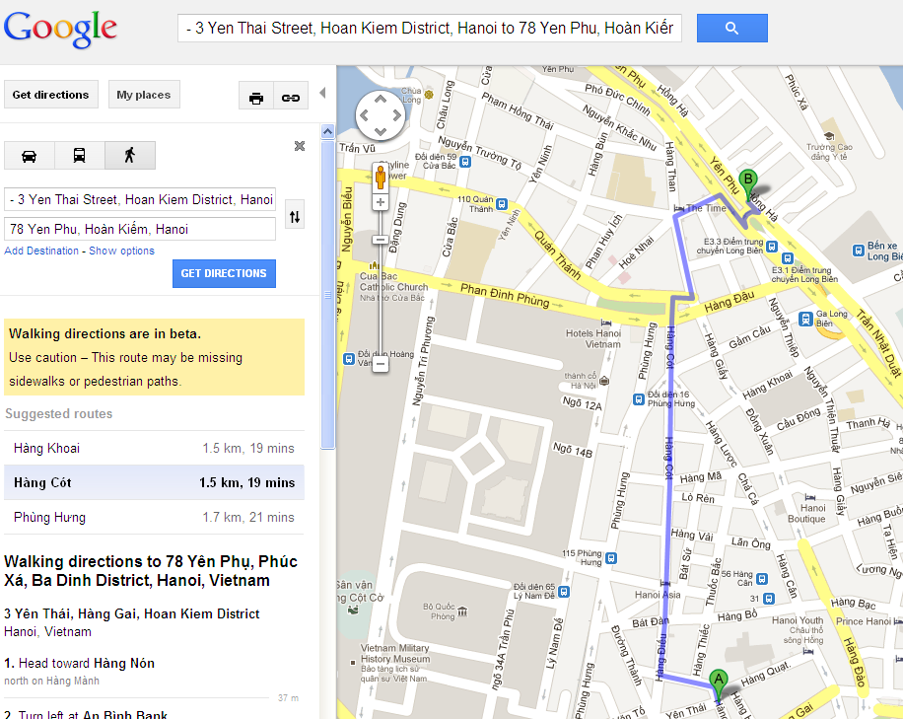
Warning 3: PROBLEMS ENCOUNTERED BY VISITORS TO HANOI
So far there have been many tourists being cheated so that this is very good information for travelers to avoid the troubles when you are traveling in Hanoi or in Vietnam. This information is written by my experiences and some travelers who had been cheated. You should take a look and print it out to bring with you while traveling in Vietnam!
@ Problem 1
There is not enough information available to first time travelers to Ha Noi either on Vietnam Airlines or at Noibai airport. Thus, travelers are not aware of their options for getting to Hanoi from the airport, what such a trip should cost, and who are reliable drivers.
@ Solution 1
Brochures with this information in many languages can be printed and put in seat pockets of all Vietnam Airlines planes; these brochures should also be made readily available at the airport.
@ Problem 2
Frequently visitors have trouble finding legitimate transportation from Noibai International Airport to their hotel in Ha Noi. Sometimes they are driven by minibus drivers who promise to take them to a specific address in Ha Noi. However, instead of being delivered to the requested hotel they are delivered to a different hotel where the bus driver has friends. They are frequently then overcharged at this hotel.
@ Solution 2
Travelers to Vietnam should be warned in advance or at the airport not to depend on either the airport driver or hotel staff that he recommends. In addition it should be a requirement that the street signs be pointed out to the traveler by the bus driver so that the traveler knows whether s/he is being delivered to the correct hotel.
@ Problem 3
Another problem arising for travelers from Norbai is that the price quoted for transportation from the airport normally includes the road tax. However, upon arrival, travelers are charged for the road tax again.
@ Solution 3
Travelers should be made aware by information available at the airport of standard prices for transportation and the fact that these prices already include the road tax.
@ Problem 4
Travelers are frequently led to foreign currency exchange venues by airport bus drivers. At these exchanges they are given a poor exchange rate, e.g., 15,000 VD for $1 USD rather than the standard rate at http://www.vietcombank.com.vn/en/Exchange%20Rate.asp. In addition the driver receives a commission from the foreign exchange seller.
@ Solution 4
Travelers should be encouraged to exchange money at the airport or at foreign exchange sellers recommended by legitimate hotel owners.
@ Problem 5
Be aware of the denomination of Vietnam Dongs which consist of too many zero (0). Some unscrupulous drivers try to rip you off by adding one more zero to your fare OR cheating that your VND500,000 note is only VND50,000. i.e overcharges you 10 times higher than actual cost.
@ Solution 5
Distinguish Vietnam Dong notes and the exchange rates. Be alerted and stand firmed if the driver asks for more notes. Call local reliable sources (hotel staff, policemen, local people) for assistance if you feel unsured of the situation.
@ Problem 6
The first person a visitor meets is frequently the boy selling postcards. These sellers frequently cheat the visitor either by overcharging for the cards or by asking for VD 5,000 but extracting VD 50,000 from the confused traveler.
@ Solution 6
Travelers should be encouraged to purchase cards, maps and other such items from bookshops rather than street vendors.
@ Problem 7
Even enterprising visitors who find a hotel on their own frequently find that a person claiming a commission has followed them to the hotel.
@Solution 7
The receptionist should ask travelers whether such a person helped them to obtain lodgings or not.
@ Problem 8
Travelers are frequently sold tickets by travel agencies for tours of local sites. They are frequently promised small group tours and good train seats. After paying, they find that either the tour does not exist at all or that there are very many people on the tour, that the quality is very bad and that they have paid for good train seats but received inferior ones.
@Solution 8
Once they are in a legitimate hotel, travelers should be able to rely on hotel staff to advise them on tour agencies that are reliable and honest. In addition, it may be better to charge for the tour after it has been taken in order to guarantee that the visitor is satisfied with its value.
@ Problem 9
Tourists are prey to pickpockets when they travel to the market.
@ Solution 9
Tourists should be advised to leave their valuables and extra money in the hotel safe.
@ Problem 10
There are imitated VND notes printed for ritual purposes like votive papers, but some taxi drivers will cheat you by giving these notes back as small changes.
@ Solution 10
Tourists should be advised to check the notes carefully. The right notes should always have the imprinted words `Ngan hang nha nuoc Viet nam` (means `The State bank of Vietnam`) & the picture of the later president Ho Chi Minh. See the fake notes below for your information:
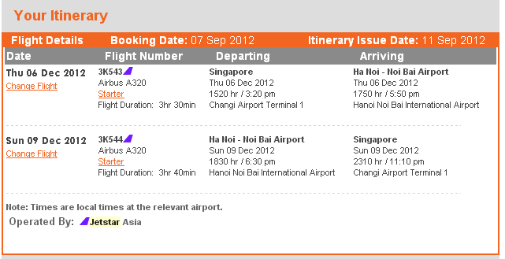

http://www.halong-bay-tours.com/category/daily-cruises/2-day-cruises/

