1. Course Title: Sourcing Strategy & Planning Initiatives

  - Basic Outsourcing

Outsource

Let's say that as a Project Manager, you are given an IT project. What would be the options available to handle the project? Well, here are three possible options:
- buy an off-the-shelf package
- build your own
- outsource
We will focus on the third option in this lesson. Outsourcing is not a new concept. You may be familiar with the concept already but are not aware that it is called outsourcing. Can you guess what other terms refer to outsourcing as well?

Benefits of Outsourcing

Taking Advantage of Future Technologies
As new technologies emerge, most companies cannot immediately take advantage of them because of the cost and learning curve associated with these technologies. Since one of the strategic initiatives for an outsourcing firm is to stay current with new technologies, they would be responsible for maintaining a high competency level in current, as well as new technologies. The technology benefit is significant for companies who are on a fast pace and who realise significant growth.

Cost Savings
While outsourcing firms can provide savings in many areas, the primary reason for these savings is their ability to take advantage of economies of scale. Since outsourcing firms are providing the same type of service for many customers, they are able to consolidate data centre operations to provide lower overhead costs on a per-customer basis. They are also in the position to receive deep discounts from hardware and software suppliers because of their annual volume of business.

Centre of Expertise
Since an outsourcing firm's primary business is to manage technology for clients, it is appropriate to assume they have experience with current, as well as new technologies. Larger outsourcing firms embrace the "center of expertise" concept, in which a group of research and development technology engineers are dedicated to evaluating new products and their applicability throughout the industry.

Resource Availability
The requirements for IT resources fluctuate according to the changes in business needs and customer demands. Outsourcing firms can provide additional professional resources on an as-needed basis. This reduces the cost of customer organisations of retaining permanent employees and/or utilising industry consultants for short term engagements.

Reduction of Risk
A properly structured outsourcing agreement will ensure the outsourcer assumes the appropriate risk. The outsourcer will have to be responsible for ensuring that the systems, among other things, are meeting the reliability and performance criteria, and that properly skilled personnel are available at the right time.

Improved IT Customer Service
Having a great customer service relationship is as important as the quality and cost effectiveness of the products being produced and maintained. As with most professions, the systems developed for IT are becoming more and more complex day by day. On the other hand, the knowledge level of the user is increasing but not at the same rate. Therefore, it is imperative to establish and maintain an excellent help desk or support centre to provide a point of contact for the user. A properly structured contract will insist that the outsourcing firm provides a state-of-the-art help desk function.
IT Professional Growth
The constant challenge that each company faces is the need to challenge the internal IT staff continuously. Many industries are in business to produce goods and services that are not IT-related. Thus, it is not the priority of these industries to train their IT staff regularly, nor to keep them abreast of new technologies in their profession. On the other hand, an outsourcing firm's revenue is heavily dependent on the quality of service their personnel provides. As such, outsourcers will typically invest a great deal more in the training and education of their IT staff.

In sourcing

An alternate approach to outsourcing is insourcing. Insourcing basically involves a contract that calls for the market to provide resources to be deployed under the client's management and control.
For example, let's say that a client is required to boost its own in-house IT capability. The client brings in specialised skills from a contractor. Having done so, the client will need to manage the resources, which could include people, facilities, technology and other assets, and of course, at the end of the day, manage the results.
In other words, insourcing is buying-in a vendor's resources and managing them internally. To further understand the concept of insourcing, take a look at the animation below.

Offshore outsourcing

Another approach to outsourcing is offshore outsourcing. Offshore outsourcing refers to the situation where the buyer's company, with offices sited in one country (e.g.Singapore) agrees to a contract with a contractor's company where the bulk of the outsourcing work is to be performed in another country (e.g. India).

  - Outsourcing Trend

Navigating opportunities and risks

Companies interested in investigating offshore opportunities must be able to tackle challenges in three areas: cultural, geographical and political. They must be willing to invest time and money in building processes to ensure proper project management , effectively evaluating and training personnel , and establishing meaningful metrics to make sure projects stay on track.
But when offshore projects go astray, frequently the reasons are poor communication or cultural miscues. To prevent your offshore projects from bobbing aimlessly on the high seas, or sinking in stormy weather, follow the golden rule of any outsourcing project: Don't assume anything, ever . Specifically, companies must have 2 Ss and 2 Cs .

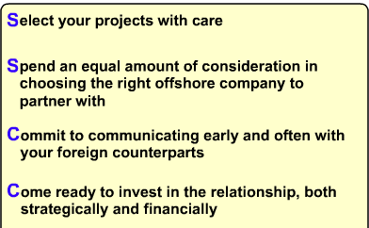

Considerations for offshore outsourcing

Companies considering offshore outsourcing should examine:
- Outsourcing firm qualifications, such as technical certifications, resource maturity, and viability
- Communication mechanisms, including two-way, Web-based capability; and on-site/offshore coordination abilities
- Location, together with operational/geopolitical risk assessments and business process/industry knowledge

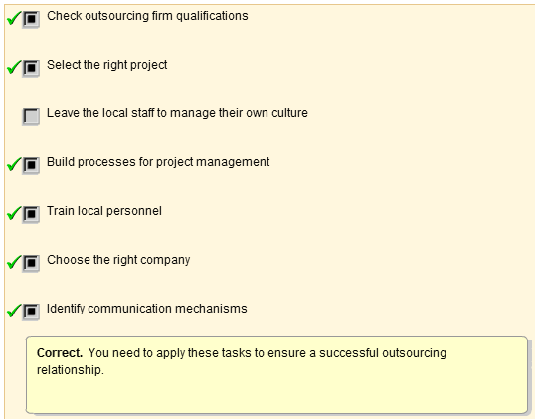
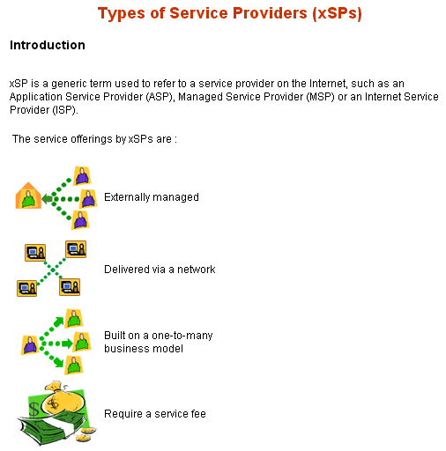
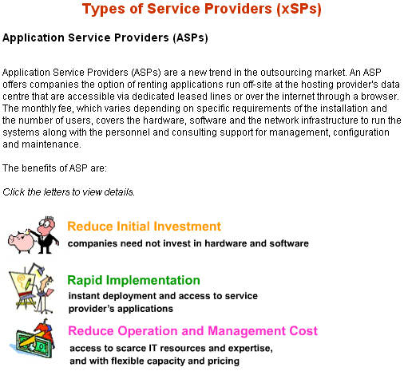
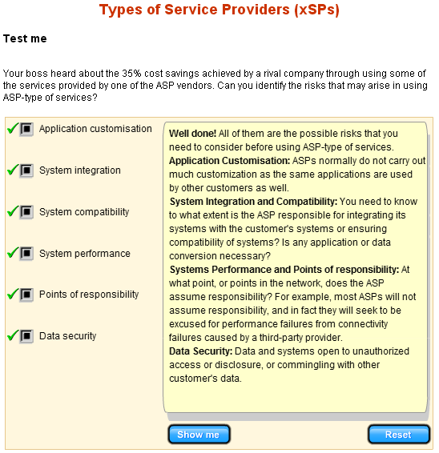
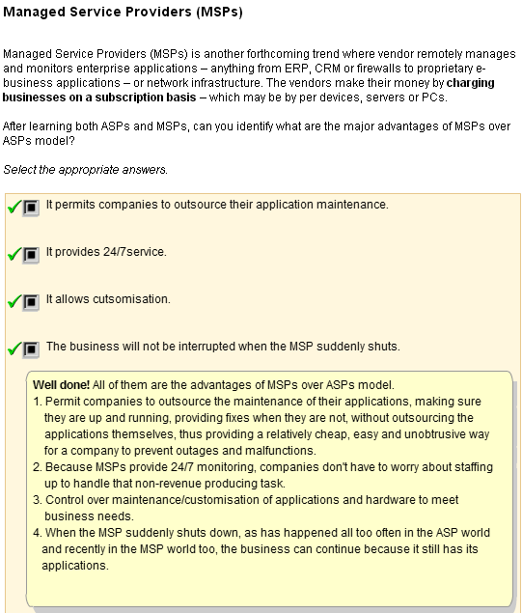
Beside ASPs and MSPs, there are a few more of other types of service providers.

Storage Service Providers (SSPs)
Storage Service Providers, such as Storage Networks, provide and manage the storage capacity either at customer’s data centre, in a co-location facility that hosts the customer’s website or in the providers own data center.

Managed Security Service Providers (MSSP)
Managed Security Service Providers offer security services such as managing firewalls, virtual private networks and securing internet applications. MSSP offerings vary considerably, from no-frills technology oversight to complete service, including software, hardware and staffing. Yankee group has estimated that organizations will spend US$2.6 billion with MSSPs by 2005.

Internet Service Providers (ISPs)
Internet Service Providers deliver internet access to organisations and individuals.

Utility computing
Utility computing is another grand concept endorsed by some big tech company. Instead of paying a fixed price, the client can pay for usage. A provider of IT services, such as outsourcing and systems integration, will in turn be able to price its services using this same consumption-based model. This concept is termed "utility computing," because it resembles the way in which people pay for their water and electricity.

"Utility Computing" is used as an envelope around a number of other concepts such as ASPs (Application Service Providers) and xSPs. It has pushed the concept of saving money on infrastructural costs by sharing computing resources. The vendors believe that clients like this payment model because it prevents them from overpaying for an underused IT product. Likewise, it protects them from finding themselves overwhelmed by a sudden computing demand that their systems can't handle. These pay-per-use arrangements are also attractive because clients don't have to buy the products and put the capital expenditure on their balance sheets.

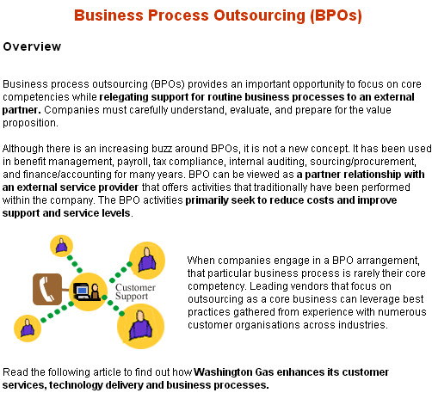

Good candidates for BPOs

BPO generally requires a company to accept vanilla business processes, and hence, the business process should not be the company's core competency or critical process to the company's strategic initiatives.

According to a Forrester report, four business segments are excellent candidates for successful and effective BPOs:
Straightforward bulk transactions
Straightforward bulk transactions, includes credit cards and stock transactions.
Broad shared-services outsourcing
Broad shared-services outsourcing, includes finance, administration, human resources, and indirect procurement.
High-volume vertical processes
High-volume vertical processes, includes policy administration, claims and loan applications.
More complex and specialised vertical applications
More complex and specialised vertical applications, includes monitoring chemical control processes and environmental data reporting.

BPOs outsourcing success factors

Clear Business Process
Understanding the outsourcing business processes means being able to:
- negotiate a contract with measurable objectives
- set clear metrics to manage the outsourcing relationship
Once BPO is in place, it is only the beginning of an ongoing process of measuring and managing the relationship. If possible, organisations should negotiate a pay-per-performance arrangement with the outsourcer.

Managing Transition
Managing the outsourcing transition well without significant loss of functionality. A project office that leads a transition task force made up of people from each specific business area affected by the project (IT, human resources, legal), as well as resources from the outsourcing partner, can help ensure success.
The client company should carefully select a project leader who is politically connected within the organisation – the manager who will serve as the regular liaison with the outsourcing provider.

Initiating Parallel Run
Considering (if possible) running legacy internal processes in parallel with the outsourced processes as a check and validation until all bugs are corrected.
Effective Communication
Ensuring effective communication (justification for BPO, how it will work) and managing people issues (training, "stay" bonuses to support legacy processes when required) as they arise.
Managing Change
Implementing an ongoing change management process with the client organization and outsourcer to ensure continuous business improvement.

  - Key Success Factors of Outsourcing
Key Success Factors of Oursourcing

Key success factors
While IT outsourcing is becoming more pervasive, clients' expectations of outsourcing are often not aligned with realistic benefits. Users may be too ambitious or optimistic in their appraisal of what an outsourcing arrangement can accomplish. Incorrect expectations are the primary reason for outsourcing arrangements being perceived as failures. Also, many organisations commit themselves to outsourcing without clearly defining their internal objectives.

Some key factors in successful outsourcing:  - Commit to outsourcing engagements with correct and realistic expectations  - Identify the primary objectives of outsourcing and risks associated with it  - Select an outsourcing vendor who is capable and motivated to meet primary objectives  - Establish well-defined contracts  - Form an experienced team to manage the outsourcing vendor throughout the contract | 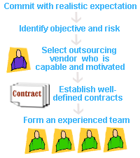

  - Define the Outsourcing Objectives and Goals

Determine the Driving Force to Outsource

So, why do you think many companies are turning to outsourcing in droves? As a Project Manager, it is essential to know the main driving force to outsource and the possible benefits of outsourcing. With this knowledge, you will be able to make a wise decision on whether to outsource your project or not. It will also be helpful to know how outsourcing supports your business goals and objectives.

The reasons for outsourcing can be categorised as:
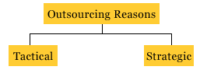
Strategic Reasons
Let's first look at the strategic reasons to outsource. The following are reasons why companies outsource their business activities:

Improve Business Focus
Outsourcing allows a company to focus on its core business by having operational functions assumed by an outside expert. The company is also relaxed from devoting energy to areas that are not in its expertise, and can focus its resources on meeting its customer's needs. this will improve its business focus and hence increase its business operations.
Gain Access to World-Class Capabilities
By the very nature of the contractors' specialisation, outsourcing providers bring extensive world - class resources to meet the needs of their customers. The outsourcing company makes extensive investments in technology, methodologies and people. This combination of specialisation and expertise gives customers the competitive advantage and in turn helps them avoid the cost of chasing technology and training. Hence steep learning curve and training on the use of new tools can be avoided.
Accelerate Business Benefits
Outsourcing is a by-product of another management tool know as the Business Process Re-engineering. It allows an organisation to immediately realise the anticipated benefits of re- engineering by letting an external organisation, one that had re-engineered to world-class standards, take over the process.

Share Risks
Another reason for outsourcing is to share the risks of the business. This can be done through building business relationships in the form of strategic alliance. The strategic alliance partners will approach the relationship as if it owns a part of your business. They will participate in strategic planning and share instrategic decisions. Companies are looking for such partnership with service providers especially in outsourcing areas that have a strategic impact to their businesses. Partnerships also come with shared risks. As new technologies emerge, the outsourcing firm will be responsible for maintaining high level of competency in both current and new technologies. Companies that outsource will be able to access the critical computer technology in lesser time, effort and incur lesser risks in implementing them.

Redirect Resources to more Strategic Activities
Every organisation has limited resources available. Outsourcing permits the redirection of resources from non-core activities towards activities that provide greater return in serving the customers. Three simple questions to test the understanding of the organisation's real competencies are:
1. If you are starting today, would you do it yourself or contract out?
2. Are you so good at an activity that others would hire you to do it for them?
3. Will tomorrow's CEO come from that skill set?

If the answer is not 'Yes' to all three, and the activities are being performed within the company out of habit, then new strategic thinking is demanded.

Tactical Reasons
Some companies outsource their business activities based on tactical reasons.

Reduce or Control Operating Costs
The single most important tactical reason for outsourcing is the reduction or control of operating costs. One way is to turn fixed costs into variable costs. Outsourcing firms can provide additional professional resources on an as-needed basis. This reduces costs of retaining permanent employees and/or utilising industry consultants for short-term engagements. There are no fixed overheads in maintaing the systems. You only pay the contractor if you use his services. This scheme reduces operating costs, and is known as the "pay-as-you-use" scheme.
Make Capital Funds Available
There is tremendous competition within most organisations for capital funds. Outsourcing can reduce the need to invest capital funds in non-core business functions, hence making capital funds readily available for core areas. Instead of acquiring the resources through capital expenditures, they are contracted for on a "as used" operational expenses basis. Outsourcing can improve certain financial measurements by eliminating the need to show return on equity from capital investments in non-core areas.
Generate a Cash Infusion
Outsourcing often involves the transfer of assets from the customer to the provider. Equipment, facilities, vehicles and licences used in current operations have value and can be sold to the contractors as part of the transaction. The contractor can then use these assests to provide service back to the client. Depending on the value of the assets involved, this sale may involve significant cash returns to the customer.
Secure Resources
Companies outsource because they do not have access to the required resources within the organisation. For example, in a new geographic region, outsourcing is a viable and important alternative to building the needed capability from ground up.
Gain Control
Gain Control Outsourcing is one way to handle backlogs in IT companies.

Chris Pickering's 1998 Survey of Advanced Technology found that 75% of organisations surveyed have backlogs running from seven months to over two years. IT companies are not able to keep up with the pace of change which continues to exceed the speed at which they can produce.

Identify Potential Risks
After determining the driving force to outsource, it is also essential to identify potential risks that are involved in outsourcing. There are generally 5 types of risks involved in outsourcing.

Irreversibility of outsourcing
It is normally difficult to reverse outsourcing decisions, when both parties have made a decision to go ahead with it. Reversing the outsourcing decision means bringing the outsourced activities back in-house. This can be done but it is difficult. Some of the questions we may ask ourselves when we want to reverse the decision are:
1. Do we have the skill set?
2. Do we have the infrastructure to run those applications?
3. How long does it take to rebuild the infrastructure and the skill set required?
4. What are the implications to the business operations?
Leakage in confidential information
Confidential information may leak to inappropriate personnel through outsourcing.
1. Disclosure to contractors without appropriate contractual safeguards may negate the requisite element of secrecy.
2. The vendor or its employees may make unauthorised disclosures.
3. Other customers of the outsourcers may gain unauthorised access to your trade secrets.
For example, the contractor will have access to all the data pulsing through your outsourced computer applications. An outsourcing user must be particularly cautious and concerned with a contractor who also provides services for a competitor. So, it is very important to address confidentiality requirements in the contract.
Dependence on specific vendor
The reason some organisations outsource projects to vendors may be because of the lack of certain skill set or expertise in their existing staff. The risk involved when this is the main reason would be that the dependence of the customers may lie only on a specific vendor. This would not be good in terms of business relationship because the vendor is at an advantage while the customer is at the mercy of the vendor.
Breach of contract by vendors
There are cases when the contractor breaches the agreement, thereby allowing you to terminate his service. Substandard contractor's performance and missed service level agreements are some examples where the contractor could breach the contract. The risk of an interruption of service or an actual breach of the provider's duties is, of course, an unavoidable risk at some level. This must be evaluated as a part of the business decisions to outsource. Of grave importance is the implications to the business once the contractors breach the contract. Of course we can sue, but the time and management effort, loss in the project and losing out to competition could be a very serious matter.
Loss of control over resources
From a management point of view, outsourcing may represent a degree of loss of control for an organisation. Although many outsourcing arrangements are reserved to the customer, matters such as strategic planning, process control, resource procurement, overall technology policy, undergo a dramatic change in control, that the organisation is able to exercise over the outsourced functions. It may also represent a significant loss of flexibility to the extent that organisation wishes to maintain a fixed scope and a fixed pricing structure over the term of contract.

Determine the Applicability of Outsourcing
After determining the driving force to outsource and also the risks involved, you can then determine the applicability of outsourcing. This simply means that you will decide how applicable it is for your organisation to outsource the project.

There are basically three key reasons to outsource:
- To reduce IT costs by offloading nonstrategic functions
- To acquire new skills in more strategic activities (new technologies)
- To re-engineer the IT and/or the business function(s)
Based on these reasons, you can then decide on the applicability of outsourcing. An algorithm has been developed to help us determine the applicability of outsourcing.

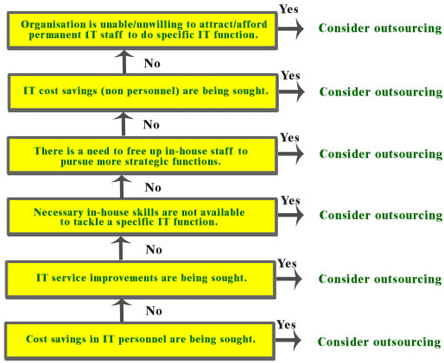
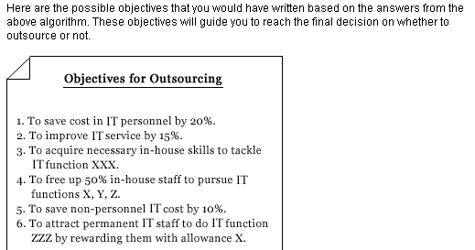

  - Sourcing Options
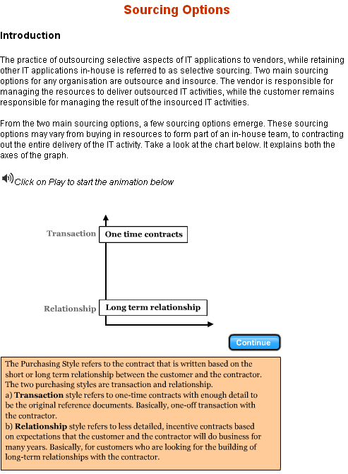
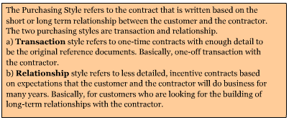

Buy-In
From the chart, Buy-In involves the transaction style with the resources option. The transaction style shows that the customer and contractor do not intend to have a long term relationship. Therefore, the customer buys the contractor's resources to meet a temporary need, such as programmers for the latter stages of a new development project. Customer organisations are often not sure of the exact hours need to complete the coding, so they sign contracts that specify the skills required and the cost per person.
Contract Out
From the chart, Contract Out involves the transaction style with the result option. Here, the contractor is responsible for delivering the result of the activity. This strategy is most successful when the companies can clearly define their needs in an airtight contract. The contract must be clear and complete in order for it to be used as a reference to manage the work done by the contractor.
Preferred Suppliers
From the chart, Preferred Supplier involves the relationship style with the resource option. With the relationship style, the customer and contractor intend to do business for many years. Therefore, the customer organisation develops a close relationship with a contractor in order to access resources for ongoing IT activities. An incentive-based contract defines complementary goals.
Preferred Contractor
From the chart, Preferred Contractor involves the relationship style with the result option. Companies contract with a particular contractor to help mitigate risk. The contractor is responsible for the management and delivery of the IT activity, that is the final deliverable. To ensure the contractor's performance, the company constructs an incentive-based contract that ensures shared goals.

What you should have learned:
- Two main sourcing options for any organisation are outsource and insource. From the two main sourcing options, a few other sourcing options emerge:
  - Outsourcing
    - Contract out
    - Preferred contractor
  - Insourcing
    - Buy-in
    - Preferred supplier
    - In-house
- Contracts can be categorized into
  - Purchasing style
    - Transaction driven or short term relationship
    - Relationship driven or long term relationship
  - Purchasing focus
    - Resource focus
    - Result focus
- Buy-in, which involves the transaction style with the resources option, is an insourcing option because in-house management retains full visibility and control of the IT activity.
- Preferred supplier, which involves the relationship style with the resources option, is an insourcing option because in-house management retains full visibility and control of the IT activity.
- Contract out, which involves the transaction style with the result option, is an outsourcing option because in-house management passes control of the IT activity to the contractor.
- Preferred contractor, which involves the relationship style with the result option, is an outsourcing option because in-house management passes control of the IT activity to the contractor.

  - Select Possible Candidates to Outsource

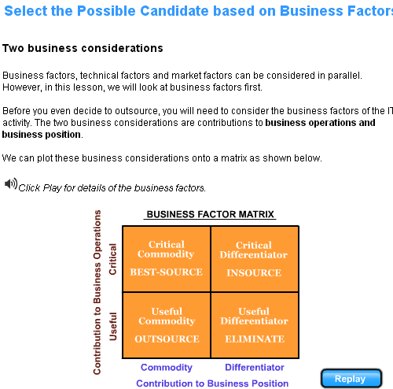

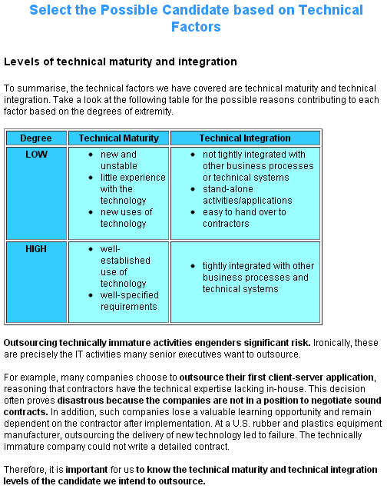
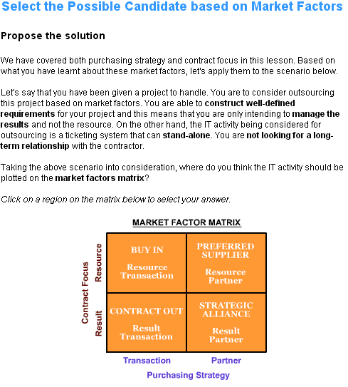
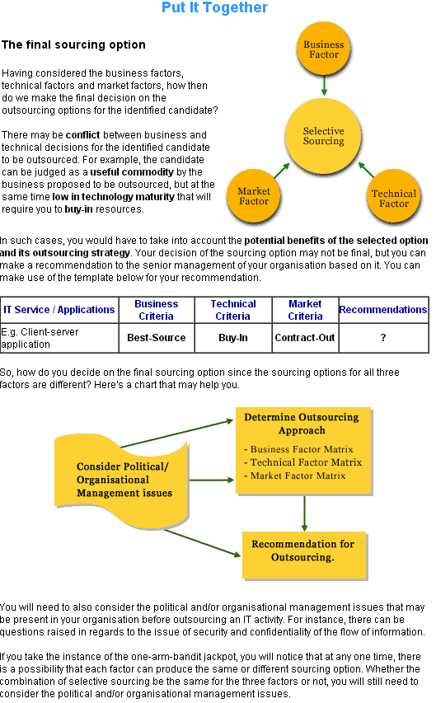

  - Types of sourcing relationship

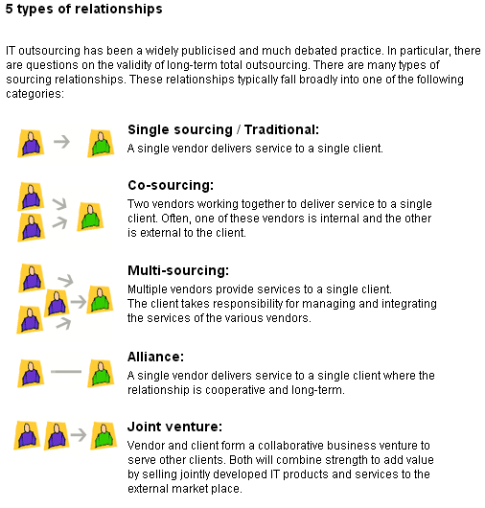
Benefits and risks
After learning the different types of sourcing relationships,now you will learn the benefits and risks of each type of relationship.

Type of relationship | Benefit | Risk
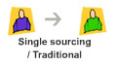 | Easier to manage as compared to multiple vendor management where one have to coordinate various issues. | Heavy dependence on a single vendor.
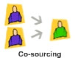 | With the internal IT providing the services together with the external vendor, transfer of knowledge will be easier. | Heavy dependence on a single vendor.
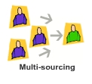 | Reduce the risk of depending on one vendor. Risks spread over multiple vendors. | The task of managing multiple vendors can be very demanding on the clients.
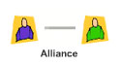 | Trust and mutual benefit for both client and vendor. This helps in sustaining long-term relationship that result in having successful projects. | As years pass, dependence on that one vendor would mean losing all those necessary skills when the day come for the alliances to be terminated.
 | Both are in as business partners and would like the business to succeed. | Products or services not well-delivered and cost incurred by commercialisation would have no returns.

2. RFP Development
2.1 RFP Process
A RFP is a formal request for vendor proposals, and such proposals often become the basis for the contract. The RFP becomes the statement of work for the contract and is an important historical document if the project begins to experience problems.

The primary purpose of a RFP is to transmit your understanding of the requirements for a project to vendors whom you believe can provide solutions.

The advantages of using a RFP are:
- A RFP forces out the potential problems of dealing directly with vendors.
- A RFP ensures a formal set of requirements to work from.
- A RFP requires the RFP team to examine the problems and issues concerning the project in greater detail than would normally occur.
- A RFP forces the vendors to create competitive solutions that not only respond to the RFP requirements but may even go beyond them, thus providing additional value for a given price.
- A RFP does not favor one vendor over another, but allows all to compete fairly based on the same set of rules and requirements.

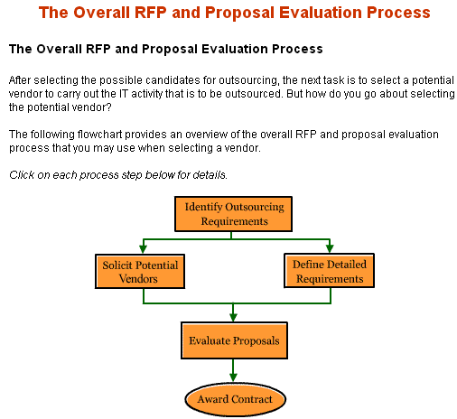
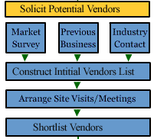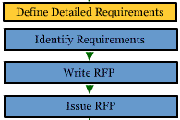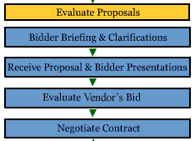
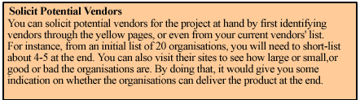
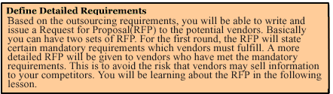
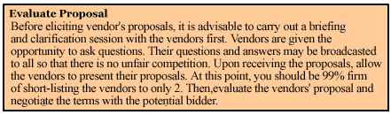

RFP Planning and Preparation

1. Set up the Project organisation
This involve setting up the Steering Committee as well as the RFP Project Team.
2. Develop project schedule
This involves developing a preliminary schedule for the whole RFP or tender process from start right up to the award of the contract.
3. Education on the available technology and the potential vendors
This involves identifying the potential vendors and suitable solutions, as well as the technologies involved.
4. Estimate project budget
This includes the budget for the RFP phase and also for the completed project.
5. Perform cost and benefit analysis
Like any other projects, you need to do a cost and benefit analysis. If this is not done before writing the RFP, at least an in-principal agreement from the senior management is required before proceeding with the project.
6. Develop evaluation criteria
You need to look at the requirements and develop the evaluation criteria so as to ensure an objective evaluation.
7. Develop the RFP
Based on the information gathered from the above steps, write the RFP for distribution to the potential vendors.
8. Review and approve the RFP for release to the vendors
You need to ensure proper and sufficient reviews by the various stakeholders are carried out before releasing to the vendors.

Sample project schedule

The sample project schedule shown here is only an example of the type of schedule and planning that needs to take place. You can use it as a guide.

Item | Activity
1 | Pre-RFP Activities
2 | Identify need
3 | Perform initial study
4 | Write project justification
5 | Estimate budget for project
6 | Approve RFP project
7 | RFP Activities
8 | Identify RFP team
9 | Identify project schedule and key dates
10 | Identify high-level requirements
11 | Start vendor and/or technology education
12 | Identify and interview users
13 | Develop technical requirements
14 | Review requirements with users
15 | Review requirements against corporate standards and constraints
16 | Finalise technical requirements
17 | Develop management requirements
18 | Review requirements with users
19 | Review against corporate standards
20 | Finalise technical requirements
21 | Write RFP
22 | Develop evaluation criteria
23 | Develop RFP schedule
24 | Review finished RFP
25 | Send RFP to suppliers
26 | Post-RFP Activities
27 | Allow question-and-answer period
28 | Receive proposals
29 | Evaluate proposals
30 | Ask suppliers’ questions if needed
31 | Select shortlist
32 | Hold supplier presentations, site visits, demonstrations, and reference checks
33 | Select winning supplier
34 | Negotiate contract
35 | Provide supplier debriefings for losing proposals
36 | Review, clean up and store losing proposal
37 | Start project implementation

The area addressed in the development of RFP

Refinement of scope and description of services
The scope of services to be outsourced needs to be confirmed and may need to be defined in more detail. Where there is to be shared responsibility for the provision of certain services, the responsibilities of each party need to be defined. For example, if staff are retained for functions such as security administration, table maintenance and user support, the transition point of responsibility needs to be spelled out. The same clarification is required if more than one vendor will be contracted to provide services. This will become a critical component of the RFP and the contract. Disputes may arise if this description is not thorough.

Human Resource Plan
Once the scope of the outsourcing has been confirmed, we need to define the process for transition of staff to the vendor, and to promote retention of staff through the transition where possible.

Vendor Characteristics and Minimum qualifications
Establishing the desired characteristics of the vendor and the minimum qualifications will have a significant effect on the nature of the contractual relationship, the structure of the service offering and the potential for competition in the process. This is a strategic business decision that will be based on the objectives for the outsourcing. For example, if an objective is to plan and implement a major technology change or to support a complex business initiative, the vendor will require different skills than it would under a more stable technology environment. If there is a decision to consider more than a single vendor, a consortium structure with a primary contractor may be required to promote accountability and cooperation between vendors.

Contract Term
The choice of a term for the contract will also be driven by the objectives for the outsourcing. For example, if there is no significant capital investment to be amortized, and no significant technology migration requiring an extended window, a relatively shorter term may be viable. The general trend has been toward terms of five to seven years. These terms are intended to avoid costs associated with termination or renewal, and to facilitate the implementation of major initiatives. However, these longer terms may increase the risk that the contract pricing becomes non-competitive over time, unless there are provisions for adjustments to the pricing to be triggered by "benchmarking" provisions.

Evaluation Process
Decisions are required on the major steps to be followed in the issuance and evaluation process. These may include:
- A vendor briefing sessions, followed by the issuance of supplementary information.
- An initial review of responses to confirm that they meet minimum requirements.
- Short-listing of superior proposals.
- Presentations and references, which may be followed by a further short-listing.
- Due diligence.
- A best and final offer stage.
- Selection to enter contract negotiations.

The optimum approach will be determined by factors such as the complexity of the service offering and the probable number of respondents. The RFP must describe the process to be followed.
Evaluation Criteria
The criteria for evaluating responses should be developed before the RFP is issued. The main principles for rating should be incorporated in the RFP itself. The development of the evaluation criteria at this point will assist in ensuring that the objectives for the outsourcing and the important characteristics of the outsourcer will be accurately reflected in the RFP. Different approaches can be taken to scoring and to weighting item scores. For example, pricing could account for 20% of the overall score. The business objectives for the outsourcing are key factors in selecting an approach.

Business Environment and Direction
The current business environment and business direction needs to be documented in the RFP. Much of this material may be available in the current business plan of the organization, but this may need to be supplemented with additional information on new initiatives and how IT is expected to support these. Any known re-structuring or re-engineering initiatives need to be identified along with the potential implications for IT. The bidders will rely heavily on this information to outline the skills and supporting technical solutions that they can bring to the business.

Technical Overview
A comprehensive description of the technology environment and how it supports the business processes is required. Even if the outsourcing affects only part of the technical environment, the bidders may need to see a bigger picture. A listing of significant assets and a summary of other assets is required. Detailed documentation may be provided in a reference library accessible to the bidders, if it is too lengthy to include in the RFP. Bidders should be required to enter into a non-disclosure agreement to protect proprietary information and to safeguard security. Any organizational-wide standards for system architecture should be outlined in this section.

Service Levels and Reporting
Baseline service levels need to be set for each service component to be outsourced, based on historical performance data and business requirements. This usually includes target and minimum service levels. Reporting expectations also need to be developed as part of this process. The maximum reporting period should be one month to facilitate the timely identification of performance issues and to ensure that serious loss of service events have an appropriate impact on the overall performance measure for the time period. Simple average measures are generally not sensitive enough for this purpose and need to be supplemented by other measures. For example, 98% average availability for a month can be achieved in spite of a single loss of service of a duration that would be unacceptable to the business users. Historical performance levels may be unsatisfactory, in which case a new target may be set with the recognition that this may increase costs. Penalties may be outlined for not meeting the established minimum service levels. These should reflect the impact of loss of service to the business users. They should be significant enough to ensure that performance issues are dealt with in a timely way, and provide for an escalation process. This would be covered in greater detail in the following lessons.

Security and Data Integrity
Minimum expectations need to be established for maintaining the security and integrity of the technical environment. This includes separation of duties in database administration, separation of test and production environments, backup processes, firewall and encryption standards, physical security, and user I.D. and password administration. In regard to the physical site for processing and storage of data, specify the mandatory condition where data will be processed and stored. Expectations need to be defined for the development, maintenance and testing of a disaster recovery plan.

Transition
The RFP should require the bidders to provide a detailed plan for the transition of staff, assets and services, along with a schedule. However, there may be business requirements that need to be stipulated in the RFP, for example a maximum time period for the transition, and a maximum period of loss of service in the case of a physical migration of application programs or assets.

Approval of key personnel
One of the critical factors for the success of an outsourcing contract is the quality of the vendor's staff, particularly those in key positions such as project manager, senior architect, senior analyst and account manager. Continuity in staffing is extremely important to ensure familiarity with the technical and business environment and to build on effective working relationships. The RFP should require the vendor to provide resumes and references for the individuals who will fill the key positions. The RFP should indicate that the contract will require that these resources stay in place for a prescribed time period and that the approval of the customer organization is required for substitutions after that time.

Risk Assessment
The term "risk assessment" is used in different contexts within these guidelines. At this point in the process, the potential costs resulting from loss of data or an extended loss of service need to be determined so that insurance, liability and performance security requirements can be established and outlined in the RFP and in the contract.

Disposition of Assets
Decisions are required concerning the disposition of significant assets that are to be operated or maintained within the scope of services. A business case needs to be developed for the assets in each service area. A number of factors will need to be considered, including the term of the agreement, the currency of the technology and need for upgrading and the transferability of software licenses. For example, if the intent is to upgrade technology in the short-term, it may be advantageous to have the vendor acquire ownership and make the upgrade immediately.

Pricing
By completing a performance review of the existing services and defining the objectives for outsourcing, the organization will have a clear idea of whether its current costs are reasonable and whether cost reduction is a key objective for outsourcing. If the RFP is designed to select a partner to provide a new strategy for IT service delivery, pricing details for the continuation of the existing services may not be the right focus. In most cases, pricing will be central to the selection decision.

It is generally better to stipulate the desired results, including service levels, rather than indicate the available budget. However, if there are expectations for major cost reductions, the RFP should indicate this relative to the base budget. The RFP should require the bidders to provide a detailed breakdown of prices for each service area to permit effective comparison between bids and an analysis of how cost reductions are going to be achieved.

Some outsourcing contracts include "benchmarking" provisions that require a periodic analysis of the vendor's prices for specific services and a comparison with industry standards to ensure that the pricing continues to be competitive. If the price is not within a specified distance from the industry optimum standard, there is an adjustment in the pricing for the subsequent measurement period. This analysis is generally conducted by a mutually acceptable independent consultant. This process can work to the advantage of both parties by ensuring against overpayment on the one hand, or service problems resulting from cost pressures on the other hand.

2.2 Establish an outsourcing project team

2.3 Strategies for information gathering
2.4 Define the required products and Services
2.5 Develop the evaluation criteria
2.6 Develop RFP

