

MITO
Workshop 1

- A0079953 : Lee Zhong De Rollei
- A0079976 : Lee Mingjian Alvin
- A0079973 : Dao Xuan Dung

Memodurum

Pacific Petroleum is in the business of locating, extracting, and transporting crude oil for refinement.

- Inventory control applications and Supply-chain Management System are critical to Pacific Petroleum as Pacific Petroleum will need to keep track of the movements of the crude/refined oil as it moves from country to country.

I have categorized our current IT functions/system into the following 3 categories

1. Core Systems – Critical systems to support daily core business functions in producing or delivering business results to customers, if any of these systems are down business cannot continue as usual.
2. Critical Systems – Important systems to support core business functions, if any of these systems are down it may not bring down the entire business operation

will impact business operations significantly but it will not stop the entire business operations.
3. All other system – important systems to support day to day business operations. Systems that will not directly impact business continuity. Business could still continue without these systems in short term.

I have then made the assessment in different perspective (business,technical, marketing) to determine which IT functions/systems could potentially
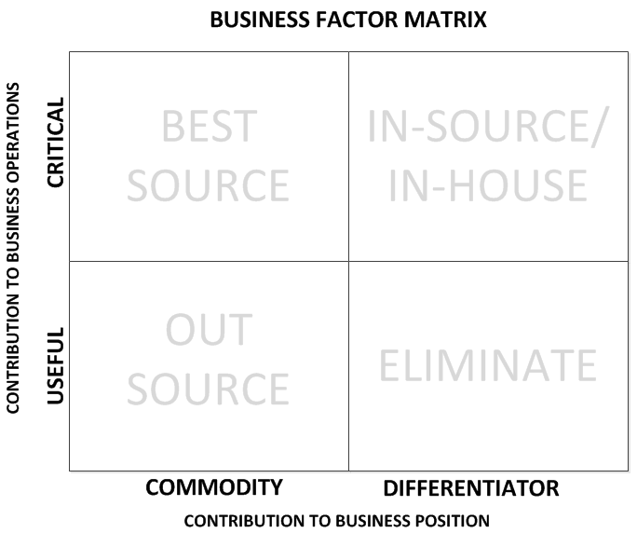
- IT Analysis GIS
- SCADA
- Sensor systems

- Inventory Control
- SCM
- Data Center & Networking

- Equipment Main Sys
- Desktop Managements
- Project Planning System
- Financial Systems
- Email and File Sharing
- CRM

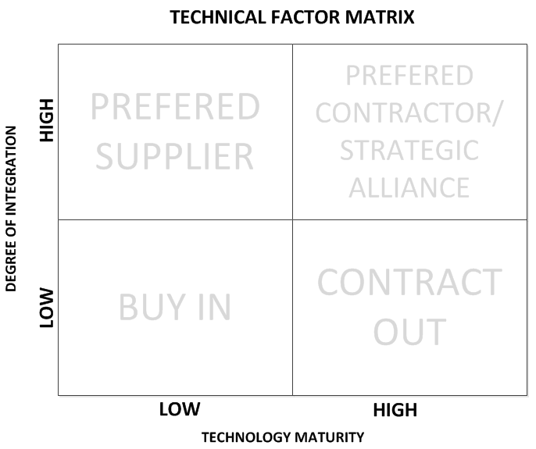
- IT Analysis GIS
- SCADA
- Sensor systems
- Inventory Control
- SCM
- Financial Systems

- Equipment Main Sys
- Desktop Managements
- Data Center & Networking
- Email and File Sharing
- Project Planning System
- CRM

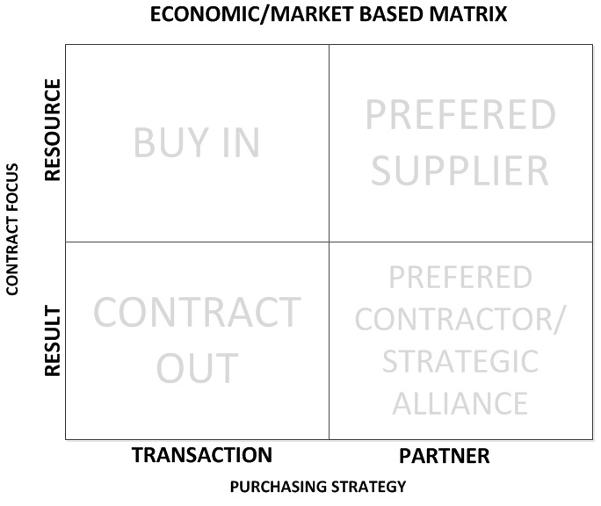
- IT Analysis GIS
- SCADA
- Sensor systems
- Inventory Control
- SCM
- Financial Systems

Listing of IT functions/systems and recommendation
# | IT Functions/Systems | Business Factors Matrix |  | Technical Factors Matrix |  | Market Based Matrix |  |  | Recommend
# | IT Functions/Systems | Commodity/  Differentiator | Critical/  Useful | Maturity High/  Maturity low | Degree of Integration High/Low | Purchasing Strategy  Transactional/  Partner |  | Contract Focus  Resource/  Results | Recommend
1 | Core Systems  - IT Analysis GIS  - SCADA  - Sensor systems | Differentiator | Critical | High | High | Partner |  | Results | In-House
1 | Core Systems  - IT Analysis GIS  - SCADA  - Sensor systems | In-house |  | Preferred Contractor / Strategic Alliance |  | Preferred Contractor / Strategic Alliance |  |  | In-House
2 | -Inventory Control System  -SCM system | Differentiator | Critical | High | High | Partner | Results |  | Preferred Contractor / Strategic Alliance
2 | -Inventory Control System  -SCM system | Best-Source |  | Preferred Contractor / Strategic Alliance |  | Preferred Contractor / Strategic Alliance |  |  | Preferred Contractor / Strategic Alliance
3 | Equipment Maintenance System | Commodity | Useful | High | Low | Partner | Results |  | Preferred Contractor / Strategic Alliance
3 | Equipment Maintenance System | Outsource |  | Contract Out |  | Preferred Contractor / Strategic Alliance |  |  | Preferred Contractor / Strategic Alliance
4 | Desktop Management | Commodity | Useful | High | Low | Transaction | Results |  | Contract Out
4 | Desktop Management | Outsource |  | Contract Out |  | Contract Out |  |  | Contract Out
5 | Data Center & Networking | Commodity | Critical | High | Low | Partner | Resource |  | Preferred Contractor / Strategic Alliance
5 | Data Center & Networking | Best-Source |  | Contract Out |  | Preferred Contractor / Strategic Alliance |  |  | Preferred Contractor / Strategic Alliance

# | IT Functions/Systems | Business Factors Matrix |  | Technical Factors Matrix |  |  | Market Based Matrix |  |  |  | Recommend
# | IT Functions/Systems | Commodity/  Differentiator | Critical/  Useful | Maturity High/  Maturity low |  | Degree of Integration High/Low | Purchasing Strategy  Transactional/  Partner |  | Contract Focus  Resource/  Results |  | Recommend
6 | Project Planning System | Commodity | Useful | High |  | Low | Transaction | Results |  | Contract Out
6 | Project Planning System | Outsource |  | Contract Out |  |  | Contract Out
7 | Financial Systems | Commodity | Critical | High |  | High | Transaction | Results |  | Contract Out
7 | Financial Systems | Best Source |  | Preferred Contractor / Strategic Alliance |  |  | Contract Out
8 | Email and file sharing | Commodity | Useful | High |  | Low | Transaction | Results |  | Contract Out
8 | Email and file sharing | Outsource |  | Contract Out |  |  | Contract Out
9 | CRM | Commodity | Useful | High | Low |  | Transaction | Results |  | Contract Out
9 | CRM | Outsource |  | Contract Out |  |  | Contract Out

Application | Core Systems  - IT Analysis GIS  - SCADA  - Sensor systems
Recommended Approach | In-House
Reason | Our (Pacific Petroleum) core business functions are locating, extracting and transporting crude oil for refinement. Hence, I will consider the above mentioned 3 systems as our company Core Systems because our daily core business processes rely entirely on these systems. If the sensor and GIS system are down there is no way our staff could locate and extract out the crude oil for further refinement. Selling refined crude oil is our main source of revenue. If it gets affected, our entire business will be affected.  There are many risks involved when we outsource our core system fully or partially to external parties, following are the few critical risks:  - lost control in critical business functions that are deeply integrated to these core systems:  - Vendor lock in – over relying on vendor, results in high cost or slow response from vendor in supporting the system  - Vendor lock out – vendor cease business and could no longer support our company crippling our core business functions.  - lost of internal expertise to provide business and technical advisory in improvising system behavior to better support critical business functions  - leakage of vital core business operation information that helps the company to create competitive advantages etc  Also, over the years we have developed a network of core systems to support our unique core business operations. External parties may not have the experience and skills to maintain or integrate into our systems.  As such, due to the enormous impact the potential risk can have on our core business, unless it is for strategic purpose, we should invest and build these systems from within our organization to have full control over it and avoid any substantial or partial dependency on external parties  Maintaining our core system in house can not only help us to avoid those risks mentioned but could also help us to develop potential competitive advantages. E.g. effectively customizing our core systems could help to optimize our business process or create additional values to our partners/customers and hence bring advantage to our company.  In additional, at this point, since we (Pacific Petroleum) do not have any prior experience in outsourcing, it is best that we will still maintain our core system in-house for now. We may explore any potential alliances or partnership in future after we had successfully outsourced some of our office systems.
Potential Benefits | - Full control over company’s most critical system  - Build internal expertise to develop potential competitive advantage against competitor  - Prevent leakage of vital information on how our company operates to produce and deliver products and services to our client. Such information is important for the company to protect existing competitive advantage
Potential Problems | - Require long-term investment  - Cost maybe out of control to sustain business if system is poorly maintained  - May not be able to compete
Remarks/  Strategies | We will continue to maintain these systems in-house for now. To ensure we could capitalize on-going technology advancement, could put in more investment to develop and upgrade/enhance our core system. To tap on external technology expertise, we could buy in consultants from external party to provide advice to help us to streamline our business with new technologies.  Ultimately, we should still have maximum control on our core system and minimal dependency on external party for maintenance or day to day support.  All these investments we made will produce long-term benefits, the knowledge to our unique business process will be kept within our organization and the customized enhancement to our system could potentially create potential competitive advantage.

Application | Data Center & Networking
Recommended Approach | Preferred Contractor / Strategic Alliance
Reason | In current technology era, almost every organization will require a stable and secure network infrastructure and data center. However, the total cost of ownership (TCO) to build and maintain a data center and network infrastructure does not come cheap.  In many organizations, data center and network infrastructure are considered common IT services. It is a business necessity to enable business to functions optimally. It is hardly been used as a competitive advantage as its primary objective is simply to store and transmit data and it usually functions the same from business to business. As such, it is always seen a good candidate for outsource.  However, as organization relies heavily on these services for day to day operation, it is critical to ensure high performance and availability of these services. Businesses have to ensure that the outsourced contractor they have selected is creditable, reliable and capable of providing these services.  Today, many organizations have already successfully outsourced their data center and networking services. As I do not see our organization require a special or unique data center or networking services, I would recommend outsourcing our data center and networking services to external contractor to ensure we could take full advantages of outsourcing within reasonable cost and risk. However, as this will be a long term solution, we should only nominate our preferred contractor.
Potential Benefits | - Lower TCO, reduce long-term liabilities  - Free out permanent staff for them to focus on their core competencies
Potential Problems | - Leakage of sensitive information
Remarks / Strategies | We will review the list of our preferred contractors and short list a contractor that offer rental of data centers with connectivity. We will buy in contract resources to manage the data center. Basically the contract staff will help to monitor and ensure there is not hardware failure and also facilitates any upgrade of server such as additional memory etc  The network will be co-managed by our own network managers and datacenter engineers. To ensure the network connectivity outsourced could be reversible when required, our contractor should provide us with detailed network schematic network diagram details on switches/routers configurations and our network managers will have visibility into the network setup.  We will establish an SLA with our contractor to ensure the contractor understands our requirements and expectation. The SLA will have to be agreed and signed-off by both parties. The SLA should clearly define the performance, security, availability requirements.  To prevent leakage of sensitive information and ensure clear intellectual property rights, we will only rent the data center space and connectivity. The servers will have to be wholly own by our company. The data center connectivity, regardless of whether is it a dedicated line, it should be treated as external party, all sensitive data using this connectivity for transmission will have to be encrypted. (through SSL etc).

Application | Email and File Sharing
Recommended Approach | Contract out
Reason | Another potential service that can be outsourced with relatively lower risk is the email and file sharing system. Email and file sharing systems are very basic tools. Due to security policies, There are numerous provider
Potential Benefits | - Lower TCO, reduce long-term liabilities  - Free out permanent staff for them to focus on their core competencies
Potential Problems | - Leakage of sensitive information
Remarks / Strategies | We will review the list of our preferred contractors and short list a contractor that offer rental of data centers with connectivity. We will buy in contract resources to manage the data center. Basically the contract staff will help to monitor and ensure there is not hardware failure and also facilitates any upgrade of server such as additional memory etc.  The network will be co-managed by our own network managers and datacenter engineers. To ensure the network connectivity outsourced could be reversible when required, our contractor should provide us with detailed network schematic network diagram details on switches/routers configurations and our network managers will have visibility into the network setup.  We will establish an SLA with our contractor to ensure the contractor understands our requirements and expectation. The SLA will have to be agreed and signed-off by both parties. The SLA should clearly define the performance, security, availability requirements.  To prevent leakage of sensitive information and ensure clear intellectual property rights, we will only rent the data center space and connectivity. The servers will have to be wholly own by our company. The data center connectivity, regardless of whether is it a dedicated line, it should be treated as external party, all sensitive data using this connectivity for transmission will have to be encrypted. (through SSL etc).

Application | - Inventory Control System (ICS)  - Supply Chain Management (SCM)
Recommended Approach | Preferred Contractor / Strategic Alliance
Reason | ICS & SCM Systems are not new in the current technologies and has a few dominant market leaders. Companies like SAP have been offering their ICS & SCM solution and a handful of big organization have migrated to SAP, therefore it is a proven and mature solution.  By engaging a Vendor who is a centre of expertise in SAP, Pacific Petroleum is able to better take advantage of the new technologies to better manage their inventory and supply chain (i.e gain world class capabilities). Preferred Contractor / Strategic Alliance is recommended as it allows the vendor to be involved and ensure the delivery of the final product.
Potential Benefits | - Lower Cost in creating/maintaining the Inventory Control application  - Accelerate business benefits by having an external vendor assume this responsibility  - Improved business focus as such systems have little in common to the company’s line of business.
Potential Problems | - Breach of Contract would result in a catastrophic loss of control in the petroleum supply chain and transport scheduling  - Irreversibility of Outsourcing when the inventory system and SCM systems is to be brought in house in the future  - Like ERP systems, the dependence on a specific vendor increases as more information is stored in the system. System migration and lock-in become issues as time passes. It could even make it impossible to transition back to an in-house team.  - Leakage of confidential information could result in attempted hijacking of vessels transporting crude/refined oil.
Remarks | Assumption  The proposed system is based on a leading Enterprise Resource Planning system like SAP.  Risk Mitigation Strategies  Breach of Contract - Regular and close monitoring of the systems will be conducted to let the vendors know that Pacific Petroleum is very serious on this outsourcing project. This will deter them from attempting to breach the contract and will make them more careful in the work that they will be doing. Furthermore, disaster recovery exercise could be part of the contractual terms.  Irreversibility of Outsourcing - Pacific Petroleum should ensure that they understand the full design of the system and that the design specification to be given to them. Regular auditing should also take place to ensure that the codes are created according to the specification. This will ensure that the Pacific Petroleum will be able to maintain the system if they decided to bring it in-house one day. Furthermore in the event of vendor utilizing latest technology, Pacific Petroleum could hire 3rd party experts/consultants to review and audit the work done by the vendor to ensure the outcomes are correct technically and functionally.  Vendor dependency - The vendor must ensure that the Inventory Control and SCM system documents (User Manual/System Design and Specifications) are up to date. Also, the codes copyright must belong to Pacific Petroleum. This will ensure that even if the vendor does not wish to continue, another vendor who is proficient in the same industry is able to come in and continue to maintain.  Leakage of confidential information - Audit trails should be present in the systems to trace the flow of the data. Unauthorized access should not be permitted. Standard confidential agreement and security agreement should be part of the SLA when doing contract preparation.

Application | Equipment Maintenance System
Recommended Approach | Preferred Contractor / Strategic Alliance
Reason | Equipment is used to maintain
Potential Benefits
Potential Problems
Remarks

