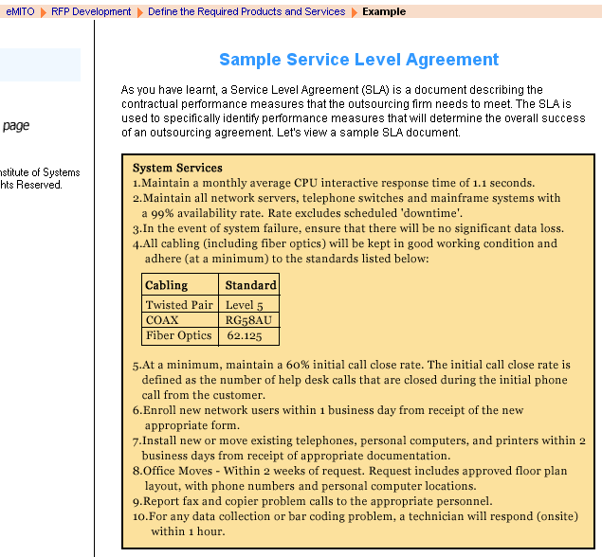
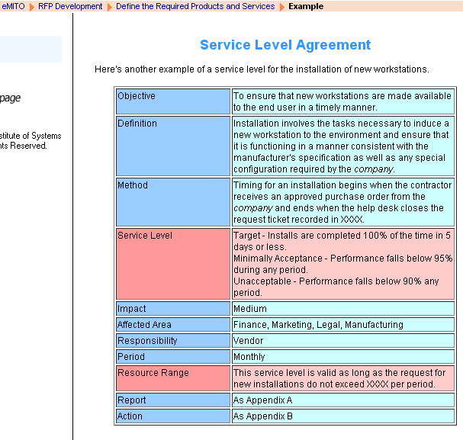

Sample Request For Proposal

Company Background
- Provide your company's name, primary address, and main telephone number.
- Is your company publicly owned? If not, give the name(s) and address (es) of principal owners, as well as the percentages owned.
- State your product distribution method.
- Provide a chronology of product development and releases for at least the past five years.
- How many releases have been issued since the product's genesis? How often are new releases issued? What is the approximate cost of new releases?
- Who will be the initial and ongoing contacts in your organisation?
- How many software systems have you installed? Of that number, what percentages of customers remain active?
- Provide ten references similar to proposed configuration in terms of functionality, including company name, contact and telephone number. Identify the system mode/release and configuration.
- Describe any other products provided by your firm other than those specifically requested in this RFP.
- Does the company provide services to assist call centers in initial or ongoing analyses to improve performance beyond the normal system training? If so, describe the services available and general pricing methodology.
Software Capabilities
- Describe the basic and optional components of the system, generally describing the role of each component and its interaction with the others.
System Requirements
- Is your system compatible with all ACDs (Automatic Call Distribution Systems)? Do you have co-market and/or technical agreements in place with major ACD producers? If so, list some.
- In what increments are statistics stored?
- Describe how raw data from the ACD are transferred to your system. What hardware or software is required in the ACD?
- Does your software have the ability to interface with other software packages? Does it employ a relational database?
- Under which operating systems does your software run? Is the system restricted to a particular hardware platform, operating system or processor? Are there additional hardware costs for non-standard operating systems?
- Is the system modular in design? Can additional modules be added later?
- Is the system password protected? What levels of system security are available?
- Can call center agents access the software?
- Is it possible to access the software from outside the call center? If so, what capabilities are provided?
- Describe your system's reporting capabilities. What customising features are included in your report package? How many standard reports are provided?
- Is it possible to archive reports?
- Is it possible to name reports?
- Does the system have any automatic reporting capabilities?
- In what time increments can reports be generated?
- Are bar graphs, line graphs, three-dimensional and colour graphs available?
- Can the system compare individual agent status to respective individual schedules on real-time basis?
- How does your real-time package notify supervisors when an agent is not adhering to schedule?
- What specific real-time schedule adherence information is displayed? How are supervisors notified when agents do not adhere to the schedule?
- Does the program differentiate between different types of adherence violations?
- Can the user define adherence parameters?
- Can adherence parameters differ by supervisor?
- Does your system provide a real-time view of the call center as a whole?
- With which ACDs is the real-time package compatible? Provide samples of all available reports.
Forecasting Call Volume
- Describe your forecasting model.
- Describe how your system accounts for holidays, non-operational days, special days and seasons in the forecast.
- Describe how your system adjusts the forecast during the business day as directed by current traffic loads.
- Describe how the forecasting mechanism is able to trend normalised averages of call volumes and handling times against the historical actual.
- Describe how current data are weighted when averaged with the historical trends. Can the weighting be user-defined? What assumptions are made in cases where limited or no historical data is available?
- What formulas are used to determine the number of agents required to handle the forecast call volume?
- Are historical growth rates used when forecasting a given week or for a daily schedule?
- Can the user define a growth rate that is different from the historical growth rate?
- Can the user compare staffing forecasts using a variety of user-defined agent service levels to occupancy rates, average delay and average handling times?
- Describe how your system accounts for variable call lengths by time of day.
- Can the lost time expectations be different for some hours or days? What data items are used for forecasting? Can they be user-defined
Scheduling
- Describe how work shifts are assigned to employees.
- What employee preferences other than seniority are used and how many preferences may be used to create a schedule? Can hourly wage rate be a criterion for prioritising the use of agents?
- Can the system create schedules in user-defined increments?
- How is non-phone related work scheduled?
- How does the system optimise the scheduling of off-phone time versus service level requirements?
- How many weeks per month can be scheduled at a time?
- What types of days-off rules are available for scheduling?
- How many agents can be scheduled at a time?
- Are schedules created daily or weekly?
- Can the system re-optimise the schedule after the known exceptions are taken into consideration?
- Can the system schedule to ensure the service level is met every incremental day?
- Can a schedule be requested (viewed/printed) for the following:
  - by day
  - by week
  - by agent
  - by supervisor
  - by work type
- Can the user compare the staff scheduled to forecast the staff required before printing the final schedules?
- How are part-time, full-time and temporary employees scheduled?
- Describe how your system reports the following:
  - total daily hours scheduled by employee
  - total weekly hours scheduled by employee
  - comparison of daily hours scheduled to actual hours worked
  - percentage of time actually handling calls versus time scheduled
- How is a schedule created for an agent dedicated to outbound calls or other non-phone activities?
- What 'Help' screens are available during the scheduling process?
- How does your system handle multiple ACD groups? How many ACD groups can be scheduled?
Installation and Maintenance
- Hardware and Operating System
- Describe the hardware required to run the proposed system. Will your company provide this hardware?
- If PC-based, is the PC dedicated to running the workforce management software?
- How many workstations does your system support?
- Does your product operate in a LAN environment in such a way that all workstations on an existing LAN can access the software?
- How many users can access the system concurrently?
- Describe the features for the system in terms of their ease of use.
- Under which operating system does your software run?
- Installation and Training
- Describe the training provided. Are there any prerequisites?
- How many users are included in your standard training package?
- Is additional training available?
- How many training personnel are available for installations of the type proposed?
- What installation assistance is provided?
- Describe the recommended approach to installation.
- Include steps and time necessary to install the system from beginning to end.
- Define supplier's tasks as well as those expected of the customer.
- Maintenance
- Describe the warranty provided by your company.
- Does it include software upgrades? Describe your support and maintenance program.
- What is your upgrade policy?
- How often is the software upgraded? Are new releases compatible with previous releases?
- What is the process of interaction required if the ACD hardware/software is changed or upgraded after installation of the system proposed?
- Describe methods of on-going communication with customers regarding new releases, additional training, user meetings, etc.
Cost
- Application software.
- Packaged applications.
- Custom application.
- Modification charges.
- Development cost for system requirements that are not currently available.
- Warranty, maintenance and support fees.
- Itemised hardware.
- Installation charges.
- Maintenance prices.
- Is software leasing an option
Miscellaneous
- List of available publication or documentation.
- Other literature appropriate to the sample proposal.

