How to improve QA Process
- All work products must be reviewed for approval. Proper review guideline must be established for consistency
- Customer involvement in review
- Prototype during high level design stage
  - To ensure architectural feasibility
  - Include UI to give user a look and feel of the system
- Peer Review at early stage
  - to ensure defects are removed as soon as they will put into.
  - Code Review: To identify issues that cannot be captured through normal testing. Spaghetti code, the code may still work but it may cause performance issue or maintenance issue in future.

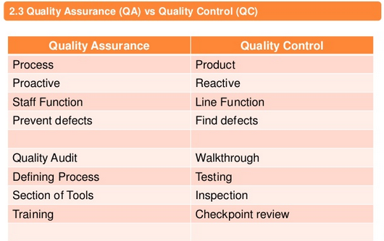

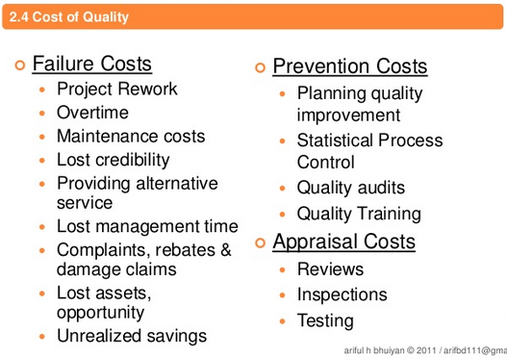
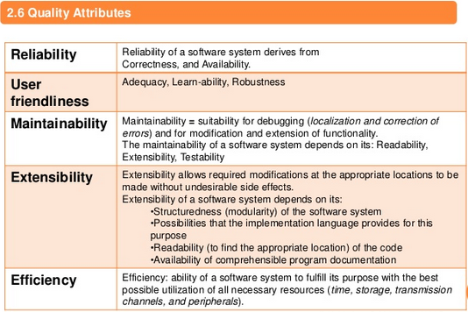

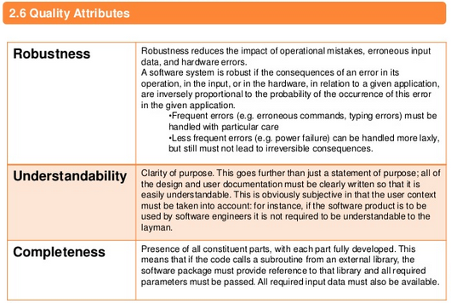

In our procedure, Major Nonconformance was defined as any nonconformance that could:
1. adversely affect safety as related to products, persons or property;
2 impact the usability of a product, performance of a service, or the integrity of the quality system;
3 significantly increase product cost;
4 potentially affect the ability to meet the customer’s requirements. Examples: incorrect process parameters, missing inspections or processing steps, failure to record required data, missed or out-of-tolerance calibration
5 result from failure to implement a corrective action from the previous audit.
6 Violated the ISO9001 requirements.
Minor Nonconformance was defined as any non-systemic, isolated nonconformance that does not:
1 adversely affect the usability of a product, performance of a service, or the integrity of the quality system;
2 affect any product or process output. Example: paperwork oversights, minor changes to procedures for clarification.
And Observation was defined as a statement of fact made during an audit and substantiated by objective evidence and auditor’s informational comments based on an assessment of a special process or quality system.A lot of auditors always think that an audit should be ended with a non-conformity. This is a misunderstanding to the goal of an audit (see posting: TIPS FOR PERFORMING QUALITY AUDITS). However, an auditor shall have a good knowledge and skill to define whereas a finding found, it is a Non-Conformity (either minor or major) or just an observation.

Non-conformity must:

- be factual/objective
- be clear and concise
- associates to the clause number of the standard (ISO 9001, ISO 14001, OHSAS 18001, etc)
- be locatable by other Auditors
- defines the exact instance - objective evidence
- be given a unique identifier
- be categorized (e.g. minor/major) if third party audit
- be acknowledged, signed by Company/Client.

Then, how to categorize a finding as Observation or Minor or Major Non-Conformity?

Observation: must be a finding which there is a possibility moving towards a non-conformity. This normally followed by a recommendation.

Minor Non-Conformity: either a failure to meet one requirement of a clause of the reference standard (ISO 9001/OHSAS 18001/ISO 14001), or a single observed lapse in following one item of a Company procedure.
Note, with minor non-conformities, the auditor should take care to make sure that the auditee understands that:
- the non-conformity is minor
- a number of minors could demonstrate a system breakdown and perhaps contribute to a major.

Major Non-Conformity: the absence or the total breakdown of a system to meet the requirements of a clause of the reference standard (ISO 9001/OHSAS 18001/ISO 14001), or a number of minor non-conformities listed against one clause can represent total breakdown of a system and thus be considered a major non-conformity.
Note, with third party audits one major non-conformity normally results in a "non-certification" recommendation, hence the more carefully decision to upgrade a collection of minors to a major must be taken by the Lead Auditor, who should review all the team members findings in the subject area.

In Reply to Parent Post by Colpart

Why do you want to categorise them major/minor? I can see the benefit of differentiating between N/C and observation not major/minor.
If you do use major and minor N/C's, what do you expect people to do different when they address them? The only thing I can see is the timescale by which they are resolved - which should always be on any corrective action anyway. By not categorising you avoid the problems of people spending longer worrying over the grade rather than the content of the N/C; you avoid auditors 'glorifying' the fact they have raised a major; you avoid 'tit for tat' grading of majors; etc.
I raise N/C's to get things changed where they need to be changed, if they are more serious we reduce the time allowed to put in place the changes.
I believe we've had this discussion before but as I have donned my ISO 9001/14001 auditing hat again to help a site out - not a Corporate gal for the next few hours at least - I'm going to jump in with my thoughts.
Why differentiate? Because of the value-added approach to problem-solving.
In my production experience, we treat a "minor" with a correction. We log it. We acknowledge it. But it's a small little hiccup in the grand scheme of things. Root cause analysis is NOT required for a hiccup. We simply wish to get rid of the annoyance....I mean, nonconformance.
I guess this would be aligned with the "observation". However, observation implies "Hey, we found something, but you don't necessarily need to do anything about." And that, to be honest, is typically unacceptable within my organization. An observation says that there is some nonconformance against requirements, does it not?
A major, on the other hand, is big issue. It implies high (potential of) risk and/or loss. It is a systematic issue and we want to get rid of it for our own sanity and the health of the management system.
An Opportunity for Improvement is for those cases where requirements are conformed to, however there is the potential to improve the process/practice/results. It is optional to implement.
When we do system audits in my company, we may note "minors" on individual processes, and we inform the area before we leave of the situation. However, at each team caucus meeting - held at the end of each day - we discuss what was found and if there are multiple minors against a particular requirement (e.g., lots of documents found to be out-of-date, unapproved but used, etc.), we'll issue a major against document control.
To summarize, why classify Minor or Major?...to ensure we take a value-added approach to treating the nonconformance.
It works for us.
Whether or not it works for others....well, I did have the local ASQ chapter president ask me to speak at a meeting on our method...

