1. Course Title: Sourcing Strategy & Planning Initiatives

  - Basic Outsourcing

Outsource

Let's say that as a Project Manager, you are given an IT project. What would be the options available to handle the project? Well, here are three possible options:
- buy an off-the-shelf package
- build your own
- outsource
We will focus on the third option in this lesson. Outsourcing is not a new concept. You may be familiar with the concept already but are not aware that it is called outsourcing. Can you guess what other terms refer to outsourcing as well?

Benefits of Outsourcing

Taking Advantage of Future Technologies
As new technologies emerge, most companies cannot immediately take advantage of them because of the cost and learning curve associated with these technologies. Since one of the strategic initiatives for an outsourcing firm is to stay current with new technologies, they would be responsible for maintaining a high competency level in current, as well as new technologies. The technology benefit is significant for companies who are on a fast pace and who realise significant growth.

Cost Savings
While outsourcing firms can provide savings in many areas, the primary reason for these savings is their ability to take advantage of economies of scale. Since outsourcing firms are providing the same type of service for many customers, they are able to consolidate data centre operations to provide lower overhead costs on a per-customer basis. They are also in the position to receive deep discounts from hardware and software suppliers because of their annual volume of business.

Centre of Expertise
Since an outsourcing firm's primary business is to manage technology for clients, it is appropriate to assume they have experience with current, as well as new technologies. Larger outsourcing firms embrace the "center of expertise" concept, in which a group of research and development technology engineers are dedicated to evaluating new products and their applicability throughout the industry.

Resource Availability
The requirements for IT resources fluctuate according to the changes in business needs and customer demands. Outsourcing firms can provide additional professional resources on an as-needed basis. This reduces the cost of customer organisations of retaining permanent employees and/or utilising industry consultants for short term engagements.

Reduction of Risk
A properly structured outsourcing agreement will ensure the outsourcer assumes the appropriate risk. The outsourcer will have to be responsible for ensuring that the systems, among other things, are meeting the reliability and performance criteria, and that properly skilled personnel are available at the right time.

Improved IT Customer Service
Having a great customer service relationship is as important as the quality and cost effectiveness of the products being produced and maintained. As with most professions, the systems developed for IT are becoming more and more complex day by day. On the other hand, the knowledge level of the user is increasing but not at the same rate. Therefore, it is imperative to establish and maintain an excellent help desk or support centre to provide a point of contact for the user. A properly structured contract will insist that the outsourcing firm provides a state-of-the-art help desk function.
IT Professional Growth
The constant challenge that each company faces is the need to challenge the internal IT staff continuously. Many industries are in business to produce goods and services that are not IT-related. Thus, it is not the priority of these industries to train their IT staff regularly, nor to keep them abreast of new technologies in their profession. On the other hand, an outsourcing firm's revenue is heavily dependent on the quality of service their personnel provides. As such, outsourcers will typically invest a great deal more in the training and education of their IT staff.

In sourcing

An alternate approach to outsourcing is insourcing. Insourcing basically involves a contract that calls for the market to provide resources to be deployed under the client's management and control.
For example, let's say that a client is required to boost its own in-house IT capability. The client brings in specialised skills from a contractor. Having done so, the client will need to manage the resources, which could include people, facilities, technology and other assets, and of course, at the end of the day, manage the results.
In other words, insourcing is buying-in a vendor's resources and managing them internally. To further understand the concept of insourcing, take a look at the animation below.

Offshore outsourcing

Another approach to outsourcing is offshore outsourcing. Offshore outsourcing refers to the situation where the buyer's company, with offices sited in one country (e.g.Singapore) agrees to a contract with a contractor's company where the bulk of the outsourcing work is to be performed in another country (e.g. India).

  - Outsourcing Trend

Navigating opportunities and risks

Companies interested in investigating offshore opportunities must be able to tackle challenges in three areas: cultural, geographical and political. They must be willing to invest time and money in building processes to ensure proper project management , effectively evaluating and training personnel , and establishing meaningful metrics to make sure projects stay on track.
But when offshore projects go astray, frequently the reasons are poor communication or cultural miscues. To prevent your offshore projects from bobbing aimlessly on the high seas, or sinking in stormy weather, follow the golden rule of any outsourcing project: Don't assume anything, ever . Specifically, companies must have 2 Ss and 2 Cs .

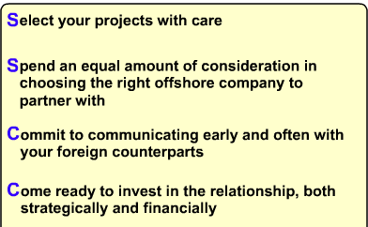

Considerations for offshore outsourcing

Companies considering offshore outsourcing should examine:
- Outsourcing firm qualifications, such as technical certifications, resource maturity, and viability
- Communication mechanisms, including two-way, Web-based capability; and on-site/offshore coordination abilities
- Location, together with operational/geopolitical risk assessments and business process/industry knowledge

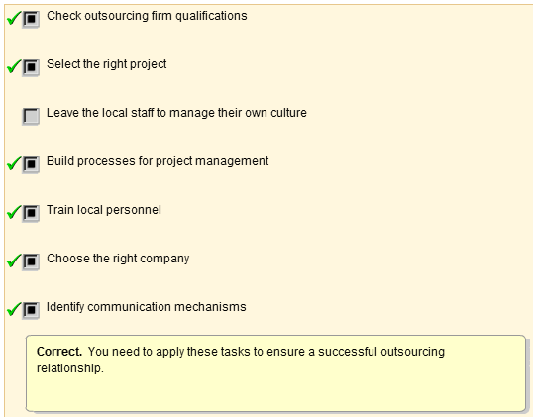
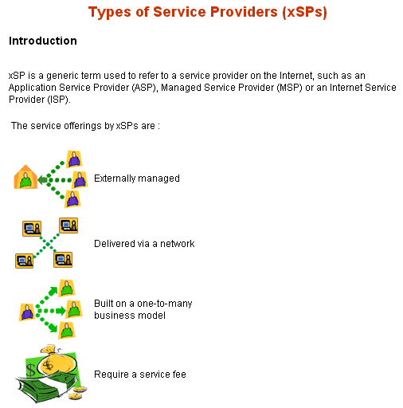
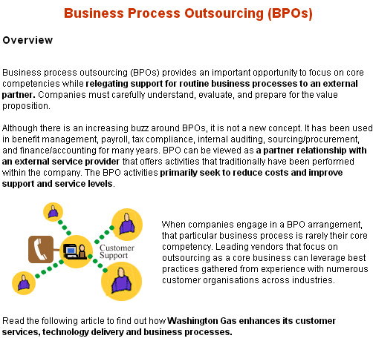

  - Key Success Factors of Outsourcing
  - Define the Outsourcing Objectives and Goals
  - Sourcing Options
  - Select Possible Candidates to Outsource
  - Types of sourcing relationship

