SI101 – Introduction to Service Innovation

What service innovation and its objective
- A new of considerably change system that individually, but most likely in combination, leads to one or more service functions that are new to the service organization
- Service innovation creates values for customers, employees, business owners, alliance through new and/or improved service offerings, service process and service business models
- Role of service has become strategic to business success
- Understand the relevance of service innovation to IT professionals in the service industry
- Innovation become a core competence

The shifting Role of IT
Current | Emerging
IT is aligned to Business | Define service and specify service systems to deliver value
IT uses a producer/provider mindset to deliver systems/solution | Service logic shifts from goods dominant to service dominant. A inter-displinary and collaborative innovation and approach used to define, design , implement and operationalize services
IT focused on the backstage | Focus shifts to the front stage  Service culture establishes new values for organization and leadership
IT operates within the Enterprise | IT services the customer, managers the value network  Service experience and relationship beyond the enterprise
IT not exploited for collaboration; enterprise boundaries shifting | Web2.0, cloud services, open innovation are participatory platforms for service dominant logic
Invention | Innovation
‘
What motivates external innovators

- Open Markets
  - Money
  - User need
- Open communities
  - Autonomy - The right or condition of self-government
  - Fun and enjoyment
  - Intellectual challenge

SI102 – Service Logic (+Gift of Value)

Service Dominant: Mindset shift from Goods to Service

A service capability is needed that embraces this mindset shift from the traditional focus of embedding the value in a service to one where relationships and collective intelligence with consumers, providers, partners and employees take center stage

# | Good Dominant (From) | Service Dominant (To) | Definition
 | Creation of goods | Process of serving | Shift the focus on the process of serving the customer than the goods been sold to customer  service-dominant logic suggests that since  these goods are actually mechanisms for service provision, the customer is always buying a service flow rather than a tangible thing, and thus the firm should focus on selling a flow of service.
 | Tangible | Intangible | Shift the focus to intangible value such as happiness, peace of mind, faith rather than tangible product. Mastercard advertisement, the card can, not only buy you tangible product, but it also buy you intangible value. Such as happiness  In business-to-business marketing it is  called solution selling. But in all firms and industries, the increasing mantra is about providing solutions
 | Static Resource | Dynamic Resource | Shift to use creation of operant resources as opposed to the consumption and depletion of static operand resources  A static operand resource is usually tangible and requires something be done to it to be useful, whereas a dynamic operant resource is largely intangible and can produce an effect [6]. In service-dominant logic, knowledge an intangible resource is the primal source of wealth and the only sustainable source of competitive advantage. (and countries) that will be able to adapt in a rapidly changing technological world are those that invest heavily in knowledge development

 | Asymmetric | Symmetric Information | A recognition of the strategic advantage of Symmetric rather than asymmetric information  A focus on symmetric information and  treatment implies: (1) one does not mislead customers, employees or partners by not sharing relevant information that could enable them to make better and more informed choices, and (2) all exchange or trading partners are treated equitably. The first implication is largely at the firm level,  however, the second provides major guidance for countries.
 | Propaganda | Conversational | A shift to conversation and dialog as opposed to propaganda  Service-dominant logic argues that communication should be characterized by conversation and dialog. This approach should include not only customers, but also employees and other relevant stakeholders that may be affected by service exchange.  In service-dominant logic, firms are encouraged to  emphasize listening as much, if not more than, talking.
 | Value added | Value proposition | In the goods-dominant logic, value was viewed as a  property (utility) of a good that was added in the  manufacturing process, equivalent to value-in-exchange. Thus, if a customer paid a price for an offering, then the exchange of money was assumed to reflect the value in the transaction. This logic implied that as firms accumulated costs in manufacturing and distribution (they exchanged money for capital and labor), they should set prices based on these added costs. Traders adopted a “cost-plus” mindset, believing that any cost could be pushed onto the  next party in the supply chain and eventually onto  consumers and society. This idea that value is something determined by the customer implies that the firm can only make an offer of value creation through the application of its resources to some need of the customer—that is, through service. Thus,  the firm can only make a value proposition and then, if it is accepted, value is co-created in concert with the customer.Value-in exchange, as reflected in price paid, is just an indication of the customer’s perceived probability that at least some minimum desired value results from acceptance of the value proposition.
 | Transactional | Relational | A shift in focus to relational rather than transactional exchange
 | Profit Maximization | Financial Feedback | A shift an emphasis on financial performance for information feedback rather than a goal of profit maximization  Profit maximization is not in the vocabulary of servicedominant logic. Service-dominant logic views business and marketing as an on-going stream of social and economic processes in which firms continually generate and test hypotheses. Firms learn from financial outcomes as they attempt to better serve customers and obtain cash flows for  the firm. Service-dominant logic embraces market and customer orientation and a learning orientation. Therefore, financial success is not just an end in itself but an important form of marketplace feedback about the fulfillment of value propositions.

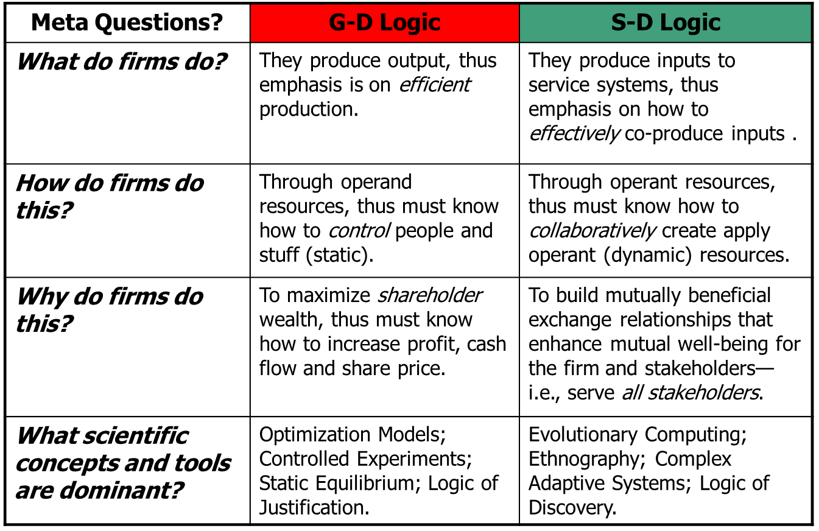
http://sdlogic.net/foundations.html

Underlying Conceptual Transitions to a S-D Logic
Goods Dominant Logic Concepts | Transitional Concepts | S-D Logic Concepts
Goods | Services | Service
Product | Offerings | Experiences
Feature/Attribute | Benefit | Solution
Value-Added | Co-Production | Co-creation of value
Value-in-exchange | Value-in-use | Value-in-context
Profit Maximization | Financial Engineering | Financial feedback/learning
Price | Value Delivery | Value Proposition
Equilibrium Systems | Dynamic Systems | Complex Adaptive Systems
Adapted from: Lusch and Vargo (2006), “Service Dominant Logic: Reactions, Reflections, Refinements” Marketing Theory 6(3), 281-288.
SI103 – Social Production
SI104 – Innovation Framework
SI105 – Developing Insights
SI106 – Innovation Areas
SI107 – Service Attributes and Selection
SI108 – Value Proposition and Service Concept
SI109 – Service Modeling (Journey Mapping)
SI110 – Service Modeling (Blue Printing)
SI111 – Service Modeling (User stories)
SI112 – Experimentation
SI113- Prototyping
Cognitive Walkthrough
Description of method:
Cognitive walkthrough is a review technique where expert evaluators analyze or "walk through” each step of task performance in the documentation mentally. They act as if they are actually working through the task. Each step the maintenance technician would take is scrutinized. This method finds mismatches between user's and writer's conceptualization of the task, poor wording choices, and inadequate feedback about the consequences of an action.
Bottlenecks where the maintenance technician is blocked from completing the task indicate that the documentation is missing something – which might be clarification or another action that needed to be taken first. Convoluted, indirect paths through task sequences indicate that it needs a revision that simplifies the task and collapses or restructures the sequence. Areas which are confusing or unclear need to be noted to add information or change wording to clarify the meaning. This procedure uncovers implicit (unspoken) or explicit (clear) assumptions made by the writer about the user’s knowledge of the task. The evaluation procedure takes the form of a series of questions asked about each step in the task that are derived from a theory of learning by exploration.
Development Lifecycle Stage: This method can be used early in the document development to find areas that need improvement. This may include language (grammar, typos), technical information (values, parts), illustrations (part identification, perspective), and procedural steps (sequence, necessity).
Number of Users/Evaluators Required: The number of evaluators needed often depends on the complexity of the procedure to be evaluated. Less complex tasks may only require the attention of a single expert maintenance technician. More complex tasks will require four or five experts in order to adequately evaluate the procedure.
Type of Evaluators: Cognitive walkthroughs require expert users. Since the actual parts are not available, the expert must rely on memory and prior experience to detect and correct potential errors. A mix of different evaluators is advised -- including the maintenance technician, maintenance engineer, design engineer, and field service engineer.
Evaluator Skills required to Use the Method: Although a basic knowledge of usability testing would be advantageous, this method can be successfully administered by reading about this method and using the cognitive walkthrough script to plan your evaluation. Experts should have extensive knowledge of the procedure and systems involved. Evaluating maintenance procedures requires a detailed and global understanding of the spatial location of the affected part, adjacent parts, and structure. The expert will also need functional knowledge of the tools and processes required to complete the procedure. Finally, the expert should be aware of the potential effects the procedure will have on the system(s) as well as on related systems. (i.e. adding hydraulic power to system B without circuit breaker xyz pulled will cause main landing gear to retract).
Advantages of method:
- The key advantages of this method is that it can identify problems very early in the development of the documentation development to find areas that need improvement. This may include language (grammar, typos), technical information (values, parts), illustrations (part identification, perspective), and procedural steps (sequence, necessity).
- Helps define users’ goals and assumptions.
- This method uses fewer resources (time, personnel, and equipment) than actual user performance testing.
Disadvantages of Method:
- The key disadvantage is that this method is more dependent upon evaluators’ biases and subjective comments.
- The errors and problems found using the cognitive walkthrough method of testing are less severe than those found in user testing.
- Experts are often forced to rely on memory of previous experiences. If the expert’s memory is incorrect or incomplete, potential errors may not be found or in some cases new errors may be introduced.
- It is often difficult for an expert evaluator to consider the maintenance procedure from the perspective of an inexperienced or naïve user.
- The process is most effective when the person conducting the evaluation is trained in cognitive psychology or the process of the cognitive walkthrough. Untrained evaluators have been found to produce poorer results (Barnum, 2002).
Level (or amount) of User and Evaluator Interaction: There is little interaction between the person conducting the test and the evaluator reviewing the procedure. The evaluator usually works alone while reading and thinking through the written procedure. After the walkthrough, the person conducting the test will clarify the information that has been recorded on the procedure sheet to confirm their intended meaning.
Data Recording Method(s): Comments and corrections are recorded directly on the procedure. Each participant should be given a copy of the procedure and any illustrations that are planned to accompany the written procedure. Additional paper should also be provided for the evaluator for drawing or writing out their thoughts. All comments are then combined for analysis and reporting.
Total Testing Time Required: Depending on participants’ schedules, it is possible for the total testing being complete within one week.
Testing Time Per User: Time required for each participant will typically range from 45 minutes to 1 ½ hours.
Typical Output from Test: The output from a cognitive walkthrough is subjective data, but is valuable in that it can be evaluated to make necessary corrections to the documentation and identify areas where the information is ambiguous.
How to Run the Test: This evaluation is usually conducted in an office setting, preferably in a quiet space with a desk. See Cognitive Walkthrough Script in the Tools & Templates section. Participants may be run simultaneously; however, there should be another person available to conduct the follow up interviews with enough distance as to not distract the other participant.
Required Testing Materials: The participants will need a copy of the written procedure, engineering blueprint, and any other supplemental information which will aid their evaluation. Additional paper should also be provided for the evaluator for drawing or writing out their thoughts.
Cost to Conduct Test: The cost to conduct a Cognitive Walkthrough is relatively low. The cost can be estimated by taking the hourly salary of each experts times the number of hours required for review, including a group meeting if required. Also, include your time in preparation for the review and recording the results.
References / Where to Learn More: See References and Useful Resources.
Type of System that Test Can Be Done On: Testing is most useful on complex procedures, but should be followed up with user performance evaluation after corrections are made. Some questionable areas found in the Cognitive Walkthrough may be targeted for exploration during a user evaluation.
Goals of Testing: The goal of a Cognitive Walkthrough is to find errors in the text and illustrations at an early stage in the process of writing the procedural task.
Subjective or Objective Test: Cognitive Walkthrough evaluation is subjective from the frame of the expert reviewer’s reference; however, the expert evaluator is instructed to think through the procedure as a user unfamiliar with the procedure.
Ease of Learning to Conduct the Test: Conducting a Cognitive Walkthrough is relatively easy if there are experts in the necessary fields available to evaluate the procedure. It is advisable to have a Usability professional as one of the experts to evaluate the documentation from a “user-centered” perspective. Since the results do not require formal analyses, research experience is not required.
Turnaround Time: The time to produce deliverable results from this method is short if there is agreement between experts as to the proposed changes. Compilation and implementation of the findings are necessary to progress to the next stage of development, so it is necessary to come to consensus on changes quickly.
Focus of Evaluation: This type of evaluation has a limited or narrow focus in that only the documentation is available for review.
Related Statistical Analysis: Results of the Cognitive Walkthrough are qualitative due to the low number of evaluators.

SI114 – Prototype – Test and Adaptation

