Vessel Tracking System (VTS) Project
End of Project Report
 | Filing Reference : | ISS/VTS/MP.2/2
 | Document Title : | End of Project Report
 | Version : | 1.0
 | Prepared By : | Teng Boon Wee
 | Date Created : | Friday 7th January 2011
 | Approved By :
 |  |  | Li Pengfei |  | Date
 |  |  | Software Lead
 | Authorised By :
 |  |  | Kyaw Thu Lin |  | Date
 |  |  | QA Manager
©1993 ISS.  The information contained in this document is the property of ISS. The contents must not be reproduced, wholly or in part, for purposes other than for which it has been supplied, without the prior permission of ISS, or, if it has been furnished under contract to another party, as expressly authorised under that contract. ISS shall not be liable for any errors or omissions. |  |  |  | ISS

ISS/VTS/MP.5/2
Version | Date | Author | Authorised by | Date
1.0 | 7th Jan 2011 | Teng Boon Wee | Kyaw Thu Lin
Vessel Tracking System (VTS)
End of Project Report
Distribution:
Name | Department | Organisation
Teng Boon Wee | - | ISS
Li Pengfei | - | ISS
Cai Xiang | - | ISS
Erik Araojo | - | ISS
Naung Naung Latt | - | ISS
Oh Chew Key | - | ISS
Plathottam Linu Thankam | - | ISS
Kyaw Thu Lin | - | ISS
Chong Imm Lam | SEG | ST Electronics

Abstract
This document discusses the management and technical issues encountered during the course of implementing the VTS (Vessel Tracking System). It takes a look at the technical approach taken, and also discusses the design that was chosen for the system. The issues that were faced by the team were also looked at. Finally the report concludes by describing the completion of the project as well as the possible future developments of the system.

Table of Contents
1. Introduction 5
2. Background 5
3. Development Methodology 5
4. Analysis 5
5. Architecture 8
5.1. Architecture Components 10
5.1.1. JBoss (ver 5.1) 10
5.1.2. Hibernate (ver 3.3.1) 10
5.1.3. EJB 3 10
5.1.4. JSF (ver 1.2) 10
5.1.5. JBoss Messaging 11
5.1.6. JBoss Remoting 11
5.1.7. JBoss Client 11
5.1.8. GeoTools 12
5.1.9. RXTXComm 12
6. Overview of Design 12
6.1. Backend Server 12
6.2. Clients 15
6.3. Security 17
6.4. Performance 17
7. Project Milestones – Actual vs Planned 17
8. Evaluation 19
8.1. Project Delivery 19
8.2. GeoTools 19
9. Conclusions and Future Work 19

Introduction
ST Electronics (Info-Software Systems) Pte Ltd is interested in finding out the potential of creating a vessel tracking system using the Java platform as well as the latest open source software available. For this purpose, this project will attempt to explore the various technologies that can be used to achieve vessel tracking, and in the process create a working system which is capable of demonstrating this.

Background
The main purpose of a vessel tracking system is to allow users to monitor the locations of vessels. Each vessel being tracked will typically use a GPS (Global Positioning System) device to find its own location, and will periodically send its own location back to a server. Users of the vessel tracking system can then query and view the locations of the vessels from the server.

Development Methodology
The project uses the Rational Unified Process (RUP) as its development methodology, and is broken up into three phases:
- Phase 1 – Inception, key activities include Project Planing, Requirements Specification, etc.
- Phase 2 – Elaboration, key activities include Requirements Analysis, High Level Design, etc.
- Phase 3 – Construction, key activities include Detailed Design, and Implementation, etc.
Due to the prototyping nature of this project, the transition phase only includes UAT; no maintenance activities.

Analysis
The VTS (Vessel Tracking System) was designed to be made up of four modules – the Information Centre, the Display Client, the Tracking Client and the Admin Portal. The diagrams below show the use cases for these modules.

TrackingClient
(from Actors)
Receive data from tracking client
(from Information Center Actions)
Add subscription
(from Information Center Actions)
Delete subscription
(from Information Center Actions)
Send tracking data to display
client
(from Information Center Actions)
<<include>>
Display Client
(from Actors)

Information Centre Use Cases
Center map
(from Display Client Use Ca...
Manage account info
(from Com...
Validate Credentials
(from Com...
if only 1 track is found or the
user selects a track from the
results, the map is centered on
the track.
Manage Tracks
(from Display Client Use Ca...
Show/Hide layer
(from Display Client Use Ca...
Customize layer
(from Display Client Use Ca...
Login
(from Com...
<<extend>>
Logout
(from Com...
Search Track
(from Display Client Use Ca...
Pan across map
(from Display Client Use Ca...
Manage Track Information
(from Display Client Use Ca...
Zoom in
(from Display Client Use Ca...
<<include>>
Zoom out
(from Display Client Use Ca...
Change Password
(from Display Client Use Ca...
User
opname()
(from Actors)
InformationCenter
(from Actors)
Receive Tracking data from information center
(from Display Client Use Ca...
<<extend>>
Reset Password
(from Display Client Use Ca...
Display Client Use Cases
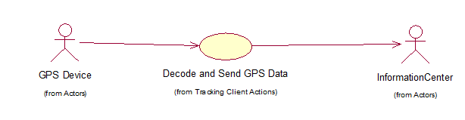
Tracking Client Use Cases

Login
(from Com...
User
opname()
(from Actors)
Logout
(from Com...
Manage Layers
(from Administrator Use Cases)
Manage track
(from Administrator Use Cases)
Manage users
(from Administrator Use Cases)
Manage groups
(from Administrator Use Cases)
Administrator
(from Actors)
Manage Layer Attribute
<<extend>>
Admin Portal Use Cases

Architecture
The initial design of the system was to have the entire system communicating through JMS (Java Messaging Service). It was questioned during the second phase of the project, after the high level designs of the system had been produced, why JMS was used, as JMS has a higher bandwidth overheads as compared to other means of commication such as using sockets. A quick analysis was done to compare the bandwidth consumption against sockets, and it was found that JMS packets consume roughly twice as much bandwidth as compare to packets sent using sockets.
With this information, it was decided that the Tracking Client, which sends periodic updates of its own location, shall use sockets as its means of communicating with the server. The Display Client however, shall continue running on JMS as it was decided that the Display Client would be unlikely to run on bandwidth constrainted networks.
The system will be using both JMS and socket for communication between client and server, and JBoss Application Server as the supporting backbone. The system consists of the following major components:
- The Admin Portal, which is basically a Java enterprise application, with complete 3 tier structure: data persistence over Hibernate, business logic over EJB3, and persentation over JSF.
- The Display Client, which presents tracks on various types of map via GeoTools, and communicate with backend server via JMS
- The Tracking Client, which is connected with external GPS device through COMM port using RXTXComm library, and communicate with backend server through socket.
- The Information Centre, which provides communication interfaces via socket and JMS.
The diagram below shows how the components of the system are arranged:
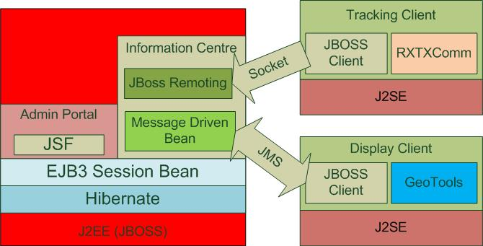
Technically there are various alternatives for each component in the above diagram, but the above final decision was made, with consideration of the factors: cost, popularity, and industry trend, etc. First of all, among the technical options, open source is perferred, as it incurs less cost. Industrial acceptance is also important, as high market share is an likely indicator of higher software quality, and it’s easy to find help from Internet when technical issues are encountered.

Architecture Components
This section describes the components that were used in the system.

JBoss (ver 5.1)
JBoss (http://www.jboss.org/) plays a key role of backend server and the communication with clients. The selection of JBoss is mainly due to its popularity. Some survey claims it is used in 30-40% of middle and large enterprises. It’s expected that rich resource could be found from Internet on its configuration, workarounds, and optimisations, etc.
Generally JBoss provides a solid framework to incorporate the VTS components. Though it takes time, but its documentation and community forum are fairly helpful on solving technical issues in the development. Also there are a lot articles on users’ past experience from network.
The selection of JBoss affects the selection of quite a few tools / technologies in the diagram. To avoid potential incompatability and integration conflict, the existing technologies in JBoss is always preferred.

Hibernate (ver 3.3.1)
Being a multi-tier architecture, VTS uses Hibernate as the framework of Data Access tier.
Hibernate (http://www.hibernate.org/) is the default DAO framework in JBoss. It generally meets the requirements of the development. However, it’s not fully JPA compliance, and this could affect the migratability of DAO code. Though it’s not something outstanding, it is unnecessary external dependency.

EJB 3
VTS makes use of EJB 3 to manage the Business Logic, especially to manage the transactions.
Compared with EJB 2, EJB 3 (http://www.jboss.org/ejb3) is much more developer-friendly. Although this is the most criticized portion in JBoss on the compliance with Java EE, no outstanding issue was encountered. Probably because the advanced features of EJB 3 was not involved in the project.

JSF (ver 1.2)
JSF is the basis of Presentation tier of VTS - Admin Portal.
The default JSF implementation in JBoss v5 is hardly satisfying. Quite a few workarounds were placed due to various reasons, like:
- JSF managed parameters were forced to be added, due to incorrect data binding.
- Id of JSF HTML control tags must be static, cannot be statement.
- The validation of form submission cannot be skipped properly; one skipped, the submitted parameters can only be retrieved from JSF Context.
- The most significant one is JBoss 5 does not support EJB injection in JSF managed beans. This was addressed by applying Business Delegate pattern, but it’s still messy, considering unnecessary development effort and missing benefit of caching, which could be achieved easily from injection.
As JBoss 6 is coming soon, in future, it may be helpful to replace it with JSF 2, if subsequent development work is required. It’s also expected the EJB injection could be solved in JBoss 6.

JBoss Messaging
VTS relies JBoss Messaging for client-server communication.
JBoss Messaging (http://www.jboss.org/jbossmessaging) is the default JMS framework in JBoss. Its configuration and relevant development is fairly straightforward.

JBoss Remoting
JBoss Remoting is specially adopted to reduce the overhead in the data sent from Tracking Client.
JBoss Remoting (http://www.jboss.org/jbossremoting) is a socket communication service provided by JBoss. It wraps the details of establishing connection and exchange data via socket.
As marine satellites are very likely required for Tracking Client, and the overhead of JMS could be significant for keep connection alive. A socket communication could largely reduce unnecessary IP data cost.

JBoss Client
JBoss Client is mainly used for VTS Clients to communicate with backend server.
JBoss Client is an enterprise client. It provides client implementation of web service, EJB, JMS, and socket, etc.
VTS requires mainly JMS and socket client, to send messages to backend server. JBoss Client reduces the development effort significantly.

GeoTools
GeoTools is used Display Client to provide mapping functions.
GeoTools (http://www.geotools.org/) is an open source GIS toolkit. It’s picked out from all kinds of open source GIS toolkit implementations, first because it’s implemented using Java; secondly, it provides all the GIS tools required for this project.
In general, GeoTools provides comprehensive mapping capability for the developers.

RXTXComm
RXTXComm (http://users.frii.com/jarvi/rxtx/index.html) is used by Tracking Client to read GPS data from GPS devices.

Overview of Design
VTS is a typical multi-tier enterprise application. It contains enterprise client and tiered enterprise server.

Backend Server
The following two figures exhibits the major implementation structure at server side.
Figure II shows the implementation of Admin Portal, via the sample of managing tracks; Figure III shows the implementation of Information Centre, via the sample of updating track position data.
As shown in the figures, they share the same implementation of business logic tier and data access tier. The only difference is their interface with external actors. Admin Portal is via web pages, while Information Centre is via JMS, and socket.
In VTS, business logic tier is purely implemented as stateless session beans, and data access tier is a standard DAO pattern. The abstract factory was not shown in these figures, but they can be found in the design modeling.
Regarding the implementation of Information Centre, currently all client messages are sent to one JMS Queue “vtsAdmin”, as shown in figure III, after processing, some of responses will be dispatched to relevant Display Clients via JMS topics as needed, e.g. the track position update shown in figure III; some may be replied over a JMS “queue” created specially for the requested clients, such as login and changing password, etc. Thus, both Point-to-Point and Publisher-Subscriber messaging modes are adopted.
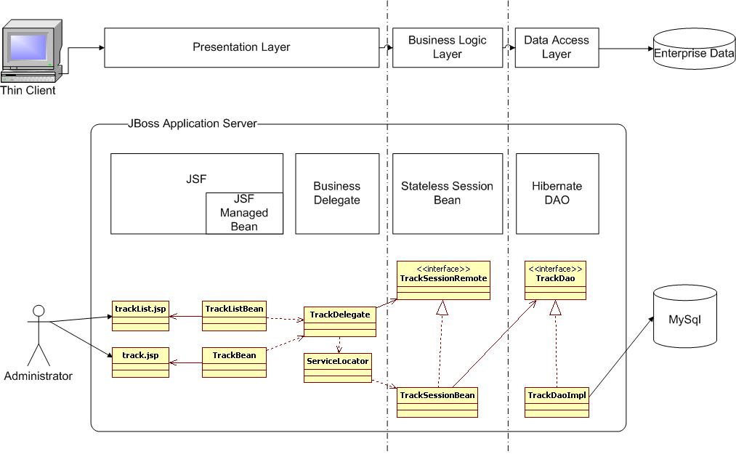
Figure II

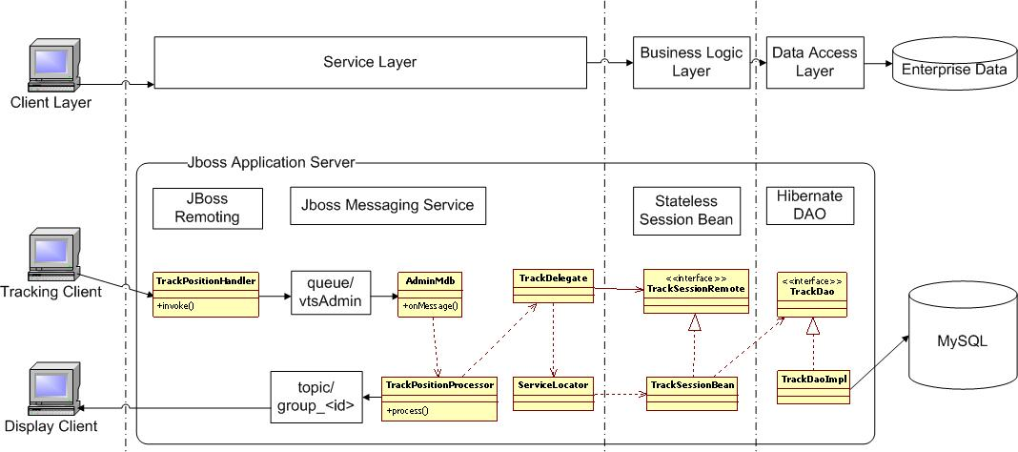
Figure III

Clients
VTS contains two functional clients – the Tracking Client and the Display Client.
The former is like a message publisher, as it continuously sends position data to the server. In fact, there are two major threads running inside Tracking Client:
- The thread of reading position data from GPS data. This thread is managed by RXTXComm, which periodically invokes a listener to process the position data it reads from the GPS device.
- The thread of sending the data to server. The reason to start a new thread for this is to ensure some messages could be sent to server even if the GPS device connection is not established, for heartbeat purpose.
Figure IV below highlights the major classes in these two threads. “GpsReader” and “CommReader” are to read the GPS data; “TrackingMessageThread”, “VtsApiSocketImpl” and “Client” are to send the position data.
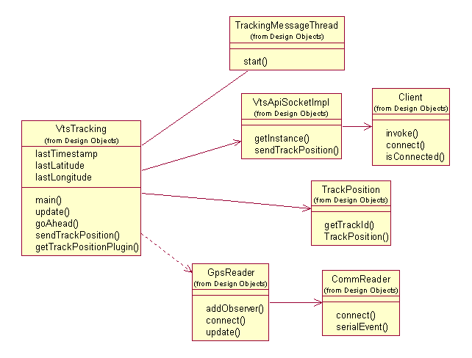
Figure IV
The Display Client is both a publisher and subscriber. It establishes a consumer for each of the groups of the login user, which means one Display Client may be subscriber of more than one topics. As mentioned before, the actual message receiver at client side is the JBoss Client. The following diagram show the structure of client side message consuming.
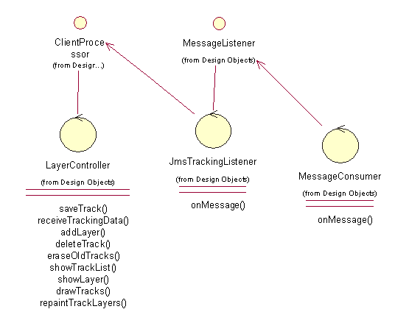
Figure V
To process more types of messages, in most cases, adding more message processing methods to “ClientProcessor” is sufficient.
Both Display and Tracking clients support plugin to allow extended tracking features. The implementation of Tracking client plugin is a simple strategy pattern. The plugin need only implement “CustomTrackPositionPlugin”. The Display Client plugin is a builder pattern, and Figure VI shows the detailed structure. The plugin need implement “TrackScreenBuilder”, right now there is an existing default implementation of this interface.
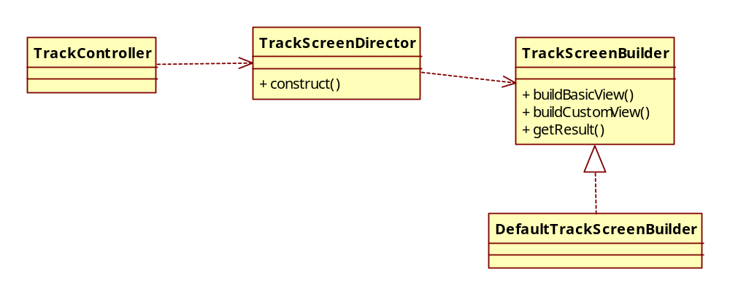
Figure VI

Security
As the position data and other sensitive information will be sent over network, it’s necessary to ensure the security of transported data.
VTS protects the communication via TLS / SSL. The backend server keeps the privary key, and the public key will be distributed together with the installation package of clients.
At server side, this is basically an SSL enabled socket server configure in JBoss Remoting; at client side, this is taken care by JBoss Client.
The development effort is mainly at configuration and setting system properties.

Performance
A load test class was specially developed for testing the system performance. This class simply simulates a number of Tracking Clients and sends track position data to the server concurrently.
The possibility of open source load test tools was explored, like Jmeter. But the integration issue with VTS is quite outstanding, a clean and comprehensive solution over thirty party is yet identified.

Project Milestones – Actual vs Planned
The table below shows the comparison between the planned milestone completion dates against the actual dates of the milestone completion.
 | Milestone | Planned Date | Actual Date
 | Management and Administration
1.1 | Project kickoff | 13/2/2010 | 13/2/2010
1.2 | Set-up filing system | 20/2/2010 | 20/2/2010
1.3 | Complete Project Plan | 20/3/2010 | 20/3/2010
1.4 | Complete Quality Plan | 27/3/2010 | 27/3/2010
1.5 | Setup Respository Enviroment | 20/2/2010 | 20/2/2010
1.6 | Complete End of Project Report | 8/1/2010 | 8/1/2010
 | Requirements Identification
2.1 | Complete User Interface Specification | 13/3/2010 | 13/3/2010
2.2 | Complete Technical Feasibility Study Report | 13/3/2010 | 13/3/2010
2.3 | Complete User Requirement Specification | 27/3/2010 | 27/3/2010
 | Functional Specification
3.1 | Complete Use Case Realization Report | 17/4/2010 | 24/7/2010
3.1 | Complete Functional Specification | 15/5/2010 | 7/8/2010
 | High Level Design
4.1 | Complete Transition Strategy | 22/5/2010 | 31/7/2010
4.2 | Complete Software Architecture Document | 22/5/2010 | 31/7/2010
 | Prototype Development
5.1 | Complete Prototyping Study Report | 10/7/2010 | 7/8/2010
 | Design Modeling
6.1 | Complete Design Document | 9/10/2010 | 23/10/2010
 | Programming
7.1 | Create Java code | 6/11/2010 | 6/11/2010
 | Systems Testing
8.1 | Complete Systems Test Plan | 16/5/2010 | 14/8/2010
8.2 | Complete Systems Testing | 27/11/2010 | 27/11/2010
 | Documentation
9.1 | Complete/Issue User Guide | 11/9/2010 | 18/9/2010
9.2 | Complete Installation Guide | 25/9/2010 | 25/9/2010
 | User Acceptance
10 | Complete Acceptance test plan | 28/8/2010 | 4/9/2010
10 | Install System | 27/11/2010 | 27/11/2010
10 | Perform User Acceptance Test | 25/12/2010 | 4/1/2011

Evaluation

Project Delivery
The initial project schedule had a very tight set of deadlines. The scedule was based on a very optimistic view, and had placed great confidence that all the team members would be able to commit their time to the project.
However by the second phase of the project, the project had already encountered overruns in the schedule. The overruns were attributed to a number of factors, which combined to form the huge delays in the schedule.
Firstly, the initial schedule did not cater sufficient buffers for delays in the projects. The schedule was done expecting that all the member would be able to commit their time to the project. But as the project progressed, some of the team members had to divert their attention from the project due to other personal commitments, and this caused delays in the schedule. Also. as the majority of the team did not have sufficient domain knowledge in the field of vessel tracking, the Functional Specifications of the system took much longer than expected to produce.
After encountering the delays during the second phase, the schedule was revised for the third phase to cater for a more realistic timeline. With the revised timeline, the team still encountered minor delays, but was eventually able to complete the system.
In spite of the delays encountered, the team was able to come out with a system that was able to meet the requirements. Having weekly meetings allowed the team to work closely and react to any issues that may have occured during the course of the project.

GeoTools
The system was tested using a simulator to load it with inputs from up to 100 Tracking Clients, with updates once every 5 seconds. While the Information Centre was able to handle the load from the tests, the map display on the Display Client started to flicker once the number of simulated Tracking Clients reaches 50.
The flickering of the map display was attributed to the performance issues of the GeoTools API used – the current version of the API could not render the display fast enough for large numbers of tracks that are constantly being updated.
Being open source, GeoTools has a huge advantage over commercial GIS APIs in terms of pricing. However, its rendering performance for fast updating tracks is still not good enough. Furthermore its documentation is also lacking – the website does not offer much help in the use of the APIs. These should all be taken into consideration when considering GeoTools for map visualization.

Conclusions and Future Work
The team has successfully completed the project , and in the process, has shown how open source software can be used to implement a vessel tracking system.
Through the delays encountered during the project, the team has realised that it is not good to plan the project schedule with the assumption that work will also be completed as planned, without any delays. Sufficient buffers should be always included in the schedule to cater for such unexpected delays.
With the basic vessel tracking features completed, future developments for the system could be to include other more advanced analysis features, such as performing data analysis on the information stored on the Information Centre. The Display Client can also be ported over to handheld devices, to allow mobility for the users.

