End of Project Report
FOR
Volunteer Management System
(VMS)

CLIENT | The Client
PROJECT | Volunteer Management System (VMS)
TITLE | End of Project Report
ADVISOR | Robert Firth
VERSION | 1.0
DATE | 07 Jan 2012
TEAM | SE 18 Team 08 Saturday

Members | Matriculation Number
Feng Yan | A0065905
Hnin Nu Aye | A0005937
Jiang Jifa | A0065734
Liu Peishan | A0065963
Phung Kim Cuong | A0065998
Thida Khin Myo Thaung | A0005954
Zaw Htet | A0065880

Abstract

This report is to give a comprehensive overview of the Volunteer Management System (VMS) project delivered by the SE18-T08S team. The VMS system is the project’s deliverable for our initial client, Gawad Kalinga, a Non-Government Organization (NGO) which unites government, corporations and individual volunteers from different parts of the world to eradicate poverty in The Philippines and other neighbour emerging countries.
The report starts with the introduction about the backgrounds and the high-level business requirements which form the context of the project. Consecutively, report explains the team’s development methodology as well as the project management strategy that helps in delivering the project. In this project, Rational Unified Process methodology and Waterfall development strategy are in used.
Subsequently, the team’s design consideration and the justifications for these choices will be discussed in details in Section 3 – Project Development, which cover various SDLC phases such as Requirements Gathering, Analysis and Design, Implementation and Testing. Certain challenges faced by the team and how the team has overcome these challenges are also elaborated in the reports at Section 4 - Evaluation. Finally, in Section 5, the team conduct an overview of how the team have performed in the project and recommend several future recommendations for the project.

Table of Contents

1. Introduction 4
2. Background 4
2.1 Business Context 4
2.2 Technical Background 4
2.3 Project Management 5
3. Project Development 5
3.1 Requirements and Planning Phase 5
3.2 Analysis and Design Phase 6
3.3 Implementation and Testing Phase 10
4. Evaluation 12
5. Conclusion 13

Introduction
The project is to build a quality software product for Gawad Kalinga, a Filipino based Non-Government Organization to manage its large and growing volunteer base of thousands of members. The system is an integrated Web-based portal that is capable of performing Project Management, Volunteer Management and Reporting tasks. The final product should be able to efficiently solve the current problems of volunteer recruitment and retention, project communication, and project status tracking via a user-friendly Web-based interface.
In order to achieve the mentioned deliverables, our team performs requirements analysis and risk estimation that lead to the decision to follow Rational Unified Process (RUP) for this product development. With RUP, the project life cycles are more predictable and the quality of the final output is more guaranteed. The whole project is split into 3 phases: Requirements and Planning Phase, Analysis and Design Phase, and finally Implementation and Testing Phase.
On a high level architecture, the system is built on modular and component-based. It consists of 3 layers: data layer, application layer, and presentation layer. As a matter of fact, an object oriented programming language, with a free open-source database and an open-source web server is used as they allow the team to obtain maximum portability and minimize the costs of development.

Background

Business Context
The client, Gawad Kalinga (GK), is a Filipino based Non-Government Organization (NGO) that focuses on community building and poverty eradication in The Philippines and other developing countries in South East Asia. Founded in 1995, Gawad Kalinga has successfully built up more than 2000 communities for the poor in The Philippines, providing them with permanent accommodation, livelihood and education.
However, Gawad Kalinga great success and its fast development couple with the severe operational challenges to manage its growing volunteer base of thousands of members from all over the world. At the time we started the project, the organisation was using its old manual volunteer registration process, paper-based status tracking and there were no formal reporting tools. The situation resulted in operational inefficiency and hindered the organisation’s growth. Understanding the business requirements, the team initiated the Volunteer Management System (VMS) project in order to develop a unified, centralized system to facilitate Gawad Kalinga in coordinating and managing its projects and volunteers.
Furthermore, through interview with several other NGOs, we found out that many of them do not have a formal VMS system and they plan to adopt one in near future. Because of the similarity in the nature of volunteer management among different NGOs, our product has a wide potential application and customer base.

Technical Background
Acknowledging the growing popularity of Internet-enabled devices and the related Web-based technology, our team decides to build the system with a Web-based interface which can provide the maximum outreach to the potential pool of volunteers. Thanks to this system, the NGO will not need to ask users to install or download separate application while still able to allow its staff to access the system from anywhere at any time. In short, a Web-based system will help Gawad Kalinga in optimising its business process of coordinating voluntary works.
Furthermore, understanding the budget limitation from a charity organisation, the team decides to build the system using total open-source platform that minimizes the total cost of ownership while maintaining maximum quality. Therefore, the System is built using the object-oriented programming language – Java 6, the popular database management system – MySQL 5 and JasperReport for reporting. The team also make use of free and high quality frameworks – Spring 2.5 and Hibernate – to facilitate the development process.

Project Management
The project is set to finish in about 11 months. To kick off the project, we form the organisational structure with one appointed Project Manager, one Quality Manager, one Technical Lead and four other members as Developers and Business Analysts. The assignment of role and responsibility is conducted based on the project’s needs and each individual’s levels of capability, availability, commitment as well as passion.
By studying the scope of requirements, the team skills set, the capability level of each resource, the Project Manager understand that the project should follow Rational Unified Process with Waterfall SDLC, which splits the whole project into 3 major phases:
- Requirements and Planning: to form the baseline of requirements, to define initial project plan, and to construct the project quality plan.
- Analysis and Design: to analyse the requirements and provide the high level design of the system, to develop and study the prototype in order to verify the feasibility of the chosen strategies.
- Implementation and Testing: to develop the actual system and to conduct necessary quality management activities to ensure a quality product.

Project Development
By applying RUP methodology and Waterfall SDLC, the project is split into 3 phases with the major deliverables as follow:

Requirements and Planning Phase
The Requirements and Planning Phase consists of activities to define the scope of user’s requirements, determine how to manage the project risks (if any) and fully plan-out the project.
In this phase, the team forms its organisational structure by appointing members to different important roles of Project Manager, Quality Manager, Technical Lead, Business Analysts and Developers. Two Business Analysts are in charge of gathering User Requirements. Furthermore, User Manager, Project Manager, and Quality Manager are in charge of producing the following deliverables:
- User Requirement Specifications: this is the final set of requirements that states the expected functionalities of the system as well as the related operational and non-functional requirements for the final product.
- Project Plan: this document defines the strategy for the project team to successfully produce all required deliverables. The team uses Function Point Counter (FPC) and COCOMO software to estimate project’s duration of 11 months with over 524 man-days.
- Quality Plan: this document defines the methods and procedures that the team must follow throughout the projects. It serves as the quality guideline and checklist for the team, and provides evidence of compliance for auditing purposes. The Quality Plan emphasizes on the importance of compliance and auditing evidences in order to deliver a quality product. Quality Manager guides the team on how to stay complied with the Quality Plan and how to produce quality management artefacts.
Close to the end of the first phase, the client indicated that they might not want to continue with the current scope of the system since they had already triggered implementation of a similar system in their head quarter in the Philippines. The team then consulted the project assessor and estimated the risks of changing project scope; after all, it is decided that the team should go on with the original set of user requirements, appoint one member as the putative User Manager while still continue to look for other potential customers.
At the end of this phase, the team went through the first audit meeting with the project assessor to validate and ensure the deliverables were up to the standards defined in the Quality Plan. In general, the deliverables complied with the quality procedures defined in Quality Plan and the met original requirements. However, there are small leftovers that need to be pursued and resolved in subsequent phases. It was documented and recorded in project meeting minutes.

Analysis and Design Phase
After the Requirements and Planning Phase, it was realised that the team need to produce a prototype to test various aspects of the to-be-built System, which include usability research and technical feasibility analysis. Therefore, the team carried out these following tasks:
- Produce a prototype based on initial User Requirements Specifications.
- Perform Prototype demonstration to the putative User Manager to gather feedback and more inputs on usability.
By finalising the URS, the Application Architecture Overview is specified:
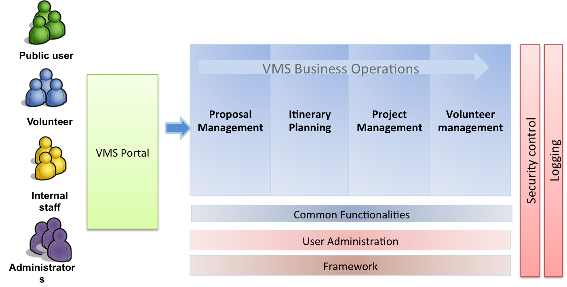
Figure 1 – Application Architecture Diagram

Subsequently, the Technical Lead, Development Lead and Quality Manager finalise the design choices and design considerations as in the following table:

Design item | Technology used | Design consideration / Rationale
Client | - Internet Explorer 7, Firefox 4.0 and later | - To produce a web-based system that support most popular browsers (up to the point).
Web layer | - Apache Web Server 2.2  - Sitemesh  - JSTL  - DWR | - Sitemesh, JSTL, DWR are both flexible and versatile technology that are proven in the industry.  - The technical lead and majority of other team members already had few years of experience working with those technologies.
Application layer | - Spring MVC Framework  - Hibernate Framework  - JasperJorge (iReport and JasperReport)  - Apache Tomcat | - Spring MVC Framework and Hibernate Framework are two most popular frameworks that can fully support the development cycle with proven quality and predictable result.  - JasperReport and iReport are also popular and proven products/technologies that can help in reporting.  - Apache Tomcat was chosen over other App Server because it is lightweight, flexible and more stable. Furthermore, the technical lead is also more familiar with Apache Tomcat since he is using it at works. The prototype also proved the ease of deployment and maintenance on Tomcat.
Database layer | - MySQL 5 | - MySQL is a popular and open-source RDBMS which is just suitable for the development platform. It offers both versatility and durability that meet the team requirements for development.
Table 1 – Design choices and consideration
The above design considerations are combined in the technologies stack to form the high level software architecture of the project:
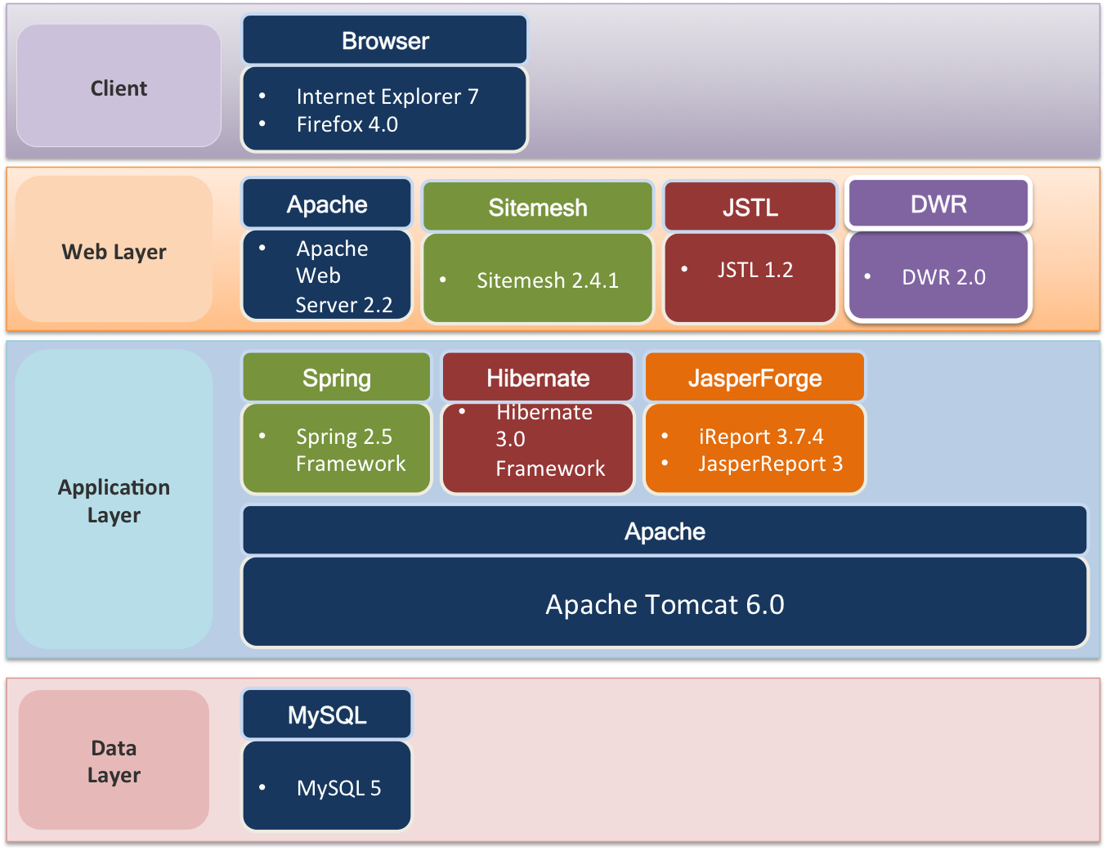
Figure 2 – High level software architecture
Similarly, the chosen technologies are combined and form the logical application component viewpoint as the following:
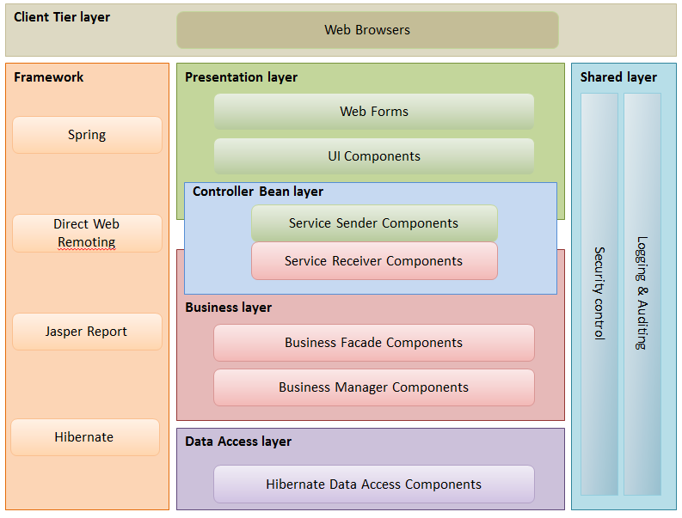
Figure 3 –Logical application viewpoint
In the logical application design, the shared layers such as Security and Common Utility (Logging & Auditing) will cater for all tiers across the system. This is to support the code reusability and to follow the DRY (Do not Repeat Yourself) principle.
In addition, the overall Use Case Model Survey and Use Case Realisation Report (Analysis) are created to capture the use case flow and object model for each use case. In total there are 20 use cases captured in UCMS.
Finally, the Project Manager requested the Technical Lead and Development Lead to define the High Level Design Specification that captured and explained the following points:
- High level software/hardware architecture
- Overview of technologies and tools to be used in development phase
- Project Source Code Structure setup
- Guideline for development in Presentation, Business Logic and Persistent Tier
- Guideline for other tools and utility used in development (JasperReport, Ants)
- Guideline for convention and other best practices
At the end of this phase, the team meet again with the project assessor to go through the second audit to confirm that the design considerations are appropriate. The outputs of this phase are the following deliverables:
- Functional Specification: include the Use Case Model Survey and Use Case Realisation Report (Analysis) for each use case.
- High-level Design Specification: include the proposed software/hardware architecture for the development.
- Prototype Study Report: present the study based on the prototype to analyse the technical feasibility and usability of the final product.

Implementation and Testing Phase
Development process
Implementation and Testing Phase kicks in as the last development phase for the project. As advised by the project assessor and according to the Project Plan, the team have performed the following activities:
- Define the Software Configuration Management (SCM) Procedure, with the help of SVN and Eclipse SVN plugins to facilitate the development team.
- Design the Detailed Use Case Realisation Report (Design), one for each use case.
- Review the UCRR (Design) to confirm the correctness of such diagrams and flows.
- Define the development and integration strategy that revolves around the inter-dependence and importance of modules. The building order is as follow:

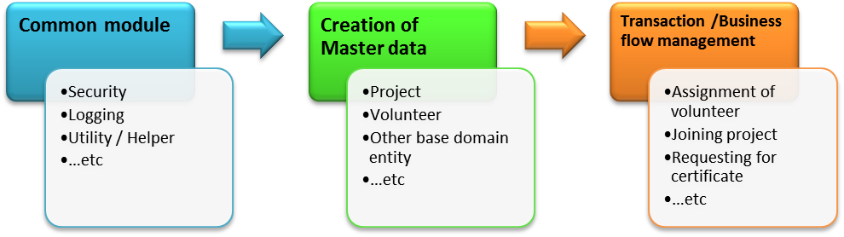
Figure 4 – Order of development

- Perform actual code development, at the same time conduct code walkthrough, peer-review to ensure correct understanding and implementation at unit code level.
Challenges and solution
During development phases, the team has faced 2 notable challenges:
- The development of inter-dependent modules: Volunteer Management, Project Management and Infrastructure Facilities (email, logging, reporting).
- Changes in the original user requirements: de-scope some use cases while adding new requirements
To handle these challenges, the Project Manager works with Technical Lead and Quality Manager to perform these following:
- Defining tasks dependency network to prioritise tasks
- Review the changes in user requirements; decide whether the changes are applicable. If applicable, perform necessary reviews in User Requirements, UCRR (Analysis) and UCRR (Design) before perform actual code implementation.
Quality Assurance
In this phase, the Test Manager, Technical Lead and Project Manager coordinated and d
efined the test cycles, with all related testing activities such as entrance criteria, exit criteria, and deliverable KPI. For System Integration Test, the team setup the test environment; prepare the test data, define the test cases that based on the User Requirement Specification and the Functional Specification.
The testing procedure in the SIT is as follow:
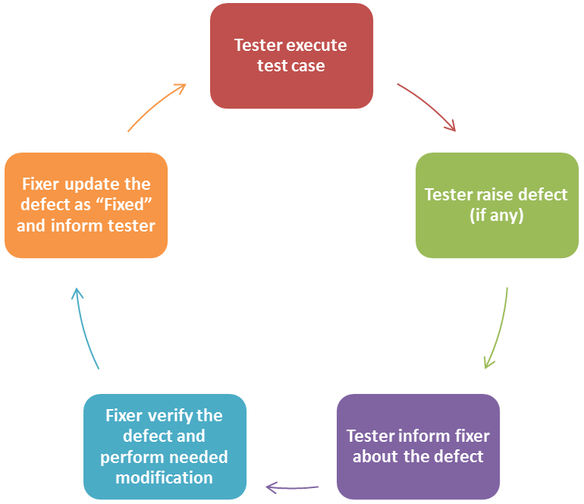
Figure 5 – Testing cycle

When the test results meet the exit criteria and are considered ready for final phase, the Test Manager informs the Quality Manager and Project Manager about the quality of the project. By that time, the PM and QM decide that the project have met the final exit criteria, thus the team has successfully deliver the project according to the Project Plan and Quality Plan.
The overview of test results is as followed:

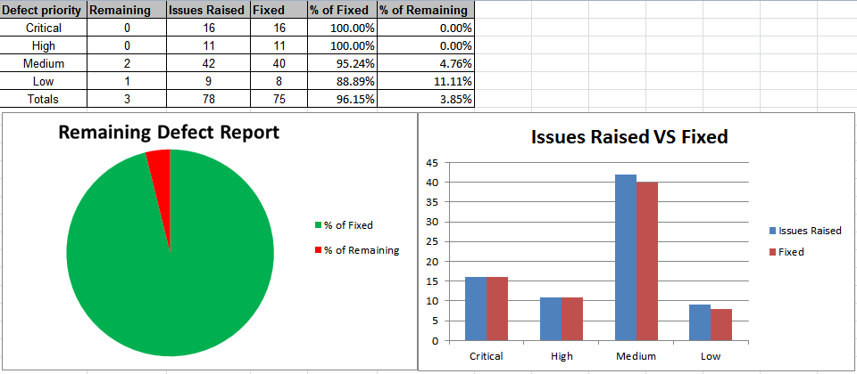

Figure 6 Overall test result

Evaluation
Throughout 11 months working on VMS project, the team has conducted 3 phases: Requirements and Planning, Analysis and Design, Implementation and Testing and delivered the required deliverables.
Over these phases, the most notable challenge is the missing of an actual user. This issue poses many difficulties on defining actual User Requirements as well as to follow the pre-defined activities such as User Acceptance Test or User Sign-off. However, the team has actively appointed one member to serve as a representative User Manager. Meanwhile, the team has also progressively sought out for potential customer of the product.
Since the beginning of the project, the team has understood the importance of defining the comprehensive and exhaustive sets of SDLC processes, guidelines and quality control mechanism to ensure the successful deliverables of the final product. Those artefacts include Project Plan, Quality Plan and all Design documents. They served as benchmarks and checklists to perform the subsequent activities.
In general, the team has strictly followed these mechanisms, from creating meeting minutes, performing documents review to auditing / tasks verification. The Quality Manager proactively managed and controlled the whole process with her extensive experience in Quality Management. It is proved by the fact that the final product passes 100% number of test cases with no critical and high priority bugs.
Product’s quality is prioritised and emphasised by the team since the beginning of the project. We strictly followed the Quality Control mechanisms. For example, every release document must be reviewed, every task must be audited, and every meeting must have detailed meeting minutes.
However, due to the time constraint of each project member, at the end of the project phases, there are several defects left over on the final deliverables such as remaining medium and low priority bugs. It is also noted that due to lack of business background and domain knowledge, the Functional Specifications still contains drawback and certain use cases are less applicable in actual context. Finally, not all of the Project Management processes were aggressively pursued and enforced. Due to the nature of remote team where certain member is not able to meet up for status reporting or project meeting, there were times when the team members were not aware of current status and what needed to be accomplished by certain time line. The Project Manager could have done the tasks better by closely following and actively engaging the team members to perform status report for the tasks on his/her hands.

Conclusion
After more than 11 months, the team has successfully delivered the project that meets the requirements and design specifications. The overall quality of the system also meets the exit criteria defined in the Test Plan and Quality Plan. The final output is proved as a capable system which can be adopted by any voluntary organisation to coordinate and manage its operations and volunteers.
The product has potential wide application. Several initial surveys with different NGOs shows that many developed NGOs do not have formal volunteer management systems. Given the similarity in the needs of different NGOs, the project is hence scalable as it is flexible enough to serve the needs of each NGO. With our modular system, one can easily extend and improve the functionality of the current system with minimum efforts and costs.
This year-long development project has emphasised the importance of continuous commitment and progressive development in meeting deadlines and the targeted quality. A lesson learnt is that the overall project development processes could be improved if the team employed more regular checkpoints or status reports. The Technical Lead and Development Lead could even consider the combination of Scrum and Agile SDLC into the Implementation and Testing phase in order to cope with the possible changes in the requirements.
In conclusion, the team has demonstrated well that with appropriate processes are defined, proper control and management mechanisms are followed, we have delivered a quality product that fulfils the business requirements and possesses much potential usage within the similar business context.

Acknowledgement

We would like to sincerely thank and show heartfelt gratitude to our lecturers and supervisor at ISS who have been giving us these challenging and intellectually intriguing challenges. Thanks to their valuable lessons and experience, we have been able to successfully complete our project and accomplish our year-long goals.
We would also thank Gawad Kalinga Foundation who has inspired us and provided us with insights and useful information to serve as the crucial inputs for our system designs.
Furthermore, our gratitude is for our beloved ones including family and friends who have provided great supports over the year. We would have not been able to finish the journey without their constant encouragement and special understanding. This list includes many others people who supported us throughout the year in one or another way
And last but not least, thanks our dearest team for the past year. Throughout the year-long journey, we have worked side-by-side to perform lots of hard-work and sometime even scarifying personal commitments to devote time for the project. We have demonstrated that the combination of youth, energy, positive attitude, determination and professionalism is a perfect recipe to overcome any challenges.

Bibliography

[1] Erich Gamma, et al., “Design Patterns: Elements of Reusable Object-Oriented Software”, Addison-Wesley, 1994, pp. 24-88.

[2] William Fox, Gerrit van der Waldt, “A Guide to Project Management”, Juta and Company Ltd, 2008, pp.12-35.

[3] Len Bass, et al., “Software Architecture in Practice” second edition, Addison-Wesley, 2004, pp. 19-45.

[4] Walter Isaacson, “Steve Jobs”, Amazon Pte. Ltd., 2011.

[5] Spring Framework 2.5 Manual, SpringSource,
Retrieved from http://static.springsource.org/spring/docs/ on May 2011.

[6] Apache Tomcat 6 Manual, Apache,
Retrieved from http://tomcat.apache.org/tomcat-6.0-doc/ on May 2011.

[7] Hibernate 3 Manual, JBoss Community,
Retrieved from http://www.hibernate.org/docs on May 2011.

[8] Java 6 manual, Oracle,
Retrieved on http://docs.oracle.com/javase/6/docs/ on May 2011.

