4. Contract Formulation and Negotiation 2
4.1 Contract Types and Essentials 2
4.2 Formulate the Contract 15
4.3 Negotiation Technique 30
4.4 Negotiate the Contract 38
4.5 Perform Final Review of Contract 54
5. Contract Execution and Management 56
5.1 Project Kick-Off 56
5.2 Manage the Transition 59
5.3 Work with the vendor 67
5.4 Manage the Progress Reporting Process 69
5.5 Analyze and Assess Vendor Performance 74
5.6 Quality Management 83
5.7 Manage Service/Product Delivery 85
5.8 Deal with Non-Conformance 87
5.8 Deal with Non-Conformance 87
5.9 Dispute Resolution – (completed in previous section) 89
5.10 Manage Change 89
5.11 Negotiate with the Vendor 92
5.12 Manage Risk 93
5.13 Assess and Manage the Relationship 95
6. Contract Termination and Migration 97
6.1 Plan for contract Completion and Termination 97
6.2 Manage contract completion and termination 101

4. Contract Formulation and Negotiation
This module provides some basic knowledge on contracts and the strategy of formulating the right contract for the outsourcing scenario. It also discusses how to negotiate the best terms while recognizing the need to remain focused on the primary objectives.

4.1 Contract Types and Essentials
Contract Strategy

Before you embark on developing the contract between your organisation and the vendor, you have to revisit the objectives and strategy for outsourcing:
- Is it desirable to build a long-term relationship with the vendor?
- Is the objective to select the “best” vendor?
- Is the objective to select the “cheapest” vendor?
- How important is domain knowledge and expertise?
- Is the contract for an “independent” vendor or merged teams?
Based on this information, you can probably devise a strategy to determine what kind of relationship you want to build with the vendor, and therefore, the kind of contract you want to sign with the him/her.
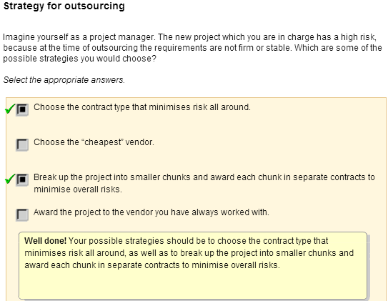
Types of Contract

Introduction
Different contract strategies will drive the contract type to be used, which carries different risks that needs to be managed. For example, some contract type would require you to monitor and measure performance closely to ensure high quality.

Based on payment arrangements, the four common types of contract are:

Fixed Price Contracts
In a Fixed Price Contract:
- The requirements in the RFP have sufficiently detailed technical information
- The price for all deliverables are fixed at the time of contract signing and the vendor is bound to it
- Any changes to the original contract must be preceded by a change request and additional charges may be justified
- Partial payments are made at defined or negotiated milestones
- Most of the risk are borne by the vendor
- Usually the vendor would determine the amount of risk and the bid is inflated to account for the risk
- Best used when
  - Requirements are clearly defined
  - Changes can be kept to minimum
  - Competitive pricing is an important
consideration
Time and Materials Contracts (I)
In cases where the RFP requirements are still unclear or are confusing or technology is new, vendors will have to either not bid, or bid very high to cover any contingencies that may occur. This is not advantageous to both the client and
the vendor. In these situations, a Time and Material Contract
may be suitable.

A Time and Materials (T & M) Contract is the opposite of a
Fixed Price Contract. Some of its features are:
- Vendors will provide a rate (normally daily or monthly)
and estimate the time and materials needed
- Rate would normally cover all overhead costs,
as well as the fees
- Reimbursement for items such as overseas calls,
transport cost, overtime may be on actual or separately
quoted in the contracts.
Another variation of the Time and Materials Contract is the Time and Material Plus Fixed Fee (sometimes also call Cost Plus Fixed Fee). The Fixed Fee is often used if there is a need to reimburse the vendor for some indirect fixed cost, such as project management fee.

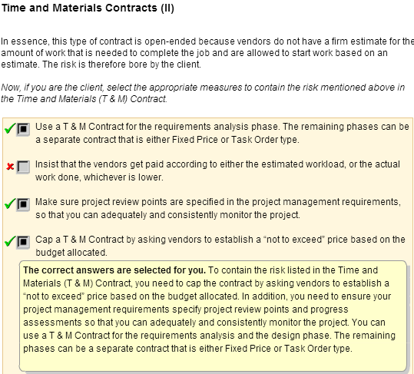

Cost Plus Award Fee Contracts (I)

For this type of contract, payments to vendor are made up of two components:
- Direct Labor and indirect cost (overhead, actual work performed, etc.) make up the bill rate, with other direct costs such as materials, hardware and software separately quoted
- Award fee, which is negotiated at the beginning of the contract
Award fee is directly tied to vendor’s performance. The vendor may
therefore only receive a portion of the fee if he fails to meet
all the conditions stated in the contract. If the vendor’s
performance is of an unacceptable level, all or portions
of the fee could be permanently withheld.
Hence, this type of contract provide the motivation for the vendor to:
- give you better, qualified personnel
- meet the key requirement you specify to be tied to
the award fee
However, you will need to specify project review points and progress assessments so that you can adequately and consistently monitor the project.Although the cost of such project tends to be higher, it is a better option than having a fixed price contract with Penalty Fee.

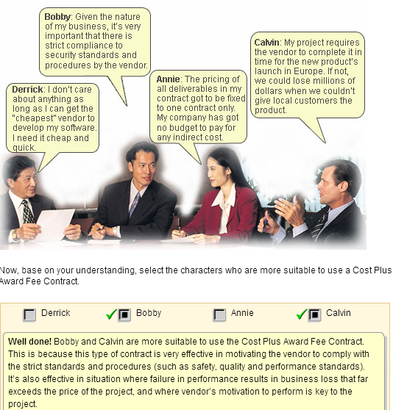
Task Order Contracts
In a Task Order Contract, the contract is broken down into smaller, manageable tasks or components,which may use any of the previous contract types for payment. This type of contract allows you to use the best methods to contractually manage your vendor. It is often used when client’s needs are composed of a series of small, independent development projects of varying complexities. These require a great diversification of skills. Below is an example:

Other types of contracts

Depending on the relationship that is to be developed with the client, other types of contracts may also be signed. A good example is a Joint Venture agreement that stipulates how revenue, cost and profits are to be shared, as well as how contribution of manpower, role and responsibilities are to be allocated.
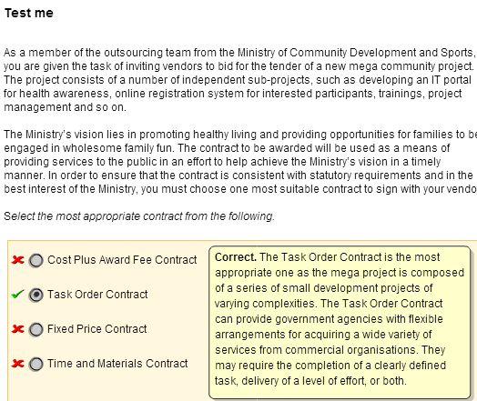
Essentials of IT Contracts
Understanding contract law

It is important for all project managers involved in outsourcing to have an understanding of contract law and the contract for the following reasons:

Drafting Stages
At the drafting stage, while a solicitor can (and must) be engaged to draft the contract, it does not necessarily mean that the client is well protected. This is especially so in an area such as outsourcing, which is relatively new and highly technical in nature. The client must analyse the contract, especially in relation to technical matters, to see if his interests are fully protected.

During Operation
Once the contract is drafted and is in operation, the contract may have to be referred to time and again to ascertain the rights and duties of the parties, and hence, it is necessary for the parties involved to have a good understanding of the contract and the law.
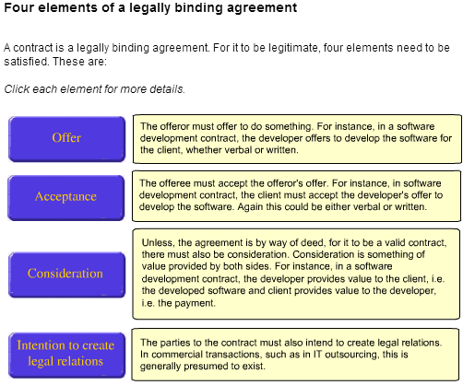
The need to put it in writing

If the four stated elements are present, there is a valid contract. Generally, there is no further requirement that a contract be in writing. However, if the contract is not put in writing, there will be little evidence as to what the parties actually agreed to and the only way to resolve such a problem might be to take out legal proceedings. This may be time consuming and expensive.

Terms of the contract

The terms in a contract can either be express terms, implied terms or exclusion clauses.
Express terms
These are the terms that are clearly, written out, stated in contract period. Parties are basically free to agree to whatever terms they want to, unless they are against public policy or illegal. In the context of IT outsourcing, as stated above, it is best that all terms are expressly agreed to in writing.
Implied terms
In addition to express terms, a contract usually contains implied terms. For instance, in a sale of goods contract, there is an implied term (by virtue of the Sale of Goods Act) that the goods sold must be of merchantable quality and fit for purpose for which they were bought.
Hence, where a hardware is being purchased, there is an implied term that the hardware be of merchantable quality and fit for the purpose for which it was bought. In relation to software, it is not entirely clear if software can be described as "goods" and whether software can be "sold" as it is usually only licensed.
Thus, in relation to software, it is crucial that the contract contains express warranties as to the quality of the software.
Exclusion clauses
Contract often contain exclusion clauses, i.e. clauses which try to exclude or limit liability. IT contracts are no exception. Clauses, which impose a limit on the amount of damages payable in the event of a breach or clauses which exclude liability for consequential losses such as loss of profits, are common in IT Contracts.
However, such clauses are not necessarily valid. Generally, under the Unfair Contracts Terms Act, for an exclusion clause to be valid it has to be reasonable. Whether a clause is reasonable, depends on various factors such as:
- The bargaining powers of the parties
- Which party could have taken out insurance to cover the loss more easily
- Whether the innocent party received an inducement to agree to the exclusion clause

Unfair Contracts Terms Act

However, it must also be pointed out that under the Unfair Contracts Terms Act, liability for personal injury or death cannot be excluded, whether or not the clause is reasonable. Thus, if a developer is engaged to develop a software relating to air traffic control, and due to a malfunction, which resulted in an accident causing death or physical injury, then liability for the loss cannot be excluded.

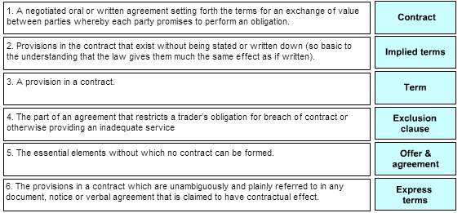

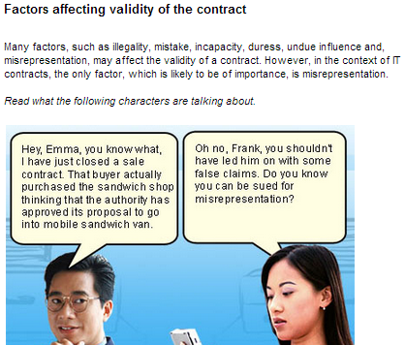
Misrepresentation

Misrepresentation is a false statement of fact which is not a term of the contract, but which induces the formation of the contract. Thus, a vendor in an IT outsourcing contract could have made all kinds of representations to the client in order to get the contract, which may turn out to be untrue. Under the Misrepresentation Act, there is a possibility of rescinding the contract and/or suing for damages where there is such misrepresentation.

However, IT contracts commonly contain an "entire agreement" clause, which will essentially state that the written agreement is to be treated as the entire agreement between the parties, superseding all previous representations and negotiations. If there is such a clause, then clients should make sure that all representations are put in writing and made as part of the contract.

Termination of the contract

A contract may be terminated in four ways.
Complete performance
Where the contract is completely performed, it comes to an end. Thus, if an outsourcing agreement is for two years, at the end of the two years, the contract comes to an end.
Mutual agreement
Generally, the contract can come to end by mutual agreement. Thus, in an outsourcing agreement which is to run for 2 years, the parties can mutually agree to terminate it earlier, or there could be a contractual provision to this effect.
Frustration
Frustration is the happening of an event after the making of the contract, which makes the further performance of the contract illegal, impossible or radically different from what was originally envisaged. In this regard, it may be pointed out that mere increase in prices or shortage of labour will not result in frustration. Thus, if a developer of a software agreed to develop a software for a particular fixed price, he cannot state that the contract is frustrated if the cost of developing the software goes up.
Frustration discharges the contract and the Frustrated Contracts Act specifies, what happens to monies paid before the frustrating event and monies payable after the frustrating event. However, since what amounts to frustration in law is limited, the parties may provide in the contract, events which will excuse performance. This is known as a "force majeure" clause.
Repudiatory Breach
If a party to a contract commits a repudiatory breach, the innocent party has the choice of terminating the agreement. What amounts to a repudiatory breach, is a question of fact. However, often, time of performance, or time of payment in a commercial contract, is seen as an important term and if it is not observed, this may amount to a repudiatory breach allowing the innocent party to terminate the agreement.
However, to make sure, it is best to state expressly in the contract that time of performance and time of payment is of essence (the vendor/developer will, of course, object to such a clause). Thus, if a client needs software by a certain date to launch a certain project and the contract provides that time is of essence, and this is not observed, the client may be able to rescind the contract.
Damages

When either party sues the other party for damages, it normally falls into two categories.
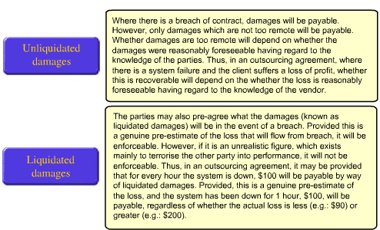

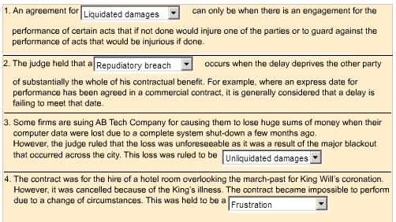
Non-Conformance
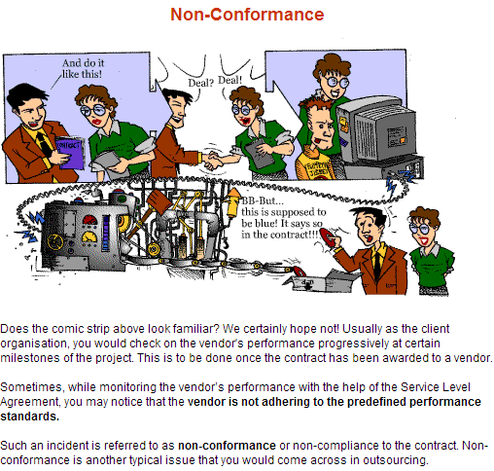
Penalty

Penalties are related to the poor performance of the vendor in meeting specific requirements as defined in the Service Level Agreement (SLA). It is highly advisable to include penalties that clearly state the cost to the vendor in the event of non-conformance.

But how do you determine penalties? There are several areas to consider when determining penalties:
- Cost of loss in productive time
- Cost of rework
- Cost of lost data
- Cost of lost business
- Indirect costs
Here's a sample of penalty clauses in a contract:

Importance of a Good Contract
Why a good contract is important

A study by Guy Fitzgerald and Leslie Willcocks of the Oxford Institute of Information Management (University of Oxford) found that most disputes in practice centred around:
- Failure of the vendor to meet service levels,
- Unclear contractual issues,
- Changing requirements and
- Unforeseen charges.
When asked if they would have done anything differently at the time of outsourcing, most of these organisations referred explicitly to:
- Tightening service contracts
- More detailed measurements and
- Making clearer what was covered by the contact and what was not.
Thus, it is absolutely important to have a well-drafted, tightly worded and detailed contract. Having said that, the following quotation from the a systems director in the above study is noteworthy:

" Basically we negotiated a tight contract and then put it to one side, which was the intention, so that we could run the thing as a partnership. But you've got to be protected"

4.2 Formulate the Contract
Identify and Define Roles and Responsibilities
Goal of defining roles and responsibilities

The task of identifying and defining the roles and responsibilities should cover not only the project team and the vendor's team, but also who will be responsible for the verification and validation of work. Also, it is important to identify the roles and responsibilities of any external parties, such as regulatory bodies.
The goal of defining the roles and responsibilities of the vendor and the client with respect to the proposed contract is to try to achieve a common understanding . Clearly defining such roles and associated responsibilities are critical for consistently and successfully executing the contract and delivering the service. It would also prevent disputes and aid dispute resolution where roles and responsibilities are not fulfilled.

Typical categories of client's and vendor's responsibilities

These are the typical client's and vendor's responsibilities. However, the responsibilities can be taken over by the other party depending on the requirements of the contract.
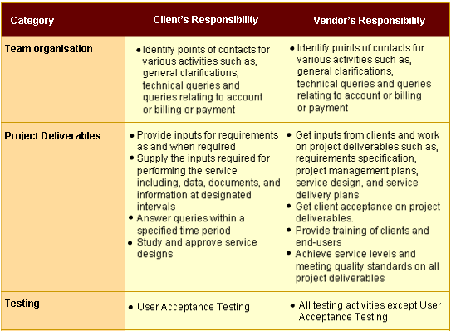
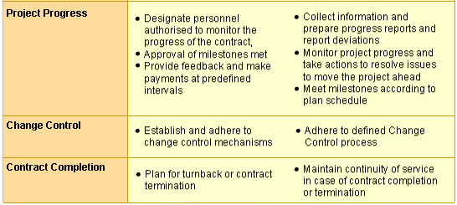
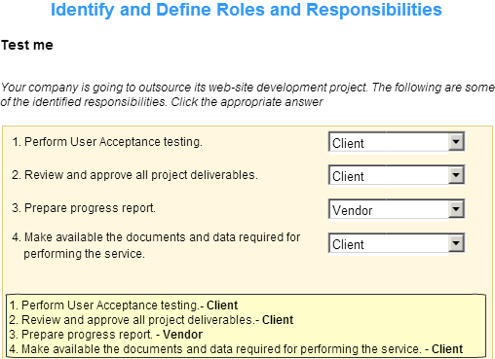
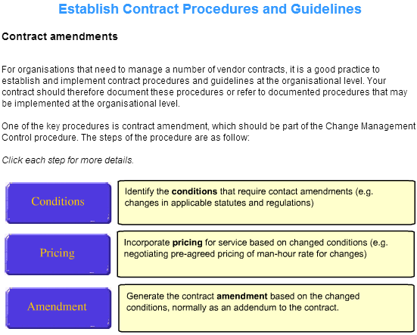
Dispute resolution and escalation process
This procedure in the contract should define how disputes should be resolved. Normally, disputes should be resolved at the level of the project managers (client and vendor). If the dispute cannot be resolved, it may be escalated to the level of the steering committee (comprising senior managers from your organisation as well as the vendor's). Very often contract also stipulates that arbitration or mediation should be used should all the above failed

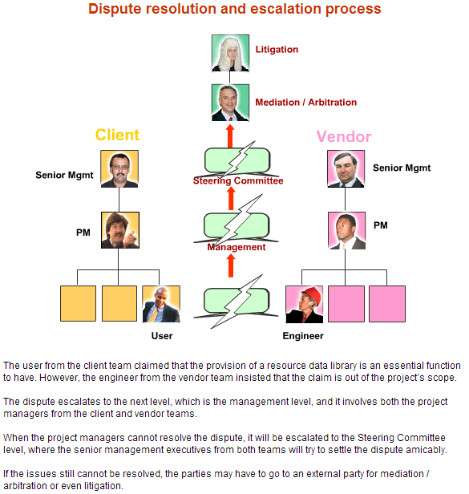
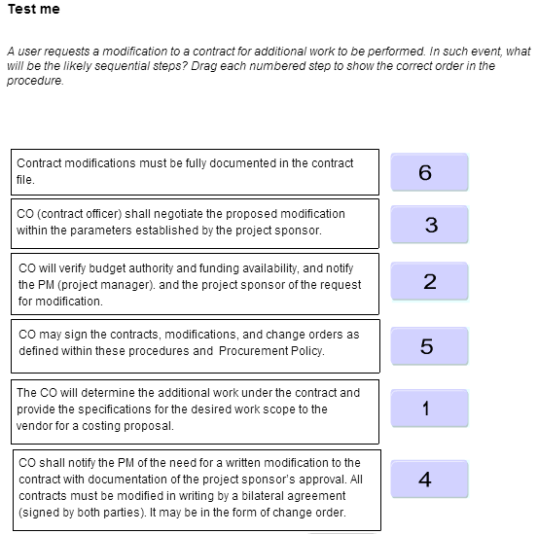
Develop the Outsourcing Contract

Using the SLA as a guideline, the outsourcing contract can then be developed. The contract should contain terms and conditions that are precise, so that they are clearly understood by both the vendor and the client.

The following can be used as a checklist while developing an outsourcing contract:
Click on each of the following sections for details.
- Services to be performed by the vendor
- Cost to be incurred
- Sourcing of the hardware
- Sourcing of the software
- Roles and responsibilities
- Warranty conditions
- Backup and disaster recovery procedures
- Exclusion of liabilities
- Termination procedures
- Turnback services
- Indemnity for breach of contract
- Confidentiality terms and conditions
- Force majeure clause
- Waiver in the contract
- Contract assigning authority
- Dispute resolution
- Payment of litigation/arbitration/other costs
- Governing law of the contract
The outsourcing contract is usually finalised after a few rounds of negotiations with the vendor.

The service levels of the services required as defined in the SLA may also affect the negotiation of the contract. You need to keep in mind that the service levels be reasonable and realistic. In addition to that, you as a project manager, should be well prepared to justify the contract document.
1. Services to be performed by the vendor
- What are the client's existing services that will be taken over by the vendor?
- What are the vendor's obligations in relation to the turnover?
- What are the new services to be provided by the vendor?
- Services to be excluded from the contract?
- Is there any implementation schedule for the provision of existing services, turnover and new services?
- What if there is a delay in providing the service by the vendor?
- If there is a growth in the client's business, will the vendor bear the cost of acquiring more software and hardware to perform the services?
2. Cost to be incurred
- How are the charges determined for the services to be provided by the vendor?
- When are the charges to be paid?
- Are the charges inclusive of any taxes?
- Does the vendor have the right to terminate when there is a delay in payment?
- Are there any provisions for variations in price?
3. Sourcing of the hardware
- Is the vendor acquiring hardware from the client?
- What is the price paid for the hardware?
- Does it include any taxes? If so, who will bear the cost?
- Whose duty is it to receive the delivery of the hardware?
- Is there any hardware maintenance contract?
- Who pays for the maintenance of the hardware? Should it be the vendor or should it be the client?
4. Sourcing of the software
- Is the vendor acquiring software from the client?
- What is the price to be paid for the software? Does it include any taxes?
- Who will take responsible for the delivery of the software?
- Is the client granting a non-transferable/non-exclusive licence?
- Are there any restrictions on the use of the software?
- Is the software that the vendor is acquiring to a third party software?
- Has the third party consented to the vendor using the software? If no, who pays for the cost of acquiring such software from other sources?
- Are third parties providing software maintenance/software support?
5. Roles and responsibilities
- Employees
  - Does the vendor require you to supply manpower?
  - What are the new job descriptions of the transferred manpower resources?
  - Can the vendor use your manpower on other projects?
- Project Managers
  - Who are the designated project managers from the client as well as the vendor's organisations?
  - Can the project managers who are once appointed, be changed?
  - How often and where should the meetings take place?
  - What authority do the project managers have?

6. Warranty conditions
- Are there any express warranties? For example, performance standards in relation to matters such as uptime/response time/output.
- What if there is a failure to meet the performance standards?
- Does it lead to termination or material breach?
- How are performance standards monitored?
- Any other warranties?
7. Backup and disaster recovery procedures
- Does the vendor have to provide for backup - especially in relation to the data?
- What is the frequency of back-up of dates for recovering purposes.
- Who owns the data and the media on which the data is stored?
- Is there any disaster recovery plan?
- Who bears the cost of providing for disaster recovery?
- Are regular tests to be done to test the feasibility of the disaster recovery plan?
8. Exclusion of liabilities

- Is there any exclusion of liabilities?
9. Termination procedures
- How long should the contract last?
- Is there any provision for the contract to be extended after the termination period?
- Is there any provision whereby the contract can be terminated earlier?
10. Turnback services
- Are turnback services triggered on termination?
- What are the vendor's duties in relation to the turnback?
- What is the hardware/documentation that can be repurchased by the client?
- What's the price of the hardware and the rate of depreciation to be taken into account?
- Should hardware maintenance contracts be reassigned?
- What are the software/documentation which shall revert to the client?
- Will the client get access to the software/ documentation that is used by the vendor to perform services to the client?
- What are the other terms and conditions? Can the client insist that the software be transferred to a third party who is subsequently going to provide the services?
- Should the vendor cease to employ the employees for a certain period of time after the termination?

11. Indemnity for breach of contract
- Does the vendor/client give an indemnity for breach of intellectual property rights such as patents, trade marks and copyright?

12. Confidentiality terms and conditions
- What are the responsibilities of the client/vendor in maintaining confidentiality of the IT activity?
- Is there any information that is particularly classified as confidential?
- Does this responsibility extend beyond the termination of the contract?
13. Force majeure clause
- Is there a force majeure clause?
- If so, what are the events?
- Is the contract suspended or terminated when the events occur?
- What happens to the payment made?
14. Waiver in the contract
- When is a party deemed to have waived his rights under the contract?
15. Contract assigning authority
- Does the vendor have the right to assign the contract?
- Does the client have the right to assign the contract?
16. Dispute resolution
- Is the dispute to be resolved by arbitration?
- Is there any prelude to arbitration?
- Can higher level officers or mediation resolve the dispute first?
- If dispute is to be resolved by arbitration, where is the arbitration to be held? Is the arbitrator named?
- What are the rules governing arbitration?

17. Payment of litigation/ arbitration / other costs
- Does the loosing party pay for all the costs during arbitration or litigation?
- What if both parties are partially at fault?
- Who bears the other costs?
18. Governing law of the contract
- What is the governing law of the contract?

Developing software contract
The following can be used as a checklist while developing a software contract:
Click on each of the following sections for details.
- Software to be developed
- Charges
- Delivery
- Installations
- Acceptance testing
- Warranty
- Maintenance
- Software
- Documentation
- Training and software support
- Project managers
- Exclusion of liability
- Indemnity
- Confidentiality
- Non-solicitation
- Termination
- Force majeure
- Waiver
- Assignment
- Dispute resolution
- Governing law
- Entire agreement
1.Software to be developed
- What are the specifications?
- Can specifications once given be varied - if so what is the mechanism?
- How are the charges for the variation to be determined - e.g. cost-plus?
2. Charges
- What type of fees to be charged - fixed lump sum or cost-plus?
- When is the fee to be paid - in stages?
- If in stages, what are the stages?
- When is a stage deemed to be completed?
- When is payment due - e.g. 3 days after invoice?
- What is the effect of delay in payment - interest?
- If there is a further delay, can the contract be terminated?
- What does price include - GST?
- If it's a fixed price contract - can it be varied - e.g. if client gives new specifications?
3. Delivery
- Is there a date by which the project must be completed and delivered?
- What if there is a delay - is time of essence?
- Liquidated damages for a certain period and thereafter right to terminate?
- What if the delay is due to the fault of the client - e.g. specifications changed?
4. Installations
- Who is to install the software?
- If developer - any additional charges for installation?
- If developer - does the client have any duty to render assistance?
5. Acceptance Testing
- What is the criterion for acceptance testing?
- Who performs the test - client/developer?
- If developer - does the client have a right to witness the tests?
- When is the test to start - e.g. after installation?
- What if the test fails - does the developer have a certain number of days to rectify the deficiencies, after which client can terminate the agreement?
- What if the rectifications fail to work; client can terminate the agreement?
- What if the test is satisfied - client gives letter of acceptance and warranty period begins to run?

6. Warranty
- Is there any warranty - if so for how long?
- What is warranted - specifications will be met/ documentation adequate/will be compatible with other software/ software is free from error?
- Are warranties implied by law if any, excluded?
- What if the warranty is breached - developer must make rectifications?
- How quickly must the rectifications be made?
- Who bears the cost of rectifications?
- Are there any exceptions to the warranty - e.g. unauthorised modification to the software by the client?
7. Maintenance
- Is the developer to provide maintenance, after the warranty period?
- What are the charges - when are they due: can charges be increased?
- Are there exceptions to maintenance - e.g. unauthorised modification of the software by the client?
8. Software
- What is to be provided - source code/object code?
- If object code - does client have a duty not to decompile the object code, etc?
- If object code, does the client get the source code in any situations - e.g. developer liquidated or does not do maintenance any longer?
- Who does the software belong to - client/ developer or both?
- If it belongs to the developer - client gets a non-exclusive/non-transferable licence?
- If developer owns the software, how many copies does the client get? Can more copies be made?
- Any restrictions as to use of software - e.g. for the sole use on a single CPU?
- What about updates - must developer supply them to the client?
- Can the client make modifications to the software - if so who owns it?
9. Documentation
- What is the documentation to be provided?
- How many copies?
- What about updates?
10. Training and software support
- Is the developer to provide training?
- When? Where? What charges? To whom? In what?
- Is the developer to provide any other software support, e.g. helpdesk?

11. Project managers
- Who are the project managers?
- Can the appointed project managers be changed?
- Can the appointed project managers be objected to?

12. Exclusion of liability
- Does the Developer seek to limit is liability to a certain amount/ certain types of losses (e.g. only direct losses and not loss of profits or indirect losses?
13. Indemnity
- Does the developer give an indemnity to the client for breach of intellectual property rights such as patents, trademarks and copyright?
14. Confidentiality
- Any duty to maintain confidentiality? By the client? By the developer?
- Any information that is particularly described to be confidential?
- Does this provision apply after the termination of the agreement?
15. Non-solicitation
- Any non-solicitation clause with regards to employees?
- Does this clause survive the termination of the agreement?
16. Termination
- Are there any situations where the contract may be terminated - e.g. client is liquidated, ceases business or one of the parties commits a material breach.
- What happens on termination - discontinues development/ work done given to developer or client? What about monies paid/payable before termination?

17. Force majeure
- Is there a force majeure clause - what are the events?
- What happens when the events occur - contract suspended/terminated?
- What happens to monies paid/payable?
18. Waiver
- When is a party deemed to have waived his rights under the contract - only when there is notice in writing signed by both parties?
19. Assignment
- Does the developer have the right to assign the contract?
- Does the client have the right to assign the contract?
20. Dispute resolution
- Disputes to be resolved by arbitration?
- Any preludes to arbitration - e.g. disputes to be resolved by higher-level officers or mediation first?
- If the dispute is to be arbitrated, where is arbitration to be held?
- Is the arbitrator named?
- What are the rules governing arbitration?
21. Governing law
- What is the governing law of the contract?
22. Entire agreement
- Is this the entire agreement; are pre-contractual representations to be excluded?

4.3 Negotiation Technique

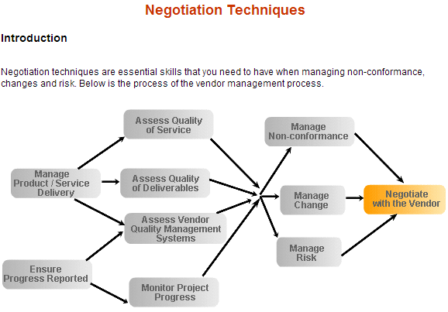
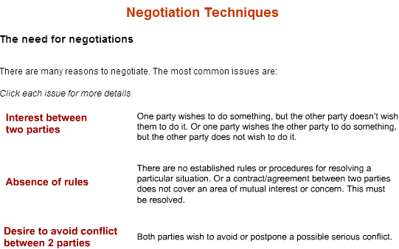
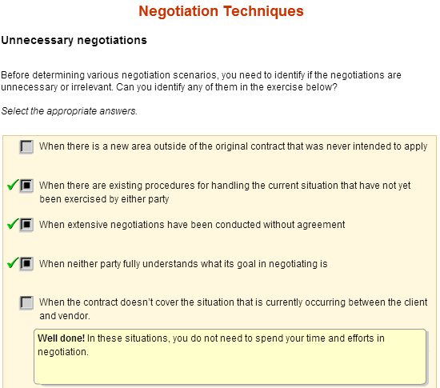
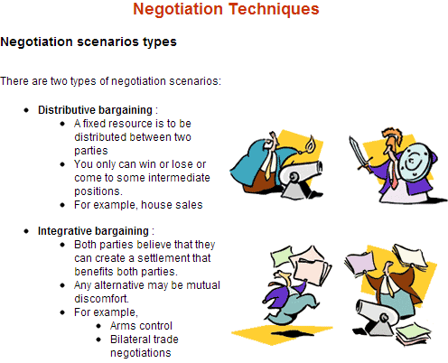
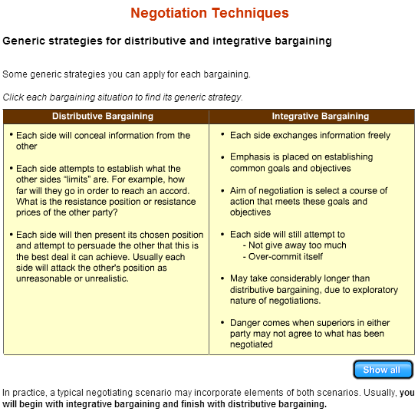
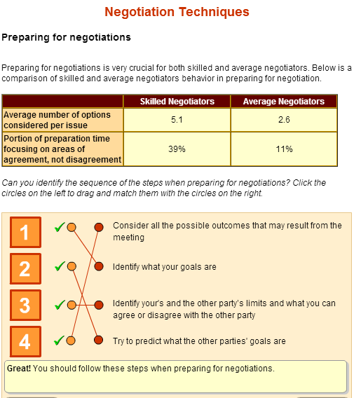
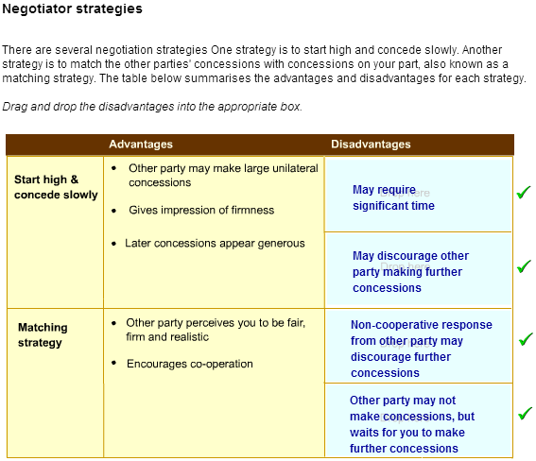
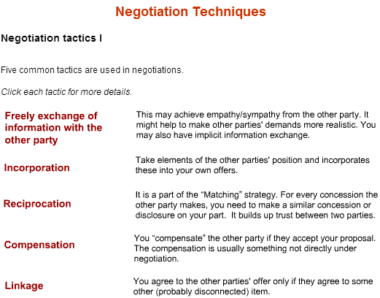
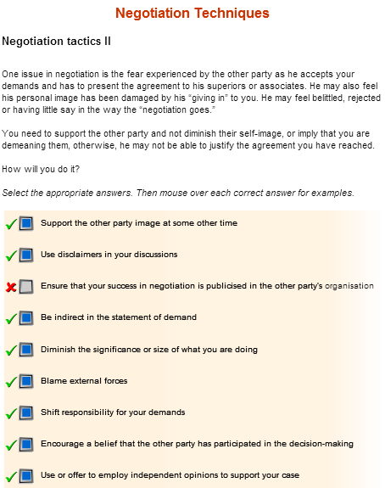
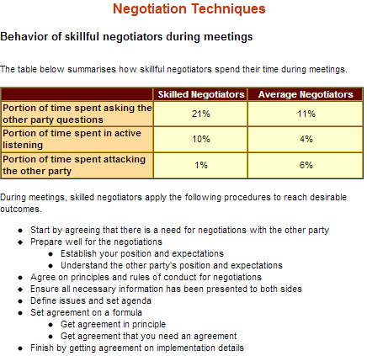

4.4 Negotiate the Contract

Plan Negotiation
Goals of negotiation guidelines

The goals of establishing negotiation guidelines are:
- To aid internal coordination
- To ensure negotiation results in an agreement that supports the business objectives of both your organisation and the vendor's
- To provide a structured approach to negotiation
- To protect your organisation from legal or predominance issues by ensuring that necessary aspects of negotiations are covered

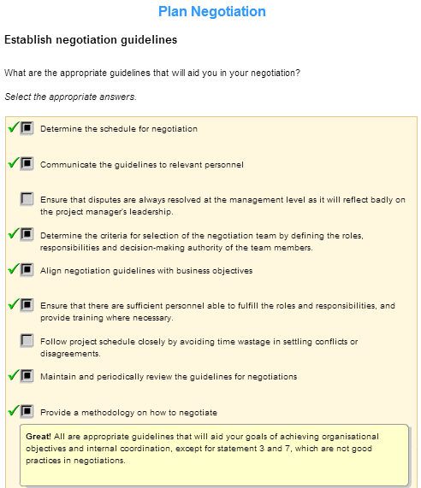
Set up negotiation team

During this phase of the project, the team composition or roles and responsibilities may need to be changed as appropriate to include personnel who would be able to negotiate effectively with the vendor. For example, if a team member is a skilled negotiator, he / she may take the lead in the negotiation.

Some of the attributes are listed below :
- Prior experience
- Presentation skills
- Communications skills
- Conflict resolution skills
- Knowledge of the issues under negotiation, including price, technology, service levels, statutory and regulatory issues, personnel transition and knowledge of the prospective vendor’s business
Gather required information

Ensure the contract person and the negotiation team has all of the information that they need to negotiate the contract effectively.

Some of the required information are listed below:
- Copies of winning proposal
- Copies of contract from vendor
- Documentation that fell outside the original proposal, such as amendments to the RFP or proposal
- Vendors comments on the contract portion of your RFP
- Ensure the negotiating team understands the pricing in the proposal
- Any other verbal agreements between you and the vendor’s sales representation. For example, the sales representative may “throw in” a development licence for your development machine, but if the contract person is not aware of this, it will not appear in the contract


Negotiate Contract with Vendor

Effective negotiation process
Here is a common way to do effective negotiation:
1. Begin by identifying an initial set of negotiation topics based on prior negotiations, existing organisational guidelines, policies and procedures, organisational objectives, marketing information about services being offered and information about the vendor.
Typical negotiation topics are flexibility, price, schedule, payment milestones and payment terms, scope of service, factors for designing and deploying the service, management and control issues, features, deliverables, Service Level, resources, transition issues (such as personnel), termination provisions, security, confidentiality, warranties and indemnities, limitation of liability, use of subcontractors and licensing.
2. Determine which topics to cover in the first negotiation meeting (the strategy for negotiation).

3. Prior to negotiation, the client communicates the initial set of topics to the vendor, and vice versa.

4. Updating topics are done during the negotiation as new topics may be uncovered. They will also decide what topics to cover in the next meeting.

5. During negotiation, monitor the status of the topics. Track them to closure, and finally into the contract.

Gather required information

Ensure the contract person and the negotiation team has all of the information that they need to negotiate the contract effectively.

Some of the required information are listed below:
- Copies of winning proposal
- Copies of contract from vendor
- Documentation that fell outside the original proposal, such as amendments to the RFP or proposal
- Vendors comments on the contract portion of your RFP
- Ensure the negotiating team understands the pricing in the proposal
- Any other verbal agreements between you and the vendor’s sales representation. For example, the sales representative may “throw in” a development licence for your development machine, but if the contract person is not aware of this, it will not appear in the contract

Key points in outsourcing negotiation
1. Insists on Itemised Pricing
Insists on prices in the outsourcing contract be broken down into components. Very often, in the RFP the client may have required that prices be itemised. However during negotiation, vendors and clients often prefer to negotiate as a package. That is fine, as long as when final negotiated pricing goes back into the contract, itemised.
2. Ask for Price Benchmarking
In addition to competitive and itemised pricing, standard contractual clauses should provide for periodic benchmarking of prices against the market, especially for services like telecommunications and disk storage, where prices can decline 10%-12% annually.
Benchmarking could be provided by an independent third party and paid equally by the vendor and client to remove any real or perceived bias. They may also agree to base benchmarking on widely accepted industrial market surveys.
3. Aim High, but do not be Unrealistic
It is good to aim high on what you can get out of a negotiation, but you have to be realistic. As far as possible, you should work on win-win situations with your vendor.
4. Avoid Vague Talks Of Partnership
Further, where negotiating is possible, vague talks of "partnership" should be avoided, and as mentioned earlier, all details must be spelt out in writing.
5. Don’t just Focus on the Price Alone
While negotiating the final price is important, teams also need to pay considerable attention to contract terms and conditions, which could have a huge impact over the course of a contract. In particular, you need to focus on gaining maximum flexibility to make changes as a result of the quick changing business environment that you may be operating in.
You may also want to focus on the prices for change. Vendors often price their base contracts very low, but charge as much as possible for changes.
6. Focus on Interests, Not Positions
This would allow the parties to go beyond what is on the table for negotiation and come out with innovative win-win situations.
7. Objective Standards based on Industry Practice
Where possible it is desirable for clients not to accept standard form contracts as these may be heavily weighted in favor of the vendor. Choose instead for objective standards and standards based on industry. Whether contracts can be negotiated or standard form contracts have to be accepted will depend on the bargaining powers of the parties concerned.
8. Allow for Price Adjustments
It may come as a surprise to clients that very often, the pricing reached during contract negotiations also fails to be best and final. Indeed, while negotiated prices may represent the best intentions of both vendor and client, standard outsourcing contracts specify a transition period (normally 90-120 days) during which operational “surprises can further adjust pricing. Unlike earlier best-and-final prices, contract terms often specify adjustment boundaries (e.g. 10%) without renegotiation.

Explore Topic – Dispute Resolution

About this lesson

A dispute may occur if there is a non-conformance in the product or service and the vendor doesn’t agree that this is a non-conformance. The issue cannot be resolved at the working level. The client contract manager must then resolve this using internal escalation or other dispute resolution procedures.

Lesson objectives
In this lesson, you will learn to:
- Apply internal escalation procedures
- Determine penalties
- Apply the mediation process
- Apply the arbitration process
- Apply the litigation process
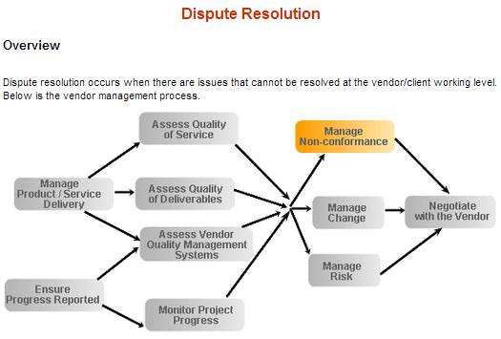
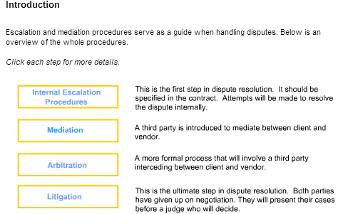

Internal escalation procedures

Internal escalation procedures should be specified within the contract. They should have:
- Clear responsibilities and authority of the personnel involve in dispute resolution
- Procedures for identifying and clarifying disputes
- Criteria for escalating disputes to the next level in the dispute escalation chain
If a dispute cannot be resolved between the client project manager or the vendor project manager then it should be raised to higher management. The below diagram explains how internal escalation procedures work.
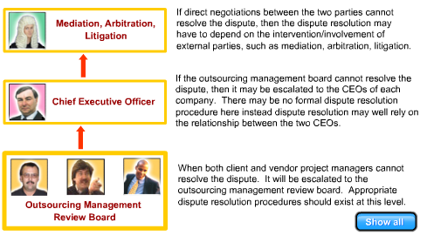
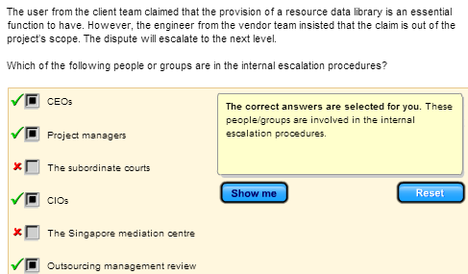
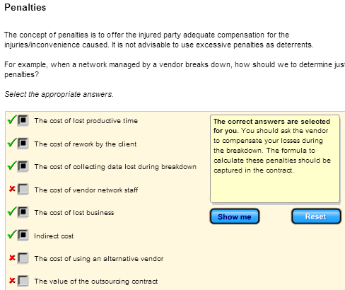
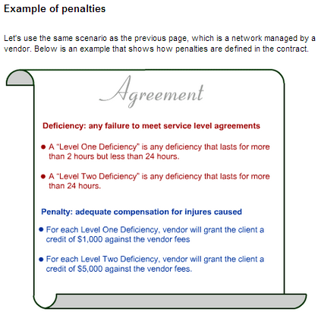
Mediation

Mediation occurs when two parties wish to resolve their differences, but they need the intervention of a third party. They are willing to:
- Be flexible
- Discuss their problems with a third party
- Work for a resolution of their problems
Mediation works when the relationship is important to two parties and both accept this. However, mediation doesn’t work if both parties are inflexible and insist on maintaining their position or legal rights.
You can find several mediation organisations in Singapore:
- The subordinate courts
- The Singapore mediation centre
- The community mediation centre
- CASE
Or you can also look for independent respected individuals or organisations identified and mutually agreed by the two parties.They may be:
- Respected academic, legal or government offices
- Respected, but informal authorities, e.g. the chairman of SCS or SITF.

The mediation process

In the mediation process, the mediators will hold several sessions to meet both parties jointly or individually, in order to reach common agreements with both parties.

1st Joint Meeting

In the initial presentation by the mediator, the mediator will discuss:
- The goal of the mediation
- The mediator's role
- The mediation process
- The rules applied during the mediation process
- Ask each party to assign authority to settle the dispute
The mediators will then:
- Let parties describe their positions
- The mediator will then summarise each position
Private Meetings with each Party
In the private meetings with each party, the mediator will:
- Obtain private information from the party and assure them of confidentiality
- Get the party to talk about their view of the dispute and get their needs and concerns
- Identify areas of common interest with the other (not present) party
- Explore options available
- Determine limits to each party's offers
- Determine whether options are realistic
- Package option(s) for discussion with the other (not present) party
Further Joint Meeting
In further joint meetings, the mediator will:
- Encourage communication and negotiation
- Encourage joint problem solving
- Generate options for discussion by both parties
Final Joint Meeting
At the final joint meeting, the mediator will:
- Help draft the settlement in a formal agreement
- Record this agreement
- Then destroy all private notes taken during the mediation process

Advantages and disadvantages of mediation

The advantages of mediation are:
- Both parties can input to the final result
- Both parties work together and not against each other
- The relationship between the vendor and client is maintained and restored
- The process is informal and non-confrontational
- The process is confidential
Can you identify any possible disadvantages of mediation?
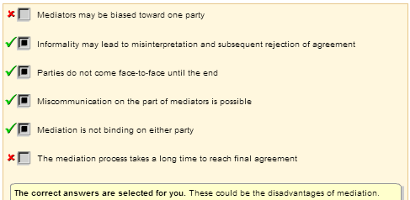
Arbitration
Arbitration is another method for dispute resolution in which the disputing parties present their case to an independent arbitrator and agree to accept his decision. The arbitrator(s) are either:
- Selected directly by the parties
- Defined in the terms of the contract
- Selected by some independent authority
When parties submit to arbitration, they agree to be bound by and comply with the arbitrators’ decision. The arbitrators’ decision is given after following a process where each side presents evidence and witnesses.
Some arbitration proceedings are enforced by government or law, such as labour disputes.
Other arbitration proceedings are selected in advance and written into contracts. This avoids the delay, expense, bitterness and formality of litigation.
Differences between mediation and arbitration (I)
After learning mediation and arbitration, can you identify the main differences between them?

Mediation
- In general, results may be unenforceable
- Is informal
Arbitration
- In general, results are binding
- Is formal
Differences between mediation and arbitration (II)
The table below summaries the differences between mediation and arbitration.
Differences between
Mediation | Arbitration
- Mediator:  – Acts as communication channel between two parties  – Explores options  – Tries to seek common ground between two parties  – works with both parties to find out solution | - Arbitrator  – Listens to both parties in the dispute  – Determines the fairest solution  – Gives the two parties his solution  between two parties  – works with both party to find out soluti
- Mediation is informal | - Arbitration is usually formal
- Results of mediation are usually unenforceable  – Results are dependent upon both parties agreeing it is in their best interests to agree to the solution | - The results of arbitration may be legally binding or have some legal enforcement statusupon both parties agreeing it is in their best interests to agree to the solution

Steps in arbitration
1. Initiate the arbitration
A request by one party for dispute to be referred to arbitration.
2. Appoint an arbitrator
Appointment of arbitrator if this is not already stipulated in the contract, or already appointed by some higher authority.
3. Discuss the dispute
In the preliminary meeting, discuss the dispute in question and discuss an appropriate process and timetable.
4. Produce statement of issues
A formal meeting in which each party summarises the matters in dispute (and perhaps, remedy sought) in a statement of issues.
  - This is needed to inform each party of what needs to be resolved.
  - It summarises the alleged facts, but does not include the evidence through which facts are to be proven.
The purpose of this statement is to identify the issues and avoid surprises.
5. Collect documentation
Each party collect relevant documentation (and other evidence) and passes this to the arbitrator.
6. Clarify information
A meeting is held in which the arbitrator listens to any oral statements by each party, questions witnesses and asks for clarification of any information.
- Both parties are entitled to put forward their case and be present.
- This meeting may not be necessary, if the issues can be dealt with entirely from the documents.
7. Make submission
If both parties are represented by lawyers, these lawyers may make legal submissions. This will include :
- A summary of their evidence.
- A reference to application laws.
These submissions are made either orally, or in writing.
8. Consider all evidence
The arbitrator will consider all the evidence. He may hold further meetings with both parties or with expert witnesses.
9. Make decision
The arbitrator considers all the information and makes a decision
- An award is written to summarise the proceedings and give the decision.
- The award usually includes the arbitrator's reasons for the decision.

Litigation
The last step in dispute resolution is litigation. It may lead to termination of contract or non-renewal of contract and should only be attempted when all other routes have been tried. You should seek good legal advice and understand what you hope to achieve before beginning litigation. You may be hoping to achieve:
- A clear understanding of the relationship between two parties
- Termination of the relationship between two parties
- Redress for injures suffered/losses incurred due to the actions/inactions of the other party
However, litigation will
- Be lengthy
- Be expensive and time consuming
- May not achieve the results you want
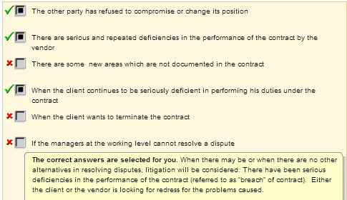

Remedies for breach of contract
What types of remedies you might obtain for breach of contract?
If the client brings an action for damages
- Damages must be specifically linked to the problems created by the vendors for breach of contract.
- Damages must be such that the affected party is brought to the same position as if the contract had been performed.
- Damages are not usually awarded if the link between failure to perform and the damage/losses incurred is too tenuous, or too long-term.
- The court must make a fair and impartial assessment of damages.
The client or the vendor may sue for specific performance
Court may order that a party in breach of contract perform his obligations under the contract. This order may be made in combination with an order for damages, unless:
  - It is no longer possible for the party to carry out those obligations.
  - The amount of damages is deemed adequate to compensate the other party. In general, specific performance is not available on contracts for personal services, contracts of employment, or in cases where it would be impossible to supervise the performance adequately.
If the vendor sues the client
He may sue on quantum merit i.e. sue for as much money as he deserved or for work done.
The client or vendor sue for injunction
Example: the client cannot market a product which incorporates a component provided by a vendor, as the vendor disputes the contract under which this component was provided.

4.5 Perform Final Review of Contract

Perform Final Review of Contract

Important reminders

At this point, all the hard work would have been done. It is a matter of putting all that into paper and ink, and getting the authorised signatures from your organisation and the vendor’s organisation. Here are some important reminders for performing a final review of the contract.

Important reminders for performing final review of contract

Track Issues
Remember to track issues that have been discussed and negotiated into the contract.

Review RFP
Useful to review RFP (the original draft contract), meeting minutes and other documentations to ensure that all the identified topics for negotiations have not been missed out.

Engage a Legally Trained Person
Very important to engage a legally trained person, possibly a lawyer well acquainted with IT outsourcing practices to draft the contract, if not, at least to do a final review of the whole contract.

Check Completeness
In the final review of the contract, this is a checklist to check completeness. Make sure the contract has the following critical terms and considerations:
- Termination clause for convenience without excessive penalties.
- Escalation of penalties for non-performance to spur improvement in services levels.
- Periodic price benchmarking.
- Clear definitions of the key processes to be outsourced.
- Limitation on employee turnover for staff on the account.
- Clear transition plans at contract termination.
- Granular itemised pricing.
- Trigger points for renegotiation of contract structure.
- Ensure all annexure / enclosures are in place before signing.

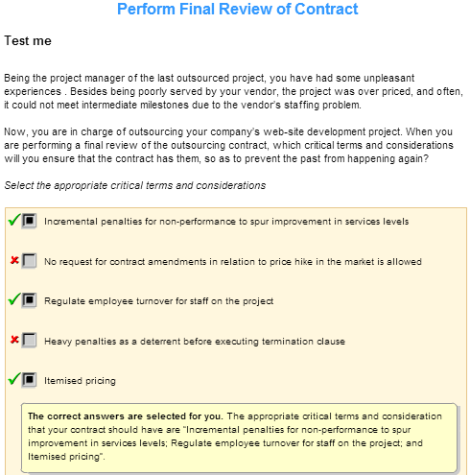

5. Contract Execution and Management

This module covers the issues that need to be addressed during the transition period. It also provides techniques for managing vendor progress by measuring the service-providers performance against service-level agreements, highlighting areas of deficiencies. It provides advice on how to negotiate and agree on remedial action for any deficiencies or for additional services required that is not covered in the original contract

5.1 Project Kick-Off
Introduction
When kicking off a new outsourcing project, you need to do the following three tasks to initiate the project
- Select the key manager and key people
- setup the management structure –organization chart
- revise project plan

Key players – client contract manager
The contract manager is the one who acts as the sole point of contact between the vendor and the customer organisation . A contract manager is appointed from the customer organisation while another contract manager is appointed from the vendor organisation.
Can you identify the roles or responsibilities expected of a client contract manager?
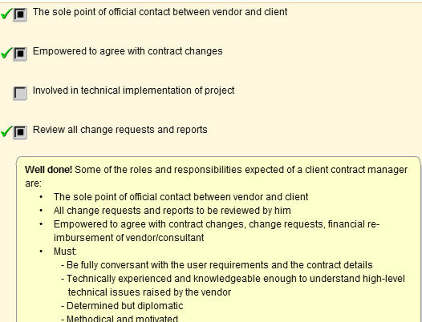
Key players – vendor project manager

The vendor project manager is another key player in an outsourcing project. A vendor project manager is responsible for:
- Managing the contract from the vendor side
- Implementation of the system that the vendor is contracted to provide
- Delivery of services the vendor is contracted to provide
- The management of the vendor team
- Implementing changes to services or products
Project management structure

After selecting the key players, you should create a structure to manage and oversee the outsourcing project.
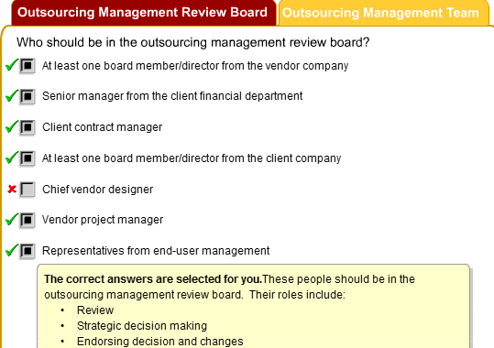
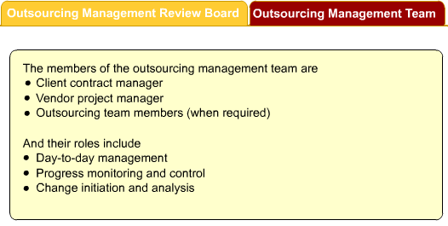
Revise the project plan

The initial task of the client management team is to revise the client project plan which describes all the activities that will take place in the outsourcing project. It should now include the plan submitted by the vendor in his proposal, with amendments agreed during contract negotiation. This vendor plan must also be reviewed for feasibility and alignment with client objectives.
The client project plan must also include client staff involvement. It should be jointly prepared by both the client contract manager and the vendor project manager, and approved by the outsourcing management review board. It must show the following items.

5.2 Manage the Transition

Introduction
When you outsource an IT activity or function to a vendor, you will go through a transition phase. It is a phase where the transfer of responsibilities and ownership takes place between the client and the vendor. In other words, it is the phase of transferring the control of the IT activity together with the assets, if any, to the vendor. Assets may include hardware, software and human resources.

For a smooth transition of the project, the best practice is to prepare a detailed transition plan with the vendor. Once the plan is decided upon, you are required to monitor the activities during the transition period with respect to the plan. The transition plan should include the following details:
- Transition activities
- Person(s) responsible for each transition activity
- Activity start date
- Activity end date
Develop the transition plan

Once the contract is signed, your task as the project manager is to ensure a smooth transition. To do so, it is advisable to use a transition plan. Basically, when you develop the transition plan, you need to answer some key questions like the ones listed below:
- What will be transferred to the vendor?
- Who will be transferred to the vendor?
- How will the transfer proceed, in phases or all at once?
- When do you intend to transfer?
- When will the vendor assume responsibility for the IT operation?
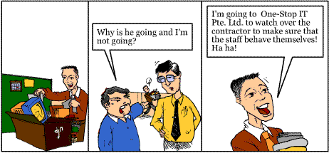

Form a transition team  Before planning for transition, it is advisable to form atransition team. This team should consist of members from both your organisation and the vendor organisation. If the transfer of personnel is involved, you might have to include the HR personnel from both organisations. | Transition Team  
The primary objective of the team is to ensure that the transition takes place withminimum impact on your overall organisation. It is important to have a smooth and seamless transition to form the proper levels of expectations and give good first impression.
To ensure that the developed transition plan is complete, the team needs to address the following:
Click on the following buttons to view the issues to be addressed



Once you have formed the transition team and addressed the transition issues, you will need to brief all who are concerned about the transition. In the next few pages, we will look at who are the groups of personnel to be briefed and also how the transition is being carried out.

Current Environment Changes
along with the transition phase are several changes to your organisation. Generally, these changes can be categorised as follows:

- New organization necessary to deal with vendor
  - When you identify the changes during transition, you should identify the new organization that will deal with the vendor in terms of:
    - Management/liaison/review board
    - Contract manager
    - Technical liaison
- New Procedures or changes in procedures
  - When transition occurs, there will also be new procedures. Some of the old procedures will also be changed. You need to identify the changes, which may include:
    - 1. operational procedures
    - Change initiation & implementation
    - Initiating contract changes
- Other changes

Transition Issues

- Maintenance
  - For maintenance responsibilities in transition to the vendor, ensure that the following are accomplished before the actual transition:
    - Proper legal authority for the vendor to perform maintenance
    - All appropriate maintenance agreements are either cancelled or transferred to the vendor

- Disaster coverage
  - During the transition planning stage, you should ensure that there is clear understanding between you organization and the vendor as to what would be done in the event of a disaster, regardless of its magnitude, beginning from the first hour of the transition

- Leasing
  - Assuming that you currently have leasing agreements you must ensure the vendor has the authority to use the leased equipment or software. AS agreed upon in the negotiating plans, the responsible party (either customer organization or vendor organization) should complete transaction to purchase the appropriate leases during the transition

- Change procedures
  - As a result of outsourcing, there will be existing procedures that will need to be revised. To ensure a smooth transition, you should ensure that all potential changes in procedures are identified and corrected prior to the transition.

- Multiples locations/division
  - If you organization has multiple locations/division, it is essential that each location and separate organization be specifically addressed in the transition plan. Using the theme of “transitioning with minimal impact”, you will want to ensure that each location is adequately informed and clearly understand how it is affected by the transition. Any processes or procedures that change as a result of the transition should be communicated prior to the actual transition day.

- Termination letter
  - If there are existing personnel in transition to the vendor, there is usually a letter of termination that is required from organization. Generally, the employees are actually terminated from your organization and hired by the vendor organization on the same day.

- Transition day
  - The actual transition day is recorded on the transition plan as milesonte. However, the process does not end here as there is still much to be done. During

Prepare for transition

The place to start preparing for transition is actually to "promote and advertise" internally and externally on the strategic advantage that you and your vendor bring to each other out of the newly formed partnership. By doing so, you will accomplish several goals:
- Your internal personnel will have a good understanding of what is to be done, and why and how it benefits your organisation.
- It provides the information to your customers that your organisation is strategically focused on improving its services and relationships.
- Your competitors are now aware of a major positive change in the organisation's strategic position. By outsourcing, you are strengthening your competitive advantage
It is important that you also ensure that the management be informed of the transition of the IT activity. In addition, the end user and the IT department must also be aware of the transition.
As the project manager, you need to ensure that the management and the users must be informed about the following:
- The support and trainingthat will be provided by the vendor
- Specific roles and responsibilities for handling the vendor
- Lines of communicationfor information on existing services or for communicating change requests
- Contractual issues, such as maintenance and leasing contracts

Prepare the IT Department
A situation like the one shown on the right could happen if you are not closely monitoring the movement of the hardware in your IT department. You wouldn't want that to happen now, would you?

In preparing the IT department for the transition, you should inform the IT personnel the new procedures for tracking project progress, such as the following:
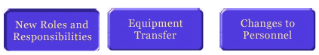
- New roles and responsibilities
  - Inform the IT dept of their new roles and responsibilities when the transition happens. As the project manager, you can inform the existing IT department on the following roles and responsibilities
    - The running of the remaining non-outsourced IT assets
    - Determining the IT strategy
    - Managing and monitoring the IT contract
    - Developing and/or customizing domain specific applications

- Equipment Transfer
  - During the transition, there is bound to be equipment transfer, It could be the transferring of your existing IT department’s equipment to the vendor’s site, depending on whether you are deploying your staff to the vendor’s site or not. If you require external expertise to come in-house, then the transfer of equipment could be from the external vendor to your IT department
- Changes to personnel
  - When the transition happens, your IT personnel will also be affected. You need to decide who will remain and who will be transfeered to the vendor’s site. As the project manager, it would be wise to decide and discuss beforehand who are the staff you need to deploy to the new work environment. This decision has to be rationally and openly discussed with each individual IT personnel who is affected.

To summarise, developing a transition plan will certainly help to ensure a smooth transition of the project from your organisation to the vendor. This plan should include:
- transition activities
- person(s) responsible for each activity
- start and end dates of each activity, and
- milestones.
Transition Plan Checklist

Example
During the transition phase, there are many activities that must be carried out. Let's view a sample checklist that is used to verify the completeness of the transition plan. It is called the Transition Plan Checklist.
Transition Plan Checklist
ITEM | Yes | No | N/A | Remarks
Organisation plan
- Are the roles & responsibilities clearly defined?
- Does the implementation schedules specify actions to be taken at department and individual levels & parties responsible?
Business Continuity
- Has arrangements been made to ensure continuity of work during transition?
Risk
- Have all transition risks been identified, including business risks?
- For each one identified, is there adequate preventive/contingency measures to address them?
Resource Requirements
- Is there adequate resources in the IT department to handle the transition phase within the proposed time frame?
- Is there adequate resources in the user department to handle the transition phase within the proposed time frame?
- Is the approved budget sufficient to acquire the resources needed for the transition?
  - e.g. temporary staff, equipment
Communication Plan
- Is there a plan to keep all stakeholders, staff and customers informed?
- Is there a need to have team-building & cohesion programmes for all affected staff, including inculcation of new values and attitudes?
Installation and Migration
- Is the installation and/or migration plan for facilities and infrastructure well defined?
- Have all the transition issues been addressed and documented in the contract?
Training/Recruitment
- Is there a plan to recruit new staff or transfer of existing staff?
- Is there a plan for training new and existing staff?

Transition Issues Checklist

We have also looked at the issues that should be addressed during the transition phase of a project. You are also able to monitor and track if these issues have been addressed in your project using the Transition Issues Checklist. Here is a sample of the checklist.
Transition Issues Checklist
ITEM | Yes | No | N/A | Remarks
Maintenance
- For the maintenance responsibilities being transfered to the outsourcing firm,
  - Is proper legal authority provided for the outsourcing firm to perform maintenance?
  - Are all appropriate maintenance agreements either cancelled or transferred to the outsourcing firm?
  - Is there a plan for the necessary arrangements before the actual transition?
Change Procedures
- Are all the potential changes in procedures identified, corrected, documented and established?
Multiple locations/divisions
- Is there a plan to ensure that each location is adequately informed and clearly understands how it is affected by the transition?
- Is there a plan to ensure that any processes or procedures that change as a result of the transition are well documented and communicated prior to the transition day?
Leasing Arrangements
- If there are current leasing arrangements, is the outsourcing firm given the authority to use/maintain the leased equipment or software?
- As agreed upon in the negotiating phase, has the responsible party (either the outsourcing firm or your company) completed transactions to purchase the appropriate leases during the transition?
Disaster Coverage
- Is there clear understanding between your company and the outsourcer as to what would be done in the event of a disaster, regardless of its magnitude, beginning from the first hour of the transition?
Human Resource
- If existing personnel are in transition to the outsourcing firm, is a review carried out with the HR and legal departments to ensure that you conform to all guidelines and that the employees in transition receive the letter within the allotted time?
Transition Day
- Have you introduced the new Accounts Manager to the key personnel in your company?
- Have you shown the outsourcer around the various departments of the company to help him do his job better?

5.3 Work with the vendor

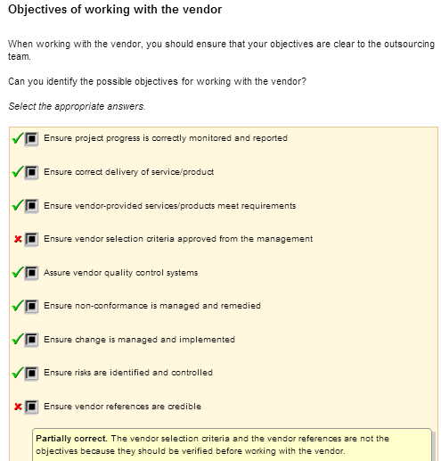
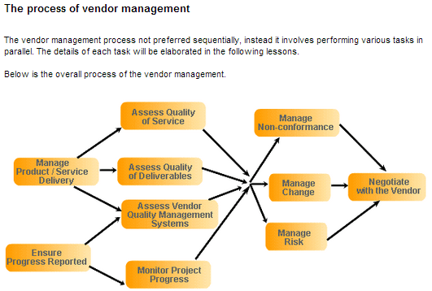

5.4 Manage the Progress Reporting Process

Manage the Progress Reporting Process
Introduction

Managing the progress reporting process is one of the key tasks in monitoring vendor performance. Below is the vendor management process.

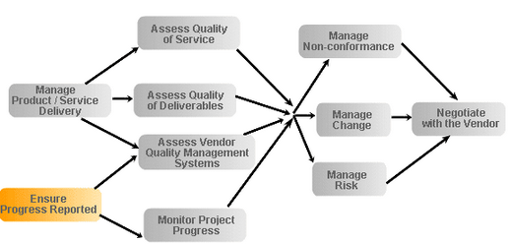

Manage the contract

Once the transition is made, your responsibility as the project manager is to manage the contract. You do not just "wash your hands" once the vendor takes over the project. To ensure effective execution and delivery of the project, you still have to manage the contract. When you manage the contract, you will have to:

- Monitor progress
- Assess Contractors Performance
- Manage Service and Product Delivery
- Deal with nonconformance
- Manage Change
- Manage Risks
Let's first look at how you can manage the vendor's performance. The SLA and the contract will help you in monitoring and managing the project. Take a look at the chart below.

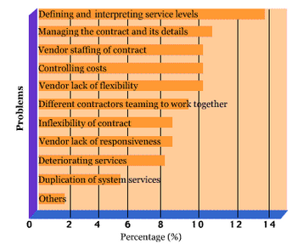

It describes some of the major problems encountered during outsourcing. As you can see, studies have shown that two major problems in outsourcing are:
- Defining and interpreting service levels
- Managing the contract and details and
Therefore, we shall begin by discussing the management and monitoring the of the vendor
Monitor the progress

You should have set the performance expectations of the vendor in the Service Level Agreement (SLA). With the help of the SLA, you are able to monitor and manage the vendor at frequent intervals.

Some of the activities that should be monitored are:

- Adherence to major milestones
- Dependencies between activities
- Adherence to vendor's project plan
Monitoring the project activities will help you to identify and manage any changes that may occur during the process of delivering the IT activity. Here are some questions to consider when you manage the vendor's performance:

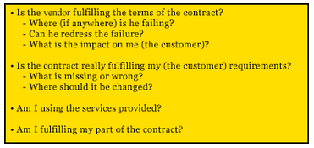

In order to monitor the vendors performance, you have to ensure that the Vendor reports and discusses progress regularly. This will be done by ensuring:
- Formal progress meetings with the vendor at agreed time intervals
- Written progress reports from the vendor at agreed time intervals
The contract manager must also provide written progress reports to higher management (i.e. the outsourcing management review board) by the client contract manager. The format and content of each of these are discussed next.

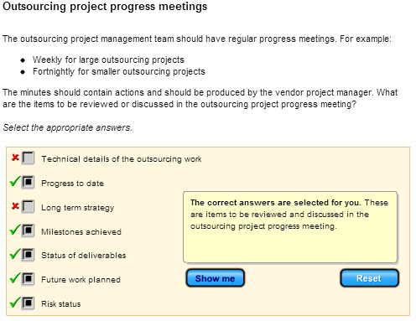
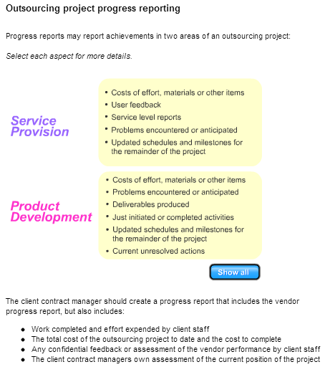

5.5 Analyze and Assess Vendor Performance

Analyse and Assess Vendor Progress against Plan
Introduction

Analysing and assessing vendor progress against plan is one of the key tasks in analysing and assessing vendor performance. Below is the vendor management process.

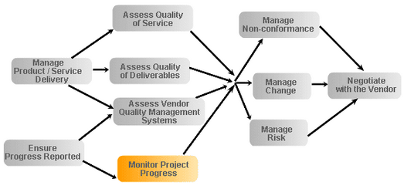

Assess vendor progress

Having received the progress reports from the vendor, you must assess how well the vendor is doing. When monitoring progress of outsourcing project against the vendor plans, you need to identify:
- Tasks started/tasks completed
- Milestones achieved
- Deliverables released
Gantt/Tracking Gantt charts are a good tool that will help you in monitoring vendor progress. These charts compare actual progress against planned progress. Tracking Gantts will show the impact of slippage on milestones and also the impact on project end-date.
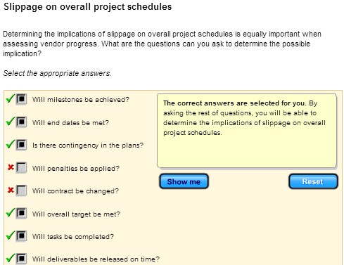

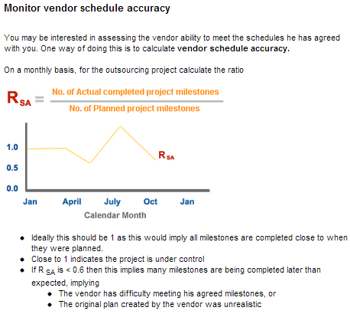
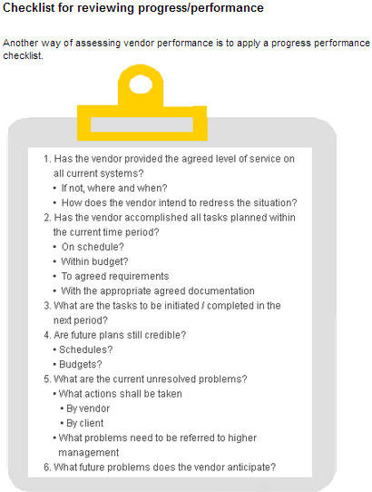
Evaluate and Validate Deliverables
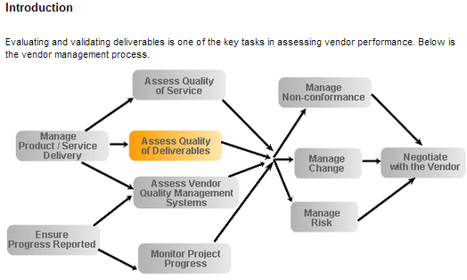

Introduction

Another task for the contract manager is to evaluate and assess the vendor products. In particular, the client must test or verify that a vendor deliverable is acceptable.

For document deliverables reviews are:
- Requirement specification
- Project plans
- Design specifications
- Acceptance test plans
For delivered software or systems:
- User manuals
- Acceptance tests
For other products, e.g. training
- Post-training feedback analysis
When performing reviews in general, it is better to perform reviews earlier on than test later. Most reviews and tests should be incorporated in the validation and verification activities within the vendor development life cycle. However, some independent testing may be engaged after installation.
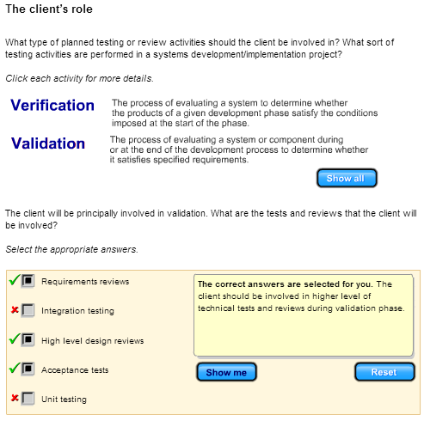
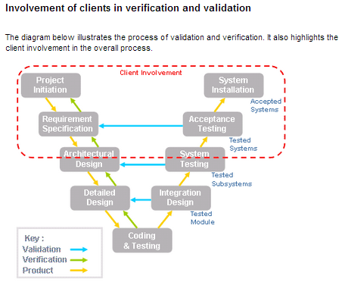
Conduct of joint vendor/client technical reviews

Joint vendor/client technical reviews should be held where products of the vendor are assessed to:
- Affirm the quality of the product
- Identify defects
- Suggest improvements
- Check conformance to standards
- Gain a common understanding of:
  - The problem under consideration
  - The solution being proposed
- Build up client's confidence that he will receive a high-quality product
The joint technical reviews should be staffed by both client and vendor staff. The reviews should be supported with checklists and processes for action and follow-up.

Acceptance testing

The objective of system acceptance planning is to ensure that there is a formal validation by the client that the work is being carried out as specified in the requirements specification or the schedule of work.

Acceptance testing will focus on 3 Ds.

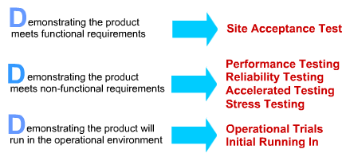
Responsibilities for and inputs to acceptance testing

Acceptance test plans should be created by, and acceptance testing should be performed by the client who will need support from the developers. The criteria for successful acceptance must be set by the clients.
Can identify what the main inputs to acceptance testing are?
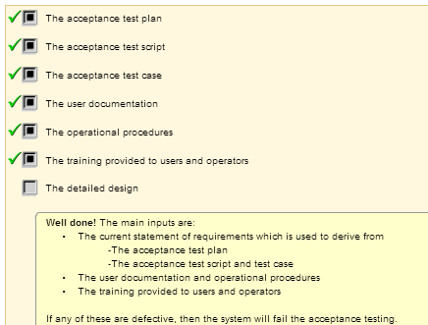

Document review

Some parts of the vendor deliverable set will be documents for use by the client:
- System development documentation required for future systems support and enhancement by the client
- User documentation for use by the user
Documents should be subjected to review or testing as well as software or services. When you review the documents, you should look for 3CAR:

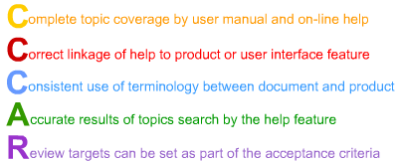
Training evaluation

The effectiveness of training should also be evaluated as part of acceptance testing.

Select the appropriate answers.
As the client project manager, you have been assigned to find how effective the user training conducted by the vendor is. A few colleagues try to give some suggestions on how it can be done

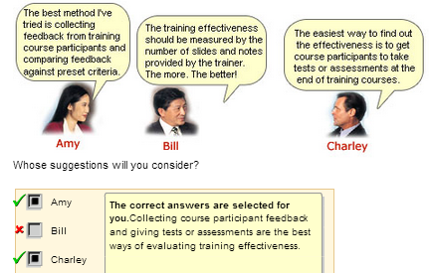

Product warranty & support period

The client will expect the vendor to support the product for a fixed period of time after acceptance.
- This may involve the vendor preparing a support plan that will show the resources devoted to this task, planned product upgrades dates and other activities.
- This must also be reviewed by the client contract manager for acceptability.
- The client may retain some of the contract payment until this warranty/support period is completed.

5.6 Quality Management
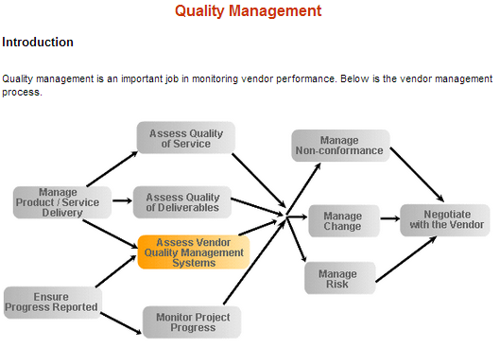

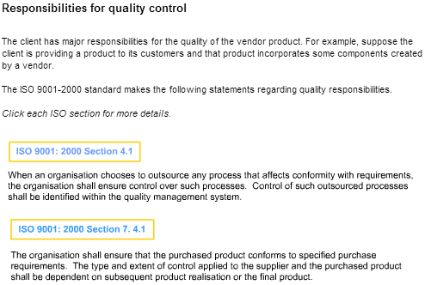
Audits

It may be necessary to perform audits on
- The vendor quality management system
- The vendor security control system
In ISO 9000 terms, an audit is an investigation into whether the agreed process has been followed. Audits, therefore, look not at delivered products, but at the internal process and hence the documents that describe these processes.
What are the internal process documents which you need to audit?

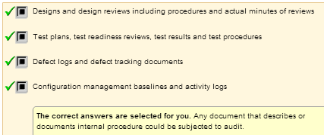

5.7 Manage Service/Product Delivery

Installation plan

If the vendor is providing a product or products to you then the process of installation must be carefully managed. The people who could be responsible for installation or service deployment are:
- The client
- The vendor
- Someone else
For significant installation exercises, such as rolling installation across multiple sites, an installation plan is needed.
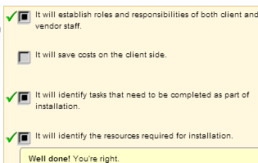
Checklist

Below is a checklist that will help you in managing service and product delivery in an outsourcing project.

1. Who is responsible for producing, reviewing and agreeing with the installation plan?
2. Who is responsible for providing resources to implement and support installation?
3. What resources are required to perform or support installation?
- Hardware
- Software infrastructure (e.g. O/S, utilities)
- Specific software tools to aid installation
- Other software systems that the product or service must interface or interact with
- Data
- Human resources skills (e.g. system operator)
- Others (e.g. administrator privileges to install software)
4. What tests need to be performed as part of installation?
- Acceptance tests
- Pre-acceptance tests
5. What support activities may need to be performed as part of installation/delivery?
- Data migration
- Training
  - Client IT staff
  - Users
6. What is the formalised handover procedure?
7. What is the criteria for agreeing installation is complete?

5.8 Deal with Non-Conformance

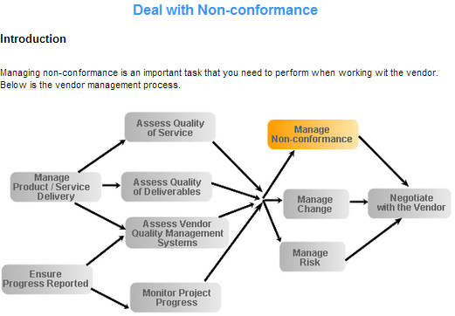

Installation and its plan
Suppose a client contract manager believes he has found some defects or omissions in the service or products provided by the vendor.
As a client contract manager, initially you must check to see if it really is non-conformance. You need to check:
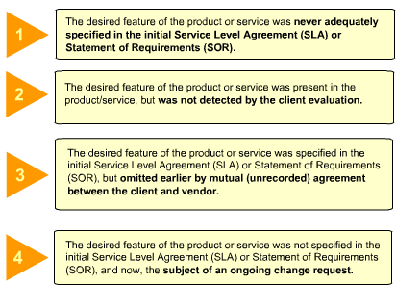
Strategies of deal with non-conformance

A notice of non-conformance is a formal notification by the customer that the product is unsatisfactory in one or more aspects. It usually states the specific requirement the product fails to meet. For example:

“The product does not correctly compute the wages of staff. For example, a senior engineer is paid $30,000 per year, but the product miscomputes this as $3,000. This is a critical defect and must be corrected in the product.”
What can you do if there is a non-conformance in the product or service?
Select the appropriate answers. After Done, mouse over each correct answer for more details.

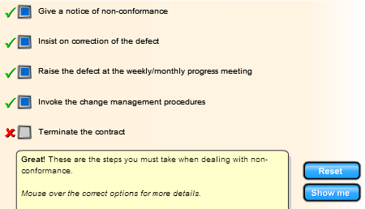

However, the vendor may not agree that this is a non-conformance. This case may then become a dispute. The client contract manager must then escalate this using internal escalation or other dispute resolution procedures.

5.9 Dispute Resolution – (completed in previous section)

5.10 Manage Change
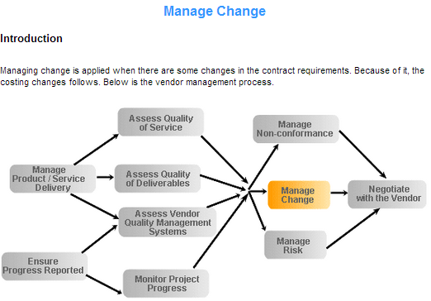

Change
Another aspect of the contract that you need to manage is changes. To understand changes, consider the following:
- A product or a service is designed to meet a requirement.
- However, requirements change over time.
- Changes in the requirement are rarely arbitrary; they are usually the consequence of natural change in the organisation or its business requirements changes are inevitable and often desirable.
- So, if the product or service is to continue to meet the requirement, it must change too.
- Therefore, the contract management team must manage the requirement change process

As a client contract manager, therefore, you should be very familiar with the terms and conditions in the contract and the SLA. Only then, will you be able to spot readily any change to the contract requirements.

Mechanism for Managing Change in Contract
So, how would you handle the changes in a contract? Most often, the costing issue is the main factor that you need to consider in managing change. But, before this, you must identify the scope of the change and agree the change with the appropriate authorities.
Consider the following steps on managing changes in the contract. Can you identify the correct sequence in managing change?
Drag and drop the remaining three activities in the correct order.

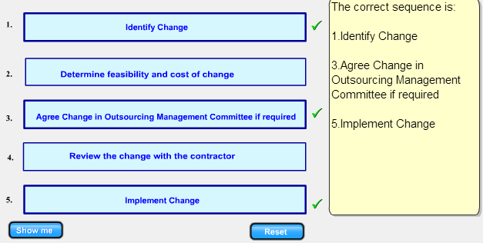

Once the changes are implemented, the next step will be to manage the change in cost.

Costing Changes in Providing Services
Changes in the contract would usually lead to a change in the cost. So, when you evaluate a certain change in the contract, you also have to consider the following

What is cost ?
This is the cost incurred due to changes to the provided services. You need to carry out change identification and implementation to such changes. For example, if there is a change in the technology, then you would need to identify the additional cost for the implementation and additional training and documentation. In this case, you will need to calculate the additional expenses that will be incurred with the changes

Customer to pay?
The customer will have to bear the expenses if he is asking for new additional or changes to the contract. The contractor must be able to justify that the change in the contract requires him to perform additional tasks, and therefore additional cost is incurred

Vendor to pay?
An occasion in which the vendor may bear costs is when there is an upgrade of the software or hardware. The vendor may decide upon upgrading , to speed up his process, so that the project will be completed earlier to provide better service. This may not be the request from the customer , but the vendor’s own upgrading plan.

Basically, you need to find a suitable mechanism to manage changes during the term of the contract.
What are your roles as a client contract manager when managing the change process?
- You must ensure that Change Control Procedures are well defined, understood and used by all
- All requested changes to any baseline deliverable (requirements, specifications, plans, etc.) are handled by these procedures
If change control processes are not applied using a formal process, then the result will be chaos. No one will know what the system or service is providing and there will be continual contractual wrangling about what was and was not contained in the original contract. It is better to avoid these problems!

5.11 Negotiate with the Vendor
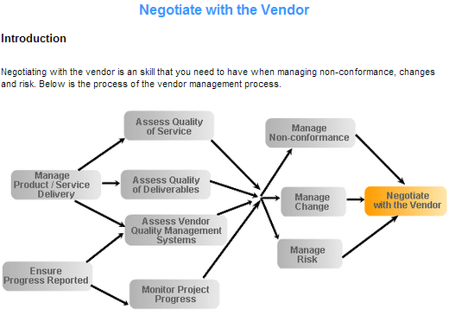

Reasons for negotiation
If there is a contract between the client and vendor, why is it necessary to have negotiations? There may be a variety of reasons for negotiations. Can you identify some of them? 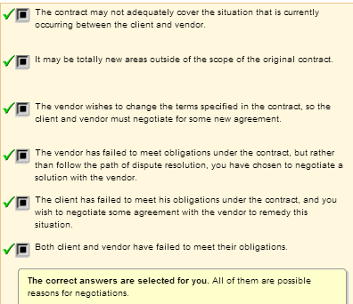
5.12 Manage Risk

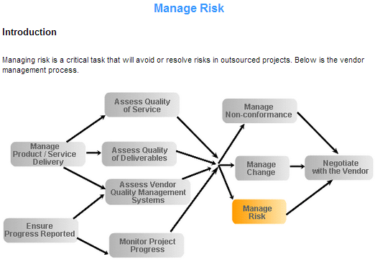

Definition

Risk is a possible future event that may occur to the project. This event may or may not happen. If it does happen, it will have a negative impact. Therefore, it is characterised by:
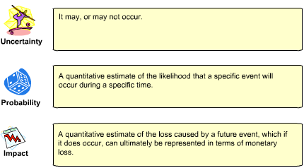
Risk management of outsourced project

You can carry out risk management processes to either overcome or avoid the risks identified in the previous page. Client management must ensure that vendors have a risk management process. What should the features of the vendor processes be?

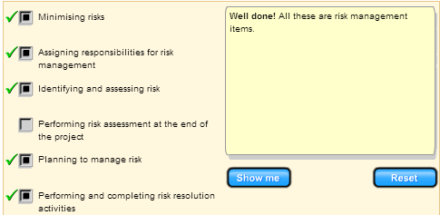

Risk management responsibilities

Both the client contract manager and the vendor project manager should be involved in managing the risks that could occur in the outsourcing project. The responsibilities for each manager are listed in the below table
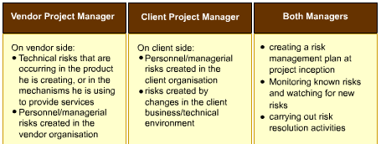

5.13 Assess and Manage the Relationship

Assess the relationship

Not only must the client conduct day to day management, but the client must also manage the long-term relationship between client and vendor. To manage the relationship you must first assess it. What questions can you ask to assess the relationship?
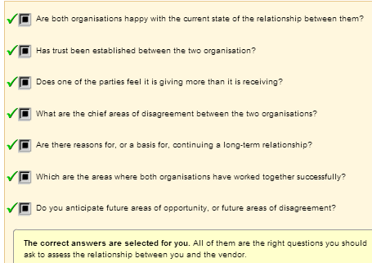

Manage the relationship

How can the relationship be managed between client and vendor? The following steps will help you build trust with your vendor.
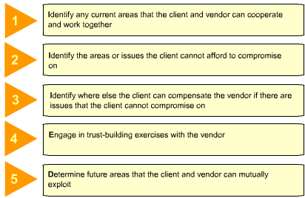

6. Contract Termination and Migration

6.1 Plan for contract Completion and Termination

Introduction
Nothing lasts forever. Unlike marriage, every outsourcing relationship/contract will end. Therefore, you should plan for the end even from the very beginning. Your leverage is best at the beginning. It is as if you draw up a "pre-nuptial agreement" at the beginning.

Turnback plan

You need to plan what to do when the contract ends. Basically, this is referred to as turnback. The purpose in planning for turnback is to accommodate the period between the expiration/termination date of your outsourcing contract and the time when you had reinstated your operation in-house or outsourced it to another vendor.

There are several events that may trigger a turnback, which are also the reasons for any contract termination:
a) Completion of the project/expiration of agreement
b) Breach of contract
c) Merger/acquisition of the organisations
d) Economic failure of either party

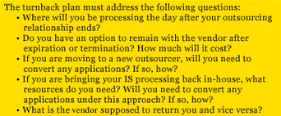

Contract termination
When your contract terminates, how do you make sure that you have the rights to the
hardware, software, and any other information assets that are residing in the vendor's organisation? As the Project Manager, it is advisable that you request that the vendor return all these assets.
The termination of an outsourcing contract creates a number of significant legal complexities that you are required to address. The contract should clearly describe the procedures for the termination of the IT activity.
Client data
Do you know who owns your data? You need to establish rights to your data because sometimes when the rights to the data are not specified, data that is still residing in your vendor's machines can 'conveniently' belong to them as well. When that happens, there will not be any confidentiality to your data.

Client software
A prime motivation for entering into an outsourcing relationship is the opportunity to access unique software that has to be used. In such cases, it is a critical decision for the user to define access to the software when the contract ends. Organisations may establish escrow arrangements in order to maintain the developed system even after the contract has been terminated.

Vendor's cooperation and assistance
When a contract ends, you will need your vendor's cooperation and assistance to ensure that the handover of the whole project is complete and successful. For instance, the next vendor should be able to go through the documentation written by the first vendor and once the new vendor is accepted, the first contract should end.

Vendor's disclosure of technical information
Over time, the technology used to run your system or application changes. It will be useful if the vendor discloses necessary technical information for the transition.

License for software owned by the vendor
You may continually need some of the software used by you for your system or application. Therefore, you should negotiate the licensing fees for the software used upfront, that is, at the beginning of the contract

License for software from a third party
You also need to negotiate the licensing fees for the software from a third party, but supplied by the vendor, for which you will have a continuing need.

Practical issues to consider
Besides legal issues, there are also several practical issues to consider when you are preparing for contract completion or termination. Basically, you need to consider:

Business implications
When you decide to terminate a contract, you need to consider the implications to your business. Would the termination affect your organisation's image or credibility? For instance, can you imagine a bank that cannot process cheques due to a system failure? The image of your bank would be at stake if you cannot provide customer service up to speed.

Operational implications
Other issues to consider are operational implications caused by the contract termination. For instance, what is the cost of putting up the infrastructure for your system? What is the lead time for putting it up?

Turnback effort
- The data and software hostage crisis - There are vendors who will hold your data or software hostage. If you do not have either a political or legal lever to recover your data or software, then your vendor has taken advantage of you.
- Uncooperative vendor- Even a vendor who does not hold hostages may not be very cooperative. When you are able to obtain your vendor's cooperation, you will save a lot of money, heartache and grief.
- Bringing outsource items in-house - If you decide to bring outsourced items back in-house, you need to consider if the effort in doing so is realistic. You should also consider any licensing issue.
- Transfer to another vendor - When you decide to transfer the current project to another vendor, be sure to come up with a new outsourcing agreement complete with the necessary details, such as a project schedule and milestones
In summary, the termination clause in the contract should be carefully structured to ensure that the decision for termination takes place without causing any disruption to the project. In particular, you must consider:
- Turnback issues and plans, and
- Legal and practical issues.

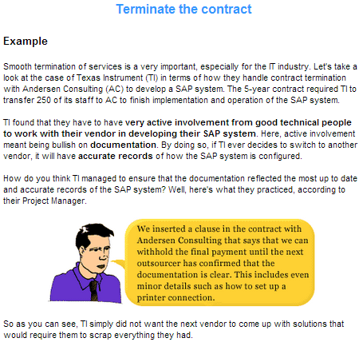
6.2 Manage contract completion and termination

Manage Contract Completion and Termination
Renew, terminate and migrate the contract
As contracts near the endpoint, the question the organisation faces is whether to renew the contract, look for a new vendor, or bring the service back in-house.

Before one can decide, the organisation has to do an re-examination of:
- The business need
- The performance of the existing arrangement
- Any new requirements
- The options for sourcing
Thinking from this stage may feedback the high-level direction setting as well as the process of acquiring a new service. This process mirrors the original acquisition but with the benefit of all the lessons learnt from acquiring and managing the previous contract.

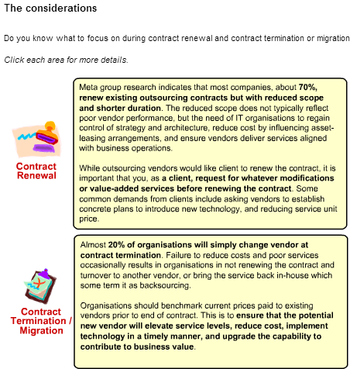
Example - Kodak

In 1989, Eastman Kodak Co. outsourced the company's data centre operations, in a
10-year, US$250 million deal with IBM Corp., Digital Equipment Corp. and Businessland Inc. It was the first well-known, successful enterprise to designate such a strategic concept of hiring vendors to run the company's computer system.

In 1992, computer seller JWP Inc. purchased Businessland and spun it off as Entex Information Services Inc. Consequently, it did not win a new Kodak contract when the initial Businessland's deal expired in 1995. Instead Kodak outsourced the work in a five-year deal with Tempe,an Arizona-based MicroAge Inc.
Likewise, Digital was acquired by Compaq Computer Corp in 1998 and it also failed to secure a second Kodak contract four years later. As for IBM, its initial outsourcing contract was renewed in 1998 and is good through 2005.

Read below on the lessons John J. Chiazza, Kodak's CIO, has learnt since signing the big deal in 1989

Keep the contracts short and simple
Ten years was too long for an outsourcing contract. Technological advancement and business trends change too much in a decade. Today, Kodak avoids anything longer than a five-year deal, and the contract language allows for much flexibility and liberty to be exercised/applied/employed.
We tended to get too specific in our initial contracts, but we’ve backed off from that. We rely more on relationship management today. We just don’t’ want people walking around and constantly referring to the contract.

Keep the relationship simple
When Kodak started outsourcing, the company employees didn’t know how to interact with four different companies (including their own) through four different channels. Subsequently, Kodak executives realised that their employees needed one unified way to access all services and service providers. Today, if users need IT help, they call one help number, and the appropriate service vendor responds. And to keep the vendors in concert, the CIO oversees the Supplier and Alliance Management Team that reviews operating issues and metrics .

Keep in touch
The CIO saw a danger signal that Kodak’s IT staff was losing touch with the end users. Only vendor personnel were interacting daily with Kodak’s non-IT employees. He determined then that he and his staff had to act as systems integrators. They must be the buffer between external service providers and internal end users. Now, he has his people keep a closer eye on the end users’ needs while he actively monitors the vendor relationships and services. I’m the gatekeeper of the company. The performance of the whole system is really my responsibility. If something is wrong, it’s not IBM’s problem; it’s my problem.

