

Software Entrepreneur
SG5013
Workshop 1

TEAM MEMEBRS:

A0079953 – LEE ZHONG DE ROLLEI
A0079949 – JIANG HAO MIN
A0080053 – CHONG CHEE YONG
A0006487 – KHINE PHYU PHYU THAN
A0079971 – TAN PIC CHENG

TABLE OF CONTENTS

1. Company Background 3
2. Names of Founders 3
3. Purpose of the company 3
4. Company Organization 4
5. Duties of Team members 4
6. Decision Making Process 5
7. Appendix: Resumes of Team members 6

1. Company Background
Virtual Stores – VS is a new start-up founded by 5 business entrepreneurs with diverse experiences in marketing, technologies evangelist and business development. The company is located and incorporated in Singapore on Jan 2013 with an initial capital of 50,000 SGD.

2. Names of Founders
- Chong Chee Yong
- Jiang Hao Min
- Khine Phyu Phyu Than
- Lee Zhong De Rollei
- Tan Pic Cheng

3. Purpose of the company

The principle purpose of the company to

- To develop virtual store software packages that will be sold to supermarket chains and departmental stores

- To assist supermarket chains and departmental stores to establish a new sales channel through the use of virtual store software packages

- Improves the lifestyle of busy shoppers by bringing virtual shopping experience to customers without them having to physically visit the stores.

The revenue will come from the sale of the software packages and consultancy in establishing virtual stores in train station, bus stops and airport transit waiting

4. Company Organization

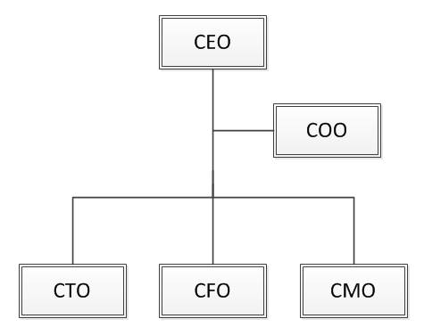

5. Duties of Team members

Team Member | Appointment | Duties
 | Chief Executive Officer (CEO) | Set organizational long term goals and lead the company in achieving the goals
 | Chief Operational Officer (COO) | Oversee the entire company day to day operation
 | Chief Technology Officer (CTO) | Evangelist, technology geek, product manager, quality assurance
 | Chief Financial Officer (CFO) | Budget projection, planning and reporting
 | Chief Marketing Officer (CMO) | Marketing, Sales and Delivery Strategies

6. Decision Making Process

Standard Decision Making
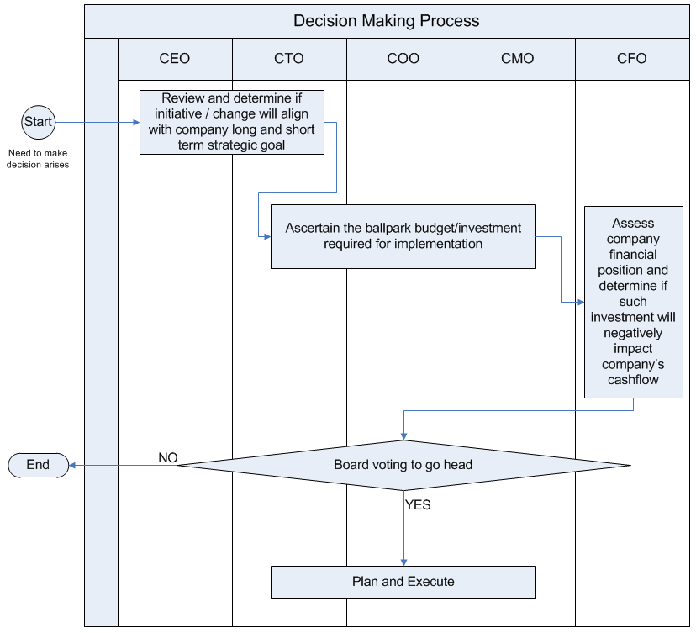
Fast track decision making
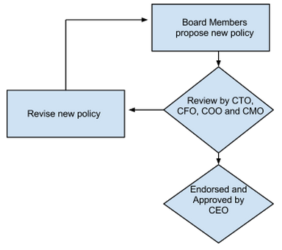

Sales Decision Making
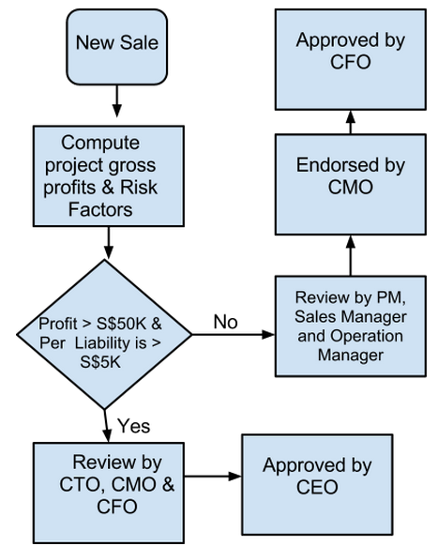

7. Appendix: Resumes of Team members

Khine Phyu Phyu Than
khinephyuphyu@nus.edu.sg

Summary
- about 5 years experience in Financial Field
- Graduated Master of Science in Financial Engineering (MFE) in 2010
- Have experience in financial management with local and international experiences and have an ability to control the cash flow of the company, make sure that all the financial data is recorded and manage well.

Objective
With much experience in financial planning in grocery store system, eager to be incorporated into business development and brand strategy team which will lead company to success.

Core Competencies and Strengths
- Good communication skills, oral and written
- understanding of complex financial strategies, financial modelling ability, and computational proficiency

Employment History
- Company Name B, Senior Financial Engineer, Jan 2010 - Present
- Company Name A, Financial Engineer, Jan 2008 - Dec 2009

Education
- Master of Science in Financial Engineering (MFE) in 2010, Risk Management Institute, National University of Singapore, SG.
- Bachelor in Financial Engineering, University of Economics, Yangon, Myanmar.

References
References available upon request.
Jiang Hao Min
h_m_jiang@nus.edu.sg

Summary
Hao Min has many years’ marketing management experience with international experience and proven ability to increase customer retention, expand market share and drive revenue. He also has many years’ management experiences on supervising, training and motivating sales staff. Increasing sales revenues. He got the MBA from National University of Singapore.

Objective
With much experience in marketing strategy in grocery store system, eager to be incorporated into business development and brand strategy team which will lead company to success.

Core Competencies and Strengths
- Effective communication skills, oral and written
- Good presentation and interpersonal skills

Employment History
- Company Name C, Senior Marketing Manager, Dec 2007 - Present
- Company Name B, Area Sales Manager, Jun 2003 - Nov 2007
- Company Name A, Senior Sales Executive, Jul 2000 - May 2002

Education
- MBA, Business School, National University of Singapore, SG.
- BS, Marketing, Sichuan University, CN.

References
References available upon request.

Chong Chee Yong
cheeyong.chong@nus.edu.sg

Summary
Chee Yong has developed various business and system software for multi-functional printers and consumer devices in his career as a Software Engineer spanning 12 years. He uses object-oriented techniques, and is skilled in Java web applications, and C/C++ system programming. Working together with Japanese partners, he currently leads a tiny team in a mission to develop a global web application. As a leader of his team, he also trains, and evaluates the work of his team members. Chee Yong has a BSc.(Honours) in Computer and Information Sciences from the National University of Singapore and is currently a candidate of the MTech.(Software Engineering) programme.

Objective
Chee Yong’s objective is to develop software that is widely useful to people in the world.

Employment History
- Senior Software Engineer, Fuji Xerox Asia Pacific Pte. Ltd., October 2003 – Present
- Software Engineer, Creative Technology Ltd., September 1999 – October 2002

Education
- Candidate, MTech (Software Engineering), ISS, NUS.
- BSc.(Hons.) in Computer & Information Sciences, NUS.

References

References available upon request.

LEE ZHONG DE ROLLEI
zhongde@gmail.com

Summary

10 years IT project management experience in managing projects with budget ranging from 2 – 10 millions in various financial institutes. 7 years experience in cross-border project implementation across Europe and South-East-Asia. Managed several high-profile projects e.g. international wide integrated security token used by multi-national banks for transaction authentication, authorization and to prevent non-repudiation. Multilingual with experience in working in countries with diverse cultures and social-political differences.

Objective

To provide project management consultancy to help business to excel in greater heights

Core Competencies and Strengths
- Extensive experience in strategic management and project management
- Effective communication skills, oral and written
- Good presentation and interpersonal skills
- Multi-lingual

Employment History
- Senior Principle Project Consultant, October 2003 – Present
- Senior Project Manager., September 1999 – October 2002

Education
- Master of Science in Financial Engineering (MFE) in 2010, Risk Management Institute, National University of Singapore, SG.
- Certified Chartered Financial Analyst (CFA)
- Certified Project Management Profession (PMP, PMI)

References
References available upon request.
TAN PIC CHENG
tanpiccheng@nus.edu.sg
Summary
Executive-Level Program Manager with 12 years of Information Technology (IT) and business management experience in both the public and private sector with key emphasis infrastructure management, billing and telecommunications, vendor management and program management.
Objective
An experienced Project Manager with strong communication skills, project management and excellent people management skills who has had the expertise and experience of managing multi-million projects within budget and timeline.

Ability to provide value proposition solutions to customers and stakeholders, resulting in overall increased customer satisfaction and high quality products. Highly reputed in IT industry for high customer retention in 80% of projects being managed by me.
Core Competencies and Strengths

- Good communication skills, oral and written
- Experienced in project management skills and ability to manage large scale multi-million projects maximizing resources and completing ALL projects on time and on budget.
Employment History

- Executive Program Director, Current Employer, May 2002 to Present
- Senior IT Project Manager , May 2000 to April 2002
Education
- Master of Technology (Software Engineering), National University of Singapore, Singapore
- Bachelor of Engineering (Electrical), National University of Singapore, Singapore.
- IT Infrastructure Library (ITIL) Foundation Certificate in IT Service Management, 2006
- Project Management Professional (PMP), Certified through Project Management Institute (PMI), 2003
References
References available upon request.

