

Software Entrepreneur
SG5013
Workshop 2

TEAM MEMEBRS:

A0079953 – LEE ZHONG DE ROLLEI
A0079949 – JIANG HAO MIN
A0080053 – CHONG CHEE YONG
A0006487 – KHINE PHYU PHYU THAN
A0079971 – TAN PIC CHENG

TABLE OF CONTENTS

1. Company Background 3
2. Names of Founders 3
3. Purpose of the company 3
4. Company Organization 4
5. Duties of Team members 4
6. Decision Making Process 5
7. Appendix: Resumes of Team members 6

1. Company Background
Virtual Groceries Place – VGP is a new start-up founded by 5 business entrepreneurs with diverse experiences in marketing, technologies evangelist and business development. The company is located and incorporated in Singapore on Jan 2013 with an initial capital of 50,000 SGD.

2. Business Opportunity

With the prevalence of world-wide-web and secured online payment, more people is buying online. Some of the factors that attract customer to buy online are the convenience, competitive prices and the wide varieties of selection available online. The availability of fast mobile internet connectivity in Singapore has also enabled customers to do online shopping using their smartphone while on-the-go. The convenience of shopping while on-the-go allows busy professionals to make full use of their valuable time.

One type of shopping that can be conveniently done online via mobile application while on-the-go is groceries shopping. Imagine you have to rush home to cook dinner for your family but you do not have the ingredients, with the mobile app, you could quickly order the ingredients from your pre-created favorite list and while on your way home pick-up the ingredients from a supermarket of your choice.

Though there are already existing online groceries stores, these websites only provide basic functionalities and are not intuitive enough to attract customers to continuously shop with them. Other smaller supermarket chain may be reluctant to develop and build their own mobile application due to its substantial initial investment cost.

A potential business opportunity is to develop an attractive and intuitive mobile application where small/large supermarkets could tap on this mobile application to sell their goods online. The business profit model used will be the transaction based fee model. i.e. Supermarkets that taps on this mobile application will only have to pay for a small sum of transaction fee for each purchase transacted using our mobile app. There will be zero initial investment/maintenance cost. Hence, this will break the barrier for smaller supermarket chain where investment cost is a concern.

Service Objective

To make use of various technologies to create a platform

To enable the use of QR technology to allow for the following 2 objectives as listed below:

- Users can experience virtual groceries shopping anytime, anyplace at the their convenience or;
- Users can make purchases directly using their smartphones at the physical stores and have the luxury of free delivery service;

Service Concept

Major supermarkets have been advertising promotions for their groceries through pamphlets, newspaper and online avenues. Therefore, this service offering to provide Virtual Groceries Shopping Experience via mobile apps provides a win-win solution for both supermarkets and its customers.

For supermarkets, this is another alternative on top of their existing advertising way to increase their source of revenue for themselves. To the customers, they can purchase their groceries
Conveniently using this apps and have their purchases delivered right to their doorsteps - all these without being at the store themselves. Another advantage is that customers are entitled to free delivery service if they were to use the apps for shopping at the stores themselves.

We strongly believe that this service is both a utilitarian (supermarket - increased revenue) and hedonic (purchase groceries using smartphone service provides convenience, no queuing and free delivery and free delivery service rendered for physical shopping) need for both the supermarkets and customers.

As such, we began our research on the online grocery stores of most major supermarkets in Singapore. From our findings, we discovered that most online stores are not user-friendly with a rather disorganised and clutter layout of grocery items.

Below are 2 screenshots we have captured from NTUC Fairprice to substantiate our findings as mentioned above.

Clutter Home Page - Disorganized arrangement with badly organized images

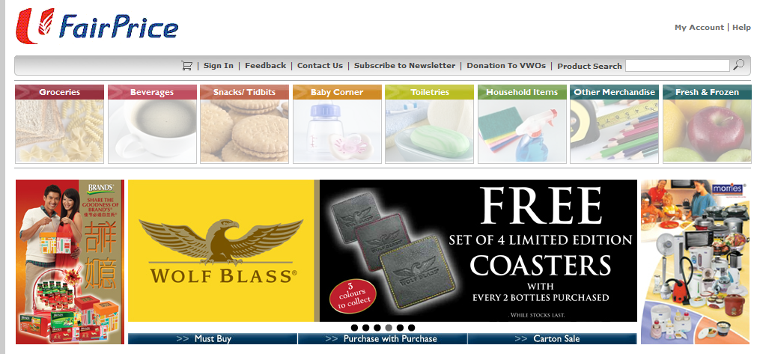
Search Page: Layout of grocery items not user-friendly and cluttered layout

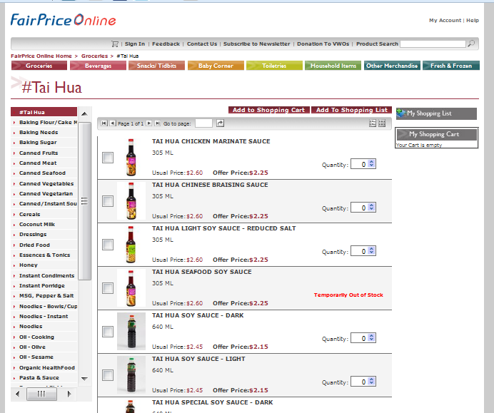

In addition to our findings, most supermarkets advertise their groceries promotions regularly via pamphlets, newspaper and posters. What this VS mobile apps can do is to tap onto their existing promotions to insert the VS QR code on these advertisements. What the customers need to do is to scan the QR code to download the VS mobile apps on their smartphones. Once they have this apps, they can start their journey on a virtual grocery shopping experience to achieve the 2 objectives for this project.

The 2 objectives that this apps can achieve are again re-iterated through pictorial illustrations as listed below.

Objective 1: Perform online grocery shopping

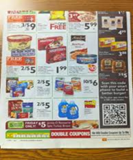*  1 – User saw the QR code on advertisement | *  2 – User scans the QR code to download groceries apps
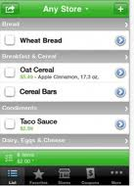*  3 – User starts online groceries shopping using apps | 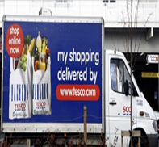*  4 – Supermarket delivers groceries
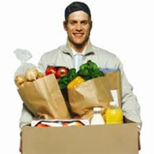  5 – Delivery man arrives at door | 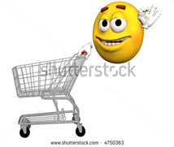*  6 – Happy Experience

Objective 2: Perform grocery shopping in store by using apps

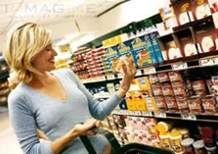  1 – User selects groceries at supermarket | *  2 – User uses apps to add grocery items into online shopping cart. User makes payment via apps
*  3 – User proceeds to counter for free delivery service | *  4 – Supermarket delivers groceries
*  5 – Delivery man arrives at door | *  6 – Happy Experience

This product can also expand to cover additional scope such as:

- Shared shopping cart. The sharing cart can be shared among members of the family
- Shopping credits for micro-payment
- business analytics to analyse the users’ purchase histories and identify trends to recommend suitable products to existing users.
- Follow shoppers comments of the products
- Product Recipes
- Rewards Programme (points system)
- Provision of interesting information about the grocery e.g.
  - source country
  - nutrition information
  - recommended consumption date
  - handling/storage instructions
4. Description of who is expected to buy it
- Geographical area
- Demographic segment
- Special features
The mobile application that will be developed will attract a wide range of users due to its convenience, time saving and

- Busy White-collar Office People: Since their works are very busy and work overtime is very frequent, so they may not have enough time to go to super market. Even they can buy the goods from 24-hours convenience store, but the good categories and brands are quite limited. So it cannot satisfy them. Otherwise, white-collar people always like reading newspaper or browsing online during their idle time. So it’s possible to put the QR-code beside the promotion advertisement, so they can use their mobile to scan it and quickly purchase the goods.
- People with No Fix Working Time: Since this kind of people’s working time is not fixed, so they may have the adequate idle time during the day. Sometimes, they may go shopping or visit supermarket. But they cannot buy the big size goods. Because they still need meet their following customers or doing other works. If the supermarket provides the delivery service, that will be more convenience for them.
- Injured People: This kind of people is also the potential customers for this service. Since they’re injured, they cannot go outside. But they still need the daily necessities and food. So they can use the online service to make the order and supermarket staff will deliver the goods to their house.
- Indoorsman: Some people don’t want to go outside during their leisure time. But they still need buy the necessary goods. If supermarket provide such services, that will be good for them.
- People with Urgent Things: This kind of people may visit supermarket to choose the goods what they want. But they cannot carry the goods back to their house since they have some urgent things or go to other places. They wish the supermarket to deliver the goods for them.
- Old People: Old people want to visit the supermarket to buy some goods in the promotions. But the goods may very heavy for them to carry. So they prefer to choose the goods and deliver by the supermarket staff.

Personas
- Persona 1 - Busy White-collar
Name | Richard Lim
Age | 30
Gender | Male
Occupation | Business Analyst
Description | Richard Lee works as business analyst in a Fortune 500 company. His work is very busy and work overtime very frequent. After he finishes his work, he is too tired to go to supermarket to buy the daily necessities. He can only go to 24-hours convenience store. But the categories are too limited to satisfy him. So he prefers to go to the supermarket.

- Persona 2 - Sales Person
Name | Cindy Ng
Age | 26
Gender | Female
Occupation | Insurance Sales
Description | Cindy Ng works as sales in Prudential Insurance Singapore Company. She need visit her customers in different places everyday. During the gap, she goes shopping or visits the supermarket. Normally, she just buys small items and put into her bag since she need meet customer. Supermarket may have promotions sometimes, she doesn’t want lose the chance to enjoy lower price or win some free gifts. But she cannot carry lots of goods to meet customer.

Scenarios
- Scenario 1 - Busy White-collar
Richard Lim works as Business Analyst in a fortune 500 company. He is very busy when he is in the office. Today, he wants to buy some snacks and daily necessities since he doesn’t have enough stock.
When he has lunch, he read the newspaper. From the newspaper, he finds some his favorites snacks which are in the promotion. So he gets his mobile and open VS Mobile Application to scan the QR code beside the promotion information on the newspaper. Then VS Mobile App access online supermarket and open the promotion screen based on the scanned QR code.
He choose his favorite biscuits and chocolates on the promotion screen. These items are put into his online shopping cart. Suddenly, he remembers that he also need buy some daily necessities. He navigate from the categories menu and find those items which he wants. Those item are also put into his online shopping cart. He proceed to view his shopping cart and alter the quantities of his chosen items.
After he finishes updating all the quantities of the items in shopping cart, he touches on the “Checkout” button from the shopping cart screen. System directs to the delivery mode and timing screen. He chooses to deliver to his house between 9 pm and 10 pm tomorrow since he can go back earlier tomorrow. Then he input his credit card info and confirm the payment.
On the following day, he received all the ordered items on time. He’s happy with the online supermarket.
- Scenario 2 - Sales Person
Cindy Ng works as Sales in Prudential Insurance Singapore Company. Today, she just finished her meeting with previous customer. For her next customer’s meeting up, there are one and half hours gap. Then she decides to go to supermarket to take a look.
She moves to the nearest NTUC FairPrice supermarket. She’s very lucky today since almost the goods are in the promotion. She gets her mobile and open VS Mobile App. Since she is the member of Virtual Store, she logon her account. Then she looks through all the products which are in the promotions. She uses VS Mobile App to scan the QR code on the product price menu. So that item will be added into her online shopping cart.
After she finds all the items, then she edits the quantities for some items. She choose the delivery mode and timing. Since she is the member of VS, she can enjoy the free delivery. She would like to pay cash. So she choose the “Cash Payment”. System generates a QR code on her mobile. She goes to the Customer Service desk and shows them the generated QR code. NTUC staff scan the QR code and proceed the cash payment.
Finally, she purchases those items with lower price. NTUC FairPrice staff will deliver her goods on the following day. She’s happy and go to meet her next customer.
5. Explanation of the technology background
- Any new or innovative technology
- Any service enabling component you need to build
- Any associated risks, an how they will be managed

Service stack
- infrastructure
- world wide web, HTTPS
- enabling technology
- QR code
- Cloud computing
- e-payment

ZD: there is a need for micro-payment
- service enabling product
- smart phone with
- Internet connectivity
- Camera
- ability to run application
- service
- application to scan QR code of a product advertisement and facilitates its purchase
- application to scan QR code of an actual good to facilitate its payment

Describe the Technology
QR code is a kind of barcode that can be scanned with a camera instead of lasers. Smart phones equipped with cameras can be used to capture the QR codes and process them.
QR codes can encode information about the service that we will provide. First we need to generate these barcodes and apply them to the advertisements. When the customer scans the QR code on the advertisement, an application is required to process the QR code and facilitate the purchase. To facilitate the purchase, a query over the Internet to a service is required to determine the status of the advertisement. If it is available for purchase, the application will request the customer to input the amount, and payment information, to create a purchase order. The application then forwards the order to the server to complete the purchase. All information needs to be transferred securely.
The application needs to be developed for smart phones. Both Apple iOS and Android application could be developed. Both have freely available SDKs. For iOS, the main programming language used is objective-c. For Android, the main programming language is Java. To deploy the application into an iOS phone, Apple's App Store needs to be used. For Android phones, Google Play could be used.
For the server, web services would be considered. This can be typically implemented using Java EE servlet technologies; or popularly using php or python. This can be deployed with a cloud provider, e.g. Google App Engine or Amazon EC. (Risk: downtime)
Information about the advertised goods is required, and also to submit purchases. This would require integration to the supermarket's system for queries, and also to submit purchases.

Risks
Lack of standardization?
6. Reason why you believe this service is desired and will sell

Online groceries shopping are still rather new in Singapore as Singapore is generally small and nearby supermarkets are just 10 minutes away. But customers are getting more affluent, they value their time more, they want to do groceries shopping at the comfort of their own home without having to visit the crowded supermarkets (esp on weekends when everyone do their weekly groceries shopping), push the trolley around, queue up for payment and lugging home heavy, bulky grocery bags.

7. Reason why this service, if it’s so good, why isn’t already on offer

Some typical issue,
  - Big stores like cold storage tend to take longer delivery time

8. Appendix: brief third party description of relevant technologies

