

Software Entrepreneur
SG5013
Workshop 2

TEAM MEMEBRS:

A0079953 – LEE ZHONG DE ROLLEI
A0079949 – JIANG HAO MIN
A0080053 – CHONG CHEE YONG
A0006487 – KHINE PHYU PHYU THAN
A0079971 – TAN PIC CHENG

TABLE OF CONTENTS

1. Company Background 3
2. Business Opportunity 3
3. Service Description 4
3.1 Service 4
3.2 Service Concept 4
4. Market 10
4.1 Potential Customer 10
4.2 Persona 11
4.3 Scenarios 12
5. Technology Background 13
5.1 Service stack 13
5.2 QR code 13
5.3 Mobile Service 13
5.4 Backend Integration 13
6. Conclusion 14

1. Company Background
Virtual Groceries Place – VGP is a new start-up founded by 5 business entrepreneurs with diverse experiences in marketing, technologies evangelist and business development. The company is located and incorporated in Singapore on Jan 2013 with an initial capital of 50,000 SGD.

2. Business Opportunity

With the prevalence of world-wide-web and secured online payment, more people is buying online. Some of the factors that attract customers to shop online are the convenience, competitive prices and the wide varieties of selection available online. The availability of fast mobile internet connectivity in Singapore has also enabled customers to do online shopping using their smartphone while on-the-go. The convenience of shopping while on-the-go allows busy professionals to make full use of their valuable time and been increasingly a phenomenon.

One type of online shopping that can be conveniently done via mobile application while on-the-go is groceries shopping. Imagine you have to rush home to cook dinner for your family but you do not have the ingredients, with the mobile app, you could quickly order the ingredients from your pre-created favorite list and while on your way home pick-up the ingredients from a supermarket of your choice.

Though there are already existing online groceries stores, these websites only provide basic functionalities and are not intuitive enough to attract customers to continuously shop with them. Other smaller supermarket chain may be reluctant to develop and build their own mobile application due to its substantial initial investment cost.

A potential business opportunity is to develop an attractive and intuitive mobile application where small/large supermarkets could tap on this mobile application to sell their goods online. The business profit model used will be the transaction based fee model. i.e. Supermarkets that taps on this mobile application will only have to pay for a small sum of transaction fee for each purchase transacted using our mobile app. There will be zero initial investment/maintenance cost. Hence, this will break the barrier for smaller supermarket chain where investment cost is a concern.

3. Service Description

3.1 Service
To establish an online mobile application platform

- for supermarket chain to reach up to more consumers and sell their products to these customers

- for customers to buy groceries using the established mobile platform

The service objective is to capitalize on Mobile and QR technologies to achieve the following:

- Improve customer’s lifestyle by providing easy and convenient way for them to conduct groceries shopping online anytime, anywhere and have the their purchases delivered to their doorstep

- Allow customers at the physical stores to avoid long queues. Customers could browse the products in the physical store, order the product by scanning its QR code submit the orders when done. The orders will them be delivered to their doorsteps.

- Enhance customers experience in online groceries shopping by providing functions that will help customers to organize their groceries shopping list, take advantage of discount coupons (QR code), participate in online community discussion for cooking secrets and receive promotion notifications

3.2 Service Concept
Major supermarkets have been advertising promotions for their groceries through pamphlets, newspaper and online avenues. Therefore, this service offering to provide Virtual Groceries Shopping Experience via mobile apps provides a win-win solution for both supermarkets and its customers.

For supermarkets, this is another alternative on top of their existing advertising way to increase their source of revenue for themselves. To the customers, they can purchase their groceries conveniently using this app and have their purchases delivered right to their doorsteps - all these without being at the store themselves. Another advantage is that customers are entitled to free delivery service if they were to use the apps for shopping at the stores themselves.

The proposed service can be both a utilitarian (supermarket - increased revenue) and hedonic (purchase groceries using smartphone service provides convenience, no queuing and free delivery and free delivery service rendered for physical shopping) need for both the supermarkets and customers.
Some research conducted also reveal that the existing online groceries stores design were rather disorganized, not-user friendly and seeming too complex to use.
Below are 2 screenshots captured from NTUC Fairprice to substantiate our findings as mentioned above.

Clutter Home Page

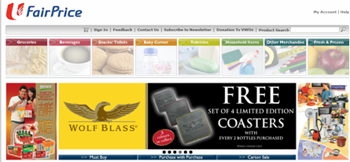s

Search Page: Layout of grocery items not user-friendly and cluttered layout
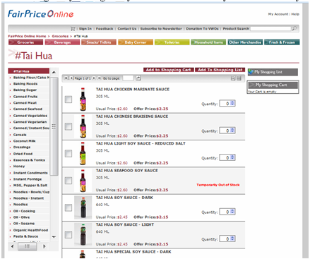
Most supermarkets advertise their groceries promotions regularly via pamphlets, newspaper and posters. It may be feasible to tap onto these existing hardcopy advertisements to promote the use of VS app by providing a QR code to download the VS mobile app. What the customers need to do is to scan the QR code to download the VS mobile apps on their smartphones. Once the customers have the app installed in their smartphones, they can start using the app to access the promotion they see in the pamphlets, newspaper etc. Customer will also be able to receive promotion notification via the app they installed.
Existing VS mobile app user can also download coupons via QR code and use it at the physical or virtual stores.

Example on the usage on VS mobile app.

Objective 1: Perform online grocery shopping

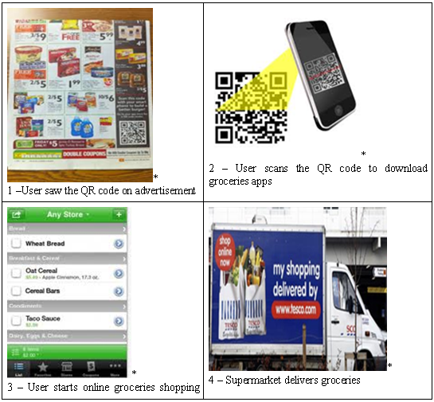
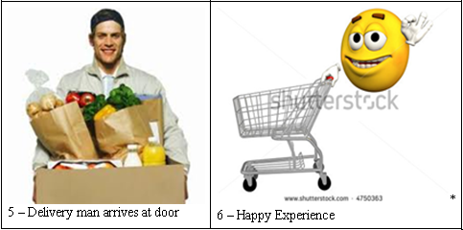

Objective 2: Perform grocery shopping in store by using app
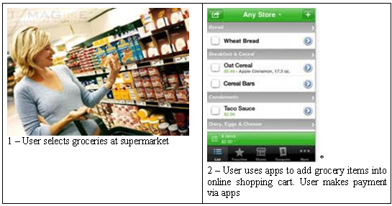
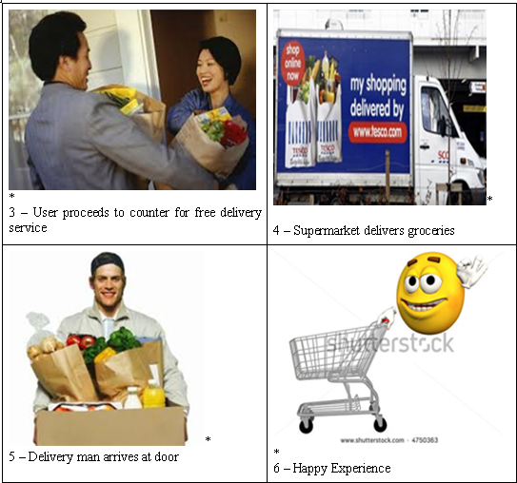

The mobile application that will be developed will cover the following functionalities

- Shared shopping cart. The sharing cart can be shared among members of the family. Any members of the family can add purchases to the shopping cart.

- Shopping credits for micro-payment

- Business analytics to analyze the users’ purchase histories and identify trends to recommend suitable products to existing users.

- Follow shoppers comments of the products

- Product Recipes

- Rewards Programme (points system)

- Provision of essential information about the grocery e.g.
  - source country
  - nutrition information
  - recommended consumption date
  - handling/storage instructions

4. Market

4.1 Potential Customer
The expected customers of VS are categorized as the followings:
Busy White-collar Office People:
Since their works are very busy and work overtime is very frequent, so they may not have enough time to go to super market. Even they can buy the goods from 24-hours convenience store, but the good categories and brands are quite limited. So it cannot satisfy them. Otherwise, white-collar people always like reading newspaper or browsing online during their idle time. So it’s possible to put the QR-code beside the promotion advertisement, so they can use their mobile to scan it and quickly purchase the goods.
People who work with shift:
Since this kind of people’s working time is not fixed, so they may have the adequate idle time during the day. Sometimes, they may go shopping or visit supermarket. But they cannot buy the big size goods. Because they still need meet their following customers or doing other works. If the supermarket provides the delivery service, that will be more convenience for them.
Injured/handicap users:
This group of user is also the potential customers for this service. Since they’re injured, they cannot go outside. But they still need the daily necessities and food. So they can use the online service to make the order and supermarket staff will deliver the goods to their house.
Indoorsman
Some people don’t want to go outside during their leisure time. But they still need buy the necessary goods and unfortunately their home is n. If supermarket provide such services, that will be good for them.
People with Urgent Things:
This kind of people may visit supermarket to choose the goods what they want. But they cannot carry the goods back to their house since they have some urgent things or go to other places. They wish the supermarket to deliver the goods for them.
Elderly folks:
Elderly folks want to visit the supermarket to buy some goods in the promotions. But the goods may very heavy for them to carry. So they prefer to choose the goods and deliver by the supermarket staff.

4.2 Persona
- Persona 1 - Busy White-collar
Name | Richard Lim
Age | 30
Gender | Male
Occupation | Business Analyst
Description | Richard Lee works as business analyst in a Fortune 500 company. His work is very busy and work overtime very frequent. After he finishes his work, he is too tired to go to supermarket to buy the daily necessities. He can only go to 24-hours convenience store. But the categories are too limited to satisfy him. So he prefers to go to the supermarket.

- Persona 2 - Sales Person
Name | Cindy Ng
Age | 26
Gender | Female
Occupation | Insurance Sales
Description | Cindy Ng works as sales in Prudential Insurance Singapore Company. She need visit her customers in different places everyday. During the gap, she goes shopping or visits the supermarket. Normally, she just buys small items and put into her bag since she need meet customer. Supermarket may have promotions sometimes, she doesn’t want lose the chance to enjoy lower price or win some free gifts. But she cannot carry lots of goods to meet customer.

4.3 Scenarios
Scenario 1 - Busy White-collar
Richard Lim works as Business Analyst in a fortune 500 company. He is very busy when he is in the office. Today, he wants to buy some snacks and daily necessities since he doesn’t have enough stock. .
When he has lunch, he read the newspaper. From the newspaper, he finds some his favorites snacks, which are in the promotion. So he gets his mobile and open VS Mobile Application to scan the QR code beside the promotion information on the newspaper. Then VS Mobile App access online supermarket and open the promotion screen based on the scanned QR code.
He choose his favorite biscuits and chocolates on the promotion screen. These items are put into his online shopping cart. Suddenly, he remembers that he also need buy some daily necessities. He navigate from the categories menu and find those items which he wants. Those item are also put into his online shopping cart. He proceed to view his shopping cart and alter the quantities of his chosen items.
After he finishes updating all the quantities of the items in shopping cart, he touches on the “Checkout” button from the shopping cart screen. System directs to the delivery mode and timing screen. He chooses to deliver to his house between 9 pm and 10 pm tomorrow since he can go back earlier tomorrow. Then he input his credit card info and confirm the payment.
On the following day, he received all the ordered items on time. He’s happy with the online supermarket.
Scenario 2 - Sales Person
Cindy Ng works as Sales in Prudential Insurance Singapore Company. Today, she just finished her meeting with previous customer. For her next customer’s meeting up, there are one and half hours gap. Then she decides to go to supermarket to take a look.
She moves to the nearest NTUC FairPrice supermarket. She’s very lucky today since almost the goods are in the promotion. She gets her mobile and open VS Mobile App. Since she is the member of Virtual Store, she logon her account. Then she looks through all the products which are in the promotions. She uses VS Mobile App to scan the QR code on the product price menu. So that item will be added into her online shopping cart.
Ater she finds all the items, then she edits the quantities for some items. She choose the delivery mode and timing. Since she is the member of VS, she can enjoy the free delivery. She would like to pay cash. So she choose the “Cash Payment”. System generates a QR code on her mobile. She goes to the Customer Service desk and shows them the generated QR code. NTUC staff scan the QR code and proceed the cash payment.
Finally, she purchases those items with lower price. NTUC FairPrice staff will deliver her goods on the following day. She’s happy and go to meet her next customer.

5. Technology Background

5.1 Service stack
The service infrastructure is the world wide web. The main enabling technologies are QR code and cloud computing. The main service enabling product is a smart phone with the ability to run application, connect to the Internet, and camera function. The service would be provided by a set of mobile and server side applications that scans the QR code and facilities purchases.

5.2 QR code
QR code is a kind of barcode that can be scanned with a camera instead of lasers. Smart phones equipped with cameras can be used to capture the QR codes and process them. These smart phones are small and light enough to be carried by our target customers everyday.
First we need to generate these barcodes and apply them to the advertisements. QR codes will encode information about the services, which we provide. The use of QR codes is widely used enough that it would not be obsolete quickly. However, the methods of how to encode contents are not Internationally standardized. To allow generic QR code readers to work with our service to some extent, a de-facto standard such as defined by Japan’s NTT DoCoMo, might be followed.

5.3 Mobile Service
When the customer scans the QR codes on these advertisements with his smart phone, an application will process the QR codes and facilitate purchases. To facilitate the purchase, a query over the Internet to our service is required to determine the status of the advertisement. If it is available for purchase, the application will request the customer to input the amount, and payment information, to create a purchase order. The application then forwards the order to the server to complete the purchase. All information needs to be transferred securely, such as with SSL. Integration with the retailers’ systems will be required to complete certain transactions, such as for stock quantity queries and purchases. Payment systems would also be integrated.
A mobile application needs to be developed for smart phones. This can be either a mobile web site, or native phone application. The mobile web site allows us to cover the case where we could not develop native applications for the phone. In terms of native application, both Apple iOS and Android applications could be developed, and both have freely available SDKs. For iOS, the main programming language used is objective-c. For Android, the main programming language is Java. To deploy the application into an iOS phone, Apple's App Store needs to be used. For Android phones, Google Play could be used.

5.4 Backend Integration
Also a server side application needs to be developed to tie the entire service together from the mobile application to the retailers’ systems. This can be typically implemented using Java EE servlet technologies, php or python.
The issues of security shall be considered. All communications, transactions, and personal data would be encrypted; privacy and data laws need to be applied. In terms of scalability and availability, the server side application would be designed for such, and hosted with a cloud provider that can guarantee the qualities required, e.g. Google App Engine or Amazon EC.

6. Conclusion

In the past, online groceries shopping did not take off, could be due to the following reasons:

- Lack of mobile internet connectivity, customer cannot shop while on-the-go.
- Absence of secured payment
- Singapore is generally small and nearby supermarkets are just 10 minutes away.
- Skeptical of the delivery service.
- Non-IT savvy

However with the improved network infrastructure, secured payment and increasing number of IT savvy customers, online shopping has already become a norm.

Singapore is also becoming a vibrant city with extremely fast pace environment, people are getting more affluent due to the improvements in standard of living, they value their time more, they want to do groceries shopping on-the-go to save time instead of having to visit the crowded supermarkets (esp on weekends when everyone do their weekly groceries shopping), push the trolley around, queue up for payment and lugging some heavy, bulky grocery bags home.

Hence, the demand for such service (mobile groceries app ) is increasingly growing.

This service will be mostly desired by the busy professional, elderly and disabled person for the various reasons discussed above. It can help these users to save their time and energy and at the same time allow them to enjoy free delivery provided. Using the self-checkout system at the physical store, customers can save more time to avoid long queues.

References
http://en.wikipedia.org/wiki/QR_code#Standards

