REVIEW III — Integrated System & Final Demonstration

Library Management System
Student: Suyash Singh
Register number: 24BYB0078
Course: BCSE302L / BCSE302P Database Systems Lab
Faculty / slot: Ramkumar T / G1
Institution: Vellore Institute of Technology

1. Review III requirements and evidence
Evaluation component | What this submission shows
Integrated Database Operation (2 marks) | Browser → Flask API → Oracle; seven linked tables, constraints, stock triggers and fine creation.
Five Real-World Transactions (3 marks) | Register member, add book, issue book, return overdue book, mark fine paid. Each operation has an explanation and its own screenshot immediately below it.
SQL/PLSQL Interaction (2 marks) | issue_book, return_book, overdue_days, calculate_fine, two triggers, bound SQL queries and an overdue cursor.
Output & Reports (1 mark) | Live dashboard, overdue report, fine totals and cursor output from Oracle.
Report & Documentation (1 mark) | ER diagram, seven-table purpose, five operation walkthroughs, verification and source references.

2. Integrated system and seven tables
The librarian uses the browser to maintain books and borrowers. JavaScript sends requests to Flask. Flask validates the input, runs bound SQL or calls Oracle PL/SQL, commits successful writes and rolls back Oracle errors. Oracle foreign keys and checks protect the data, while triggers keep book stock consistent. The screenshots in this document were captured from the running website with /api/status reporting connected: true and demo_mode: false.
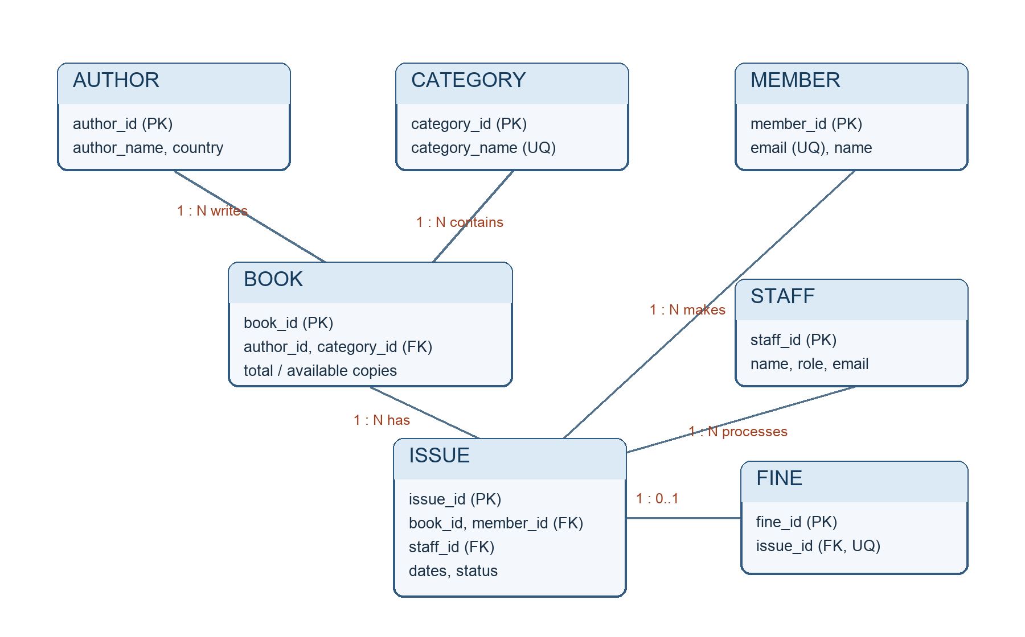
ER diagram for the seven related tables
Table | Use in the library | Link to other tables
AUTHOR | Stores each writer once. | One author can write many books.
CATEGORY | Groups titles for filtering and reports. | One category can contain many books.
BOOK | Stores title, price, total copies and available copies. | References AUTHOR and CATEGORY; one book can have many issues.
MEMBER | Stores borrower details and membership type. | One member can borrow many times. Email must be unique.
STAFF | Identifies the librarian handling a loan. | One staff member can handle many issues.
ISSUE | Records each loan, due date, return date and status. | References BOOK, MEMBER and STAFF; its triggers change available stock.
FINE | Records a positive late fee and Paid/Unpaid status. | References one ISSUE; issue_id is unique, so an issue has at most one fine.
ISSUE is the central transaction table. Its book, member and staff foreign keys join the catalog to a real borrowing event. Primary keys identify rows; foreign keys reject missing parents; unique, check and default constraints prevent duplicate emails, invalid status values and invalid copy counts. Full definitions are in sql/schema.sql.

3. Five meaningful real-world operations
The following screenshots show the relevant live Oracle-backed application screens. Capturing them did not change the database. The observed Oracle results cited below came from reversible transaction verification; those test writes were rolled back to preserve the sample data. A successful operation performed through the UI commits normally.

Operation 1 — Register a member
Why: A borrower must exist before a book can be issued to them. The librarian enters a name, unique email, optional phone and membership type on Members → Register Member. Flask inserts into MEMBER; Oracle supplies the join date and enforces unique email and membership-type checks. The new member becomes selectable on the Issue Book form.
SQL/verification: INSERT INTO MEMBER (...) VALUES (...); verify with SELECT member_id, name, email, membership_type FROM MEMBER WHERE email = :email. In a reversible Oracle check, MEMBER 11 (Review 3 Test Member, Student) appeared, and rollback restored the original count of 10.
Screenshot — Register Member form:
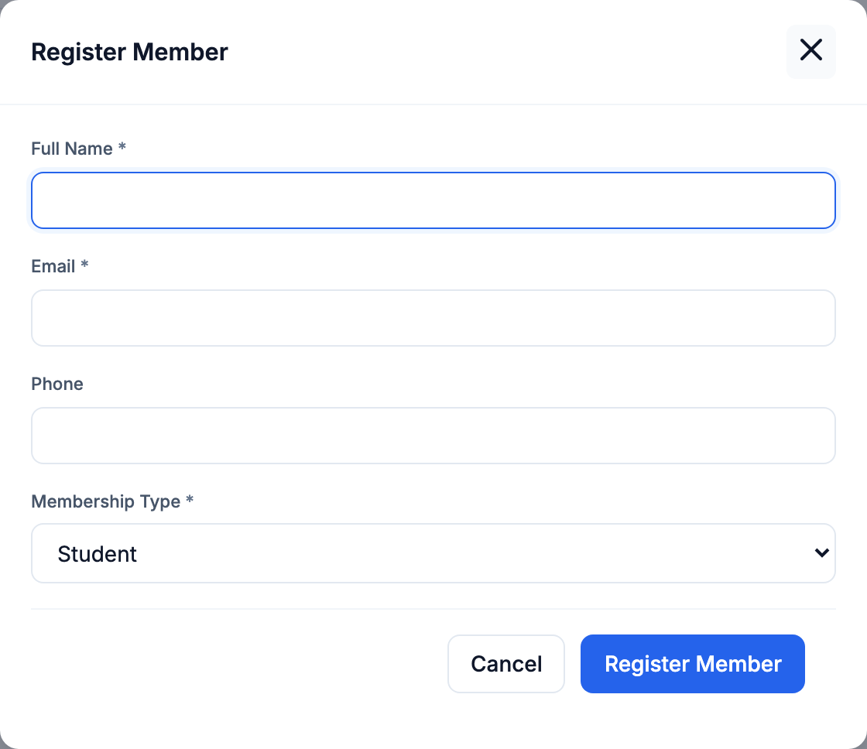
Operation 1: live Register Member form

Operation 2 — Add a catalog book
Why: A title needs an author, category, price and stock count before it can be lent. On Books → Add Book, the librarian selects existing AUTHOR and CATEGORY rows and enters the title, price and total copies. Flask inserts BOOK with available_copies = total_copies; Oracle checks the two foreign keys, positive price and valid copy range.
SQL/verification: INSERT INTO BOOK (...) VALUES (...); verify with SELECT book_id, title, total_copies, available_copies FROM BOOK WHERE book_id = :book_id. In a reversible Oracle check, BOOK 11 was added with 2 total and 2 available copies; BOOK count changed 10 → 11 and returned to 10 after rollback.
Screenshot — Add Book form:
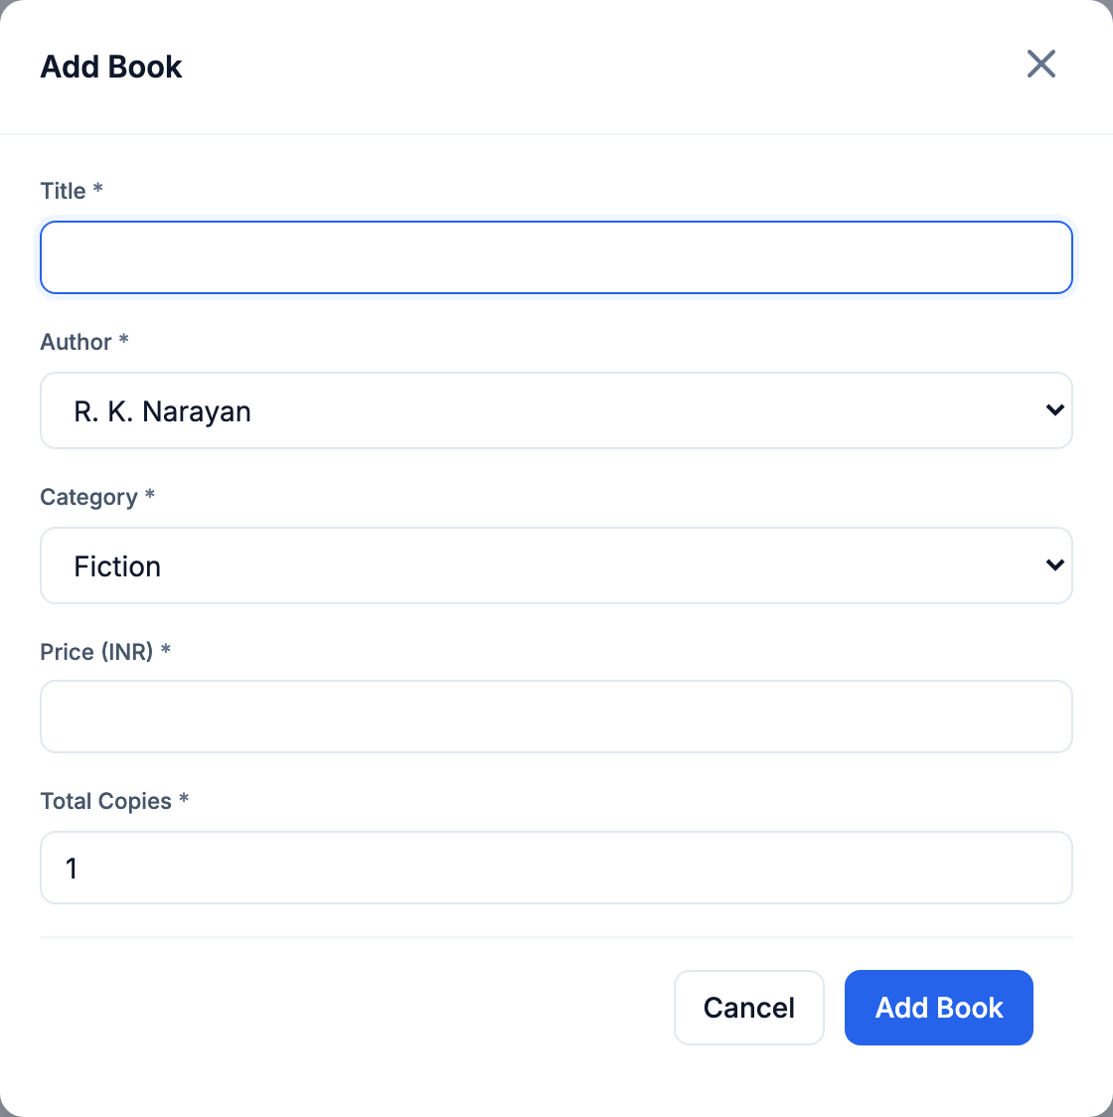
Operation 2: live Add Book form

Operation 3 — Issue an available book
Why: The librarian selects a member, available book, staff member and due date on Issue Book. Flask calls the issue_book procedure. The procedure inserts an ISSUE row, then trg_issue_insert rejects zero stock or decrements BOOK.available_copies once. This keeps the loan and stock change in one Oracle transaction.
SQL/verification: BEGIN issue_book(:issue_id, :book_id, :member_id, :staff_id, :due_date); END; Then check ISSUE.status and BOOK.available_copies. In reversible verification, ISSUE 16 became Issued and BOOK 1 availability changed 4 → 3; rollback removed the issue and restored 4 copies. The currently committed issue history is shown after the form.
Screenshot — Issue Book form:
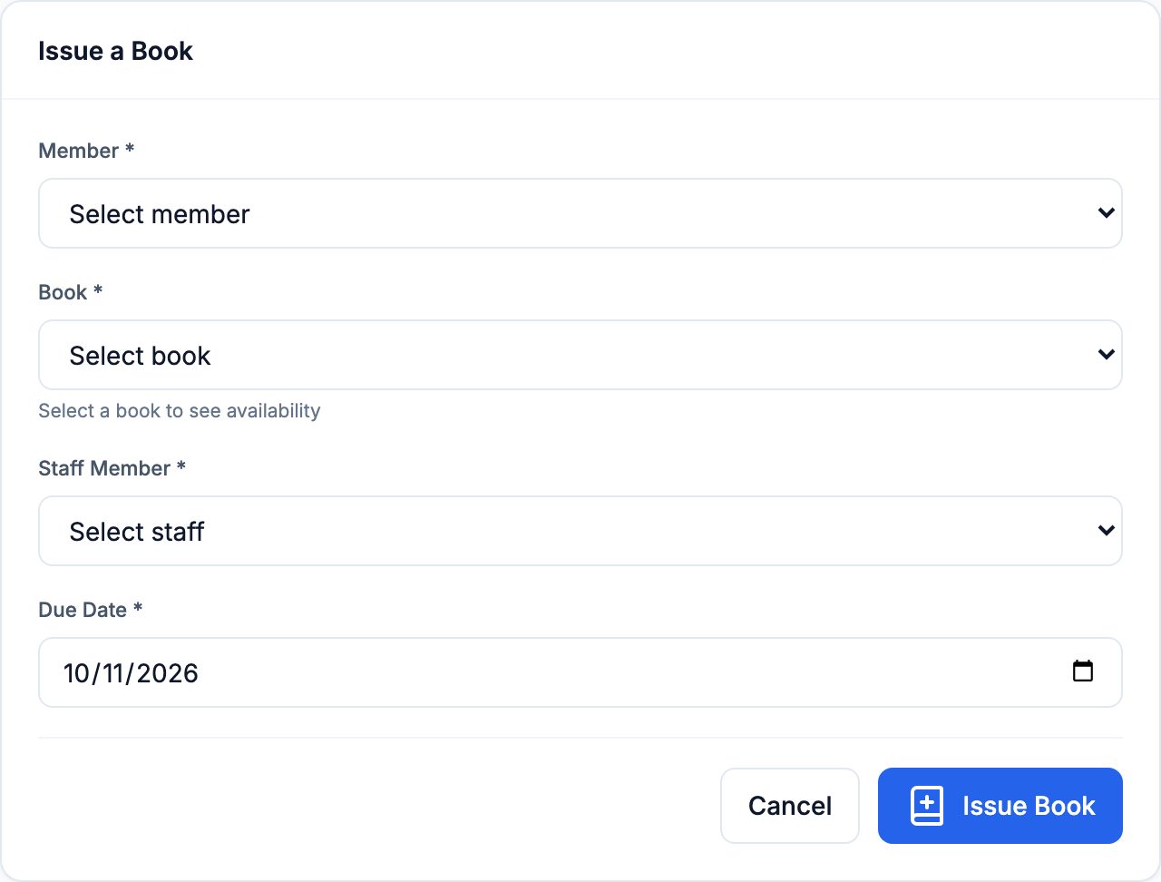
Operation 3: live Issue Book form
Screenshot — Issue History output:
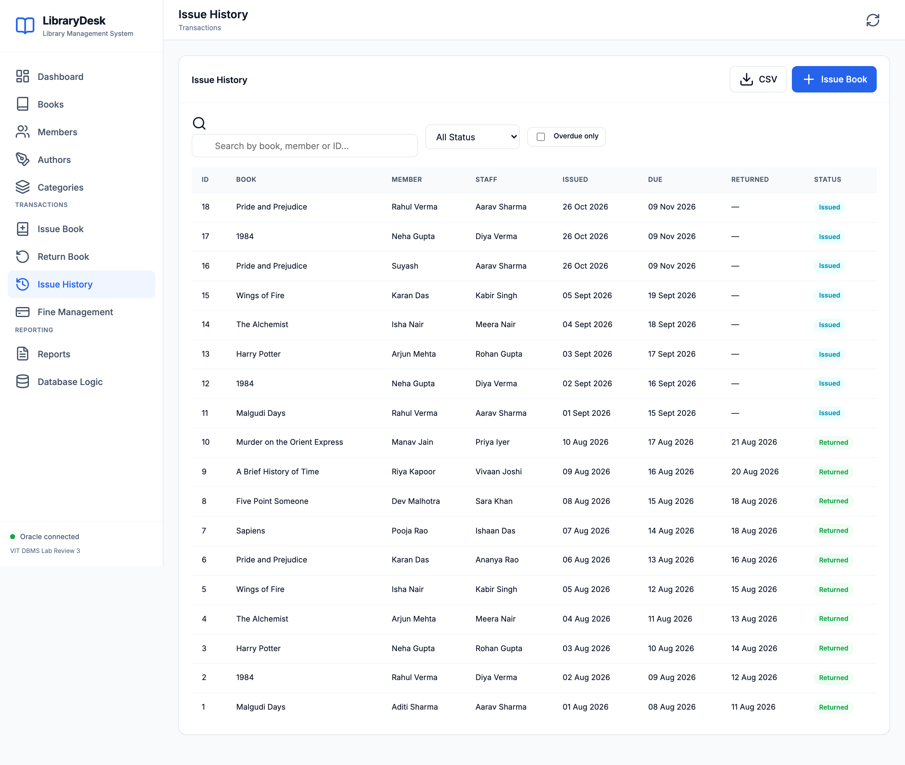
Operation 3: committed issue rows and status in the live history

Operation 4 — Return an overdue book
Why: On Return Book, the librarian selects an active overdue issue. return_book locks that issue, rejects a second return, computes the fee through calculate_fine and overdue_days, changes status to Returned and inserts one unpaid FINE when late. trg_issue_return restores one available copy. The five original sample issues 11–15 were overdue when these screenshots were taken, so one of them can demonstrate fine creation during the viva.
SQL/verification: BEGIN return_book(:issue_id); END; Then join ISSUE, BOOK and FINE by the issue ID to confirm Returned status, restored stock and fee. In reversible verification, a one-day-overdue ISSUE 16 returned, stock changed 3 → 4 and an Unpaid ₹5 fine appeared; rollback preserved the original data. The live fee for a sample issue depends on Oracle’s SYSDATE at return time.
Screenshot — Return Book screen with active issues:
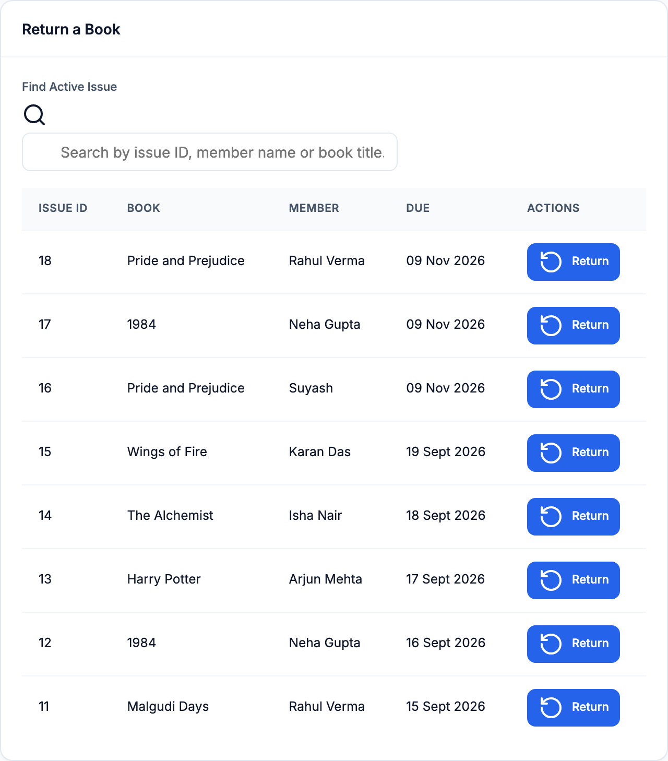
Operation 4: live Return Book list with overdue issue choices

Operation 5 — Mark a fine paid
Why: Once a late fee is settled, the librarian selects Mark Paid in Fine Management. Flask updates FINE.paid_status from Unpaid to Paid. The summary query groups fine amounts by payment status, so the amount moves between the two totals. This is a recorded status change; the application does not process a bank payment.
SQL/verification: UPDATE FINE SET paid_status = 'Paid' WHERE fine_id = :fine_id; verify with SELECT fine_id, amount, paid_status FROM FINE WHERE fine_id = :fine_id. In reversible verification, sample FINE 1 became Paid inside the transaction; rollback left it Unpaid.
Screenshot — Fine Management and Paid/Unpaid totals:
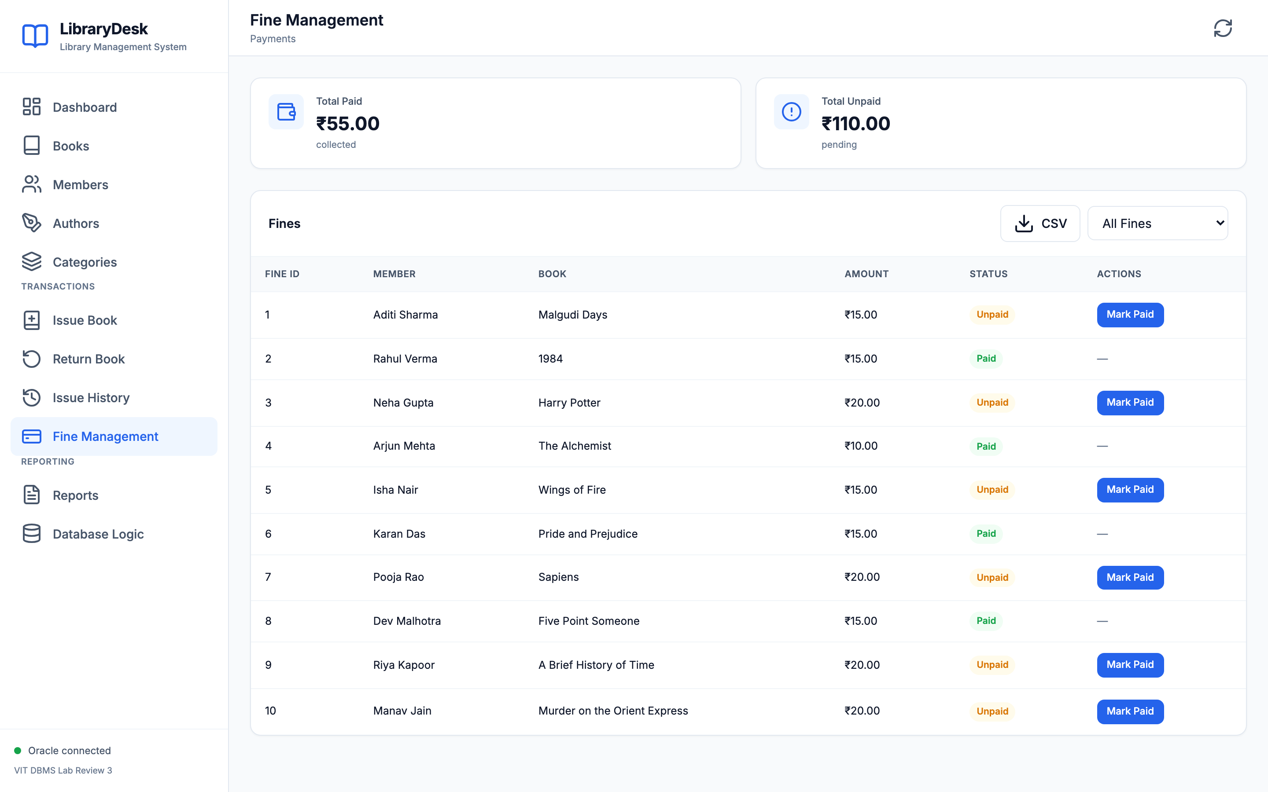
Operation 5: live Fine Management records and totals

4. SQL/PLSQL interaction and meaningful output
Database object | Use during the workflow
issue_book procedure + trg_issue_insert trigger | Create ISSUE and decrement stock when a book is lent.
return_book procedure + trg_issue_return trigger | Close ISSUE and restore stock on return.
calculate_fine + overdue_days functions | Compute ₹5 per late calendar day for a returned overdue issue.
Explicit overdue_cursor / web SYS_REFCURSOR | Read active overdue issues and show issue, member, title and due date.
Joined and grouped SQL reports | Show book availability, overdue loans, fine totals and category/staff activity.
The Overdue Issues report joins ISSUE, MEMBER and BOOK and filters status = 'Issued' AND TRUNC(due_date) < TRUNC(SYSDATE). It returned five sample rows during capture. The Database Logic page fetched the corresponding rows through a PL/SQL SYS_REFCURSOR. The report also offers CSV export. The following screenshots are placed next to these report explanations rather than collected with the five operation screenshots.
Screenshot — Overdue Issues report and CSV export:
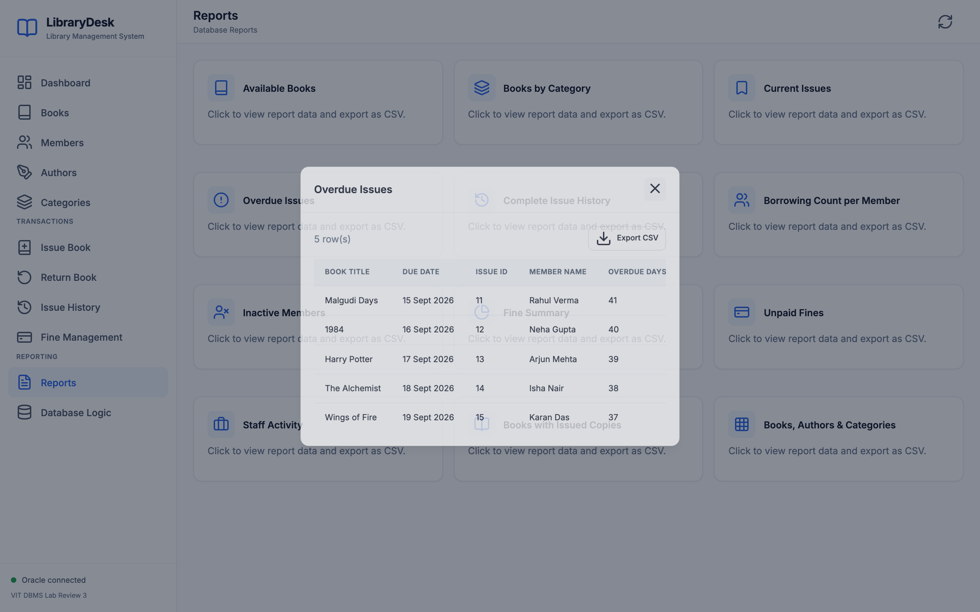
Live Overdue Issues report with five results
Screenshot — PL/SQL overdue cursor result:
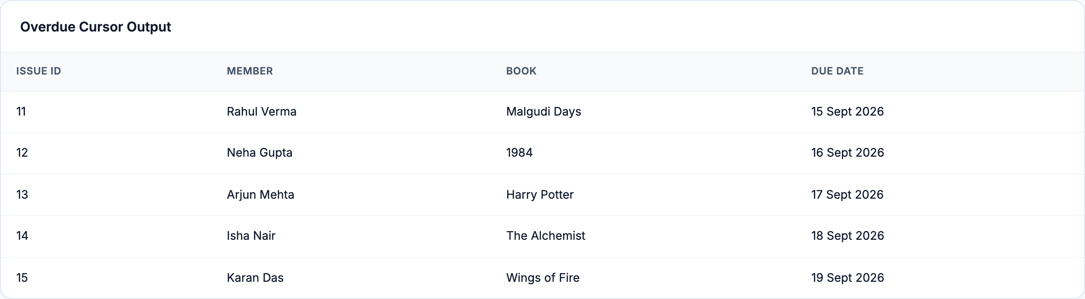
Live overdue cursor output from Oracle

5. Verification and conclusion
The screenshots were captured on 27 October 2026 from the live local site. Oracle’s server clock was still on 26 October at capture, so overdue-day figures follow Oracle SYSDATE. The current dashboard showed 10 titles, 12 members, 18 issue rows, 8 active loans, 5 overdue loans, 46 total copies and 38 available copies. These are live values after earlier UI activity; the original prepared-sample counts in the reversible test evidence are older.
scripts/verify_oracle.py confirmed the seven tables and required stored objects. Automated tests and live Oracle checks had passed. The five write operations and the read-only cursor/report demonstration satisfy the Review III rubric. The application is a local librarian demonstration without login or a payment gateway.
Source files: sql/schema.sql, sql/procedures.sql, sql/queries.sql, app.py, db.py, and static/. The detailed reversible query evidence remains in docs/live-verification.md; it is intentionally not repeated in this focused Review III submission.

