NetGuard AI: Malware Detection Using AI-Based Network Traffic Analysis
BCSE308P – COURSE PROJECT
Submitted in partial fulfillment of the requirements for the degree of
Bachelor of Computer Science and Engineering (Artificial Intelligence and Data Engineering) / Bachelor of Computer Science and Engineering (Cyber Security)
in
Department of Cybersecurity and Intelligent Systems
by
<Student Names>
<Register Numbers>


School of Computer Science Engineering and Information Systems [SCORE]
VIT, Vellore

November, 2026
DECLARATION
I hereby declare that the BCSE308P – Computer Networks Course Project entitled "NetGuard AI: Malware Detection Using AI-Based Network Traffic Analysis" submitted by me, for the award of the degree of Bachelor of Computer Science and Engineering (Artificial Intelligence and Data Engineering) / Bachelor of Computer Science and Engineering (Cyber Security), School of Computer Science Engineering and Information Systems to VIT is a record of bonafide work carried out by me under the supervision of <Faculty Guide Name, Designation, SCORE, VIT, Vellore>.
I further declare that the work reported in this project has not been submitted and will not be submitted, either in part or in full, for the award of any other degree or diploma in this institute or any other institute or university.

Place: Vellore
Date:

Signature of the Candidate

CERTIFICATE
This is to certify that the BCSE308P – Computer Networks Course Project entitled "NetGuard AI: Malware Detection Using AI-Based Network Traffic Analysis" submitted by <Student Name & Reg. No.>, SCORE, VIT, for the award of the degree of Bachelor of Computer Science and Engineering (Artificial Intelligence and Data Engineering) / Bachelor of Computer Science and Engineering (Cyber Security), School of Computer Science Engineering and Information Systems, is a record of bonafide work carried out under my supervision during the period <start date> to <end date>, as per the VIT code of academic and research ethics.
The contents of this report have not been submitted and will not be submitted either in part or in full, for the award of any other degree or diploma in this institute or any other institute or university. The project fulfills the requirements and regulations of the University and in my opinion meets the necessary standards for submission.

Place: Vellore
Date:

Signature of the VIT-SCORE - Guide

ACKNOWLEDGEMENT
I express my sincere gratitude to my guide, <Faculty Guide Name>, School of Computer Science Engineering and Information Systems, VIT, Vellore, for the guidance, encouragement and constructive feedback given throughout this project.
I thank the Head of the Department of Cybersecurity and Intelligent Systems and the Dean of SCORE for providing the academic environment and facilities that made this work possible.
I am grateful to the Canadian Institute for Cybersecurity, University of New Brunswick, for publishing the CIC-IDS2017 dataset, and to the developers of the open-source tools used in this project, including pandas, scikit-learn, FastAPI, React and Vite.
Finally, I thank my family and friends for their constant support.

<Student Name>

Executive Summary
NetGuard AI is a web application that detects malicious network traffic by applying machine learning to network flow records. It is built on the public CIC-IDS2017 dataset, whose 2,830,743 flows were analysed in detail. The analysis found 331,200 exact duplicate rows, infinite and missing rate values caused by zero-duration flows, protocol sentinel values, eight constant features and an extremely uneven distribution of attack types. A preprocessing pipeline removes duplicates before a stratified 500,000-flow sample is split into training, validation and test sets. Random Forest, Decision Tree and Logistic Regression were trained and compared; the Random Forest, selected on the validation set, achieved 99.83% accuracy, 99.58% precision, 99.44% recall and an F1-score of 99.51% on 100,000 unseen flows. A per-attack evaluation showed near-perfect detection of denial-of-service, port-scan and brute-force attacks but weak detection of the rarest labels, a direct consequence of the dataset. The model is served through a validated FastAPI backend and a React dashboard that accepts CSV uploads, shows predictions and genuine evaluation metrics, and exports the results.

CONTENTS
Page No.
Acknowledgement iv
Executive Summary v
Table of Contents vi
List of Figures ix
List of Tables x
Abbreviations xii
Symbols and Notations xiv
1 INTRODUCTION 1
1.1 Objective 2
1.2 Motivation 2
1.3 Background 3
1.3.1 Network traffic and the TCP/IP model 3
1.3.2 Network flows 4
1.3.3 Intrusion detection systems 5
1.3.4 Machine learning for intrusion detection 6
1.3.5 Intrusion detection datasets 6
1.3.6 Attack types in CIC-IDS2017 7
2 PROJECT DESCRIPTION AND GOALS 9
2.1 Problem statement 9
2.2 Project description 9
2.3 Goals 10
2.4 Scope 11
2.5 Deliverables 11
2.6 Users and use cases 11
3 TECHNICAL SPECIFICATION 13
3.1 Hardware specification 13
3.2 Software specification 13
3.3 Dataset specification 14
3.4 Functional requirements 14
3.5 Non-functional requirements 14
3.6 API specification 15
4 DESIGN APPROACH AND DETAILS 16
4.1 Design Approach / Materials & Methods 16
4.1.1 Methodology 16
4.1.2 System architecture 17
4.1.3 The CIC-IDS2017 dataset 18
4.1.4 Flow features 20
4.1.5 Exploratory data analysis 23
4.1.6 Data preprocessing pipeline 32
4.1.7 Sampling and data splitting 33
4.1.8 Machine learning models 35
4.1.9 Evaluation metrics and model selection 37
4.1.10 Backend design 38
4.1.11 Frontend design 39
4.2 Codes and Standards 39
4.3 Constraints, Alternatives and Tradeoffs 40
5 SCHEDULE, TASKS AND MILESTONES 42
5.1 Tasks 42
5.2 Gantt chart 42
5.3 Milestones 43
5.4 Risks and mitigation 43
6 PROJECT DEMONSTRATION 45
6.1 Sample Codes 45
6.1.1 Shared preprocessing (ml/preprocess.py) 45
6.1.2 Cleaning, deduplication and splitting (ml/train.py) 46
6.1.3 Model definitions and selection (ml/train.py) 47
6.1.4 Loading the model and predicting (backend/app/model_store.py) 48
6.1.5 Upload validation and the prediction endpoint (backend/app/main.py) 48
6.1.6 Frontend API client (frontend/src/api.ts) 49
6.1.7 Automated tests (backend/tests/test_api.py) 50
6.1.8 Per-attack evaluation (ml/analyze_dataset.py) 50
6.1.9 Running the project 51
6.2 Sample Screen Shots 52
7 RESULT & DISCUSSION 58
7.1 Overall model comparison 58
7.2 Confusion matrices 59
7.3 Threshold-independent evaluation 60
7.4 Detection rate per attack type 61
7.5 Feature importance 64
7.6 Results on the demonstration files 65
7.7 Limitations and threats to validity 65
7.8 Cost analysis 66
8 SUMMARY 67
9 REFERENCES 69
APPENDIX A 72
A.1 Repository structure 72
A.2 Example API response 72
A.3 Features required by the model 72
A.4 Demonstration files 73

List of Figures
Figure No. Title Page No.
1.1 Forward and Backward Packets, Flow Duration and Inter-Arrival Time in One TCP Flow 5
4.1 System Architecture of NetGuard AI 17
4.2 Generation of the CIC-IDS2017 Flow Records 18
4.3 Benign and Malicious Flows in Each CIC-IDS2017 File 19
4.4 Feature Groups of the CICFlowMeter Feature Set 20
4.5 Number of Flows per Label in the Raw Dataset (Log Scale) 24
4.6 Share of Each Label Removed as Exact Duplicates 25
4.7 Infinite, Missing and Negative Values in the Raw Files (Log Scale) 26
4.8 Distribution of Six Flow Features for Benign and Malicious Flows 27
4.9 Cumulative Distribution of Flow Duration by Class 28
4.10 Ten Most Frequent Destination Ports for Benign and Malicious Flows 30
4.11 Pearson Correlation Among the Fifteen Most Important Features 31
4.12 Preprocessing Pipeline With Row Counts at Each Step 32
4.13 Share of Each Label in the Cleaned Dataset and in the Training Sample 34
5.1 Project Gantt Chart 43
6.1 Dashboard on Start-Up With the Model Status and Upload Panel 52
6.2 Analysis Summary for 2,000 Held-Out Test Flows 53
6.3 Prediction Results Table With Probabilities and Actual Labels 54
6.4 Results Filtered to the Misclassified Flows 54
6.5 Validation Error for a File With Missing Feature Columns 55
6.6 Model Comparison Table and Chart in the Dashboard 55
6.7 Confusion Matrix and Training Data Summary 55
6.8 Most Important Features of the Random Forest Model 56
6.9 Interactive API Documentation Generated by FastAPI 56
6.10 Dashboard on a 390-Pixel-Wide Mobile Screen 57
7.1 Accuracy, Precision, Recall and F1-Score of the Three Models 58
7.2 Test-Set Confusion Matrices With Row Percentages 59
7.3 ROC and Precision–Recall Curves on the Test Set 60
7.4 Distribution of the Random Forest Malicious Probability by Actual Class 61
7.5 Detection Rate per Attack Label on the Test Set 62
7.6 Fifteen Most Important Features of the Random Forest 64

List of Tables
Table No. Title Page No.
1.1 TCP Header Flags Counted in CIC-IDS2017 Flow Features 4
1.2 Classification of Intrusion Detection Systems 5
1.3 Public Network Intrusion Detection Datasets 6
1.4 Attack Types in CIC-IDS2017 and Their Network Behaviour 7
2.1 Project Scope 11
2.2 Project Deliverables and Their Location in the Repository 11
3.1 Hardware Used for Development and Training 13
3.2 Software Stack and Versions 13
3.3 Dataset Specification 14
3.4 Functional Requirements 14
3.5 Non-Functional Requirements 14
3.6 REST API Endpoints 15
3.7 API Error Responses 15
4.1 CIC-IDS2017 Files, Flow Counts and Attacks 19
4.2 Feature Dictionary of the 77 CIC-IDS2017 Flow Features 21
4.3 Flows per Label Before and After Deduplication and in the Training Sample 24
4.4 Invalid and Sentinel Values in the Raw Dataset 26
4.5 Median and Mean of Key Features by Class (Unique Flows) 28
4.6 Median Traffic Profile of Each Label 29
4.7 Most Strongly Correlated Feature Pairs 30
4.8 Composition of the Training, Validation and Test Sets 34
4.9 Rare Attack Labels in Each Set 35
4.10 Model Configurations 36
4.11 Input Validation Rules 38
4.12 Frontend Components 39
4.13 Standards Followed in the Project 39
4.14 Design Alternatives and the Chosen Trade-Offs 40
5.1 Project Tasks and Planned Weeks 42
5.2 Project Milestones 43
5.3 Project Risks and Mitigation 43
7.1 Test-Set Performance of the Three Models (Positive Class = Malicious) 58
7.2 Confusion Matrix Counts and Error Rates 59
7.3 Area Under the ROC Curve and Average Precision 60
7.4 Detection Rate per Label on the Test Set 62
7.5 Project Cost 66
A.1 Model Input Features 72
A.2 Demonstration Files in dataset/samples 73

List of Abbreviations
ACK | Acknowledgement (TCP flag)
API | Application Programming Interface
AUC | Area Under the Curve
AP | Average Precision
CIC | Canadian Institute for Cybersecurity
CIC-IDS2017 | CIC Intrusion Detection Evaluation Dataset 2017
CORS | Cross-Origin Resource Sharing
CSV | Comma-Separated Values
CWR / CWE | Congestion Window Reduced (TCP flag; CWE in the dataset)
DDoS | Distributed Denial of Service
DNS | Domain Name System
DoS | Denial of Service
DT | Decision Tree
ECE | ECN-Echo (TCP flag)
ECN | Explicit Congestion Notification
FIN | Finish (TCP flag)
FN | False Negative
FP | False Positive
FPR | False Positive Rate
FTP | File Transfer Protocol
HIDS | Host-based Intrusion Detection System
HTTP(S) | Hypertext Transfer Protocol (Secure)
IAT | Inter-Arrival Time
IDS | Intrusion Detection System
IETF | Internet Engineering Task Force
IP | Internet Protocol
IPFIX | IP Flow Information Export
IR | Imbalance Ratio
JSON | JavaScript Object Notation
LR | Logistic Regression
MDI | Mean Decrease in Impurity
ML | Machine Learning
NaN | Not a Number (missing value)
NIDS | Network-based Intrusion Detection System
NTP | Network Time Protocol
OAS | OpenAPI Specification
PCAP | Packet Capture (file format)
PSH | Push (TCP flag)
REST | Representational State Transfer
RF | Random Forest
RFC | Request for Comments
ROC | Receiver Operating Characteristic
RST | Reset (TCP flag)
SMOTE | Synthetic Minority Over-sampling Technique
SQL | Structured Query Language
SSH | Secure Shell
SYN | Synchronise (TCP flag)
TCP | Transmission Control Protocol
TLS | Transport Layer Security
TN | True Negative
TP | True Positive
UDP | User Datagram Protocol
UI | User Interface
UNB | University of New Brunswick
URG | Urgent (TCP flag)
WCAG | Web Content Accessibility Guidelines
XSS | Cross-Site Scripting

Symbols and Notations
x, xᵢ | Feature vector of a flow / of the i-th flow
xᵢⱼ | Value of feature j for flow i
y, yᵢ | Class label (0 = benign, 1 = malicious)
ŷ | Predicted label
n, N | Number of flows
N꜀ | Number of flows of class c
p | Number of features (69)
T | Number of trees in the Random Forest (100)
m | Features considered at each split (⌊√p⌋ = 8)
hₜ(x) | Prediction of tree t
pₖ | Share of class k at a tree node
G | Gini impurity
ΔG | Impurity decrease of a split
Impⱼ | Importance of feature j
σ(·) | Sigmoid function
w, b | Weights and bias of Logistic Regression
μⱼ, σⱼ | Mean and standard deviation of feature j (training set)
zᵢⱼ | Standardised feature value
r | Pearson correlation coefficient
TP, TN, FP, FN | Confusion-matrix counts
F₁ | F1-score
µs | Microsecond (unit of Flow Duration)

CHAPTER 1
INTRODUCTION
Computer networks carry almost every activity of a modern organisation, from e-mail and file sharing to banking, cloud services and remote administration. The same connectivity that makes these services possible also exposes them to attack. Malicious software rarely acts in isolation: a worm spreads by scanning for vulnerable hosts, a botnet client contacts its command-and-control server, ransomware downloads keys and exfiltrates data, and denial-of-service tools flood a victim with requests. Every one of these activities leaves a trace in the network traffic, so analysing that traffic is one of the most effective ways of detecting malware and intrusions.
Traditional intrusion detection systems (IDS) compare traffic with a database of known attack signatures. They are precise for attacks they already know but cannot recognise new variants, and maintaining the signature database requires constant expert effort. Machine learning (ML) offers a complementary approach: instead of writing rules by hand, a model learns the statistical difference between normal and malicious traffic from labelled examples. Because ML works on summary statistics of network flows, such as how long a connection lasted, how many packets were exchanged and how large they were, it can also analyse encrypted traffic whose payload is unreadable.
This project, NetGuard AI, builds a complete and working malware detection system based on AI-driven analysis of network traffic. It uses the public CIC-IDS2017 dataset published by the Canadian Institute for Cybersecurity, which contains 2,830,743 labelled network flows recorded over five working days in a realistic testbed. The dataset is analysed in depth, cleaned and prepared; three classifiers (Random Forest, Decision Tree and Logistic Regression) are trained and compared on held-out data; and the best model is served through a FastAPI backend and a React dashboard where a user can upload a CSV file of flows and receive a benign or malicious verdict for every flow. Particular attention is given to the dataset itself, because the quality, balance and structure of the data determine what any model can learn.
1.1 Objective
The primary objective of this project is to develop a web-based system that uses machine learning and data analysis techniques to classify network flows as benign or malicious, and to understand and document the dataset on which such a system depends. The specific objectives are:
- To study the CIC-IDS2017 dataset in detail: how it was generated, what each of its 78 flow features means in networking terms, how its classes are distributed and what data-quality problems it contains.
- To design a cleaning and preprocessing pipeline that handles missing and infinite values, duplicate records and uninformative features, and that is applied identically during training and prediction.
- To split the data correctly into training, validation and test sets so that the reported performance reflects traffic the model has never seen.
- To train Random Forest, Decision Tree and Logistic Regression classifiers and compare their accuracy, precision, recall and F1-score using genuine evaluation results.
- To analyse detection performance separately for each attack type, linking strengths and weaknesses of the model back to properties of the dataset.
- To deploy the selected model behind a validated REST API and a responsive dashboard named NetGuard AI that shows predictions, evaluation metrics, a confusion matrix and a model comparison chart, and lets the user download the results.
1.2 Motivation
Network traffic grows faster than the number of analysts who can inspect it. A single office network in the CIC-IDS2017 testbed produced more than half a million flows on an ordinary Monday with no attacks at all. Manually separating the few malicious flows from this background is impossible, and signature-based tools only flag what they have been told to look for. A model that learns from flow statistics can screen every flow automatically and draw the analyst's attention to the suspicious ones.
A second motivation is the gap between research results and working systems. Many published studies report very high accuracy on CIC-IDS2017, but few explain how the data were cleaned, whether duplicate records leaked between training and testing, or how well rare attack types are detected. This project therefore treats the dataset as a first-class subject of study. Every number in this report is produced by scripts in the project repository, and every chart in the dashboard is read from files written by the training pipeline, so the results can be reproduced and questioned.
Finally, the project connects the theory of the Computer Networks course with a practical security problem. The features used by the model, such as TCP flag counts, initial window sizes, packet-length statistics, inter-arrival times and destination ports, are direct measurements of the protocols studied in the course. Understanding why a SYN-heavy, single-packet flow to a random port looks like a port scan, or why a connection that stays open for 100 seconds while sending almost no data looks like a slow denial-of-service attack, is exactly the kind of reasoning the course aims to develop.
1.3 Background
This section introduces the networking and machine-learning concepts on which the project is built: the TCP/IP protocol suite, the notion of a network flow, the main families of intrusion detection systems, the use of machine learning for intrusion detection, the public datasets available for this task and the attack types contained in CIC-IDS2017.
1.3.1 Network traffic and the TCP/IP model
Communication on the Internet follows the layered TCP/IP model. The application layer (HTTP, DNS, FTP, SSH, SMTP) produces messages; the transport layer (TCP or UDP) splits them into segments and identifies the communicating programs with 16-bit port numbers; the network layer (IP) addresses and routes packets between hosts; and the link layer delivers frames on each physical network [1], [2]. Every packet therefore carries a header for each layer, and an observer on the network can measure its size, its timing, its addresses and ports and, for TCP, its control flags.
TCP is connection-oriented. A connection starts with a three-way handshake (SYN, SYN-ACK, ACK), transfers data in acknowledged segments and ends with FIN or RST segments [3]. The flags carried in the TCP header describe what each segment is doing, and attacks often misuse them: a port scan sends SYN segments without completing the handshake, and a SYN flood leaves thousands of half-open connections. UDP, used by DNS and NTP, has no handshake and no flags [4]. Table 1.1 lists the TCP flags that CIC-IDS2017 counts for every flow.
Table 1.1 TCP Header Flags Counted in CIC-IDS2017 Flow Features
Flag | Name | Meaning | Dataset feature
SYN | Synchronise | Opens a connection and synchronises sequence numbers | SYN Flag Count
ACK | Acknowledge | Acknowledges received data; set on almost every segment after the handshake | ACK Flag Count
FIN | Finish | Sender has no more data; graceful connection close | FIN Flag Count
RST | Reset | Aborts the connection immediately | RST Flag Count
PSH | Push | Asks the receiver to pass data to the application without waiting | PSH Flag Count, Fwd/Bwd PSH Flags
URG | Urgent | Urgent pointer field is significant | URG Flag Count, Fwd/Bwd URG Flags
ECE | ECN-Echo | Explicit Congestion Notification echo [5] | ECE Flag Count
CWR | Congestion Window Reduced | Sender reduced its congestion window [5]; called CWE in the dataset | CWE Flag Count

1.3.2 Network flows
Inspecting every packet of a busy network is expensive and, for encrypted traffic, reveals little. Network monitoring therefore usually works with flows. A flow is a sequence of packets that share the same five-tuple (source IP address, destination IP address, source port, destination port and transport protocol) within a limited time window. Router-based standards such as NetFlow version 9 [6] and IPFIX [7] export one record per flow with counters such as packets and bytes.
CIC-IDS2017 uses bidirectional flows produced by CICFlowMeter [8], [9]. The host that sends the first packet defines the forward direction and the reply traffic forms the backward direction, so a single record describes both sides of a conversation. A TCP flow ends when the connection is closed with FIN; any flow also ends when it exceeds the flow timeout. In the published files no flow lasts longer than 120,000,000 µs, i.e. 120 seconds, which is the flow timeout used by the dataset authors. Fig. 1.1 shows how the main timing and size features are measured on one TCP connection.
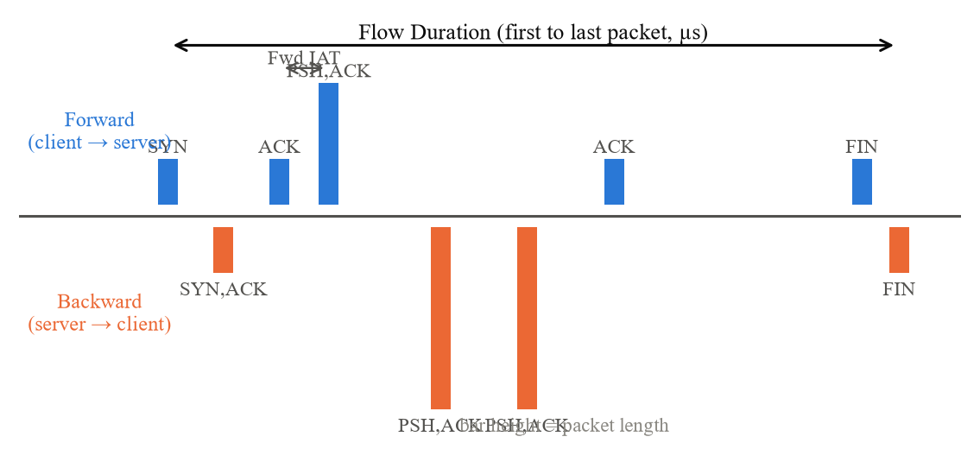
Fig. 1.1 Forward and Backward Packets, Flow Duration and Inter-Arrival Time in One TCP Flow
For each flow CICFlowMeter computes more than 80 statistics: counts and sizes of packets in each direction, rates in bytes and packets per second, inter-arrival times (IAT) between consecutive packets, counts of each TCP flag, header lengths, initial TCP window sizes, bulk-transfer and sub-flow statistics, and the durations of active and idle periods. These features are the input of the NetGuard model and are described one by one in Chapter 4.
1.3.3 Intrusion detection systems
An intrusion detection system monitors a host or network and raises alerts when it observes behaviour that indicates an attack. Denning's intrusion-detection model [10] introduced the idea that attacks can be recognised as deviations from normal behaviour. Today IDS are classified by where they collect data and how they decide, as summarised in Table 1.2.
Table 1.2 Classification of Intrusion Detection Systems
Criterion | Type | Description | Example
Data source | Network-based (NIDS) | Analyses packets or flows observed on a network link | Snort, Zeek, NetGuard AI
Data source | Host-based (HIDS) | Analyses logs, system calls and files on one host | OSSEC, Wazuh
Detection method | Signature (misuse) | Matches traffic against patterns of known attacks | Snort rules
Detection method | Anomaly | Learns normal behaviour and flags deviations | Statistical profiles
Detection method | Supervised ML | Learns from labelled benign and attack examples | Random Forest on flows

NetGuard AI is a network-based system that uses supervised machine learning on flow records. It does not capture packets itself; it analyses flow files produced by a flow meter, which keeps the system simple and lets it be evaluated on a standard dataset.
1.3.4 Machine learning for intrusion detection
In supervised classification a model is trained on examples (x, y), where x is a vector of features describing a flow and y is its label, and then predicts the label of new flows. Surveys of the field [11] show that tree-based models, support vector machines, k-nearest neighbours and neural networks have all been applied to intrusion detection, with decision-tree ensembles such as Random Forest performing strongly on tabular flow features while remaining fast and interpretable [12], [13].
Applying ML to security also has well-documented pitfalls. Sommer and Paxson [14] warned that intrusion detection differs from other ML problems because errors are costly, traffic is diverse and attacks are rare. Arp et al. [15] listed common mistakes in security ML research, including sampling bias, data snooping (using test data for decisions) and inappropriate baselines. This project addresses these points explicitly: duplicates are removed before splitting, all decisions use a separate validation set, simple baselines are compared and results are broken down by attack type.
1.3.5 Intrusion detection datasets
Supervised models need labelled traffic, and collecting real labelled attack traffic is difficult because of privacy and the rarity of attacks. Researchers therefore rely on public datasets [16]. Table 1.3 compares the most widely used ones.
Table 1.3 Public Network Intrusion Detection Datasets
Dataset | Year | Records / features | Remarks
KDD Cup 99 | 1999 | ≈4.9 million connections, 41 features | Derived from DARPA 1998; many duplicates and dated attacks [17]
NSL-KDD | 2009 | 125,973 train / 22,544 test, 41 features | Cleaned KDD 99 without duplicates [17]
UNSW-NB15 | 2015 | 2,540,044 records, 49 features | Nine attack families, modern traffic generator [18]
CIC-IDS2017 | 2017 | 2,830,743 flows, 78 features | Realistic benign profiles, 14 attack labels, CICFlowMeter features [19]
CSE-CIC-IDS2018 | 2018 | Larger capture on AWS, same feature set | Successor of CIC-IDS2017 [16]

CIC-IDS2017 was chosen because it is recent compared with KDD-based data, it contains a broad set of attacks that are still relevant (denial of service, brute force, web attacks, botnets, port scans), it provides flow features computed by a documented open-source tool, and it is freely available. Its known weaknesses, such as labelling errors and flow-meter artefacts reported by Engelen et al. [20] and Lanvin et al. [21], are examined in Chapters 4 and 7.
1.3.6 Attack types in CIC-IDS2017
The dataset labels each flow either BENIGN or with one of 14 attack names. Table 1.4 explains how each attack works at the network level and which service it targets in the dataset; the target ports were measured from the data.
Table 1.4 Attack Types in CIC-IDS2017 and Their Network Behaviour
Label | Category | Network-level behaviour | Main port
DoS Hulk | Denial of service | HTTP GET flood with randomised URLs and headers to exhaust the web server | 80
DoS GoldenEye | Denial of service | HTTP flood that keeps connections alive to occupy server workers | 80
DoS slowloris | Denial of service | Opens many connections and sends partial HTTP headers very slowly | 80
DoS Slowhttptest | Denial of service | Slow HTTP attacks that hold connections open with minimal traffic | 80
DDoS | Distributed DoS | Several machines flood the web server at the same time (LOIC tool) | 80
Heartbleed | Vulnerability exploit | Malformed TLS heartbeat requests leak server memory (CVE-2014-0160) [22] | 444
PortScan | Reconnaissance | Probes thousands of ports with short connection attempts (Nmap) | many ports
FTP-Patator | Brute force | Repeated FTP login attempts with a password list | 21
SSH-Patator | Brute force | Repeated SSH login attempts with a password list | 22
Web Attack – Brute Force | Web application | Automated login attempts against a vulnerable web application | 80
Web Attack – XSS | Web application | Injects scripts into web pages (cross-site scripting) | 80
Web Attack – Sql Injection | Web application | Injects SQL statements through web form parameters | 80
Bot | Botnet | Infected hosts contact a command-and-control server (Ares botnet) | 8080
Infiltration | Internal compromise | A victim host is compromised and then used to attack the internal network | 444

Apart from PortScan, whose flows are spread over thousands of destination ports, each attack targets one service. Port 80 (HTTP) dominates because the denial-of-service, DDoS and web attacks all aim at the testbed's web server, the brute-force tools target FTP (21) and SSH (22), the botnet uses port 8080 for its command channel, and the Heartbleed and Infiltration flows use port 444.

CHAPTER 2
PROJECT DESCRIPTION AND GOALS
This chapter defines the problem addressed by NetGuard AI, describes what the system does from the user's point of view, states its goals in measurable terms and sets the boundaries of the project.
2.1 Problem statement
Given a file of network flow records in CICFlowMeter format, decide for every flow whether it is benign or malicious, and present the decision together with an honest account of how reliable the deciding model is. Formally this is a binary classification problem: each flow is described by a feature vector x containing numeric flow statistics, and the system must predict a label y ∈ {0, 1}, where 0 means benign and 1 means malicious (any of the 14 attack types).
Three difficulties make the problem harder than it first appears. The classes are imbalanced, since most traffic is benign. The dataset contains duplicate, missing, infinite and constant values that must be handled without leaking information from the test set. And some attack types are extremely rare, so a model can achieve a high overall score while still missing them. A good solution must handle all three, and its evaluation must expose them.
2.2 Project description
NetGuard AI consists of three parts that work together. The machine learning pipeline reads the eight CIC-IDS2017 CSV files, cleans and deduplicates them, builds a stratified sample, splits it into training, validation and test sets, trains three classifiers, evaluates them and saves the selected model together with an evaluation report. A separate dataset analysis script measures the properties of the data and produces the figures used in this report.
The FastAPI backend loads the saved model and exposes endpoints that accept a CSV upload, validate it, apply the same preprocessing as training, and return a prediction and a malicious probability for every flow, or the uploaded file with the predictions appended as new columns. The React dashboard lets the user upload a file, start the analysis, read the benign and malicious counts, inspect and filter a results table, download the results and view the evaluation of all three models, including a confusion matrix and a comparison chart.
A typical session proceeds as follows. The user opens the dashboard, which reports that the Random Forest model is loaded. The user selects a CSV file of flows and presses Analyze traffic. Within a few seconds the dashboard shows how many flows were analysed and how many were classified as malicious; if the file contains a Label column, the agreement between the predictions and the labels is also shown. The user can filter the table to see only malicious flows or only misclassified ones, and can download the full result as a CSV file.
2.3 Goals
The project goals, with the criterion used to verify each one, are:
- Dataset understanding: document the origin, features, class distribution and data-quality issues of CIC-IDS2017 using measurements on the real files (verified in Chapter 4).
- Correct methodology: remove duplicates before splitting, use a stratified split with a fixed random seed, and never use the test set for any decision (verified by the reproducibility check in Section 4.1.7).
- Detection quality: reach an F1-score above 99% on the test set with the primary model; achieved 99.51% (Chapter 7).
- Honest comparison: report accuracy, precision, recall and F1-score for Random Forest, Decision Tree and Logistic Regression from the same test set, plus per-attack detection rates.
- Working application: serve real predictions from the saved model through a validated API and a responsive dashboard, with automated backend tests and a successful production build.
- Reproducibility: every number in the dashboard and in this report is generated by scripts in the repository from the public dataset.
2.4 Scope
Table 2.1 lists what is included in the project and what is deliberately left out to keep the system focused and explainable.
Table 2.1 Project Scope
In scope | Out of scope
Binary classification of CICFlowMeter flow records (benign / malicious) | Classifying the exact attack type (multi-class)
Offline training on CIC-IDS2017 with a documented pipeline | Live packet capture or reading .pcap files
CSV upload, validation, prediction and CSV download | User accounts, authentication and a database
Random Forest, Decision Tree, Logistic Regression | Deep learning models
Evaluation dashboard with real metrics | Automatic blocking of traffic (intrusion prevention)
Detailed dataset analysis and reporting | Testing on other datasets or production networks

2.5 Deliverables
Table 2.2 Project Deliverables and Their Location in the Repository
Deliverable | Location
Shared preprocessing used by training and API | ml/preprocess.py
Training and model comparison pipeline | ml/train.py
Dataset analysis and report figures | ml/analyze_dataset.py, reports/figures/
Trained model bundle | models/netguard_model.joblib
Evaluation report | reports/metrics.json, reports/model_report.md
Dataset analysis results | reports/dataset_analysis.json
FastAPI backend and tests | backend/app/, backend/tests/
React dashboard | frontend/src/
Demo CSV files from the held-out test set | dataset/samples/
README, viva guide and this report | README.md, docs/

2.6 Users and use cases
The primary users are students and security analysts who want to screen a set of flow records. The main use cases are: checking whether a captured set of flows contains suspicious traffic; demonstrating how a machine learning IDS works, including its evaluation; and studying how the properties of a dataset affect what a model learns. Because the dashboard shows the probability behind every prediction and the per-model evaluation, users can judge how much to trust a result rather than receiving an unexplained verdict.

CHAPTER 3
TECHNICAL SPECIFICATION
This chapter specifies the hardware and software used, the dataset, the functional and non-functional requirements, and the interface of the backend API.
3.1 Hardware specification
Table 3.1 Hardware Used for Development and Training
Component | Specification
Processor | Intel Core i5-1135G7 (11th Gen) @ 2.40 GHz, 6 logical CPUs available to Linux
Memory | 7 GB available to the Linux environment (WSL 2)
Storage | 1 TB virtual disk; the dataset needs about 844 MB, the project about 100 MB plus dependencies
Peak memory during training | 2.8 GB (measured with /usr/bin/time)
Training time | About 11 minutes for the full pipeline (about 4 minutes of it reading the CSV files)

3.2 Software specification
Table 3.2 Software Stack and Versions
Layer | Software | Version | Purpose
Operating system | Linux on WSL 2 | kernel 6.18 | Development and execution environment
Language | Python | 3.14.7 | ML pipeline, analysis and backend
Data processing | pandas / NumPy | 3.0.6 / 2.5.4 | Loading and cleaning CSV data
Machine learning | scikit-learn | 1.9.1 | Models, pipelines, metrics, splitting
Model storage | joblib | 1.6.0 | Saving and loading the trained pipeline
Web API | FastAPI / Uvicorn | 0.157.0 / 0.54.0 | REST endpoints and ASGI server
File upload | python-multipart | 0.0.32 | Parsing multipart/form-data uploads
Testing | pytest / httpx2 | 9.1.1 / 2.13.1 | Automated backend tests
Figures and report | matplotlib / python-docx | 3.11.2 / 1.2.0 | Dataset figures and this document
Runtime | Node.js / npm | 24.21.0 / 11.19.0 | Frontend tooling
UI library | React | 19.3.0 | Dashboard components
Build tool | Vite | 8.1.6 | Development server and production build
Language | TypeScript | 5.9.3 | Type-checked frontend code
Styling | Tailwind CSS | 4.3.3 | Utility-first CSS, dark navy theme
Charts / icons | Recharts / lucide-react | 3.10.1 / 1.52.0 | Comparison chart, feature importance, icons

3.3 Dataset specification
Table 3.3 Dataset Specification
Property | Value
Name | CIC-IDS2017 (MachineLearningCSV / MachineLearningCVE version)
Publisher | Canadian Institute for Cybersecurity, University of New Brunswick [19]
Capture period | Monday 3 July to Friday 7 July 2017 (five working days)
Files | 8 CSV files, one or more per day, about 844 MB in total
Records | 2,830,743 flows (2,273,097 benign, 557,646 attack)
Columns | 78 numeric flow features + 1 Label column (79 in total)
Labels | BENIGN and 14 attack labels
Encoding | Latin-1 / Windows-1252 (web attack labels contain the dash byte 0x96)
Feature extractor | CICFlowMeter, bidirectional flows, ≈120 s flow timeout
Licence / access | Free for research; official download after a short form, mirrored on Kaggle

3.4 Functional requirements
Table 3.4 Functional Requirements
ID | Requirement
FR1 | The system shall clean the dataset and convert its labels to Benign (BENIGN) and Malicious (all attacks).
FR2 | The system shall split the data into training, validation and test sets using stratified sampling.
FR3 | The system shall train Random Forest, Decision Tree and Logistic Regression and report accuracy, precision, recall and F1-score on the test set.
FR4 | The system shall save the selected model with its feature list and reuse it for every prediction.
FR5 | The API shall accept a CSV upload and return a prediction and malicious probability for every row.
FR6 | The API shall reject files that are not CSV, are empty, exceed 100 MB, miss required features or contain non-numeric feature values.
FR7 | The API shall return HTTP 503 with an explanation when no trained model is available.
FR8 | The dashboard shall show total, benign and malicious counts and, when labels are present, the agreement with them.
FR9 | The dashboard shall show a filterable, paginated results table and allow the results to be downloaded as CSV.
FR10 | The dashboard shall show the model comparison table and chart, the confusion matrix, the dataset split and feature importances from the saved evaluation report.

3.5 Non-functional requirements
Table 3.5 Non-Functional Requirements
Quality | Requirement and how it is met
Correctness | No hard-coded predictions or statistics; all values come from the model or from files written by training.
Consistency | Training and inference share ml/preprocess.py, and imputation is stored inside the saved scikit-learn Pipeline.
Reproducibility | Fixed random seed (42); re-running training reproduces identical metrics and the analysis script verifies this.
Performance | A 2,000-flow file is uploaded, classified and returned in about 1.2 s, and a 5,000-row raw file in about 1.5 s.
Usability | Responsive layout from 390 px phones to desktops, clear error messages, colour-blind-safe chart colours.
Maintainability | Small modules with one responsibility each; code is commented for explanation in a viva.
Testability | 17 automated tests run in about one second using a synthetic model, independent of the real dataset.

3.6 API specification
Table 3.6 REST API Endpoints
Method | Endpoint | Input | Output
GET | /api/health | – | Whether a model is loaded, its name, training time and feature count
GET | /api/model/features | – | List of the 69 feature columns an upload must contain
GET | /api/metrics | – | The evaluation report written by training (metrics.json)
POST | /api/predict | multipart file (CSV) | Summary counts, optional agreement with labels, first 5,000 rows with predictions
POST | /api/predict/download | multipart file (CSV) | The uploaded CSV with Prediction and Malicious_Probability columns

Table 3.7 API Error Responses
HTTP status | Condition | Example message
400 Bad Request | Wrong extension, empty file, header only, unparseable CSV | Please upload a file with a .csv extension.
413 Payload Too Large | File larger than 100 MB | File is larger than 100 MB.
422 Unprocessable Entity | Required feature columns missing or non-numeric | CSV is missing 3 required feature column(s).
503 Service Unavailable | No trained model found or model file unreadable | No trained model found. Run python -m ml.train first.

Uploaded files may contain extra columns (for example source and destination IP addresses or the original Label); these are ignored for prediction. If a Label column is present, the API compares it with the predictions and reports the agreement, which is how the demonstration in Chapter 6 shows that the predictions are genuine.

CHAPTER 4
DESIGN APPROACH AND DETAILS
This chapter explains how NetGuard AI was designed. It begins with the overall methodology and system architecture, then studies the CIC-IDS2017 dataset in depth: how it was generated, what its features measure, how its classes are distributed and what quality problems it has. The findings of that analysis drive the preprocessing, sampling and splitting design that follows. The chapter then describes the three models, the evaluation metrics, the backend and frontend, the standards followed and the constraints and trade-offs.
4.1 Design Approach / Materials & Methods
4.1.1 Methodology
The project follows a data-centred methodology in which every stage produces files that the next stage reads:
- Data acquisition: download the eight MachineLearningCSV files of CIC-IDS2017 and verify the row count (2,830,743 flows) against the official figure.
- Exploratory data analysis: measure class and attack distributions, missing, infinite and negative values, duplicates, constant and correlated features, and per-attack traffic profiles (ml/analyze_dataset.py).
- Preprocessing: clean headers and values, remove duplicates, map labels to two classes.
- Sampling and splitting: stratified sample, then stratified train / validation / test split.
- Modelling: train Random Forest, Decision Tree and Logistic Regression inside scikit-learn Pipelines.
- Evaluation and selection: choose the model on the validation set and report all metrics on the test set, overall and per attack type.
- Deployment: serve the selected Pipeline through FastAPI and visualise it in the React dashboard.
4.1.2 System architecture
Fig. 4.1 shows the architecture. The lower half runs once, offline: the training script reads the dataset and writes two artefacts, the model bundle (models/netguard_model.joblib) and the evaluation report (reports/metrics.json). The upper half runs for every user request: the browser uploads a CSV file to the FastAPI backend, which validates it, prepares the features with the same preprocessing module used in training, runs the saved Pipeline and returns JSON (or a CSV file) to the browser. The backend never retrains the model, and the dashboard never computes metrics itself; it only displays what the backend returns.
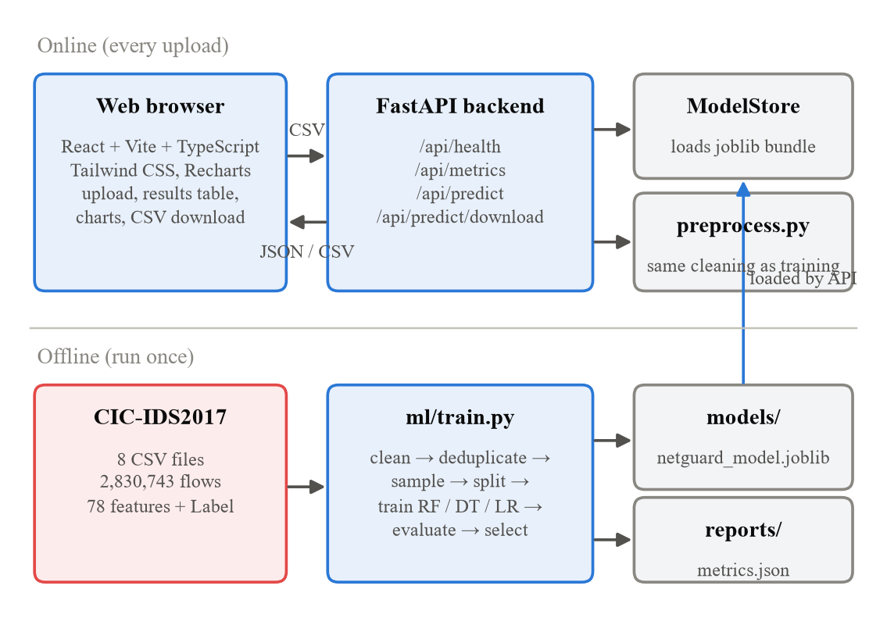
Fig. 4.1 System Architecture of NetGuard AI
Separating the offline and online parts keeps each part simple. Training can take minutes and several gigabytes of memory, whereas prediction must be fast and light. Because the saved bundle contains the fitted imputer, the optional scaler, the classifier and the exact list of feature names, the online part cannot drift from the offline part.
4.1.3 The CIC-IDS2017 dataset
CIC-IDS2017 was created by Sharafaldin, Habibi Lashkari and Ghorbani at the Canadian Institute for Cybersecurity [19]. The authors built a testbed with a victim network of Windows, Linux and macOS machines and servers protected by a firewall, and a separate attack network running Kali Linux. To produce realistic benign traffic they profiled the behaviour of 25 users over protocols such as HTTP, HTTPS, FTP, SSH and e-mail and replayed that behaviour with agents (the B-Profile system). Traffic was captured for five working days, from Monday 3 July to Friday 7 July 2017, while attacks were launched according to a schedule. Fig. 4.2 summarises how the published CSV files were produced.
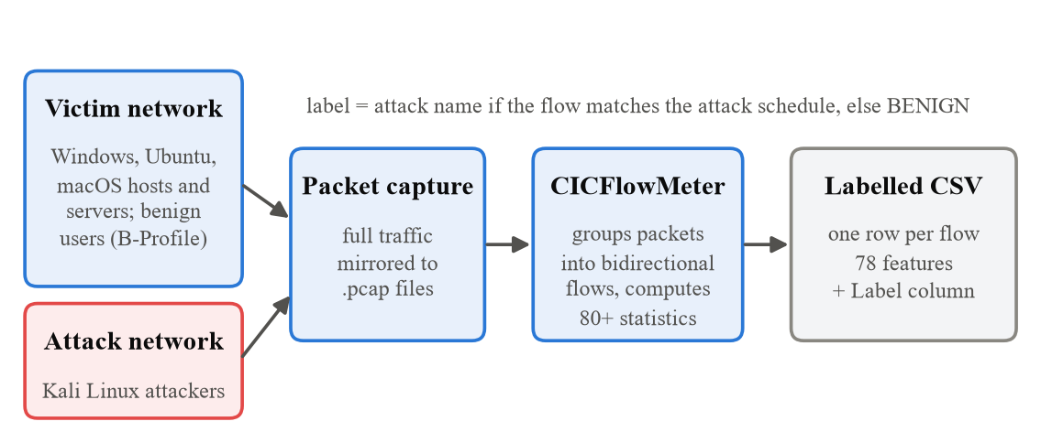
Fig. 4.2 Generation of the CIC-IDS2017 Flow Records
The full packet captures were processed with CICFlowMeter, which grouped packets into bidirectional flows and computed the flow statistics. Each flow was then labelled BENIGN or with the name of the attack running at that time between the attacker and victim addresses. The MachineLearningCSV version used here removes the identifying columns (flow ID, IP addresses, source port, protocol and timestamp) and keeps the destination port, 77 statistical features and the label. One feature, Fwd Header Length, appears twice, so the files have 79 columns in total. Table 4.1 lists the eight files, measured directly from the data.
Table 4.1 CIC-IDS2017 Files, Flow Counts and Attacks
File (day and period) | Flows | Benign | Attack labels (flows)
Monday-WorkingHours | 529,918 | 529,918 | none
Tuesday-WorkingHours | 445,909 | 432,074 | FTP-Patator (7,938), SSH-Patator (5,897)
Wednesday-workingHours | 692,703 | 440,031 | DoS Hulk (231,073), DoS GoldenEye (10,293), DoS slowloris (5,796), DoS Slowhttptest (5,499), Heartbleed (11)
Thursday-WorkingHours-Afternoon-Infilteration | 288,602 | 288,566 | Infiltration (36)
Thursday-WorkingHours-Morning-WebAttacks | 170,366 | 168,186 | Web Attack – Brute Force (1,507), Web Attack – XSS (652), Web Attack – Sql Injection (21)
Friday-WorkingHours-Afternoon-DDos | 225,745 | 97,718 | DDoS (128,027)
Friday-WorkingHours-Afternoon-PortScan | 286,467 | 127,537 | PortScan (158,930)
Friday-WorkingHours-Morning | 191,033 | 189,067 | Bot (1,966)
Total | 2,830,743 | 2,273,097 | 557,646 attack flows

Monday contains only benign traffic and serves as a clean baseline. Attacks start on Tuesday with FTP and SSH brute force, continue on Wednesday with the denial-of-service tools and Heartbleed, on Thursday with web attacks in the morning and infiltration in the afternoon, and end on Friday with the botnet, the port scan and the DDoS attack. Fig. 4.3 shows the volume of each file. Wednesday is the largest file because DoS Hulk alone generated 231,073 flows, whereas the Friday afternoon DDoS and PortScan files are more than half malicious.
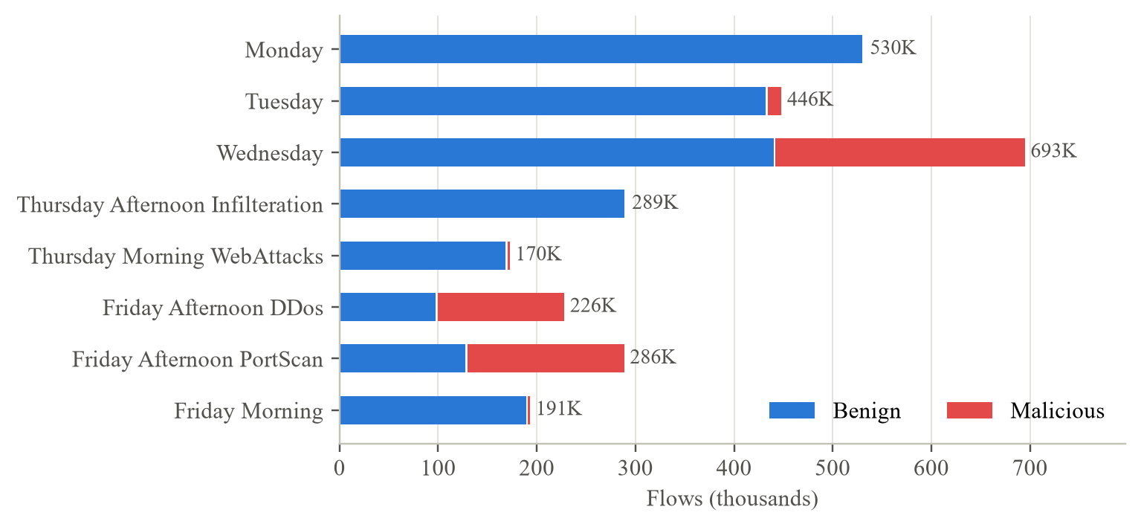
Fig. 4.3 Benign and Malicious Flows in Each CIC-IDS2017 File
4.1.4 Flow features
The 77 distinct features can be grouped by what they measure. Fig. 4.4 shows the size of each group and how many features of each group were dropped because they never change in the training data (Section 4.1.5). The groups are:
- Basic flow: destination port, duration and the number and total size of packets in each direction.
- Packet length: minimum, maximum, mean and spread of packet sizes, per direction and overall.
- Flow rate: bytes and packets per second.
- Inter-arrival time (IAT): timing between consecutive packets, overall and per direction.
- TCP flags: how many packets carried each TCP flag.
- Header and window: header bytes, TCP initial window sizes, data-carrying packets and the download/upload ratio.
- Bulk transfer and sub-flow: statistics of bulk data transfers and of sub-flows within a flow.
- Active / idle: how long the flow alternated between activity and silence.
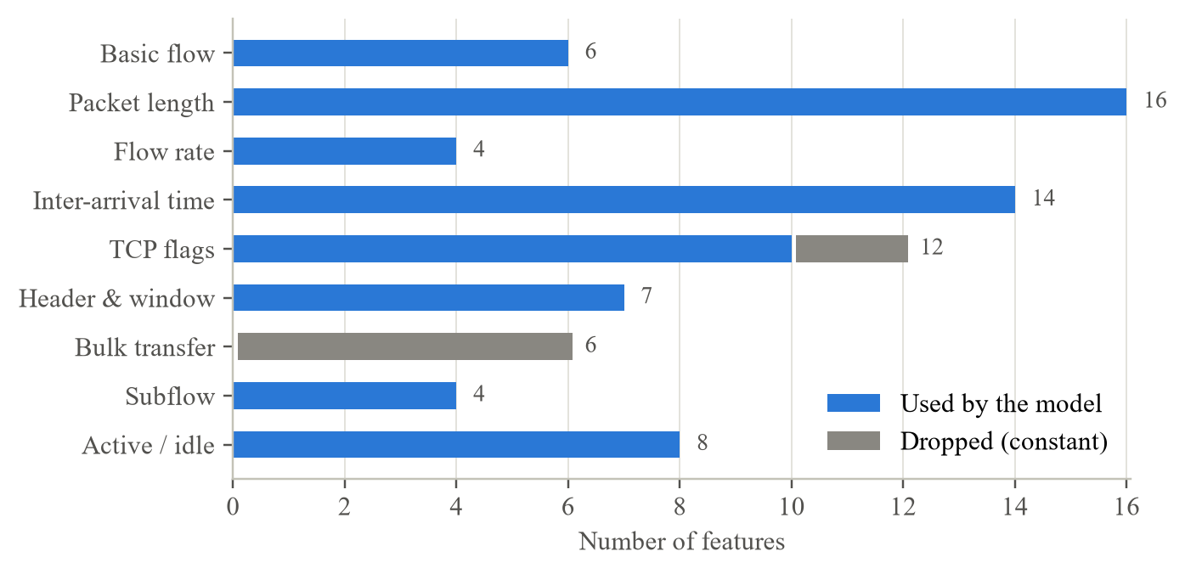
Fig. 4.4 Feature Groups of the CICFlowMeter Feature Set
Two of the features are derived quantities whose definitions matter for the data-quality analysis. The flow byte rate and packet rate are computed from the totals and the duration, which is measured in microseconds, as shown in Eqn. 4.1 and Eqn. 4.2:
$Flow Bytes/s = \frac{Total Length of Fwd Packets + Total Length of Bwd Packets}{Flow Duration} × {10}^{6}$ (4.1)
$Flow Packets/s = \frac{Total Fwd Packets + Total Backward Packets}{Flow Duration} × {10}^{6}$ (4.2)
These definitions were checked against the files: on all 529,466 Monday flows with a positive duration, the published Flow Bytes/s and Flow Packets/s agree with Eqn. 4.1 and Eqn. 4.2 to within 0.1%. When the duration is zero, the division in these equations is undefined, which explains the infinite and missing values described below. Table 4.2 gives the meaning of every feature; features marked as constant or identical to another feature were confirmed by measurement.
Table 4.2 Feature Dictionary of the 77 CIC-IDS2017 Flow Features
Feature | Group | Description | Model
Destination Port | Basic flow | Destination TCP/UDP port of the first packet; identifies the targeted service | used
Flow Duration | Basic flow | Time between the first and the last packet of the flow, in microseconds | used
Total Fwd Packets | Basic flow | Number of packets sent in the forward direction (initiator to responder) | used
Total Backward Packets | Basic flow | Number of packets sent in the backward direction (responder to initiator) | used
Total Length of Fwd Packets | Basic flow | Total size of the forward packets in bytes | used
Total Length of Bwd Packets | Basic flow | Total size of the backward packets in bytes | used
Fwd Packet Length Max | Packet length | Largest forward packet (bytes) | used
Fwd Packet Length Min | Packet length | Smallest forward packet (bytes) | used
Fwd Packet Length Mean | Packet length | Mean forward packet size (bytes) | used
Fwd Packet Length Std | Packet length | Standard deviation of forward packet sizes | used
Bwd Packet Length Max | Packet length | Largest backward packet (bytes) | used
Bwd Packet Length Min | Packet length | Smallest backward packet (bytes) | used
Bwd Packet Length Mean | Packet length | Mean backward packet size (bytes) | used
Bwd Packet Length Std | Packet length | Standard deviation of backward packet sizes | used
Min Packet Length | Packet length | Smallest packet in either direction | used
Max Packet Length | Packet length | Largest packet in either direction | used
Packet Length Mean | Packet length | Mean packet size in either direction | used
Packet Length Std | Packet length | Standard deviation of packet sizes | used
Packet Length Variance | Packet length | Variance of packet sizes (square of the standard deviation) | used
Average Packet Size | Packet length | Mean size of all packets in the flow | used
Avg Fwd Segment Size | Packet length | Mean forward segment size (equals Fwd Packet Length Mean) | used
Avg Bwd Segment Size | Packet length | Mean backward segment size (equals Bwd Packet Length Mean) | used
Flow Bytes/s | Flow rate | Bytes per second over the whole flow (Eqn. 4.1) | used
Flow Packets/s | Flow rate | Packets per second over the whole flow (Eqn. 4.2) | used
Fwd Packets/s | Flow rate | Forward packets per second | used
Bwd Packets/s | Flow rate | Backward packets per second | used
Flow IAT Mean | Inter-arrival time | Mean time between two consecutive packets of the flow (either direction) | used
Flow IAT Std | Inter-arrival time | Standard deviation of the flow inter-arrival time | used
Flow IAT Max | Inter-arrival time | Largest gap between consecutive packets | used
Flow IAT Min | Inter-arrival time | Smallest gap between consecutive packets | used
Fwd IAT Total | Inter-arrival time | Sum of gaps between consecutive forward packets | used
Fwd IAT Mean | Inter-arrival time | Mean gap between consecutive forward packets | used
Fwd IAT Std | Inter-arrival time | Standard deviation of forward inter-arrival times | used
Fwd IAT Max | Inter-arrival time | Largest gap between forward packets | used
Fwd IAT Min | Inter-arrival time | Smallest gap between forward packets | used
Bwd IAT Total | Inter-arrival time | Sum of gaps between consecutive backward packets | used
Bwd IAT Mean | Inter-arrival time | Mean gap between consecutive backward packets | used
Bwd IAT Std | Inter-arrival time | Standard deviation of backward inter-arrival times | used
Bwd IAT Max | Inter-arrival time | Largest gap between backward packets | used
Bwd IAT Min | Inter-arrival time | Smallest gap between backward packets | used
Fwd PSH Flags | TCP flags | Forward packets with PSH set (identical to SYN Flag Count in the files) | used
Bwd PSH Flags | TCP flags | Backward packets with PSH set (always 0 in the files) | dropped (constant)
Fwd URG Flags | TCP flags | Forward packets with URG set | used
Bwd URG Flags | TCP flags | Backward packets with URG set (always 0 in the files) | dropped (constant)
FIN Flag Count | TCP flags | Packets with the FIN flag | used
SYN Flag Count | TCP flags | Packets with the SYN flag | used
RST Flag Count | TCP flags | Packets with the RST flag | used
PSH Flag Count | TCP flags | Packets with the PSH flag | used
ACK Flag Count | TCP flags | Packets with the ACK flag | used
URG Flag Count | TCP flags | Packets with the URG flag | used
CWE Flag Count | TCP flags | Packets with the CWR (congestion window reduced) flag | used
ECE Flag Count | TCP flags | Packets with the ECE (ECN-echo) flag | used
Fwd Header Length | Header & window | Total bytes of headers in forward packets | used
Bwd Header Length | Header & window | Total bytes of headers in backward packets | used
Init_Win_bytes_forward | Header & window | TCP initial window size in the first forward packet (-1 if not TCP / not seen) | used
Init_Win_bytes_backward | Header & window | TCP initial window size in the first backward packet (-1 if not seen) | used
act_data_pkt_fwd | Header & window | Forward packets carrying at least one byte of TCP payload | used
min_seg_size_forward | Header & window | Minimum segment (header) size observed in the forward direction | used
Down/Up Ratio | Header & window | Ratio of download (backward) to upload (forward) traffic | used
Fwd Avg Bytes/Bulk | Bulk transfer | Mean bytes per bulk transfer, forward (always 0) | dropped (constant)
Fwd Avg Packets/Bulk | Bulk transfer | Mean packets per bulk transfer, forward (always 0) | dropped (constant)
Fwd Avg Bulk Rate | Bulk transfer | Mean bulk transfer rate, forward (always 0) | dropped (constant)
Bwd Avg Bytes/Bulk | Bulk transfer | Mean bytes per bulk transfer, backward (always 0) | dropped (constant)
Bwd Avg Packets/Bulk | Bulk transfer | Mean packets per bulk transfer, backward (always 0) | dropped (constant)
Bwd Avg Bulk Rate | Bulk transfer | Mean bulk transfer rate, backward (always 0) | dropped (constant)
Subflow Fwd Packets | Subflow | Mean forward packets per sub-flow (equals Total Fwd Packets) | used
Subflow Fwd Bytes | Subflow | Mean forward bytes per sub-flow (equals Total Length of Fwd Packets) | used
Subflow Bwd Packets | Subflow | Mean backward packets per sub-flow (equals Total Backward Packets) | used
Subflow Bwd Bytes | Subflow | Mean backward bytes per sub-flow | used
Active Mean | Active / idle | Mean time the flow was active before becoming idle | used
Active Std | Active / idle | Standard deviation of active periods | used
Active Max | Active / idle | Longest active period | used
Active Min | Active / idle | Shortest active period | used
Idle Mean | Active / idle | Mean time the flow was idle before becoming active again | used
Idle Std | Active / idle | Standard deviation of idle periods | used
Idle Max | Active / idle | Longest idle period | used
Idle Min | Active / idle | Shortest idle period | used

4.1.5 Exploratory data analysis
Before designing the preprocessing, the raw files were analysed with ml/analyze_dataset.py. The script reads all eight files, measures them before and after cleaning, and saves every number to reports/dataset_analysis.json, from which the tables and figures in this section are generated.
Class and attack distribution. Fig. 4.5 shows the number of flows per label on a logarithmic scale. The distribution is extremely skewed: BENIGN accounts for 80.30% of all flows, the three largest attack labels (DoS Hulk, PortScan and DDoS) for 18.30%, and the four smallest labels together contain only 720 flows. Heartbleed has just 11 flows and SQL injection 21.
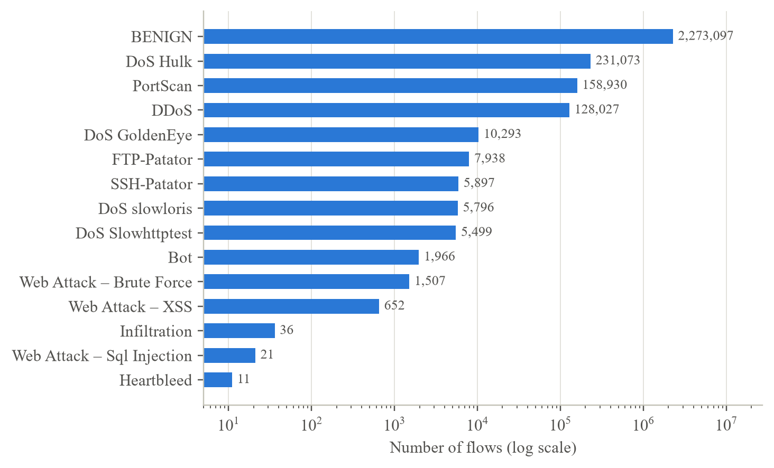
Fig. 4.5 Number of Flows per Label in the Raw Dataset (Log Scale)
For the binary problem the imbalance ratio, defined in Eqn. 4.3, is moderate: after deduplication there are 2,073,680 benign and 425,863 malicious flows, a ratio of 4.87 to 1. Within the malicious class, however, the ratio between the largest and smallest attack label exceeds 15,000 to 1, which is the root of the per-attack differences reported in Chapter 7 [23].
$IR = \frac{N_{benign}}{N_{malicious}}$ (4.3)
Table 4.3 Flows per Label Before and After Deduplication and in the Training Sample
Label | Raw flows | Unique flows | Duplicates | In 500k sample
BENIGN | 2,273,097 | 2,073,680 | 8.8% | 414,812
DoS Hulk | 231,073 | 172,849 | 25.2% | 34,475
PortScan | 158,930 | 90,819 | 42.9% | 18,151
DDoS | 128,027 | 128,016 | 0.0% | 25,587
DoS GoldenEye | 10,293 | 10,282 | 0.1% | 2,092
FTP-Patator | 7,938 | 5,933 | 25.3% | 1,204
SSH-Patator | 5,897 | 3,219 | 45.4% | 648
DoS slowloris | 5,796 | 5,374 | 7.3% | 1,078
DoS Slowhttptest | 5,499 | 5,228 | 4.9% | 1,095
Bot | 1,966 | 1,953 | 0.7% | 405
Web Attack – Brute Force | 1,507 | 1,470 | 2.5% | 298
Web Attack – XSS | 652 | 652 | 0.0% | 141
Infiltration | 36 | 36 | 0.0% | 9
Web Attack – Sql Injection | 21 | 21 | 0.0% | 1
Heartbleed | 11 | 11 | 0.0% | 4
Total | 2,830,743 | 2,499,543 | 11.7% | 500,000

Duplicate records. 331,200 rows (11.70%) are exact copies of another row, with identical values in all 78 features and the same label. Fig. 4.6 shows that duplication is very uneven. SSH-Patator (45.4%) and PortScan (42.9%) are the most duplicated, because these tools repeat the same short exchange thousands of times: a scan probe or a failed login produces a flow with the same packet counts, sizes and flags every time. Benign traffic is far more varied, and only 8.8% of it is duplicated.
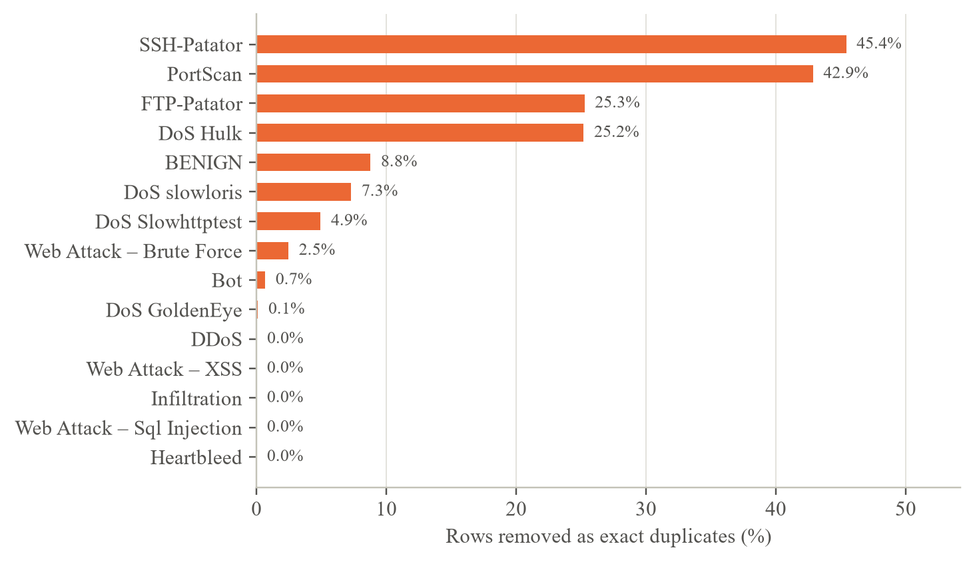
Fig. 4.6 Share of Each Label Removed as Exact Duplicates
Duplicates matter for evaluation. If one copy of a record falls in the training set and another in the test set, the model is tested on a flow it has already memorised, and the test score overstates how well it generalises. Because the most duplicated labels are attacks, keeping duplicates would also inflate the apparent detection rate of exactly those attacks. NetGuard therefore removes duplicates before any sampling or splitting.
Missing, infinite and negative values. Fig. 4.7 and Table 4.4 summarise the invalid values found in the raw files. Flow Bytes/s is missing (NaN) in 1,358 rows and infinite in 1,509 rows, and Flow Packets/s is infinite in 2,867 rows. All of them come from flows whose measured duration is zero: when both totals are also zero, Eqn. 4.1 evaluates 0/0 (NaN); otherwise it divides a positive number by zero (infinity).
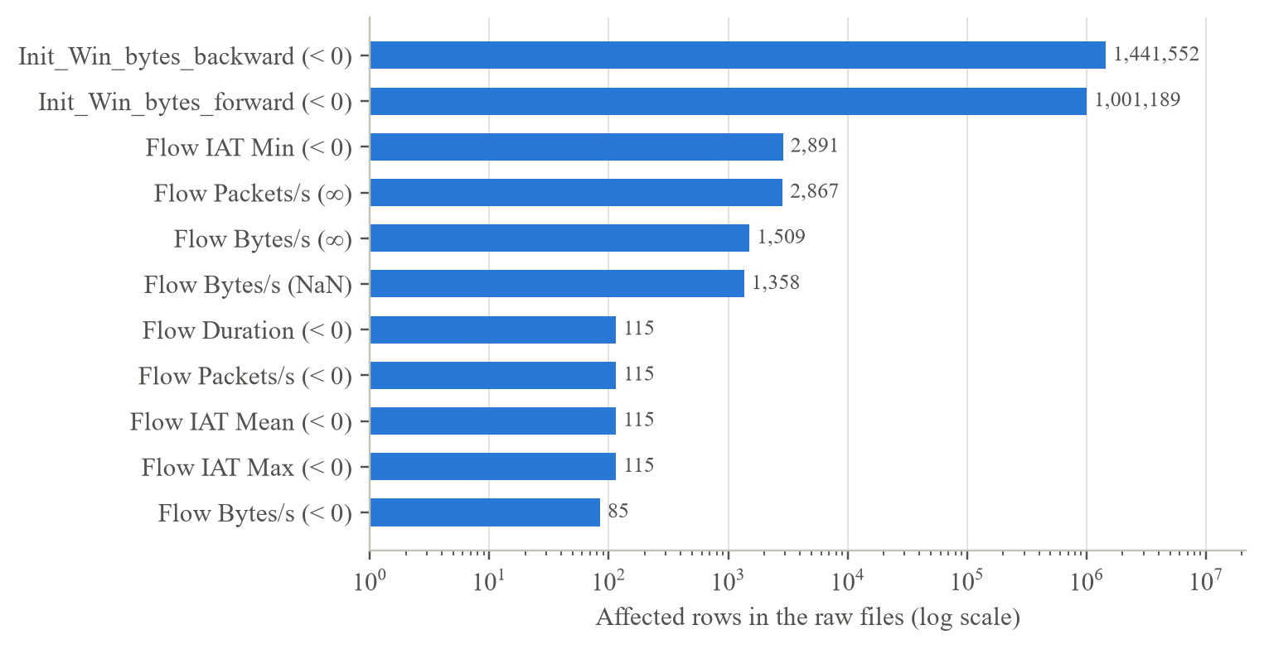
Fig. 4.7 Infinite, Missing and Negative Values in the Raw Files (Log Scale)
Table 4.4 Invalid and Sentinel Values in the Raw Dataset
Feature | Issue | Rows | Explanation and handling
Flow Bytes/s | NaN | 1,358 | 0/0 for zero-duration flows → median imputation
Flow Bytes/s | +∞ | 1,509 | Division by zero duration → treated as missing
Flow Packets/s | +∞ | 2,867 | Division by zero duration → treated as missing
Init_Win_bytes_backward | -1 | 1,441,552 | Sentinel: no TCP window seen (UDP or no reply) → kept as a value
Init_Win_bytes_forward | -1 | 1,001,189 | Sentinel: no TCP window seen → kept as a value
Flow IAT Min | < 0 | 2,891 | Timestamp ordering artefact of the flow meter → kept
Flow Duration | < 0 | 115 | Clock artefact, physically impossible → kept (rare)

The value -1 in the initial window features is not an error but a sentinel. In the Monday file, every flow to port 53 (DNS) and port 123 (NTP), both UDP services, has Init_Win_bytes_forward equal to -1, whereas only 0.6% of flows to port 443 do. UDP has no window field [4], so the flow meter records -1. Because the sentinel carries protocol information that tree-based models can use, it is kept as an ordinary value rather than treated as missing. The small number of negative durations and inter-arrival times are physically impossible and point to timestamp problems in the flow meter, which Engelen et al. [20] also reported; they affect fewer than 0.01% of rows and are left unchanged.
Constant features. Eight features have the same value in every one of the 2,499,543 unique flows: Bwd PSH Flags, Bwd URG Flags, Fwd Avg Bytes/Bulk, Fwd Avg Packets/Bulk, Fwd Avg Bulk Rate, Bwd Avg Bytes/Bulk, Bwd Avg Packets/Bulk, Bwd Avg Bulk Rate. All six bulk-transfer statistics are always zero, which suggests that the bulk-detection logic of the flow-meter version used did not trigger, and the backward PSH and URG counters are never set. A feature that never changes cannot separate classes, so these features are removed. The training script detects constant features on the training split only and finds the same eight, leaving 69 features for the model.
Feature distributions. Fig. 4.8 compares benign and malicious flows on six features. Values span many orders of magnitude, so they are plotted as log10(value + 1). Malicious flows last longer at the median, because slow DoS attacks and brute-force sessions keep connections open, and they have much larger variation in backward packet size, because attacked web servers return a mix of large pages and small error responses. The boxes overlap substantially, which shows that no single feature separates the classes; the model has to combine many features.
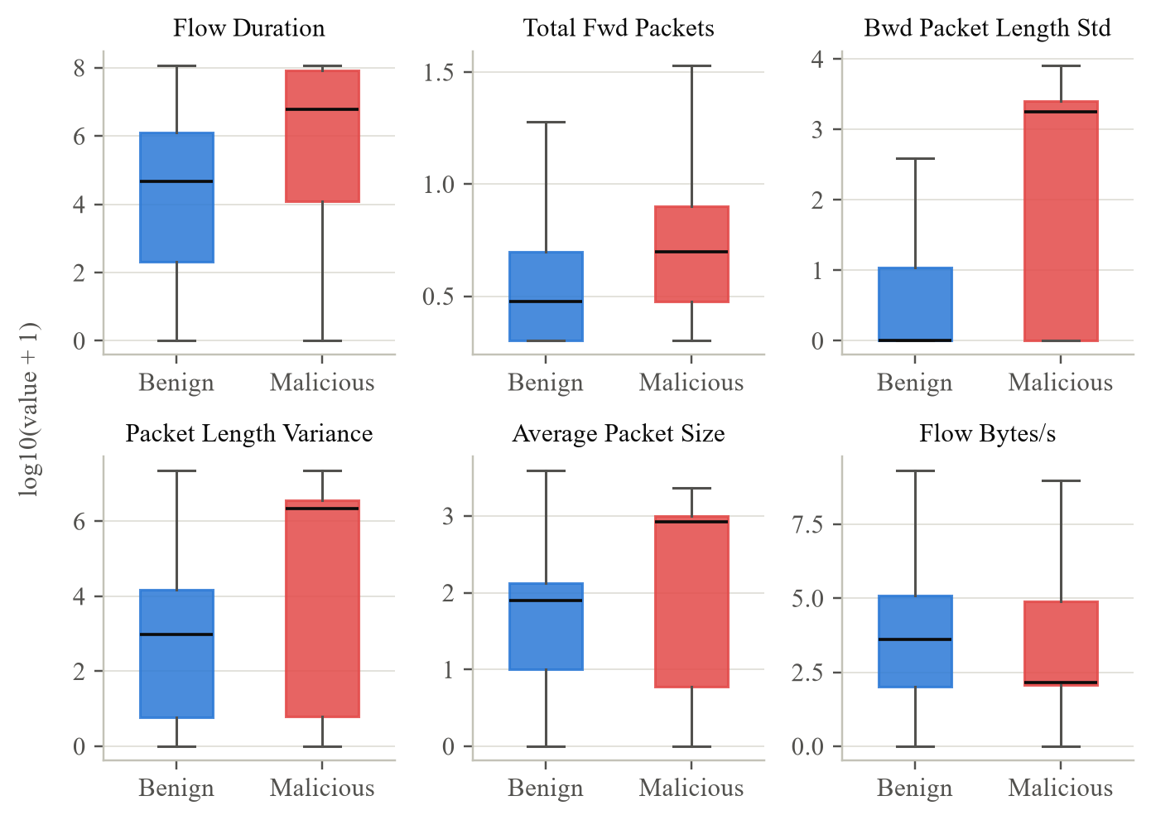
Fig. 4.8 Distribution of Six Flow Features for Benign and Malicious Flows
Table 4.5 Median and Mean of Key Features by Class (Unique Flows)
Feature | Benign median | Benign mean | Malicious median | Malicious mean
Flow Duration | 46,172.0 | 12,279,842.3 | 6,027,848.0 | 38,383,902.3
Total Fwd Packets | 2.0 | 11.5 | 4.0 | 4.9
Total Backward Packets | 2.0 | 13.2 | 5.0 | 4.1
Bwd Packet Length Std | 0.0 | 135.0 | 1,757.6 | 1,571.7
Average Packet Size | 78.5 | 131.9 | 829.5 | 612.0
Flow Bytes/s | 4,147.3 | 1,681,239.4 | 143.3 | 106,220.9
Flow Packets/s | 84.5 | 53,833.0 | 1.1 | 16,459.7
Init_Win_bytes_forward | 123.0 | 7,344.5 | 274.0 | 7,177.3

The large gap between median and mean in Table 4.5 shows heavily skewed distributions. For benign flows the median duration is 46.2 ms but the mean is 12.3 s, because most flows are short DNS lookups while a few long sessions dominate the mean. Fig. 4.9 shows the same effect as a cumulative distribution: more than half of the benign flows finish within 50 ms, whereas more than half of the malicious flows last longer than five seconds. Skewed, heavy-tailed features favour tree-based models, which split on thresholds and are unaffected by scale, over linear models that assume roughly linear effects.
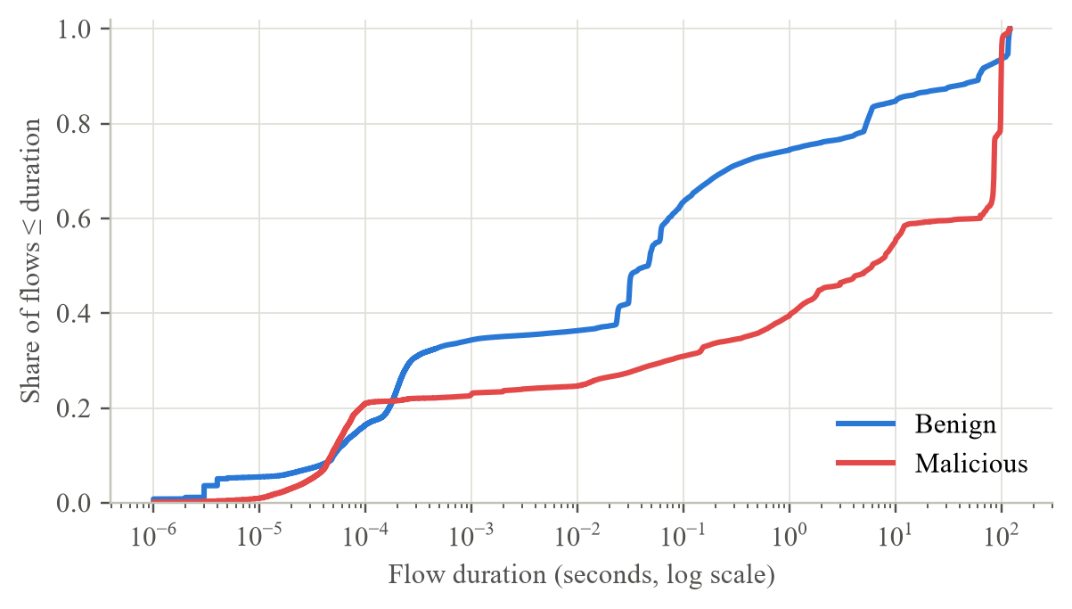
Fig. 4.9 Cumulative Distribution of Flow Duration by Class
Per-attack traffic profiles. Each attack leaves a distinctive network signature. Table 4.6 lists median values per label, computed on unique flows.
Table 4.6 Median Traffic Profile of Each Label
Label | Duration (s) | Fwd pkts | Bwd pkts | Bytes/s | Top port (share)
BENIGN | 0.046 | 2 | 2 | 4,147.3 | 53 (41%)
DoS Hulk | 86.401 | 6 | 6 | 123.8 | 80 (100%)
DDoS | 1.879 | 4 | 4 | 160.1 | 80 (100%)
PortScan | 0.000 | 1 | 1 | 137,931.0 | many
DoS GoldenEye | 11.588 | 7 | 5 | 651.0 | 80 (100%)
FTP-Patator | 8.686 | 9 | 15 | 33.9 | 21 (100%)
DoS slowloris | 99.999 | 3 | 2 | 0.2 | 80 (100%)
DoS Slowhttptest | 63.120 | 7 | 0 | 0.0 | 80 (100%)
SSH-Patator | 12.030 | 21 | 32 | 389.4 | 22 (100%)
Bot | 0.071 | 3 | 3 | 5,013.1 | 8080 (64%)
Web Attack – Brute Force | 5.568 | 3 | 1 | 0.0 | 80 (100%)
Web Attack – XSS | 5.399 | 3 | 1 | 0.0 | 80 (100%)
Infiltration | 93.189 | 26 | 26 | 173.4 | 444 (100%)
Web Attack – Sql Injection | 5.006 | 4 | 3 | 210.2 | 80 (100%)
Heartbleed | 119.261 | 2,792 | 2,069 | 66,172.2 | 444 (100%)

The profiles match how the tools work. PortScan flows last 50 µs and contain one packet in each direction (a probe and a reset), spread over thousands of ports, so no port holds even 5% of them. DoS slowloris holds connections open for about 100 seconds at 0.16 bytes per second, and DoS Slowhttptest flows typically receive no backward packet at all, which is the essence of a slow attack: occupying server resources while sending almost nothing. Brute-force sessions exchange tens of packets with the FTP or SSH server, and Heartbleed flows are long TLS sessions with thousands of packets in both directions. These distinct signatures explain why most attacks are easy to detect, and the labels whose profiles resemble benign traffic, such as Bot, are where errors concentrate.
Destination ports. The unique flows use 53,805 distinct destination ports. Fig. 4.10 shows the ten most frequent ports for each class.
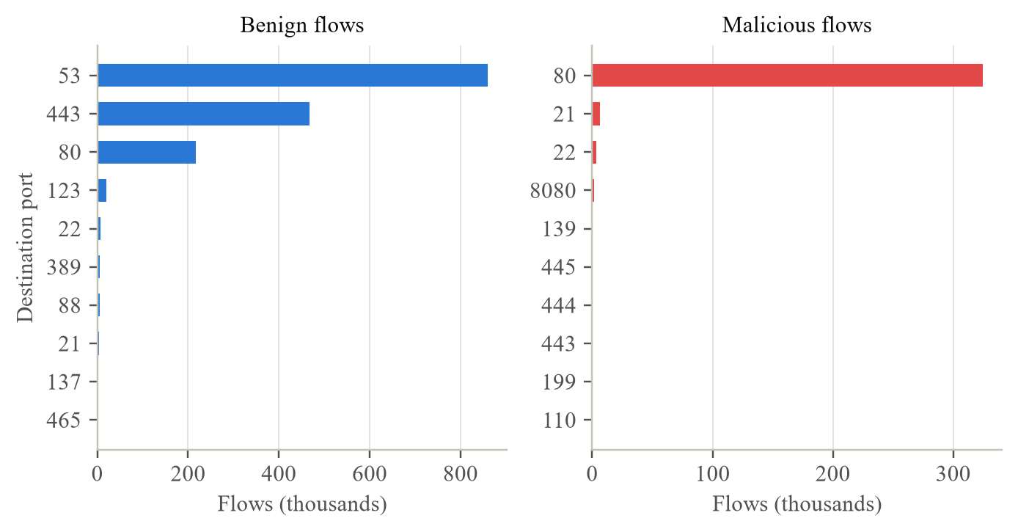
Fig. 4.10 Ten Most Frequent Destination Ports for Benign and Malicious Flows
Benign traffic is dominated by DNS (port 53, 859,553 flows), HTTPS (443) and HTTP (80), followed by NTP (123), SSH (22), LDAP (389) and Kerberos (88), which is typical of a Windows domain network. Malicious traffic is concentrated on port 80 (324,262 flows) because the DoS, DDoS and web attacks all target the web server, followed by FTP (21), SSH (22) and the botnet port 8080. Destination port is therefore informative, but it is not sufficient: benign HTTP traffic also uses port 80, so the model must look at how the connection behaves, not only where it goes.
Correlation and redundancy. Linear dependence between features was measured with the Pearson correlation coefficient (Eqn. 4.4) on a random sample of 200,000 unique flows, after removing constant features and filling missing values with medians.
$r_{ab} = \frac{\sum_{i=1}^{n}{\left(a_{i} - \bar{a}\right)\left(b_{i} - \bar{b}\right)}}{\sqrt{\sum_{i=1}^{n}{{\left(a_{i} - \bar{a}\right)}^{2}}}\sqrt{\sum_{i=1}^{n}{{\left(b_{i} - \bar{b}\right)}^{2}}}}$ (4.4)
44 feature pairs have |r| ≥ 0.95, and 8 pairs are perfectly correlated (|r| = 1). Table 4.7 lists the strongest pairs and Fig. 4.11 shows the correlation among the fifteen features the model finds most important.
Table 4.7 Most Strongly Correlated Feature Pairs
Feature A | Feature B | r
Total Fwd Packets | Subflow Fwd Packets | 1.0000
Total Backward Packets | Subflow Bwd Packets | 1.0000
Total Length of Fwd Packets | Subflow Fwd Bytes | 1.0000
Fwd Packet Length Mean | Avg Fwd Segment Size | 1.0000
Bwd Packet Length Mean | Avg Bwd Segment Size | 1.0000
Fwd PSH Flags | SYN Flag Count | 1.0000
Fwd URG Flags | CWE Flag Count | 1.0000
Total Length of Bwd Packets | Subflow Bwd Bytes | 1.0000
Total Fwd Packets | Total Backward Packets | 0.9987
Total Fwd Packets | Subflow Bwd Packets | 0.9987
Total Backward Packets | Subflow Fwd Packets | 0.9987
Subflow Fwd Packets | Subflow Bwd Packets | 0.9987

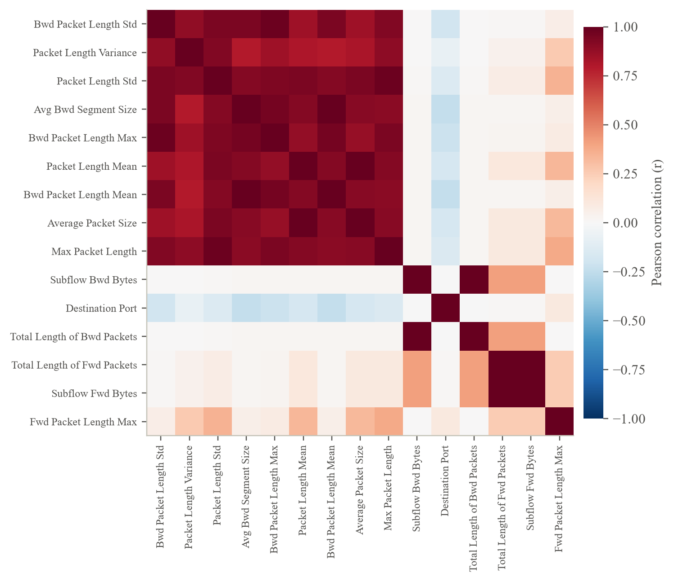
Fig. 4.11 Pearson Correlation Among the Fifteen Most Important Features
The perfect correlations reveal redundancy built into the feature set. The sub-flow features equal the corresponding totals because CICFlowMeter found one sub-flow per flow; the average segment sizes equal the mean packet lengths; and, surprisingly, Fwd PSH Flags equals SYN Flag Count in every row, which indicates that the flow meter stored the wrong counter in one of these columns. Redundant features do not harm a Random Forest's predictions, but they split the importance score between copies, so the importance ranking in Chapter 7 is read at the level of feature groups. They were kept to preserve compatibility with standard CIC-IDS2017 files.
4.1.6 Data preprocessing pipeline
The findings above define the preprocessing steps shown in Fig. 4.12. Steps 1 to 4 run once on the full dataset in ml/train.py; steps 5 to 7 build the training data; step 8 lives inside the saved scikit-learn Pipeline and is therefore applied automatically to every uploaded file.
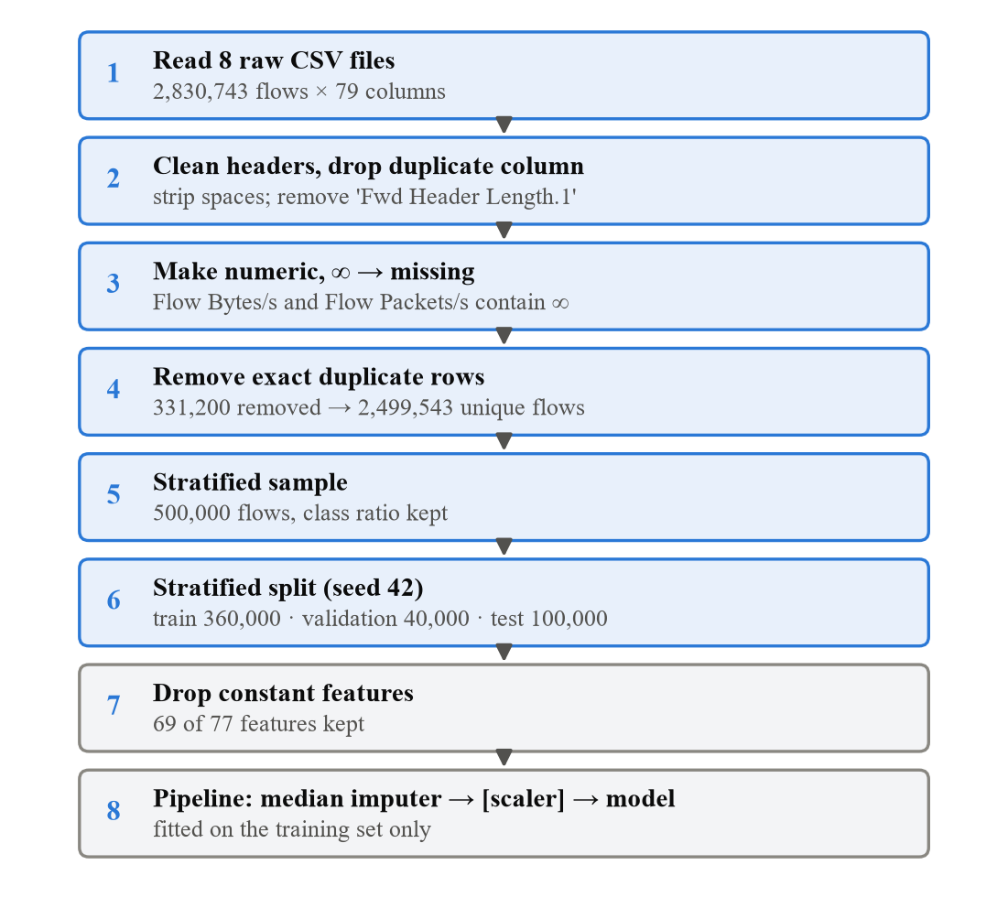
Fig. 4.12 Preprocessing Pipeline With Row Counts at Each Step
- Header cleaning. Column names in the files start with a space (" Flow Duration"), so names are stripped. The duplicated Fwd Header Length column, which pandas renames to Fwd Header Length.1, is dropped.
- Type conversion. Every feature is converted to a number; text that cannot be converted becomes missing, and +∞ and -∞ become missing. Features are stored as 32-bit floats, halving memory use.
- Label mapping. Labels are stripped and mapped to two classes with Eqn. 4.5.
- Deduplication. Each row (all features and the label) is hashed to a 64-bit value with pandas.util.hash_pandas_object and only the first row of each hash is kept. Hashing 2.8 million rows takes seconds, whereas pandas' column-by-column drop_duplicates had not finished after nine minutes in an early version of the pipeline. With 2.8 million rows, the probability of two different rows sharing a 64-bit hash is about 2 × 10⁻⁷, which is negligible.
$y_{i} = \left\{0 if {label}_{i} = BENIGN; 1 otherwise\right.$ (4.5)
Missing values that remain after cleaning are replaced by the median of the training data (Eqn. 4.6). The median is used instead of the mean because the features are heavily skewed (Table 4.5), so the mean would be pulled towards rare extreme values. For Logistic Regression the features are additionally standardised (Eqn. 4.7), because that model is sensitive to the very different scales of, for example, Destination Port and Flow Duration.
${x^{'}}_{ij} = \left\{median\left(x_{j} ∣ train\right) if x_{ij} is missing; x_{ij} otherwise\right.$ (4.6)
$z_{ij} = \frac{x_{ij} - μ_{j}}{σ_{j}}$ (4.7)
The median, mean and standard deviation in these equations are learned with fit() on the training split only and then applied with transform() to the validation set, the test set and every uploaded file. Fitting them on all data would leak information about the test set into the model.
4.1.7 Sampling and data splitting
Training on all 2,499,543 unique flows would need far more than the 7 GB of memory available, so the pipeline draws a stratified random sample of 500,000 flows. Stratification keeps the benign/malicious ratio of the sample equal to that of the full data, as expressed in Eqn. 4.8, where N_{c} is the number of flows of class c.
$\frac{N_{c}^{sample}}{N^{sample}} ≈ \frac{N_{c}}{N}, c ∈ \{benign, malicious\}$ (4.8)
Fig. 4.13 compares the share of every label in the sample with its share in the cleaned dataset. For the large labels the two agree closely, but the sample is stratified on the binary class, not on the attack label, so very rare labels are kept only by chance: the sample contains 4 of the 11 Heartbleed flows, 9 of the 36 Infiltration flows and 1 of the 21 SQL injection flows.
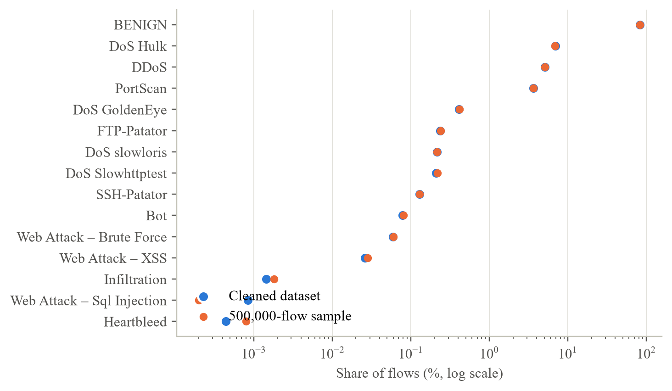
Fig. 4.13 Share of Each Label in the Cleaned Dataset and in the Training Sample
The sample is then split in two stages, both stratified on the binary class with random_state = 42. First 20% is set aside as the test set. Then 10% of the remaining 80% becomes the validation set. The result is 360,000 training, 40,000 validation and 100,000 test flows (72% / 8% / 20%). Table 4.8 shows the class balance of each part.
Table 4.8 Composition of the Training, Validation and Test Sets
Set | Flows | Benign | Malicious | Malicious share
Training | 360,000 | 298,665 | 61,335 | 17.04%
Validation | 40,000 | 33,185 | 6,815 | 17.04%
Test | 100,000 | 82,962 | 17,038 | 17.04%

The three sets have the same malicious share to three decimal places, which confirms the stratification. Their roles are strictly separated. The training set is used to fit the models. The validation set is used for one decision only, choosing which model to deploy. The test set is used only to report the final scores, so it estimates the performance on unseen traffic. As a reproducibility check, the dataset analysis script rebuilds the sample and split independently and re-runs the saved model on the rebuilt test set; it reproduces the stored confusion matrices of all three models exactly.
Table 4.9 shows how the rare attack labels were distributed over the three sets.
Table 4.9 Rare Attack Labels in Each Set
Label | Train | Validation | Test
Bot | 298 | 33 | 74
Web Attack – Brute Force | 224 | 20 | 54
Web Attack – XSS | 102 | 11 | 28
Infiltration | 4 | 0 | 5
Heartbleed | 1 | 0 | 3
Web Attack – Sql Injection | 1 | 0 | 0

The table exposes an important property of the data. Only one Heartbleed flow and four Infiltration flows are available for training, and SQL injection has a single training example and none in the test set. No classifier can learn a reliable pattern from one or four examples, so detection of these labels in Chapter 7 must be interpreted with this in mind. Stratifying on the attack label, or keeping every flow of the rarest labels, would reduce the problem; this is discussed as a recommendation in Chapter 8.
4.1.8 Machine learning models
Three classifiers of increasing complexity were compared, all implemented with scikit-learn [24]. Each is wrapped in a Pipeline together with its preprocessing, so the whole chain is saved and reused as one object.
Decision Tree. A decision tree [13], [25] splits the data recursively. At each node it chooses the feature and threshold that make the two resulting groups as pure as possible. Purity is measured with the Gini impurity (Eqn. 4.9), where p_{k} is the share of class k among the N samples at a node; a node with only one class has G = 0. The chosen split maximises the impurity decrease (Eqn. 4.10), where L and R are the left and right children. The tree grows until its leaves are pure, which makes it accurate on training data but prone to overfitting.
$G = 1 - \sum_{k=1}^{K}{{p_{k}}^{2}}$ (4.9)
$ΔG = G_{parent} - \frac{N_{L}}{N}G_{L} - \frac{N_{R}}{N}G_{R}$ (4.10)
Random Forest. A Random Forest [12] trains T decision trees, each on a bootstrap sample of the training data (rows drawn with replacement), and at every split considers only a random subset of m features (Eqn. 4.12). The randomness makes the trees different from each other, so their errors partly cancel. The forest's malicious probability is the average of the trees' votes (Eqn. 4.11), and a flow is classified as malicious when this probability is at least 0.5.
$P\left(malicious ∣ x\right) = \frac{1}{T}\sum_{t=1}^{T}{h_{t}\left(x\right)}$ (4.11)
$m = \left\lfloor \sqrt{p}\right\rfloor = \left\lfloor \sqrt{69}\right\rfloor = 8$ (4.12)
Here h_{t}(x) is the prediction of tree t (strictly, scikit-learn averages each tree's class probability), and p = 69 is the number of features. The forest also measures feature importance as the mean decrease in impurity (Eqn. 4.13): the total Gini decrease contributed by splits on a feature, averaged over all trees and normalised to sum to one.
${Imp}_{j} = \frac{1}{T}\sum_{t=1}^{T}{\sum_{s ∈ t : feature(s) = j}{\frac{N_{s}}{N}ΔG_{s}}}$ (4.13)
Logistic Regression. Logistic Regression [26] is a linear model. It computes a weighted sum of the standardised features and passes it through the sigmoid function to obtain a probability (Eqn. 4.14). The weights are learned by minimising the log-loss (Eqn. 4.15). Because its decision boundary is a hyperplane, it serves as a baseline that shows how much the non-linear tree models gain.
$P\left(y = 1 ∣ x\right) = σ\left(w^{T}x + b\right) = \frac{1}{1 + e^{-\left(w^{T}x + b\right)}}$ (4.14)
$L\left(w, b\right) = -\frac{1}{n}\sum_{i=1}^{n}{\left[y_{i} log p_{i} + \left(1 - y_{i}\right) log\left(1 - p_{i}\right)\right]}$ (4.15)
Table 4.10 Model Configurations
Model | Pipeline steps | Main hyper-parameters
Random Forest | SimpleImputer(median) → RandomForestClassifier | 100 trees, max_features = √p, unlimited depth, n_jobs = −1, random_state = 42
Decision Tree | SimpleImputer(median) → DecisionTreeClassifier | Gini criterion, unlimited depth, random_state = 42
Logistic Regression | SimpleImputer(median) → StandardScaler → LogisticRegression | L2 penalty, C = 1.0, lbfgs solver, max_iter = 1000

Default hyper-parameters were used deliberately. The aim is a fair, explainable comparison rather than a tuned competition; tuning would also require additional validation data, and the models already reach very high scores. Class weights were not used because the binary imbalance (4.9 to 1) is moderate.
4.1.9 Evaluation metrics and model selection
Malicious is treated as the positive class. From the test-set confusion matrix, with TP (attacks correctly flagged), TN (benign flows correctly passed), FP (false alarms) and FN (missed attacks), the following metrics are computed:
$Accuracy = \frac{TP + TN}{TP + TN + FP + FN}$ (4.16)
$Precision = \frac{TP}{TP + FP}$ (4.17)
$Recall = \frac{TP}{TP + FN}$ (4.18)
$F_{1} = 2 × \frac{Precision × Recall}{Precision + Recall}$ (4.19)
$FPR = \frac{FP}{FP + TN}$ (4.20)
Accuracy alone is misleading for imbalanced data: a model that labels every flow benign would reach 82.96% accuracy on this dataset while detecting nothing. Precision tells an analyst how many alerts are real, recall (the detection rate) how many attacks are caught, and F1 balances the two. The false positive rate matters operationally because even a small FPR produces many false alarms on a large benign volume. The ROC curve [27] and the precision–recall curve [28] summarise performance over all decision thresholds.
The model to deploy is chosen on the validation set using F1-score. Random Forest is the primary model of the project, so it is kept unless another model's validation F1 is higher by more than 0.001. This margin prevents a difference of one or two flows, which is statistical noise, from changing the deployed model. The rule was added after the first training run showed a near-tie between Random Forest and Decision Tree, and it uses validation data only, so the test set plays no part in the choice.
4.1.10 Backend design
The backend is a FastAPI application (backend/app/main.py) created by a factory function, create_app(), which receives the model and metrics paths. The factory makes the application easy to test: the tests create an app that points at a small synthetic model in a temporary folder. A ModelStore object (backend/app/model_store.py) loads the joblib bundle on first use, checks that it contains a pipeline, a feature list and a model name, and reloads it automatically if the file changes after retraining.
Every prediction request follows the same path. The upload is checked for a .csv extension, a size limit of 100 MB and non-empty content; it is parsed with pandas; column names are stripped; the prepare_features() function from ml/preprocess.py checks that all 69 model features are present and numeric and orders them as in training; and the Pipeline returns predictions and probabilities. Table 4.11 lists the validation rules.
Table 4.11 Input Validation Rules
Check | Rule | Response
File type | Name must end in .csv | 400
Size | At most 100 MB (the server stops reading after the limit) | 413
Content | Not empty, parseable as CSV, at least one data row | 400
Columns | All 69 required features present (extra columns ignored) | 422 + list of missing columns
Values | Feature values numeric; blank, NaN and Infinity accepted as missing | 422 + list of bad columns
Model | Saved model file present and loadable | 503

The JSON response contains summary counts computed over every row, the first 5,000 rows for the dashboard table (with five readable columns, the prediction, the malicious probability and the actual label when present) and, if the file has a Label column, the agreement between predictions and labels. The download endpoint returns the whole file with two added columns, so no row is lost however large the upload. Cross-origin requests from the Vite development server are allowed, and when the frontend has been built the backend also serves it, so the complete application can run on one port.
4.1.11 Frontend design
The dashboard is a single-page React application written in TypeScript and styled with Tailwind CSS. It uses a dark navy theme with restrained accent colours, Lucide icons and no decorative animation. Table 4.12 lists its components.
Table 4.12 Frontend Components
Component | Responsibility
Header | Product name and live model status from /api/health
UploadPanel | File picker with drag and drop, Analyze and Clear buttons, validation error display
SummaryCards | Flows analysed, benign and malicious counts, agreement with labels, composition bar
ResultsTable | Filter (all / benign / malicious / misclassified), pagination, probability bars, CSV download
ModelComparison | Test-set metrics table and grouped bar chart for the three models
ConfusionMatrix | 2 × 2 matrix with counts and row percentages, model selector
DatasetInfo | Raw and used flow counts, duplicates removed, train / validation / test split
FeatureImportance | Top ten Random Forest features as a horizontal bar chart
api.ts | Typed API client with readable error messages for network and validation failures

Colours were chosen by job, not decoration. Benign is blue and malicious red, a pair that remains distinguishable for the common forms of colour-vision deficiency (verified with a palette validator), and every coloured mark is accompanied by a text label or icon so that colour is never the only cue. Each model keeps the same colour in every chart. Bar charts start at zero so that bar lengths are honest, and exact values are always available in an adjacent table.
4.2 Codes and Standards
The project follows the protocol, data-format and software standards in Table 4.13.
Table 4.13 Standards Followed in the Project
Standard | Title | Where it applies
RFC 791 | Internet Protocol [29] | Addressing and packet structure behind every flow record
RFC 9293 | Transmission Control Protocol [3] | Handshake, flags and window fields used as features
RFC 768 | User Datagram Protocol [4] | Explains the −1 window sentinel for UDP flows
RFC 3168 | Explicit Congestion Notification [5] | ECE and CWR flag features
RFC 3954 / RFC 7011 | NetFlow v9 / IPFIX [6], [7] | Flow-record concept used by CICFlowMeter
RFC 9110 | HTTP Semantics [30] | REST API methods and status codes (400, 413, 422, 503)
RFC 7578 | multipart/form-data [31] | CSV file upload
RFC 4180 | CSV format [32] | Input files and downloaded results
RFC 8259 | JSON [33] | API responses and saved reports
OpenAPI 3.1 | OpenAPI Specification [34] | Interactive API documentation generated at /docs
PEP 8 | Style Guide for Python Code [35] | Python code layout and naming
WCAG 2.2 | Web Content Accessibility Guidelines [36] | Contrast, non-colour cues, keyboard focus

4.3 Constraints, Alternatives and Tradeoffs
The design had to respect the following constraints:
- Memory: about 7 GB of RAM, which rules out loading and training on all 2.5 million unique flows at once; hence float32 storage and the 500,000-flow stratified sample.
- Explainability: the system must be explainable in a 20-minute viva, which favours classical models and a small, readable code base over deep learning.
- Data access: the official download requires a form, so a byte-identical Kaggle mirror was used and the row count was verified.
- Scope: no database, authentication or live capture, as required by the project brief.
Table 4.14 Design Alternatives and the Chosen Trade-Offs
Decision | Chosen | Alternative | Reason
Problem type | Binary (benign / malicious) | Multi-class attack type | Matches the project goal; rare classes make multi-class unreliable
Training data size | 500k stratified sample | All 2.5M unique flows | Fits in memory and trains in minutes; results stable
Duplicates | Removed before splitting | Kept | Prevents train/test leakage and inflated attack scores
Missing values | Median imputation inside the Pipeline | Drop rows | Keeps every uploaded row predictable; robust to skew
Primary model | Random Forest | Gradient boosting, neural networks | Strong, fast, needs no scaling, gives feature importance
Model choice | Validation F1 with 0.001 margin | Best test score | Test set must not influence decisions
Deduplication method | 64-bit row hashing | pandas drop_duplicates | Seconds instead of more than nine minutes
Serving | FastAPI + saved joblib Pipeline | Retrain per request / notebook | Fast, consistent, automatically documented
Frontend | React + Vite SPA | Server-rendered templates | Interactive table and charts, clean API boundary

The main trade-off is between completeness and practicality. Training on a sample loses some of the rare attack flows, and binary labels hide which attack was detected. In return the system is fast, fits on a laptop and is simple enough to explain completely, while the dataset analysis makes the cost of these choices visible instead of hiding it.

CHAPTER 5
SCHEDULE, TASKS AND MILESTONES
The project was planned as a twelve-week course project. Work was organised so that each stage produced a concrete artefact that the next stage depended on: the verified dataset, the analysis results, the trained model and report, the API, the dashboard and finally this document.
5.1 Tasks
Table 5.1 Project Tasks and Planned Weeks
No. | Task | Weeks | Output
1 | Literature survey and dataset selection | W1–W2 | Comparison of IDS datasets (Table 1.3)
2 | Dataset download and verification | W2 | 8 CSV files, row count verified
3 | Exploratory data analysis | W3–W4 | Distributions, quality issues, duplicates
4 | Preprocessing and deduplication | W4–W5 | ml/preprocess.py, cleaning functions
5 | Sampling, splitting and model training | W5–W6 | ml/train.py, three trained models
6 | Evaluation and model selection | W7 | metrics.json, model_report.md
7 | FastAPI backend and input validation | W7–W8 | backend/app/
8 | React dashboard | W8–W9 | frontend/src/
9 | Backend tests and integration | W10 | 17 passing tests, production build
10 | Dataset analysis for the report | W10–W11 | dataset_analysis.json, figures
11 | Report, viva guide and demonstration | W11–W12 | This report, docs/VIVA_GUIDE.md

5.2 Gantt chart
Fig. 5.1 shows the same plan as a Gantt chart. Several tasks overlap where they were independent.
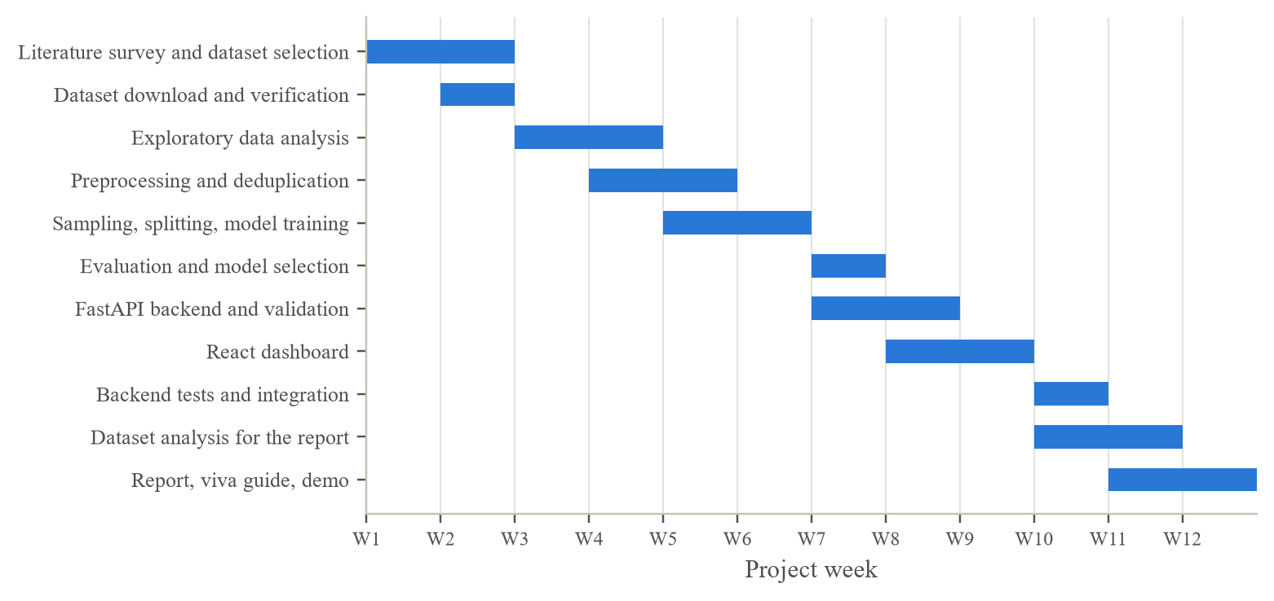
Fig. 5.1 Project Gantt Chart
5.3 Milestones
Table 5.2 Project Milestones
Milestone | Week | Completion criterion
M1 Dataset ready | W2 | 2,830,743 flows loaded, matching the official count
M2 Data understood | W4 | Quality issues, duplicates and distributions documented
M3 Models trained | W7 | Three models evaluated on the test set; Random Forest F1 > 99%
M4 API working | W8 | Real predictions returned; invalid files rejected with clear errors
M5 Dashboard working | W9 | Upload, results, download and evaluation views working end to end
M6 Verified | W10 | 17 backend tests pass; frontend production build succeeds; browser test passes
M7 Submitted | W12 | Report, viva guide and demonstration complete

5.4 Risks and mitigation
Table 5.3 Project Risks and Mitigation
Risk | Impact | Mitigation
Official dataset download requires a form | Delay in obtaining data | Byte-identical Kaggle mirror; row count verified
Training exceeds available memory | Pipeline cannot run | float32 storage, 500k stratified sample; peak 2.8 GB measured
Slow deduplication | Long iteration cycle | Replaced column-wise comparison with 64-bit row hashing
Data leakage between train and test | Over-optimistic results | Deduplicate first; fit preprocessing on training data only
Training/inference mismatch | Wrong predictions in the app | Shared preprocess.py and a saved Pipeline with feature list
Results not reproducible | Report cannot be verified | Fixed seeds; analysis script re-checks the saved confusion matrices

CHAPTER 6
PROJECT DEMONSTRATION
This chapter shows the most important parts of the implementation and the working application. The code excerpts are taken verbatim from the project repository; the screenshots were captured from the running application analysing real CIC-IDS2017 flows from the held-out test set.
6.1 Sample Codes
6.1.1 Shared preprocessing (ml/preprocess.py)
prepare_features() is called both by the training pipeline's callers and by the API. It strips the column names, rejects files with missing or non-numeric feature columns and returns the features in the exact order used in training, with infinities converted to missing values.
def clean_column_names(df: pd.DataFrame) -> pd.DataFrame:
"""Strip spaces from headers and drop the known duplicate column."""
df = df.rename(columns=lambda c: str(c).strip())
return df.drop(columns=[c for c in DUPLICATE_COLUMNS if c in df.columns])

def to_binary_labels(labels: pd.Series) -> np.ndarray:
"""Map 'BENIGN' -> 0 and every attack type -> 1 (Malicious)."""
cleaned = labels.astype(str).str.strip().str.upper()
return (cleaned != BENIGN_LABEL).astype(np.int8).to_numpy()

def prepare_features(df: pd.DataFrame, feature_names: list[str]) -> pd.DataFrame:
"""Validate a raw DataFrame and return only the model's numeric features.

Raises FeatureValidationError if columns are missing or contain text that
cannot be interpreted as a number.
"""
df = clean_column_names(df)

missing = [name for name in feature_names if name not in df.columns]
if missing:
raise FeatureValidationError(
f"CSV is missing {len(missing)} required feature column(s).", missing
)

features = pd.DataFrame(index=df.index)
bad_columns = []
for name in feature_names:
column = df[name]
numeric = pd.to_numeric(column, errors="coerce")
# A value is "bad" if it was present in the file but is not a number.
if (numeric.isna() & column.notna() & (column.astype(str).str.strip() != "")).any():
bad_columns.append(name)
features[name] = numeric

if bad_columns:
raise FeatureValidationError(
f"{len(bad_columns)} feature column(s) contain non-numeric values.", bad_columns
)

features = features.astype(np.float64).replace([np.inf, -np.inf], np.nan)
return features

6.1.2 Cleaning, deduplication and splitting (ml/train.py)
clean_frame() applies the cleaning steps to one raw file; remove_duplicates() hashes rows; split_data() makes the stratified 72/8/20 split.
def clean_frame(df: pd.DataFrame) -> pd.DataFrame:
"""Clean one raw file: tidy headers, drop unlabelled rows, make every
feature numeric and turn +/-infinity into NaN."""
df = clean_column_names(df)
df = df.dropna(subset=[config.LABEL_COLUMN])
df[config.LABEL_COLUMN] = df[config.LABEL_COLUMN].astype(str).str.strip()

feature_cols = [c for c in df.columns if c != config.LABEL_COLUMN]
df[feature_cols] = (
df[feature_cols]
.apply(pd.to_numeric, errors="coerce")
.replace([np.inf, -np.inf], np.nan)
.astype(np.float32) # float32 halves memory use
)
return df

def remove_duplicates(data: pd.DataFrame) -> pd.DataFrame:
"""Drop exact duplicate rows (identical features AND label).

Identical rows add no information and can leak between train and test.
Hashing each row (64-bit) is much faster than comparing all 79 columns.
"""
row_hashes = pd.util.hash_pandas_object(data, index=False)
return data[~row_hashes.duplicated().to_numpy()].reset_index(drop=True)

def split_data(data: pd.DataFrame) -> dict:
"""Stratified 80/20 train+validation/test split, then 10% of the training
part becomes the validation set. Original attack names are kept alongside
so results can be broken down per attack type."""
y = to_binary_labels(data[config.LABEL_COLUMN])
X = data.drop(columns=[config.LABEL_COLUMN])
labels = data[config.LABEL_COLUMN]

X_trval, X_test, y_trval, y_test, lab_trval, lab_test = train_test_split(
X, y, labels, test_size=config.TEST_SIZE,
stratify=y, random_state=config.RANDOM_STATE,
)
X_train, X_val, y_train, y_val, lab_train, lab_val = train_test_split(
X_trval, y_trval, lab_trval, test_size=config.VALIDATION_SIZE,
stratify=y_trval, random_state=config.RANDOM_STATE,
)
return {
"y": y,
"X_train": X_train, "y_train": y_train, "labels_train": lab_train,
"X_val": X_val, "y_val": y_val, "labels_val": lab_val,
"X_test": X_test, "y_test": y_test, "labels_test": lab_test,
}

6.1.3 Model definitions and selection (ml/train.py)
Each model is a Pipeline, so the imputer (and scaler) is saved with it. select_model() applies the validation-set rule.
def build_models() -> dict[str, Pipeline]:
"""Each model is a Pipeline so preprocessing is saved together with it."""
return {
"Random Forest": Pipeline([
("imputer", SimpleImputer(strategy="median")),
("model", RandomForestClassifier(
n_estimators=100, n_jobs=-1, random_state=config.RANDOM_STATE
)),
]),
"Decision Tree": Pipeline([
("imputer", SimpleImputer(strategy="median")),
("model", DecisionTreeClassifier(random_state=config.RANDOM_STATE)),
]),
"Logistic Regression": Pipeline([
("imputer", SimpleImputer(strategy="median")),
("scaler", StandardScaler()), # LR needs features on a similar scale
("model", LogisticRegression(max_iter=1000)),
]),
}

def evaluate(y_true: np.ndarray, y_pred: np.ndarray) -> dict:
"""Standard binary metrics with Malicious (1) as the positive class."""
return {
"accuracy": float(accuracy_score(y_true, y_pred)),
"precision": float(precision_score(y_true, y_pred, zero_division=0)),
"recall": float(recall_score(y_true, y_pred, zero_division=0)),
"f1_score": float(f1_score(y_true, y_pred, zero_division=0)),
# [[TN, FP], [FN, TP]] - rows = actual, columns = predicted
"confusion_matrix": confusion_matrix(y_true, y_pred, labels=[0, 1]).tolist(),
}

def select_model(results: list[dict]) -> dict:
"""Pick the model to deploy using the validation set (never the test set).

Random Forest is the primary model. A baseline replaces it only when its
validation F1 is higher by more than SELECTION_MARGIN, so a difference of
one or two flows (noise) does not change the deployed model.
"""
by_name = {r["name"]: r for r in results}
primary = by_name[config.PRIMARY_MODEL]
challenger = max(results, key=lambda r: r["validation_f1"])
if challenger["validation_f1"] - primary["validation_f1"] > config.SELECTION_MARGIN:
return challenger
return primary

6.1.4 Loading the model and predicting (backend/app/model_store.py)
class ModelStore:
"""Keeps the trained pipeline in memory and reloads it if the file changes."""

def __init__(self, model_path: Path):
self.model_path = Path(model_path)
self._bundle: dict | None = None
self._loaded_mtime: float | None = None

def get(self) -> dict:
if not self.model_path.exists():
raise ModelNotAvailableError(
"No trained model found. Run `python -m ml.train` first."
)
mtime = self.model_path.stat().st_mtime
if self._bundle is None or mtime != self._loaded_mtime:
try:
bundle = joblib.load(self.model_path)
except Exception as exc: # corrupted or incompatible file
raise ModelNotAvailableError(f"Model file could not be loaded: {exc}") from exc
if not {"pipeline", "feature_names", "model_name"} <= set(bundle):
raise ModelNotAvailableError("Model file has an unexpected format.")
self._bundle, self._loaded_mtime = bundle, mtime
return self._bundle

def predict(self, raw: pd.DataFrame) -> tuple[np.ndarray, np.ndarray]:
"""Return (predicted class 0/1, probability of Malicious) for every row."""
bundle = self.get()
features = prepare_features(raw, bundle["feature_names"])
pipeline = bundle["pipeline"]
predictions = pipeline.predict(features)
malicious_probability = pipeline.predict_proba(features)[:, 1]
return predictions.astype(int), malicious_probability

6.1.5 Upload validation and the prediction endpoint (backend/app/main.py)
def read_csv_upload(upload: UploadFile) -> pd.DataFrame:
"""Validate the uploaded file and parse it into a DataFrame."""
if not upload.filename or not upload.filename.lower().endswith(".csv"):
raise HTTPException(status_code=400, detail="Please upload a file with a .csv extension.")

content = upload.file.read(MAX_UPLOAD_MB * 1024 * 1024 + 1)
if len(content) > MAX_UPLOAD_MB * 1024 * 1024:
raise HTTPException(status_code=413, detail=f"File is larger than {MAX_UPLOAD_MB} MB.")
if not content.strip():
raise HTTPException(status_code=400, detail="The uploaded file is empty.")

try:
df = pd.read_csv(io.BytesIO(content), encoding="latin-1", low_memory=False)
except (pd.errors.ParserError, pd.errors.EmptyDataError, ValueError) as exc:
raise HTTPException(status_code=400, detail=f"Could not parse CSV: {exc}") from exc

if df.empty:
raise HTTPException(status_code=400, detail="The CSV has a header but no data rows.")
return clean_column_names(df)

@app.post("/api/predict")
def predict(file: UploadFile = File(...)):
df = read_csv_upload(file)
predictions, probabilities = predict_or_raise(df)

total = len(predictions)
malicious = int(predictions.sum())
labelled = has_labels(df)
actual = to_binary_labels(df[config.LABEL_COLUMN]) if labelled else None

display_columns = [c for c in DISPLAY_COLUMNS if c in df.columns]
rows = []
for i in range(min(total, MAX_TABLE_ROWS)):
pred = int(predictions[i])
rows.append({
"row": i + 1,
"values": {c: json_value(df[c].iat[i]) for c in display_columns},
"prediction": config.CLASS_NAMES[pred],
"malicious_probability": round(float(probabilities[i]), 4),
"actual": config.CLASS_NAMES[int(actual[i])] if labelled else None,
})

evaluation = None
if labelled:
correct = int((actual == predictions).sum())
evaluation = {
"accuracy": correct / total,
"correct": correct,
"actual_malicious": int(actual.sum()),
"actual_benign": int(total - actual.sum()),
}

return {
"filename": file.filename,
"model_name": store.get()["model_name"],
"summary": {
"total": total,
"benign": total - malicious,
"malicious": malicious,
"malicious_ratio": malicious / total,
},
"evaluation": evaluation,
"display_columns": display_columns,
"rows": rows,
"rows_truncated": total > MAX_TABLE_ROWS,
}

6.1.6 Frontend API client (frontend/src/api.ts)
The client turns HTTP errors into readable messages and keeps the list of offending columns for the error box.
async function request(url: string, init?: RequestInit): Promise<Response> {
let response: Response;
try {
response = await fetch(url, init);
} catch {
throw new ApiError("Cannot reach the backend. Is the FastAPI server running on port 8000?");
}
if (!response.ok) {
let message = `Request failed (${response.status})`;
let columns: string[] = [];
try {
const body = await response.json();
if (typeof body.detail === "string") message = body.detail;
else if (body.detail?.message) {
message = body.detail.message;
columns = body.detail.columns ?? [];
}
} catch {
// Not JSON: usually the Vite proxy reporting that the backend is down.
if (response.status >= 500) message = "Backend unavailable. Start it with: uvicorn backend.app.main:app";
}
throw new ApiError(message, columns);
}
return response;
}

6.1.7 Automated tests (backend/tests/test_api.py)
The tests use a synthetic model, so they check the API behaviour without needing the real dataset.
def test_predict_returns_counts_for_every_row(client):
flows = synthetic_flows(n=120, seed=1)
response = upload(client, to_csv_bytes(flows))
assert response.status_code == 200
body = response.json()

summary = body["summary"]
assert summary["total"] == 120
assert summary["benign"] + summary["malicious"] == 120
assert len(body["rows"]) == 120
assert {r["prediction"] for r in body["rows"]} <= {"Benign", "Malicious"}
# The synthetic pattern is easy, so the model should get almost everything right.
assert body["evaluation"]["accuracy"] > 0.9

def test_missing_columns_are_rejected(client):
flows = synthetic_flows(n=10).drop(columns=["Flow Duration", "Total Fwd Packets"])
response = upload(client, to_csv_bytes(flows))
assert response.status_code == 422
assert set(response.json()["detail"]["columns"]) == {"Flow Duration", "Total Fwd Packets"}

def test_predict_without_model_returns_503(client_without_model):
response = upload(client_without_model, to_csv_bytes(synthetic_flows(n=5)))
assert response.status_code == 503

6.1.8 Per-attack evaluation (ml/analyze_dataset.py)
The dataset analysis rebuilds the split, verifies it against the saved results and computes the detection rate per attack label.
# Sanity check: the rebuilt split must reproduce the saved evaluation exactly.
reproduced = {}
for m in metrics["models"]:
cm = confusion_matrix(y_test, predictions[m["name"]], labels=[0, 1]).tolist()
reproduced[m["name"]] = cm == m["confusion_matrix"]
result["reproduces_saved_metrics"] = reproduced
print(f" reproduces saved confusion matrices: {reproduced}")

support = {k: int(v) for k, v in pd.Series(labels_test).value_counts().items()}
per_label = {}
for name, pred in predictions.items():
per_label[name] = {}
for label in support:
mask = labels_test == label
expected = 0 if label == "BENIGN" else 1
per_label[name][label] = float((pred[mask] == expected).mean())
result["test_support"] = support
result["per_label_detection"] = per_label

6.1.9 Running the project
The complete project is run with the commands below, from the project folder.
# 1. Install dependencies
python3 -m venv .venv && source .venv/bin/activate
pip install -r requirements.txt
cd frontend && npm install && cd ..

# 2. Train the models (dataset in dataset/raw/) and analyse the dataset
python -m ml.train
python -m ml.analyze_dataset

# 3. Start the backend (port 8000) and the frontend (port 5173)
uvicorn backend.app.main:app --port 8000
cd frontend && npm run dev

# 4. Run the tests
pytest

The training script prints its progress and results; the log of the run used in this report is:
Loading dataset...
reading Friday-WorkingHours-Afternoon-DDos.pcap_ISCX.csv
reading Friday-WorkingHours-Afternoon-PortScan.pcap_ISCX.csv
reading Friday-WorkingHours-Morning.pcap_ISCX.csv
reading Monday-WorkingHours.pcap_ISCX.csv
reading Thursday-WorkingHours-Afternoon-Infilteration.pcap_ISCX.csv
reading Thursday-WorkingHours-Morning-WebAttacks.pcap_ISCX.csv
reading Tuesday-WorkingHours.pcap_ISCX.csv
reading Wednesday-workingHours.pcap_ISCX.csv
500,000 flows used ({'Benign': 414812, 'Malicious': 85188})
69 features kept, 8 constant features dropped
Training Random Forest...
validation F1=0.9955 test accuracy=0.9983 F1=0.9951 (74.2s)
Training Decision Tree...
validation F1=0.9957 test accuracy=0.9981 F1=0.9946 (31.0s)
Training Logistic Regression...
validation F1=0.8688 test accuracy=0.9561 F1=0.8701 (31.4s)
Selected model: Random Forest
Saved model to /home/titan/vit/suyash/cnproj/models and reports to /home/titan/vit/suyash/cnproj/reports
peak memory: 2816712 KB, wall time: 10:55.34

6.2 Sample Screen Shots
When the dashboard opens it calls /api/health and shows that the Random Forest model with 69 features is loaded. The upload panel accepts a CSV file by clicking or by drag and drop.
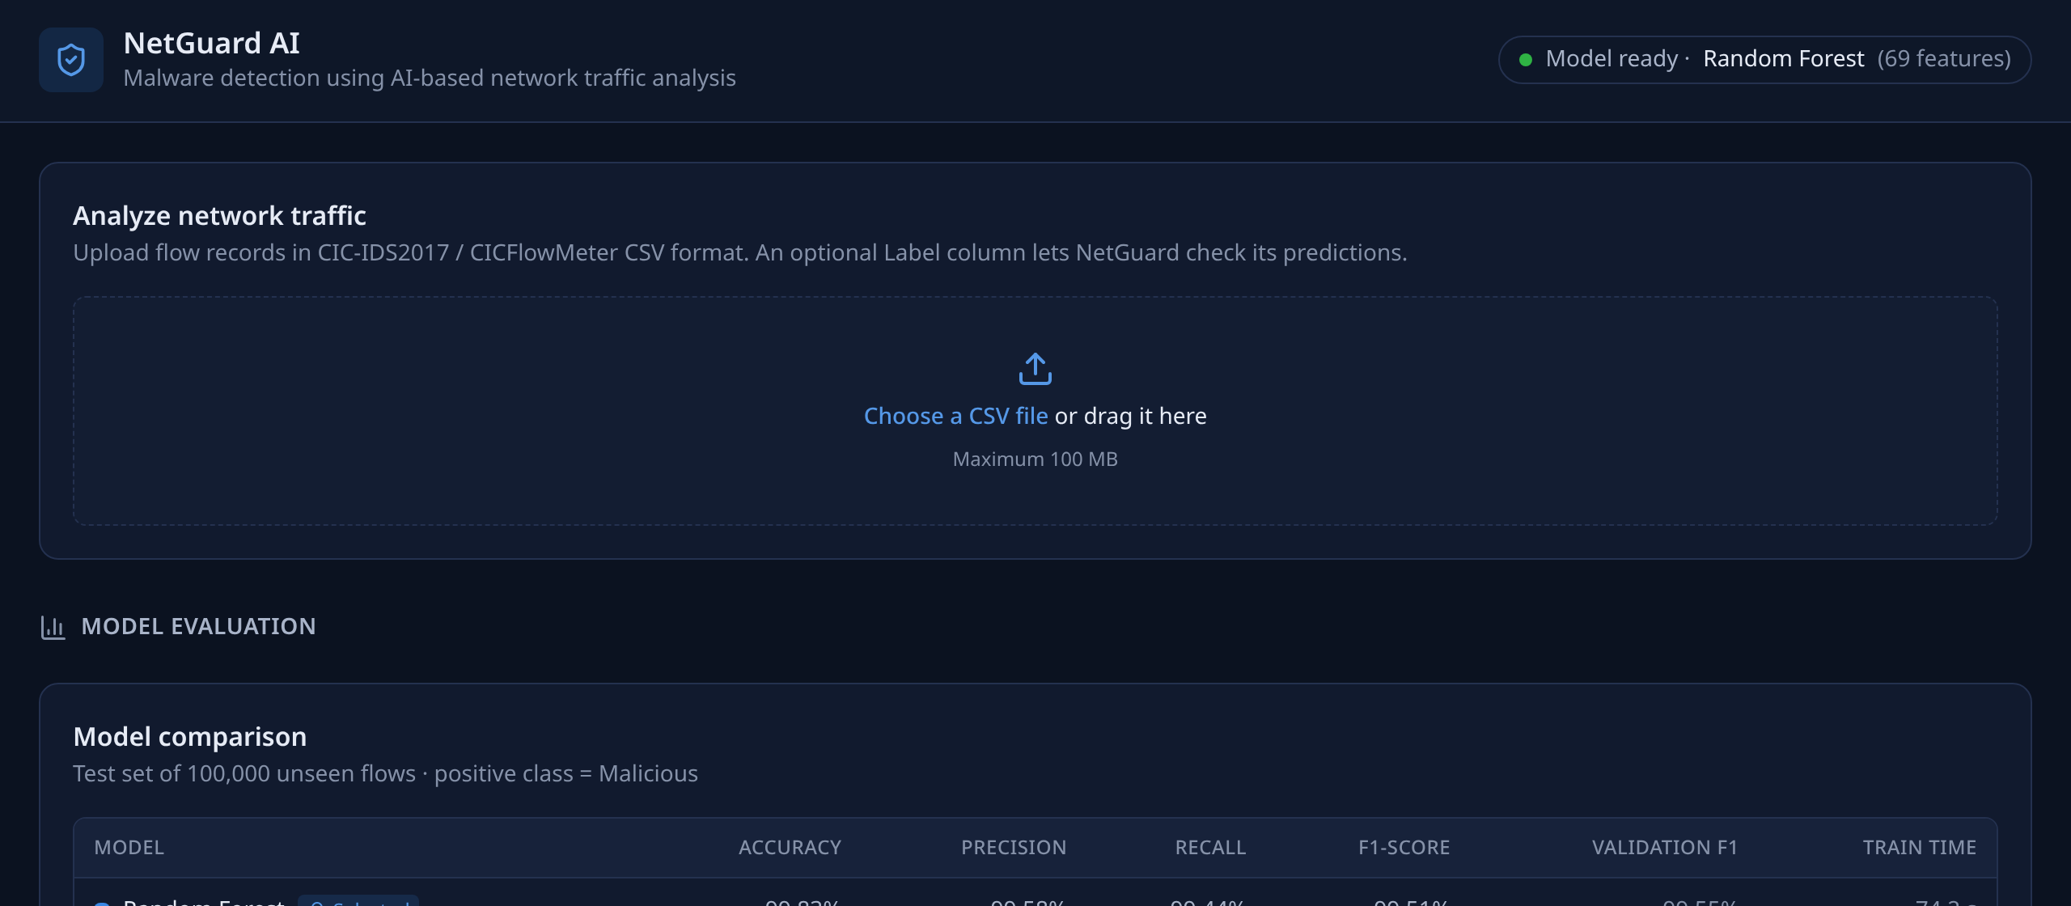
Fig. 6.1 Dashboard on Start-Up With the Model Status and Upload Panel
After demo_test_flows.csv (2,000 real flows from the test set) is analysed, the summary cards show 1,679 benign and 321 malicious predictions. Because the file contains the original labels, the dashboard also reports that 1,998 of the 2,000 predictions (99.90%) agree with them.
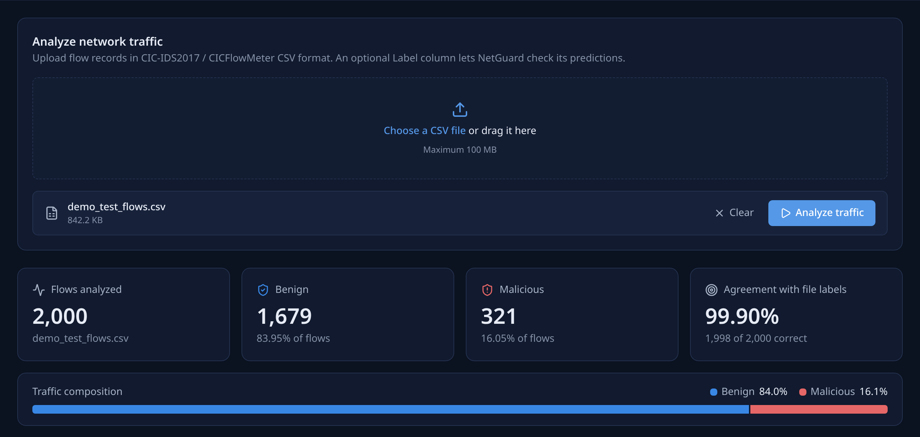
Fig. 6.2 Analysis Summary for 2,000 Held-Out Test Flows
The results table shows readable flow features, the Random Forest's malicious probability, the prediction and the actual label. The Download CSV button returns the full file with two added columns.
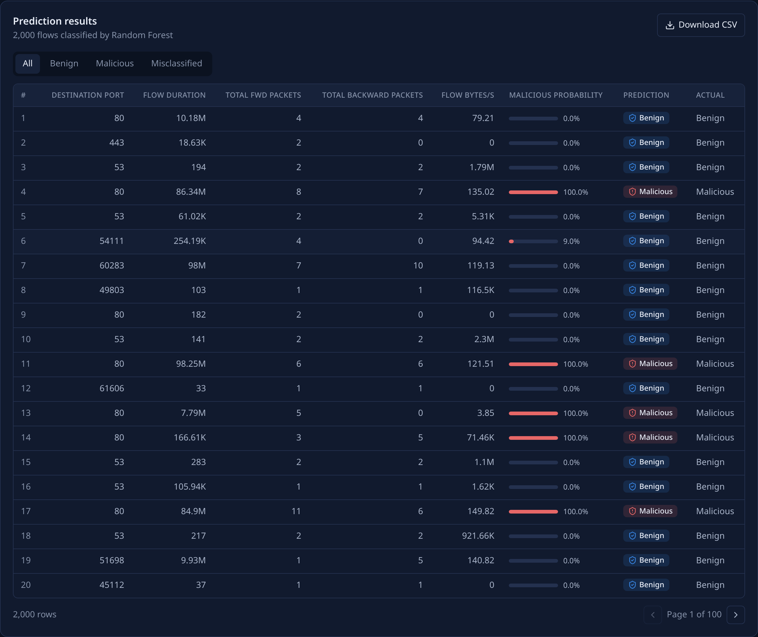
Fig. 6.3 Prediction Results Table With Probabilities and Actual Labels
The Misclassified filter isolates the two flows on which the model disagrees with the dataset label, which is useful for error analysis during a demonstration.
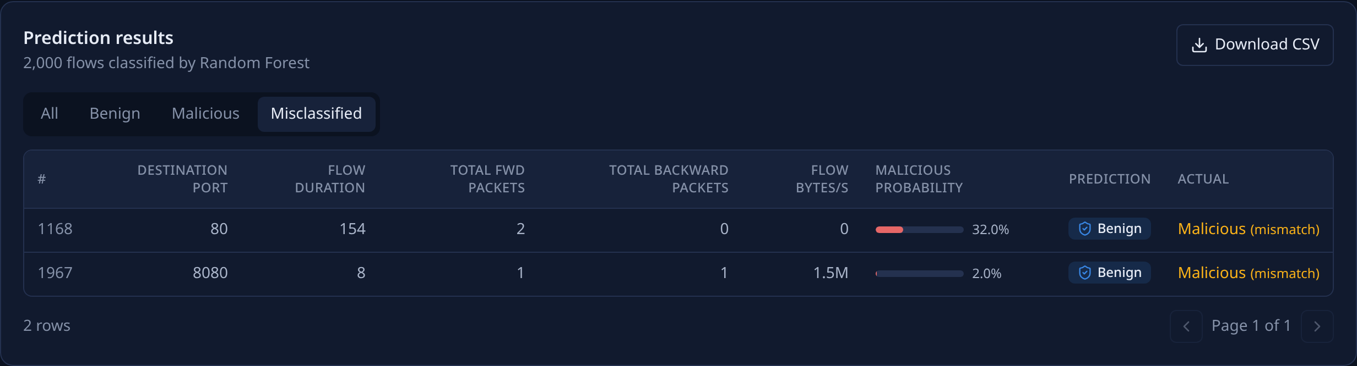
Fig. 6.4 Results Filtered to the Misclassified Flows
Uploading invalid_missing_columns.csv, from which three required features were removed, produces a clear error listing the missing columns instead of a wrong prediction.
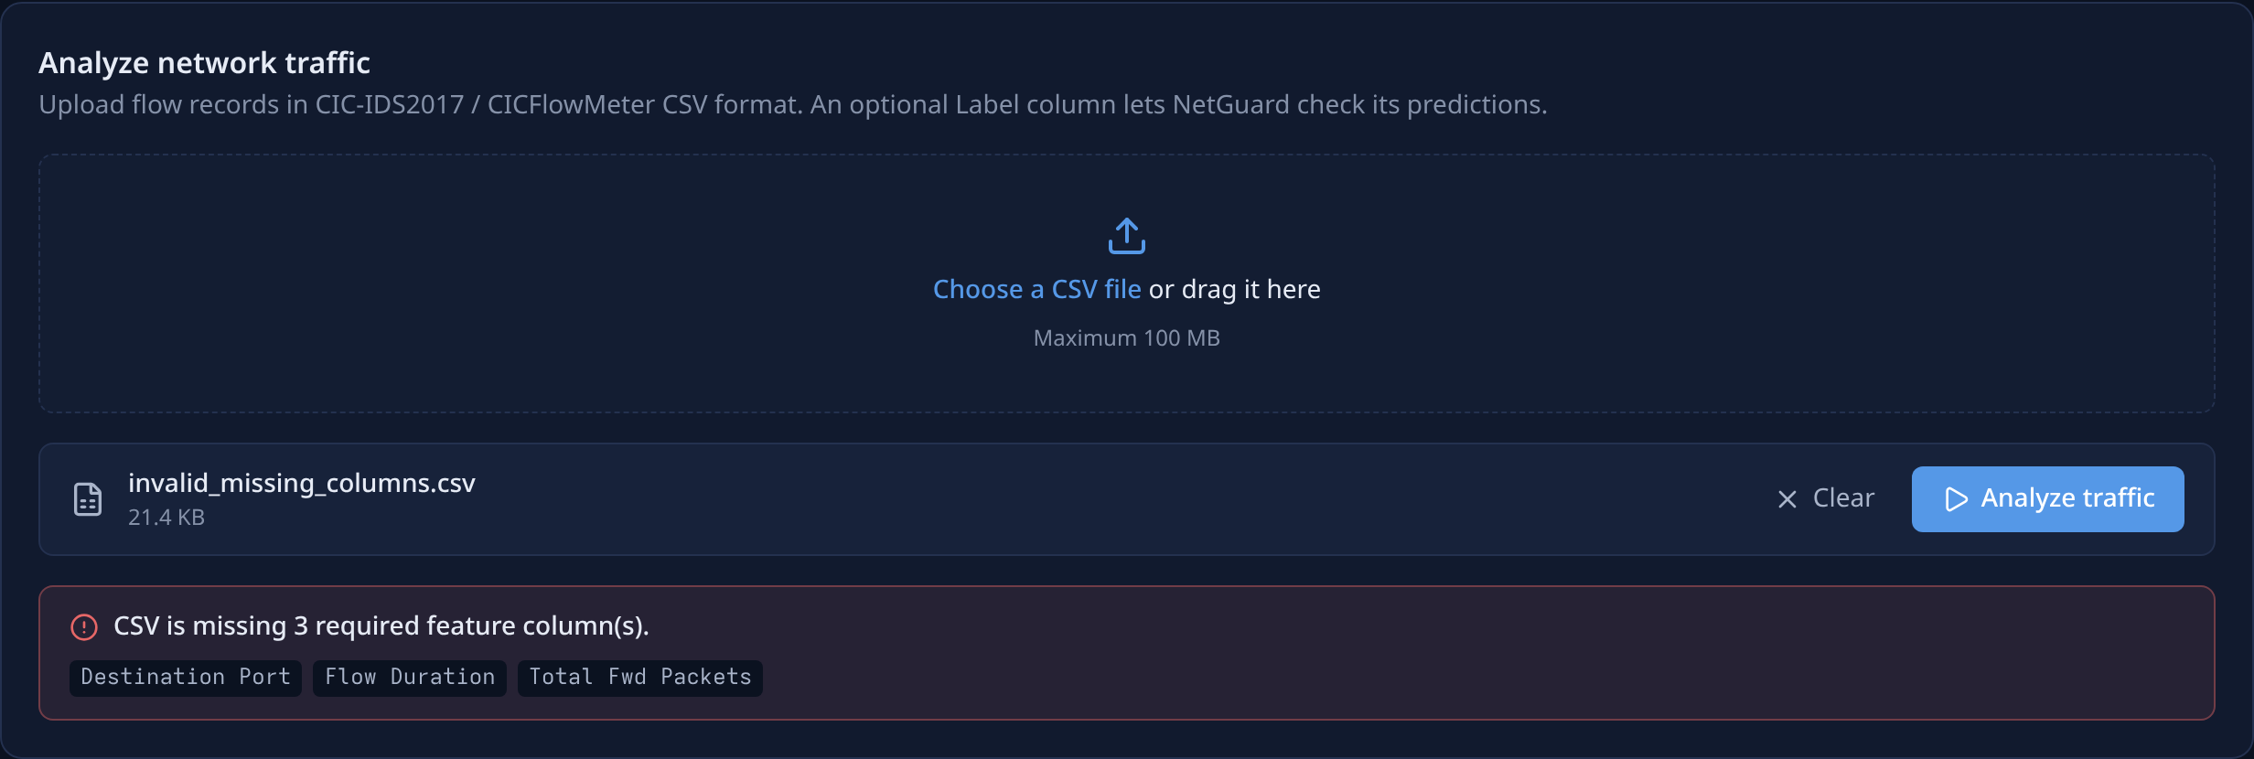
Fig. 6.5 Validation Error for a File With Missing Feature Columns
The evaluation section reads reports/metrics.json and shows the test-set metrics of all three models, the validation F1 used for selection and the training time.
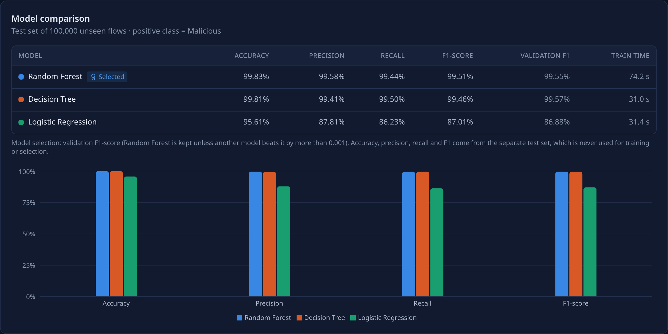
Fig. 6.6 Model Comparison Table and Chart in the Dashboard
The confusion matrix can be switched between models. The training data card shows the raw and used flow counts and the stratified train / validation / test split.
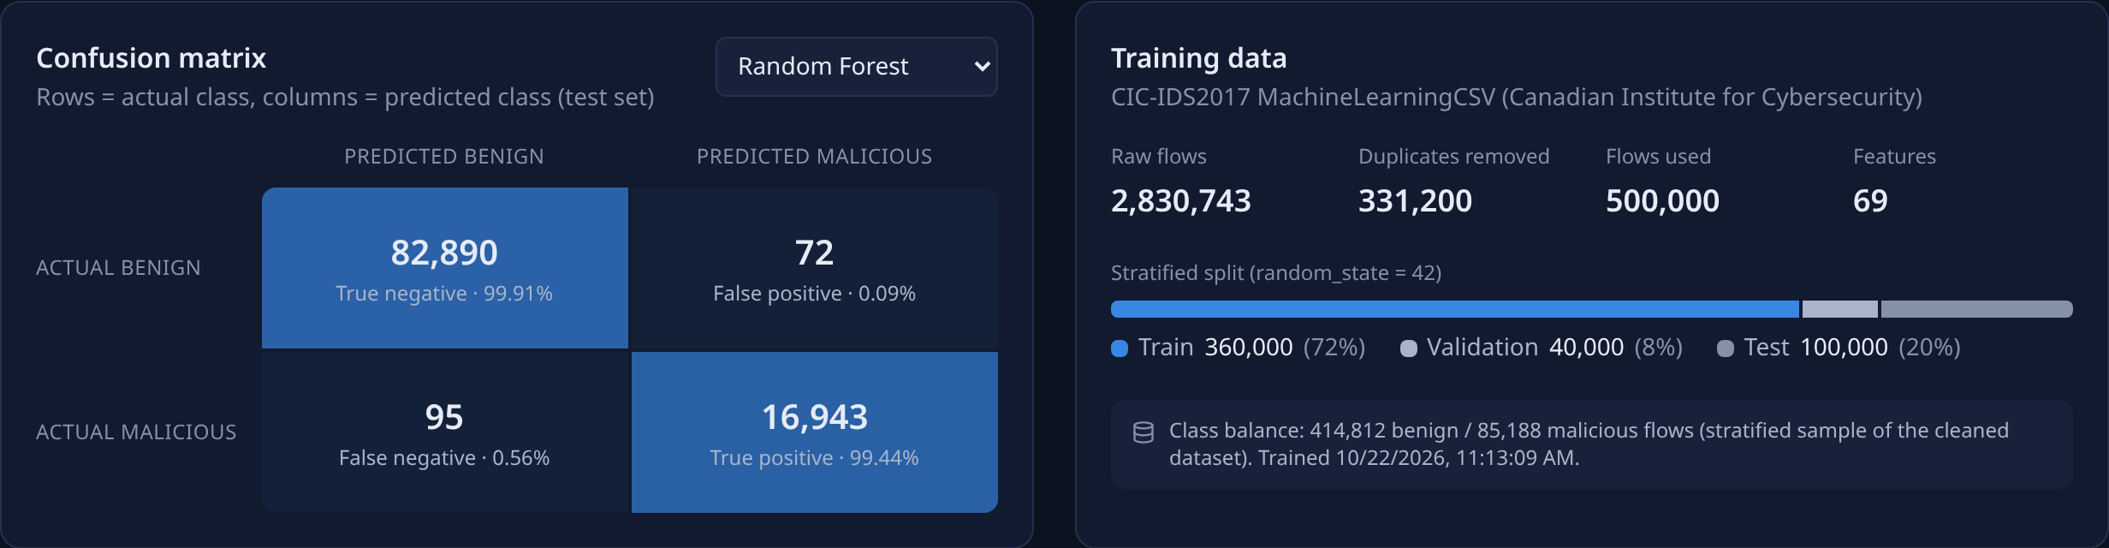
Fig. 6.7 Confusion Matrix and Training Data Summary
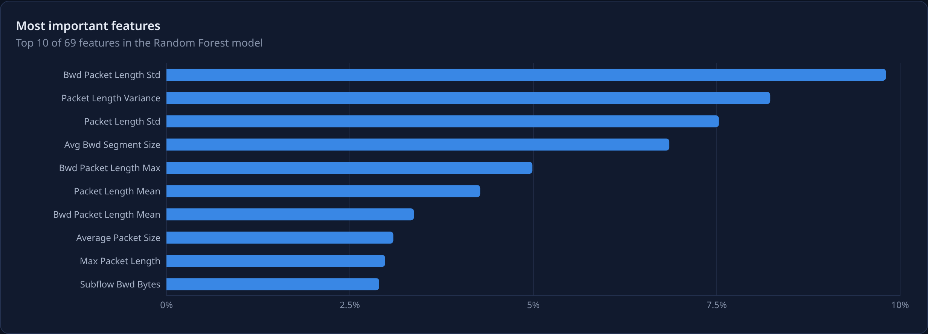
Fig. 6.8 Most Important Features of the Random Forest Model
FastAPI generates OpenAPI 3.1 documentation at /docs, where every endpoint can be tried from the browser.
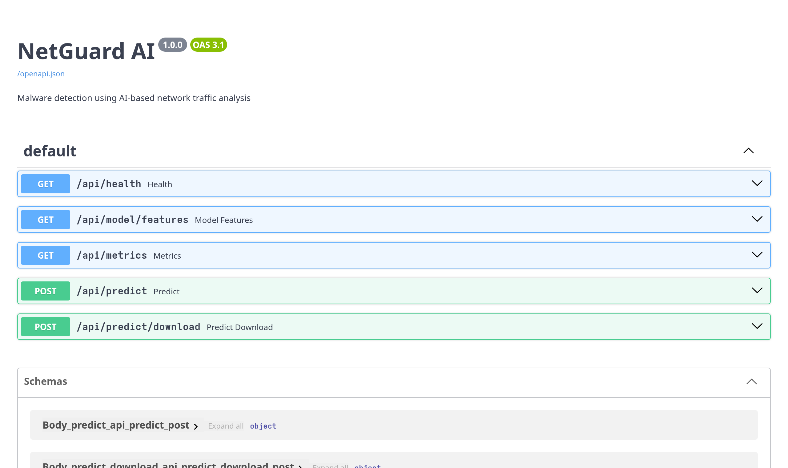
Fig. 6.9 Interactive API Documentation Generated by FastAPI
The layout adapts to small screens. On a 390-pixel-wide phone the cards stack vertically and the results table scrolls horizontally inside its own frame, as shown in Fig. 6.10.
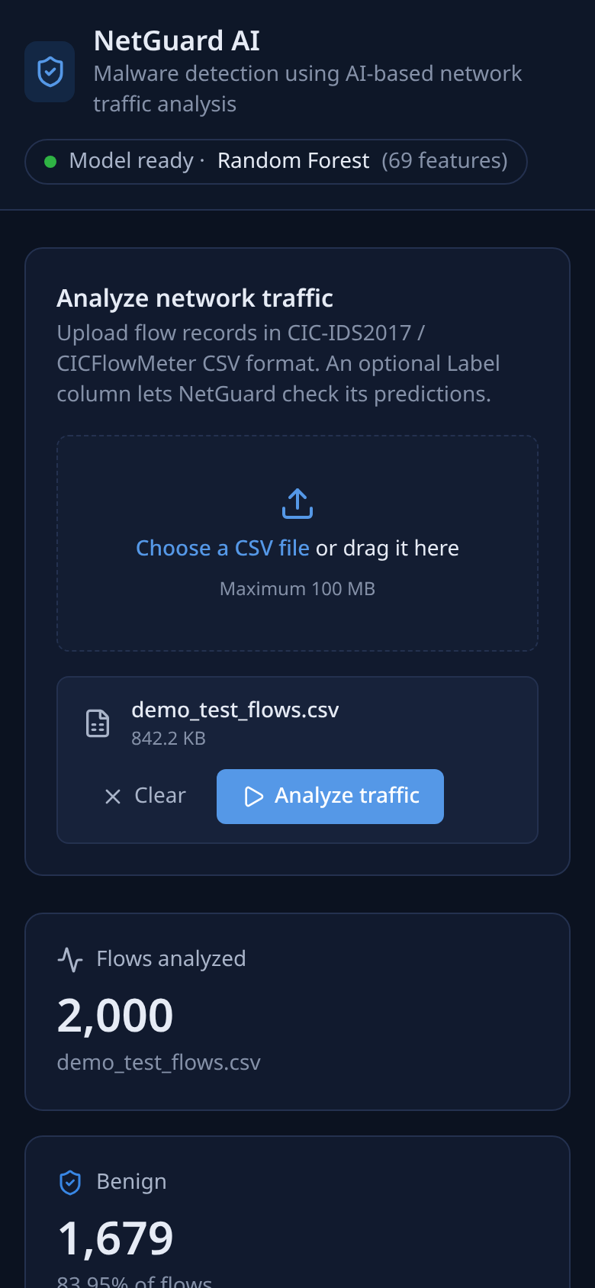
Fig. 6.10 Dashboard on a 390-Pixel-Wide Mobile Screen

CHAPTER 7
RESULT & DISCUSSION
This chapter presents the evaluation of the three models on the held-out test set of 100,000 flows, breaks the results down by attack type, explains which features drive the decisions and discusses the limitations that come from the dataset. All numbers are produced by ml/train.py and ml/analyze_dataset.py.
7.1 Overall model comparison
Table 7.1 Test-Set Performance of the Three Models (Positive Class = Malicious)
Model | Accuracy | Precision | Recall | F1-score | Validation F1 | Train time
Random Forest | 99.83% | 99.58% | 99.44% | 99.51% | 99.55% | 74.2 s
Decision Tree | 99.81% | 99.41% | 99.50% | 99.46% | 99.57% | 31.0 s
Logistic Regression | 95.61% | 87.81% | 86.23% | 87.01% | 86.88% | 31.4 s

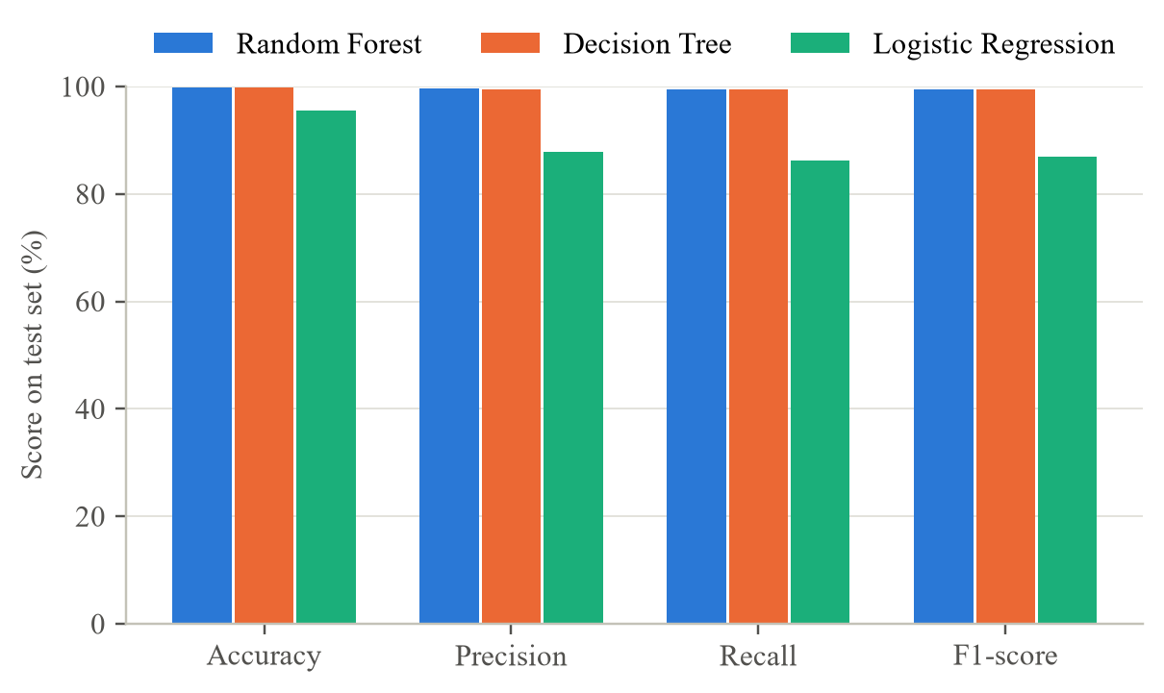
Fig. 7.1 Accuracy, Precision, Recall and F1-Score of the Three Models
Random Forest and Decision Tree are almost tied, with F1-scores of 99.51% and 99.46%. Random Forest has the higher precision (99.58% against 99.41%), meaning fewer false alarms, whereas Decision Tree has a slightly higher recall (99.50% against 99.44%). Logistic Regression is clearly weaker, with an F1-score of 87.01%: its single linear boundary cannot capture the threshold-like, non-linear patterns revealed by the exploratory analysis, such as a flow being suspicious when it is very short and targets an unusual port, or very long and almost silent.
On the validation set Decision Tree scored 99.57% and Random Forest 99.55%. The difference of 0.02 percentage points, about one or two flows, is below the 0.001 selection margin, so the primary model, Random Forest, was kept. The test results support the choice, since Random Forest leads on accuracy, precision and F1. Accuracy is high for all models partly because 83% of the test flows are benign, which is why the following sections rely on per-class measures.
7.2 Confusion matrices
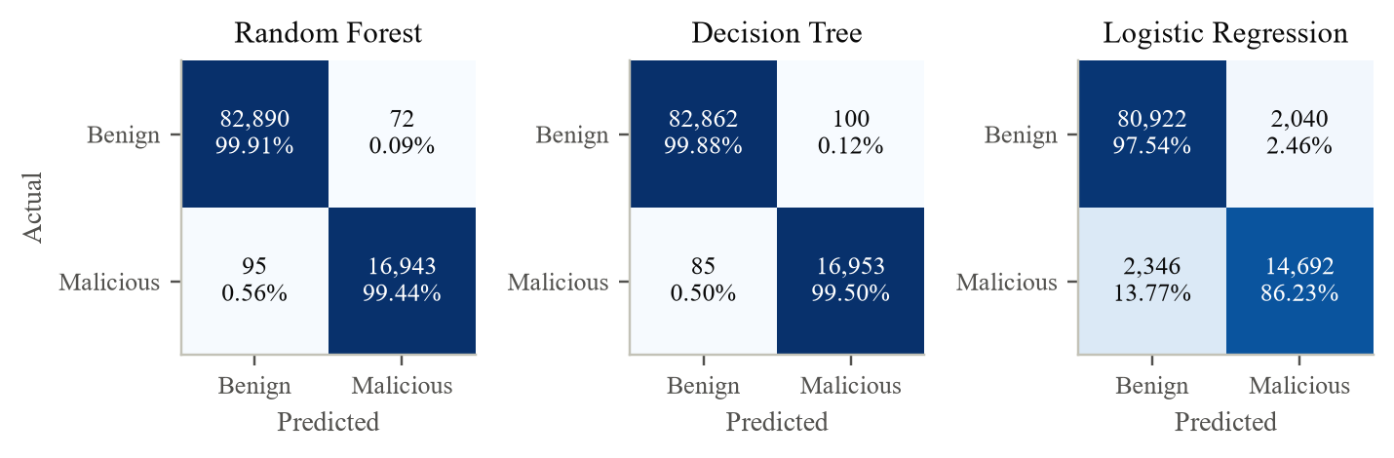
Fig. 7.2 Test-Set Confusion Matrices With Row Percentages
Table 7.2 Confusion Matrix Counts and Error Rates
Model | TN | FP | FN | TP | FPR | Miss rate
Random Forest | 82,890 | 72 | 95 | 16,943 | 0.087% | 0.558%
Decision Tree | 82,862 | 100 | 85 | 16,953 | 0.121% | 0.499%
Logistic Regression | 80,922 | 2,040 | 2,346 | 14,692 | 2.459% | 13.769%

Out of 82,962 benign test flows, Random Forest raised 72 false alarms, a false positive rate of 0.087%. Out of 17,038 malicious flows it missed 95. For an operator this means that roughly one alert in 236 is a false alarm and roughly one attack flow in 179 is missed. Logistic Regression would produce 2,040 false alarms and miss 2,346 attack flows on the same traffic, a workload that would quickly make the alerts useless.
7.3 Threshold-independent evaluation
The metrics above use a fixed threshold of 0.5 on the malicious probability. Fig. 7.3 shows the ROC and precision–recall curves, which summarise performance over all thresholds [27], [28]; the false positive rate is plotted on a logarithmic axis because the interesting region is below 1%.
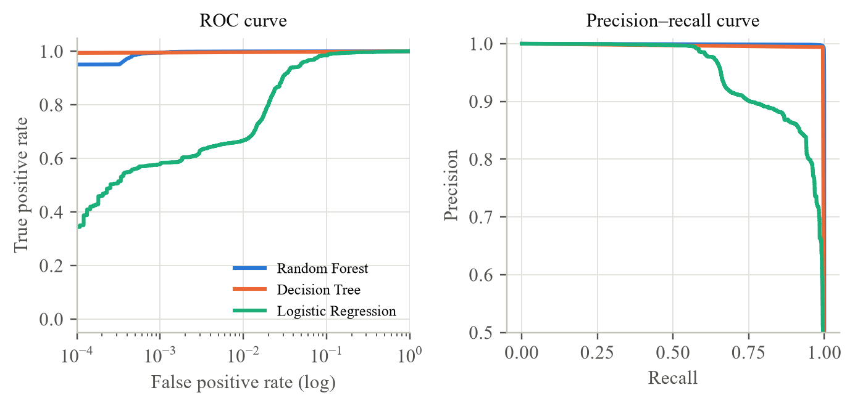
Fig. 7.3 ROC and Precision–Recall Curves on the Test Set
Table 7.3 Area Under the ROC Curve and Average Precision
Model | ROC AUC | Average precision
Random Forest | 0.99969 | 0.99806
Decision Tree | 0.99696 | 0.99012
Logistic Regression | 0.98773 | 0.94893

Random Forest reaches a ROC AUC of 0.9997 and an average precision of 0.9981. Its curve dominates the others at every false positive rate, so its advantage is not an artefact of the chosen threshold. The Decision Tree's curve has few points because an unpruned tree outputs almost only probabilities of 0 or 1. Fig. 7.4 shows that the Random Forest's probabilities are also well separated: most benign test flows receive a probability close to 0 and most malicious flows a probability close to 1, with few flows near the threshold.
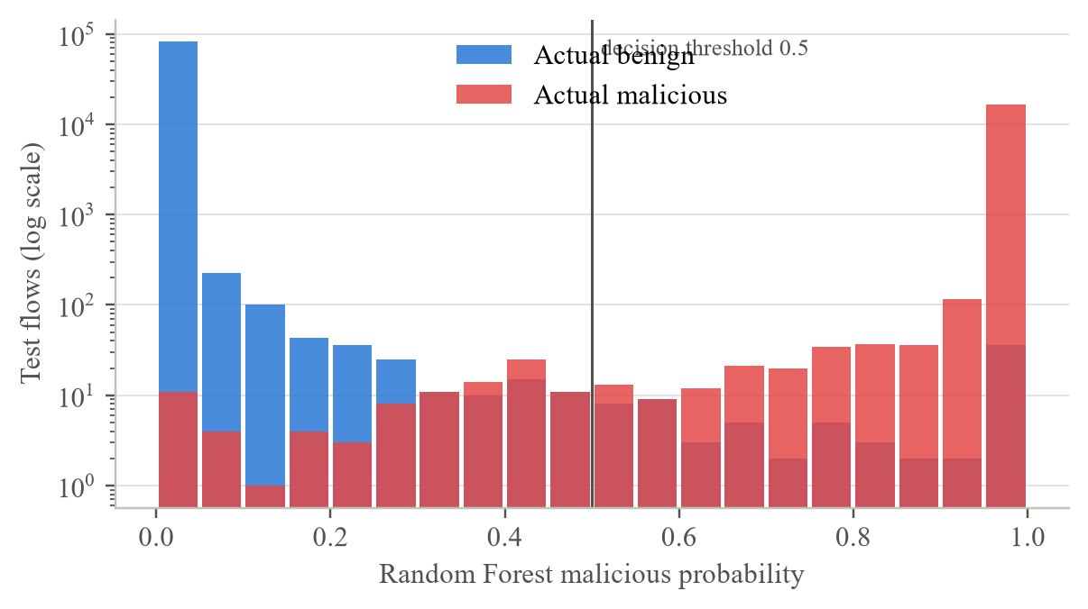
Fig. 7.4 Distribution of the Random Forest Malicious Probability by Actual Class
7.4 Detection rate per attack type
Because the test set keeps the original attack names, the recall can be computed for each attack label separately. This is the most informative result about the dataset. Fig. 7.5 and Table 7.4 show the detection rate per label; for BENIGN the value is the share correctly passed.
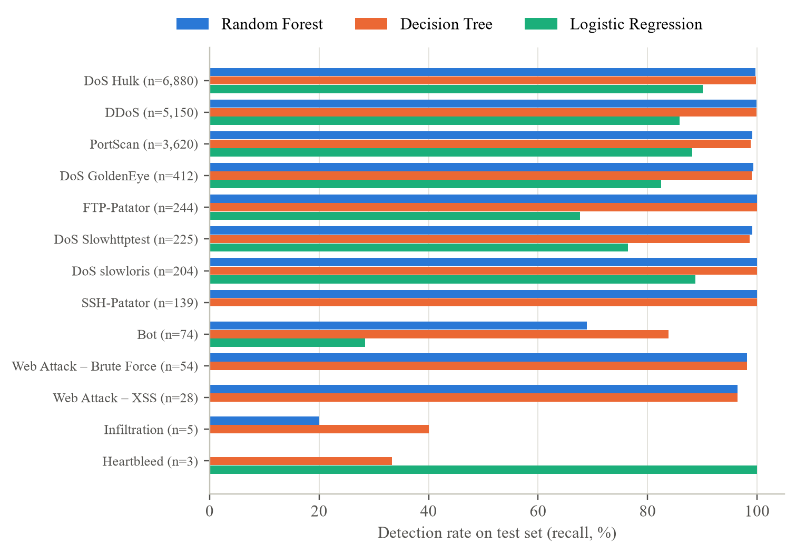
Fig. 7.5 Detection Rate per Attack Label on the Test Set
Table 7.4 Detection Rate per Label on the Test Set
Label | Test flows | RF | DT | LR | RF errors
BENIGN | 82,962 | 99.9% | 99.9% | 97.5% | 72
DoS Hulk | 6,880 | 99.7% | 99.8% | 90.1% | 21
DDoS | 5,150 | 99.9% | 99.9% | 85.8% | 6
PortScan | 3,620 | 99.1% | 98.8% | 88.1% | 31
DoS GoldenEye | 412 | 99.3% | 99.0% | 82.5% | 3
FTP-Patator | 244 | 100.0% | 100.0% | 67.6% | 0
DoS Slowhttptest | 225 | 99.1% | 98.7% | 76.4% | 2
DoS slowloris | 204 | 100.0% | 100.0% | 88.7% | 0
SSH-Patator | 139 | 100.0% | 100.0% | 0.0% | 0
Bot | 74 | 68.9% | 83.8% | 28.4% | 23
Web Attack – Brute Force | 54 | 98.1% | 98.1% | 0.0% | 1
Web Attack – XSS | 28 | 96.4% | 96.4% | 0.0% | 1
Infiltration | 5 | 20.0% | 40.0% | 0.0% | 4
Heartbleed | 3 | 0.0% | 33.3% | 100.0% | 3

Every attack label with at least 100 test flows is detected at a rate of 99.1% or higher by Random Forest, and FTP-Patator, SSH-Patator and DoS slowloris are detected completely. These are the labels with distinctive profiles in Table 4.6: fixed target ports, characteristic packet counts and durations that benign traffic rarely shows.
The weak points are Bot, Infiltration and Heartbleed. Random Forest detects 68.9% of the 74 Bot flows, 1 of 5 Infiltration flows and none of the 3 Heartbleed flows. The cause is visible in the dataset analysis. Bot traffic consists of short, low-volume HTTP exchanges with a command-and-control server (median three packets each way, Table 4.6), which look very similar to ordinary web requests. Infiltration and Heartbleed are so rare that the training set contained only 4 and 1 examples (Table 4.9). A Random Forest averages the votes of trees that each saw a bootstrap sample in which these examples may be absent, so it tends to assign such isolated patterns to the majority class.
Decision Tree detects more Bot flows (83.8%) because a single unpruned tree isolates even one or two training examples in their own leaves, the same property that makes it overfit elsewhere. Logistic Regression catches all three Heartbleed flows, whose thousands of packets and bytes lie far out on the linear scale, but fails completely on SSH-Patator and the web attacks. The per-attack view therefore shows that the excellent overall F1 hides weaknesses on rare labels that together make up less than 0.1% of the test set. Since attack types that are rare in a dataset can be the most dangerous ones in practice, this result is the strongest argument for the dataset recommendations in Chapter 8.
7.5 Feature importance
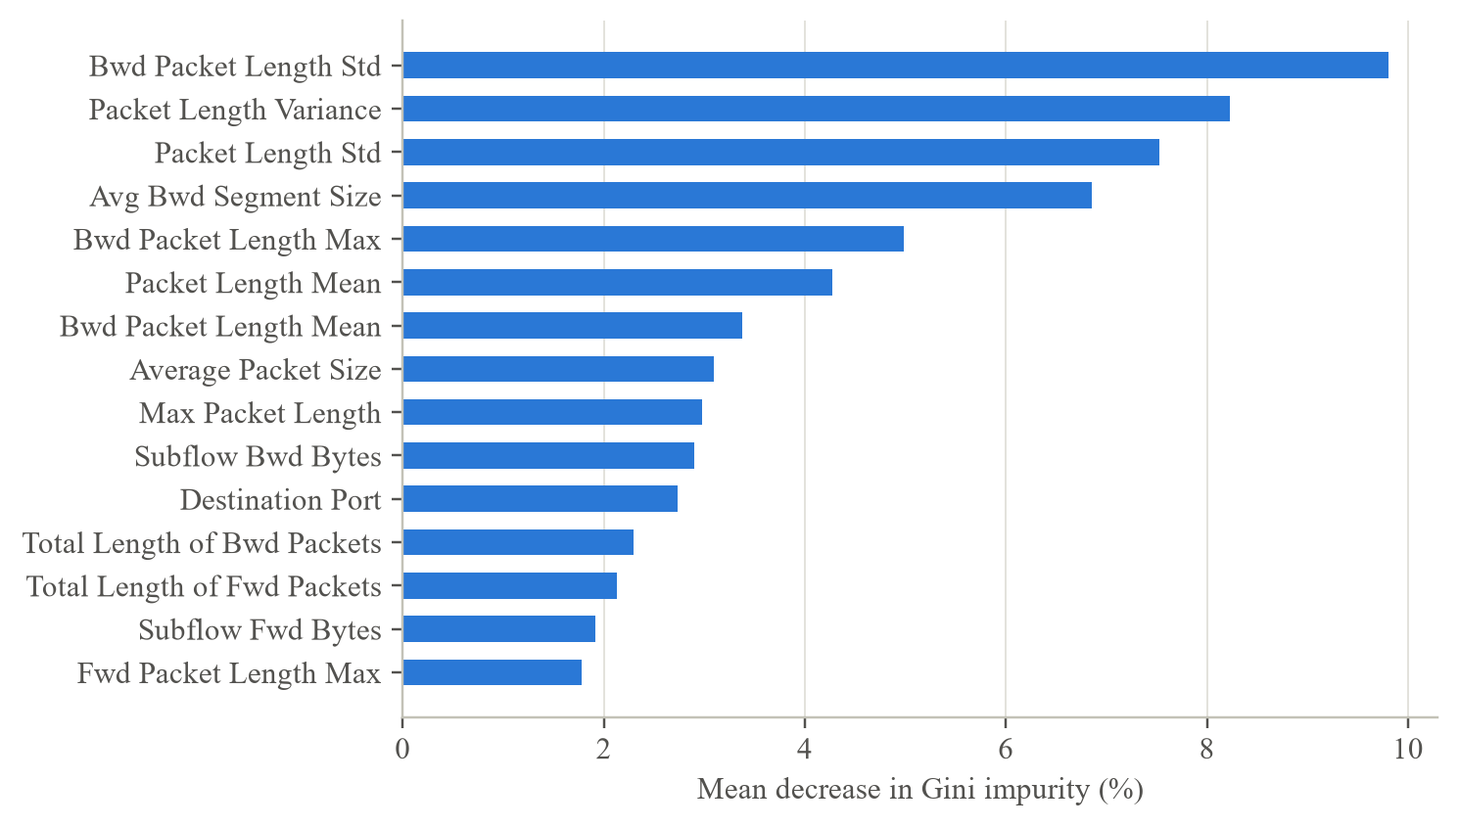
Fig. 7.6 Fifteen Most Important Features of the Random Forest
Fig. 7.6 shows the features with the largest mean decrease in impurity. Packet-size features dominate: Bwd Packet Length Std (9.8%), Packet Length Variance, Packet Length Std and Avg Bwd Segment Size lead the ranking, and size-related features account for 62% of the importance among the top fifteen. This agrees with the exploratory analysis: attacked web servers return a mixture of large pages and small error responses, so the size variation of backward packets is high for DoS and DDoS flows and low for typical benign flows.
Because many features are almost perfectly correlated (Table 4.7), the importance of a property is spread over its copies; for example Packet Length Variance and Packet Length Std carry the same information. The ranking should therefore be read at the level of properties: packet sizes and byte totals first, the destination port next (rank 11), and timing, flag and TCP window features further down, rather than as a strict order of individual columns. The destination port matters but is not decisive, so the model is not merely memorising that port 80 was attacked in this testbed.
7.6 Results on the demonstration files
The demonstration file demo_test_flows.csv contains 2,000 flows drawn from the test set with their labels. Through the running application the Random Forest classified 1,998 of them correctly (99.90%), predicting 321 as malicious against 323 actually malicious flows, which is consistent with the test-set results. A raw, unmodified file from the original dataset (5,000 Wednesday flows with leading spaces in the headers and Infinity values) was also accepted and classified, confirming that the API handles the published format directly.
7.7 Limitations and threats to validity
- Single laboratory network. All traffic comes from one testbed recorded in 2017. Attack tools, benign applications and network size differ in real networks, so performance elsewhere will be lower [14], [15].
- Dataset errors. Engelen et al. [20] and Lanvin et al. [21] found labelling mistakes and flow-meter artefacts in CIC-IDS2017, such as flows of failed attack attempts labelled as attacks and incorrectly terminated TCP flows. This analysis found further artefacts: negative durations, Fwd PSH Flags identical to SYN Flag Count, and bulk features that are always zero.
- Rare labels. Heartbleed, Infiltration and SQL injection have too few flows for reliable learning or evaluation; their test results are based on three to five flows, or none.
- Sampling. The model uses a 500,000-flow sample of the 2.5 million unique flows. The sample is stratified on the binary class, so rare labels are represented only by chance.
- Site-specific features. Destination ports and window sizes partly reflect the testbed's configuration, and a model may learn them as shortcuts.
- Binary output. The system says whether a flow is malicious, not which attack it belongs to.
7.8 Cost analysis
The project uses only open-source software and a public dataset, and it runs on an ordinary laptop. Table 7.5 lists the cost items.
Table 7.5 Project Cost
Item | Choice | Cost
Dataset | CIC-IDS2017 (public) | Free
Programming languages and libraries | Python, scikit-learn, FastAPI, React, Vite, Tailwind, Recharts | Free (open source)
Hardware | Existing laptop (Intel Core i5, 8 GB RAM) | No additional cost
Hosting for the demonstration | Local machine (single process on one port) | Free
Computation | About 11 minutes of training, 4 minutes of analysis | Negligible electricity

CHAPTER 8
SUMMARY
NetGuard AI is a complete, working system for malware and intrusion detection based on AI-driven analysis of network flows. Its machine learning pipeline turns the eight CIC-IDS2017 files into a clean, deduplicated and correctly split dataset; three classifiers are trained and compared; and the selected Random Forest is served through a validated FastAPI backend and a React dashboard that shows real predictions and real evaluation results.
The dataset received particular attention. The analysis of all 2,830,743 flows showed that 11.7% of the rows are exact duplicates, concentrated in the attack labels PortScan and SSH-Patator; that rate features contain infinite and missing values because of zero-duration flows; that the -1 values in the window features are protocol sentinels for UDP rather than errors; that eight features are constant and several others are exact copies; and that the attack labels are distributed extremely unevenly, from 231,073 DoS Hulk flows to 11 Heartbleed flows. Each finding led to a specific design decision in the preprocessing pipeline.
On 100,000 unseen test flows the Random Forest achieved an accuracy of 99.83%, precision of 99.58%, recall of 99.44% and an F1-score of 99.51%, with a ROC AUC of 0.9997. The Decision Tree performed almost identically, and Logistic Regression was clearly weaker, which confirms the non-linear structure of the data. The per-attack analysis showed that the high overall score hides weak detection of the rarest labels, which is a property of the dataset rather than a defect of the model.
Based on these findings, the following recommendations are made:
- Stratify on the attack label. Stratifying the sample and split on the original attack label instead of the binary class would guarantee that every attack type appears in training, validation and test.
- Keep every flow of rare labels. Including all Heartbleed, Infiltration, SQL injection and Bot flows in the training data, or oversampling them (for example with SMOTE [38]), would give the model enough examples to learn from.
- Use a corrected version of the dataset. The relabelled CIC-IDS2017 released by Engelen et al. [20] fixes known labelling and flow-meter errors and should be used for further work.
- Test across datasets. Training on CIC-IDS2017 and testing on CSE-CIC-IDS2018 or traffic from another network would measure how well the model generalises beyond one testbed.
- Extend the system. Multi-class output (naming the attack), live flow capture with CICFlowMeter, and threshold tuning for a target false-alarm rate are natural next steps.
The project demonstrates that a small, explainable system built from standard tools can detect most network attacks in a realistic dataset very accurately, and that understanding the dataset is as important as choosing the model.

CHAPTER 9
REFERENCES
[1] J. F. Kurose and K. W. Ross, Computer Networking: A Top-Down Approach, 8th ed. Hoboken, NJ, USA: Pearson, 2021.
[2] A. S. Tanenbaum, N. Feamster and D. J. Wetherall, Computer Networks, 6th ed. Pearson, 2021.
[3] W. Eddy, Ed., "Transmission Control Protocol (TCP)," IETF, RFC 9293, Aug. 2022.
[4] J. Postel, "User Datagram Protocol," IETF, RFC 768, Aug. 1980.
[5] K. Ramakrishnan, S. Floyd and D. Black, "The Addition of Explicit Congestion Notification (ECN) to IP," IETF, RFC 3168, Sep. 2001.
[6] B. Claise, Ed., "Cisco Systems NetFlow Services Export Version 9," IETF, RFC 3954, Oct. 2004.
[7] B. Claise, B. Trammell and P. Aitken, Eds., "Specification of the IP Flow Information Export (IPFIX) Protocol for the Exchange of Flow Information," IETF, RFC 7011, Sep. 2013.
[8] G. Draper-Gil, A. H. Lashkari, M. S. I. Mamun and A. A. Ghorbani, "Characterization of encrypted and VPN traffic using time-related features," in Proc. 2nd Int. Conf. Information Systems Security and Privacy (ICISSP), 2016, pp. 407–414.
[9] A. H. Lashkari, G. Draper-Gil, M. S. I. Mamun and A. A. Ghorbani, "Characterization of Tor traffic using time based features," in Proc. 3rd Int. Conf. Information Systems Security and Privacy (ICISSP), 2017, pp. 253–262.
[10] D. E. Denning, "An intrusion-detection model," IEEE Transactions on Software Engineering, vol. SE-13, no. 2, pp. 222–232, Feb. 1987.
[11] A. L. Buczak and E. Guven, "A survey of data mining and machine learning methods for cyber security intrusion detection," IEEE Communications Surveys & Tutorials, vol. 18, no. 2, pp. 1153–1176, 2016.
[12] L. Breiman, "Random forests," Machine Learning, vol. 45, no. 1, pp. 5–32, 2001.
[13] L. Breiman, J. H. Friedman, R. A. Olshen and C. J. Stone, Classification and Regression Trees. Belmont, CA, USA: Wadsworth, 1984.
[14] R. Sommer and V. Paxson, "Outside the closed world: On using machine learning for network intrusion detection," in Proc. IEEE Symposium on Security and Privacy, 2010, pp. 305–316.
[15] D. Arp et al., "Dos and don'ts of machine learning in computer security," in Proc. 31st USENIX Security Symposium, 2022, pp. 3971–3988.
[16] M. Ring, S. Wunderlich, D. Scheuring, D. Landes and A. Hotho, "A survey of network-based intrusion detection data sets," Computers & Security, vol. 86, pp. 147–167, 2019.
[17] M. Tavallaee, E. Bagheri, W. Lu and A. A. Ghorbani, "A detailed analysis of the KDD CUP 99 data set," in Proc. IEEE Symposium on Computational Intelligence for Security and Defense Applications (CISDA), 2009, pp. 1–6.
[18] N. Moustafa and J. Slay, "UNSW-NB15: A comprehensive data set for network intrusion detection systems," in Proc. Military Communications and Information Systems Conference (MilCIS), 2015, pp. 1–6.
[19] I. Sharafaldin, A. H. Lashkari and A. A. Ghorbani, "Toward generating a new intrusion detection dataset and intrusion traffic characterization," in Proc. 4th Int. Conf. Information Systems Security and Privacy (ICISSP), 2018, pp. 108–116. Dataset: https://www.unb.ca/cic/datasets/ids-2017.html
[20] G. Engelen, V. Rimmer and W. Joosen, "Troubleshooting an intrusion detection dataset: The CICIDS2017 case study," in Proc. IEEE Security and Privacy Workshops (SPW), 2021, pp. 7–12.
[21] M. Lanvin, P.-F. Gimenez, Y. Han, F. Majorczyk, L. Mé and É. Totel, "Errors in the CICIDS2017 dataset and the significant differences in detection performances it makes," in Risks and Security of Internet and Systems (CRiSIS 2022), LNCS, vol. 13857. Springer, 2023, pp. 18–33.
[22] Z. Durumeric et al., "The matter of Heartbleed," in Proc. ACM Internet Measurement Conference (IMC), 2014, pp. 475–488.
[23] H. He and E. A. Garcia, "Learning from imbalanced data," IEEE Transactions on Knowledge and Data Engineering, vol. 21, no. 9, pp. 1263–1284, 2009.
[24] F. Pedregosa et al., "Scikit-learn: Machine learning in Python," Journal of Machine Learning Research, vol. 12, pp. 2825–2830, 2011.
[25] J. R. Quinlan, "Induction of decision trees," Machine Learning, vol. 1, no. 1, pp. 81–106, 1986.
[26] D. R. Cox, "The regression analysis of binary sequences," Journal of the Royal Statistical Society: Series B, vol. 20, no. 2, pp. 215–242, 1958.
[27] T. Fawcett, "An introduction to ROC analysis," Pattern Recognition Letters, vol. 27, no. 8, pp. 861–874, 2006.
[28] T. Saito and M. Rehmsmeier, "The precision-recall plot is more informative than the ROC plot when evaluating binary classifiers on imbalanced datasets," PLoS ONE, vol. 10, no. 3, e0118432, 2015.
[29] J. Postel, "Internet Protocol," IETF, RFC 791, Sep. 1981.
[30] R. Fielding, M. Nottingham and J. Reschke, Eds., "HTTP Semantics," IETF, RFC 9110, Jun. 2022.
[31] L. Masinter, "Returning Values from Forms: multipart/form-data," IETF, RFC 7578, Jul. 2015.
[32] Y. Shafranovich, "Common Format and MIME Type for Comma-Separated Values (CSV) Files," IETF, RFC 4180, Oct. 2005.
[33] T. Bray, Ed., "The JavaScript Object Notation (JSON) Data Interchange Format," IETF, RFC 8259, Dec. 2017.
[34] OpenAPI Initiative, "OpenAPI Specification v3.1.0," Feb. 2021. [Online]. Available: https://spec.openapis.org/oas/v3.1.0
[35] G. van Rossum, B. Warsaw and N. Coghlan, "PEP 8 – Style Guide for Python Code," Python Software Foundation, 2001. [Online]. Available: https://peps.python.org/pep-0008/
[36] W3C, "Web Content Accessibility Guidelines (WCAG) 2.2," W3C Recommendation, Oct. 2023.
[37] R. Panigrahi and S. Borah, "A detailed analysis of CICIDS2017 dataset for designing intrusion detection systems," International Journal of Engineering & Technology, vol. 7, no. 3.24, pp. 479–482, 2018.
[38] N. V. Chawla, K. W. Bowyer, L. O. Hall and W. P. Kegelmeyer, "SMOTE: Synthetic minority over-sampling technique," Journal of Artificial Intelligence Research, vol. 16, pp. 321–357, 2002.
[39] S. Ramírez, "FastAPI documentation." [Online]. Available: https://fastapi.tiangolo.com
[40] Meta Open Source, "React documentation." [Online]. Available: https://react.dev

APPENDIX A
PROJECT FILES, API EXAMPLE AND MODEL FEATURES
A.1 Repository structure
NetGuardAI/
├── ml/ config.py, preprocess.py, train.py, analyze_dataset.py
├── backend/app/ main.py (FastAPI), model_store.py
├── backend/tests/ conftest.py, test_api.py, test_training.py
├── frontend/src/ App.tsx, api.ts, format.ts, index.css, components/
├── dataset/raw/ CIC-IDS2017 CSV files (not in git, ≈844 MB)
├── dataset/samples/ demo_test_flows.csv, demo_unlabeled_flows.csv,
│ invalid_missing_columns.csv
├── models/ netguard_model.joblib
├── reports/ metrics.json, model_report.md, dataset_analysis.json,
│ training_log.txt, figures/
├── report/ scripts that generate this document
├── docs/ VIVA_GUIDE.md, screenshots/, project report
├── requirements.txt
└── README.md

A.2 Example API response
Abbreviated response of POST /api/predict for demo_test_flows.csv (first row only):
{
"filename": "demo_test_flows.csv",
"model_name": "Random Forest",
"summary": {"total": 2000, "benign": 1679, "malicious": 321, "malicious_ratio": 0.1605},
"evaluation": {"accuracy": 0.999, "correct": 1998,
"actual_malicious": 323, "actual_benign": 1677},
"display_columns": ["Destination Port", "Flow Duration", "Total Fwd Packets",
"Total Backward Packets", "Flow Bytes/s"],
"rows": [{"row": 1,
"values": {"Destination Port": 80.0, "Flow Duration": 10175832.0,
"Total Fwd Packets": 4.0, "Total Backward Packets": 4.0,
"Flow Bytes/s": 79.20728},
"prediction": "Benign", "malicious_probability": 0.0, "actual": "Benign"}],
"rows_truncated": false
}

A.3 Features required by the model
An uploaded CSV must contain the following 69 columns (names are matched after stripping spaces):
Table A.1 Model Input Features
Features 1–23 | Features 24–46 | Features 47–69
1. Destination Port | 24. Fwd IAT Max | 47. URG Flag Count
2. Flow Duration | 25. Fwd IAT Min | 48. CWE Flag Count
3. Total Fwd Packets | 26. Bwd IAT Total | 49. ECE Flag Count
4. Total Backward Packets | 27. Bwd IAT Mean | 50. Down/Up Ratio
5. Total Length of Fwd Packets | 28. Bwd IAT Std | 51. Average Packet Size
6. Total Length of Bwd Packets | 29. Bwd IAT Max | 52. Avg Fwd Segment Size
7. Fwd Packet Length Max | 30. Bwd IAT Min | 53. Avg Bwd Segment Size
8. Fwd Packet Length Min | 31. Fwd PSH Flags | 54. Subflow Fwd Packets
9. Fwd Packet Length Mean | 32. Fwd URG Flags | 55. Subflow Fwd Bytes
10. Fwd Packet Length Std | 33. Fwd Header Length | 56. Subflow Bwd Packets
11. Bwd Packet Length Max | 34. Bwd Header Length | 57. Subflow Bwd Bytes
12. Bwd Packet Length Min | 35. Fwd Packets/s | 58. Init_Win_bytes_forward
13. Bwd Packet Length Mean | 36. Bwd Packets/s | 59. Init_Win_bytes_backward
14. Bwd Packet Length Std | 37. Min Packet Length | 60. act_data_pkt_fwd
15. Flow Bytes/s | 38. Max Packet Length | 61. min_seg_size_forward
16. Flow Packets/s | 39. Packet Length Mean | 62. Active Mean
17. Flow IAT Mean | 40. Packet Length Std | 63. Active Std
18. Flow IAT Std | 41. Packet Length Variance | 64. Active Max
19. Flow IAT Max | 42. FIN Flag Count | 65. Active Min
20. Flow IAT Min | 43. SYN Flag Count | 66. Idle Mean
21. Fwd IAT Total | 44. RST Flag Count | 67. Idle Std
22. Fwd IAT Mean | 45. PSH Flag Count | 68. Idle Max
23. Fwd IAT Std | 46. ACK Flag Count | 69. Idle Min

A.4 Demonstration files
Table A.2 Demonstration Files in dataset/samples
File | Content | Purpose
demo_test_flows.csv | 2,000 real flows from the held-out test set, with Label | Shows predictions and agreement with labels
demo_unlabeled_flows.csv | The same 2,000 flows without the Label column | Shows prediction on unlabelled traffic
invalid_missing_columns.csv | 50 flows with three required columns removed | Shows input validation

