**Shrut Makde**

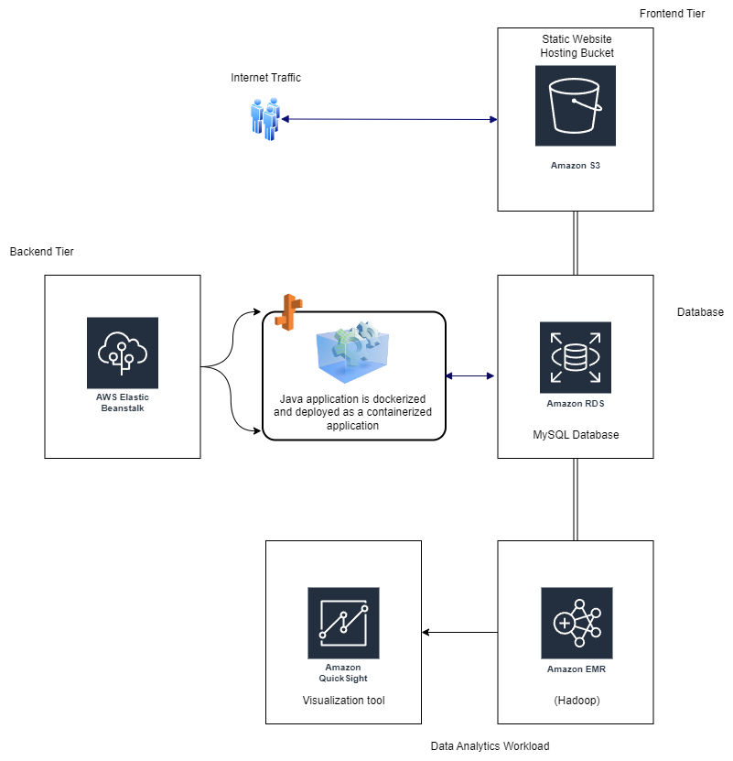

1. **Three tier architecture:**
2. **Frontend:** Configure an Amazon S3 bucket to host frontend components (HTML, CSS, JavaScript) for static website hosting and make it publicly accessible.
3. **Backend:** Replacing the Apache web serve and Java application and deploying it through and Amazon Elastic Beanstalk environment. Java application is dockerized and deployed as containerized application in Elastic Beanstalk container.
4. **Database:** Replace the MySQL database by creating an Amazon RDS instance running MySQL and migrate all the data and schema and update the configuration of the backend application and connect it to the RDS instance.
5. **Data analytics workload:  
   a. Apache Hadoop:** As per the instructions provided, We can replace the on-premises Apache Hadoop clusters and use Amazon EMR (Elastic MapReduce) cluster instead and configure it with necessary storage (either by using amazon S3 or HDFS) to store the input and the output data.  
   **b. Visualization Tools:** Amazon QuickSight can be used that is also compatible with EMR to derive insights of the operations/analysed data and to create visualizations and dashboards.