Project Plan

SYD Airbnb Data Analysis and Visualisation Tool

Md Tanvir Mannan-s5202602

Quoc Nam Ngo –s5239492

TszHoi Leung S5245510

Table of Contents

1.0 Introduction 3

1.1 Problem Background 3

1.2 Scope 3

1.3 Document contents 3

2.0 Work Breakdown Structure 4

3.0 Activity Definition & Estimation 5

4.0 Gantt Chart 6

# Introduction

## Background

* This project is to develop an analysing app which focus on Sydney Airbnb data. As the border restriction has been removed in NSW, the huge Airbnb market which includes over 1000 stays has been recovering. More Airbnb users and investors will be interested in this service. Visitors would want to get better planning for their trips to prevent late booking in peak seasons or be trapped by bad hosts. Moreover, Airbnb hosts would try to keep an eye of the changes of market to utilise their listings to enhance business performances. Also, there may be some new investors want to enter the market and know the fiercest competition of different price levels property to calculate the best rate of return. By developing the app could assist users in different purposes.

## Scope

## **Product Scope Description**

The project will develop and implement an app for the visualising of the analysing of the Sydney Airbnb data with the objective of let users get better and easier understanding of the Sydney Airbnb market. By providing analysis charts and reports could assist Airbnb users to get better booking and living experiences. Moreover, for Airbnb hosts could use the app to track the changes of Airbnb market trends and customers’ requirements which could help hosts to improve their listings and expand their targeted customer-bases.

## **Project Deliverables**

Showing and collecting the records of Airbnb users’ comments, reporting the specific information and price levels of different suburb’s listing, and (1 new specific feature). Both charts and reports will be presented by graphic and xml doc. App users could choose different criteria to get different results, like customised keywords, drop-down list of choices, ordering and sorting according to the results etc.

Required tools: Python/ html+php, SQL, Git hub, xml software.

Required OS: Windows, Mac

Supported language: English

## Document contents

Below documents are included in the development of this project. These documents could help to arrange time management and cost estimation to achieve the project objective by defining key activities and identifying risks to get rid of delay during the development.

* Project Plan
* WBS Gantt chart
* Software Design Document
* Git log
* System Vision statement
* ERM diagram of system components and app design.
* Early user interface design.

# Work Breakdown Structure

And coding The Work breakdown structure chart provide a visual and hierarchical deconstruction of the project. By using the chart, it allows the project scope to be broke down and visualise all the project tasks to arrange better management. The chart below is divided into five major Activity, Initial, Planning, implementation, Testing and Closure. First two activities are for the project team to set up and design the requirements and scopes of the app, the third and fourth activities, implementation, and testing, are for the team to proceed the coding and testing of the beta version of app. The last activity is to launch the app for end-users and prepare all the documentation for reviewing and instructions.

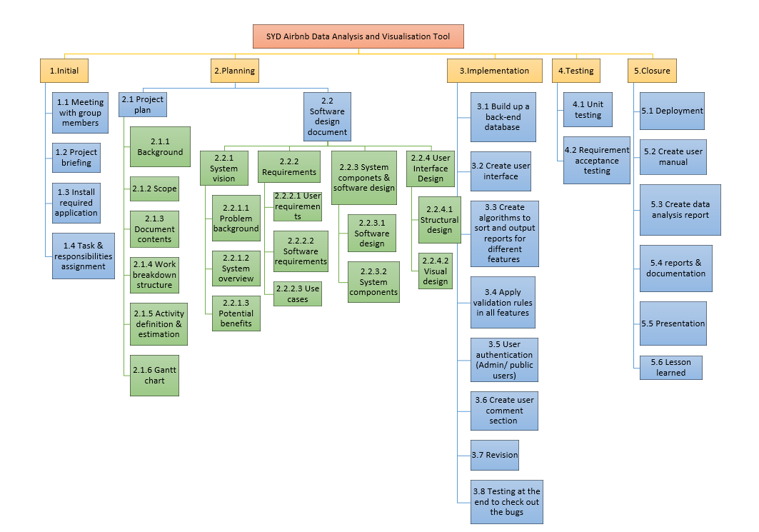

# Activity Definition & Estimation

|  |  |  |  |
| --- | --- | --- | --- |
| ID | Activity name | Description | Estimation |
| 1. Initial | | | |
| 1.1 | Meeting with group members | First meeting: Introduce with each other | 1 day |
| 1.2 | Project briefing | Introduce & describe the project |
| 1.3 | Install required application | Install & familiar with required software |
| 1.4 | Task & responsibilities assignment | Assign roles & responsibilities to group members |
| 1. Planning | | | |
| 2.1 | Project plan | This section will cover the project plan | 1 day |
| 2.1.1 | Background | Introduce & describe the project background |
| 2.1.2 | Scope | Describe scope of the project & project deliverables to provide clear picture to readers |
| 2.1.3 | Document contents | Introduce documents which are included in the development of this project |
| 2.1.4 | Work breakdown structure | List out all project activities that need to be completed in a hierarchy chart | 1 day |
| 2.1.5 | Activity definition & estimation | Define the tasks mentioned in the WBS and estimate the time needed to perform each task |
| 2.1.6 | Gantt chart | Display the project’s overall schedule & keep track of the actual time it takes to accomplish each task | 1 day |
| 2.2. | Software design document | This section will cover the software design document | 8 days |
| 2.2.1 | System vision | Introduce the system vision of the software | 1 day |
| 2.2.1.1 | Problem background | Introduce the system problem background |
| 2.2.1.2 | System overview | Describe the deliverables, functionality & technology & Data, information, content |
| 2.2.1.3 | Potential benefits | Briefly identify potential benefits from this project |
| 2.2.2 | Requirements | Introduce & describe the requirements | 3 days |
| 2.2.2.1 | User requirements | Describe the User requirements | 1 day |
| 2.2.2.2 | Software requirements | Describe the software requirements | 1 day |
| 2.2.2.3 | Use cases | Identify Use cases and Create Use case diagram | 1 day |
| 2.2.3 | System components & software design | Introduce the system components & software design | 2 days |
| 2.2.3.1 | Software design | Create a high-level design-logical block Diagram | 1 day |
| 2.2.3.2 | System components | Describe functions, Data structures/Data sources & detailed design | 1 day |
| 2.2.4 | User interface design | Describe the tools used for this design stage | 2 days |
| 2.2.4.1 | Structural design | Define the navigational and information structure of the software | 1 day |
| 2.2.4.2 | Visual design | Detailed Visual design such as layout, visual elements, icons, graphics, style, colour, fonts, general screen designs | 1 day |
| 1. Implementation | | | |
| 3.1 | Build up a back-end database | Collect spreadsheet data from Kaggle.com and transform into the Database. | 1 day |
| 3.2 | Create user interface | Create the user interface of both Main Menu page and Feature pages through wxPython. | 2 days |
| 3.3 | Create algorithms to sort & output reports for different features | Use python and SQL query to create the algorithms of the analysing like filtering, sorting of required data. Then to create functions to output Charts and reports through the analysed data. | 4 days |
| 3.4 | Apply validation rules in all features | Apply logic conditions to all input/selection fields | 1 day |
| 3.5 | User authentication | Set up security user database for guests and developers. | 1 day |
| 3.6 | Create user comment section | Create a page for user to comment and will upload to the database. | 1 day |
| 3.7 | Revision | Create clearly identified revision codes which continue in sequence from the first issue to the end. | 2 days |
| 3.8 | Testing at the end to check out the bugs | Apply testing conditions and different scenarios of actual applications to test the app. | 2 days |
| 1. Testing | | | |
| 4.1 | Unit testing | Create individual tests for every functionality in the application | 14 days (run simultaneously with the implementation) |
| 4.2 | Requirement acceptance testing | Analyse and create a testing requirement document. Set up a verification checklist for the test execution. | 3 days |
| 1. Closure | | | |
| 5.1 | Deployment | Finalizing the application and deploying it | 1 day |
| 5.2 | Create user manual | Create user manual | 1 day |
| 5.3 | Create data analysis report | Analyses the data over a 12-month period & create a report | 1 day |
| 5.4 | Reports & documentation | Create and finalize all reports & documentation | 2 days |
| 5.5 | Presentation | Present the application | 1 day |
| 5.6 | Lesson learned | Reflects both positive and negative experience during the development process | 1 day |

# Gantt Chart

