|  |
| --- |
| <Sydney Airbnb Data Analysis and Visualisation Tool> Executive Summary |
| Tszhoi Leung S5245510 Md Tanvir Mannan s5202602  Quoc Nam Ngo s5239492 2810ICT Software TechnologiesOctober 9, 2022 |

# Abstract

This report shows us the data analysis for year 2017. It reports the information of all listing in a specified suburb, produce a chart to show the distribution of prices of properties, retrieve all records that contain a keyword and analysing how many customers commented on factors related to cleanliness.

# Introduction

This report aims to provide Sydney Airbnb data analysis tool information. The date range covered in this data analysis tool from 01/01/2017 to 31/12/2017. Feature 1 reports the information of all listings in a specified suburb, feature 2 produces a chart to show the distribution of prices of properties, feature 3 retrieves all records containing a keyword, and feature 4 analyses how many customers commented on factors related to cleanliness.

# **Analysis 1 <List By Suburb>**

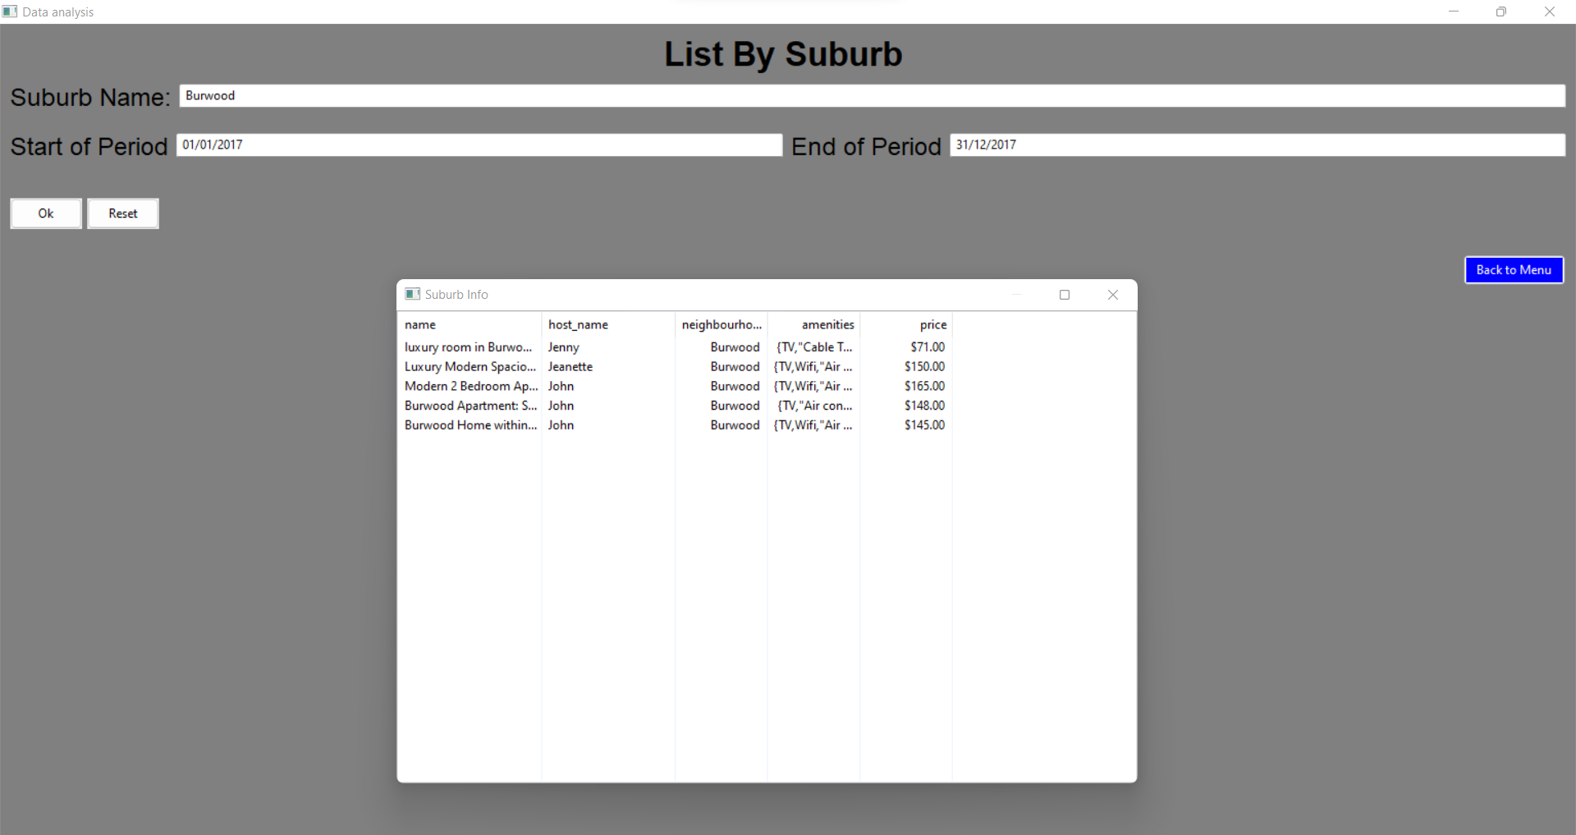

This feature displays the details of every Airbnb rental in the Burwood area between the dates of January 1, 2017, and December 31, 2017.

# **Analysis 2 <Price of Listing Chart Display>**

This feature shows us the distribution of prices of properties from 01/01/2017 to 01/12/2017. x-Axis is representing prices and y-Axis is representing the density of prices.

# **Analysis 3 <Retrieve Keyword>**

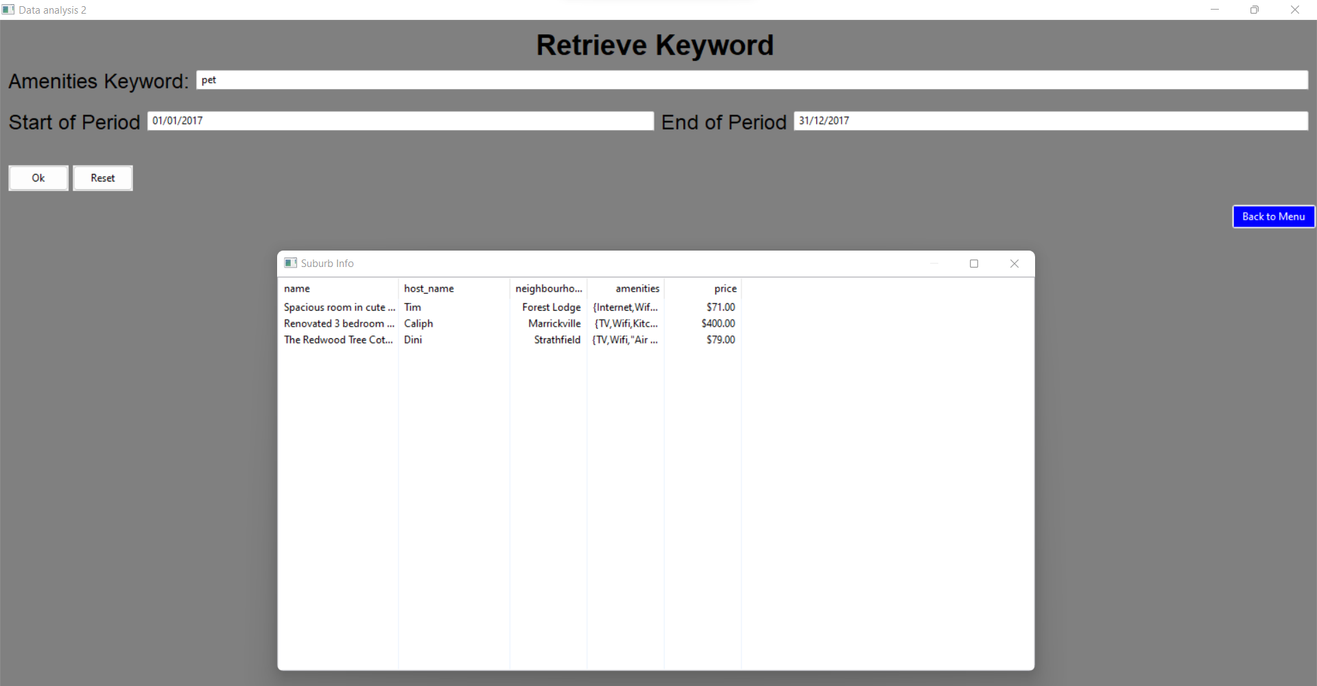

This feature shows the information of AirBnb listing in Sydney which records contain a keyword 'Pet'

# **Analysis 4 <Customer Clearance>**

This feature shows us the information of analysis of how many customers commented on factors related to cleanliness.