Software Design Document

<SYD Airbnb Data Analysis and Visualisation Tool>

Quoc Nam Ngo – s5239492

Md Tanvir Mannan – s5202602

Tszhoi Leung - S5245510

Table of Contents

1.0 System Vision 2

1.1 Problem Background 3

1.2 System Overview 3

1.3 Potential Benefits 3

2.0 Requirements 4

2.1 User Requirements 5

2.2 Software Requirements 5

2.3 Use Cases & Use Case Diagram 5

3.0 Software Design and System Components 6

3.1 Software Design 7

3.2 System Components 7

3.2.1 Functions 7

3.2.2 Data Structures / Data Sources 8

3.2.3 Detailed Design 9

4.0 User Interface Design 11

4.1 Structural Design 12

4.2 Visual Design 13

# System Vision

## Problem Background

Airbnb is one of the major online platforms for lodging and primarily homestays for vacation rental and tourism activities. With the recovery of the Sydney tourism industry, the need for, and tourism activities. With the recovery of the Sydney tourism industry, the need of Airbnb listings has been increasing. This software is to assist advance uses of Airbnb and enhance the user’s experience for both Airbnb’s Hosts and users by providing five different analysing tools.

## System Overview

**Deliverables/Outcomes:**

The app will be able to provide the analysing reports and charts as a supporting tool for Airbnb Users. There are four different analysing features including generating a list by suburb in Sydney, generating a chart to show the different price levels of a selecting range of listings, a report of showing the number of listings that fulfilled requirements, and a report that contains all users’ comments that related to cleanness. Moreover, the app provided a login function to provide an extra function for admin and developers to revise and update backend data.

*What will be the end result, what will the project produce. If it will result in a website, discuss that website. Based on your project name, what is its domain/URL (remember, a domain name is an important part of a project’s visibility/promotion/recognition.*

**Functionality & Technology**

This app is designed by SQL, python, and wxPython. After logging in, there is a menu page to lead users to their selected feature. On each feature page, there are search history and export buttons for users to download their reports. Reports will be presented in .xml format; so that users could download them for further use. Moreover, Bar Charts and Pie Charts will be used in the price display feature, and they will be presented in graphics or created by python. In order to store back-end data, the data retrieved from the Kaggle.com spreadsheet will be transferred into a database which could be easier for data querying.

## Potential Benefits

* Target Users
  + Airbnb Hosts
    - Flexible changes on the rents depends on the peak/ off-peak season
    - To analysis the most concerned issues by Airbnb users
  + Travellers
    - Better trip planning
    - To prevent choosing low-quality host
  + (property) Investors
    - To analysis the fierce competition ranges from different level of properties.
    - To calculate the rate of return
* Business side:
* Understanding customer behaviour with analytics to improve the customer experience
* forecasting future trends to aid in better corporate decision-making
* Understanding what works and what does not in marketing strategies to improve them
* Increasing operational effectiveness by identifying and eliminating bottlenecks
* earlier detection of fraud and other forms of abuse

# Requirements

## User Requirements

* The users must have the proper device to run the tool
* The users need to have a basic knowledge about data analytic diagram
* The users must input or select the valid value to get the correct results or necessary information
* The users must enter the input value in the appropriate form (place) to make the input value valid

## Software Requirements

1. The tool shall be able to display the details of all valid files.
2. The tool shall display an appropriate error message if the input value does not exist or not match with any of the dataset
3. The program shall check the user input until the appropriate input is entered.
4. The search bar shall catch the key words users typed in and print out the existed data the related to the key words
5. The tool shall print out properly the results of input value as request by the user
6. The tool shall store all the users 'comments when they successfully added and display them in the table
7. The tool shall display the chart with the date range selected by the user correctly to show the distribution of prices of properties

## Use Cases & Use Case Diagram

Use Case:

* HelloWorld Travel uses SYD Airbnb Data analysis tool to improve customer experiences. They used the review section to find out their customers’ expectation regarding their interests, satisfaction, demands, feedback and so on. The travel agency identifies negative comments and does what is necessary to remedy the situation. By publicly addressing these issues and offering solutions, it helps the company build good customer relations.
* Ray White - Australia's largest real estate media spender uses SYD Airbnb Data analysis to do their business. It consists of most of the information that the customer expecting to know about the properties (prices, location, review, planning, rent trend…)
* Tom and his family are looking for a rental to stay in Sydney for their holiday, but they are not really sure about the location because they have not been there before and also do not know any local people in there. As a result, they come up with using SYD Airbnb Data app to gather the necessary information (prices, suburb, neighbourhoods...) to find out the suitable place for his family that reaching their expectation.
* Bill is working for Griffith University in Sydney; he is a busy guy, so he does not want to spend too much time for gathering data by reading word by word. He said that took too much time for him for reading, scanning to find out the main point data that he is expecting to know. As a result, he comes up with using the SYD Airbnb visualisation tool to analytic the data get information about the rent – price trending of the properties in Sydney.

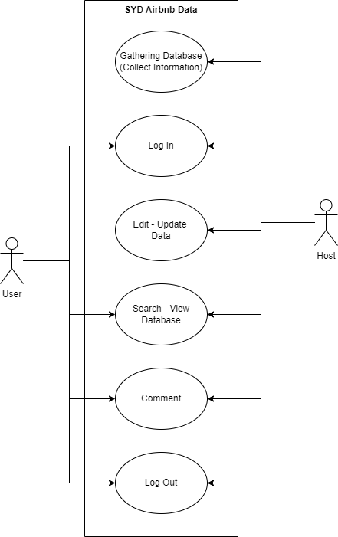

Use Case Diagram

# Software Design and System Components

## Software Design

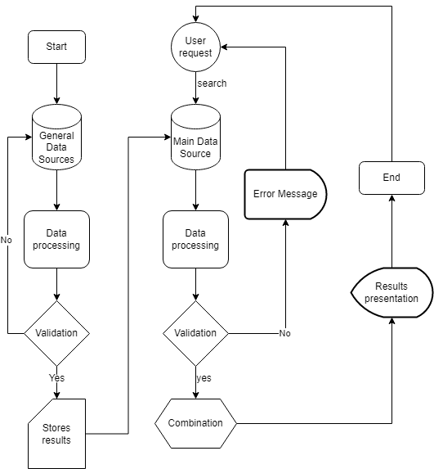 **High Level Design – Logical Block Diagram SYD Airbnb Data Application**

## System Components

### Functions

There are different functions used to build a ladder-gram. The name of the functions and their description are described as follows:

1. List_by_suburb(**parameter 1**: string -Suburb, **parameter 2**: list – records)

This function checks the enter input of the users if they are searching for the information by a specified suburb within a range of time. If the input is valid, it will report the information of all listings in a specified suburb for a user-selected period. Otherwise, datanotfoundError message will popup

1. Chart_price_display(**parameter 1**: time range, **parameter 2:** prices, **parameter 3:** locations)

To help users get comprehend vast amounts of data at a glance and in a better way. this function will be used to display the chart with the distribution of prices of properties for a selected period

1. Retrieve_keyword(**parameter 1**: string -keyword, **parameter 2**: list – records)

This function checks the input value of the users to present the information by a keyword. If the input is valid and contain a keyword that may be related to the records. All records will be retrieved. Otherwise, datanotfoundError message will popup

1. Customer_cleancare(**parameter 1**: string -"cleanliness”, “clean”, “dirty” and “messy”, **parameter 2**: list - comments)

Cleanliness is one of the most crucial factors that concern people about Airbnb. This function will help to check out how many customers commented that mentioned about somethings that related to cleanliness. Then, listing out those comments

1. Login_funcntion (**parameter 1**: string - username, **parameter 2**: string-password)

This function will distinguish between clients and the host. To be able to edit update the data, the users (the host) need to login the proper account to be allowed to update the data.

### Data Structures / Data Sources

Feature List:

1. List_by_suburb

2. Chart_price_display

3. Retrieve_keyword

4. Customer_cleancare

5. Login_funcntion

* + Suburb – List (String), a pre-set and fixed List which is allowed to use to match with the user’s input and output the grouped results. (Applied feature: 1)
  + Time Range – String (date format MM/YYYY), use a Get_Date function to change the string into Month and Year, so that could assign filtering criteria to the result. (Applied feature: 1, 2, 3, 4)
  + Keyword – String (max-length: 20), typed by users; and used to do searching. (Applied feature: 3)
  + Keyword CleanCare – List (String) - A fixed List to store cleanness-related keywords which could be edited by Admin. (Applied feature: 4)
  + Restricted-list – Array(string), used to store restricted characters like ‘“’, ‘;’, ‘:’, ‘?’ to prevent SQL injection and other vulnerabilities. (Applied feature: 1, 3, 4, 5)
  + Comments – Array(string), to store user’s comments.
  + User ID and Password – (String) stored in database, restricted character list is applied. (Applied feature: 5)
  + Backend data – spreadsheet/ Tables, provided by Kaggle dataset, can be edited by Admin. (Applied feature: 1-5)

### Detailed Design

Function checkUser(id)

Check if the login Id is admin and authorise restricted functions permission.

Else

authorise users to regular functions permission.

Function login (id, pw)

Check if the id and password are matched with the database records.

Function Menu ()

List the feature menu and then check what feature has been chosen and redirect to required page.

Function Restricted_Character_Check(agruement1)

Check if the user input is contained suspicious characters or symbols which may be harmful to the app.

Else

Print error message and request to input again

Function Build_Chart(arguement1, argument2, arguement3)

Use MatplotLib and SSRS to assist the chart creation base the argument data.

Function Get_date(argument 1)

To transform User chosen date into two strings MM and YYYY for further sorting and filtering.

Function Check_Suburb(argument 1)

Check if the inputted suburb is matched with the database

Else

Print invalid message and ask to input again.

Function report_Build(argument 1, argument 2)

Print the SQL result according to the arguments.

Function Export_Result(argument 1)

Output a Pdf/ xml/ jpeg file according to the argument.

Function Comment_Upload(argument 1)

Update the user comment into the database by SQL;

Function Update_cleanliness_List(arguement1)

Update the array which stored all the cleanliness keyword

Function Matching(arguement1)

Transform the inputted keyword into SQL to query the database.

Function History_Record()

Store the last searched input and result.

{

Print the login Page

Check_User(ID)

Login(ID, PW)

in the main function

Print the UI

Menu()

Take the user to selected feature page and provide specific functions according to the feature.

Take the input from users and use Restricted_Character_Check to check the input is suspicious or not.

Build_Chart() or Report_Build() to generate result for users

History_Record(Result)

Export()

Menu()

Logout()

}

# User Interface Design

The goal of user interface (UI) design for the SYD Airbnb Data is to foresee what users would need to accomplish and make sure that the interface has elements that are simple to use, access, and comprehend to facilitate those actions. The SYD Airbnb Data system's user interfaces were created using best practices and concepts in user interface design. Usability, or the ease with which a system may be learned and used, was a major consideration. As a result, the detail of designing the user interfaces for the app is presented in the sub-sections below:

## Structural Design

App navigation serves the critical yet simple goal of helping the visitor know where they are and where to proceed next. Even when just browsing, they are trying to accomplish a goal. Therefore, in the SYD Airbnb Data app, the navigation must be designed every page to help users succeed in their quest. If the app looks like it does not serve what the users are looking for, or, even worse, if it increases the fears, uncertainties, and doubts of the users, it may force the users to bounce off or exit the app very quickly. Even highly motivated users tend to lose patience with a dataset application that does not give them the information they need. As the result, the SYD Airbnb Data will be designed to keep it simple and most effective way.

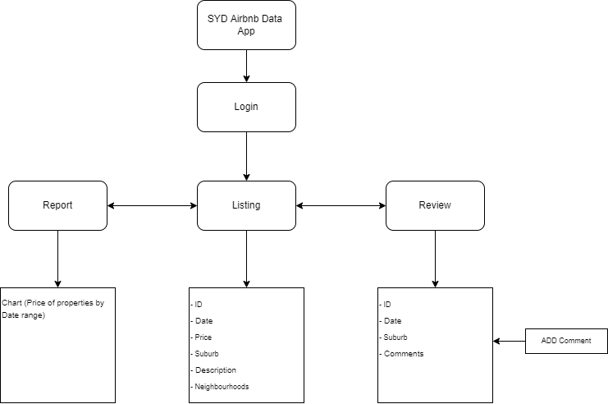

SYD Airbnb Data App structural Designing

**SYD Airbnb Data App structural Designing**

After login to identify the users, they will be led to the listing page directly. Here is the page that contains most of the information of the dataset and get the most attention from the uses during the first moments. Hence, the purpose of designing this screen as a home page appear immediately after the use login is that help the users are able to find out the content that they are looking for immediately that prevent from wasting time and prevent to bring up the feeling to bounce off the app before browsing around the other pages. From here the user can navigate between all the pages of the app anywhere and anytime they like.

## Visual Design

Everything stems from knowing the target users, including understanding their goals, skills, preferences, and tendencies. As mentioned above, the app that is building in the project is an analytic data application so the design will be mostly focus on clarifying the content - data of the app that are about scan ability, legibility, and readability. Therefore, Keep the interface simple is especially important to this application. The best interfaces are almost invisible to the user. They stay clear in their messaging and avoid adding anything that is not necessary. Besides that, create consistency and use common UI elements is another critical rule. Users feel more at ease and can complete tasks more quickly by using UI features that are popular. To increase efficiency, it is crucial to establish themes in the language, organisation, and design used throughout the website. When a user masters a skill, they need to be able to apply it to other parts of the system. To be more detail, the designing of the SYD Airbnb data app is considered the following:

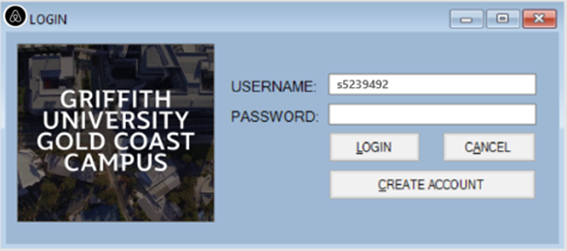

Figure 1. Login wireframe

The figure above is showing the log in screen of the SYD Airbnb Data App. To access the system, the users need to create an account that is authenticated. A user can input the username and the password together to the text boxes provided and click the login button below the input box to log in. The cancel button next to that is used to empty the input box that they can redo the input process quickly. The long button under is the sign-up button that for new user to create a new account.

The background of the login screen is using the simple pale blue colour to reduce the contrast between the text and background and this colour also is applied to the other the pages of the app that create unity and harmony between the pages and to ease of the eye and provide the high readability. The large text font is used for this page to enhance visibility.

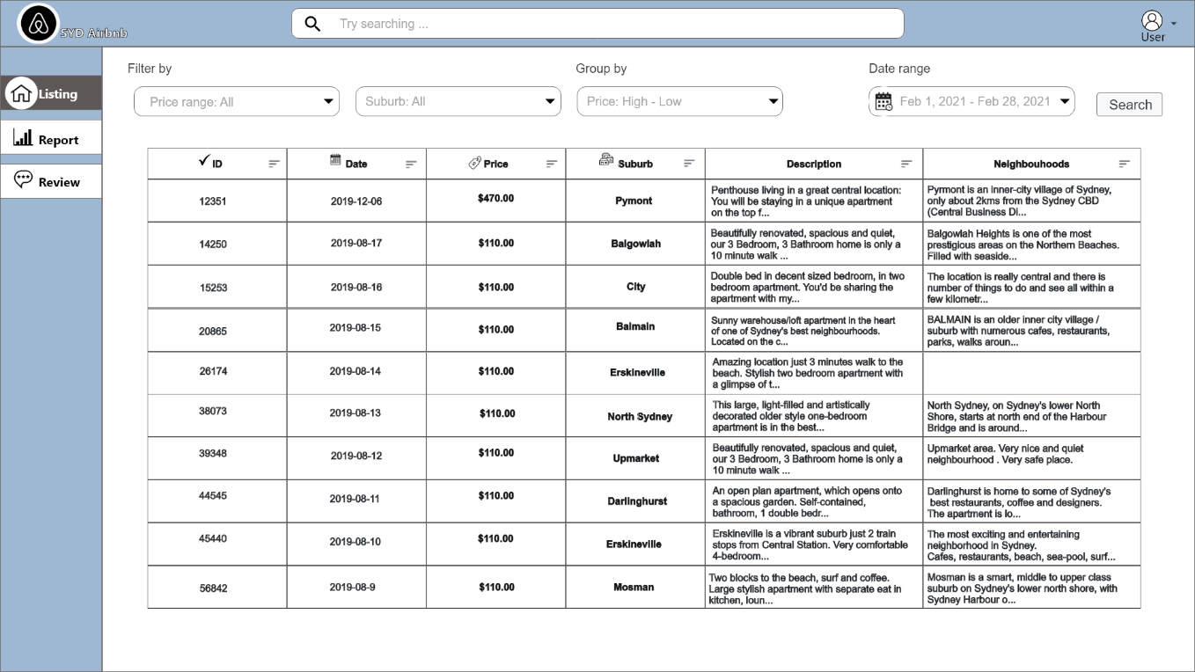

Figure 2. Listing page

Storyboard 2 figure as displaying above illustrates the listing of Data screen of the SYD Airbnb Data. This will appear after the users successfully logged in to the app. Most of the dataset are displayed in this page. The purpose of designing this screen as a home page is that help the users are able to find out the content that they are looking for immediately that prevent from wasting time and prevent to bring up the feeling to bounce off the app before browsing around the other pages. With this screen they can search for the data that they are looking for with the search bar always displayed on the top of the screen or filter out the specific data and group them by their certain demand with these bars below the search bar. After selected the appropriate keys with the filters bar sequently from left to right the user will come up with the search button on the right side. After clicking that, all the specific data will be displayed follow the request of the user.

The logo and name of the app are always stand in the left corner, behind that is the navigate bar that enable the users to navigate between the pages. The users can use the navigate bar wherever and whenever they like.

The information of the dataset are displayed as a table which includes the data ID, date, price, suburb, description and neighborhoods. these are set horizontally on the top of the table to help users get easily when doing the checking process. The font of the data is set as 17 that not too big to keep more space on the screen but also not too small that influence the readiability.

All the main content – data will be separated by the pale blue color that helps increase the ease of the eye and provide the high readability. That prevents users getting distracted from the other parts when need to focus on the information section.

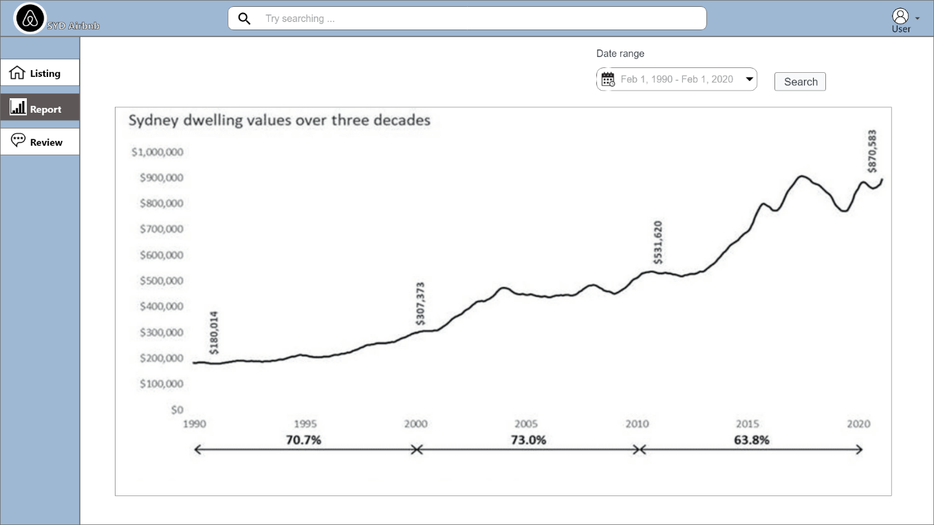

Figure 3. Report Page

Storyboard 3 figure as displaying above illustrates the chart to show the distribution of prices of properties by a specific range of data. This will appear after the user clicked on the Report button from the navigate bar on the left side. The users use the date range filter bar provided on the top right to request the chart with the prices of the properties within the specific date range they would like. After clicked on the search button the chart will be showed up within the date range that they requested.

In the chart, the prices of the properties are display vertically from the smallest to higher number. And the years are displayed horizontally at the bottom with the sequence of time from oldest to new from left to right

By using visual elements like charts data visualization tools provide an accessible way to see and understand trends, outliers, and patterns in data for the users.

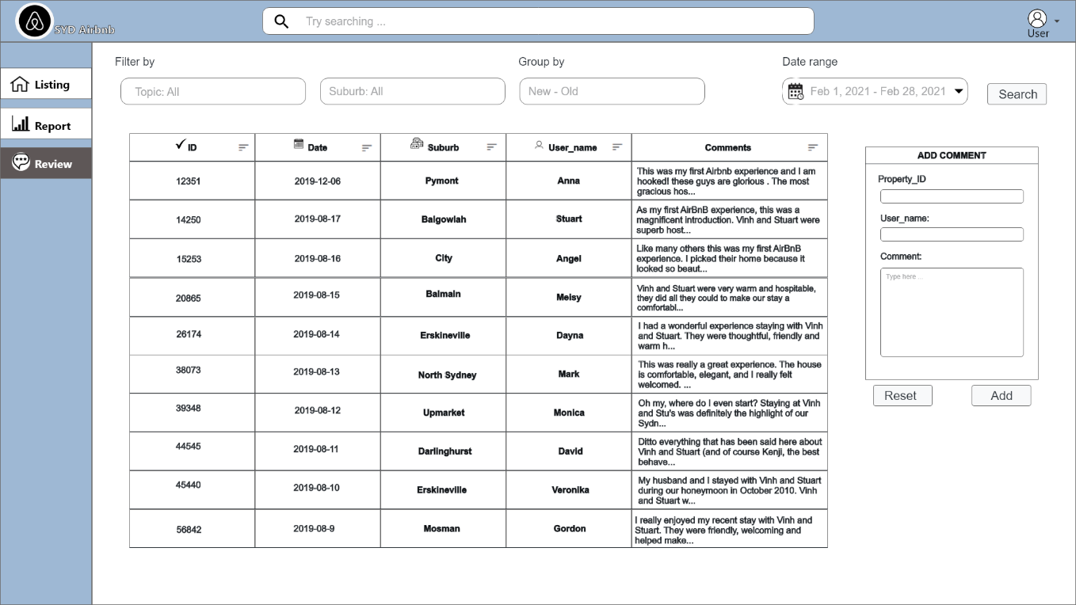

Figure 4. Review page

Storyboard 4 figure as displaying above illustrates the list of Review screen of the SYD Airbnb Data. This will appear after the users clicked on the Review button in the navigate bar. Similar to listing page, the Review also has the filter bars, date range bar and search button on the right side to search the data and dataset are also displayed as a table that are separated by the pale blue colour to help increasing the ease of the eye and enhance the high readability. However, the data displayed in this page is mainly focused on the comments that are collecting from the users.

The information of the dataset are displayed as a table which includes the data: ID, date, suburb, user_name and comments. these are set horizontally on the top of the table to help users get easily when doing the checking process. The font of the data is set as 17 that not too big to keep more space on the screen but also not too small that influence the readiability.

Besides that, on the right side of screen the users have an extra table that uses to add their own comment with a specific property each time. On the Add comment table, there are 3 text fields that the users need to full fill in to be able to add their comment. Firstly, on the top we have a property_ID field, in the dataset each property has its ID number, to comment about a specific property, users need to write down the proper number ID of the object. Secondly, below that us a user_name field to identify the name of the person who is writing the comment. And the final field is the comment content. The users can write down whatever they like about their feelings, complain or feedback to the property. The, below the add comment table, it has two buttons that are reset on the left and add on the right. If the users change their mind, they can use the reset button to clear all the text that they wrote down before in 1 second and start to write a new one. Otherwise, they can use the add button to submit their comment to the database and it will be displayed in the table.