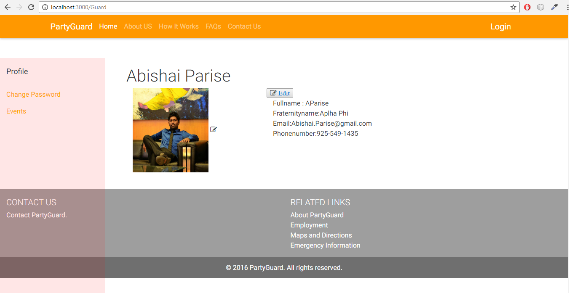

Added funtionality to edit the guard details by routing to new html page(GuardUserEdit.html) where he can edit the form

Fields will be stored in the form of json

Created GuardUserEdit.html page.

<https://github.com/s525080/PartyGuardWebApp_PartyFreaks/commit/09c3de6916998bc69691acb06033e7c498096b4b>

Added some UI changes to GuardProfile.html page

<https://github.com/s525080/PartyGuardWebApp_PartyFreaks/commit/314927c87ab9562247f954123369284935ad431e>

