Inventory Web System

Software Requirements Specification

Version - 03

December 09 2016

Team Members

Amrit Dhimal

Sai Krishna

Koti Reddy Nusum

Suresh Kumar Madugula

**Prepared for**

**Graduated Directed Project - I**

**Instructor:** Dr. [Zhengrui Qin](https://nwmissouri.instructure.com/groups/463/users/4399) (Jerry)

**Fall 2016**

**Revision history:**

|  |  |  |  |
| --- | --- | --- | --- |
| **Date** | **Version** | **Description** | **People** |
| October 07, 2016 | 1.0 | First draft | **Project Owner and Client:**  Dr. [Zhengrui Qin](https://nwmissouri.instructure.com/groups/463/users/4399) (Jerry)  **Faculty Advisor:**  Dr. [Zhengrui Qin](https://nwmissouri.instructure.com/groups/463/users/4399) (Jerry)  **Project Group:**  Amrit Dhimal  Sai Krishna  Koti Reddy Nusum  Suresh Kumar Madugula |
| November 15, 2016 | 2.0 | Second draft  Updated prototypes and use cases. | **Project Owner and Client:**  Dr. [Zhengrui Qin](https://nwmissouri.instructure.com/groups/463/users/4399) (Jerry)  **Faculty Advisor:**  Dr. [Zhengrui Qin](https://nwmissouri.instructure.com/groups/463/users/4399) (Jerry)  **Project Group:**  Amrit Dhimal  Sai Krishna  Koti Reddy Nusum  Suresh Kumar Madugula |
| December 09, 2016 | 3.0 | Third draft  Updated use case and prototypes. Added new functionality like adding and deleting the Buyer list of products. | **Project Owner and Client:**  Dr. [Zhengrui Qin](https://nwmissouri.instructure.com/groups/463/users/4399) (Jerry)  **Faculty Advisor:**  Dr. [Zhengrui Qin](https://nwmissouri.instructure.com/groups/463/users/4399) (Jerry)  **Project Group:**  Amrit Dhimal  Sai Krishna  Koti Reddy Nusum  Suresh Kumar Madugula |

**Document approval:**

The following Software Requirements Specification has been accepted and approved by the following:

|  |  |  |  |
| --- | --- | --- | --- |
| **Signature** | **Printed Name** | **Title** | **Date** |
| Amrit Dhimal | Amrit Dhimal | Client Manager | 11/15/2016 |
|  | Dr. [Zhengrui Qin](https://nwmissouri.instructure.com/groups/463/users/4399) (Jerry) | Faculty Advisor |  |
|  | Dr. [Zhengrui Qin](https://nwmissouri.instructure.com/groups/463/users/4399) (Jerry) | Project Sponsor |  |
| Amrit Dhimal | Amrit Dhimal | Client Manager | 12/09/2016 |
|  | Dr. [Zhengrui Qin](https://nwmissouri.instructure.com/groups/463/users/4399) (Jerry) | Faculty Advisor |  |
|  | Dr. [Zhengrui Qin](https://nwmissouri.instructure.com/groups/463/users/4399) (Jerry) | Project Sponsor |  |

#### **Table of Contents**

**1. Introduction** 1

**1.1 Purpose** 1

**1.2 Scope** 1

**1.3 Definitions** 1

**1.4 Overview** 2

**2. General Description** 3

**2.1 Product Perspective** 3

**2.2 Product Functions** 3

**2.3 User Characteristics** 3

**2.4 General Constraints** 4

• User cannot post same product multiple times. 4

**2.5 Assumptions and Dependencies** 4

**3. Specific Requirements** 5

**3.1 External Interface Requirements** 5

3.1.1 User Interfaces 5

Feature #1: User login Home Page 5

Feature #2: Forgot Password Page 6

Feature #3: Register Home page 6

Feature #4: Inventory system Home Page 7

Feature #5: Product Page 8

Feature #6: Buyer Page 9

Feature #7: Reporting/Shipping Page 9

Feature #8: Shipping Address Add Page 10

Feature #9: Shipping Address Delete Page 11

3.1.2 Hardware Interfaces 12

3.1.3 Software Interfaces 13

3.1.4 Communications Interfaces 14

**3.2** **Requirement Traceability Matrix:** 15

**3.3 Use cases** 15

3.3.1 Common use cases for each user 15

**3.4 Non Functional Requirements** 27

3.4.1 Performance 27

3.4.3 Availability 27

3.4.4 Security 27

3.4.5 Maintainability 27

**4. Analysis Models** 28

**4.1 Data Flow Diagram (DFD):** 28

**5. Change Management Process** 29

**6. Client Acceptance** 30

# **1. Introduction**

This document is to present the purpose, scope and functional and non-functional requirements which we are going to be implemented during the development of the project. This document will give an overview of the application.

## **1.1 Purpose**

The purpose of this document is to give an outline of the application and it’s working to all the team members and the client.

## **1.2 Scope**

The project is about developing an application titled “Inventory web system”. The Inventory system is a web based application, which help’s a businessman manage their online store, allows collecting information about products bought. The application provides user friendly version to store the product’s data and billing information. The application saves data collected in the database. Its operational status is under development. Inventory system operates on all devices, irrespective of any operating system. The idea of the application evolved mainly to ease the restrictions imposed on limited products during sales time by considering all the limitations and priorities of all the sales members.

## **1.3 Definitions**

|  |  |
| --- | --- |
| **Term** | **Definition** |
| Database | A collection of all the information monitored by this system. |
| Software Requirements Specification (SRS) | A document that completely describes all of the functions of a proposed system and the constraints under which it must operate. |
| Stakeholder | Any person with an interest in the project. |
| User | The person who uses the application seeking help. |
| Scheduler | A Person who schedule classes for faculty. |
| Use cases | Graphical representation of flow in project. |
| Mockups | Sample User Interfaces of the project. |
| Server | Web Server which handles request send by the user and sends back the response. |

## **1.4 Overview**

This document provides an outline of the system functionality and system interfaces and interaction. Further, non-functional requirements, use cases, software and hardware interfaces and other requirements of the project.

# **2. General Description**

This section will give an overview of the whole application. This section describes the perspective of the product, the basic functions, and the types of users that will be using the application, the constraints and the assumptions.

## **2.1 Product Perspective**

The main goal of this web project is to provide an effective user interface for the system to keep track of inventory and billing records.

The “Inventory Web System” application is mainly useful for Sales authorities to keep the billing records safely, easily and buyers can view their products in an interactive way. System Administrator and registered users can access this application.

## **2.2 Product Functions**

In this application administrator (sales head) can login with credentials, created in the system. If user forgot his/her password, he/she can click on the “forgot password” link on the login page, as a result a notification is sent to user’s email to reset his/her password. Once the user logs in, user will be navigated to home page. User can access multiple tabs in this page like product, buyer home, Inventory system tab. Administrator or user can request/add products by using product tab by clicking on it and can view product details using detailed view based on their priority like date wise view or cost wise view. Seller can also login to this application using his provided credentials. User will be navigated to home page, where he can view products based on his priority like deal wise view or products wise view. And at any point of time the user can logout by clicking on the logout button.

## **2.3 User Characteristics**

There are two types of users that interact with this application – administrator user and Normal (Registered) user.

The Administrator user is the one who’s having permissions to request for the classes or add the products to the inventory and he acts like responsible person for all the tasks. The Administrator user assign products to different categories based on their requirement criteria and limitations of that products like due to their unavailability.

The users registered can act in two roles both buyer and seller, the one who can sell the products to the admin in the inventory. Buyer who has freedom to buy products posted in the inventory based on their availability.

## **2.4 General Constraints**

## User cannot add same product multiple times at same place.

* Same product can’t be permission to checkout at the same time by multiple users, depends on their availability.
* Products count in inventory is determined based on number of seller’s sales each day.
* Updating number of products as soon as process is scheduled, indicating how many products are still needed to be deployed.
* Updating billing records as soon as product is available for shipment, if a defective product has reached then it is not allowed to be scheduled for purchase, this is done by manual check on the product, an alert message on the user interface application.

## **2.5 Assumptions and Dependencies**

The assumptions about the product is that it can also be used only for all platforms as long there is network. If server gets down or in poor internet connection situation, it is not possible to use this application. Only authorized persons can use this application. System will supply the login credentials for the admin and faculty.

# **3. Specific Requirements**

## **3.1 External Interface Requirements**

### 3.1.1 User Interfaces

### Feature #1: User login

**Requirements:**

Once the webpage is launched the first display in the screen faculty will be directed to login page. In user login page user need to enter his/her credentials and these credentials will be validated in the database and the authentication for login will be provided.

**Input:**

User need to enter his/her credentials i.e. Username and password and need to click/select login button to login.

**Description:**

1. User need to provide username and password to login.

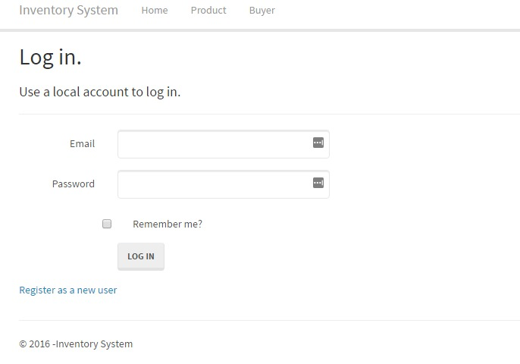

**Figure 1. Log in Tab of Inventory web system**

**Outputs:**

If user is registered he/she will be redirected to system home page. If user is administrator he/she will be redirected to administrator home page. If the administrator is a general user then he is provided with the administrator rights.

**Error Handling:**

If the provided login credentials are wrong or forget to enter credentials and click login an error is thrown.

If user forgot his/her password then he/she should click on forgot password link.

### Feature #2: Forgot Password Page

**Introduction:**

In user clicks on forgot password link then this page will be displayed.

**Inputs:**

1. User will enter email id and new password.

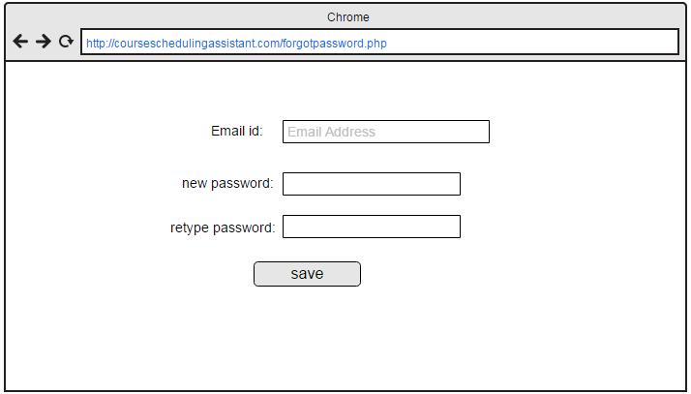

**Figure 2. Password reset Tab of Inventory web system**

**Outputs:**

It reset password of user.

### Feature #3: Register Home page

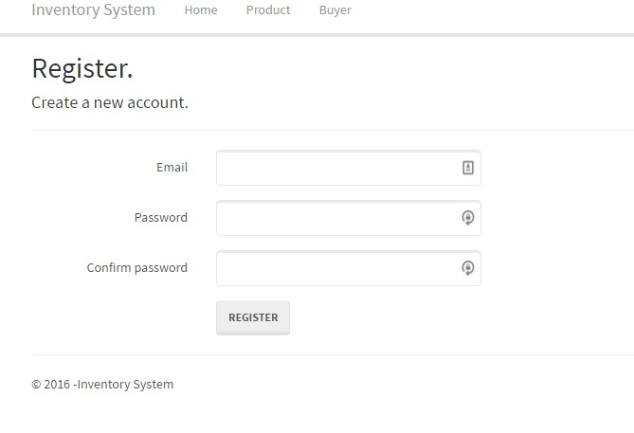

**Figure 3. Register Tab of Inventory web system**

**Introduction:**

If the user is new to the system and not registered, to navigate in the system, users should be registered. The register tab consists of three input fields, provide credential information to login so that data will be stored in the database, when a user registers. It needs email and the password (Figure 3) chosen by the user.

**Inputs:**

1. In this page admin/user will should enter requested data. He/she need to provide details depending on his requirement.
2. User has to click on Register button to register in to the system.

**Description:**

If user is administrator he/she will be registered to the system. If user is administrator he/she will be redirected to administrator home page.

**Outputs:**

Email, password both are text input fields. When both these fields are entered by the respective credential user can register into the system by clicking on the register button (Figure 3). So now a user has registered, can login and use the system with ease.

### Feature #4: Inventory system Home Page

**Introduction:**

In faculty course page, faculty will select subject for which he/she going to see the schedule.

**Inputs:**

1. User/admin has to click on the Inventory system tab.

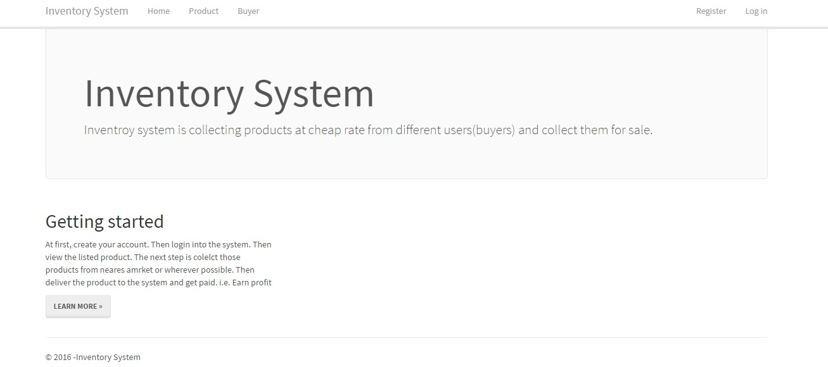  
 **Figure 4. Inventory web system home page**

**Description:**

Tab named inventory system navigates to web page (homepage) which shows the details of the web page shown in the figure.

**Outputs:**

1. If user clicks on inventory system tab, it displays information about inventory system.
2. If user clicks on learn more detailed info view is displayed.

**Error Handling:**

If user did not select tab from menu, it displays alert message.

### Feature #5: Product Page

**Introduction:**

In product page, user or admin will select product tab then this page will be displayed.

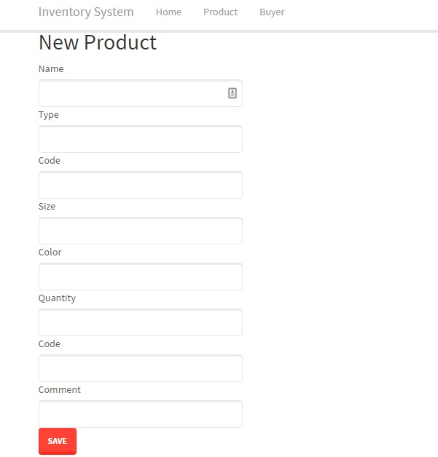

**Figure 5. Product Tab of Inventory web system**

**Output:**

Information of the product is saved in to the system.

### Feature #6: Buyer Home Page

**Introduction:**

If user wants to buy a product then information should be provided.

**Inputs:**

When user selects the buyer tab, navigates to the following page.

**Description:**

This page is the Buyers information home page.

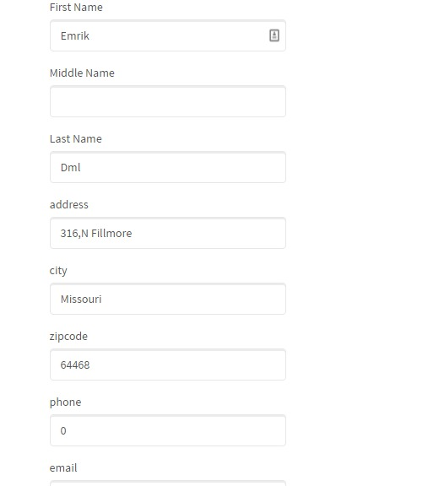

**Figure 6. Buyer Tab of Inventory web system**

**Outputs:**

Buyer address is ready for shipment.

### Feature #7: Reporting/Shipping Page

**Introduction:**

If admin/user wants to send the shipment.

**Inputs:**

Information about each buyer is created with a list (Figure 5) with seven columns such as first name, middle name, last name, verified, discount rate, and address.

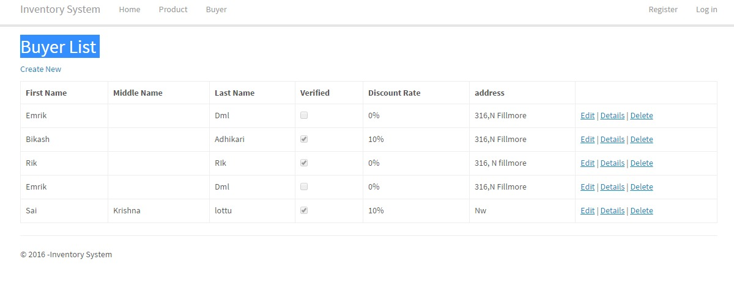

**Figure 7. Buyer List of Inventory web system**

**Output**:

Buyer information will be added to the list.

**Error Handling:**

If administrator did not entered the data in given fields, pop up message will be displayed.

### Feature #8: Shipping Address Add Page

**Introduction:**

If admin wants to add address in to the list of buyers.

**Inputs:**

Information about each buyer address can be added to the list.



**Figure 8. Buyer List address list of Inventory web system**

**Output:**

Buyer’s info will be added in to the list.

**Error Handling:**

If administrator did not entered the data in given fields, pop up message will be displayed.

If given data is incorrect (i.e., given name does not matches from given list) then pop up message will be displayed.

### Feature #9: Shipping Address Delete Page

**Introduction:**

When user click on the buyer tab button this page will be displayed.

**Inputs:**

Buyer’s info will be added in to the list.

**Description:**

In this user is going to delete/update the existing address.



**Figure 9. Buyer List of Inventory web system**

**Outputs:**

Respective Address is available to delete.

**Error Handling:**

If administrator did not enter any value, it displays alert message to enter mandatory fields.

### 3.1.2 Hardware Interfaces

The hardware interfaces required for this application are – Desktop or laptop with any Operating system, with any features with JavaScript functioning. The device should also have internet.

### 3.1.3 Software Interfaces

Before we start developing a web based application in, we need to setup software development environment for that we need to have following tools.

* Windows system
* Advanced java script
* Enrollment into Java developer program
* Testing tools

### 3.1.4 Communications Interfaces

The Department course scheduling assistant application shall use the HTTP protocol for communication over the internet and for the intranet communication will be through TCP/IP protocol suite.

## **Requirement Traceability Matrix:**

|  |  |  |  |  |
| --- | --- | --- | --- | --- |
| **Requirement No.** | **Name** | **Category** | **Source** | **Status** |
| **1** | Laptop and memory | Hardware | Software Requirement specification. | Every laptop must have a memory of at least 32GB of memory |
| **2** | Application developers | Human resource | Project charter and management plan | Require software developers for developing application. |
| **3** | Application testers | Human resource | Project charter and management plan | Require for testing application. |
| **4** | MS project | Software | Time management | To develop the Gantt chart. |
| **5** | Software Environment | Software | Software Requirement specification | To develop application. |

## **3.3 Use cases**

This section describes the use cases of different users in this project. Different users of this application are university administrator and faculty.

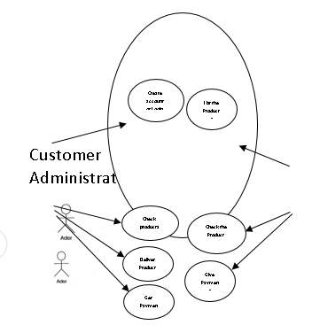

## **3.4 Non Functional Requirements**

### 3.4.1 Performance

The system should be able to show the classes and its timings for faculty in course wise view and in faculty wise view. The system should show the scheduled classes to Admin in two ways, in addition to that Admin can able to schedule class’s course wise and faculty wise based on the requirements and limitations.

**3.4.2 Reliability**

System is reliable in terms of scheduling classes by admin, viewing the classes by both admin and faculty.

### 3.4.3 Availability

The app is available to both the users.

### 3.4.4 Security

All the user information data can able to fetch from database so there is no chance for fault misrepresentation, every user is provided a unique credentials, so that only authorized persons can access this web application.

### 3.4.5 Maintainability

The system can be flexible to add more functionality in future. System can be tested.

# **4. Analysis Models**

**4.1 Data Flow Diagram (DFD):**

A data flow diagram (DFD) is a graphical representation of the "flow" of data through an information system.

## 

# **5. Change Management Process**

1. All the changes in the requirements will be initially discussed with our instructor and will be documented as a minor version.
2. The modified document will be sent to the client for approval.
3. This document will be published as a major version only after the approval from the client.

# **6. Client Acceptance**

Signature: Dr. [Zhengrui Qin](https://nwmissouri.instructure.com/groups/463/users/4399) (Jerry)

Date: December 06, 2016