Q3

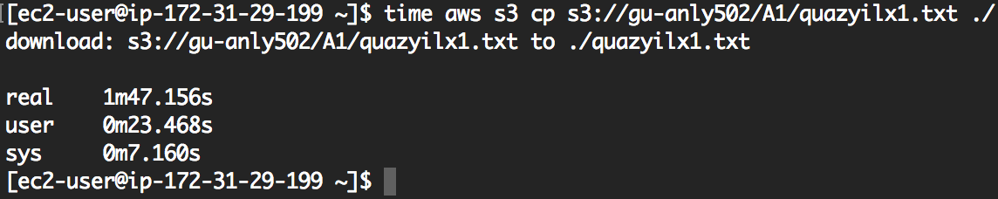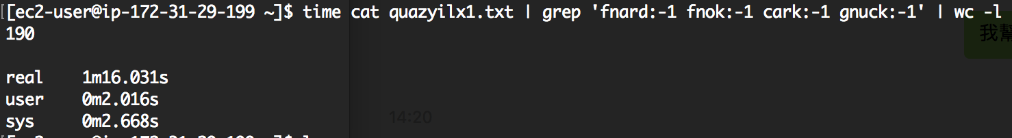

# download and serch to a t2.nano instance

source: s3://gu-anly502/A1/quazyilx1.txt # should be proper S3 URL

date: 2016-01-18T16:09:11 # Date, in ISO-8601 time

mode: download

download: 107 # in seconds

search: 76 # also in seconds

malfunctions: 190 # in lines

Q4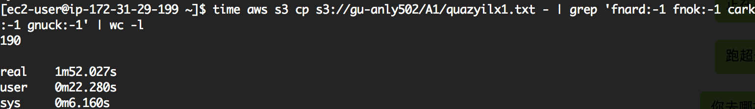

# streaming to a t2.nano

date: 2016-02-04T16:15:50 # Date, in ISO-8601 time

mode: streaming

streaming: 112

malfunctions: 190

Q5

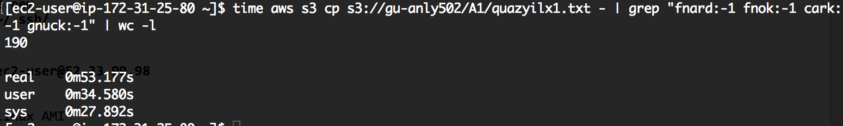

# streaming to a t2.large

date: 2016-02-04T10:10:10 # Date, in ISO-8601 time

mode: streaming

streaming: 53

malfunctions: 190

Q6