HW1

Yuan-Yao Chang

Introduction

This Web-based report includes the official federal statistics on cancer incidence from registries that have high-quality data and cancer mortality statistics for each year and 2010–2014 combined. It is produced by the Centers for Disease Control and Prevention (CDC) and the National Cancer Institute (NCI).

Questions

* What State own the most cancer sited count?
* In the State I live in, how is the cancer sites count between different perspective?

Visualization

1. Using Tableau to plot the US cancer statistic on US map, knowing the cancer focus in the state of California on the west; while cancer is more scatter on the east coast. Would like to know the actual rank of the Cancer case in the States, so I come up with a bar chart with the sorted States and Count.

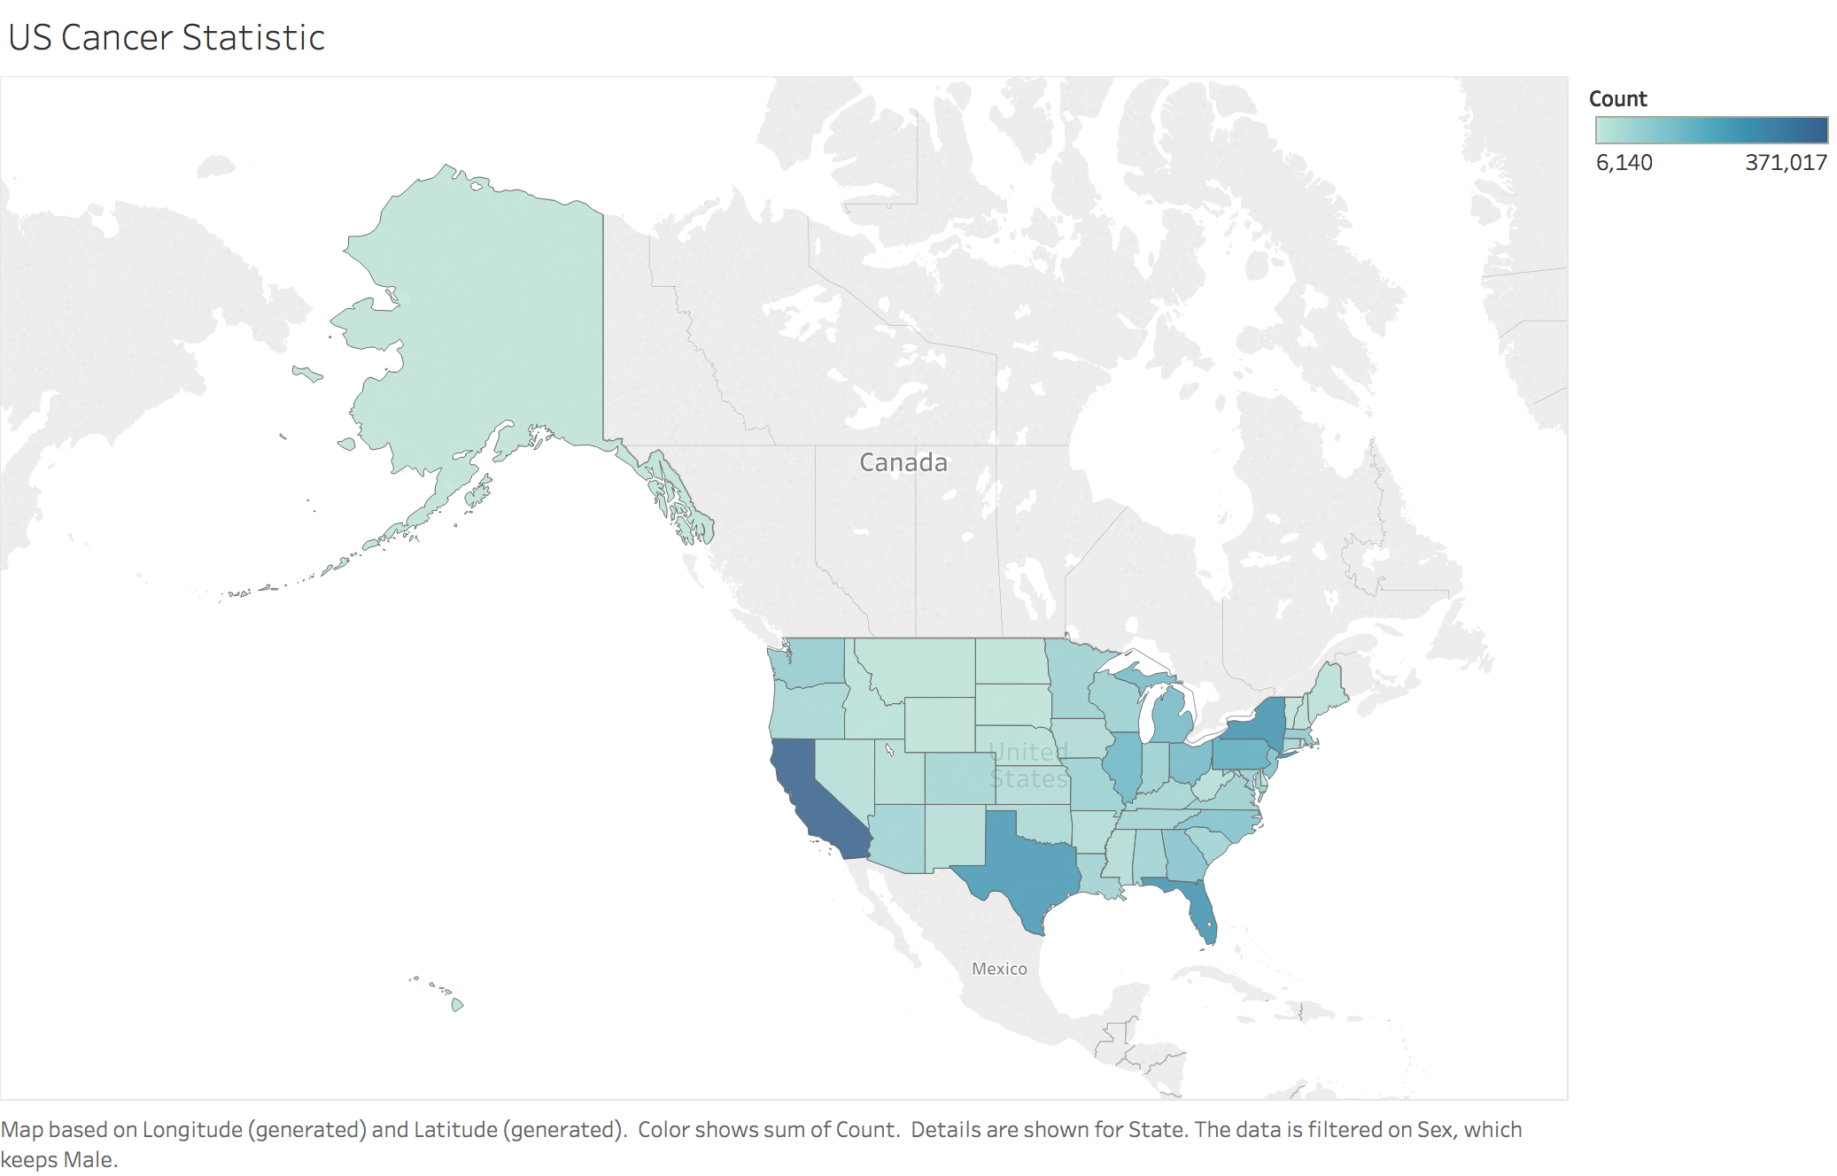

1. US Cancer Count using Bar Graph

Turn out that California is at the first place way high than the second and third place New York and Florida. While DC is at the tail of this chart.

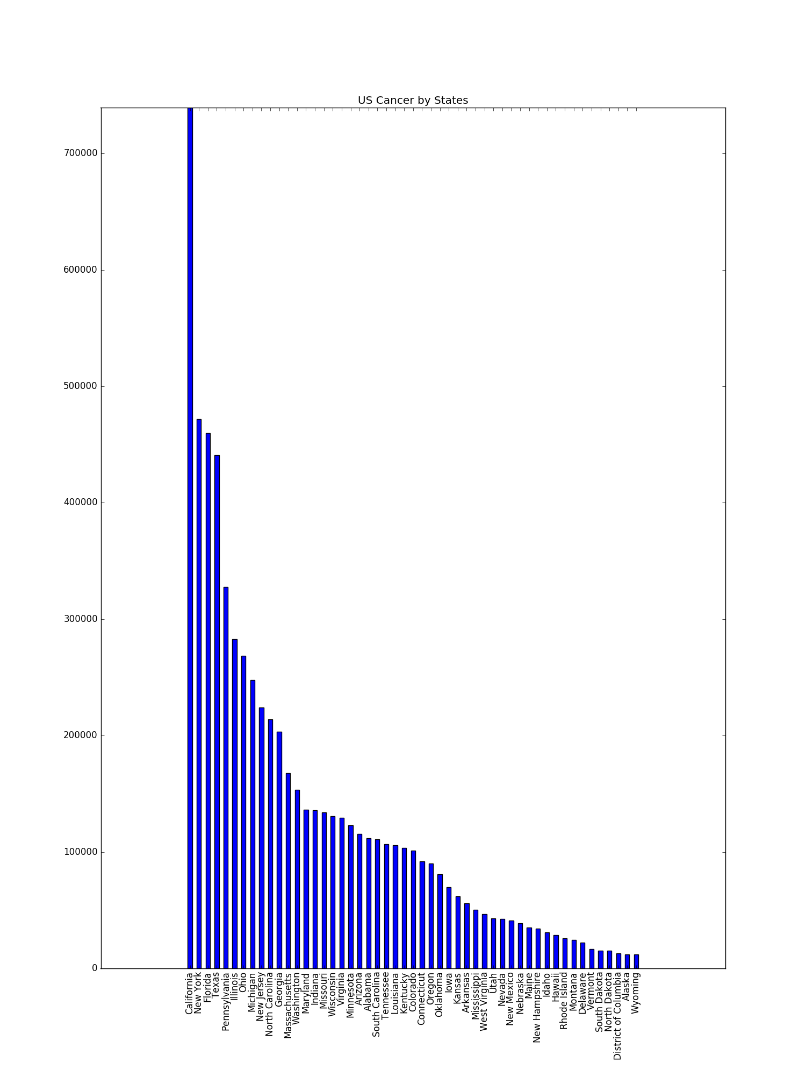

1. Cancer Type in US

This bar graph indicates that Breast and Prostate and the most usual sites can spot cancer occurrence. And I want to do further research on DC’s data.

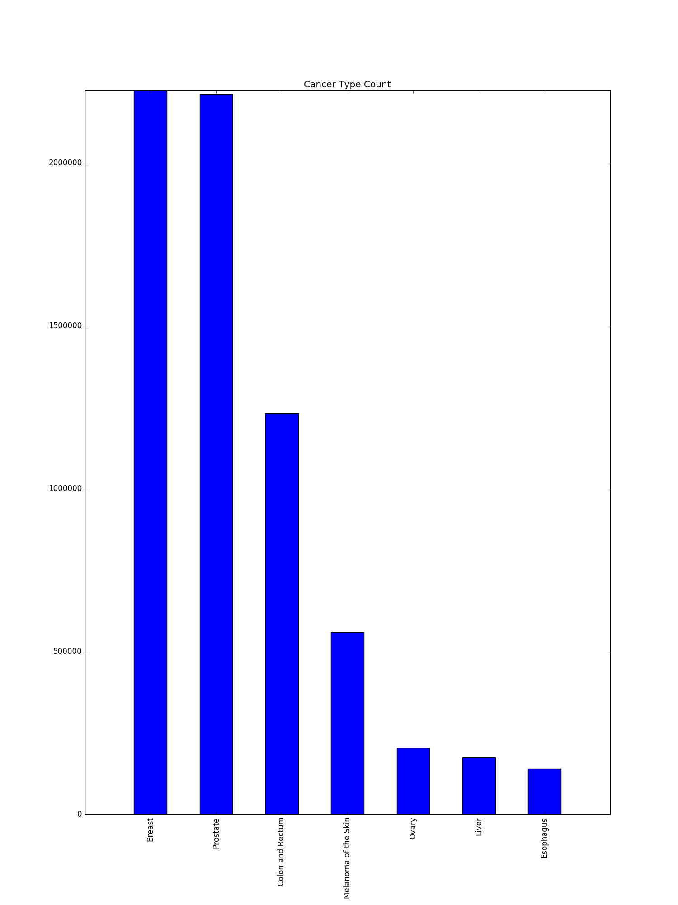

1. Cancer Type in DC

The pie chart shows that the top three cancer sites takes over 90% of the total possible sites. Surprisingly, the DC’s fourth place is Liver while liver in the national’s statistic at the second-last. Indicating, people in DC should take care of liver more careful than the other states.

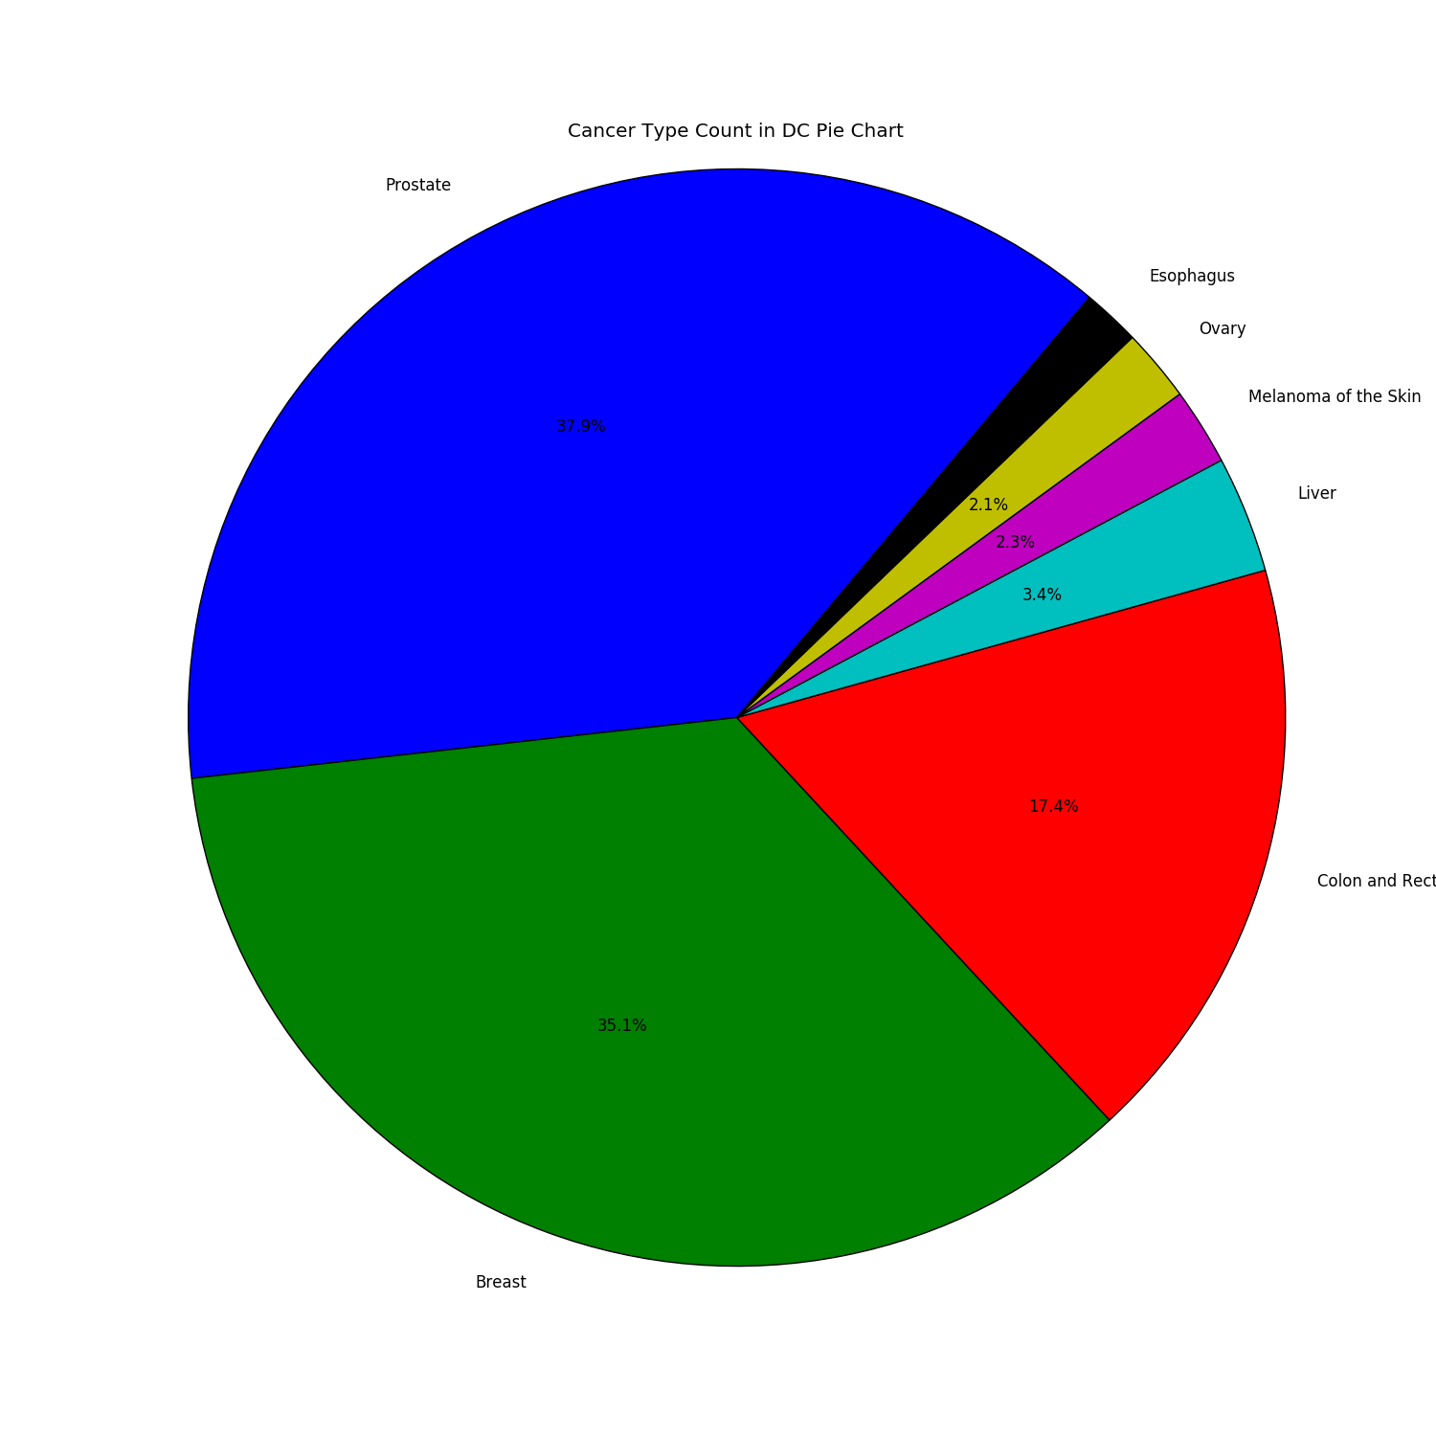

5.

This graph show that the White and Black or African American takes over most of the population (or the survey). While the first and second place cancer sites happen to be the same, but in the African American cancer sites colon and rectum holds greater amount than the other races. The African American’s ranking of cancer sites is identical to the state statistic while the white population owns more sites on Melanoma and Skin then the states rank.

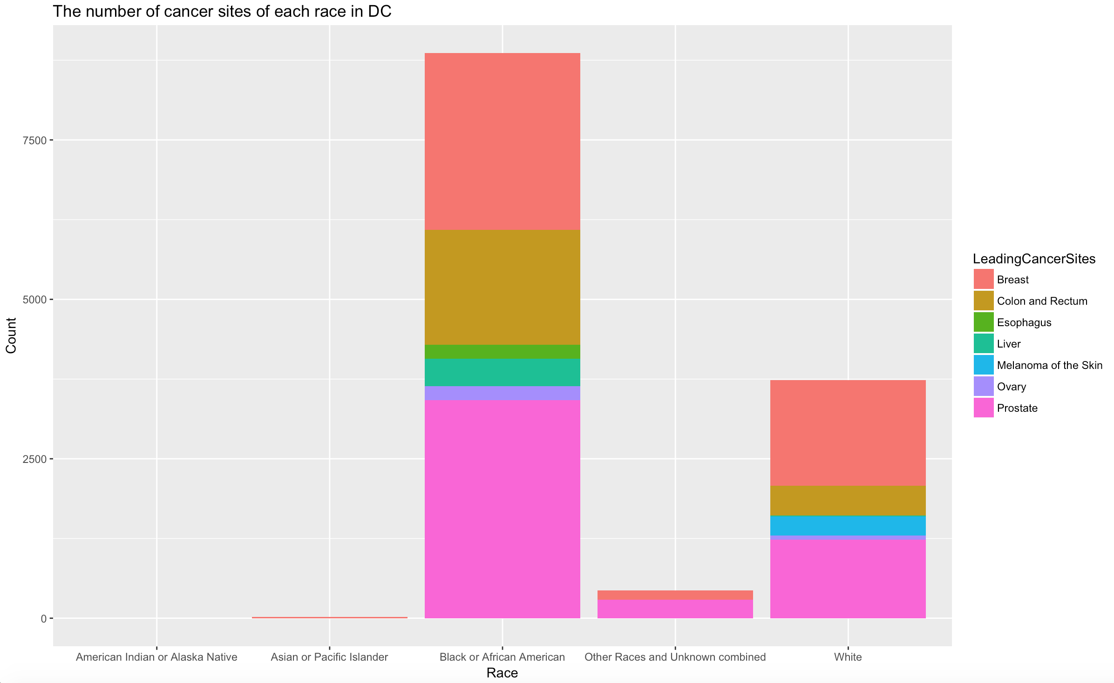

6.

For further research on the different races, I selected White population and separate different cancer sites while showing two genders in the bar. Ignoring the cancer that only occur on particular gender. The finding that the majority of the melanoma and skin cancer stands out most of them are male. And the male takes over entire counts of liver cancer.

