library(ggplot2)  
library(reshape2)  
library(ggthemes)  
require(gridExtra)

## Loading required package: gridExtra

#set new label  
new_label <- c("Date", "Mean_Rate", "Mean_Score", "Group_Size", "Group_Label")  
data = read.csv('STK_Data_Gates_2017.csv')  
names(data) <- new_label  
#Date  
new_Date_format<-as.Date((data$Date),"%m/%d/%Y")  
data$Date <-strftime(new_Date_format,"%m/%d")  
#stats 5 summary  
print(summary(data))

## Date Mean_Rate Mean_Score Group_Size   
## Length:21 Min. :10.78 Min. :2.430 Min. : 80   
## Class :character 1st Qu.:13.53 1st Qu.:2.600 1st Qu.:122   
## Mode :character Median :15.00 Median :2.690 Median :171   
## Mean :15.56 Mean :2.691 Mean :155   
## 3rd Qu.:16.93 3rd Qu.:2.800 3rd Qu.:182   
## Max. :20.69 Max. :2.970 Max. :213   
## Group_Label  
## A:7   
## B:7   
## C:7   
##   
##   
##

11

#different groups  
  
g1<-ggplot(data, aes(Mean_Rate,Mean_Score,color = Group_Label,size = Group_Size)) + geom_point() + theme_solarized() +  
scale_color_solarized() + ggtitle("Mean_Rate and Mean_Score with Group_Size and Group_Label") + facet_grid(. ~ Group_Label) + theme(legend.position="none")  
g2<-ggplot(data, aes(Mean_Rate,Mean_Score,color = Group_Label,size = Group_Size)) + geom_point() + theme_solarized() +  
scale_color_solarized()   
grid.arrange(g1,g2,nrow=2,ncol=1)

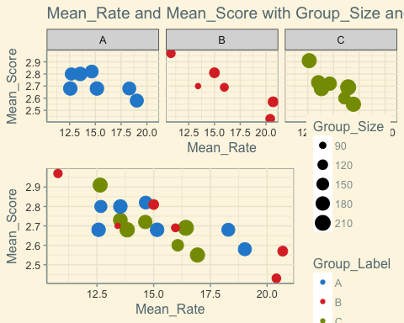

ggplot(data, aes(Group_Label,Group_Size,color=Group_Label)) + geom_point() + theme_solarized_2(light = FALSE) + ggtitle("Group_Label with Group_Size")

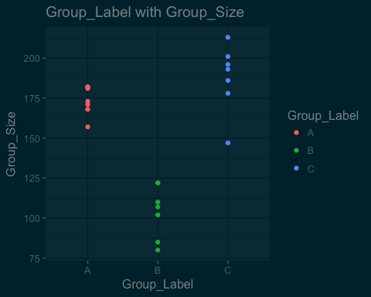 22

#subplots  
  
#boxplot  
g1<-ggplot(data, aes(Group_Label,Mean_Score,color = Group_Label)) + geom_boxplot() + theme_solarized_2(light = FALSE) + ggtitle("Mean_Score and Mean_Rate with Group_Label")  
g2<-ggplot(data, aes(Group_Label,Mean_Rate,color = Group_Label)) + geom_boxplot() + theme_solarized_2(light = FALSE)   
grid.arrange(g1,g2,nrow=2,ncol=1)

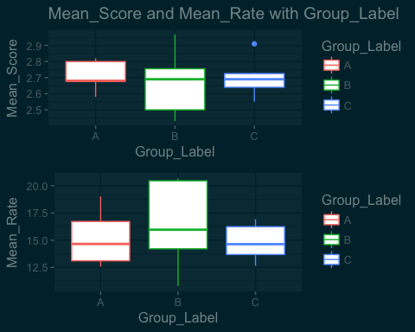

g1<-ggplot(data, aes(Group_Size,Mean_Score,color = Group_Label)) + geom_point() + theme_solarized_2(light = FALSE) + ggtitle("Mean_Score and Mean_Rate with Group_Size")  
g2<-ggplot(data, aes(Group_Size,Mean_Rate,color = Group_Label)) + geom_point() + theme_solarized_2(light = FALSE)   
grid.arrange(g1,g2,nrow=2,ncol=1)

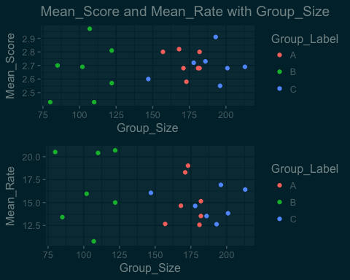

#subplot & timeline  
g1<-ggplot(data, aes(Date,Mean_Rate,group=1)) + geom_line(color = 'red') + geom_smooth(method = 'loess') + scale_fill_ptol() +  
 theme_minimal() + theme(axis.text.x= element_text(angle = 65, vjust = 0.7)) + ggtitle("Mean_Score and Mean_Rate with Date")  
g2<-ggplot(data, aes(Date,Mean_Score,group=1)) + geom_line(color = 'red') + geom_smooth(method = 'loess') + scale_fill_ptol() +  
 theme_minimal() + theme(axis.text.x= element_text(angle = 65, vjust = 0.7))  
grid.arrange(g1,g2,nrow=2,ncol=1)

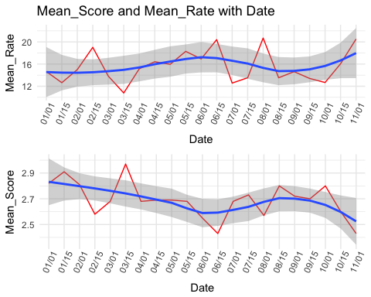

#timeline   
g1 <- ggplot(data, aes(Date,Mean_Rate,group = Group_Label,color = Group_Label)) + geom_point() + geom_line() + scale_x_discrete(limits= data$Date) + scale_fill_ptol() + theme_minimal() + theme(axis.text.x= element_text(angle = 65, vjust = 0.7)) + ggtitle("Mean_Score and Mean_Rate with Date seperated by Group")  
g2 <- ggplot(data, aes(Date,Mean_Score,group = Group_Label,color = Group_Label)) + geom_point() + geom_line() + scale_x_discrete(limits= data$Date) + scale_fill_ptol() + theme_minimal() + theme(axis.text.x= element_text(angle = 65, vjust = 0.7))   
grid.arrange(g1,g2,nrow=2,ncol=1)

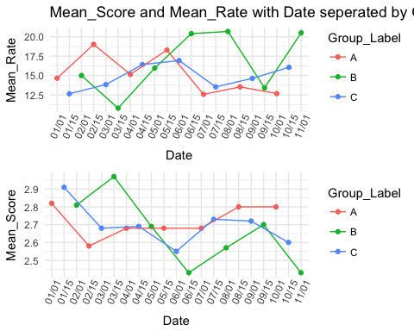

g1 <- ggplot(data, aes(Date,Group_Label,color = Group_Label,group =1)) + geom_point() + geom_step() + scale_x_discrete(limits= data$Date) + scale_fill_ptol() + theme_minimal() + theme(axis.text.x= element_text(angle = 65, vjust = 0.7)) + ggtitle("Group_Label and Group_Size with Date seperated by Group")  
g2 <- ggplot(data, aes(Date,Group_Size,group = Group_Label,color = Group_Label)) + geom_point() + geom_line() + scale_x_discrete(limits= data$Date) + scale_fill_ptol() + theme_minimal() + theme(axis.text.x= element_text(angle = 65, vjust = 0.7))   
grid.arrange(g1,g2,nrow=2,ncol=1)

