HW8 Part1

*Yuan-Yao Chang(yc704) 11/1/2017*

DataSet:

The dataset base on the CS department’s course list, with 22 nodes and 30 edges.

1. **Four networks using different layouts**

The subplot using four different kinds of layout methods, including Circle, Sphere, Star and Fruchterman-Reingold layout. The Sphere and the Circle layout seems not appropriate to the dataset, because the dataset owns several center node with more input and output; showing by circle and star will lost focus on the center nodes.

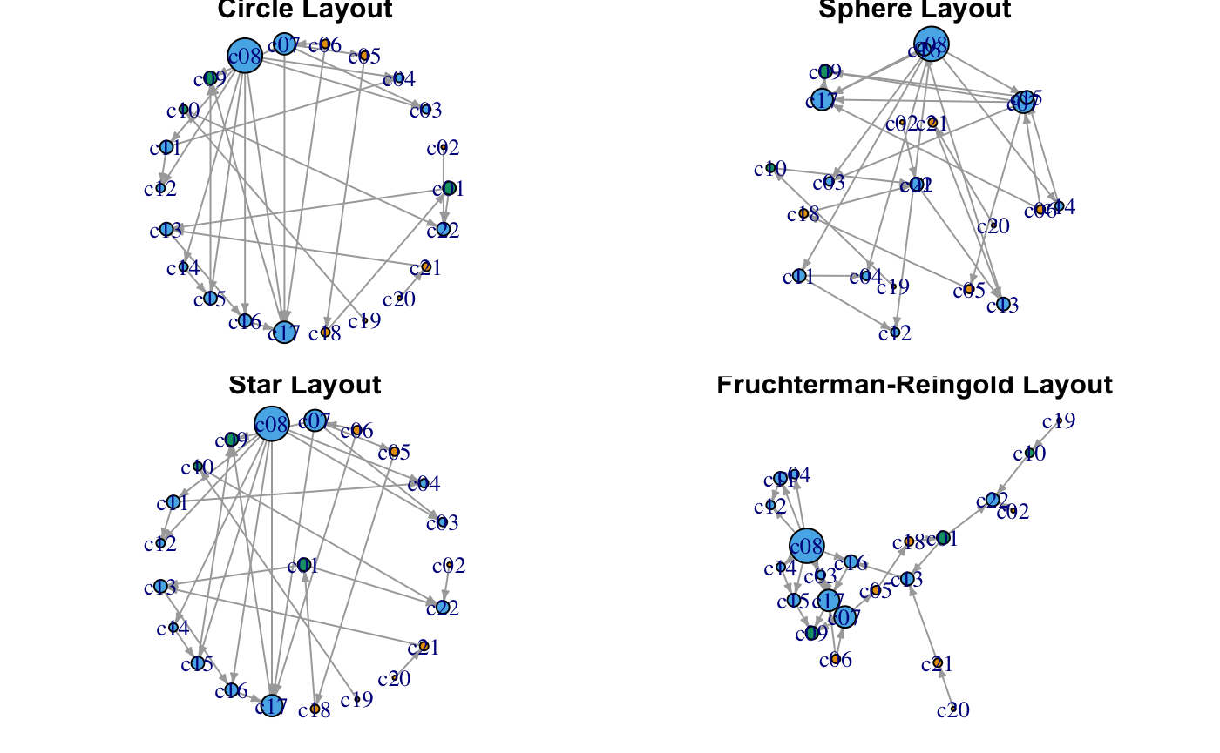

1. **Heat map plot**

Heat map plot is base on weight of the edges, the more dense color the higher the weight is. We can see there is one or two course have a significant higher weight.

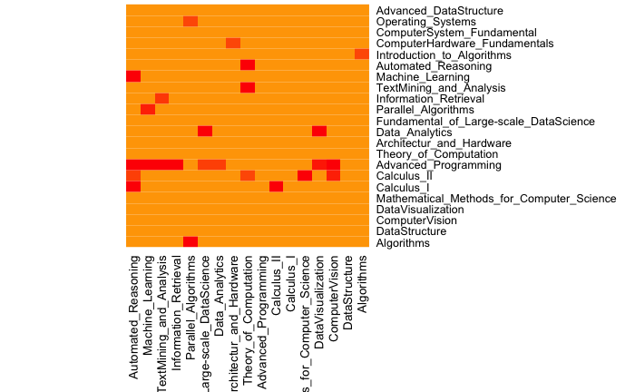

1. **Network colored by community**

As we can see, the graph is colored by two communities. Group B is a larger community highlighted as green and a smaller Group A community highlighted as orange; while the lengend is labeled at the bottom left corner.

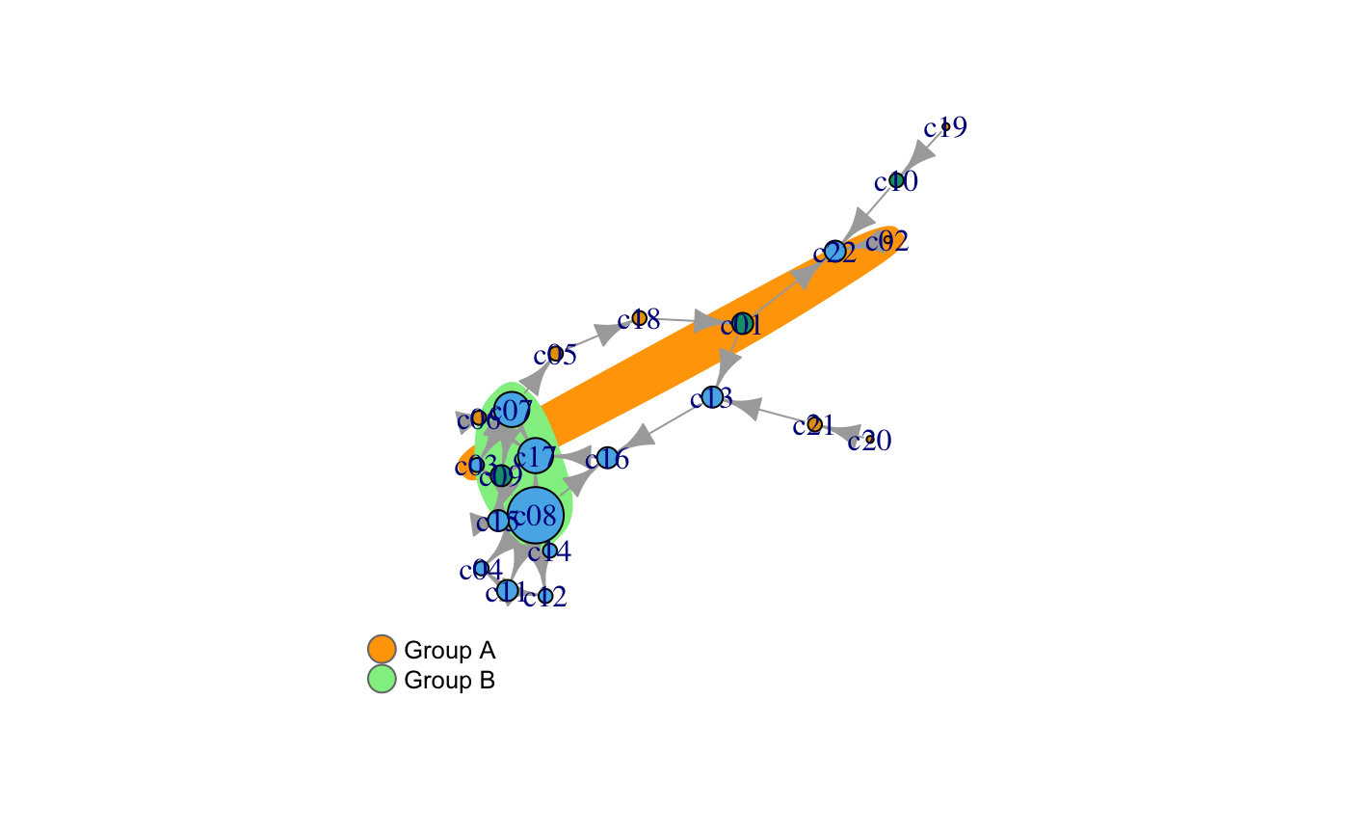

**4)tkplot**

This is an interactive graph created by tkplot, which is very limited. The graph nodes can be moved showing the entire picture fo the dataset.

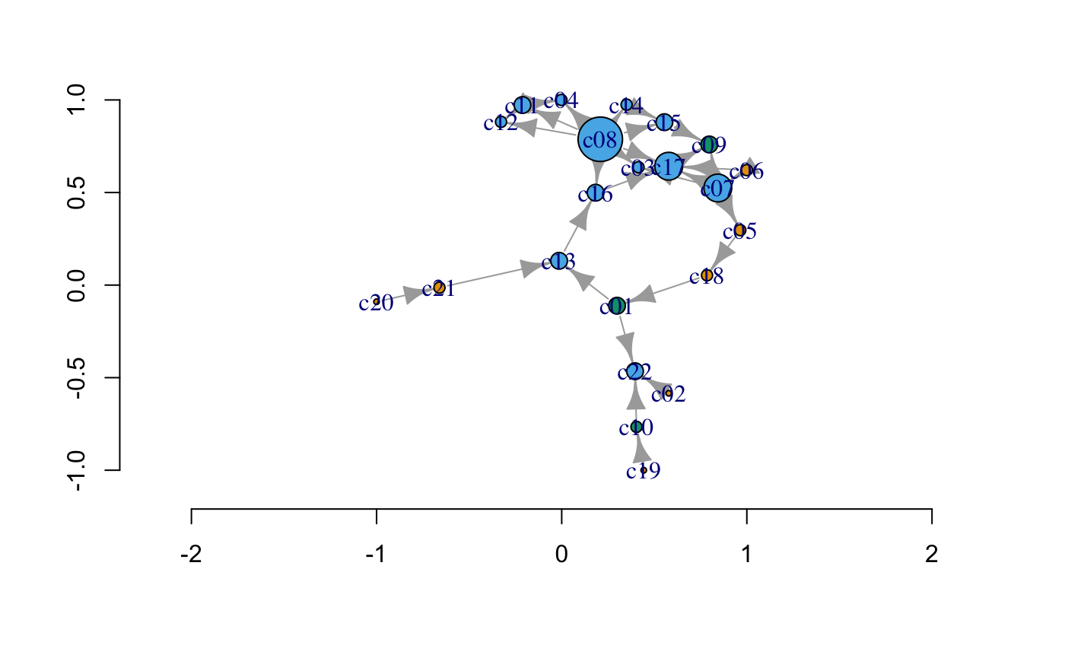

**5)Reference:**

c01,Algorithms

c02,DataStructure

c03,ComputerVision

c04,DataVisualization

c05,Mathematical_Methods_for_Computer_Science

c06,Calculus_I

c07,Calculus_II

c08,Advanced_Programming

c09,Theory_of_Computation

c10,Architectur_and_Hardware

c11,Data_Analytics

c12,Fundamental_of_Large-scale_DataScience

c13,Parallel_Algorithms

c14,Information_Retrieval

c15,TextMining_and_Analysis

c16,Machine_Learning

c17,Automated_Reasoning

c18,Introduction_to_Algorithms

c19,ComputerHardware_Fundamentals

c20,ComputerSystem_Fundamental

c21,Operating_Systems

c22,Advanced_DataStructure