HW8 Part2

*Yuan-Yao Chang(yc704) 11/1/2017*

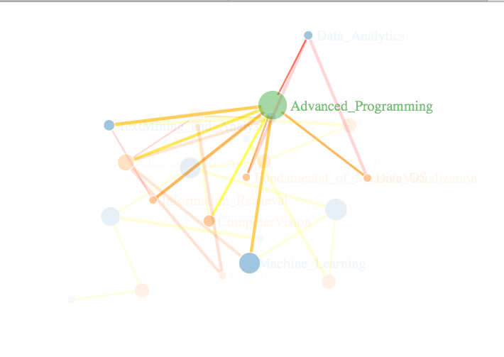

The screenshot is a D3 interactive network graph using R’s NetworkD3. The data set is identical to the part1’s data set, because of the interactive and the highly customizable graph I use the actual name of the class to show on the graph instead of the ids. We can see the connection between courses and different level of the dependency. Also we can identify the courses which is relatively necessary than the other courses.

URL:

<http://stevenyychang.georgetown.domains/HWs/D3_Part2.html>