Let It Go

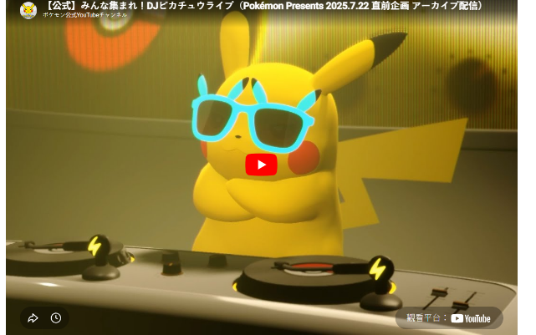 | The snow glows white on the mountain tonight  Not a footprint to be seen  A kingdom of isolation and it looks like I’m the queen  The wind is howling like this swirling storm inside  Couldn’t keep it in, heaven knows I tried

