HUNTR

Nothing but the truth now 此刻我只說真話
Nothing but the proof of what I am 只剩我真實存在的證明
The worst of what I came from, patterns I’m ashamed of 那些我來自的黑暗、令我羞愧的循環
Things that even I don’t understand 甚至連我自己都無法理解的事
I tried to fix it, I tried to fight it 我努力修補，也試圖抗拒
My head was twisted, my heart divided 我的腦袋混亂，內心分裂
My lies all collided 我的謊言全都撞在一起
I don’t know why I didn’t trust you to be on my side 我不知道為何不相信你會站在我這邊

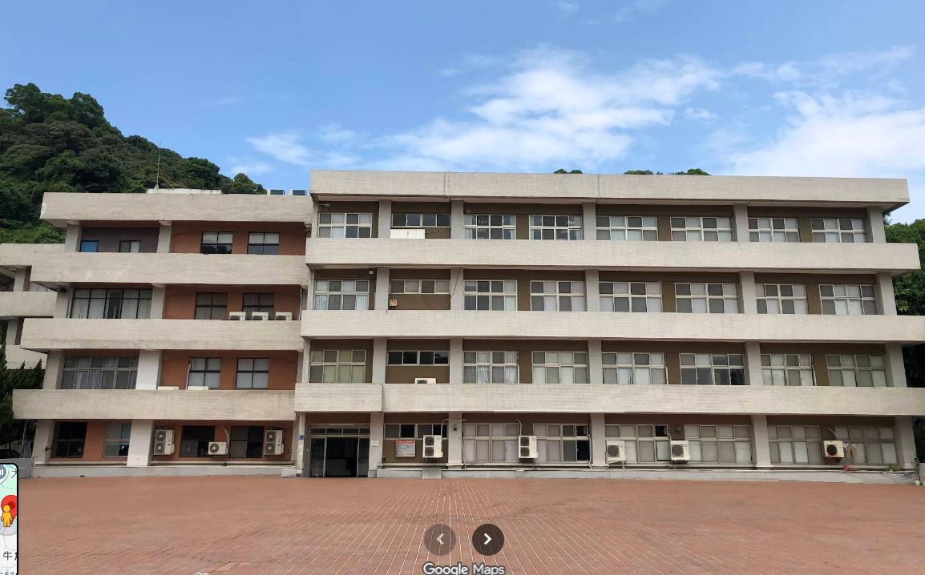 | 勞動部勞動力發展署北基宜花金馬分署泰山職業訓練場

