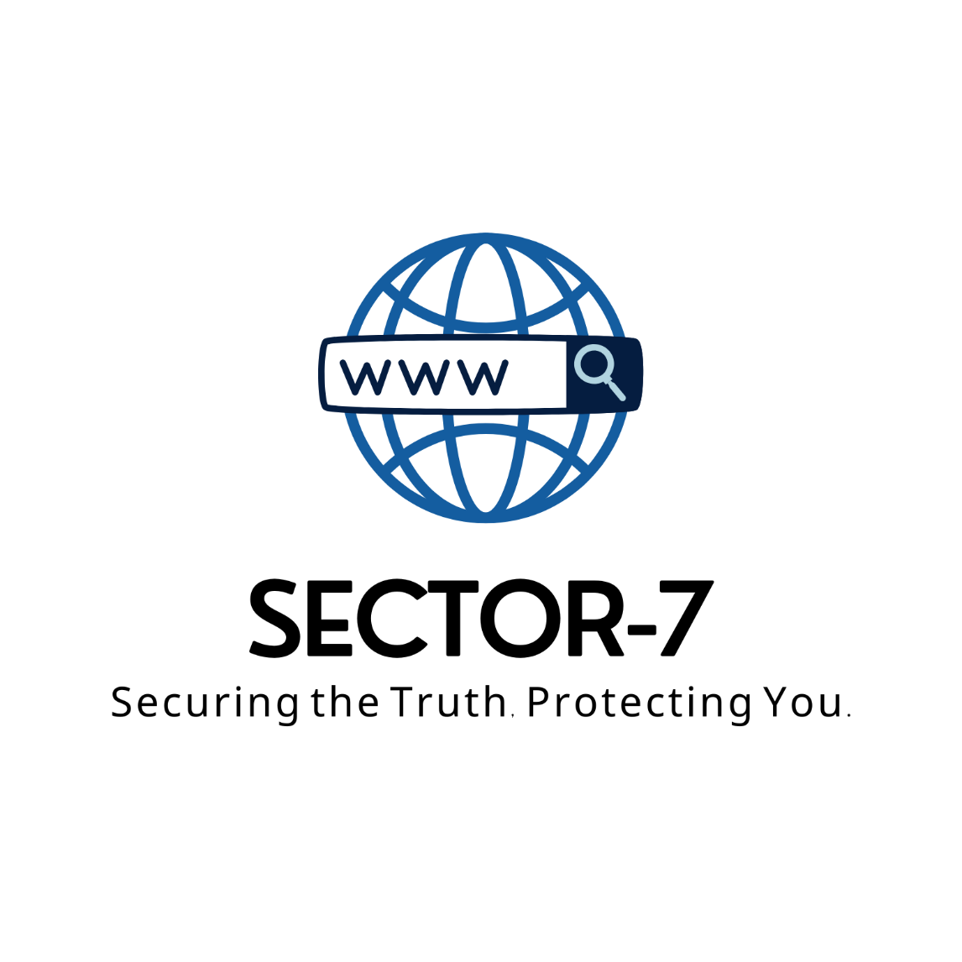

Sector-7 Whistleblowing Platform Security Guidelines
Version: 1.0
Date: March 28, 2025
Classification: PUBLIC

Table of Contents
- Introduction
- Guidelines for Submitting Reports
- Data Handling and Privacy
- Incident Response Guidelines
- How to Stay Anonymous
- Policy Enforcement and Training
- Conclusion
- Appendices

1. Introduction
Overview:
Sector-7 is committed to maintaining the highest standards of security, confidentiality, and transparency for anyone reporting unethical or illegal practices. Our whistleblowing platform ensures that all submissions are handled with robust data protection and clear incident response procedures.
Purpose:
This document outlines the security guidelines governing the submission of reports, the management and privacy of collected data, incident response protocols (both internal and external), and best practices for maintaining anonymity when reporting.
Scope & Audience:
These guidelines apply to all employees, contractors, and external stakeholders using the Sector-7 platform. The document is intended for both reporting users and internal teams responsible for managing and investigating reports.

2. Guidelines for Submitting Reports
Overview
Reporting misconduct promptly and securely is essential for a transparent and ethical environment. Sector-7 provides secure channels that ensure reports remain confidential and are processed promptly.
Reporting Channels
- Secure Web Portal: Use our encrypted online submission form.
- Secure Email: Email reports to using PGP encryption.
Steps for Submitting a Report
- Access the Platform: Log in to your account using multi-factor authentication.
- Complete the Reporting Form: Provide a detailed description of the incident, including date, time, location, and any supporting evidence.
- Choose Reporting Mode: Select whether to report anonymously or with your identity attached.
- Submit Securely: Confirm submission and receive a unique tracking number.

Best Practices
- Double-Check Your Details: Ensure all information is accurate before submission.
- Use Encrypted Channels: Always use the designated secure options to avoid data leaks.
- Report Timely: Report as soon as you become aware of any potential wrongdoing.
Frequently Asked Questions
- Q: How is my identity protected?
A: Reports can be submitted anonymously, and even if you choose to disclose your identity, strict confidentiality measures are in place.
- Q: Can I attach documents securely?
A: Yes, the portal supports encrypted file uploads.

3. Data Handling and Privacy
Overview
Sector-7 is committed to safeguarding all data provided by whistleblowers. We adhere to global data protection standards (including GDPR and ISO 27001) to ensure the confidentiality, integrity, and availability of sensitive information.
Data Collection
- What We Collect: Personal identifiers (if provided), incident details, and any attached evidence.
- Purpose: To verify and investigate the reported misconduct while protecting the rights of all involved.
Data Storage & Encryption
- Storage: All data is stored on secure, encrypted servers.
- Encryption: Data is encrypted at rest and in transit using industry-standard protocols.
Access Control
- Restricted Access: Only authorized personnel with a need-to-know basis may access the data.
- Audit Trails: All data access is logged and periodically reviewed.
Data Retention and Disposal
- Retention Period: Data is retained only as long as necessary to complete investigations and meet legal requirements.
- Secure Deletion: Once data is no longer required, it is securely deleted using certified deletion protocols.
Compliance & Audits
- Regular Audits: Conducted internally and by third parties to ensure compliance with data protection laws.
- Incident Reviews: Data handling processes are reviewed regularly to improve our security posture.

4. Incident Response Guidelines
Overview
Sector-7 maintains robust protocols to address security incidents. Whether the incident is internal (affecting our systems) or external (related to a whistleblower submission), swift and effective measures are in place.
Incident Identification
- Detection Tools: Automated monitoring systems alert our security team to any anomalous activities.
- Reporting Channels: Users are encouraged to report suspected incidents via the secure channels provided.
Response Procedures
- Initial Assessment: The security team verifies the incident and assesses its severity.
- Containment: Immediate actions are taken to isolate affected systems and prevent further data loss.
- Investigation: A thorough investigation is conducted to determine the root cause and scope of the breach.
- Remediation: Steps are implemented to mitigate damage and restore normal operations.
- Documentation: Every step is logged in an incident response report for accountability and future reference.
Internal vs. External Incidents
- Internal Incidents: Handled by our dedicated IT and cybersecurity teams with strict internal controls.
- External Incidents: Coordinated with law enforcement and regulatory bodies as necessary, with clear communication protocols for stakeholders.
Communication Plan
- Internal Notifications: Immediate alerts are sent to key personnel.
- External Communication: A predefined statement is released if necessary, ensuring sensitive details remain confidential.
Post-Incident Analysis
- Lessons Learned: A review meeting is conducted to analyse the incident and update policies accordingly.
- Preventative Measures: Recommendations for improved security practices are implemented to prevent recurrence.

5. How to Stay Anonymous
Overview
Maintaining anonymity is critical to protect the identity of whistleblowers. Sector-7 employs both technological and procedural safeguards to ensure users can report without fear.
Tools & Technologies
- VPNs & Tor: Users are encouraged to use a VPN or access the platform via the Tor network for additional anonymity.
- Encrypted Communications: All data exchanges are secured with end-to-end encryption.
- Secure Browsers: We recommend using privacy-focused browsers (e.g., Firefox with privacy add-ons).
Best Practices for Anonymity
- Avoid Personal Identifiers: When possible, do not include personally identifying details in your report.
- Use Pseudonyms: Choose an alias when submitting reports if you prefer to remain anonymous.
- Secure Your Devices: Ensure your device is updated with the latest security patches and antivirus software.
- Separate Accounts: Use a separate, anonymous email or account solely for whistleblowing purposes.
Platform Features
- Anonymous Submission Option: Our platform allows you to choose complete anonymity.
- Encryption & Masking: All submitted data is encrypted, and metadata that could reveal your identity is automatically stripped.
- User Guidance: Step-by-step instructions are provided on how to maximize anonymity while using the platform.

6. Policy Enforcement and Training
Overview
To ensure adherence to these guidelines, Sector-7 implements strict enforcement measures and ongoing training for all personnel.
Roles & Responsibilities
- Data Protection Officer (DPO): Oversees all aspects of data security and privacy.
- Incident Response Team: Responsible for managing and resolving security incidents.
- Compliance Team: Ensures all processes meet regulatory standards.
Training Programs
- Regular Security Training: All employees undergo periodic training on data security and incident response.
- Whistleblowing Workshops: Specialized sessions to educate users on how to report securely and maintain anonymity.
- Policy Updates: Updates are communicated promptly to ensure everyone is aware of new protocols or changes.
Consequences for Non-Compliance
- Internal Disciplinary Action: Violations of these guidelines may result in disciplinary action, up to and including termination.
- Legal Repercussions: Breaches may also lead to legal consequences under relevant data protection laws.

7. Conclusion
Sector-7 remains committed to fostering a secure, transparent, and ethical environment. By adhering to these guidelines, we ensure that all whistleblower reports are handled with the utmost care, protecting both the individuals who report misconduct and the integrity of our organization. Future updates will be provided as necessary, and our support team is always available for any inquiries or further assistance.

8. Appendices
Glossary of Terms
- Whistleblowing: The act of reporting unethical or illegal activities within an organization.
- Encryption: The process of encoding information to protect it from unauthorized access.
- VPN: Virtual Private Network, a tool used to secure internet connections.
- DPO: Data Protection Officer, responsible for overseeing data protection strategies.
Legal and Regulatory References
- General Data Protection Regulation (GDPR)
- ISO 27001 Information Security Standard
- Relevant national and local data protection laws
Additional Resources and Templates are available on the Resources page.

