

Framework Based Mobile Application Development
(CSM3114)

LAB REPORT 1

Name : Mohd Isyraf Aiman bin Ibrahim
Matric : S75717
Date : 31/10/2025
Group : K1
Programme : Computer Science(Software Engineering)

Flutter basic Installation and Development

Flutter Configuration
- Describe the steps-by-step process for performing the Flutter configuration?
- Download the Flutter SDK: Download the latest stable Flutter SDK installation bundle (a ZIP file) for the operating system (Windows, macOS, or Linux) that we use from the official Flutter website.
- Extract the SDK: Extract the contents of the ZIP file to a stable, non-temporary location on the computer.
- Update the System PATH: Add the directory path to the flutter/bin folder to the system's environment variables (PATH). This step is crucial, as it allows us to run the flutter command from any terminal window.
- Install/Setup Platform Tools:
- Android: Install Android Studio. During or after installation, ensure the Android SDK, Android SDK Command-line Tools, and Android SDK Build-Tools are installed via the SDK Manager.
- iOS/macOS (on Mac): Install Xcode for developing iOS and macOS apps.
- Install IDE Plugins: Install the Flutter and Dart extensions/plugins to our preferable IDE.
- Run Doctor: Execute the command flutter doctor in our terminal to check for any remaining dependencies or configuration issues.

- Describe the actions required to ensure the Flutter configuration is successfully deployed and setup on your machine.
- Run the Health Check: Execute the command flutter doctor in our terminal. This is the primary diagnostic tool that checks all dependencies.
- Accept Android Licenses: If flutter doctor indicates issues with Android licenses, run command flutter doctor --android-licenses and type y (yes) to accept all agreements.
- Verify PATH Variable: Open a new terminal session and type flutter to ensure the SDK's location is correctly added to the system's environment variables (PATH).
- Test Application Execution: Make a mock_app
- Write a command line to update the Android license when performing health checking on the Flutter configuration.
flutter doctor --android-licenses

2.1 Create the basic Flutter Apps by using Text widget
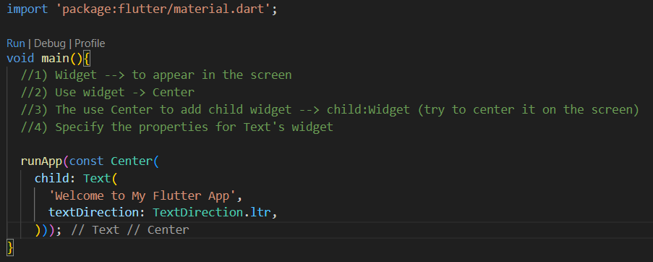
Output:
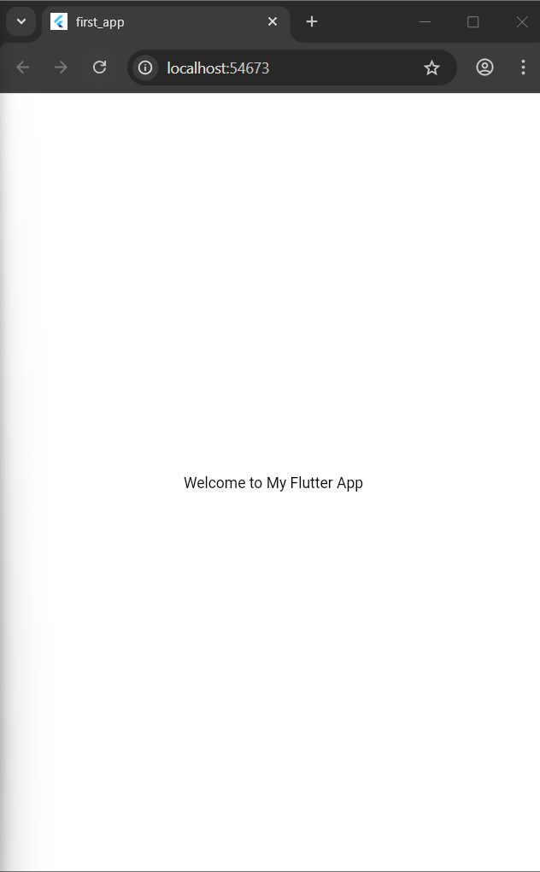

Change the text
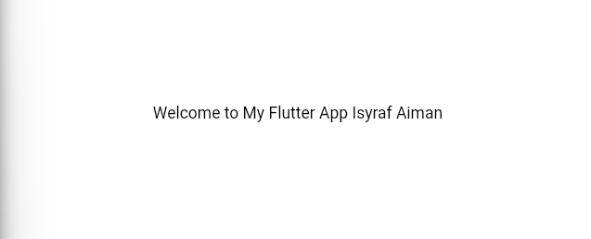
Add style’s properties
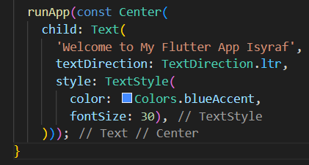
Output:


2.2 Exercise 1
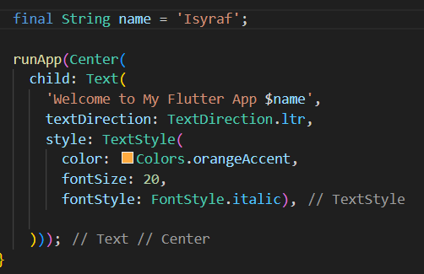
Output:


3.1 Basic Dart Program
1. 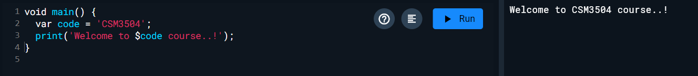
2. 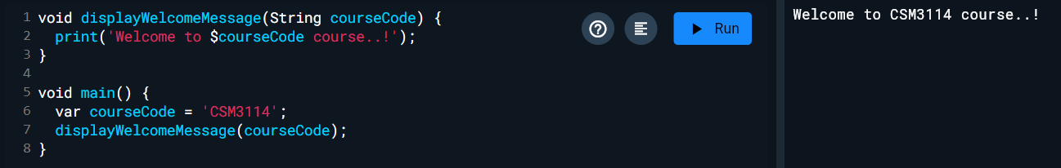
3. 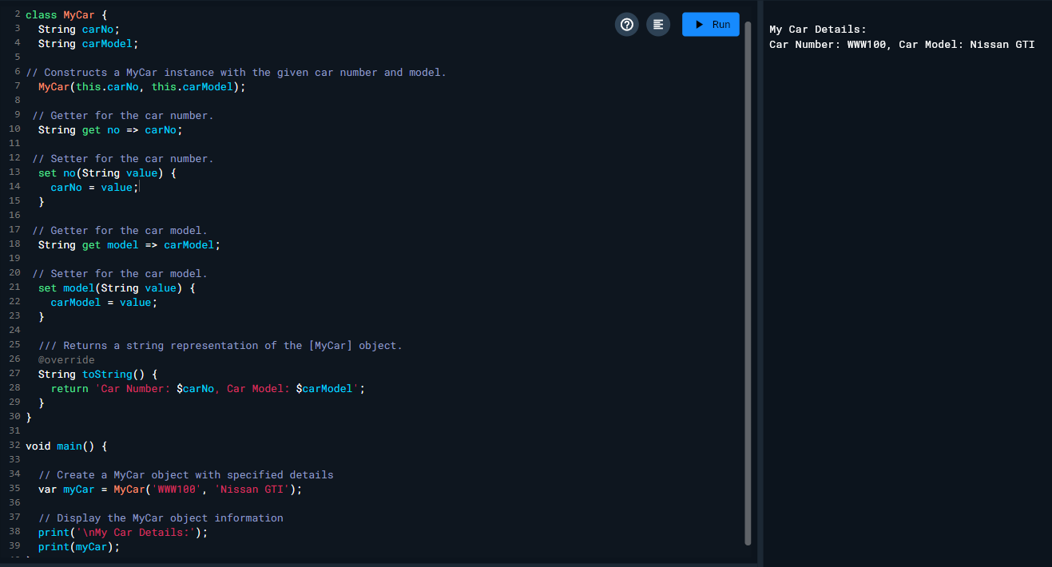

4.2 Implement MaterialApp and Scaffold widgets
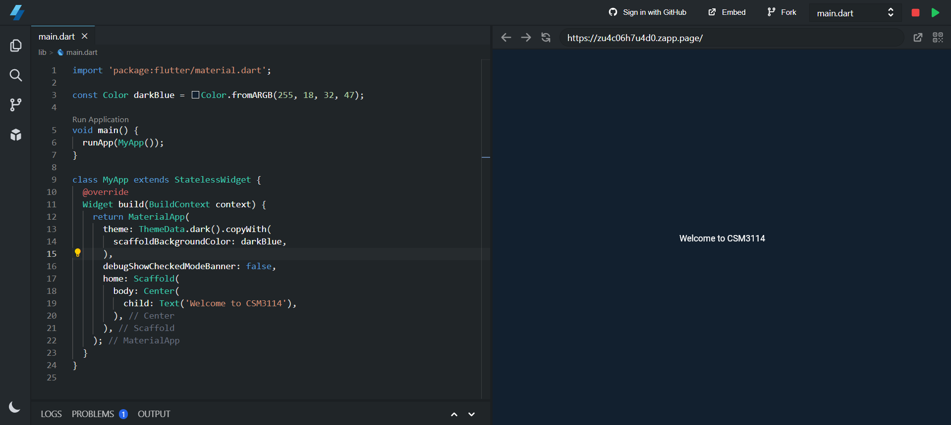
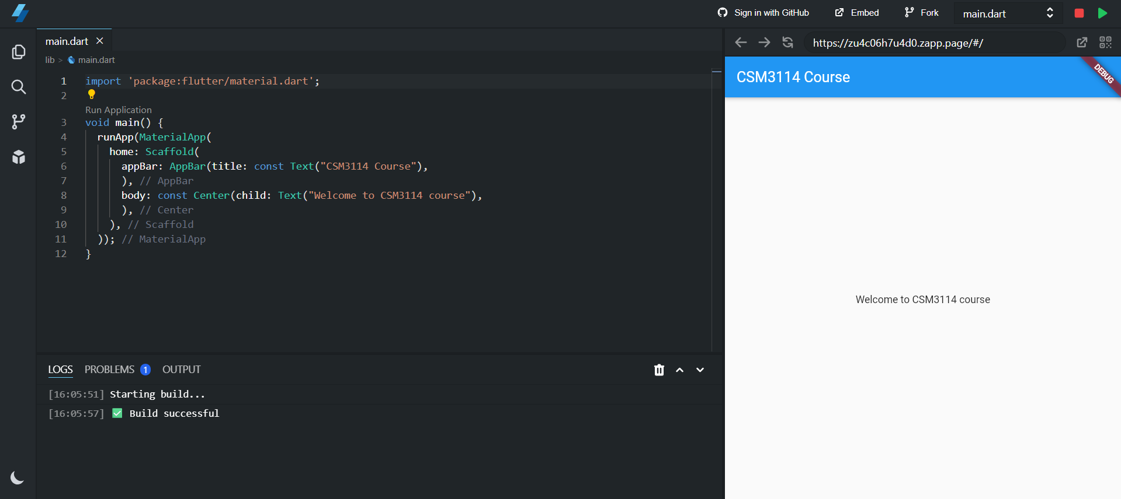
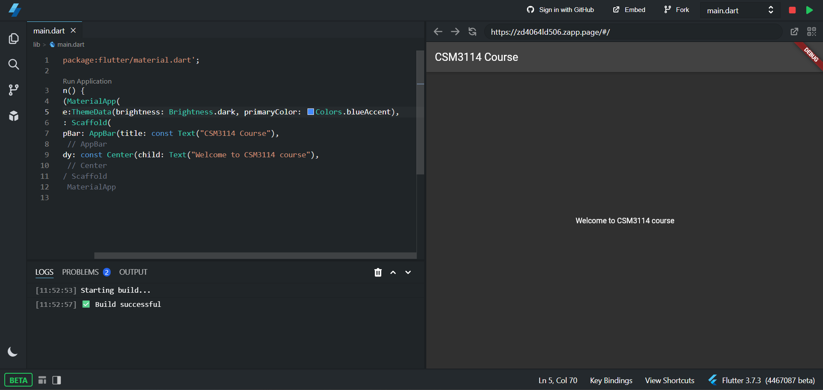
4.3 Exercise 2
