

Framework
(CSM3114)

LAB REPORT 2

Name: Mohd Isyraf Aiman bin Ibrahim
Matric: S75717
Date: 30/10/2025
Group: K1
Programme: Computer Science(Software Engineering)
1 Creating a simple quiz application
1.1 Creating a new application
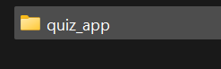
1.2 Adding a Layout Widget for Quiz app
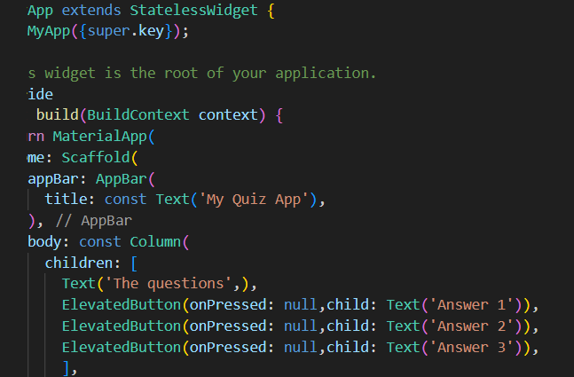
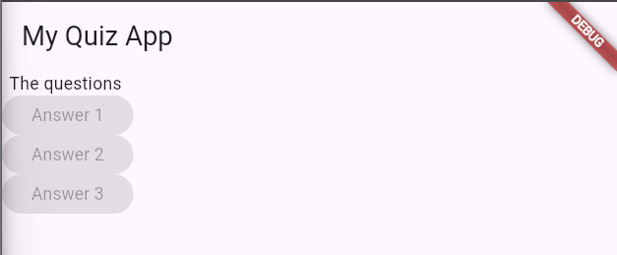

1.3 Exercise: Replace the ElevationButton widget with OutlineButton widget

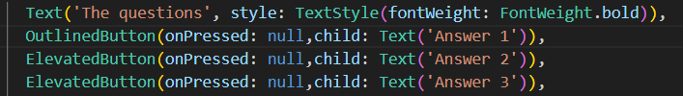
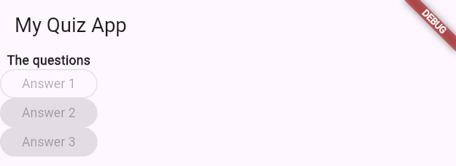

2 The Flutter Official Documentation
2.2 Exploring Text Widget
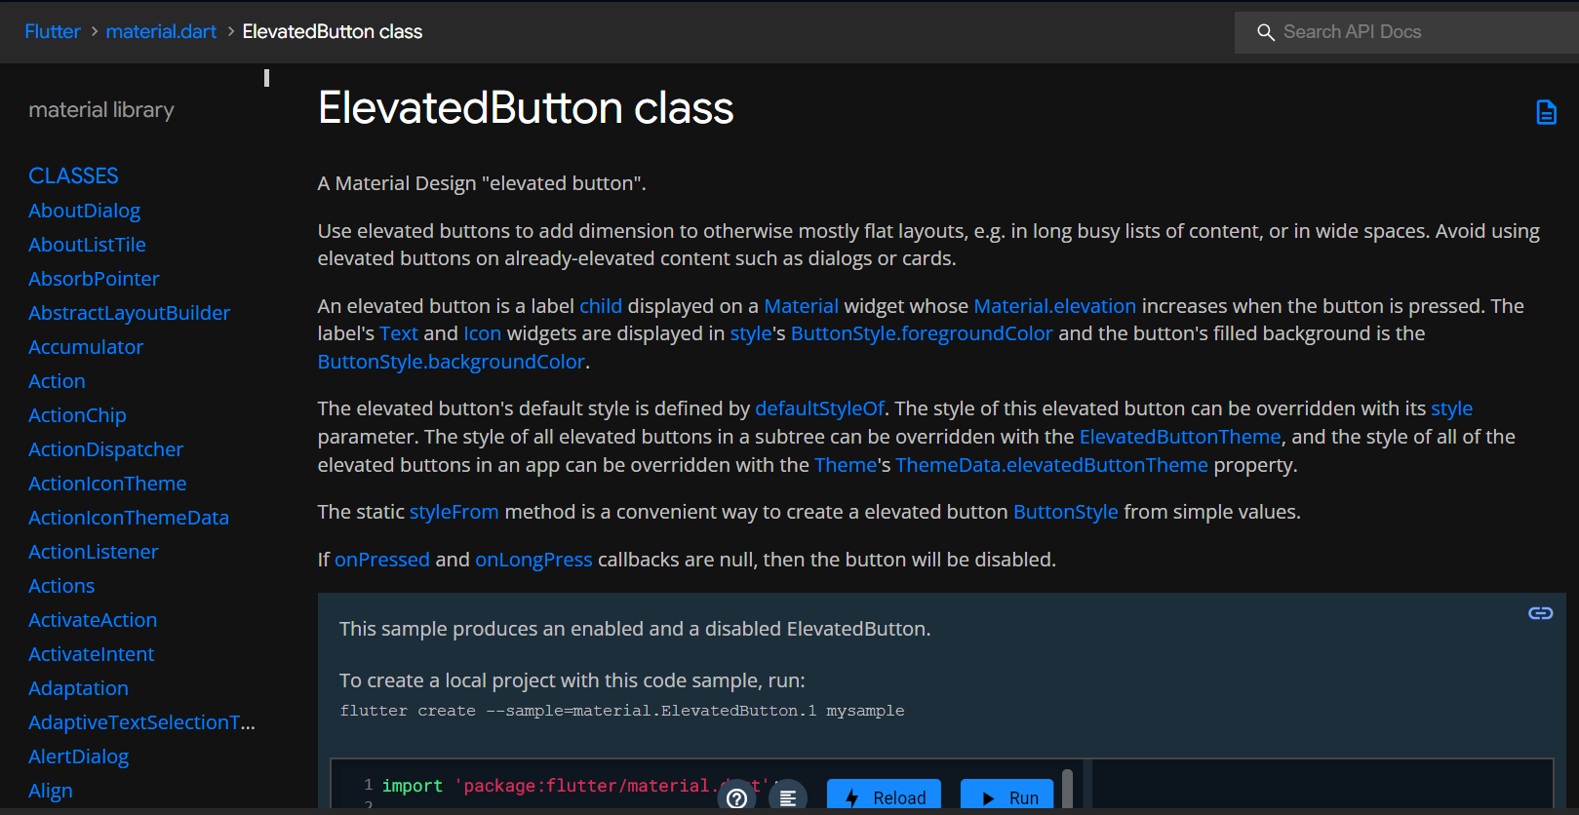
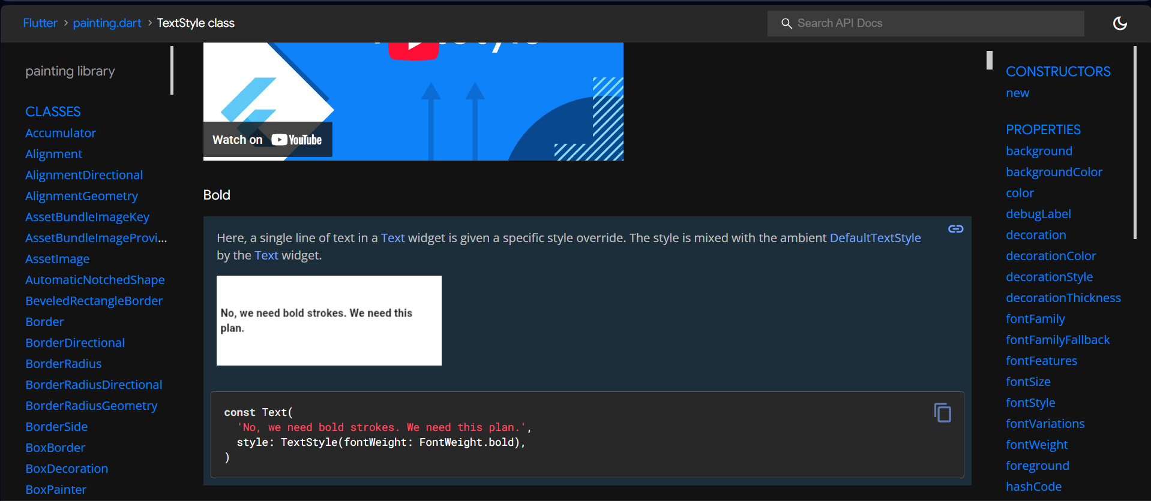
2.2 Exploring Text Widget

3 Passing Callback function
3.1 Creating function and attach to button
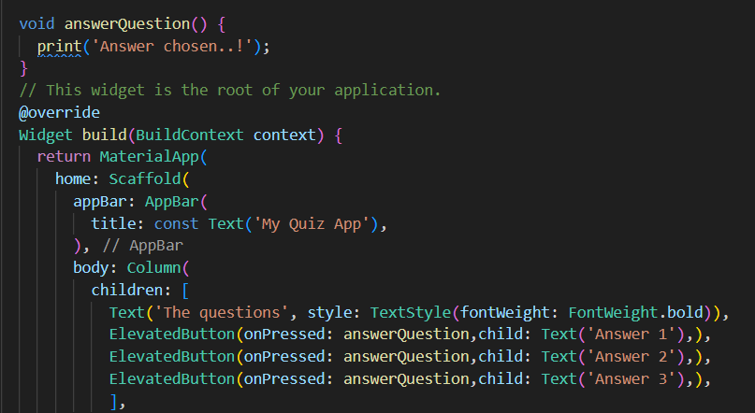
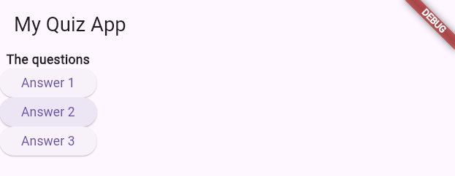
3.2 Using anonymous fuction
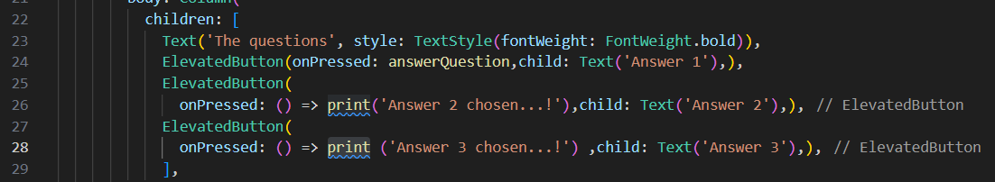
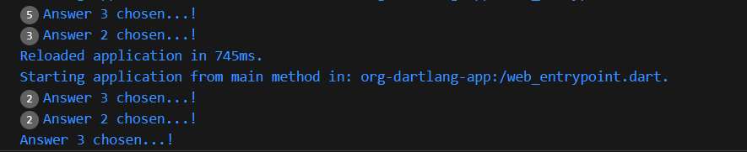
3.3 Updating Widget Data using Stateful Widget
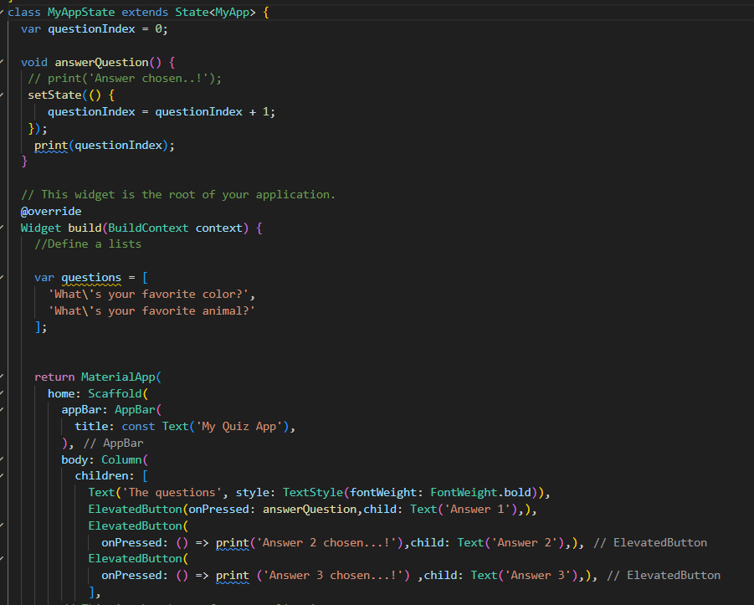
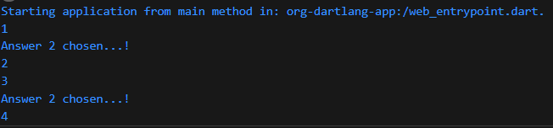

3.4 Exercise
