

Native Programming
(CSM3123)

LAB REPORT 1

Name : Mohd Isyraf Aiman bin Ibrahim
Matric : S75717
Date : 31/11/2025
Group : K1
Programme : Computer Science(Software Engineering)
Task 1
Source : https://github.com/s75717/NativeLab1Task1.git
Output :
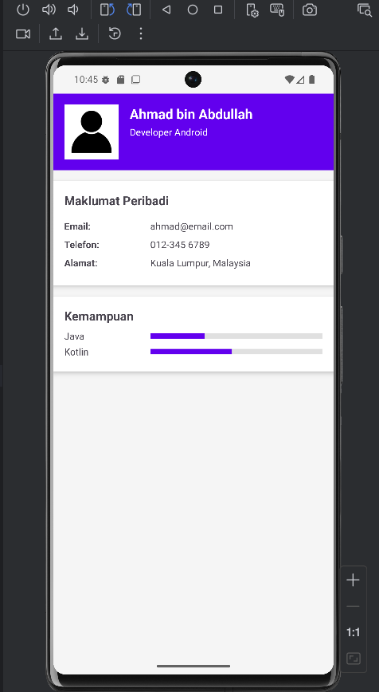

Task2
Source: https://github.com/s75717/NativeLab1Task2.git
Output:
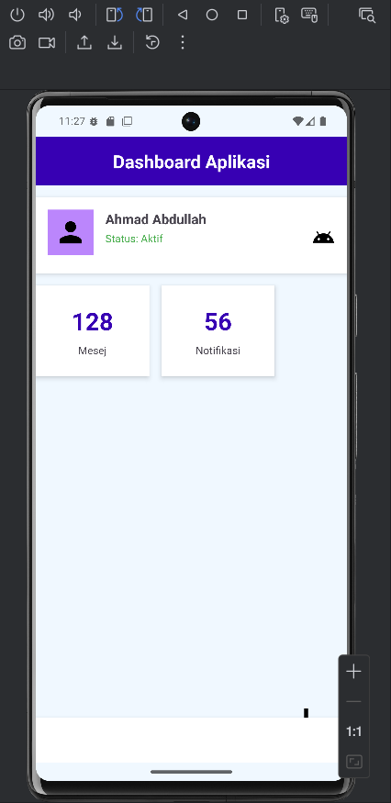

Task 3
Source: https://github.com/s75717/NativeLab1Task3.git
Output:
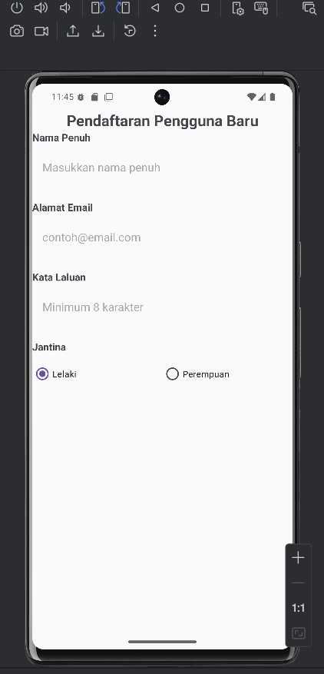
Task 4
Source: https://github.com/s75717/NativeLab1Task4.git
Output:
