

UNIVERSITI MALAYSIA TERENGGANU

FACULTY OF COMPUTER SCIENCE AND MATHEMATICS

COMPUTER SCIENCE (SOFTWARE ENGINEERING) WITH HONORS

SEMESTER II 2025/2026

CSA3023
WEB-BASED APPLICATION DEVELOPMENT

LAB 1:
DEVELOPMENT ENVIRONMENT SETUP FOR JAVA
WEB APPLICATIONS

Prepared by:
NURSYAHEERA BINTI MOHD HISHAM

Prepared for:
SIR. MOHAMAD ARIZAL SHAMSIL MAT RIFFIN

Date:
1 APRIL 2026

TASK 6: WRITING A SIMPLE JAVA SERVLET

Objective: Develop and execute a simple Java Servlet using Apache NetBeans and
Apache Tomcat.

- Modify the existing code as instructed (refer to the provided figure).

ANSWER:

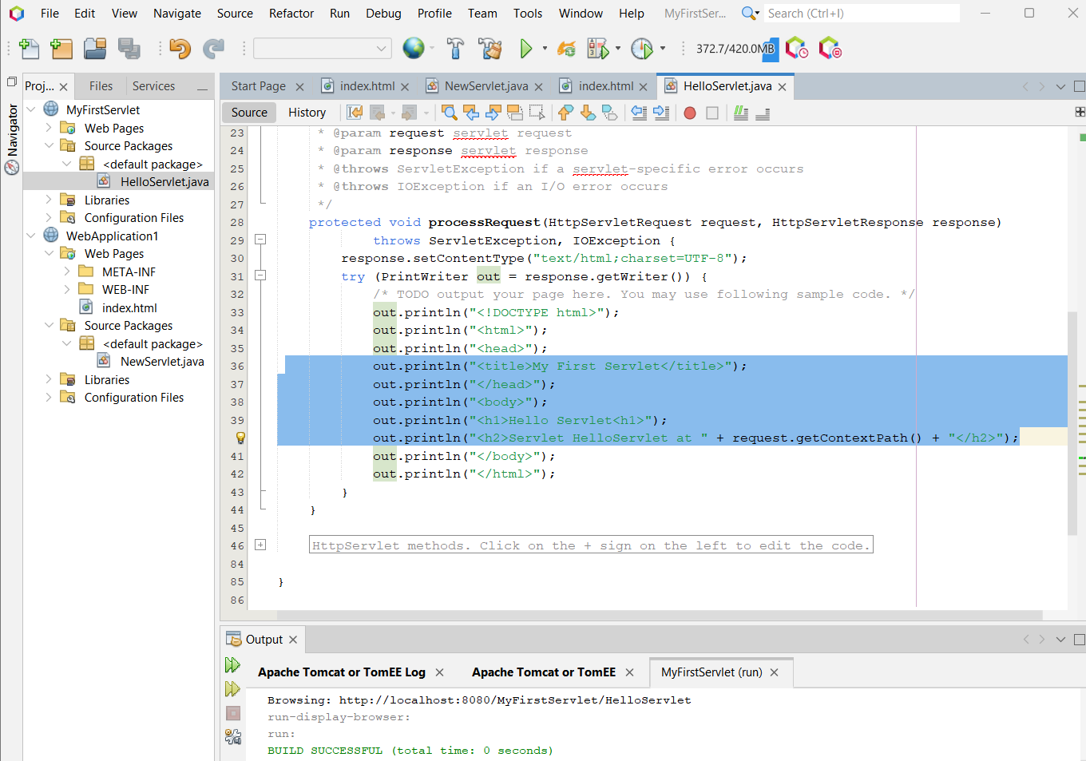

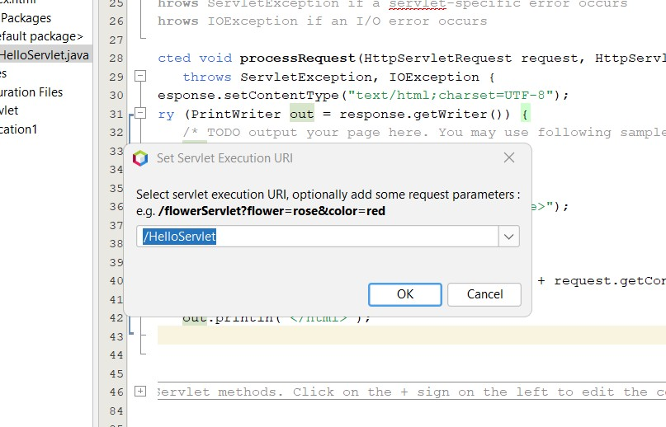

OUTPUT:

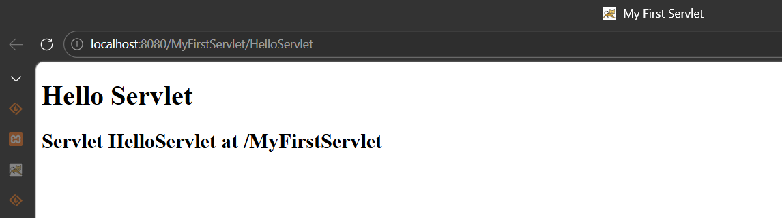

- Modify the doGet() method:

• Locate the doGet() method in HelloServlet.java
• Replace its content with the provided code
• Remove any call to processRequest() inside doGet()

ANSWER:

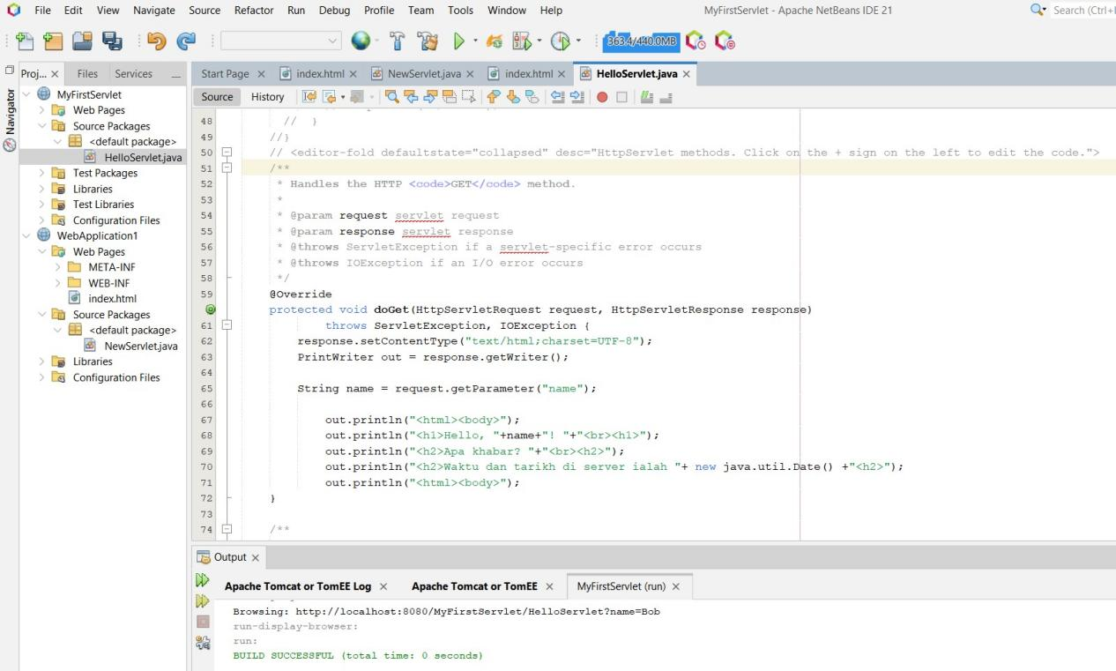

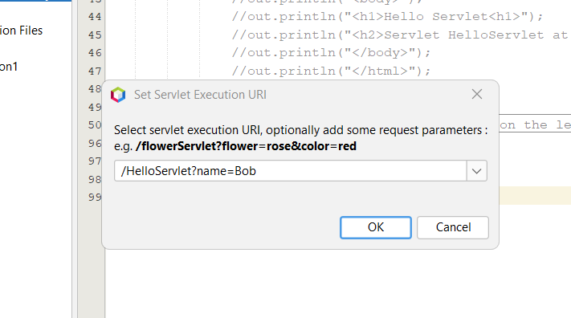

OUTPUT:
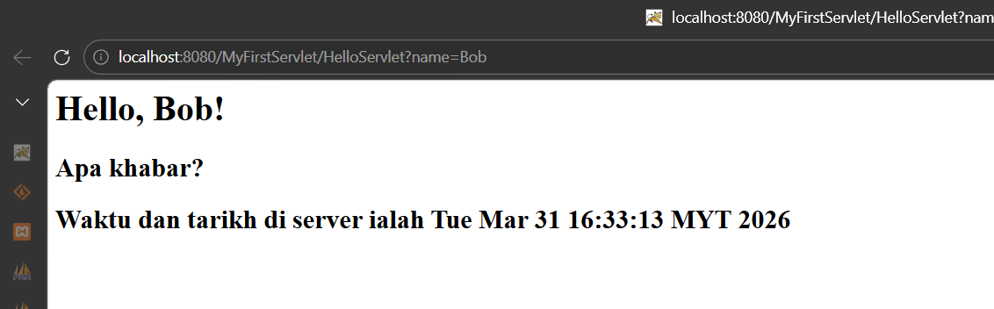

TASK 7: WRITING A SIMPLE JSP PROGRAM

Objective: Create and execute a simple JavaServer Pages (JSP) application using
Apache NetBeans and Apache Tomcat.

- Ensure a successful compilation message appears at the bottom of the NetBeans
IDE.

ANSWER:
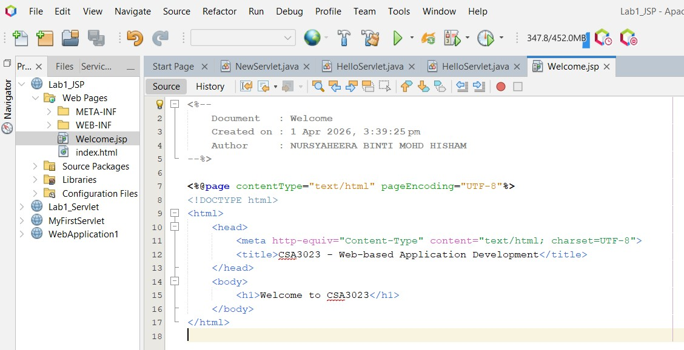

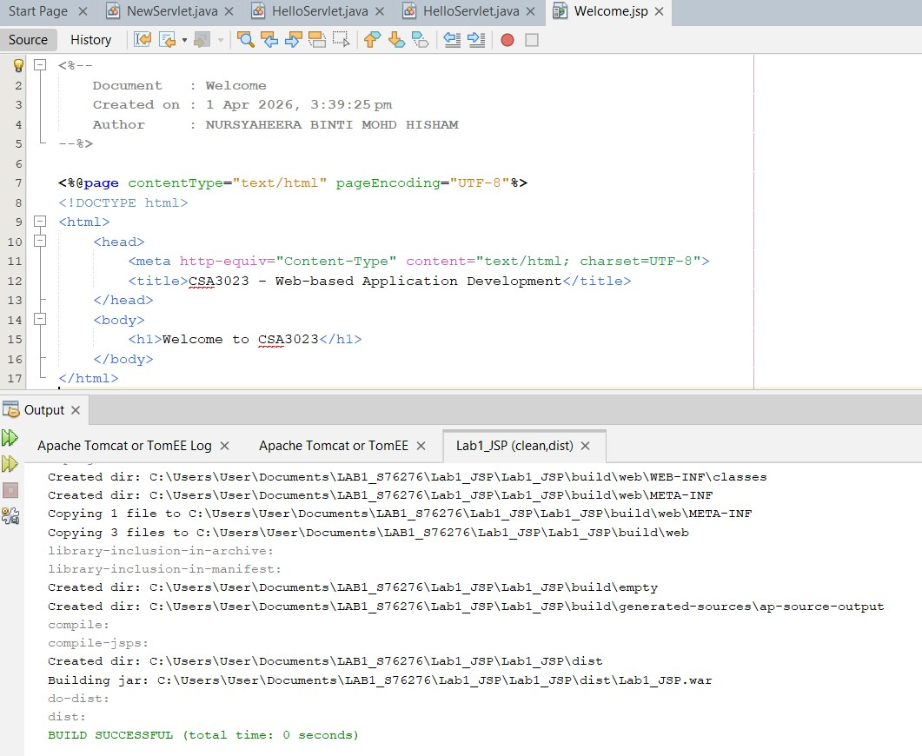

OUTPUT:

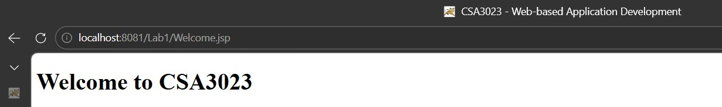

TASK 8: USE JAVA REFERENCE DATATYPE/CLASS WRAPPER IN JSP

Objective: Use Java classes within JSP to display dynamic content such as the
current date and implement auto-refresh functionality.

1. Modify the page title:
Using Java Object in JSP Page

OUTPUT:
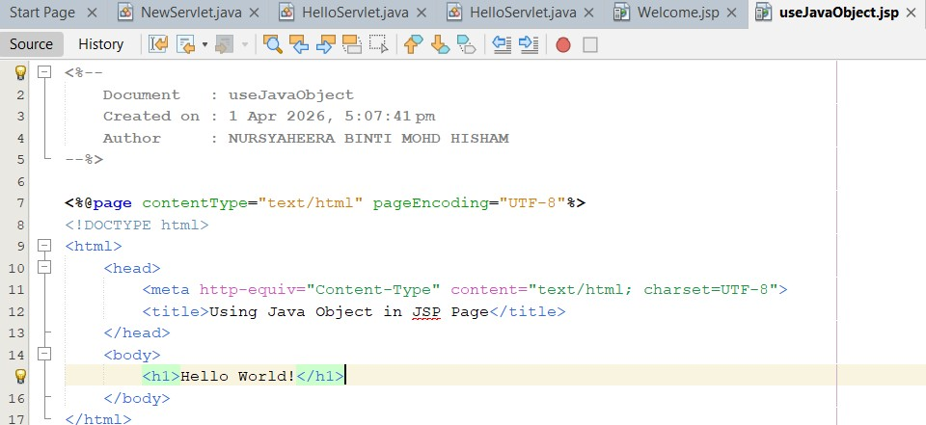

2. Modify the main heading:
Display Current Date and Perform Auto Refresh

OUTPUT:
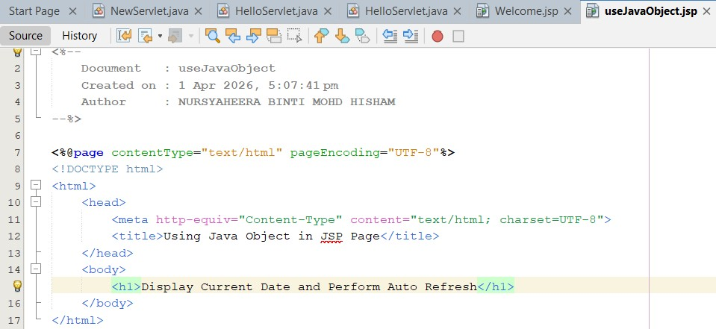

3. Import the Java utility package for date handling:
<%@ page import="java.util.Date" %>

OUTPUT:

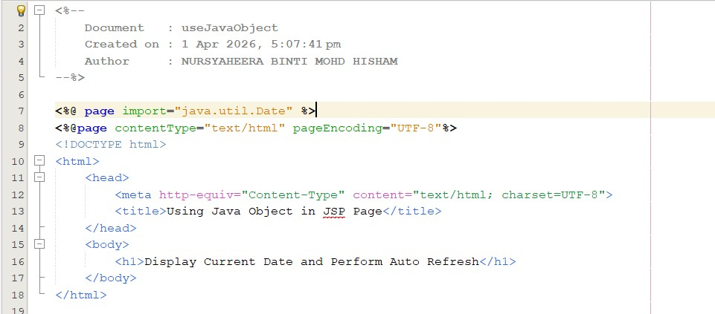

4. Write a JSP scriptlet to create a Date object and display the current date and time:
<%
Date currentDate = new Date();
out.println("<p>Current date and time is " + currentDate.toString() + "</p>");
%>

OUTPUT:

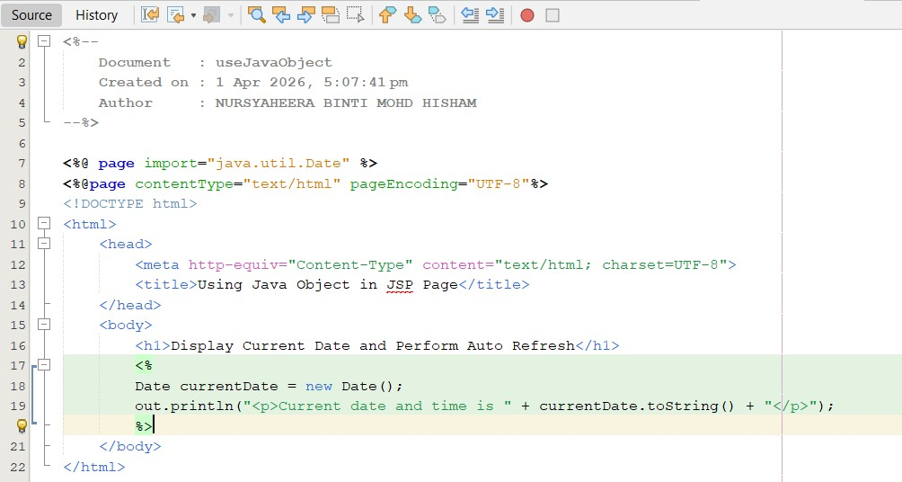

5. Add code to enable automatic page refresh (e.g., every 5 seconds):
<%
response.setIntHeader("Refresh", 5);
%>

OUTPUT:

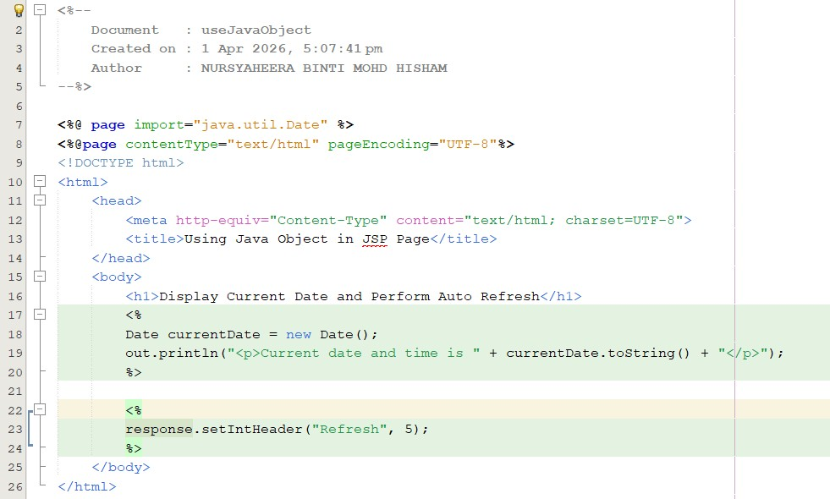

- Observe the output in the web browser. The current date and time should be
displayed and refreshed automatically

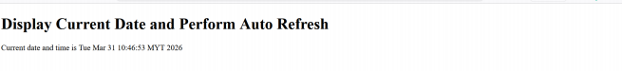

1.12 EXERCISE

Objective: Apply knowledge of Servlets and JSP to build a simple dynamic web
application.

Task: Simple Greeting Web Application
You are required to develop a simple web application that integrates both Servlet
and JSP.

1. Create a new Servlet named GreetingServlet.

2. In the doGet() method:
• Retrieve a request parameter named name.
• If the parameter is not provided, set the value to Guest.
• Forward the request to a JSP page named greeting.jsp.

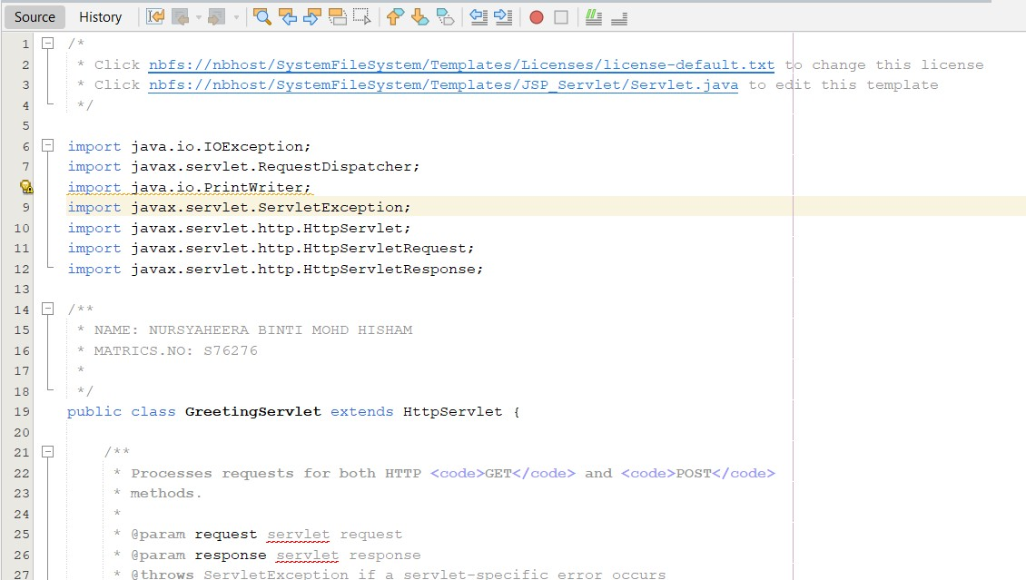

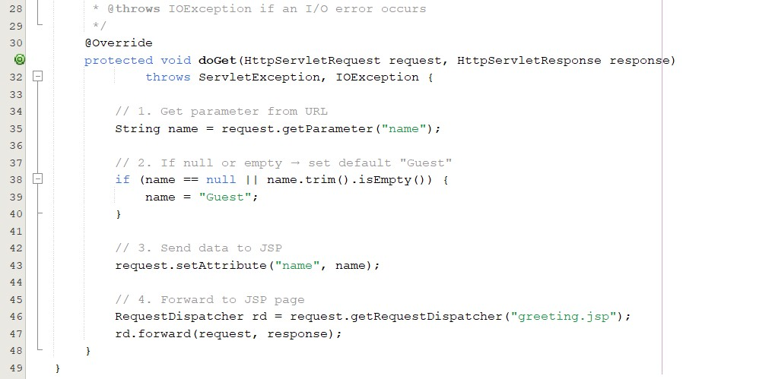

3. Create a JSP file named greeting.jsp.

4. In the JSP page:
• Display the message:
Hello, [name]!
• Display the current date and time.
• Ensure the page refreshes automatically every 5 seconds.

OUTPUT:
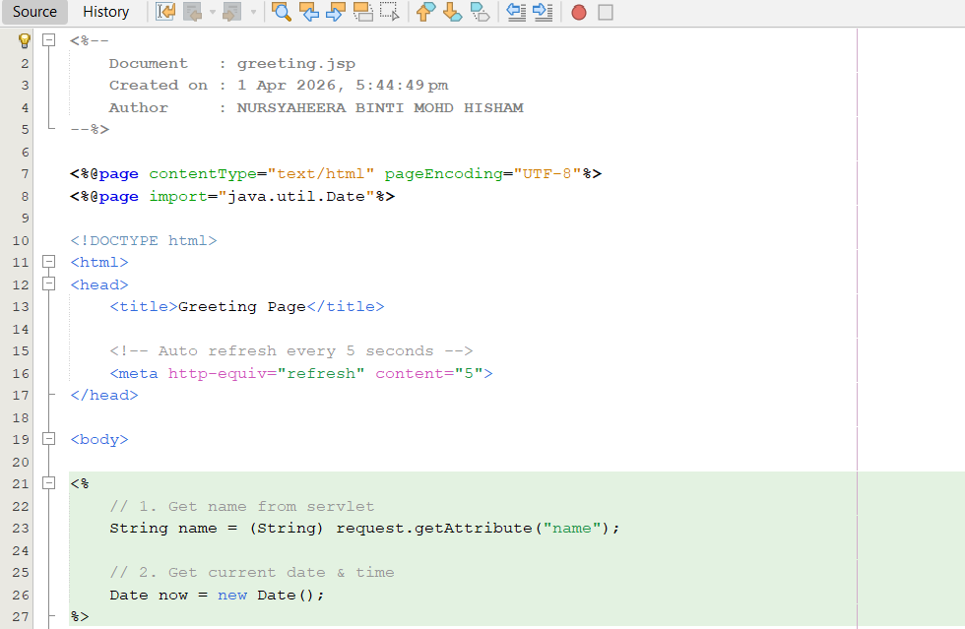

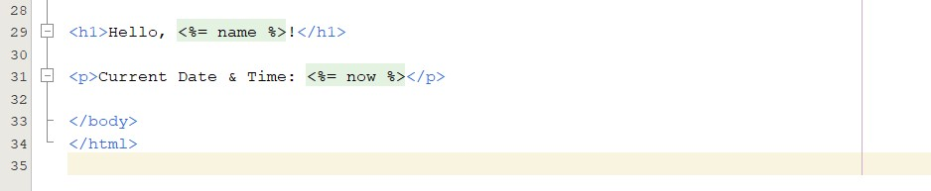

5. Run the application using the following format:
http://localhost:8080/Lab1/GreetingServlet?name=Ali

6. Observe the output:
• The name should be displayed correctly.
• If no name is provided, Guest should be shown.
• The date and time should update automatically

OUTPUT:
