

UNIVERSITI MALAYSIA TERENGGANU

FACULTY OF COMPUTER SCIENCE AND MATHEMATICS

COMPUTER SCIENCE (SOFTWARE ENGINEERING) WITH HONORS

SEMESTER II 2025/2026

CSA3023
WEB-BASED APPLICATION DEVELOPMENT

LAB 3:
JSP: SCRIPLET, PAGE DIRECTIVE & INCLUDE DIRECTIVE

Prepared by:
NURSYAHEERA BINTI MOHD HISHAM

Prepared for:
SIR. MOHAMAD ARIZAL SHAMSIL MAT RIFFIN

Date:
14 APRIL 2026

Task 1: Passing Data from Main JSP’s Page to Other JSP’s Page

Objective: To demonstrate the use of request.getParameter (“fieldName”) for passing input from one JSP’s page to another JSP’s page.

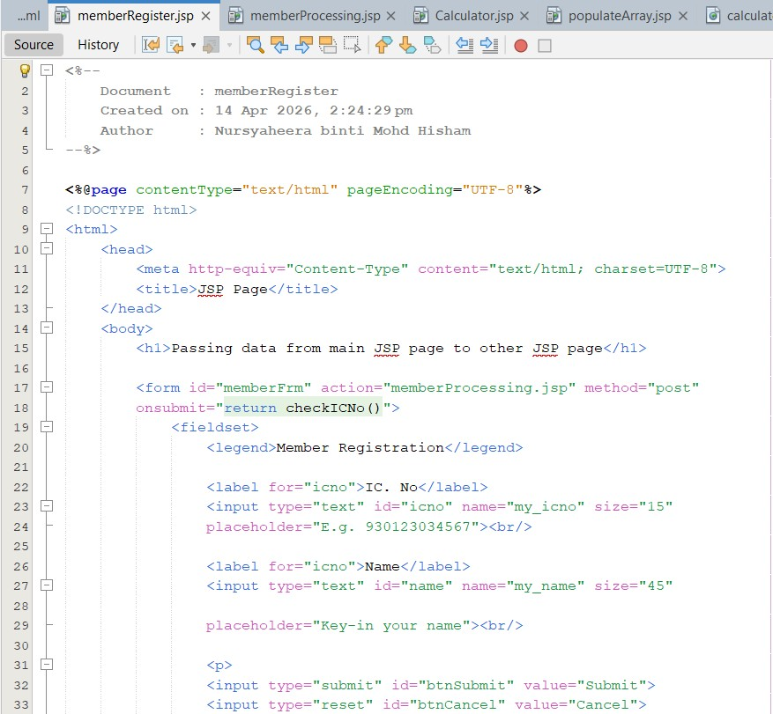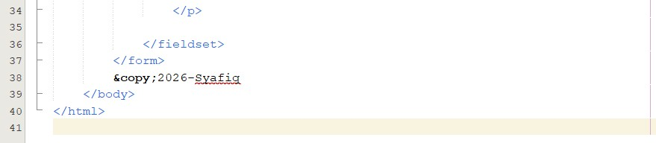

Output:

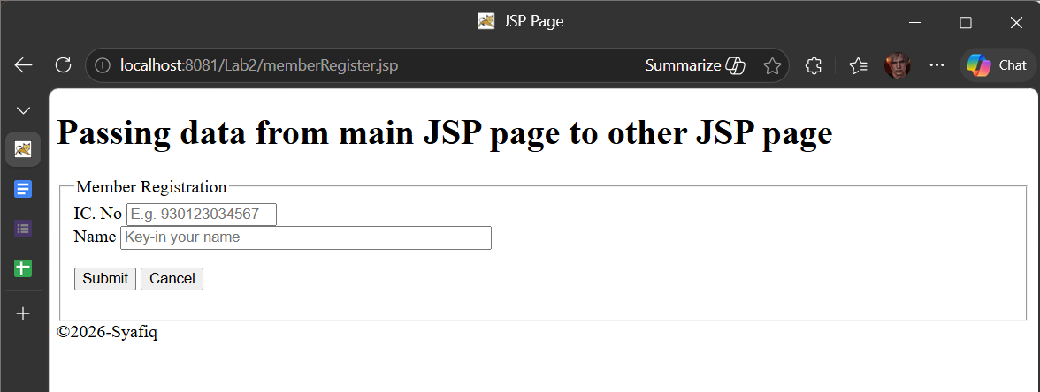
Figure 1.1: memberRegister.jsp Interface

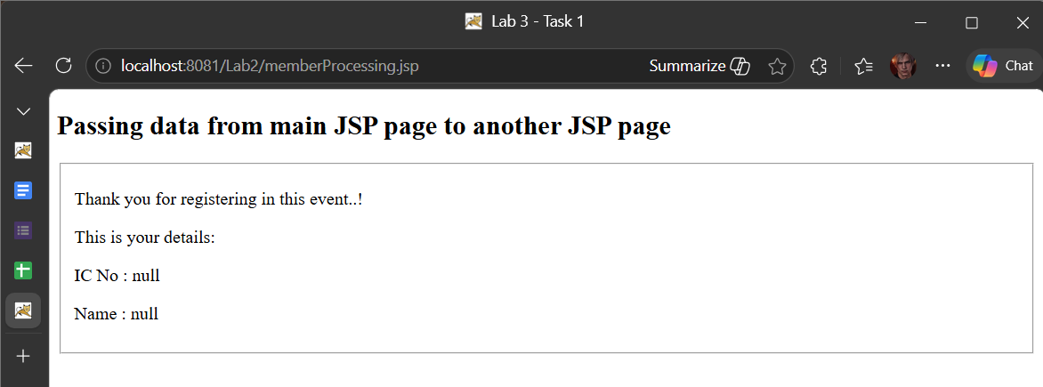

Figure 1.2: memberProcessing.jsp before input data

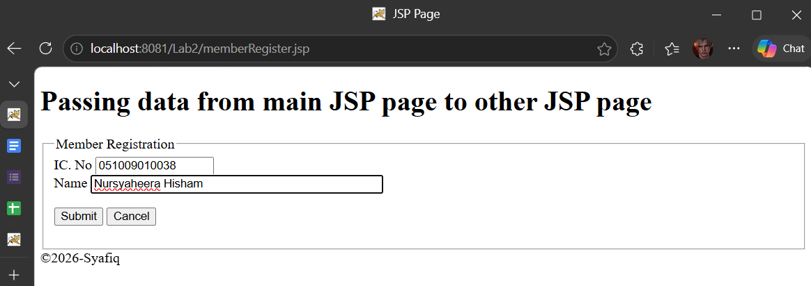
Figure 1.3: memberRegister.jsp Interface Input Data

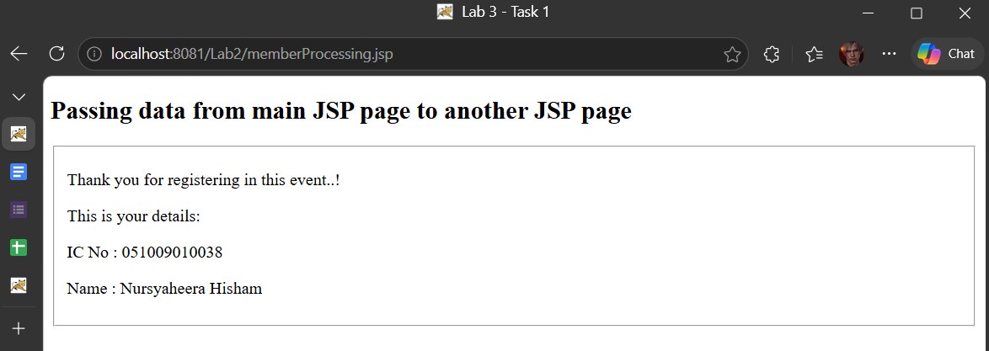
Figure 1.4: memberProcessing.jsp Interface After Input Data

Task 2: Using Mathematics Operations in JSP

Objective: To demonstrate the use of request.getParameter(“Mathematics operations”) in JSP’s page.

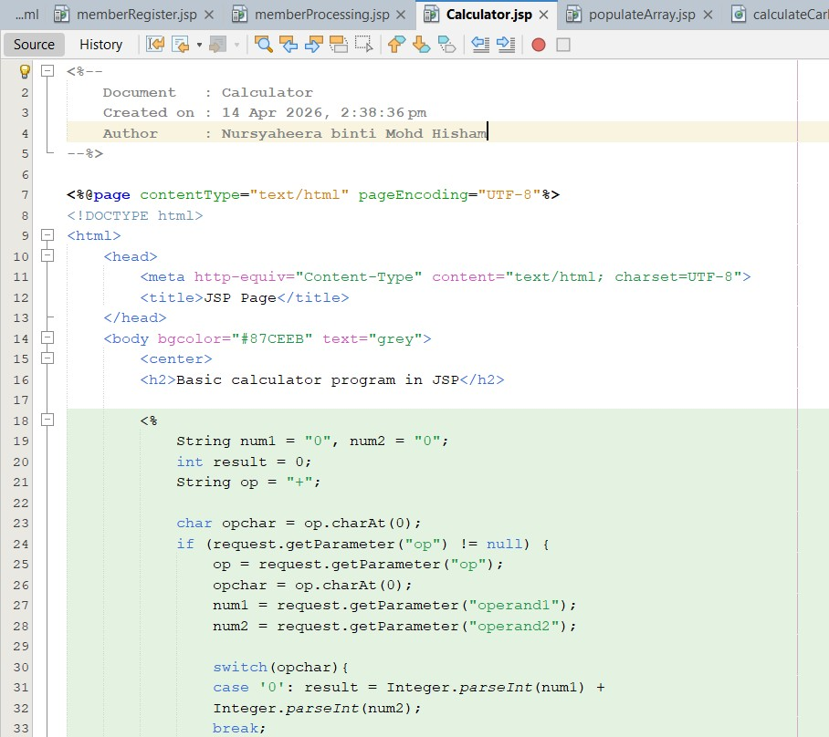
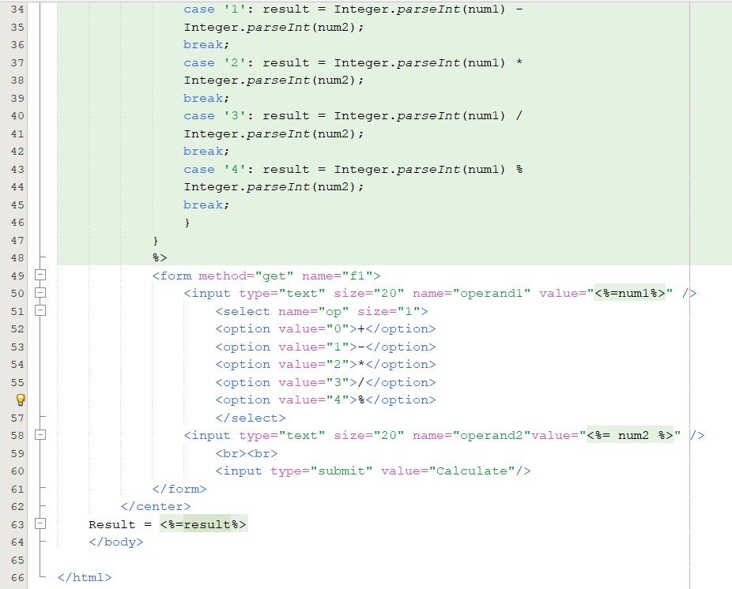

Output:

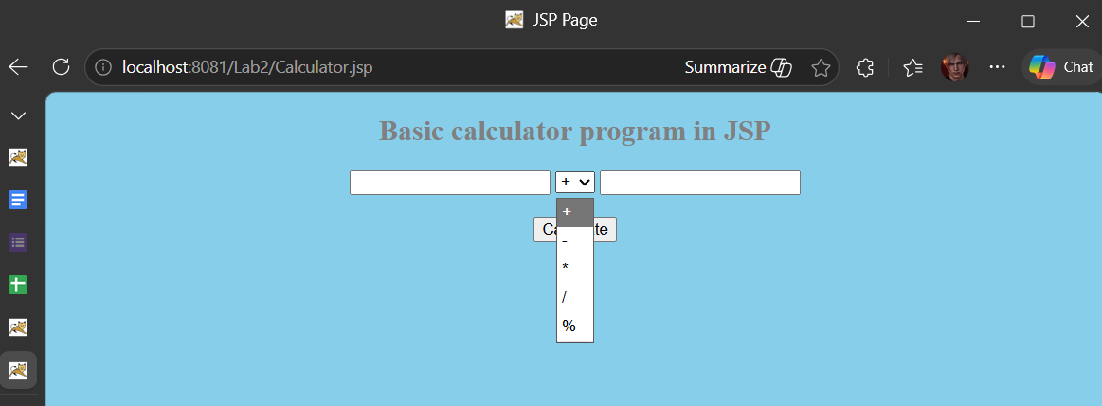

Figure 2.1: calculator.jsp Interface

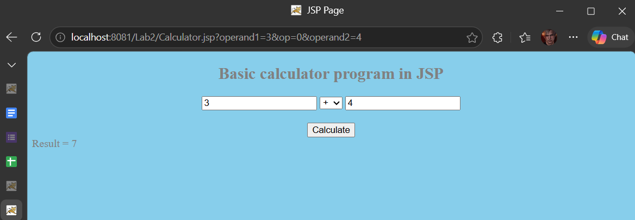

Figure 2.1: calculator.jsp Result

Task 3: Populate an Array Values into HTML’s Table

Objective: Read Java array and populate it into HTML’s table.

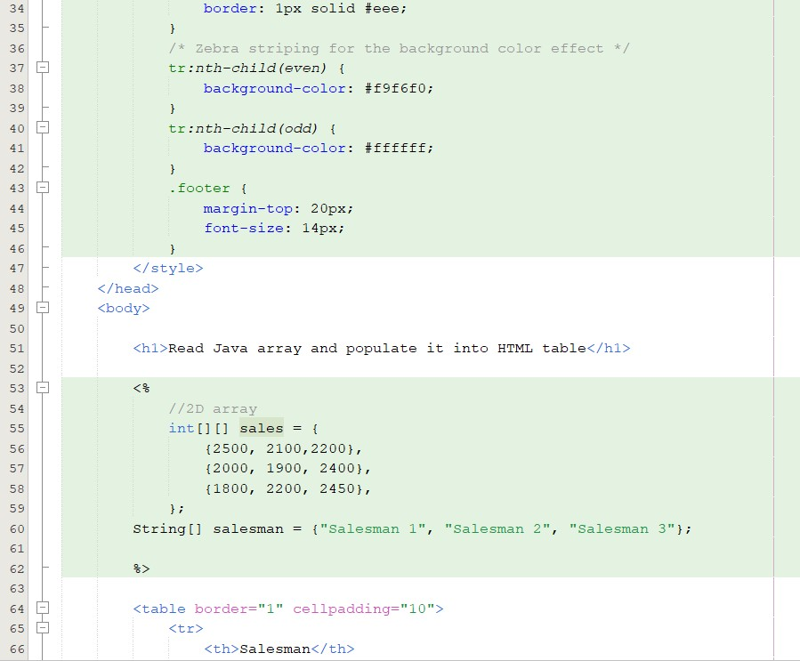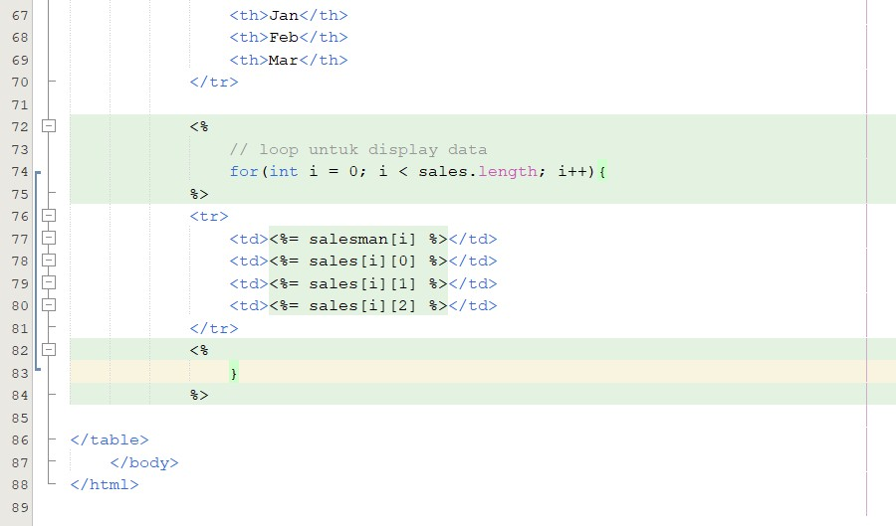

Output:

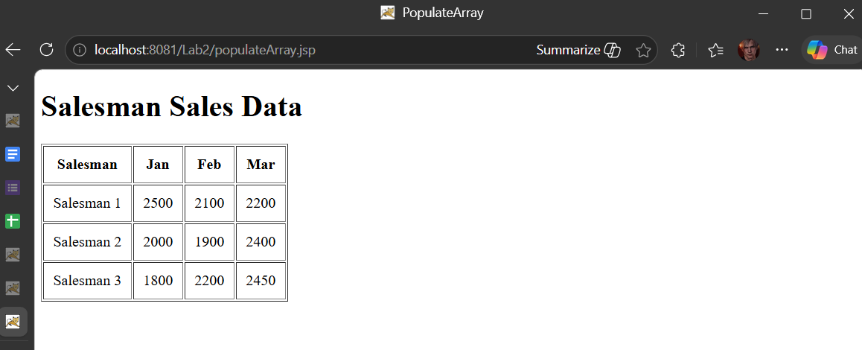

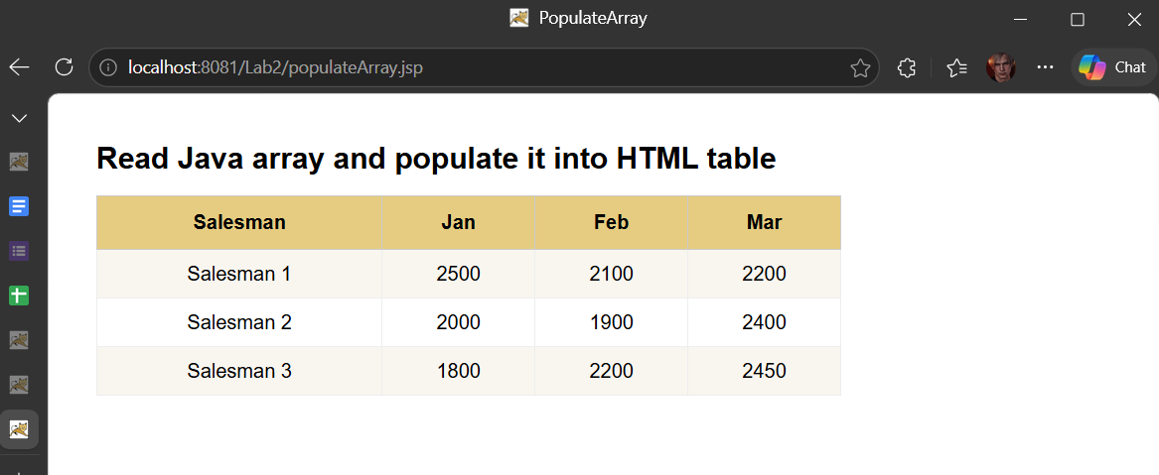

Task 4

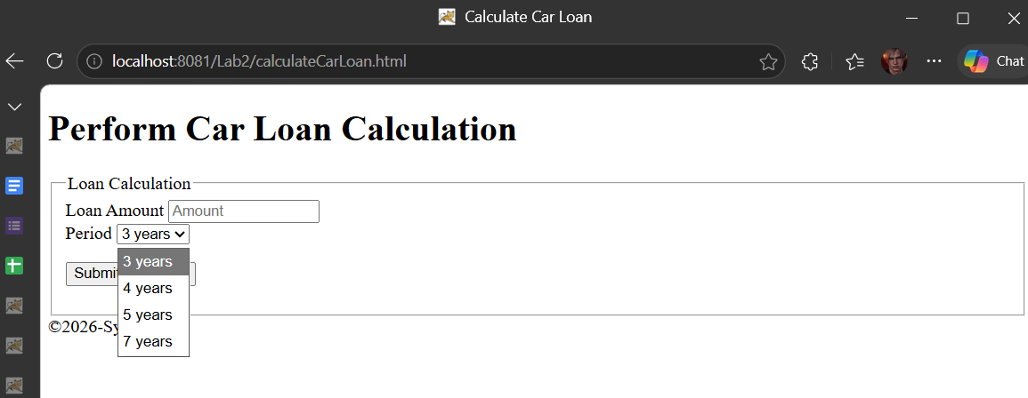

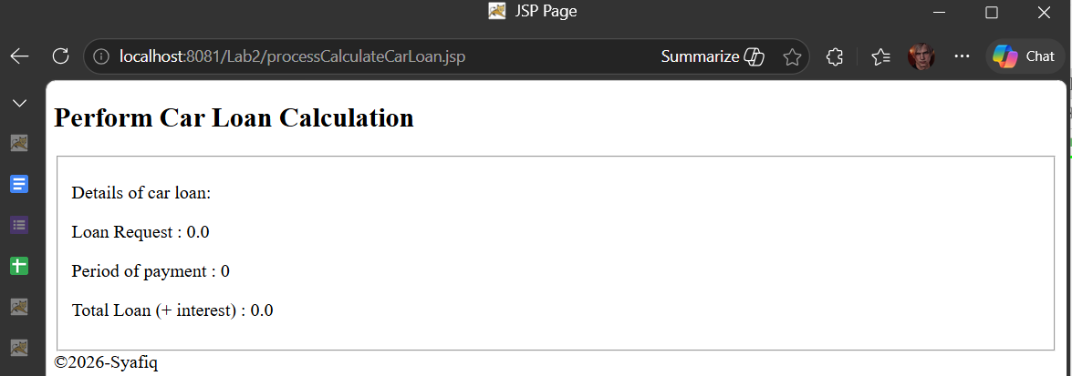

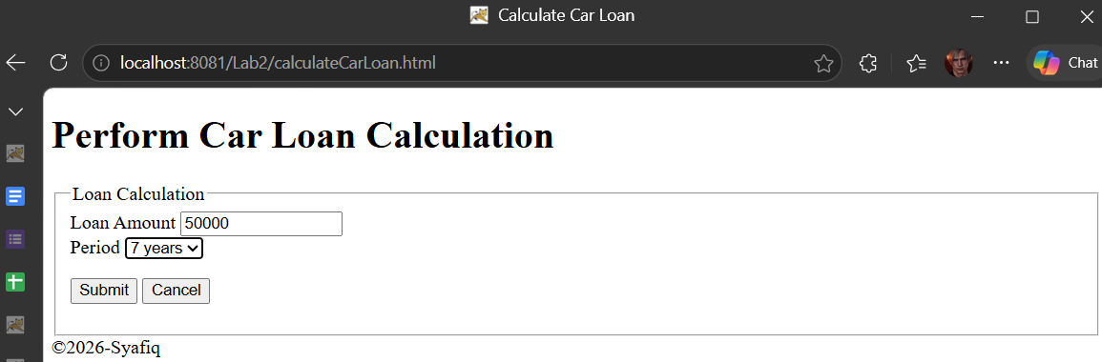

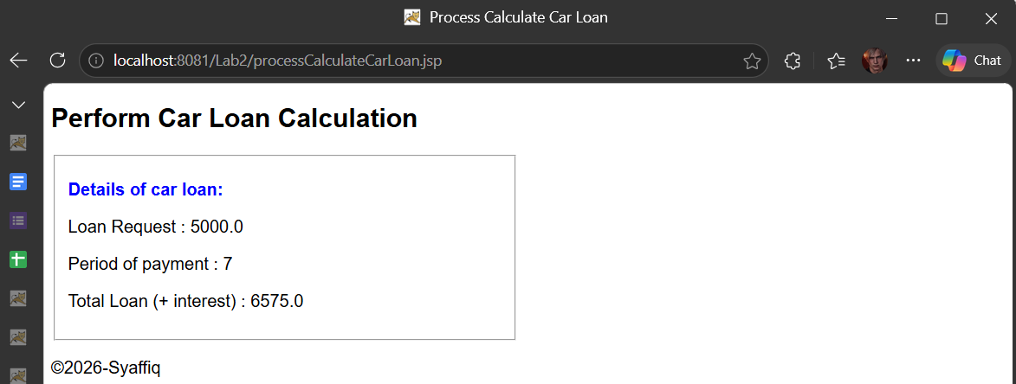

Task 5

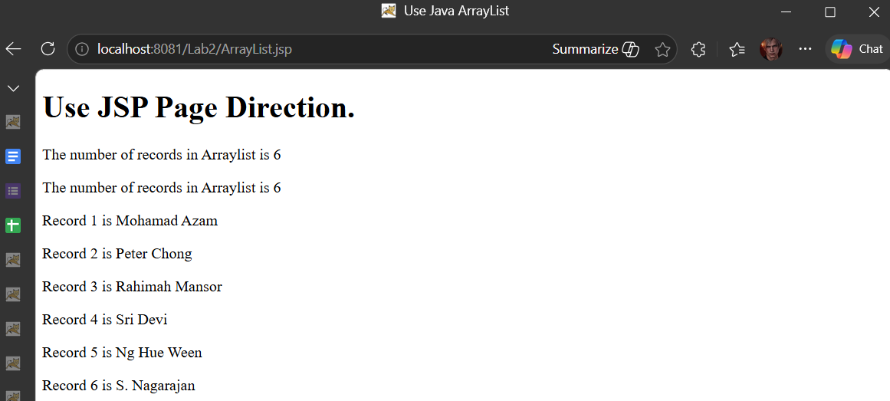

Task 6

