

UNIVERSITI MALAYSIA TERENGGANU

FACULTY OF COMPUTER SCIENCE AND MATHEMATICS

COMPUTER SCIENCE (SOFTWARE ENGINEERING) WITH HONORS

SEMESTER II 2025/2026

CSA3023
WEB-BASED APPLICATION DEVELOPMENT

LAB 3:
JSP: SCRIPLET, PAGE DIRECTIVE & INCLUDE DIRECTIVE

Prepared by:
NURSYAHEERA BINTI MOHD HISHAM

Prepared for:
SIR. MOHAMAD ARIZAL SHAMSIL MAT RIFFIN

Date:
14 APRIL 2026

Task 1: Passing Data from Main JSP’s Page to Other JSP’s Page

Objective: To demonstrate the use of request.getParameter (“fieldName”) for passing input from one JSP’s page to another JSP’s page.

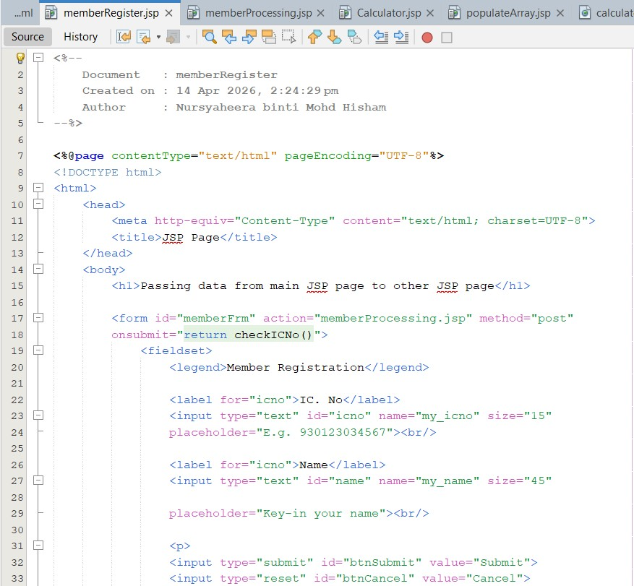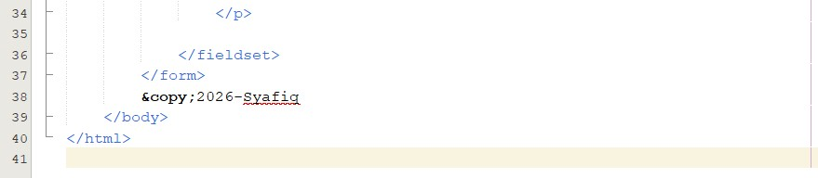

Output:

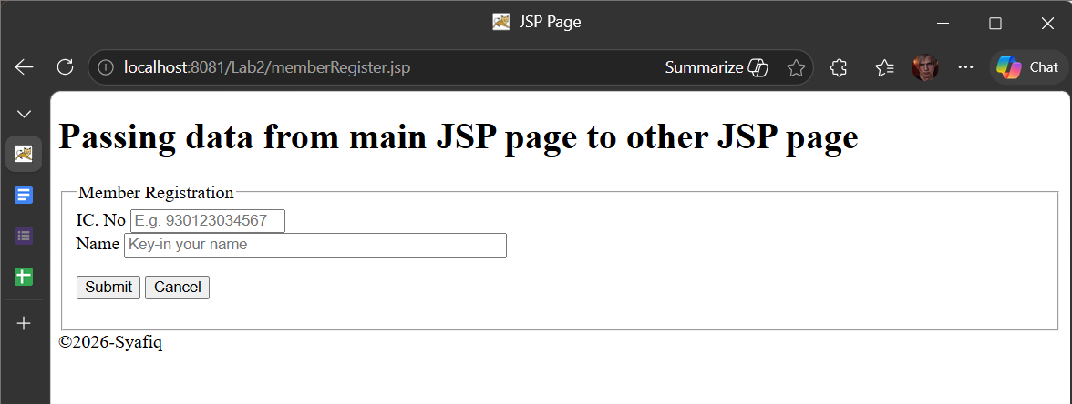
Figure 1.1: memberRegister.jsp Interface

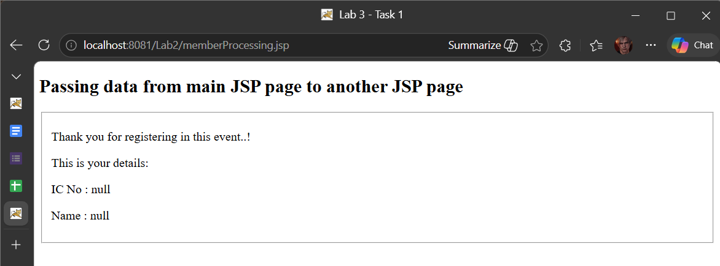

Figure 1.2: memberProcessing.jsp before input data

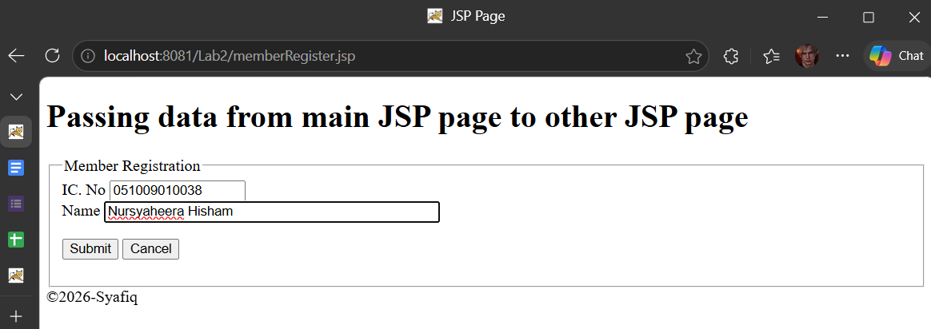
Figure 1.3: memberRegister.jsp Interface Input Data

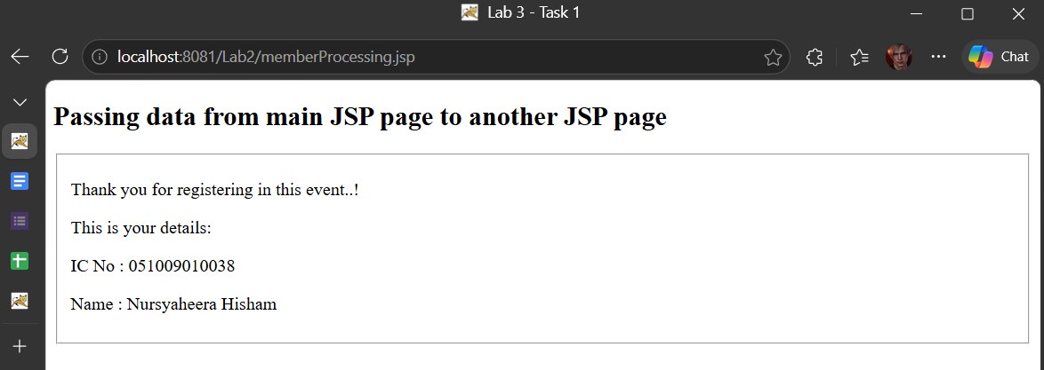
Figure 1.4: memberProcessing.jsp Interface After Input Data

Reflection

- How do you want to submit specific information from one form to next form?

Answer:
By using an HTML form with action and method (GET/POST), then retrieving the data in the next page using request.getParameter("field_name");.

- What happened if the field name you specify in request.getParameter(“field_name”) in second page is different from the field name you defined in first page?

Answer:
The value will not be retrieved (null) because the parameter name does not match.

Task 2: Using Mathematics Operations in JSP

Objective: To demonstrate the use of request.getParameter(“Mathematics operations”) in JSP’s page.

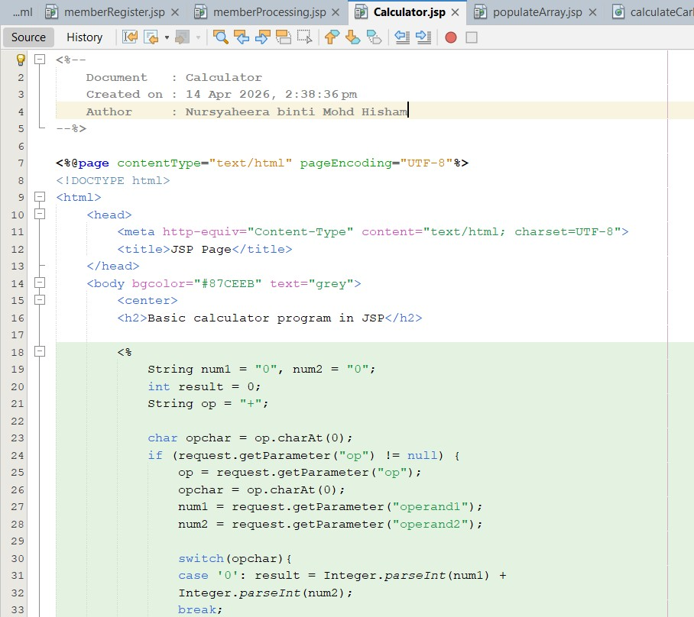
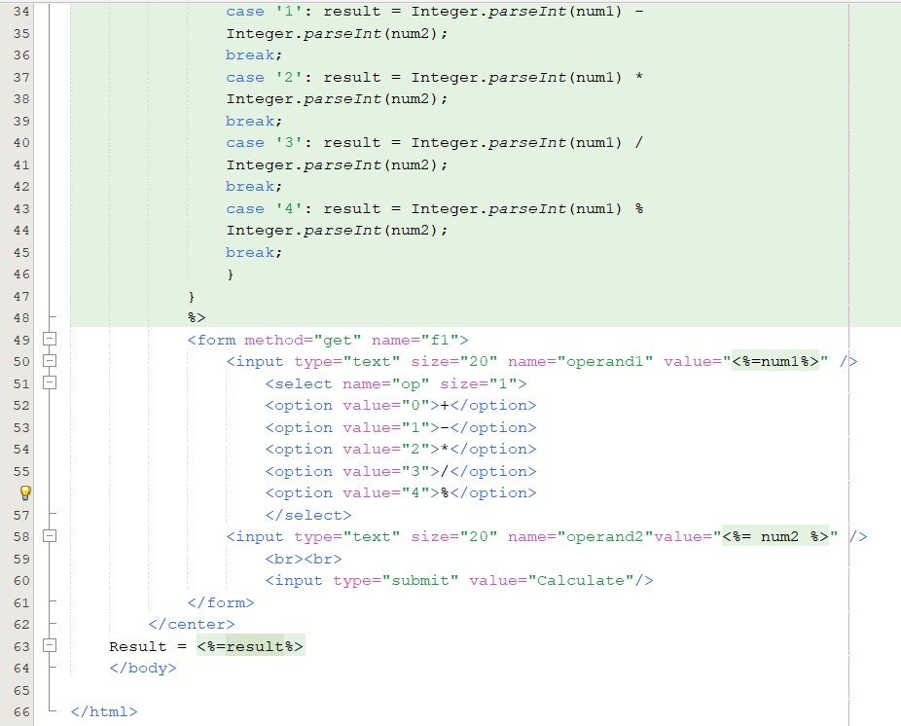

Output:

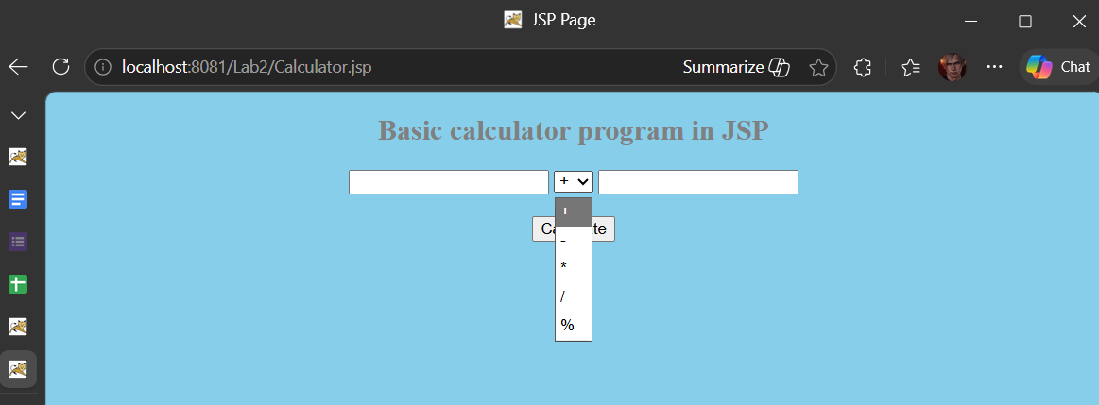

Figure 2.1: calculator.jsp Interface

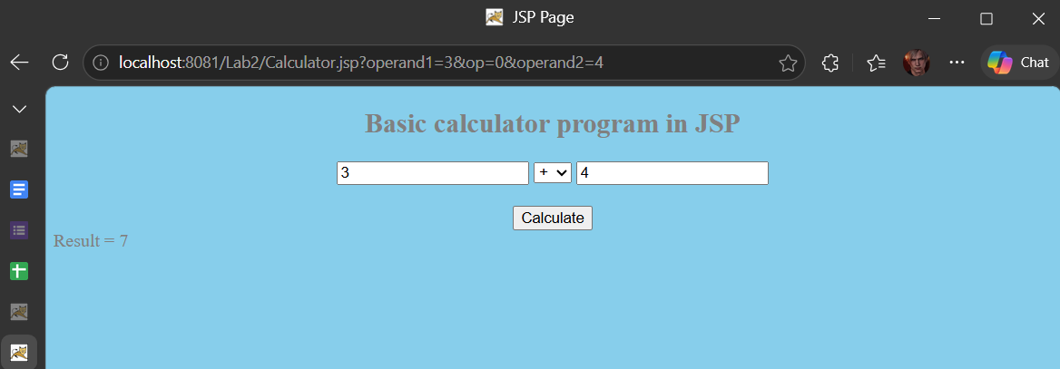

Figure 2.1: calculator.jsp Result

Reflection

- How do you want to submit specific information from one form to next form?

Answer:
By using an HTML form with action and method (GET/POST), then retrieving the data in the next page using request.getParameter("field_name");.

- What happened if the field name you specify in request.getParameter(“field_name”) in second page is different from the field name you defined in first page?

Answer:
The system will return null, which may cause errors in calculation.

Task 3: Populate an Array Values into HTML’s Table

Objective: Read Java array and populate it into HTML’s table.

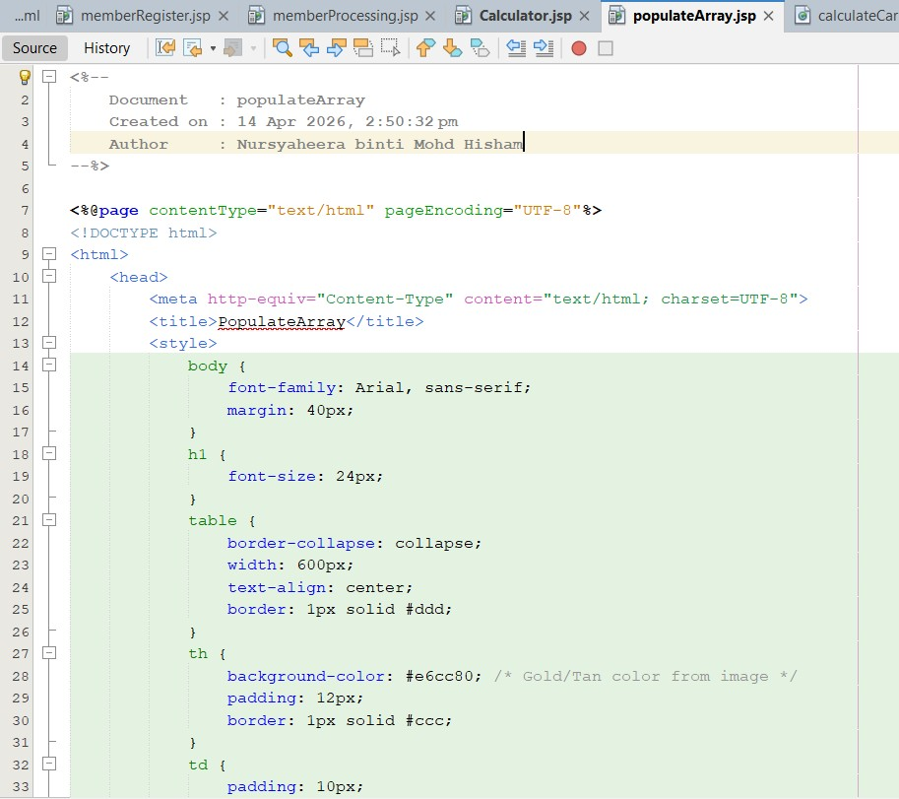
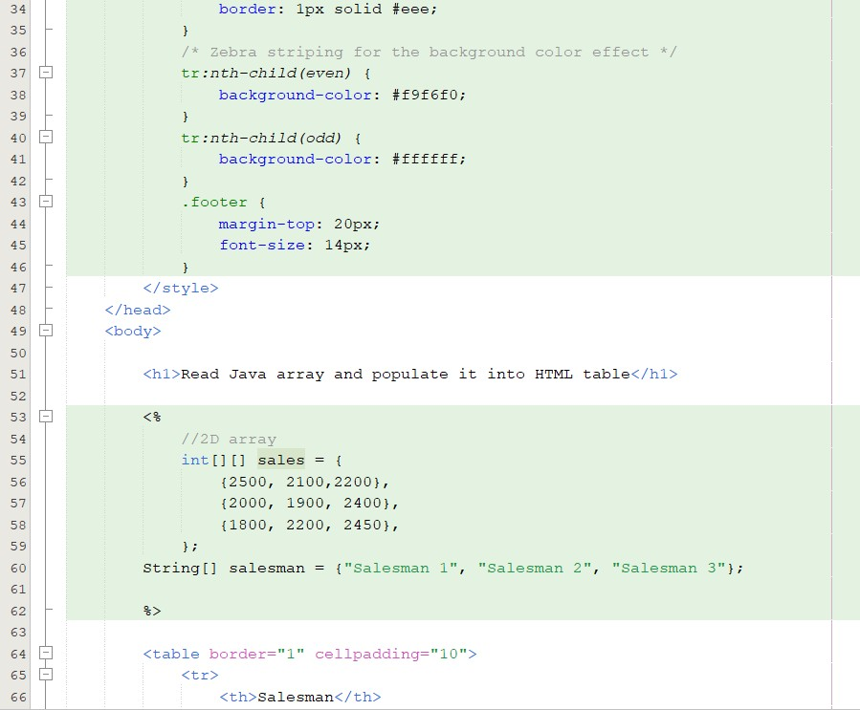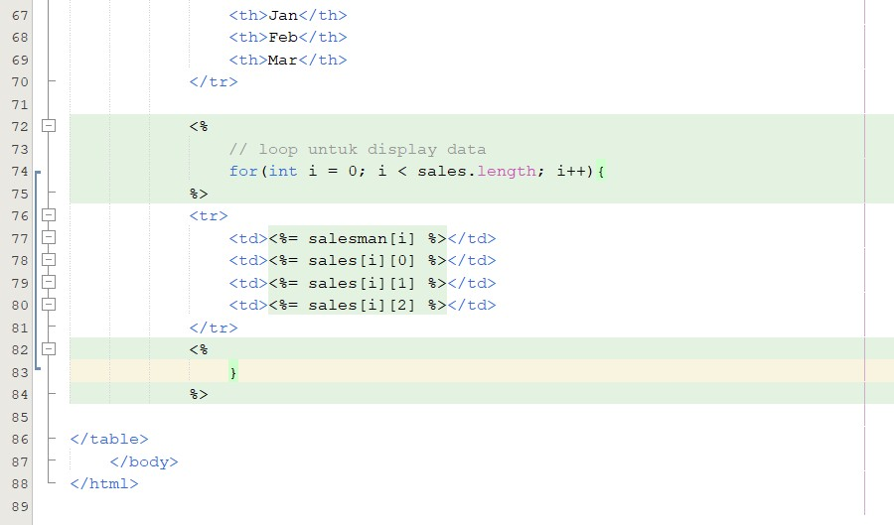

Output:

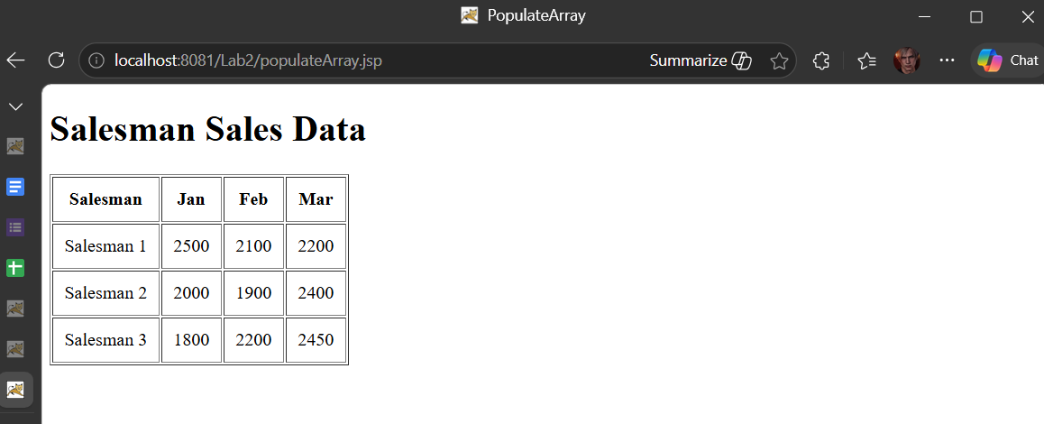

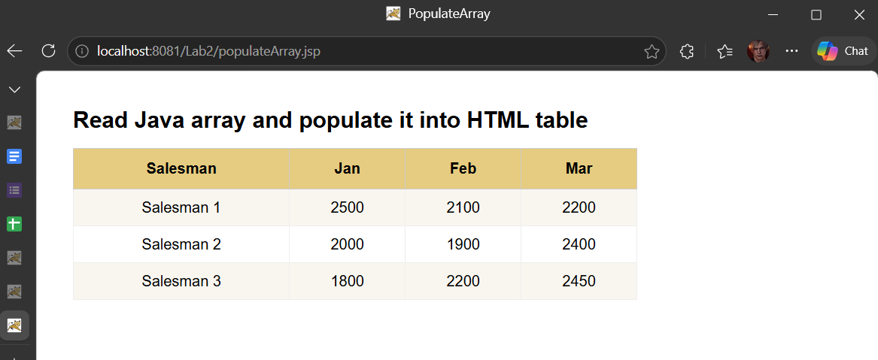

Reflection
- Write a sample syntax to declare 2D Java array.

Answer:
int[][] sales = {
{2500, 2100, 2200},
{2000, 1900, 2400},
{1800, 2200, 2450}
};

- Define a sequence of steps on how you accomplish Task 7.
Answer:
  - Create a JSP file
  - Declare and initialize the array in a scriptlet
  - Use a loop (for) to read the array
  - Display the data in an HTML table
  - Run the JSP file

- What is the difference between HTML’s page and JSP’s page.
Answer:
HTML | JSP
Static content | Dynamic content
No Java code | Support Java code
Client-side only | Server-side processing

Task 4: Perform Calculation of Car Loan

Objective: Passing input to next page for further processing.

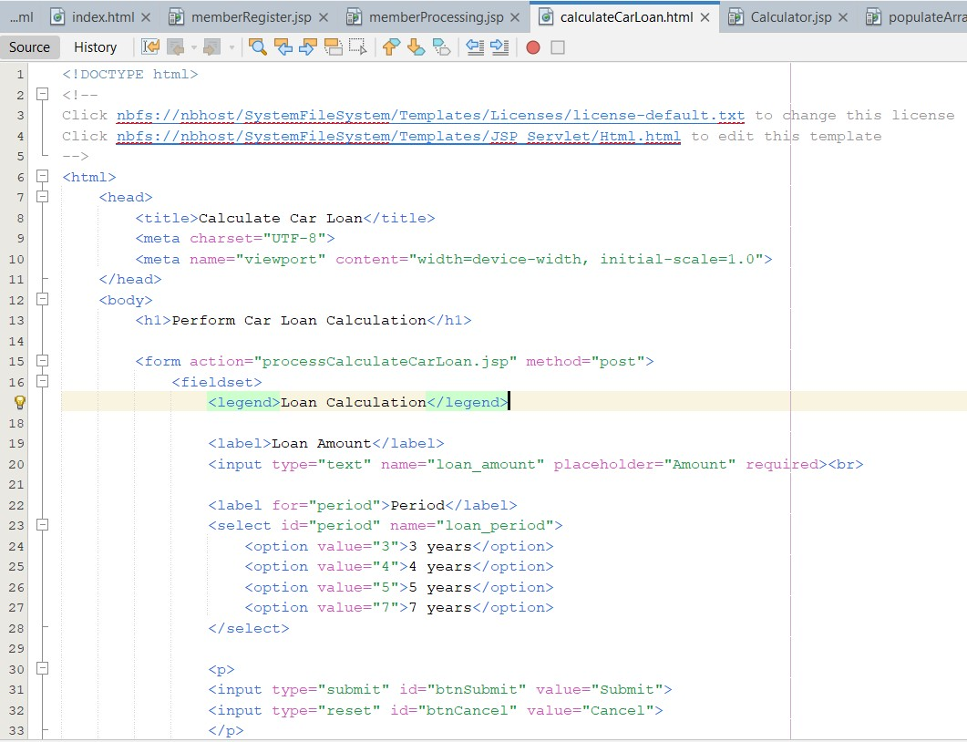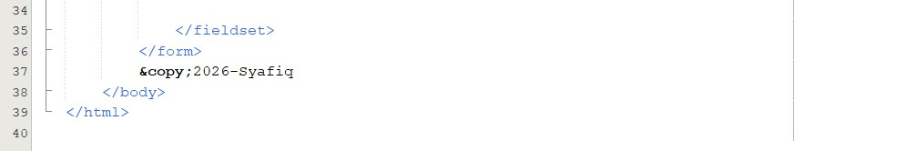

Output:

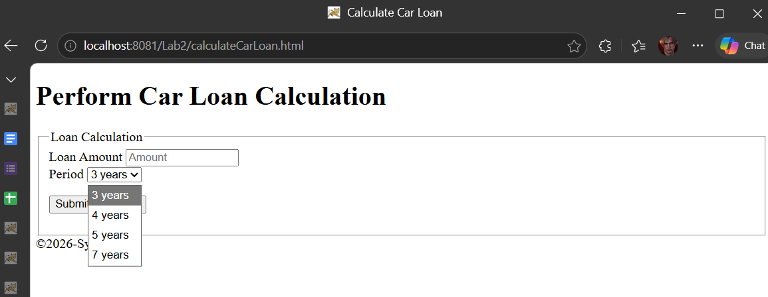

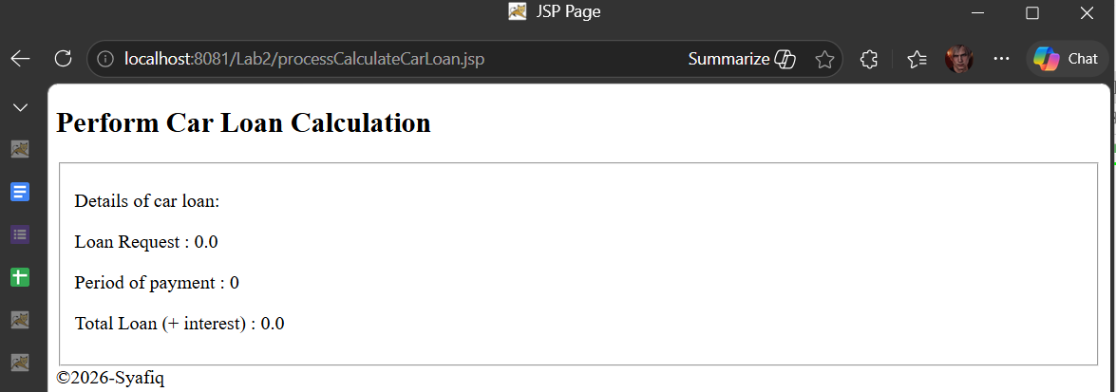

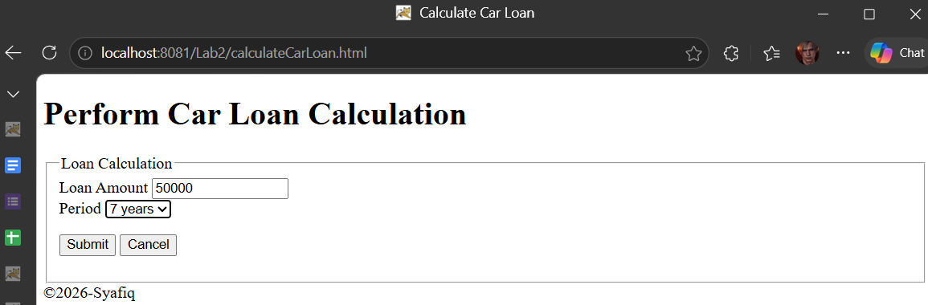

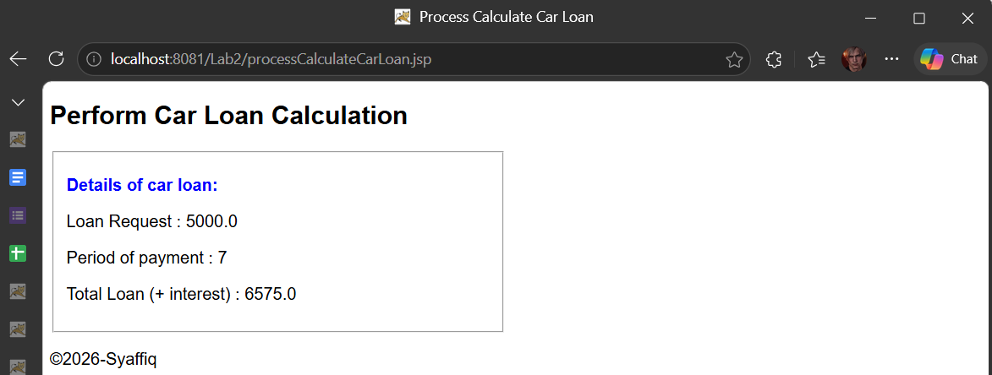

Reflection
- How you want to retrieve data from previous page?

Answer:
Using request.getParameter("parameter_name");

- Where the construction of logic occur for calculating Total Loan ( + interest)?

Answer:
In the JSP processing page like processCalculateCarLoan.jsp, not in the HTML form.
Task 5: Using JSP Page Directive to Call Java API

Objective: Use JSP page directive elements to call certain Java API.

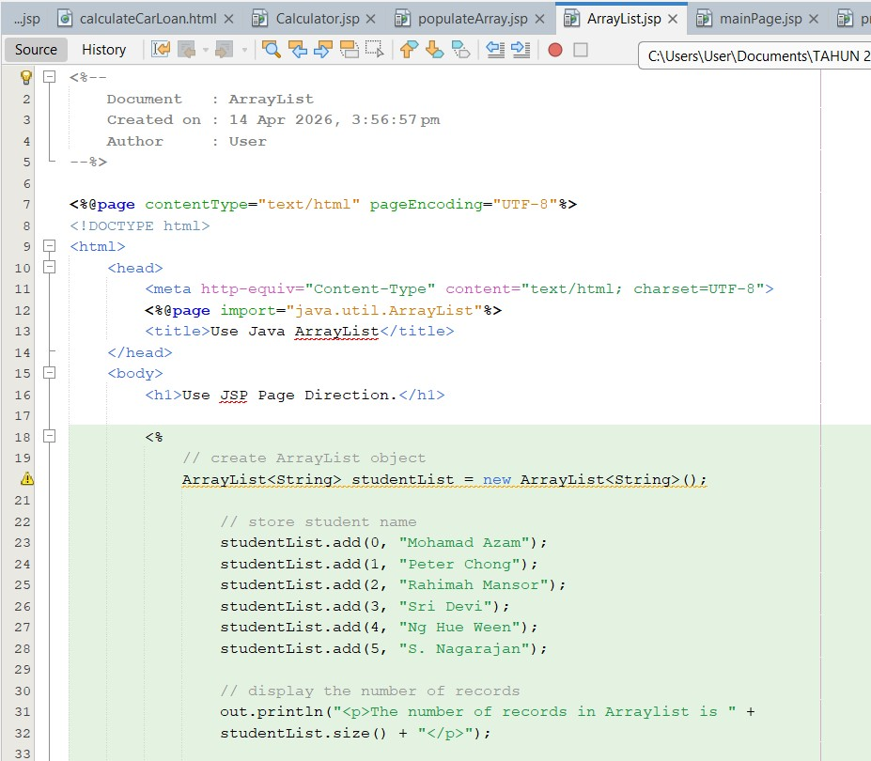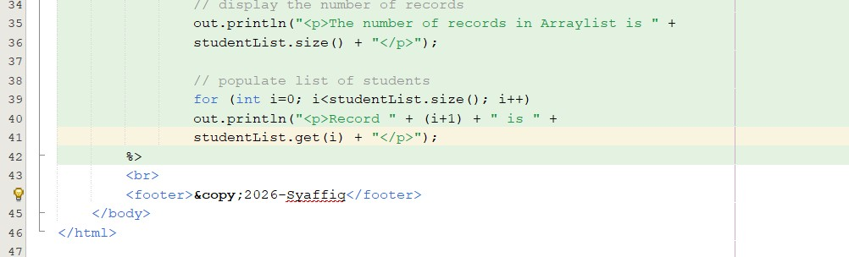

Output:

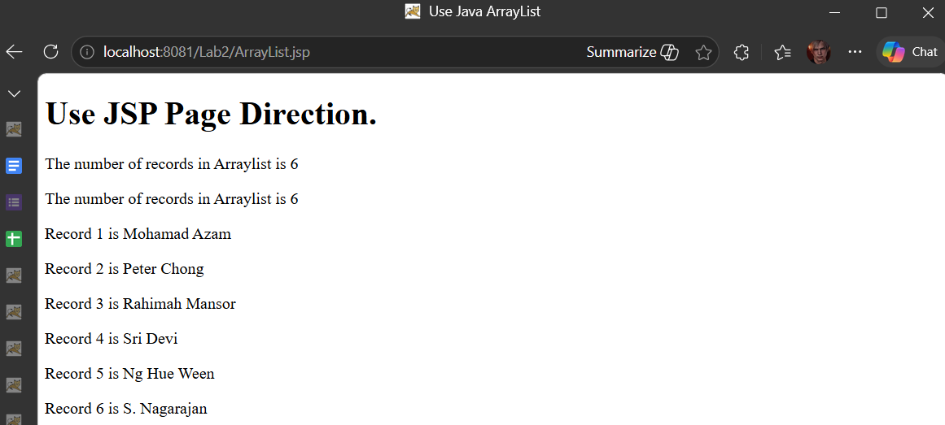

Reflection
- What you have learnt from this exercise?
Answer:
How to use JSP Page Directive

- Write a sample syntax how you want to use java Math object in JSP?
Answer:

<%
double result = Math.sqrt(25);
out.println(result);
%>

- List and write a sample syntax for THREE (3) of JSP page directive.
Answer:
(1) Import directive
<%@ page import="java.util.ArrayList" %>
(2) Content type
<%@ page contentType="text/html" %>
(3) Page encoding
<%@ page pageEncoding="UTF-8" %>

Task 6: Use JSP Include directive for JSP Page
Objective: Demonstrate the use of JSP Page Include directive

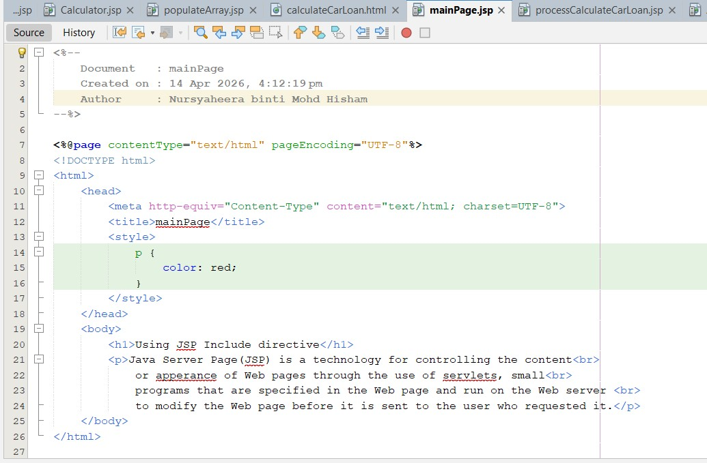

Output:

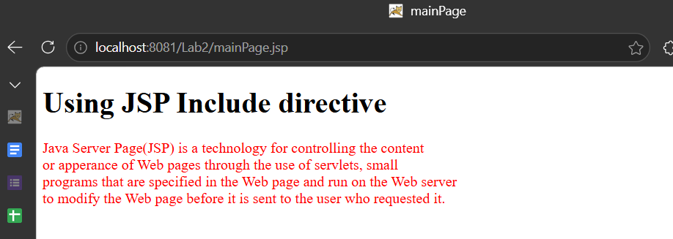

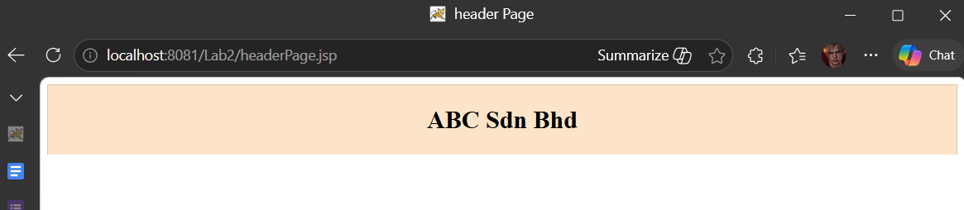

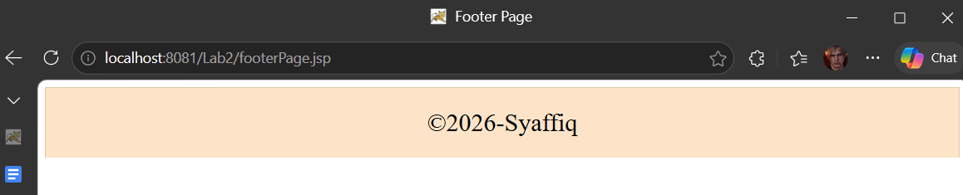
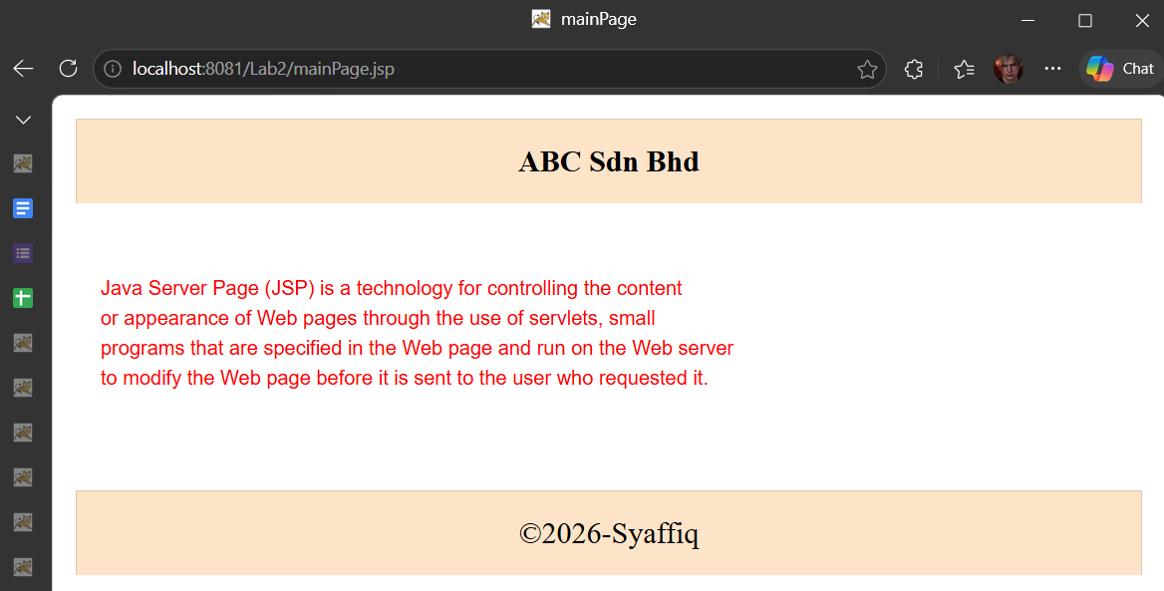

Reflection
- What you have learnt from this exercise?
Answer:
How to reuse components like header and footer

- Write a syntax how you want to include common.html file that located at a directory known as master
Answer:
<%@ include file="master/common.html" %>

Excercise
Objective: Develop a Student Club Registration System by integrating JSP Scriptlets, Page Directives, Include Directives, form handling, and dynamic data processing techniques learned throughout this lab.

Case Study
Faculty of Computer Science and Mathematics, UMT is organizing a Student Club Recruitment Week to allow students to register for extracurricular clubs and activities. As a web developer, you are required to build a simple JSP-based registration system to assist the organizing committee in managing student registrations and displaying activity information.

Instruction
Develop the system by fulfilling the following requirements:
- Create a reusable header.jsp and footer.jsp for the system layout.

- Apply the JSP Include Directive to include the header and footer in all JSP pages.

- Design a navigation menu in the header that links to the following pages: • Registration Page • Fee Calculator Page • Club Member Directory

Answer:
Header:
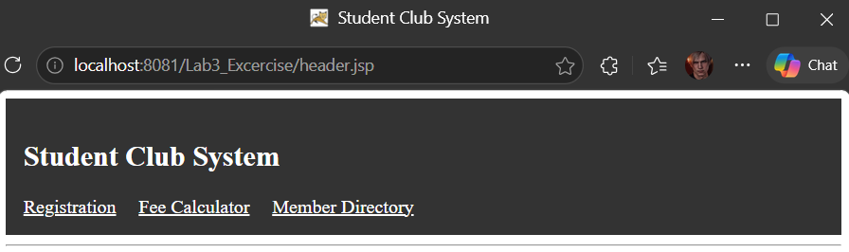

Footer.jsp
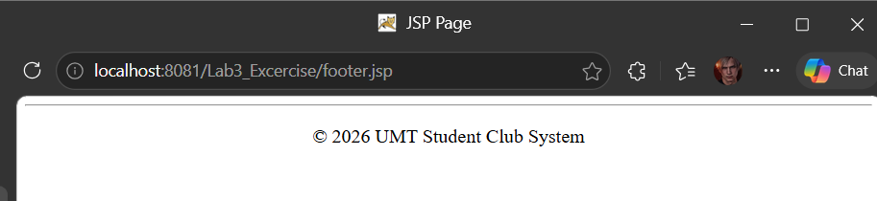

- Create a registration form in registerClub.jsp that collects: • Student Name • Matric Number • Selected Club

Answer:
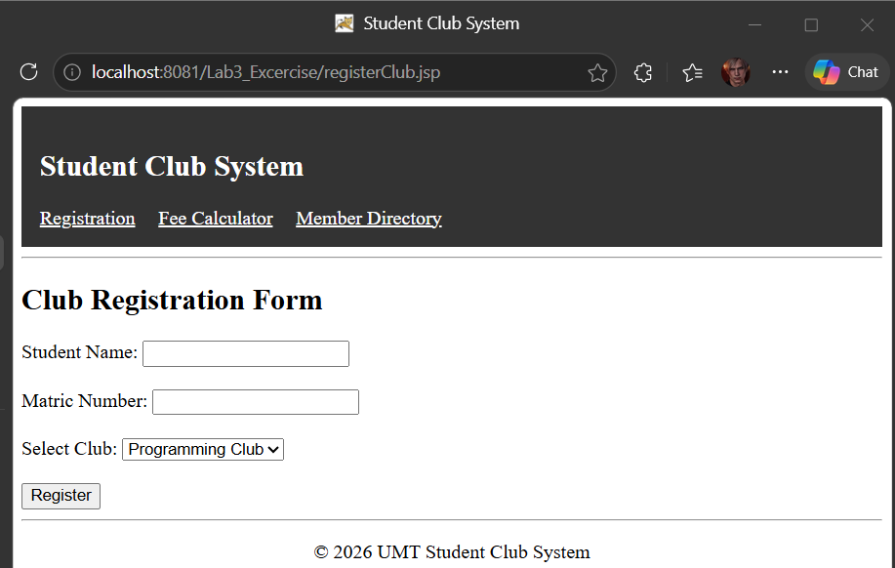

- Submit the registration form to processRegistration.jsp and display all submitted information using request.getParameter().
Answer:

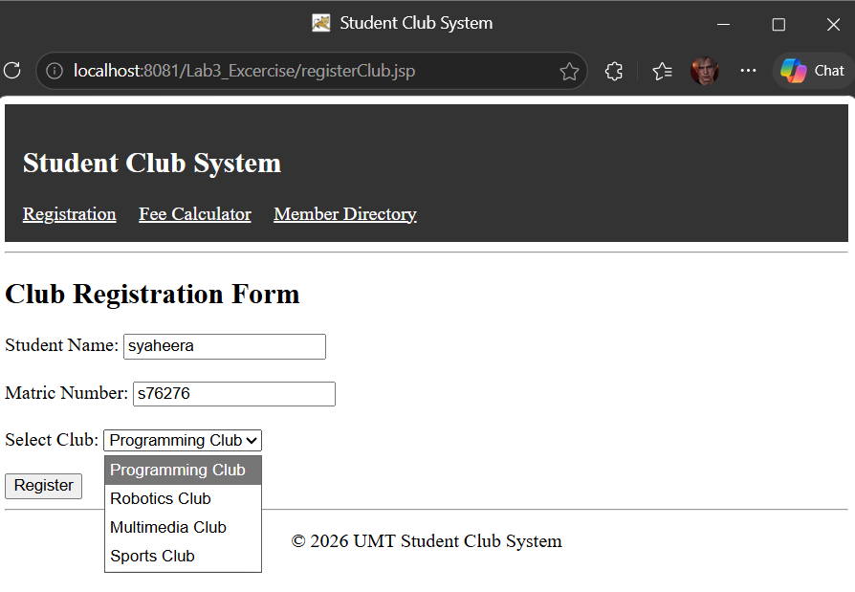
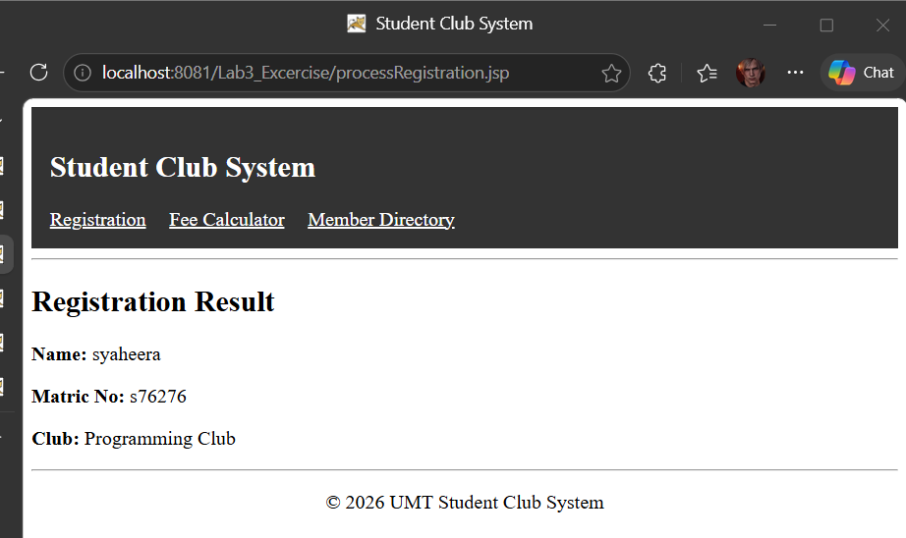

- Create a membership fee calculator in feeCalculator.jsp that:
• Accepts the number of activities joined.
• Calculates the total fee where each activity costs RM10.
• Displays the final amount formatted to 2 decimal places.
Answer: 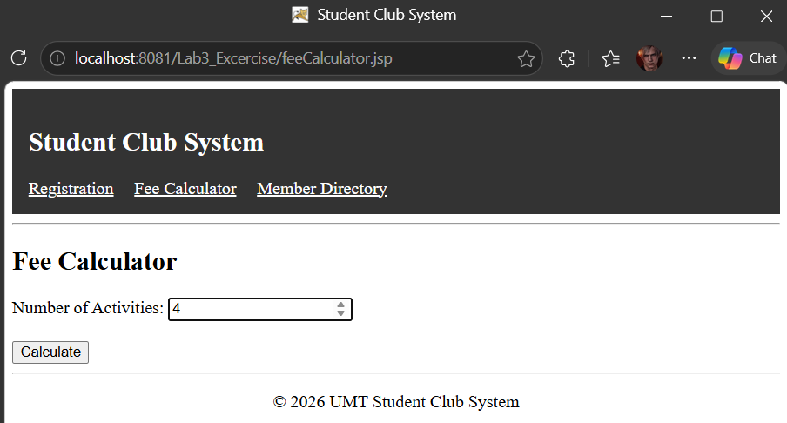

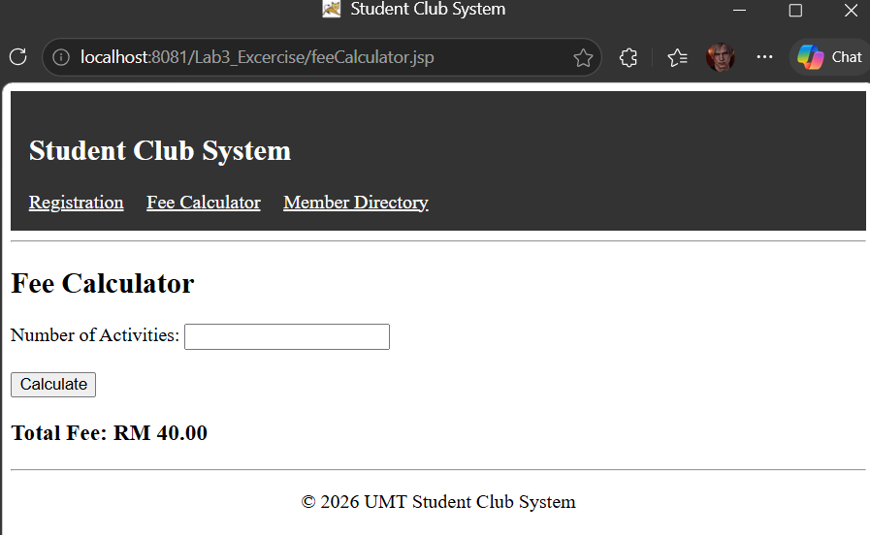

- Create a club member directory page in memberDirectory.jsp that:
• Uses JSP Page Directive to import the required Java API.
• Stores at least five committee member names using an ArrayList.
• Dynamically displays the names in an HTML table.
Answer:
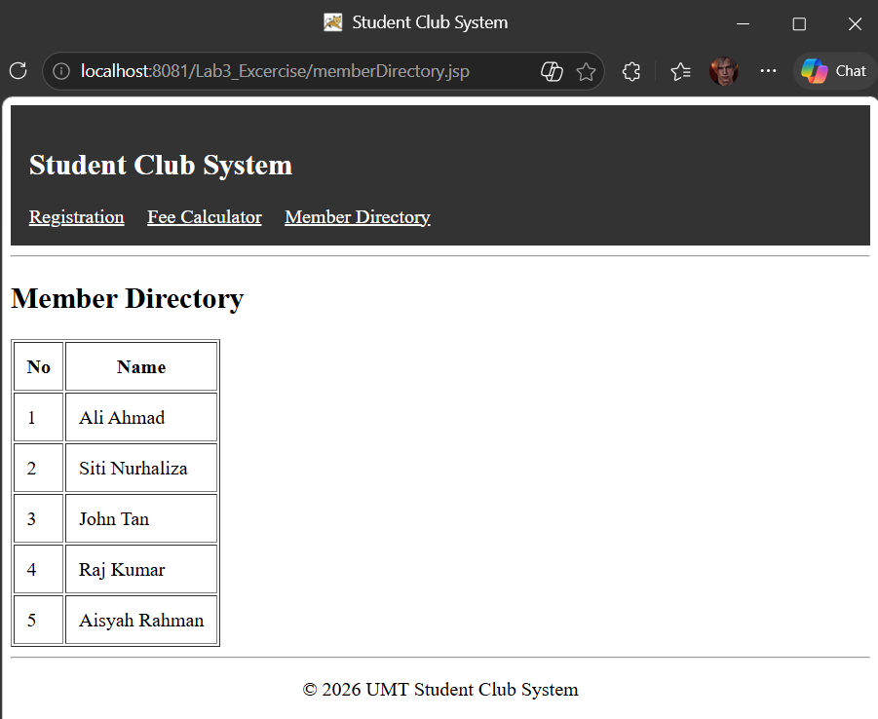

Code:

