1.

1. ture
2. false, the *is-a* relationship represents inheritance, not composition.
3. false, A Student class has a *has-a* relationship with the Faculty and Course classes.
4. ture
5. ture

2.

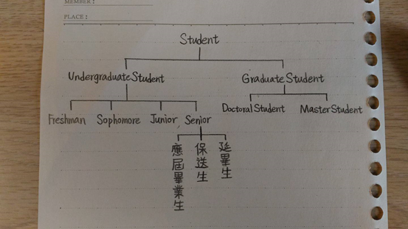

Undergraduate Student 和 Graduate Student繼承了 Student

Freshman, Sophomore, Junior, Senior 繼承了 Undergraduate Student和 Student

Doctoral Student 和 Master Student 繼承了 Graduate Student 和 Student

應屆畢業生, 保送生, 延畢生繼承了 Senior, Undergraduate Student 和 Student