Tables - Part One

<<rr_ starts a group of repeating rows
<<er_ ends a group of rows

Rows that contain an <<rr_ or <<er_ instruction are removed.
The rows between the start/end markers are filled with the data.

A Simple Table

<<rr_animals>>
<<type>> | <<color>> | <<name>>
<<er_animals>>

Setting Table Properties

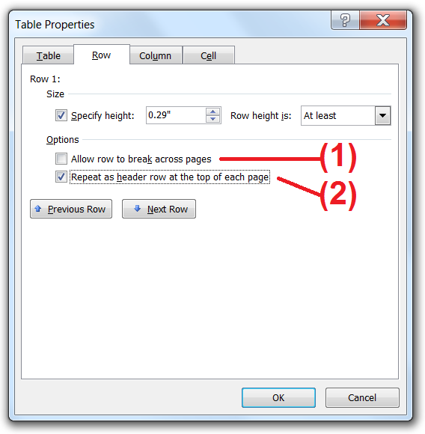 | The table below has:  - “Allow row to break across pages” - deselected for every row.  - “Repeat as header row at the top of each page” – selected for the first row.  - When the table is filled with data it will extend over the page.

This row will always appear as a Header Row.
<<rr_animals>>
Everybody knows that
<<name>> the <<type>>
is <<color>>
<<er_>>

Built-in variables for numbering rows

Type | Value of “rowidx” | Value of “rownum”
<<rr_animals>>
<<type>> | <<$rowidx>> | <<$rownum>>
<<er_>>

Setting Paragraph Properties

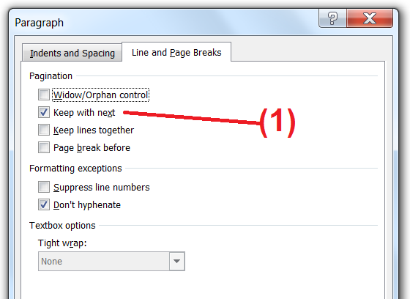 | The table below has the Paragraph Property:  - “Keep with next” - selected for the cells in row A.  - “Keep with next” – deselected for all the other cells.  This will ensure that row A “sticks” with row B if the table breaks over a page.

A table that runs over the page
<<rr_animals>>
A | I want to keep the (A) row | <<name>>
B | With the (B) row | <<type>>
<<er_>>

Note: This example was set-up so that when the table is filled with data, even though there is enough room for the A row with “Miss Piggy” to fit on the bottom of the table on the previous page, it has been pulled on to the this page. The “Keep with next” property will ensure that it “sticks” to the B row.

