1.工作流结构：
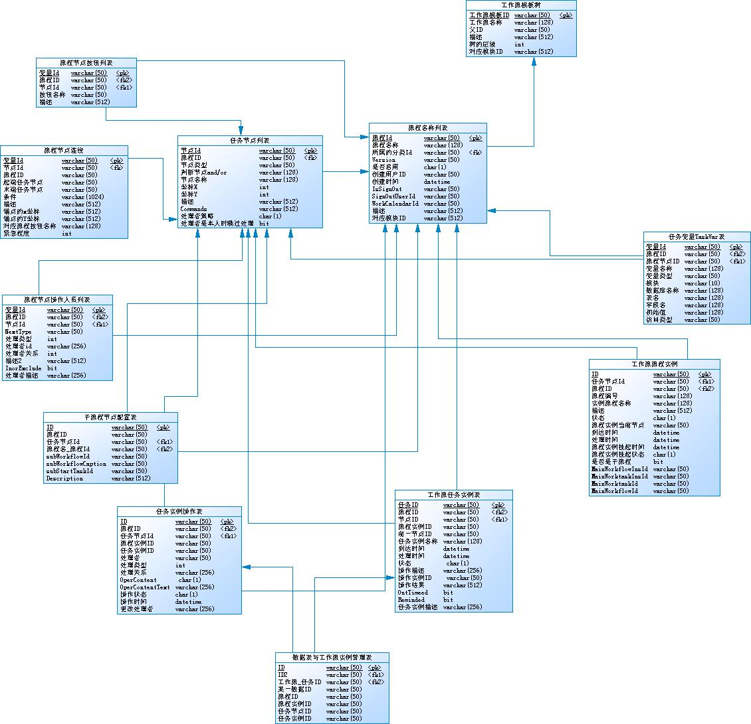
工作流模板树WF_WorkFlowClass：存储树结构，起始节点FatherId=####
WF_WorkFlow：存储流程列表
WF_WorkTask：存储流程的任务节点列表
WF_SubWorkFlow：存储子流程节点列表
WF_WorkTaskCommands：存储流程的任务节点命令按钮列表
WF_WorkLink：存储流程的任务节点连线列表
WF_TaskVar：存储流程的任务变量列表
WF_Operator：存储流程节点操作人员列表
WF_WorkFlowInstance：工作流流程实例列表
WF_WorkTaskInstance：工作流任务节点实例表
WF_OperatorInstance：任务实例操作记录表
WFP_RecordWorkTaskIns：数据表与工作流实例关联表

2.流程新建：

a)新建分类：
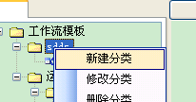

b)新建流程：
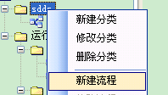

c)选择对应模块,并启用。
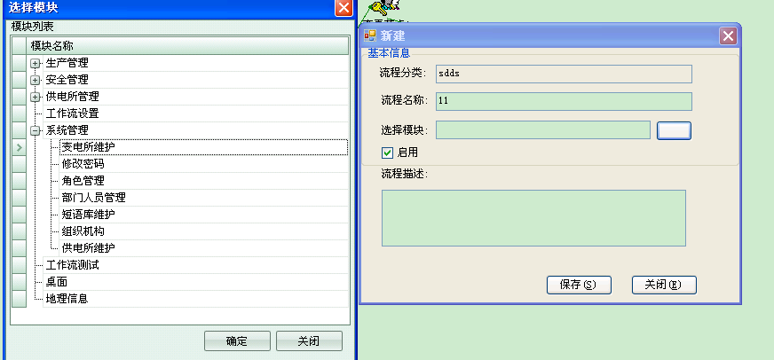
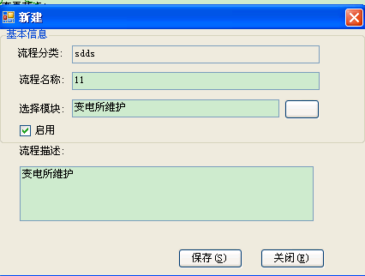
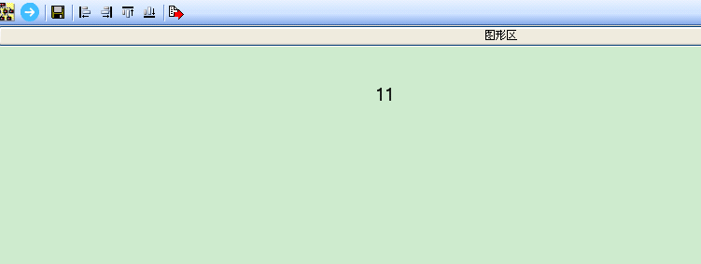

D）绘制流程
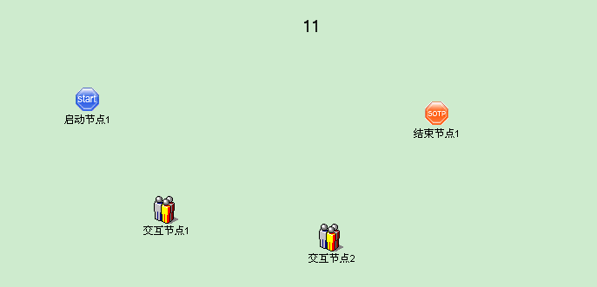

1）增加处理命令：
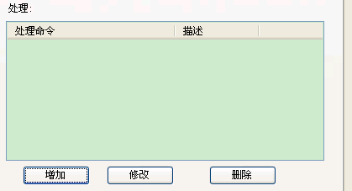
一个节点必须有一个命令按钮。
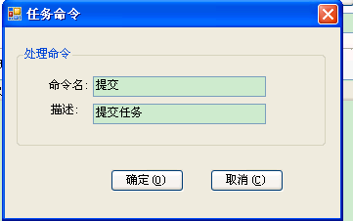
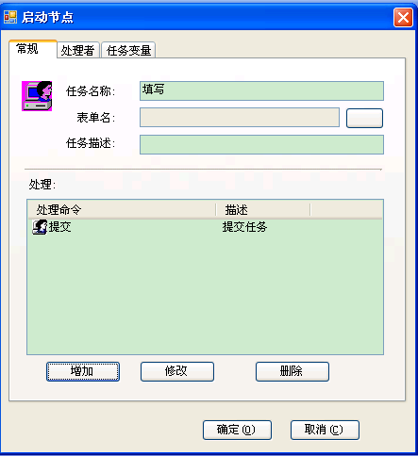

2）增加处理者：
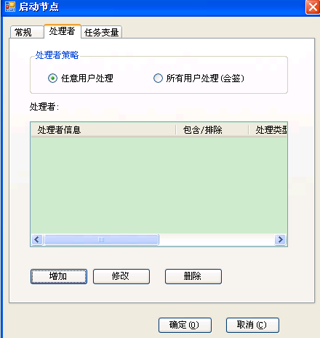
选择通过角色限制：
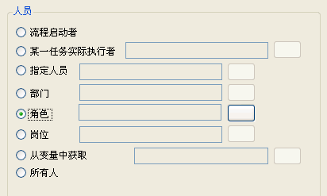
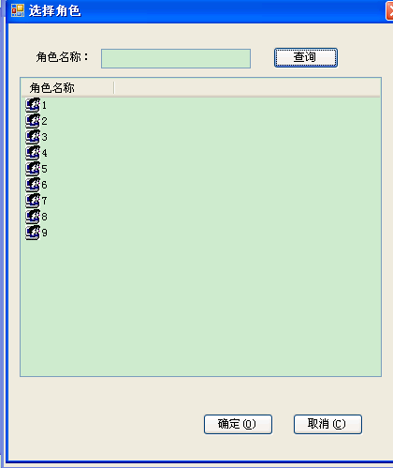
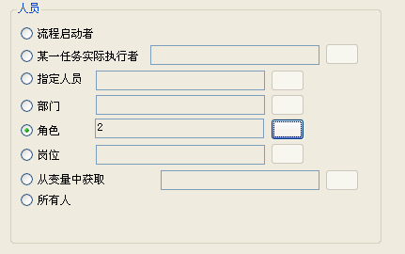

3）连接节点
选中连线按钮：
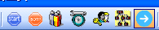
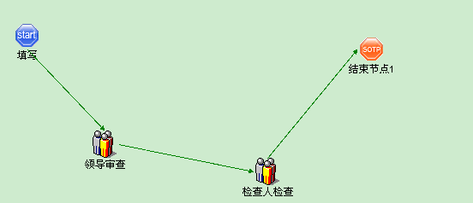

3接口：

a)创建流程：
/// <summary>
/// 创建流程
/// </summary>
/// <param name="userID">用户ID</param>
/// <param name="WorkFlowId">流程ID</param>
/// <param name="workTaskId">任务ID</param>
/// <param name="workFlowInstanceId">流程实例ID</param>
/// <param name="WorkTaskInstanceId">任务实例ID</param>
/// <param name="FlowCaption">流程名称</param>
/// <param name="command">按钮命令名称</param>
/// <returns>返回流程执行结果</returns>

public static string CreatWorkFlow(string userID, string WorkFlowId, string workTaskId, string workFlowInstanceId, string WorkTaskInstanceId, string FlowCaption, string command)
{
WorkFlowRuntime wfruntime = new WorkFlowRuntime();
wfruntime.UserId = userID;
wfruntime.WorkFlowId = WorkFlowId;
wfruntime.WorkTaskId = workTaskId;
wfruntime.WorkFlowInstanceId = workFlowInstanceId;
wfruntime.WorkTaskInstanceId = WorkTaskInstanceId;
wfruntime.WorkFlowNo = WorkFlowInstance.GetWorkflowNO();
wfruntime.CommandName = command;
wfruntime.WorkflowInsCaption = FlowCaption;
wfruntime.IsDraft = false;//保存并执行流程流转
wfruntime.Start();
return Toollips(wfruntime.WorkTaskInstanceId);
}
实例：参见运行分析（frmyxfxEdit.cs，RecordWorkTask.cs）
RecordWorkTask.RunNewYXFXRecord(rowData.ID, yxfx.type);
/// <summary>
/// 创建运行分析流程
/// </summary>
/// <param name="recordID">记录ID</param>
/// <param name="recordIkind">运行分析记录种类</param>
/// <returns>流程创建结果</returns>
public static string RunNewYXFXRecord(string recordID, string recordIkind)
{
DataTable dt = null;
string command = "", workFlowId = "", workTaskId = "", flowCaption = "", workFlowInstanceId = "", workTaskInstanceId = "";
if (MainHelper.UserOrg.OrgName.IndexOf("供电所") > -1)
{
if (recordIkind == "定期分析")
{
dt = WorkFlowTemplate.GetSelectedNameWorkFlows(MainHelper.User.UserID, "供电所定期分析");
}
else if (recordIkind == "专题分析")
{
dt = WorkFlowTemplate.GetSelectedNameWorkFlows(MainHelper.User.UserID, "供电所专题分析");
}
}
else if (MainHelper.UserOrg.OrgName.IndexOf("局") > -1)
{
if (recordIkind == "定期分析")
{
dt = WorkFlowTemplate.GetSelectedNameWorkFlows(MainHelper.User.UserID, "局定期分析");
}
else if (recordIkind == "专题分析")
{
dt = WorkFlowTemplate.GetSelectedNameWorkFlows(MainHelper.User.UserID, "局专题分析");
}
}
workFlowId = dt.Rows[0]["WorkFlowId"].ToString();
workTaskId = dt.Rows[0]["workTaskId"].ToString();
flowCaption=dt.Rows[0]["FlowCaption"].ToString();
workFlowInstanceId=Guid.NewGuid().ToString();
workTaskInstanceId = Guid.NewGuid().ToString();
DataTable taskCommand = WorkFlowTask.GetTaskCommands(workFlowId,workTaskId);
if (taskCommand.Rows.Count > 0)
{
command = taskCommand.Rows[0]["CommandName"].ToString();
}
else
{
command = "提交";
}
string strmes = CreatWorkFlow(MainHelper.User.UserID, workFlowId, workTaskId, workFlowInstanceId, workTaskInstanceId, flowCaption, command);
WFP_RecordWorkTaskIns wpfrecord = new WFP_RecordWorkTaskIns();
wpfrecord.RecordID = recordID;
wpfrecord.WorkFlowId = workFlowId;
wpfrecord.WorkFlowInsId = workFlowInstanceId;
wpfrecord.WorkTaskId = workTaskId;
wpfrecord.WorkTaskInsId = workTaskInstanceId;
if ( strmes.IndexOf("未提交至任何人")== -1) MainHelper.PlatformSqlMap.Create<WFP_RecordWorkTaskIns>(wpfrecord);
return strmes;
}

b)执行流程：
/// <summary>
/// 执行流程
/// </summary>
/// <param name="userID">用户ID</param>
/// <param name="OperatorInsId">操作ID</param>
/// <param name="WorkTaskInsId">任务记录ID</param>
/// <param name="command">命令名称</param>
/// <returns>返回流程执行结果</returns>
public static string RunWorkFlow(string userID, string OperatorInsId, string WorkTaskInsId, string command)
{
WorkFlowRuntime wfruntime = new WorkFlowRuntime();
//wfruntime.RunSuccess += new WorkFlowRuntime.RunSuccessEventHandler(wfruntime_RunSuccess);
//wfruntime.RunFail += new WorkFlowRuntime.RunFailEventHandler(wfruntime_RunFail);
wfruntime.Run(userID, OperatorInsId, command);
return Toollips(WorkTaskInsId);
}
实例：参见运行分析（frmyxfxEdit.cs，RecordWorkTask.cs）：
string strmes = RecordWorkTask.RunDQFXRecord(rowData.ID, WorkFlowData.Rows[0]["OperatorInsId"].ToString(), WorkFlowData.Rows[0]["WorkTaskInsId"].ToString(), "提交");
if (strmes.IndexOf("未提交至任何人") > -1)
{
MsgBox.ShowTipMessageBox("未提交至任何人,创建失败,请检查流程模板和组织机构配置是否正确!");
return;
}
else
MsgBox.ShowTipMessageBox(strmes);
/// <summary>
/// 执行流程
/// </summary>
/// <returns></returns>
public static string RunDQFXRecord(string recordID, string OperatorInsId,string WorkTaskInsId, string command)
{

WorkFlowRuntime wfruntime = new WorkFlowRuntime();
//wfruntime.RunSuccess += new WorkFlowRuntime.RunSuccessEventHandler(wfruntime_RunSuccess);
//wfruntime.RunFail += new WorkFlowRuntime.RunFailEventHandler(wfruntime_RunFail);
wfruntime.Run(MainHelper.User.UserID, OperatorInsId, command);

return Toollips(WorkTaskInsId);
//return "";
}

c)获得执行流程的结果：
/// <summary>
/// 返回任务实例的操作结果
/// </summary>
/// <param name="workTaskInsId">任务实例ID</param>
/// <returns>操作结果</returns>
public static string Toollips(string workTaskInsId)
{
string title = "";
string TaskToWhoMsg = "";
string ResultMsg = "";
TaskToWhoMsg = WorkTaskInstance.GetTaskToWhoMsg(workTaskInsId);
ResultMsg = WorkTaskInstance.GetResultMsg(workTaskInsId);
title = "操作结果:" + ResultMsg;
if (TaskToWhoMsg.Length <= 0)
{
TaskToWhoMsg = "未提交至任何人,请检查流程模板和组织机构配置是否正确!";
if (ResultMsg == WorkFlowConst.WorkflowOverMsg)//流程结束
{
TaskToWhoMsg = "流程结束!";
}
if (ResultMsg == WorkFlowConst.TaskBackMsg)
{
TaskToWhoMsg = WorkFlowConst.TaskBackMsg;
}
}

return TaskToWhoMsg = "成功提交至:" + TaskToWhoMsg + "。你已完成该任务处理,可以关闭该窗口。";
}

d)获得流程的设计图：
/// <summary>
/// 获得流程图片（Bitmap）
/// </summary>
/// <param name="recordID">记录ID</param>
/// <param name="sz">图片大小</param>
/// <returns>Bitmap</returns>
public static Bitmap WorkFlowBitmap(string recordID,Size sz)
{
Bitmap objBitmap = new Bitmap(sz.Width, sz.Height );
IList<WFP_RecordWorkTaskIns> wf = MainHelper.PlatformSqlMap.GetList<WFP_RecordWorkTaskIns>("SelectWFP_RecordWorkTaskInsList", "where RecordID='" + recordID + "'");
if (wf.Count == 0) return null;
objBitmap=WorkFlowInstance.WorkFlowBitmap(wf[0].WorkFlowId, wf[0].WorkFlowInsId, sz);
return objBitmap;
}
实例：参见运行分析（frmyxfxEdit.cs，RecordWorkTask.cs）：
/// <summary>
/// 刷新数据
/// </summary>
/// <param name="slqwhere">sql where 子句 ，为空时查询全部数据</param>
public void RefreshData(string slqwhere)
{
//gridViewOperation.RefreshData(slqwhere);
if (gridtable != null) gridtable.Rows.Clear();
IList<PJ_03yxfx> li = MainHelper.PlatformSqlMap.GetList<PJ_03yxfx>("SelectPJ_03yxfxList", slqwhere);
if (li.Count != 0)
{
gridtable = ConvertHelper.ToDataTable((IList)li); }
else
{
if (gridtable == null) gridtable = new DataTable();
}

if (!gridtable.Columns.Contains("Image")) gridtable.Columns.Add("Image", typeof(Bitmap));
int i = 0;
for ( i = 0; i < gridtable.Rows.Count; i++)
{
gridtable.Rows[i]["Image"] = RecordWorkTask.WorkFlowBitmap(gridtable.Rows[i]["ID"].ToString(), imageEdit1.PopupFormSize);
}
gridControl1.DataSource = gridtable;
}

