Opportunistic Escalation Analysis
5/3/2021

Goal
The goal in the proposed research is to identify threats before they arise. This has two components:
- Which actors represent threats to the US and its interests, especially those not already identified as threats? Conversely, which actors might improve relations with the US and its allies?
- Which actors might engage in opportunistic escalation if the US became constrained due to international or domestic shocks?
This is a general problem that faces all nations in the international system; e.g., what downstream consequences would occur if China and India become involved in a conflict? For the current work, however, we focus on the United States and note that this approach can be generalized to other nations. And, here we focus on a few, easy tests based on historical data to see if more work is warranted in this area. This document is a non-technical overview of our work to date.

Sample
Time frame: To answer the above questions, we completed several steps in terms of data collection and the development of measures. To provide you with initial results in a timely fashion, we limited our sample to the period 1980 – 2019 and measures are at the annual level.
Actors of interest: As an initial pass, we focused our attention on the actions of, and attitudes toward 12 countries: the United States, Russia, China, Pakistan, Iran, Saudi Arabia, Japan, South Korea, Estonia, France, the United Kingdom, and Germany.
This initial set includes two strategic rivals (Russia and China), a regional rival (Iran), two countries that the US has more ambivalent relations with (Pakistan and Saudi Arabia), two allies (South Korea and Japan), and one relatively neutral country (Estonia). In addition, we added France, the UK, and Germany to examine the impact of US constraint on our European allies.

Measuring US Constraint
US Constraint: We have developed a measure of US constraint / distraction to capture a variety of mechanisms that might limit US action. In broad terms, we believe (based on SME input and prior research) that constraint is a function of three possible sources:
- Active conflicts that the US is involved in with an emphasis on those conflicts that represent significant materiel commitment and US casualties
- US force commitments around the globe
- US political or economic distraction caused by either foreign or domestic shocks.
To population these categories, we relied on sixteen variables distributed across the following broader categories:

Variables | Source
Defense spending | World Bank, DoD
Troops levels, by region | DoD, Kane
US Casualties | DoD, Kane
Market Crises | Frieden & Lake
Economic variables | Trading Economics

The main source of constraint that is incomplete in the above is domestic political crises (i.e., apart from a response to economic shocks, which is captured). Prior work has shown that political crises of this sort are rare / not likely consequential (Frieden, et al., 2017), but we will add an improved measure if we continue the project. A simple latent variable model of the above variables produced three variables, representing active US conflicts, US defense spending / commitments, and the economy.
These latent variables define the level of US constraint; in what follows, we will however focus on the first two latent variables because they more narrowly affect the US (and not other members of our sample). Our analyses are relatively straight-forward: examine opportunistic behavior as a function of US constraint. The hypothesis here is that in periods where the US is constrained, we will see more opportunistic action by adversaries.
In the next two sections, we examine two distinct approaches to test this hypothesis. The first is a test using event data to see if cooperation and conflict vary as a function of US constraint. The second is a system level approach to see if other states align, particularly with China and Russia, as a function of US constraint.

Initial Results: Cooperation and Conflict
Data on conflict and cooperation from ICEWS: In order to measure directly how actors respond to opportunities created by US constraint, we use ICEWS event data to create dyadic measurements of verbal and material conflict and cooperation.
This is a starting point to examine whether, for example, China initiates more conflictual events during times of US distraction. While there are clear limitations to using ICEWS data, these issues are attenuated by our approach: we use custom categories and aggregate counts into annual measures.
Results: We use these yearly counts of verbal cooperation, verbal conflict, material cooperation, and material conflict for each of the 12 states of interest to ascertain if there is more or less conflict and cooperation initiated by each state while the US is constrained. Our hypothesis is that third parties will be more willing to cooperate with strategic rivals of the US and enter into or escalate conflict with our allies when the US is constrained (and unable to impose costs). We report the correlations between US distraction and raw ICEWS event data in the figures below.

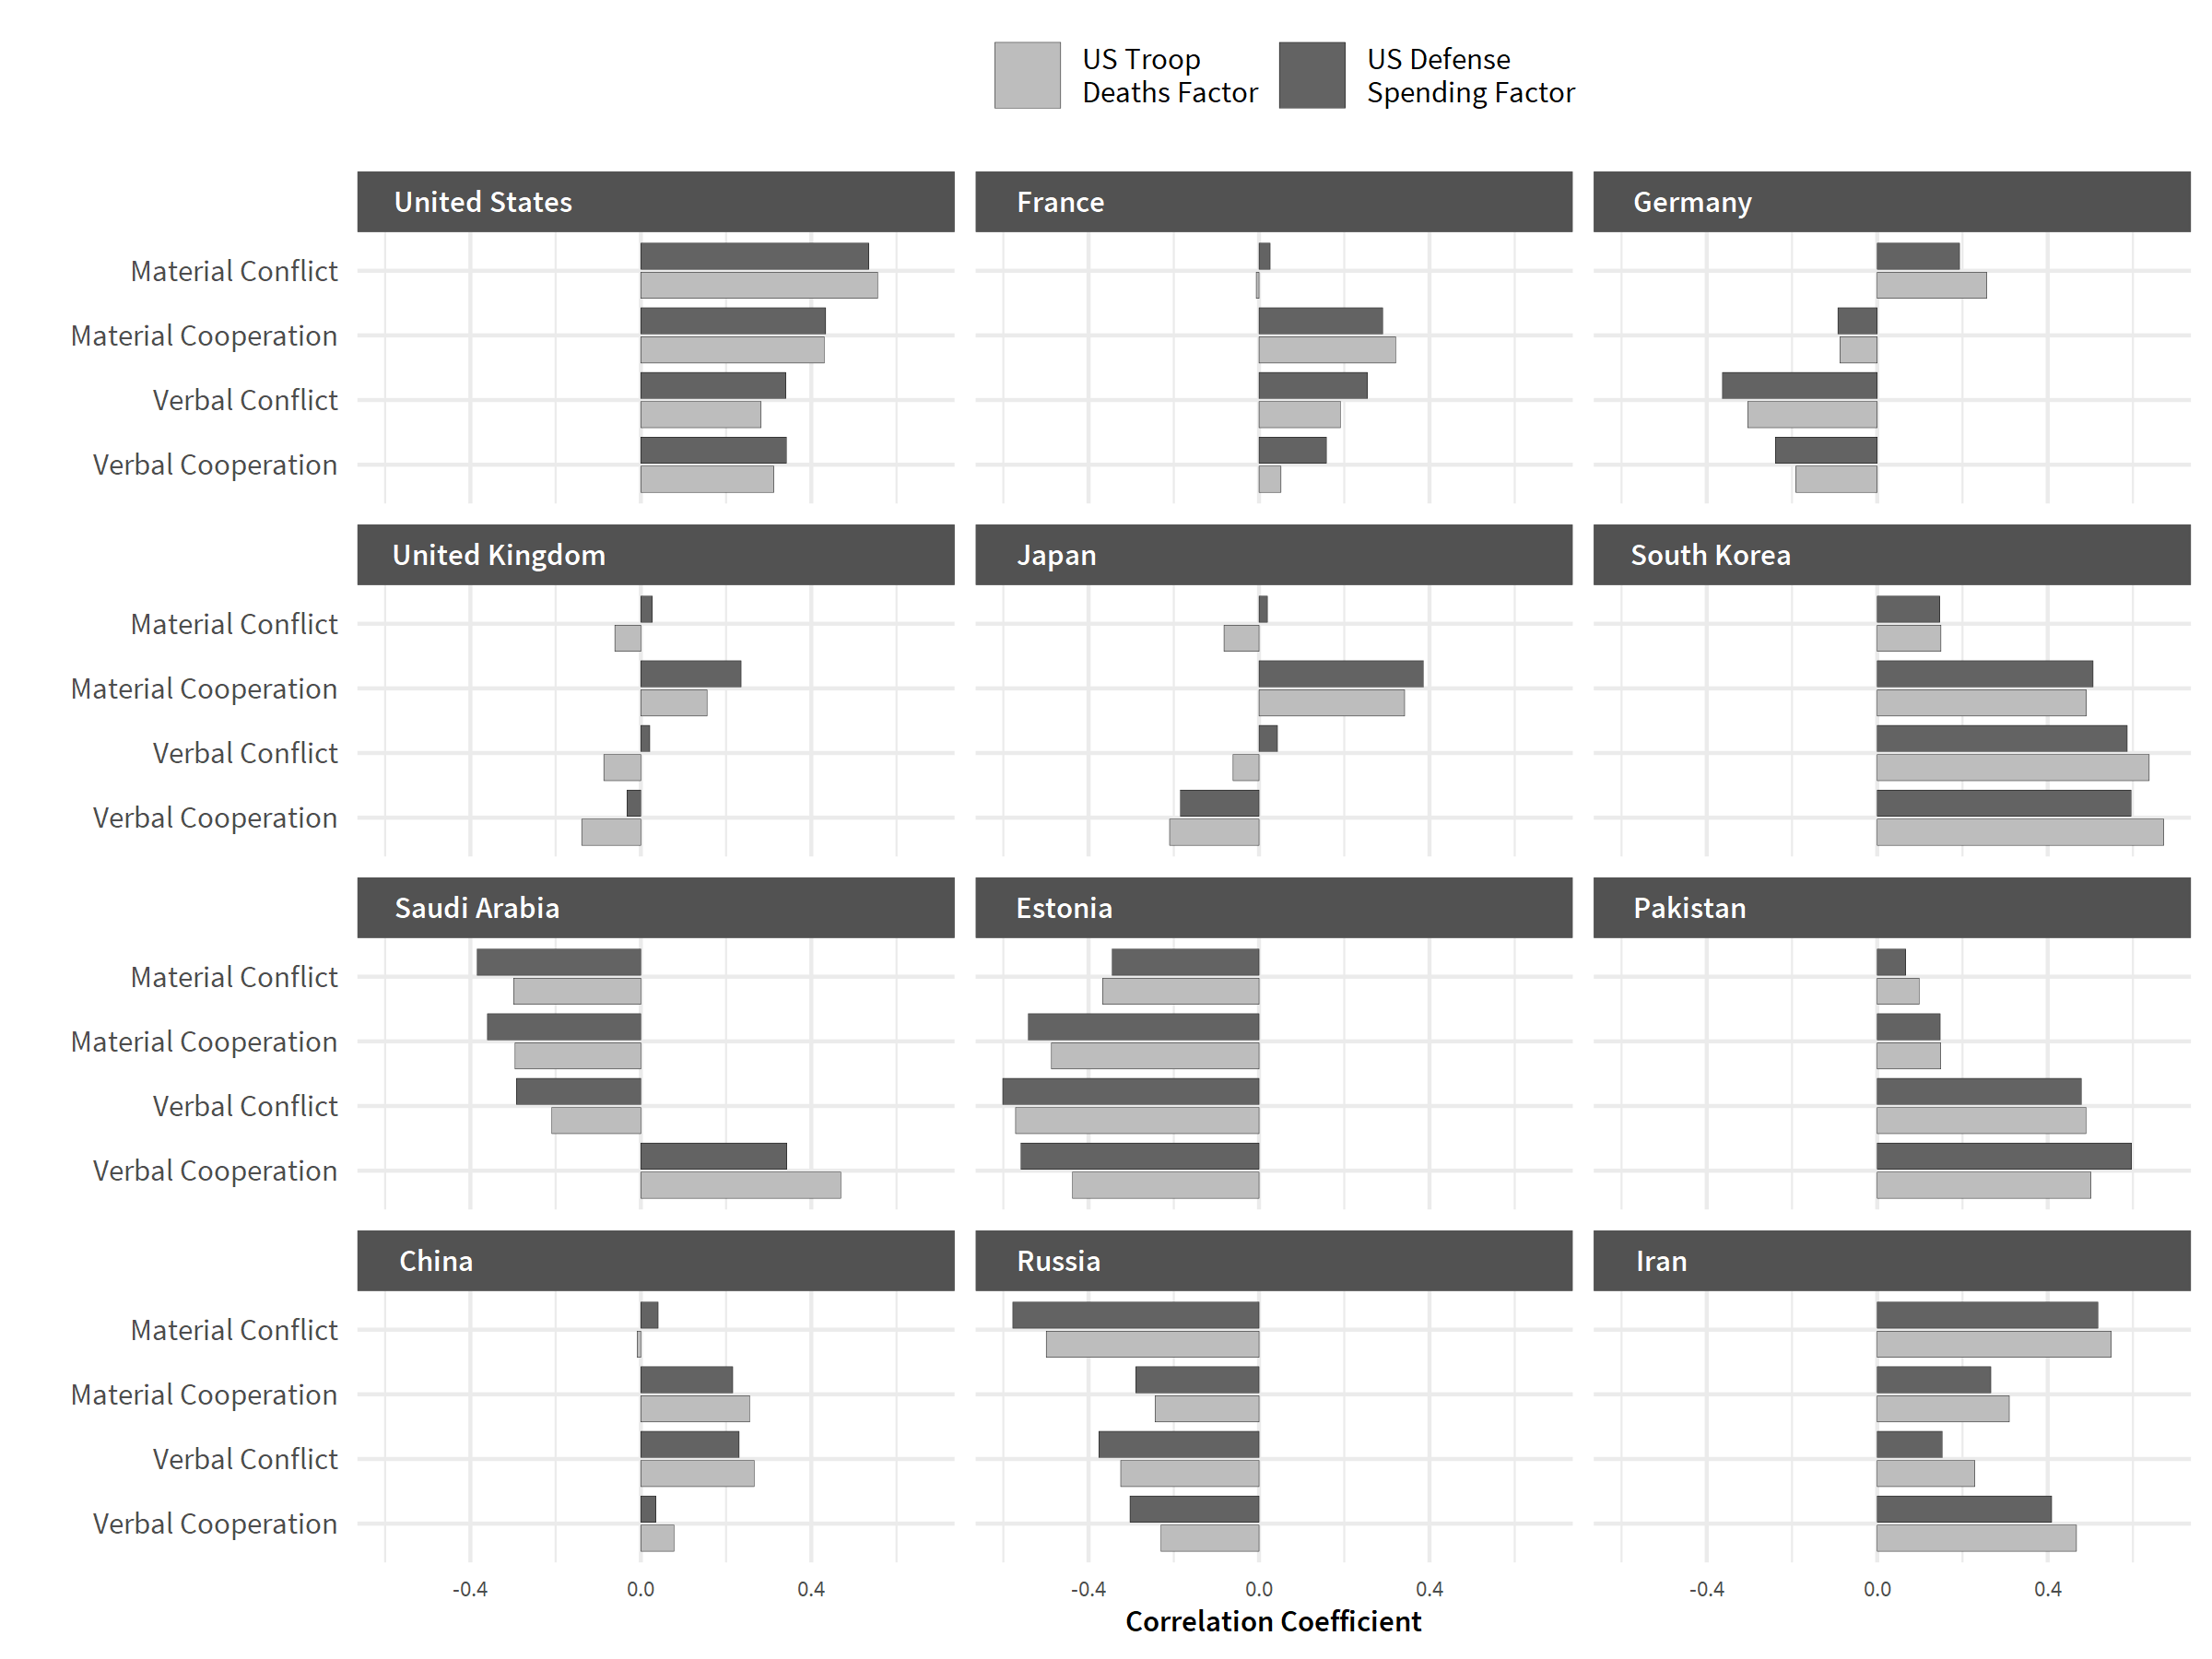

The largely positive correlation between US constraint and the conflict / cooperation measures are not entirely surprising since they generally indicate that the US is an active player in the world. More interestingly, we can also see that countries such as Iran and even allies like Germany are engaging in more material conflict when the US is distracted. Additionally, China and Iran may be taking advantage of moments of US distraction by attempting to improve relations with other countries via greater levels of material and verbal cooperation. Unexpectedly, Russia’s behavior seems to have a strong negative relationship with US distraction.
It is important to note the limitations of these analyses given their dependence on ICEWS event data. Crucially, the conflict and cooperation measures provide news coverage rather than ground truth. The volume of events varies by year, and not just in ways related to the overall eventfulness of the world. Certain regions have better media coverage which affects counts in obvious ways (though this does not likely apply to our limited set in this analysis). There is also no one-to-one mapping of a real-world event and the (possibly large) set of stories that cover it.
Most important, however, is that counts of event data treat each instance of conflict and cooperation as occurring independently (i.e., in a vacuum). For example, in 2014 we have an event of "Use conventional military force" between Russia and the Ukraine, followed by both Canada and the United States "Impose embargo, boycott, or sanctions" on Russia. The US, Germany, Japan and 9 other countries also signed a formal agreement with the Ukraine. Each of these events is independently counted in ICEWS data as an example of conflict and cooperation. A superior approach would involve aggregating ICEWS “events” to more closely align with real-world events (and the links between them).
To develop confidence in these results, we turn to an alternative approach based on similarities between states.

Initial Results: State Realignment
Data on state realignment from network analysis: This set of measures captures the responses of other nations to US constraint. Understanding how limits to US attention or capacity affect the behavior of other actors necessitates a network-based measure of the strategic interdependence of actors in the international system. This is due to the spatial nature of US constraint (in some cases) and the location of opportunistic actors. E.g., if the US is bogged down in a conflict in Africa compared to East Asia, the set of reactions that we would expect from other actors are vastly different.
Studying the behavior of countries at the system level allows us to explore not only how actors react to US constraint, but also how countries in the international system as a whole reorient themselves. While we are interested in direct effects for US constraint (e.g., states taking opportunistic actions), we are also interested in indirect effects. For example, there may be a set of states that more closely align with China as a result of the constraints imposed by US involvement in the Middle East and Afghanistan.
We address this by developing a network model that tracks how countries respond to each other as well as how the system as a whole is changing. The logic of this is that for matched states, we can make inferences about their future interactions based on the past behavior of either state separately. E.g., for two similar states A and B, if we only observe B’s interactions with another state C, that helps us understand how A and C will respond to each other even if their history of responses is sparse (Gallop and Minhas, 2020).
There has been a great deal of discussion in the international relations (IR) literature and popular press about the economic gravity of the world shifting towards China and away from the United States, for example. Our model provides a constantly updating projection of the configuration of the international system, which will enable us to study how particular crisis moments are affecting behaviors of other major powers and changing the gravitational pull that they exert on every other country.
Results: The current state of the art in academic IR scholarship seeks to estimate state preference similarity using either data from voting at the UN General Assembly, or alliance portfolio similarity. However, in their estimation of preference, IR scholarship assumes that an interaction between any particular pair of countries in the international system occurs in a vacuum. We improve substantially on these measures of preference similarity using the same raw information and acknowledging that both alliance membership and UN voting are layers of relationships that take place simultaneously and in an interdependent context. Specifically, the relations between states constitute a multilayer network. Research has shown that accounting for network structure necessitates an approach that can account for the indirect relations states share.
The essence of our approach is summarized in the figure below for the case of mapping diplomatic preferences in the international system. In the top row, we represent UN voting and alliance patterns at time t as a pair of adjacency matrices that form an evolving multilayer network. Our goal is to extract a lower dimensional representation of this system, such that the output is a series of n x n matrices, where n represents the number of actors and where the cross-sections denote our estimates of the preference similarities between countries.
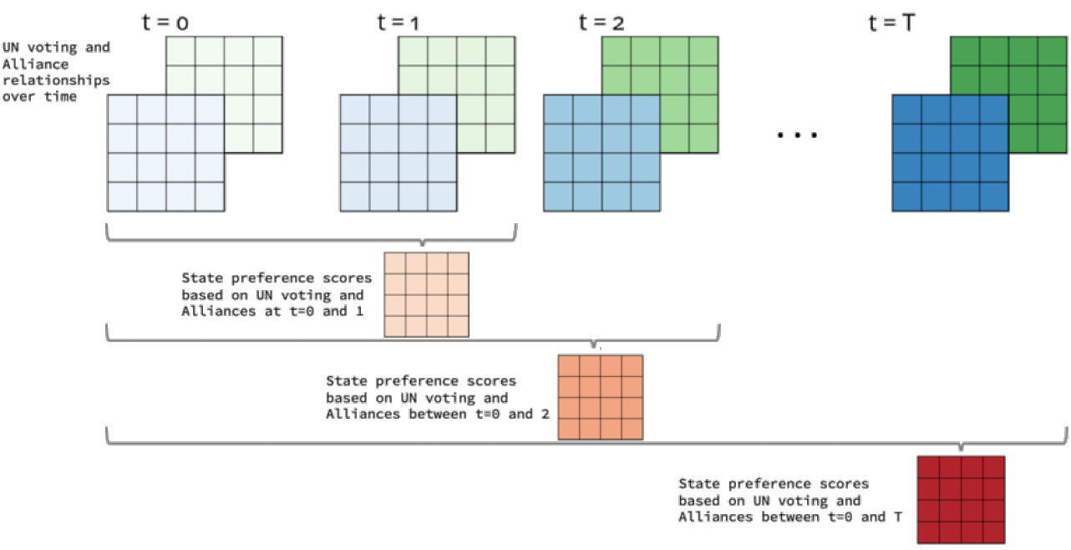
To develop a yearly measure of how a pair of states relate to one another based on multiple, longitudinal inputs we use a tensor decomposition framework, details of which can be found in Minhas, Hoff, & Ward, 2016. We employ this framework to measuring how states relate on three key dimensions:
- Diplomacy (visualization above).
    - Alliances from the Alliance Treaty Obligations and Provisions (ATOP) Project (Leeds et al., 2002)
    - UN Voting (Bailey et al., 2015)
    - Timespan of diplomacy index: 1980 to 2019
- Economics.
    - IMF Trade Flows
    - Economic Agreements as measured from the Design of Trade Agreements (DESTA) Database (Dur et al., 2014).
    - Timespan of economics index: 1995 to 2020
- ICEWS cooperation and conflict events.
    - Material Cooperation
    - Material Conflict (rescaled such that higher values correspond to less material conflict)
    - Verbal Cooperation
    - Verbal Conflict (rescaled such that higher values correspond to less verbal conflict)
    - Timespan of ICEWS index: 2000 to 2020
Both the diplomacy and economic dimensions are based on traditional IR variables that provide a measurement of how states relate to one another annually. The downside of this approach is that these measures, especially alliances, are not available in real-time or in response to particular events. The measure of state preference that we obtain using ICEWS inputs comes with the benefit of occurring in real-time but has the disadvantages listed above. Higher values on any of these measures indicates that states are more similar to one another based not only on their direct ties but also on ties to third parties.
To run our correlation analysis between these measures of state preference and our measures of US constraint, we aggregate each of these measures to the country-year level via a simple average. For example, to generate an economic similarity value for China we take the economic state preference measure that we calculate using our tensor decomposition and average together all the of the values between China and other countries in a particular year. This provides us with a crude representation of how the world is perceiving China on this dimension; higher values over time would indicate that more countries in the world are shifting to China’s sphere of orbit and vice versa. Correlation results between these measures are shown below.

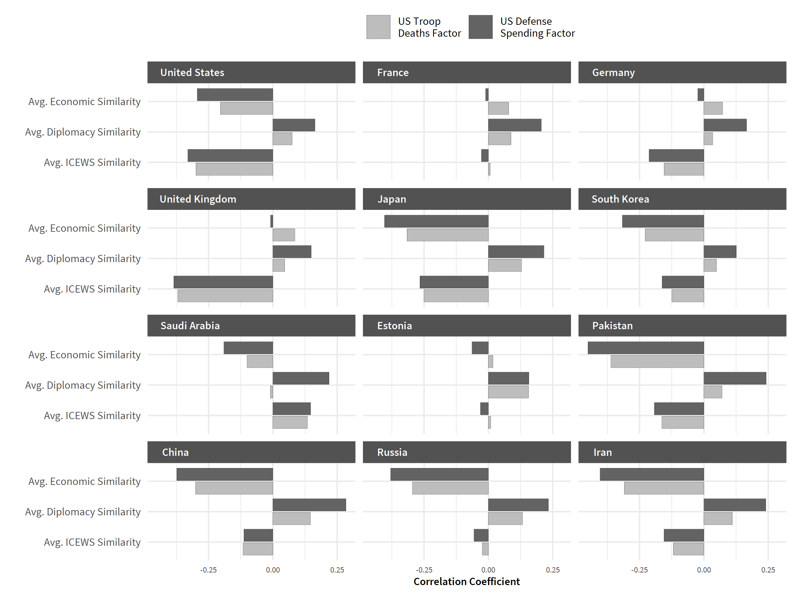

We find some evidence that the world is drifting away from the US during periods of US distraction over the last two decades, at least on the basis of our economics and ICEWS variables. Additionally, despite frequent popular press claims, there is at present little evidence that the world is notably drifting towards China or Russia in terms of the economic and ICEWS variables during periods of US constraint. More interestingly, it seems as though more and more countries are moving away from Russia’s economic sphere of influence.

Next Steps
We have a number of extensions we have not completed due to time constraints but that are underway:
- We have successfully built an alternative measure of state similarity based on a large number of variables detailing economic, political, and cultural features of states. Most commonly, researchers have assumed linearity and used PCA to uncover these dimensions. The downside to this approach is that most researchers believe that there are nonlinear relationships in the data as well as “local” neighborhood effects for different regions. Our approach explored non-linear mappings between the input variables and the latent space using a neural networks based autoencoder approach (for an overview, see de Marchi and Stewart, 2020). We are currently determining what the best approach is to interpreting these latent variables and comparing them to the results of our network model. At present, we are using scores which assess proximity to the US. While this isn’t as general as we would like, it does allow us to discover states that are more or less “close” to the US than one would expect. This analysis is complementary to the forgoing network based work, but depends on a much larger set of input variables.
- We would like to expand our analysis to look at other outcomes of interest, in particular, whether autocratic governments become more repressive / fragile democracies are more likely to slide into autocracy when the US is constrained. We have done a first pass using polity scores at the annual level, but we have concerns about the quality of these data and are looking to develop better measures before sending you results.
- The results presented here are a blunt first attempt to see if the work is worth continuing. Given they are purely correlational, we would like to work on better models to pin down the effects of US constraint. In particular, we would like to disaggregate results by region and use finer grain results to build a “what if?” engine. I.e., we would like to provide support to planners on what to expect if the US becomes constrained, who the most likely actors are that would engage in conflict with the US or its allies, and where this conflict would occur. As part of this, we should adjust for the fact that not all states are of equal strategic interest.
- Additionally, though the MLTR model that we focus on here provides useful information, it is not only the network model that we can use for this problem. The latent factor model (see Hoff 2005; Minhas, Hoff, & Ward 2019; Dorff, Gallop, & Minhas 2020; Huhe, Gallop, & Minhas 2021) has also proven to be a very flexible model for estimating some underlying dimension of preference from networks. We show results using this framework below:
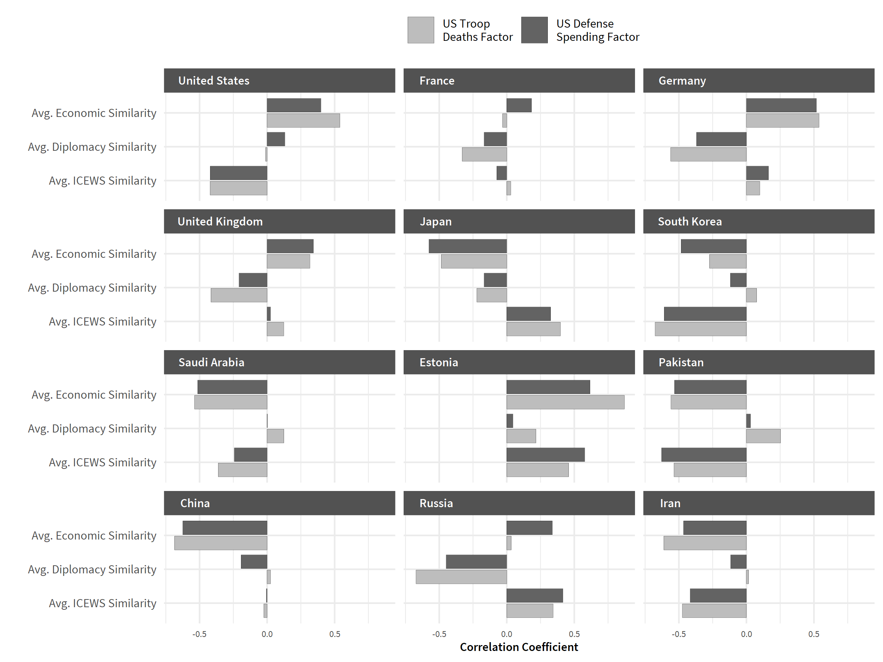
However, arbitrating between which model is the right choice here is rather difficult. An important next step is to focus in on a key variable that we might want to predict using these measures of state preference, and then determining which one in an out of sample setting performs best.

It is possible to extend the sample, but trustworthy historical measures are harder to come by and there are regime effects that would need to be accounted for. It is also possible to go finer – e.g., focus on observations at the monthly or quarterly level.
Adding a larger set of nations would improve the analysis, but this initial set was suggested by our SME input and JWAC.
A PCA with three latent variables explained 89% of the variance in the raw data, which is great. Scree plots / an examination of eigenvalues supported the use of three latent variables.
We focus on the first two dimensions of US constraint in these results. Economic shocks, while interesting, are not in most cases confined to the US and we need to do more work to determine how best to use the third constraint variable.
These categories conflate cooperation and the cessation of conflict in ways that can confuse analysis ("retreat or surrender militarily" and "cooperate militarily" are both considered cooperation) while also including a number of neutral actions as examples of verbal cooperation (e.g., "decline comment" and "deny responsibility"). We thus curate a list of event types before aggregating into our four conflict / cooperation measures.
We have access to superior measures of state cooperation and conflict based on in-house event data and could use these measures for future work. The current limitation to our in-house event data are that they are focused solely on Russia and China.
Note that the US is included in this list of 12 states, which complicates interpretation given that US constraint could in some cases be a function of ties to these states. If we expand to the entire international system, we will have to address this issue.
Note that we are not at present conditioning these results on constraints faced by nations other than the US. This would be an important extension of the results.
In our view, any level of granularity finer than a year (e.g., quarterly or monthly) would have to take these issues seriously.

