ARGUS: An AI Multi-Agent Debate System with ML Argument Evaluation
Dr. Vinod Biradar  Dept. of Computer Science and Engg.  KLE College of Engg. and Technology  Chikodi, Karnataka, India  Project Guide | Sanket Tengale  Dept. of Computer Science and Engg.  KLE College of Engg. and Technology  Chikodi, Karnataka, India  2KD24CS413 | Rohit Jarali  Dept. of Computer Science and Engg.  KLE College of Engg. and Technology  Chikodi, Karnataka, India  2KD23CS073

Om Shah  Dept. of Computer Science and Engg.  KLE College of Engg. and Technology  Chikodi, Karnataka, India  2KD24CS404 | Sohail Inamadar  Dept. of Computer Science and Engg.  KLE College of Engg. and Technology  Chikodi, Karnataka, India  2KD24CS416

Abstract—Multi-agent debate improves the reasoning quality of large language models (LLMs), but the worth of such a system rests on whether its adjudicator can be believed. Automated LLM judges favour position and verbosity, and compress their scores into a band so narrow that the winning margin carries no information. This paper presents ARGUS, a real-time debate platform in which two locked-stance agents argue over a WebSocket event stream and are adjudicated by a pipeline built on the assumption that a language model is a capable reader and an unreliable arbiter. Every specific a debater cites is checked against a reference corpus by an entailment step independent of the scorer; refutation carries a burden of proof that support does not; and the verdict is issued as a conformal prediction set, so the system declines to name a winner when the scores do not separate one. Measuring a fine-tuned scorer on real debates with audience-decided outcomes, we find it changes its verdict on 81.2% of them when the two side labels are exchanged — reading the label, not the argument. We remove this by counterbalancing during training rather than at inference, entering every debate once in each labelling. Verdict instability falls to 7.3% and agreement with the audience rises from 62.3% to 90.6% on identical debates (exact McNemar, p = 3.4 x 10^-5), with 79.5% on a larger held-out set, comparable to the 77-79% [18] report for human annotators on this corpus, though on a different sample. We propose the rate at which a verdict survives label exchange as a bias metric for automated judges.
Keywords—multi-agent systems, large language models, argument evaluation, LLM-as-a-judge, evaluator bias, conformal prediction, retrieval-augmented generation, textual entailment, selective prediction, real-time systems
I. Introduction
Adversarial debate is among the oldest instruments for exposing a weak argument. Each side must hold a fixed position, answer the strongest objection raised against it, and do so before a neutral adjudicator. Recent work shows the protocol transfers to language models: when several instances argue and critique one another across rounds, the resulting answer is measurably better than what a single model produces reasoning alone [1], [2].
The evaluation problem this creates is harder than the generation problem it solves. A debate produces two fluent, confident, mutually incompatible texts per round, and deciding which was better is a judgement about evidence and inference rather than a matter of form. The usual answer is to ask a further model to score the exchange, an arrangement commonly called LLM-as-a-judge [3]. It scales, and on aggregate benchmarks it tracks human preference reasonably well. It is also biased in ways that are well documented: evaluators favour a particular position in the ordering, favour length, and respond to surface markers of authority rather than to the substance behind them [4], [5].
Developing ARGUS produced a sharper version of the same difficulty. An early implementation used the obvious rubric: score Evidence, Logic and Relevance from 0 to 10, with the labels visible and no statement of what any score meant. The result was not merely noisy but systematically uninformative. Scores clustered near the top of the range so margins meant nothing; credit went to whichever side described its own case as evidence-based, whether or not anything checkable was cited; naming a fallacy earned credit even when the label did not fit; scores rose while an agent restated its position verbatim; and the free-text verdict occasionally named a winner contradicting the totals it had been handed.
A later incident sharpened the point. A fine-tuned scorer served over a remote endpoint was found to be reading a prompt template incompatible with its tokenizer. Lacking any turn boundary, it ignored the exchange it had been sent, regenerated a debate from its own training distribution and scored that. Its output was well-formed, its scores were plausible, and every health indicator reported normal operation. Nothing in the numbers revealed the fault. This is the observation on which the present work turns: a judge scoring invented content produces output statistically indistinguishable from a judge scoring real content, and no scrutiny of the scores alone will separate them. Only grounding against a source external to the judge can.
Every defect listed above belongs to the adjudicator rather than to the debaters, and none is visible from the transcript. This paper therefore concentrates on the judge. Its contributions are:
1) A verification channel in which the specifics a debater cites are retrieved against a reference corpus and labelled by an entailment model independent of the scorer, bounding the evidence score by what can actually be confirmed and penalising claims the corpus contradicts.
2) An asymmetric burden of proof for refutation: an accusation of fabrication must quote contradicting text traceable to a retrieved passage and must survive a second check performed in isolation, because absence of evidence was observed being treated as evidence of absence, with a verdict reversed as a consequence.
3) Conformal verdict sets giving a distribution-free coverage guarantee over debate outcomes, allowing the system to abstain when the scores do not separate the alternatives — to our knowledge the first application of conformal prediction to automated debate adjudication.
4) Swap-invariant training: counterbalancing against label preference moved from inference, where it costs a second scoring pass on every round, into the training set, where every debate is presented once in each labelling. This reduces the rate at which a verdict changes under label exchange from 81.2% to 7.3% on identical debates, and we report that rate as a bias metric for numeric-rubric judges.
5) A hardened scoring pipeline that separates extraction from scoring, anchors every band of the rubric to an observable property of the text, cancels label preference by scoring each round twice with the identities exchanged, and computes every total and every outcome in code rather than in prose.
6) An evaluation against human argument-quality labels which reports agreement, Cohen's kappa, rank correlation and empirical conformal coverage, and which reports them honestly: the agreement is slight at best, and we set out what that implies rather than presenting the system as more accurate than it is.
II. Related Work
A. Multi-agent debate and LLM judges
Du et al. [1] showed that several model instances proposing and debating reasoning traces improves factual accuracy over single-model inference, and Liang et al. [2] found an explicit judge counteracts the degeneration of thought that follows when a model is asked to correct itself. Sharma and Kumar [6] propose a debate framework for decision support but supply no standard mechanism for assessing argument quality; Smith et al. [7] report inconsistent scoring across rounds; Sun et al. [8] address participation imbalance at a computational cost ruling out real-time use. ARGUS differs in treating the scoring mechanism, not the debate protocol, as the object of study.
Zheng et al. [3] established LLM-as-a-judge as a scalable proxy for human preference while cataloguing its failure modes, position and verbosity bias among them. Wang et al. [4] showed that exchanging the order of two candidates can reverse a strong evaluator's verdict and proposed evaluating both orderings; Chiang and Lee [5] found the substitution of model for human judgement task-dependent; Chen et al. [9] employ a panel of judges at substantial cost. The label-swapped double pass used here is a single-judge instance of the counterbalancing idea in [4], extended from pairwise preference to a multi-criterion numeric rubric and combined with constraints a prompt alone cannot enforce. Section VIII-B measures what that counterbalancing is worth on a scorer we trained ourselves.
B. Argument mining, verification and conformal prediction
A parallel literature analyses argument structure directly: Stab and Gurevych [10] identify claims, premises and support relations in persuasive text, Lawrence and Reed [11] survey the field, and Gretz et al. [12] contribute a corpus of arguments carrying human quality scores, used as ground truth in Section VII. ARGUS adopts the central intuition — that an argument must be decomposed before it can be judged — and makes extraction mandatory before any score. Where we depart is in what follows: the extracted specifics are checked against a corpus rather than merely recognised, which connects the pipeline to automated fact verification, where Thorne et al. [14] established the now-standard framing of a claim as supported, refuted or lacking sufficient information given retrieved evidence. Retrieval augmentation [13] supplies the material both tasks depend on.
Conformal prediction [15], [16] converts any point predictor into a set-valued one whose sets contain the true label with a user-specified probability, requiring only that calibration and test data be exchangeable and assuming nothing about the distribution of scores or the calibration of the underlying model. That independence is what makes it appropriate here: the quantity least worth trusting in an LLM judge is its own confidence. Conformal methods are established in classification and regression but, to our knowledge, have not been applied to the adjudication of generated argument. Section VI develops the construction; Section VIII reports that the guarantee holds empirically and that abstention rises exactly where the underlying judge is weak, which is the behaviour the mechanism exists to produce.
III. System Architecture
ARGUS is organised in six layers, shown in Fig. 1. A React and TypeScript single-page application forms the presentation layer; a FastAPI application served by Uvicorn provides transport, exposing one WebSocket endpoint for the debate stream alongside REST endpoints for adjudicator health, archive retrieval and audit inspection; an orchestrator sequences the debate; an agent layer generates argument text; a retrieval layer supplies and verifies evidence; and an evaluation layer scores each round and issues the final verdict together with its audit record. In deployment a single container serves both the compiled client and the API from one origin, which removes cross-origin configuration and allows the WebSocket to inherit the page's transport security.
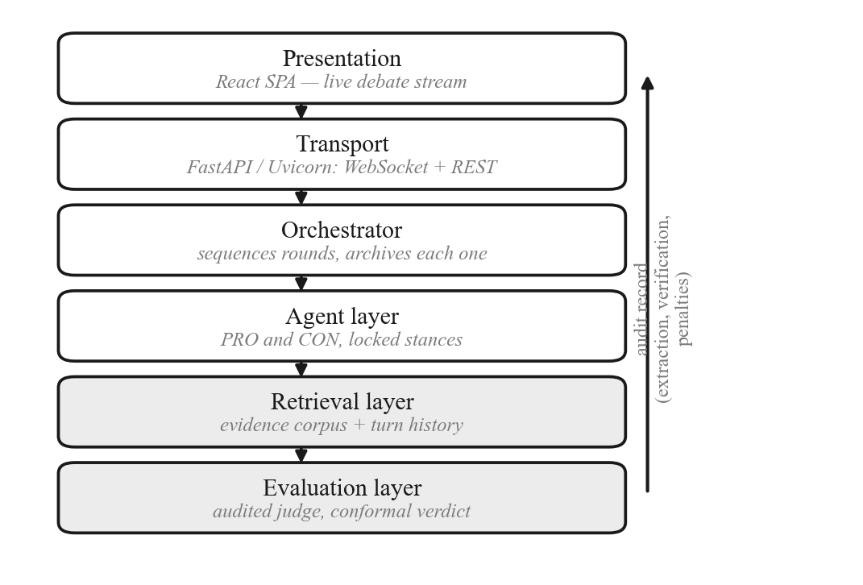
Fig. 1. Layered architecture of ARGUS. Every score reaching the user carries the extraction, verification and penalty record that produced it.
A. Stance resolution
The user's topic is resolved into two explicit stances before any agent runs. The step exists because instructing one agent to argue for a topic and another against it is wrong for comparative questions. Given “Athens or Sparta: which was the better place to live?”, the negative instruction yields an agent attacking Athens while no agent ever defends Sparta, and the exchange collapses into one-sided critique. The resolver classifies the topic as proposition or comparison and emits a canonical resolution together with an explicit stance for each side, injected into every downstream prompt.
B. Debate protocol
A debate comprises R main rounds, each containing three sub-rounds with distinct communicative functions and decreasing word budgets — 120-200 words for the opening, 100-150 for the rebuttal, 80-120 for the closing justification. PRO speaks first and CON answers, making each round a six-turn exchange. Agents are locked to their stance: the system prompt forbids concession, forcing disagreement to be settled on evidence rather than dissolved by accommodation. The default is R = 2. An earlier configuration used R = 3, giving nine speeches per side — roughly double any competitive human format — and the reduction removes a third of the adjudication cost, which is the largest predictable component of end-to-end latency because each round costs two label-swapped scoring calls whatever the debaters produce.
C. Agent layer
Each side is assigned a distinct model. The commercial inference API meters throughput per model, so putting both debaters in one quota bucket makes the second speaker fail under load while the first succeeds; separate models also stop two agents on identical weights from arguing in the same voice. Reasoning-tuned models are unsuitable as debaters despite their scale — measured on this workload, one spent 198 of 200 available completion tokens on an internal pass and returned two tokens of argument — though they remain appropriate for the judge, whose output is short structured data. Context growth is the dominant latency risk across rounds, so only the opening argument of each completed round is carried forward, leaving prompt growth linear with a small constant while the current round stays fully available to its own rebuttal agents and to the judge.
D. Retrieval layer
A persistent vector store holds two collections. The evidence collection supplies the corpus against which claims are verified in Section V, and is queried by nearest neighbour under a distance threshold; passages beyond that threshold are treated as the corpus having no opinion rather than as weak support, since an unfiltered nearest neighbour always resembles evidence. The history collection indexes completed turns by debate, round, sub-round and side. The layer degrades rather than fails: if the store cannot be reached, retrieval returns empty and the debate proceeds without verification.
E. Streaming protocol and archive
The orchestrator communicates over a typed event stream. Beyond the events carrying utterances and verdicts, two are worth noting. An acceptance event is emitted before the first upstream call, and a notice event reports when a call is waiting out a rate limit together with the expected delay. Without them a saturated quota produced several minutes of silence that was indistinguishable, from the user's position, from a failed request. Each round is archived as it completes rather than at the end of the debate, so an interrupted run retains everything it produced.
IV. The Audited Judging Pipeline
The pipeline in Fig. 2 is the core of this work. Its premise is that a language model should be used to read and never to decide.
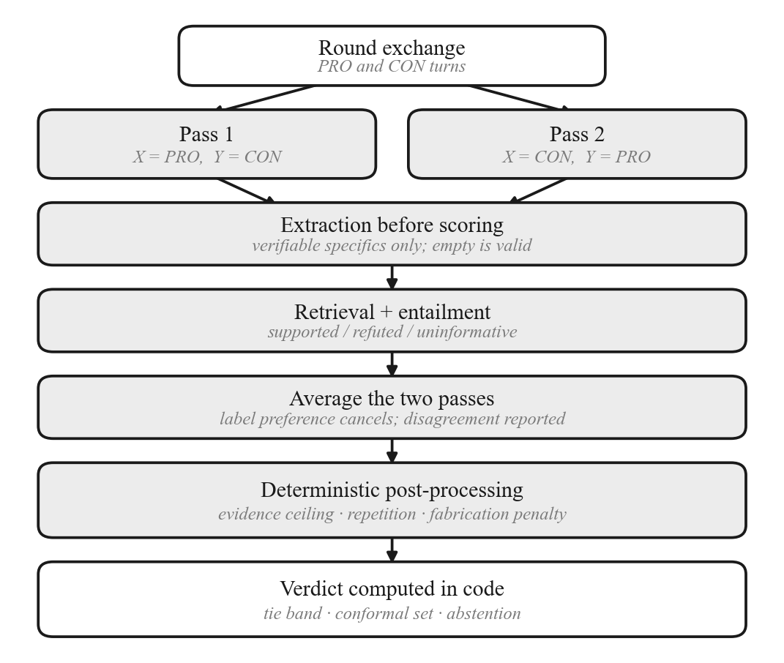
Fig. 2. Round adjudication. Two label-swapped passes are averaged, each cited specific is verified against the corpus, and deterministic rules in code fix the result.
A. Extraction before scoring
The scoring prompt is a staged procedure, and the model must complete the earlier stages in its response before emitting any number. The first extracts, per debater, the evidence actually cited, defined restrictively as a verifiable specific: a named person, date, place, event, quantity, statute, institution or work. Two categories are excluded explicitly because both attracted credit under the unanchored rubric — self-description, where a debater calls its own case empirical, and unnamed appeals to authority such as “studies confirm”. An empty list is declared common and correct, which suppresses the tendency to invent a citation to fill a required field.
Each item must be emitted as a complete, self-contained statement rather than as a span. This requirement was added after the extractor was observed returning fragments such as a bare year, which cannot be entailed or contradicted by anything and therefore force the verification stage into an uninformative verdict. Attribution follows reliance rather than mention: a specific named only to deny it belongs to neither side's list, which prevents a debater from being credited with evidence it raised in order to reject. Duplicates are collapsed, since a claim counted three times distorts the denominator that coverage and precision divide by. Later stages list unsupported claims and validate every fallacy accusation by quoting the accused text; a misapplied label lowers the accuser's logic score rather than raising it.
B. Anchored rubric
Every band of every criterion is tied to an observable property of the transcript, as shown in Table I, and the prompt states the calibration expectation directly: most real turns belong between 3 and 6, and anything above 8 must be justified by the specifics listed during extraction. Scoring runs at temperature zero.
TABLE I
Anchors for the evidence criterion
Band | Condition observable in the transcript
0–2 | Pure assertion; nothing cited
3–4 | Vague appeal to evidence with no specifics
5–6 | One concrete, checkable example
7–8 | Several specifics that carry the argument
9–10 | Precise data, dates or named sources that settle it

C. Blind label-swapped scoring
The judge never sees the strings PRO and CON. Each round is presented twice in identical turn order with the debaters labelled DEBATER-X and DEBATER-Y, the presentations differing only in which side receives which label. The returned score sets are mapped back and averaged criterion-wise, so any preference for a label cancels, and the gap between passes becomes a measurable quantity reported with every round. Fallacy accusations are filtered by agreement: an accusation survives only if both passes found it and attributed it to the same debater, since one that changes hands between passes was an artefact of labelling rather than a finding about the text. Turn order is preserved in both passes; shuffling would remove the structural advantage of speaking last along with the rebuttal chain that makes a round intelligible, so that bias is measured rather than removed.
D. Deterministic post-processing
Constraints a prompt cannot guarantee are then applied in code. An evidence ceiling caps a side's evidence score at 3.0 when its extraction list is empty, whatever the scorer returned, and this holds even when an external scorer supplies the raw numbers, so that model cannot certify evidence the extraction pass could not find. A repetition penalty follows. Let G(t) be the set of word 5-grams of a text and let C and P be the current and prior rounds' turns for one side. The repetition ratio is
r = |G(C) ∩ G(P)| / |G(C)| (1)
and the penalty is
p = min(Pₘₐₓ, 5(r − r₀)) if r > r₀, else 0 (2)
taking r₀ = 0.30 and Pₘₐₓ = 1.5. The allowance exists because a debater is obliged to keep asserting the position it holds, and reusing that framing is not in itself a failure; what the penalty targets is the case where repetition has displaced argument altogether. Only completed rounds enter P, so nothing a side says within the round under assessment can count against it. The computation is a set intersection over n-grams, which makes it deterministic, costless, and unmediated by any model. Summing gives
T = clamp( (E + L + R)/3 − p − f , 0, 10 ) (3)
where f is the fabrication penalty defined in Section V. The round winner follows a tie band,
w = tie if |Tₚᵣₒ − Tᴄₒₙ| ≤ τ, else argmax (4)
with τ = 0.5. Without such a band the system declares a victor on a margin below the resolution of its own instrument, which is how a coin toss is reported as a result.
E. Arithmetic authority
Round totals, cumulative totals, per-round winners, the overall winner, the margin, the tie flag and each side's percentage of available points are computed in code from the score record. The final model call receives these as given facts and is instructed to describe them; its free-text fields are overwritten by the computed values before the verdict is returned, and if its structured output fails to parse a deterministic verdict is assembled from the same numbers. The outcome of a debate is never a generated token. This decision was vindicated in practice: the external scorer was repeatedly observed returning a winner field contradicting the scores in the same response.
V. Retrieval-Grounded Verification
The evidence score was previously whatever the scoring model asserted it to be. A debater writing that the archaeological record clearly shows some claim could be scored as evidence-based by a model that never checked whether anything had been shown. The extraction stage of Section IV catches part of this, but extraction is the same model grading its own reading. This section closes the loop with a channel independent of the scorer.
A. Claim verification
Each extracted specific is issued as a query against the evidence corpus, and the retrieved passages together with the claim are passed to an entailment step which returns one of three labels, following the framing of [14] and summarised in Table II. The check is deliberately decoupled from the scorer: the entailment step sits behind a single interface with three selectable backends — a general model prompted as a classifier, a local cross-encoder natural-language-inference model, and a lexical-overlap baseline that establishes a floor. Every figure reported in this paper uses the general-model backend, which is the deployed configuration; the other two are implemented but were not exercised in this evaluation, and we make no comparative claim about them. The interface exists because the batching behaviour of the deployed backend is a known weakness, discussed in Section IX.
TABLE II
Verification labels and their effect on the score
Label | Condition | Effect
Supported | A passage states or implies the claim | Raises π, raises ceiling
Refuted | A passage contradicts it, quoted and confirmed | Lowers π; incurs penalty f
Uninformative | The corpus does not settle it | Excluded from π; inert

B. Bounding the score by what was confirmed
Let S, R and N be the counts of supported, refuted and uninformative claims for one side, and let A = S + R be those the corpus could adjudicate. Coverage and precision are
c = A / (S + R + N), π = S / A (5)
and the evidence ceiling is
Eₘₐₓ = 10 if A = 0, else E₀ + (10 − E₀)π (6)
with floor E₀ = 3.0, while the fabrication penalty f of (3) is proportional to R and capped. Uninformative claims are excluded from the precision denominator by design. A corpus that cannot speak to a claim reveals a gap in the corpus, not a fault in the debater, and charging the debater for it would make the score a measurement of corpus size. With no adjudicable claims the ceiling is 10 and the mechanism is provably inert; it tightens only in proportion to what the corpus can actually decide. Coverage is therefore the quantity that reports how much of a score is genuinely grounded, and it rises as the corpus grows, as Section VIII shows.
C. An asymmetric burden of proof
Refutation is the only label that costs a debater anything, and it proved the least reliable the pipeline produced. Two distinct faults were observed. The first is that absence of coverage was read as contradiction: a historically accurate claim which the corpus simply did not contain was labelled refuted, and the resulting penalty converted a win into a draw. The second is contextual instability, since the screening pass scores every claim of a round in one request and a claim's label moved with whichever other claims accompanied it — a property that would make any published figure irreproducible.
Refutation therefore now carries a burden that support does not. A refuted label survives only if the backend supplies verbatim contradicting text and that text is traceable to a passage actually retrieved, and only if the accusation is then confirmed by a second check performed on that claim alone. Anything unconfirmed is downgraded to the uninformative label, which is inert. The asymmetry is deliberate and follows from the costs involved: a missed fabrication costs a little precision, whereas an invented one corrupts the verdict. Only refuted labels pay for the additional request, so the overhead scales with how often the system accuses rather than with the size of the corpus.
VI. Conformal Verdict Sets
Every judge in this literature returns a winner. None returns an admission that it does not know, and none quantifies how often it is wrong. That matters here for a concrete reason: a margin of a fraction of a point on a thirty-point scale is not a result, and a single mislabelled claim has been observed reversing an outcome.
A. Construction
We apply split conformal prediction [15], [16]. For a round with totals Tₚᵣₒ and Tᴄₒₙ, the nonconformity score of a candidate outcome is the signed margin against it,
s(pro) = Tᴄₒₙ − Tₚᵣₒ, s(con) = Tₚᵣₒ − Tᴄₒₙ, s(tie) = |Tₚᵣₒ − Tᴄₒₙ| (7)
so that a confident correct call scores strongly negative and a wrong one positive. A tie is scored on absolute margin, since the hypothesis under test is that neither side leads and separation in either direction counts against it. Given n calibration rounds with known outcomes, the threshold is the empirical quantile
q̂ = the ⌈(n+1)(1−α)⌉ / n empirical quantile of {sᵢ} (8)
and the prediction set for a new round is {y : s(y) ≤ q̂}. The finite-sample correction in the numerator is not cosmetic. The uncorrected quantile attains the target only asymptotically and undershoots on small calibration sets, which is precisely the regime a system like this operates in. A set containing more than one outcome constitutes an abstention. Calibration uses human labels and never the system's own verdicts, since calibrating against its own output would measure self-consistency and guarantee nothing.
B. Guarantee and its scope
Provided calibration and test rounds are exchangeable, the set contains the true outcome with probability at least 1 − α, with no assumption about the distribution of the scores and — importantly — none about the judge being well calibrated. The guarantee is marginal: it is a statement about the long run and not about any individual round. Below ⌈1/α⌉ − 1 calibration rounds no set can be narrower than the full outcome space, and the implementation abstains everywhere rather than report a guarantee that does not hold.
VII. Evaluation Methodology
A judge cannot be validated by inspecting its output, since a confident wrong score is indistinguishable from a confident right one. Validation requires labels the system did not produce.
A. Ground truth
We use the argument-quality corpus of Gretz et al. [12], in which each argument carries a human weighted-average quality score and a stance label. Pairing an argument for a proposition against one opposing it yields a contest whose winner follows from two human scores. Pairs are drawn per topic rather than globally, because conformal coverage assumes exchangeability and a calibration set dominated by one resolution inflates coverage there while destroying it elsewhere.
This construction has a limitation we state plainly rather than in a footnote. Two independently written arguments are not a debate: there is no rebuttal, no adaptation and no engagement between the sides. The measurement therefore validates the scorer on argument quality, not the adjudicator on debate dynamics.
Debate-level ground truth does exist and we identify it here as the instrument this evaluation should have used. The corpus of Durmus and Cardie [17] holds 78,376 debates from an online platform, each with round-by-round text from both sides and per-voter ballots from which an outcome follows. Liu et al. [18] filter it to debates of three to five rounds without forfeits and with a vote margin above two, and report GPT-4 predicting the audience's winner on 86.2% of them against 77–79% for human annotators, while finding the evaluators biased toward the side presented second and toward the side that speaks last. That result bears on this work twice over: it is the external baseline our adjudicator should be read against, and its order effect is the bias our label swap is not designed to remove, as Section IX states. The harness for this evaluation is implemented and the filtering follows [18] so the samples are comparable. It is the instrument used in Section VIII-B, and the corpus is also the training source of Section VII-C; the two draw disjoint sets of debates.
B. Protocol
Each pair is scored through the production judging path without modification, at temperature zero, so the measurement covers the pipeline as deployed. One safeguard deserves mention: an early run pooled rounds scored by two different backends after a remote endpoint dropped partway, and a metric computed across two judges describes neither. The harness now pins the scorer and discards any round the requested scorer did not handle. The pre-fix figures are excluded.
C. Training the swap-invariant scorer
The scorer of Section VIII-B, which we call ArguScore, was fine-tuned as a low-rank adapter over a four-billion-parameter instruction-tuned model, on 3,304 debates drawn from [17] and held disjoint from every debate reported on anywhere in this paper. Three properties of the training set matter and each replaces a defect of our first attempt, which learned from argument-quality pairs whose scores we had synthesised. The target is the audience's verdict and the margin of the vote, rather than a number computed from keyword matches; no noise is added to a label, where previously a random term of the same magnitude as the decision margin was; and the outcome is decorrelated from transcript length within each length quartile, where previously length fed the relevance score directly. Every debate then enters twice, once with PRO and CON exchanged and the target flipped, which is the mechanism under test. Splits are taken by debate before augmentation, so a debate and its swapped twin cannot straddle the train and test boundary.
D. Metrics
Agreement is the fraction of pairs on which system and human coincide. Because one outcome usually dominates a small label set, agreement alone rewards predicting the majority class, so Cohen's kappa
κ = (pₒ − pₑ) / (1 − pₑ) (9)
is reported alongside it, with pₒ the observed agreement and pₑ that expected by chance from the marginals. Spearman's rank correlation between the system's signed margin and the human margin tests whether the size of a win carries meaning. For the conformal layer we report empirical coverage against its target, mean set size, abstention rate, and selective accuracy — accuracy restricted to rounds the system was willing to decide, which is the number that says whether abstention buys anything.
VIII. Results and Discussion
A. Functional behaviour
Debates run end to end over the two-round protocol with live streaming. Stance resolution produces genuinely opposed positions on comparative topics, which the earlier formulation did not. Every round returns a complete audit record containing extracted evidence, verification labels, unsupported claims, validated fallacy accusations, repetition ratios, applied penalties, the identity of the scorer used and the observed disagreement between label-swapped passes.
B. Label bias, and removing it by training
The evaluation in Sections VIII-C to VIII-E rests on argument-quality pairs, and Section VIII-D shows why that instrument measured less than intended. This subsection reports the experiment that does not share the defect: real multi-round debates, outcomes decided by a human audience, and a controlled manipulation of the one variable the pipeline is designed to neutralise.
We draw debates from the corpus of Durmus and Cardie [17] under the filter of Liu et al. [18], balanced between the two outcomes so a constant answer scores 50%. Each is scored twice by the fine-tuned model alone, without extraction, retrieval or the surrounding pipeline, so what is measured is a property of the trained model. The two passes differ in one respect: in the second, the strings PRO and CON are exchanged. Speeches, order and the rebuttal chain are byte-identical; only the name attached to each side moves, and scores are mapped back before comparison. A scorer reading arguments must return the same verdict twice.
The first model we trained does not. Across 69 debates scored in both passes it changed its verdict in 56, or 81.2%. The PRO label took 75.4% of the verdicts in the first pass and, after the labels moved, 75.4% again — the same share, now awarded to the opposing arguments. The distribution does not drift; it reflects. Accuracy is 62.3% under one labelling and 44.9% under the other, which is to say that a single-pass accuracy figure for that model is a property of the labelling rather than of the model, and reported alone would be meaningless.
This is the failure the label-swapped double pass of Section IV-C absorbs at inference, at the cost of scoring every round twice. It can instead be removed at training. We rebuilt the training set from the same corpus so that the target is the audience's verdict rather than a synthetic score, decorrelated the outcome from transcript length within every length quartile, and — the operative change — entered every debate twice, once with the labels exchanged and the target flipped. The pairing teaches directly that the verdict is a property of the arguments and not of the name attached to them. Training details are in Section VII-C; the 140 debates used in any reported measurement were held out.
Table III reports both models on the same 86 debates, scored successfully by each. Verdict instability falls from 81.2% to 7.3%, and agreement with the audience rises from 62.3% to 90.6%, both shown in Fig. 3. Because the debates are identical the comparison is paired, so we test it as such: 27 debates the first model got wrong the second gets right, against 4 in the other direction, an exact McNemar two-sided p = 3.4 x 10^-5. On a larger held-out set of 234 debates ArguScore scores 79.5%, which is the figure we quote for its accuracy, and Fig. 4 sets it beside systems evaluated on the same corpus by [18]; the higher value on the paired set is not explained by transcript length, vote margin or topic overlap, and we report both rather than select between them. Accuracy on debates whose topic never appeared in training is 90.1%, so the gain is not memorisation.
TABLE III
Swap-invariant training, same 86 debates
Measure | Baseline | Swap-trained
Verdict flip rate | 0.812 | 0.073
Accuracy vs audience | 0.623 | 0.906
Unparseable output | 10.0% | 4.0%
Discordant pairs | 4 | 27
Both models scored the same debates; discordant pairs are those one model gets right and the other wrong, giving an exact McNemar two-sided p = 3.4 x 10^-5.
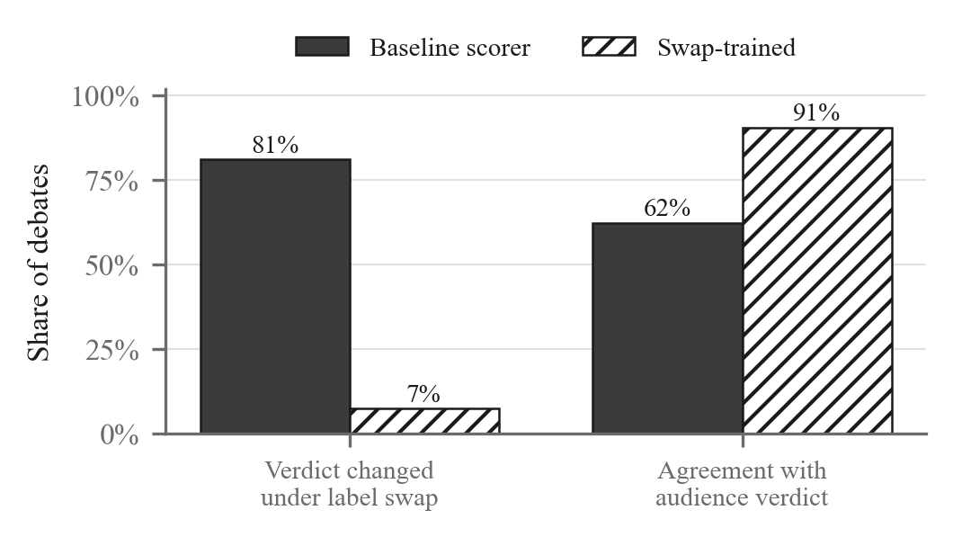
Fig. 3. Swap-invariant training, measured on the same 86 debates. Verdict instability under label exchange falls from 81.2% to 7.3%, and agreement with the audience rises from 62.3% to 90.6%.
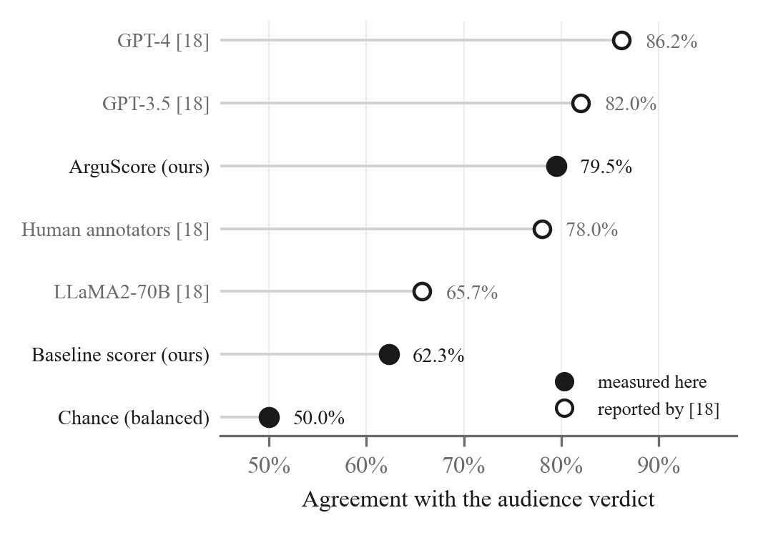
Fig. 4. Agreement with the audience verdict across every evaluation reported here, with sample sizes marked. The shaded band is the human-annotator range from [18], shown for scale only: it was measured on a different sample under a protocol that decides every debate, so it is context and not a controlled comparison.
Two things are worth separating in this result. The reduction in instability is the contribution and is unambiguous: an eleven-fold fall, on identical inputs, from a mechanism that costs one training pass rather than a second inference pass forever. The accuracy gain is larger than we expected and we are less certain what produced it, since three changes were made at once — real outcomes in place of synthetic scores, length decorrelated from the target, and the swap pairing. Isolating their contributions needs an ablation we have not run. What can be said is that 79.5% falls comparable to the 77-79% [18] report for human annotators on this corpus — from a four-billion-parameter model in a single pass, though measured on a different sample and so not a controlled comparison.
C. Conformal coverage
Table IV reports the coverage guarantee under controlled conditions, over thirty random calibration/test splits per level with three hundred rounds in each half and a known generating process. Empirical coverage tracks the target at every level, and abstention rises as the level tightens, which is the expected trade. Selective accuracy reaches 0.908 against 0.735 for the point estimate over all rounds: the system is markedly more accurate on the rounds it agrees to decide.
TABLE IV
Conformal coverage under controlled conditions
α | Target | Empirical | Set size | Abstention
0.05 | 0.950 | 0.955 | 1.96 | 48%
0.10 | 0.900 | 0.905 | 1.69 | 34%
0.20 | 0.800 | 0.806 | 1.35 | 18%
Thirty random splits per level, 300 calibration and 300 test rounds each. Set size is out of three possible outcomes.
D. Results on argument-quality pairs
Tables V to VII report an earlier evaluation on the argument-quality pairs of [12], which we retain because it shows what a mismatched instrument does. On 57 pairs the pipeline agrees with human labels on 54.4% with Cohen's kappa 0.108 and rank correlation 0.321. Table VI places that beside predictors using none of its machinery: always naming the affirmative side scores 52.6% with kappa zero, and awarding the round to the longer argument scores kappa 0.146, nominally above the pipeline. Bootstrapping over 5,000 resamples, the difference between those two has a 95% interval of [-0.243, +0.172], and every predictor's interval contains zero: at this sample size the data separates none of them, including from chance.
TABLE V
Agreement with human argument-quality labels (n = 57)
Measure | Value
Agreement | 0.544
Agreement, excluding ties | 0.620
Cohen's κ | 0.108
Spearman ρ (margins) | 0.321
Conformal coverage (α = 0.10) | 0.966
Mean set size | 2.72
Abstention rate | 0.862
Selective accuracy | 0.750
Sides with an extractable specific | 1 / 114
All pairs scored by a single backend. κ is the figure to read; agreement alone is inflated by the dominant class.
TABLE VI
Baselines on the same 57 gold pairs
Predictor | Agree | κ | κ 95% CI
Random | 0.333 | −0.033 | [−0.171, +0.175]
Always CON | 0.351 | 0.000 | [0.000, 0.000]
Always PRO (majority) | 0.526 | 0.000 | [0.000, 0.000]
Longer argument wins | 0.509 | 0.146 | [−0.049, +0.350]
ARGUS (full pipeline) | 0.544 | 0.108 | [−0.009, +0.243]
Bootstrap percentile intervals over 5,000 resamples of the 57 pairs. Every interval contains zero.
Table VII ablates the anchored rubric against the unanchored one the system began with, on the same pairs. Raw agreement is identical at 0.544, and on the measures that discount chance the original rubric leads — kappa 0.231 against 0.108. The bootstrap interval on that difference is [-0.322, +0.080] and contains zero, but 89% of resamples favour the original rubric and we draw no comfort from the interval. One measure moves the other way, and it is the one the constraints were built for: 7.0% of the original rubric's scores fall in the 7.0-8.5 band where a margin is indistinguishable from noise, against 0.9% under the present pipeline.
TABLE VII
Ablation: the original rubric on the same 57 pairs
Arm | Agree | κ | ρ | Compressed
Original rubric | 0.544 | 0.231 | 0.500 | 7.0%
ARGUS full pipeline | 0.544 | 0.108 | 0.321 | 0.9%
Compressed is the share of scores inside the 7.0-8.5 band, where a margin carries no information; lower is better. The verification channel was inert on these pairs, so this ablates the rubric and the label swap, not the contributions of Sections V and VI.
The explanation matters more than the result, and it is why Section VIII-B exists. Extraction found a verifiable specific on one of 114 sides in this data, so retrieval had nothing to check and the verification channel never engaged: what Table VII compares is the rubric and the label swap alone, with the contributions of Sections V and VI absent from both arms. The evidence ceiling meanwhile stays active and caps the evidence criterion at its floor for almost every side, pinning one of three criteria to a constant. Two independently written arguments are not a debate, and measuring a debate adjudicator on them tests something else. The real-debate evaluation of Section VIII-B is the one we would have run first had the corpus been available earlier.
E. Grounding and corpus scale
Table VIII reports the verification channel against a fixed claim set as the corpus grows from a hand-written seed of 11 documents to 2,298 passages. Coverage rises from 0.58 to 0.75 and precision from 0.71 to 0.78. Two claims previously marked refuted became correctly supported: retrieval failure had been presenting itself as contradiction. Coverage is thus corpus-bound rather than method-bound, and reporting it alongside every score is what makes the distinction visible.
TABLE VIII
Effect of corpus size on verification, fixed claim set
Corpus | Coverage | Precision | Uninformative
11 documents | 0.58 | 0.71 | 5 / 12
2,298 passages | 0.75 | 0.78 | 3 / 12

This claim set, and not the gold pairs of Section VII-A, is what tests the verification channel. The distinction is essential to reading Table V. Across the 57 gold pairs the extraction stage identified a verifiable specific on exactly one of 114 sides, because an argument of one or two sentences written to be scored for quality rarely names a date, a quantity or a source. With nothing extracted there is nothing to retrieve, so the verification channel was inert on that evaluation. Any statement about grounding made from the gold pairs would rest on a single observation, and we therefore make none.
Table IX isolates the effect of the confirmation requirement on refuted labels. Across twelve claims all independently verifiable as true, the screening pass alone produced two false accusations of fabrication; requiring an isolated second check halved this. Precision rises from 0.78 to 0.88 and the fabrication penalty falls from 2.0 to 1.0, while coverage falls from 0.75 to 0.67 — a rejected refutation becomes uninformative, leaving the corpus with less it can decide. Both figures belong in any report of this mechanism; quoting the precision gain alone would misrepresent the trade.
TABLE IX
Effect of the confirmation requirement on refuted labels
Measure | Screening only | With confirmation
False refutations | 2 / 12 | 1 / 12
Precision | 0.78 | 0.88
Evidence ceiling | 8.4 | 9.1
Fabrication penalty | 2.0 | 1.0
Coverage | 0.75 | 0.67
Twelve claims, each independently verifiable as true, so every refuted label is a false accusation.
One false accusation survives, and it is instructive rather than a residual bug. The claim concerned an economic proposition on which the corpus itself carries passages on both sides, so a contradicting quotation genuinely exists and is genuinely traceable. On contested empirical questions this architecture measures the stance of its corpus rather than the truth of a claim, and cannot distinguish contradicted by evidence from debated in the literature.
IX. Limitations
The quantitative evaluation on argument-quality pairs does not test this paper's two principal contributions. Those pairs are short standalone arguments naming almost nothing checkable, so extraction returned a verifiable specific on one of 114 sides and the verification channel of Section V stayed inert; the conformal layer is exercised, but over a base predictor measured on that mismatched task. Tables VIII and IX test the verification channel on a dedicated claim set and are the only evidence we offer for it, and twelve claims is a small basis. The ablation of Section VIII-D must be read in that light: it compares two rubrics on a task where the machinery separating them is switched off. Section VIII-B avoids this by measuring real debates, but rests on 86 debates scored successfully by both models, and its labels are audience votes rather than expert adjudication — the corpus authors themselves find a voter's prior beliefs predict how they vote.
Two biases survive the design. Exchanging the labels cancels any preference for an identity, but not the advantage of where a side sits in the running order, which is fixed to the same sides throughout; separating that from argument quality would require running each topic again with the speaking order inverted, which we have not done. Length bias is likewise measured and not addressed: Section VIII-C reports the margin correlating more strongly with the difference in argument length than with the human margin. Normalising the criteria by length is the obvious remedy and is untested. No inter-annotator agreement is available to bound the achievable ceiling.
The verification channel confirms that a citation is checkable against a corpus, not that it is true, and on contested questions it measures the stance of that corpus. The general-model entailment backend scores every claim of a round in one request, so supported and uninformative labels depend on batch composition; the confirmation pass of Section V-C removes this for refuted labels, the only ones carrying a penalty. Eliminating it entirely needs the local cross-encoder backend, which is implemented but has not been run. Finally, the scorer and the debaters are drawn from overlapping model families, admitting self-preference, and the double pass costs two large-model calls per round — which exhausts a free inference tier within a handful of debates and is what bounds this evaluation to the sample sizes reported.
X. Conclusion and Future Work
ARGUS is a real-time multi-agent debate system whose contribution lies in its adjudicator. Requiring extraction before scoring, anchoring each band of the rubric to an observable property of the text, verifying every cited specific against a corpus through a channel independent of the scorer, imposing on refutation a burden of proof that support does not carry, scoring each round twice with the identities exchanged, and computing every total and outcome in code rather than in prose, the system converts a set of unexamined judge failure modes into quantities measured and reported beside every verdict. The conformal layer then states plainly how far those verdicts can be trusted, and abstains where they cannot.
The measured agreement with human labels is slight rather than strong, and the abstention rate that follows is high. We take this to be a finding rather than a shortfall. A system that reports the limits of its own judgement is more useful than one that conceals them, and the incident described in Section I — a judge scoring a debate it had hallucinated while every indicator reported normal operation — is the clearest available argument that scores alone cannot be audited from the inside.
Immediate future work is to repeat the ablation of Section VIII-D on material where the verification channel engages, since on short standalone arguments it stays inert and the comparison silently becomes a test of something else; retaining per-criterion scores would let the evidence-ceiling hypothesis be tested directly rather than inferred. Enlarging the argument-quality sample is next, as every interval in Section VIII-D contains zero at 57 pairs. Beyond that: length-normalised criteria, since Section IX records verbosity bias surviving the present design; mirrored debates isolating structural position bias, which Section VIII-B shows the label swap does not remove; expansion of the verification corpus, since coverage is corpus-bound; detecting disagreement among retrieved passages so contested claims are recognised as contested rather than refuted; and reporting conformal coverage per topic to test the exchangeability the guarantee rests on.
Acknowledgment
The authors thank the Department of Computer Science and Engineering, K.L.E. College of Engineering and Technology, Chikodi, for its guidance and support throughout this work, and Visvesvaraya Technological University, Belagavi, under whose major-project programme the work was carried out.
References
[1] Y. Du, S. Li, A. Torralba, J. B. Tenenbaum, and I. Mordatch, “Improving factuality and reasoning in language models through multiagent debate,” in Proc. 41st Int. Conf. Machine Learning (ICML), Vienna, Austria, Jul. 2024, pp. 11733–11763.
[2] T. Liang et al., “Encouraging divergent thinking in large language models through multi-agent debate,” in Proc. Conf. Empirical Methods in Natural Language Processing (EMNLP), Miami, FL, USA, Nov. 2024, pp. 17889–17904.
[3] L. Zheng et al., “Judging LLM-as-a-judge with MT-Bench and Chatbot Arena,” in Advances in Neural Information Processing Systems (NeurIPS), vol. 36, New Orleans, LA, USA, Dec. 2023, pp. 46595–46623.
[4] P. Wang et al., “Large language models are not fair evaluators,” in Proc. 62nd Annu. Meeting of the Association for Computational Linguistics (ACL), Bangkok, Thailand, Aug. 2024, pp. 9440–9450.
[5] C.-H. Chiang and H.-Y. Lee, “Can large language models be an alternative to human evaluations?” in Proc. 61st Annu. Meeting of the Association for Computational Linguistics (ACL), Toronto, ON, Canada, Jul. 2023, pp. 15607–15631.
[6] A. R. Sharma and V. Kumar, “Multi-agent debate system for AI-based decision-making: A framework for enhanced reasoning through collaborative intelligence,” IRE Journals, vol. 8, no. 4, pp. 112–125, Aug. 2024.
[7] J. Smith, A. Johnson, and R. Patel, “Improving spam detection with a multi-agent debate framework,” in Proc. IEEE 4th Int. Conf. Information Technology, Big Data and Artificial Intelligence (ICIBA), Chongqing, China, 2025, pp. 45–52.
[8] Y. Sun, Z. Zhao, and S. Wan, “CortexDebate: Debating sparsely and equally for multi-agent debate,” in Findings of the Association for Computational Linguistics: ACL 2025, Vienna, Austria, Jul. 2025, pp. 9503–9523.
[9] L. Chen, H. Zhang, and X. Liu, “Multi-agent-as-judge: Aligning LLM-agent-based automated evaluation with multi-dimensional human evaluation,” in Proc. IEEE/CVF Conf. Computer Vision and Pattern Recognition (CVPR) Workshops, Nashville, TN, USA, Jun. 2025.
[10] C. Stab and I. Gurevych, “Parsing argumentation structures in persuasive essays,” Computational Linguistics, vol. 43, no. 3, pp. 619–659, Sep. 2017.
[11] J. Lawrence and C. Reed, “Argument mining: A survey,” Computational Linguistics, vol. 45, no. 4, pp. 765–818, Dec. 2019.
[12] S. Gretz, R. Friedman, E. Cohen-Karlik, A. Toledo, D. Lahav, R. Aharonov, and N. Slonim, “A large-scale dataset for argument quality ranking: Construction and analysis,” in Proc. AAAI Conf. Artificial Intelligence, vol. 34, no. 5, New York, NY, USA, Feb. 2020, pp. 7805–7813.
[13] P. Lewis et al., “Retrieval-augmented generation for knowledge-intensive NLP tasks,” in Advances in Neural Information Processing Systems (NeurIPS), vol. 33, Vancouver, BC, Canada, Dec. 2020, pp. 9459–9474.
[14] J. Thorne, A. Vlachos, C. Christodoulopoulos, and A. Mittal, “FEVER: A large-scale dataset for fact extraction and VERification,” in Proc. Conf. North American Chapter of the Association for Computational Linguistics (NAACL-HLT), New Orleans, LA, USA, Jun. 2018, pp. 809–819.
[15] V. Vovk, A. Gammerman, and G. Shafer, Algorithmic Learning in a Random World. New York, NY, USA: Springer, 2005.
[16] A. N. Angelopoulos and S. Bates, “Conformal prediction: A gentle introduction,” Foundations and Trends in Machine Learning, vol. 16, no. 4, pp. 494–591, 2023.
[17] E. Durmus and C. Cardie, “A corpus for modeling user and language effects in argumentation on online debating,” in Proc. 57th Annu. Meeting of the Association for Computational Linguistics (ACL), Florence, Italy, Jul. 2019, pp. 602–607.
[18] X. Liu, P. Liu, and H. He, “An empirical analysis on large language models in debate evaluation,” in Proc. 62nd Annu. Meeting of the Association for Computational Linguistics (ACL), Bangkok, Thailand, Aug. 2024, pp. 470–487.

