Manual

The main page includes two tabs: one for creating a New Order and another tab My Orders – it’s the list of client’s orders.
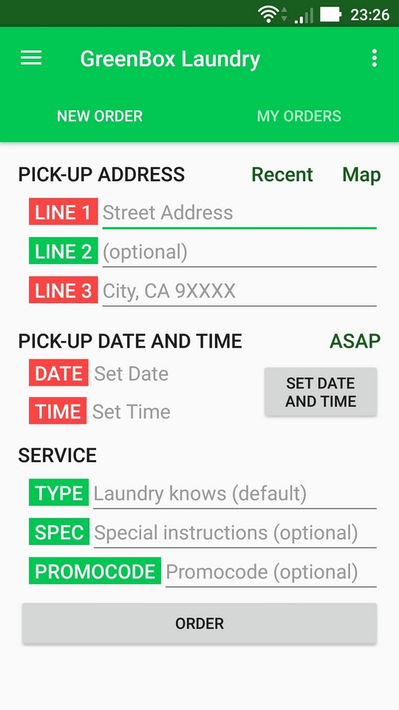
New Order Tab
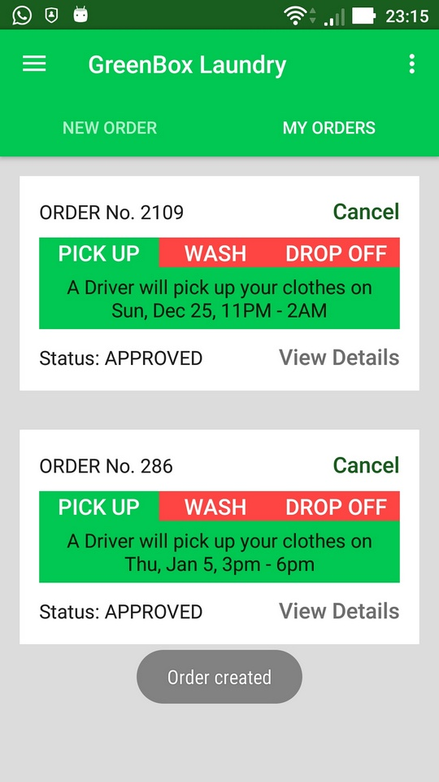
My Orders Tab
A Client may fill the Address fields by click on Map or manually.
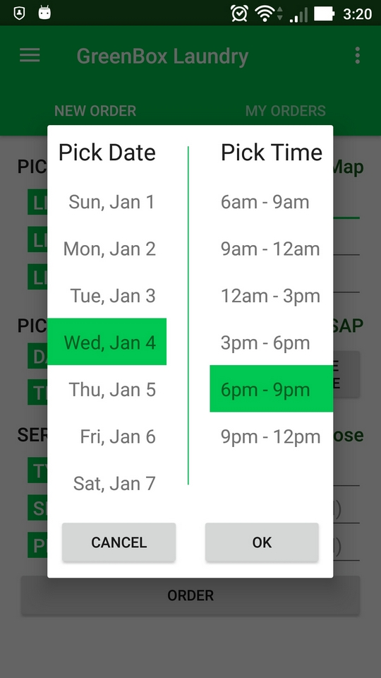
Set Date and Time Dialog

If a Client created an Order, the app saves his Address and he may easy fill the form by clicking on the Recent button. It doesn’t need to use map or fill form again for this Address.

ASAP button sets the pick-up time to As Soon As Possible. If a Client wants to determine the Date and Time by more flexible way, he may use Set Date and Time button, which shows a dialog with dates and times.

The Map activity provides useful interface which allows pick the Address by click on Map (the app detects address by coordinates) or by clicking on My Location button which uses GPS to find an Address.
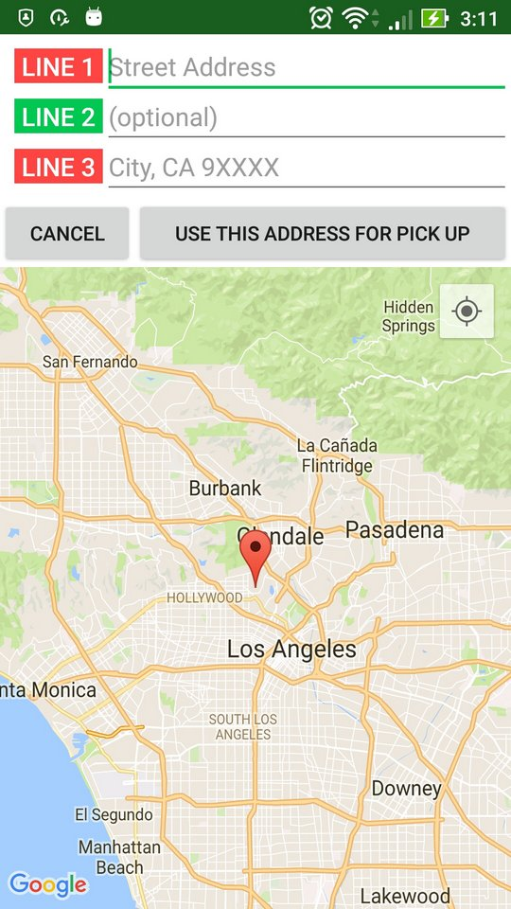
Map Activity

My Orders tab shows the Client orders, their status and other info. Cancel button works, View Details button is not implemented yet.

There are Settings button on the right top corner and Navigation button on the left top. They don’t do anything for the present, but are prototypes for future use.

