Project Report

On

HOSPITAL MANAGEMENT SYSTEM


Submitted in partial fulfilment for the award of PG-Diploma in Advance Computing PG-DAC

Guided By,
Ms. Kishori Khadilkar

Presented By

Name : | 1
Name : | 2

Centre of Development of Advanced

Computing (C-DAC), Pune

Hospital Management System

ACKNOWLEDGEMENT

This project “HOSPITAL MANAGEMENT SYSTEM” was truly a great learning experience for us and we are submitting this work to Advanced Computing Training School (CDAC ACTS). We are very glad to mention Ms. Kishori for her valuable guidance to work on this project. Her guidance and support helped us to overcome various obstacles and intricacies during the course of project work.

We are highly grateful to Ms. Risha P.R., Manager of ACTS training Centre, C-DAC, for her guidance and support whenever necessary during the course of our journey to acquire PG-Diploma in Advanced Computing (PG-DAC) through C-DAC ACTS, Pune. Our heartfelt thanks goes to Ms. Shilpi Shalini, our Course Coordinator, PG-DAC who gave all the required support and kind coordination to provide all the necessities

From
Prerna Ravindra Chaudhari | 210940120047

1

Hospital Management System

Contents

1.Introduction

2.Project Overview

2.1 Purpose

2.2 Scope

2.3 Feasibility Study

3.Overall Description

3.1 Product Features

3.2 Technology Used

3.3 User Classes

3.4 General Constraints

4.Software Requirement Specification

4.1Functional Requirement

5 Sequence Details

6.Non Functional Requirements

6.1 Performance Requirement

6.2 Security Requirement

7 Database Tables

8.Entity Relationship Diagram

9.UML Diagram
10.Interfaces

11.Future Scope

12.References

13.Conclusion

2

Hospital Management System

1. Introduction

The project Hospital Management System includes registration of patients, storing their details into the system, and also computerized billing in the pharmacy, and labs. The software has the facility to give a unique id for every patient and stores the details of every patient automatically. The Hospital Management System can be accessed by different users using a username and password. It is accessible by an administrator, receptionist, doctor and a pharmacist. Only the admin can register users into the database. The data can be retrieved easily. The interface is very user-friendly. The data is well protected for personal use and makes the data processing very fast.
Hospital Management System is powerful, flexible, and easy to use and is designed and developed to deliver real conceivable benefits to hospitals.
Hospital Management System is designed for multispeciality hospitals, to cover a wide range of hospital administration and management processes. It is an integrated end-to-end Hospital Management System that provides relevant information across the hospital to support effective decision making for patient care, hospital administration in a seamless flow.
Hospital Management System enables you to develop your organization and improve its effectiveness and quality of work.

3

Hospital Management System

2. Project Overview

2.1 Purpose:

The project is a web-based application where doctors can find data related to their patients and update treatment status and receptionist can maintain records for patients,their treatments and bills. Pharmacists can use the software to keep a track of medicines available at Hospital and their usage for treatment of patient. This system supports automatic bill generation.

2.2 Scope:

The scope of our project is this software reduces the amount of manual data entry and gives greater efficiency. The User Interface of it is very friendly and can be easily used by anyone.
1.It also decreases the amount of time taken to write details.

2.Admin does not have to keep a manual track of the users. The system automatically calculates bill for patients.

3.Patient data is auto generated by the system just by entering ID at the time of appointment.

2.3 Feasibility Study:

Feasibility is determination of whether a projects worth doing or not. Before actually recommending the new system, it is important to investigate if it is feasible to develop the new system.

Before developing and implementing a system we have sure that our system is feasible in the following ways:

- Technical Feasibility:

This study is carried out to check the technical feasibility, that is,the technical requirements of the system. Any system developed must not have a high demand on the available available technical resources. The system runs effectively on Windows platform and hence are suitable for the end-user. The system is technically feasible because it does not require too much manpower and runs with the basic available equipment.

- Operational Feasibility:

In this type of feasibility study the operation implementation of the system is considered. Checking is done regarding whether it is feasible for the user department to use the software or will there be any inertial resistance from the users. Thus, the proposed system is said to be

4

Hospital Management System

operationally feasible only of the end users are able to understand the system clearly and correctly and can use the system with ease and with the minimum training.

We need to train our staff so that system will be handled efficiently. As the system developed is very user-friendly and easy to operate for any person with minimum computer knowledge of computer is also able to handle our system. It is also easy to operate due to the user-friendly interface developed using Java.

- Economical Feasibility:

In this type of feasibility study, the benefits of the system to the organization are considered by taking into consideration the cost-benefit analysis. The basic software, which is required for the implementation of the system, is Java which easily available. Also with the basic training user can use this software thus reducing the training cost to the organization. Thus, using this system is feasible for the organization and loading Java and the proposed system is economically feasible for the organization.

5

Hospital Management System

3. Overall Description: -

3.1 Product Features

The main feature of this system is maintaining the hospital records in constructive manner and regenerating them as per our need by their ID. The user must be a registered by the admin before he uses this hospital management system. The receptionist can see the patient’s bill report and treatment status. Doctor can view his list of patients and their diagnosis history. Pharmacists and Distributors can register themselves in the system and add medicines.

3.2 Technology Used

- BACK END

Framework

ORM Tool
Database
Build Tool
Language
Spring MVC
Hibernate
MySQL
Maven
Java

- FRONT END

HTML CSS JavaScript Bootstrap
JSP

3.3 User Classes

- Admin

The super user, admin class represents complete authority over the system an admin can

  - Admin can register Doctors, Pharmacists and Receptionists

  - View the number of users.

  - Admin can update his own profile.

  - Admin can update and delete the users.

  - Admin can view his dashboard which displays all the data entered and generated by the system.

  - Admin can see bill report for particular patient.

- Doctor

  - Can view his/her Patients and their appointments.

  - Can update Patient treatment status.

  - Can assign medicines to Patients based on their diagnosis

  - Adds the fee amount for that particular patient.

6

Hospital Management System

- Pharmacist

  - Can add Medicines.

  - Can add Distributors.

  - Can add Medicine Company.

- Receptionist
- Can register Patients.
- Can book appointments for patients.
- Can view Appointment status and Treatment status for patients.
- Can generate and download patient Bill.

3.3 General Constraints

The “Hospital Management System” should run on all Internet Browser

and all processors which supports the Internet Browser.

- Architecture Diagram: -

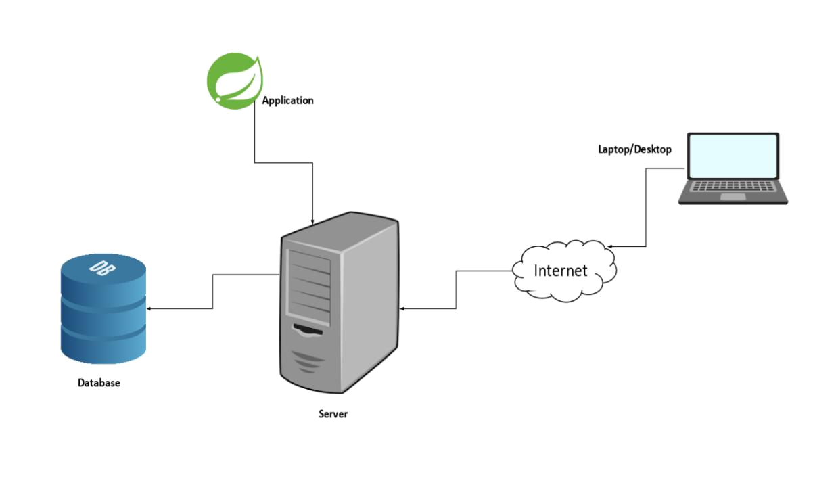

Figure 1. Architecture Diagram

7

Hospital Management System

- Control Flow

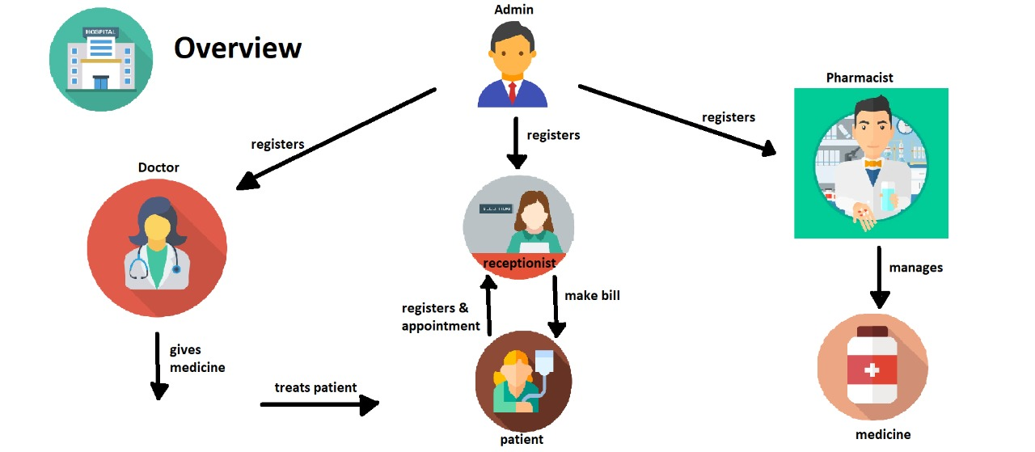

Figure 2: Flow diagram

8

Hospital Management
- Software Requirements Specification

    - Functional Requirements

- Scenario 1: Mainline Sequence

  - Admin: Enter Username and Password.

  - System:

        - Display the Admin page where admin can see options as admin dashboard and resgister users.

        - Admin can register doctor ,receptionist and pharmacist.

- Scenario 2: Mainline Sequence

    - Receptionist: Enter username and Password.

    - System:

      - Register patients.

      - Book Appointments.
      - Generate Bill.

- Scenario 3: Mainline Sequence

  - Doctor: Enter username and Password

  - System:

      - View Appointments

      - Treat Patients and change status.

      - Assign Treatment Price.

      - Suggest Medicines.

- Scenario 4: Mainline Sequence

  - Pharmacist : Enter username and Password

  - System:

      - Add Medicine Distributors

      - Add Medicine Company.

      - Add Medicines.

9

Hospital Management System

- Non-Functional Requirements

  - Performance Requirement

        - The time between request and response should be less

        - Minimum time should be taken by the application to display the result.

        - In case of power failure, the data should be stored in the state that was last saved by the user

13

Hospital Management System

- Database Tables

Tables in Database :

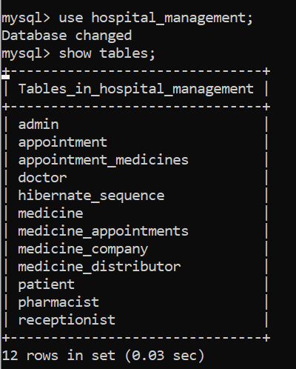

- Admin Table :

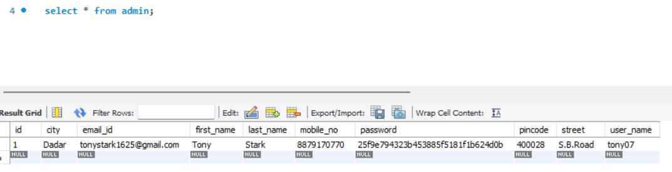

- Receptionist Table :
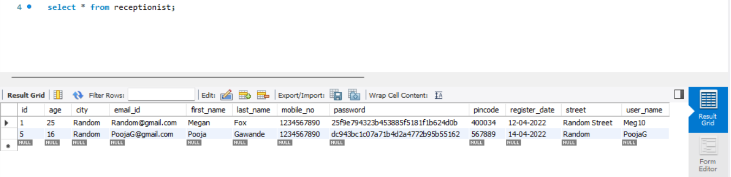

14

Hospital Management System

- Doctor Table :

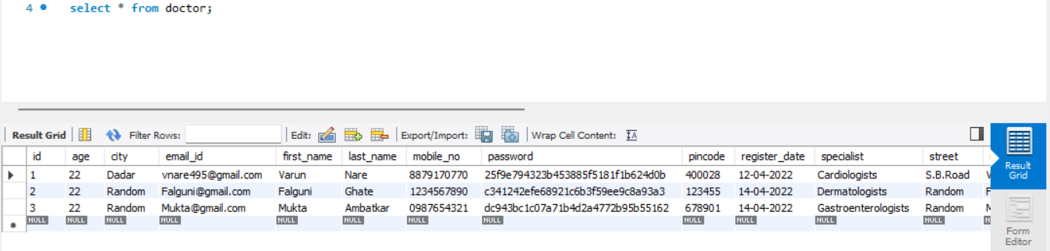

- Pharmacist Table :

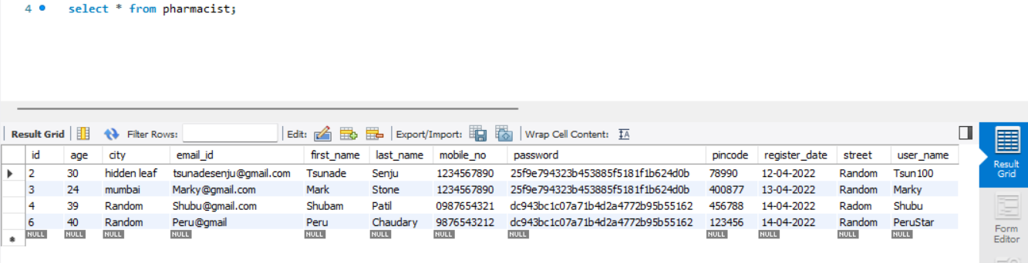

- Patient Table :

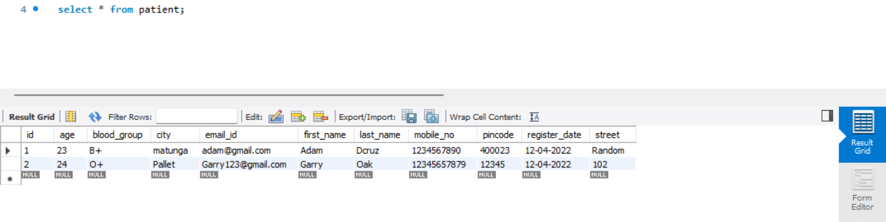
- Medicine Table :

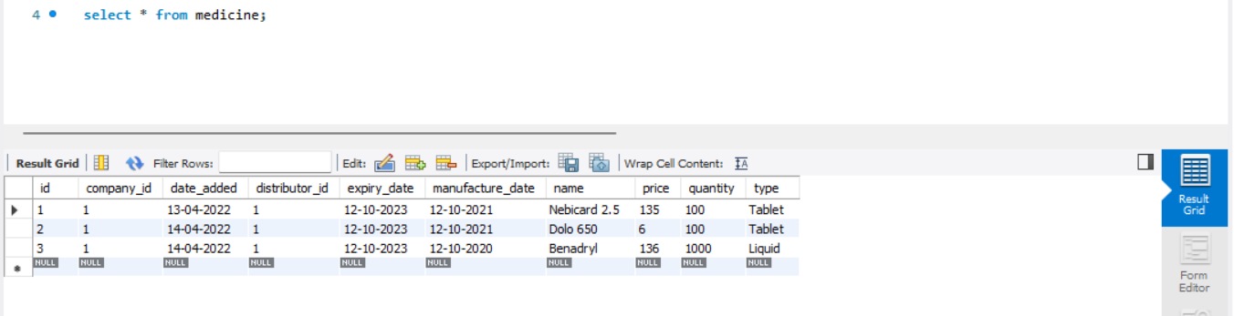

15

Hospital Management System

- Use Case Diagrams :

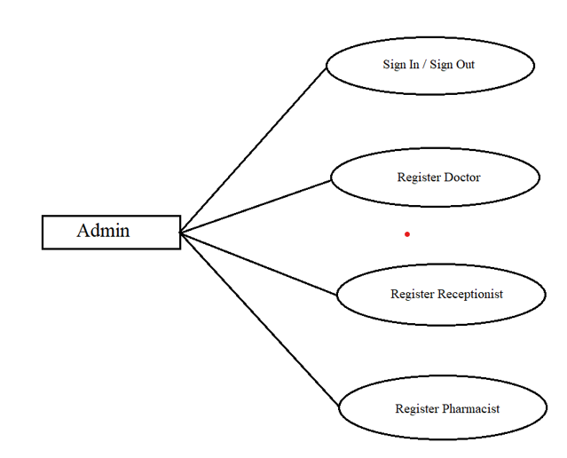

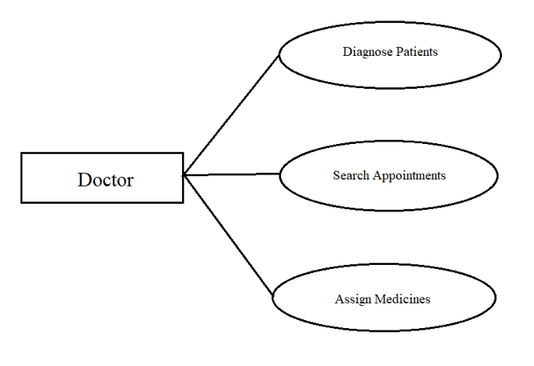

17

Hospital Management System

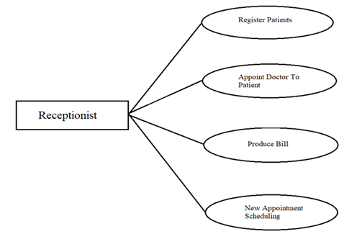

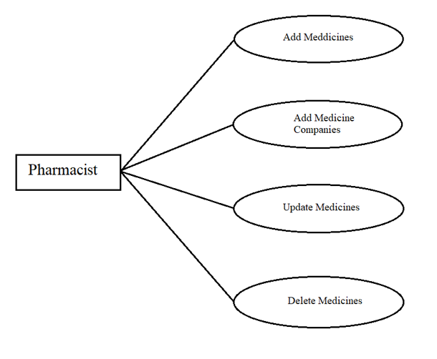

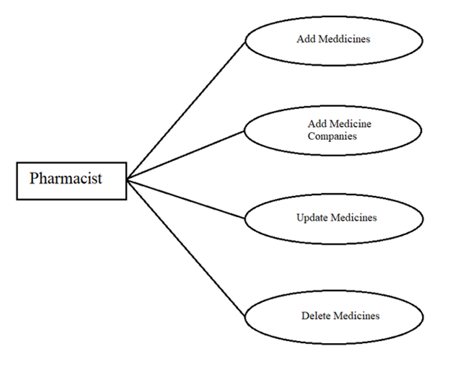

18

Hospital Management System

- Data Flow Diagram :
      - DFD 0:
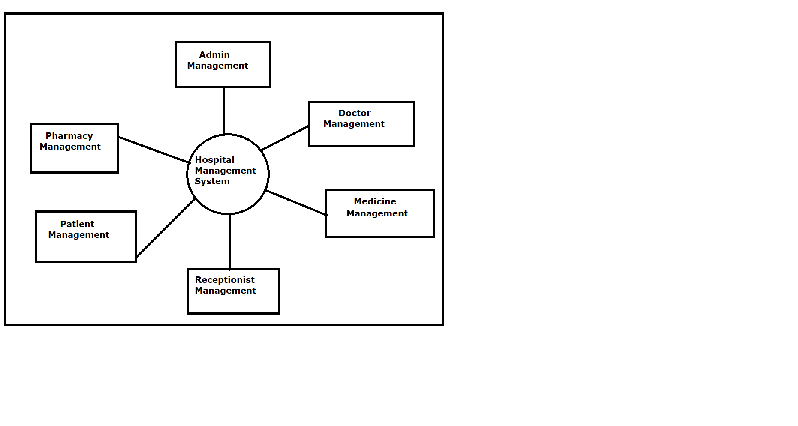
      - DFD 1:
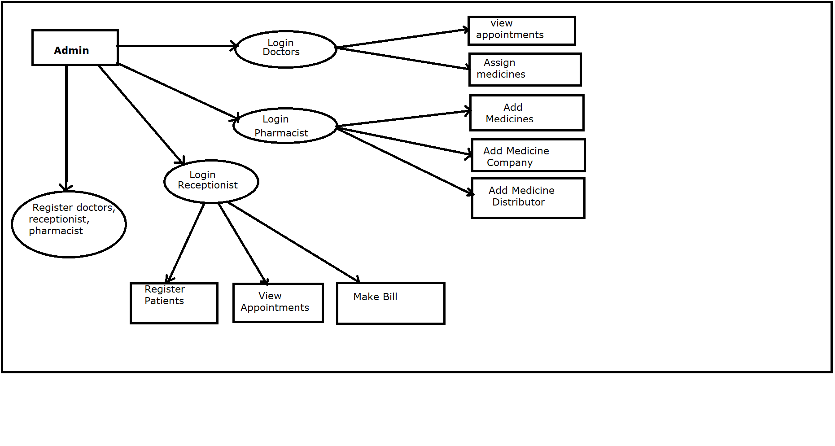

19

Hospital Management System

- Entity Relationship Diagram :
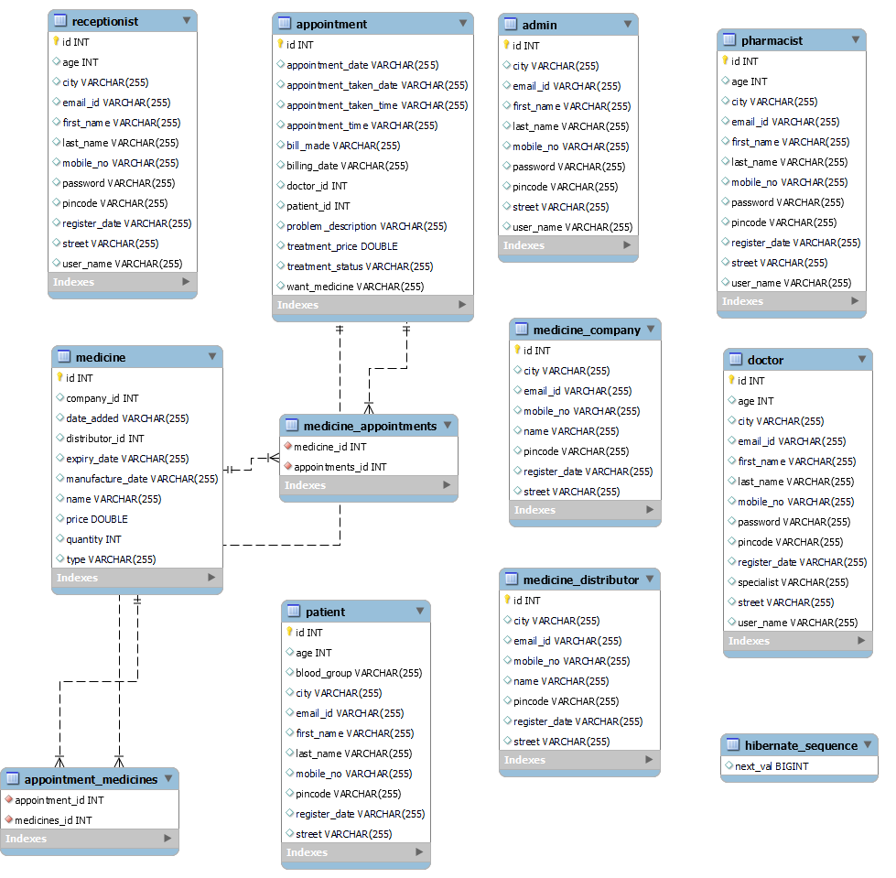


20

Hospital Management System

- Interface :

- Home Page :

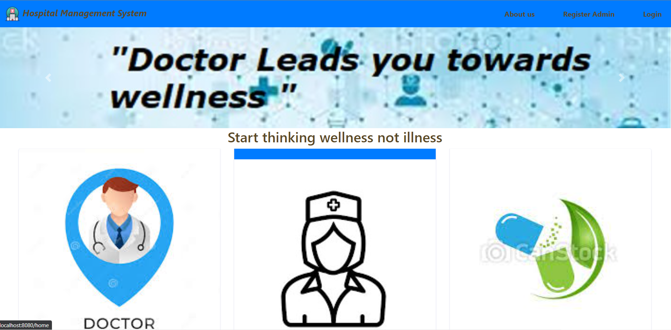

- Admin Register

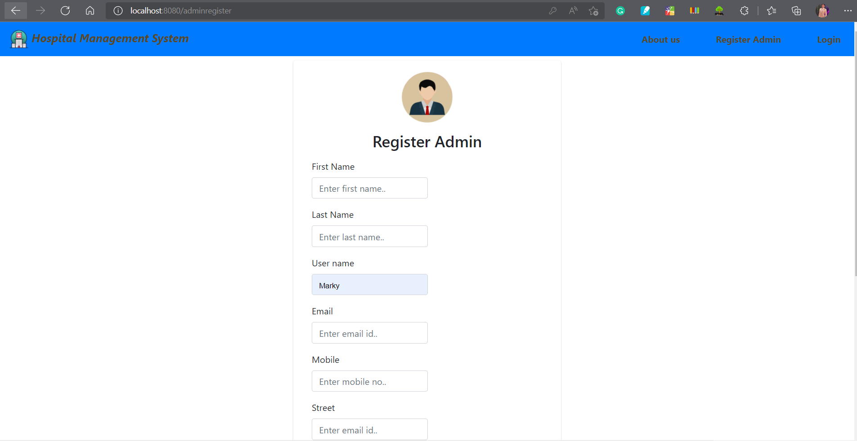

21

Online Electricity Bill Management System

- Admin Login

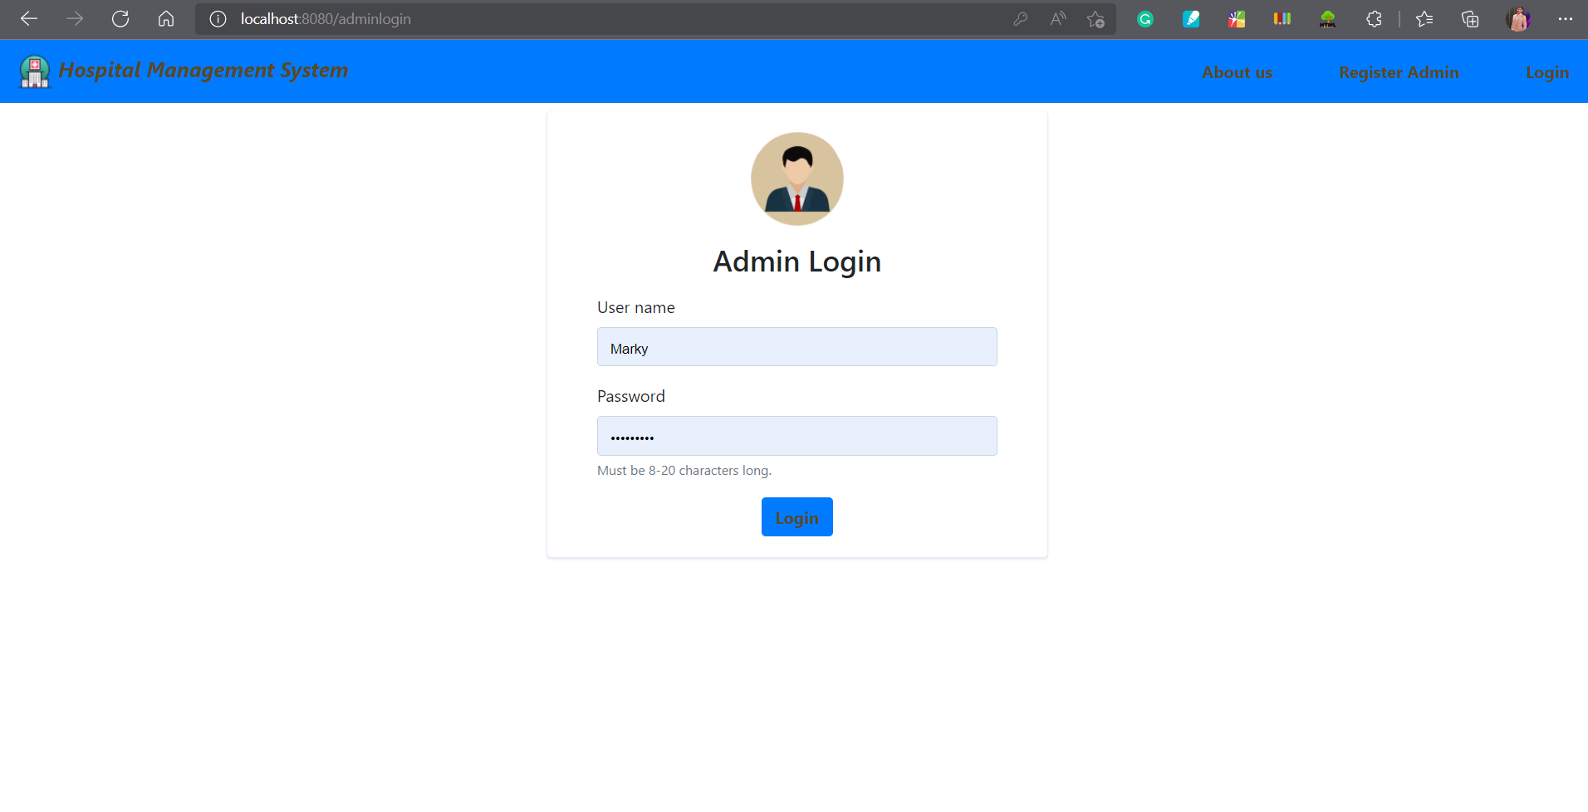
- Admin Dashboard

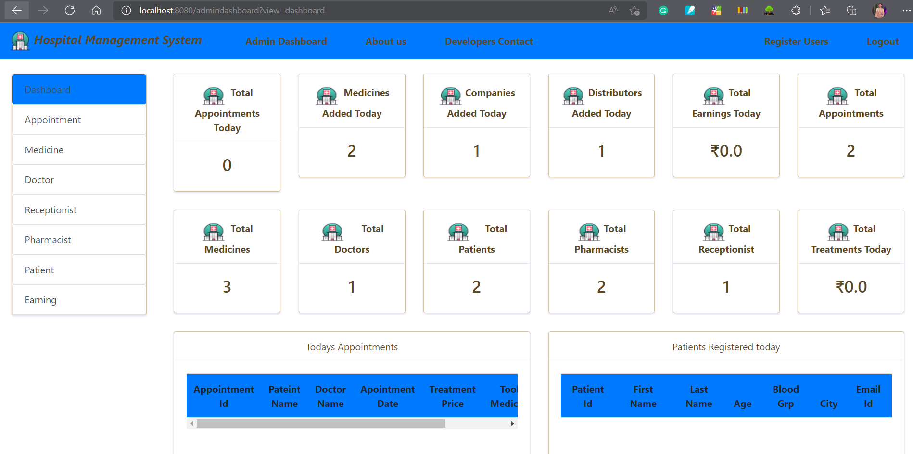
- Login Page
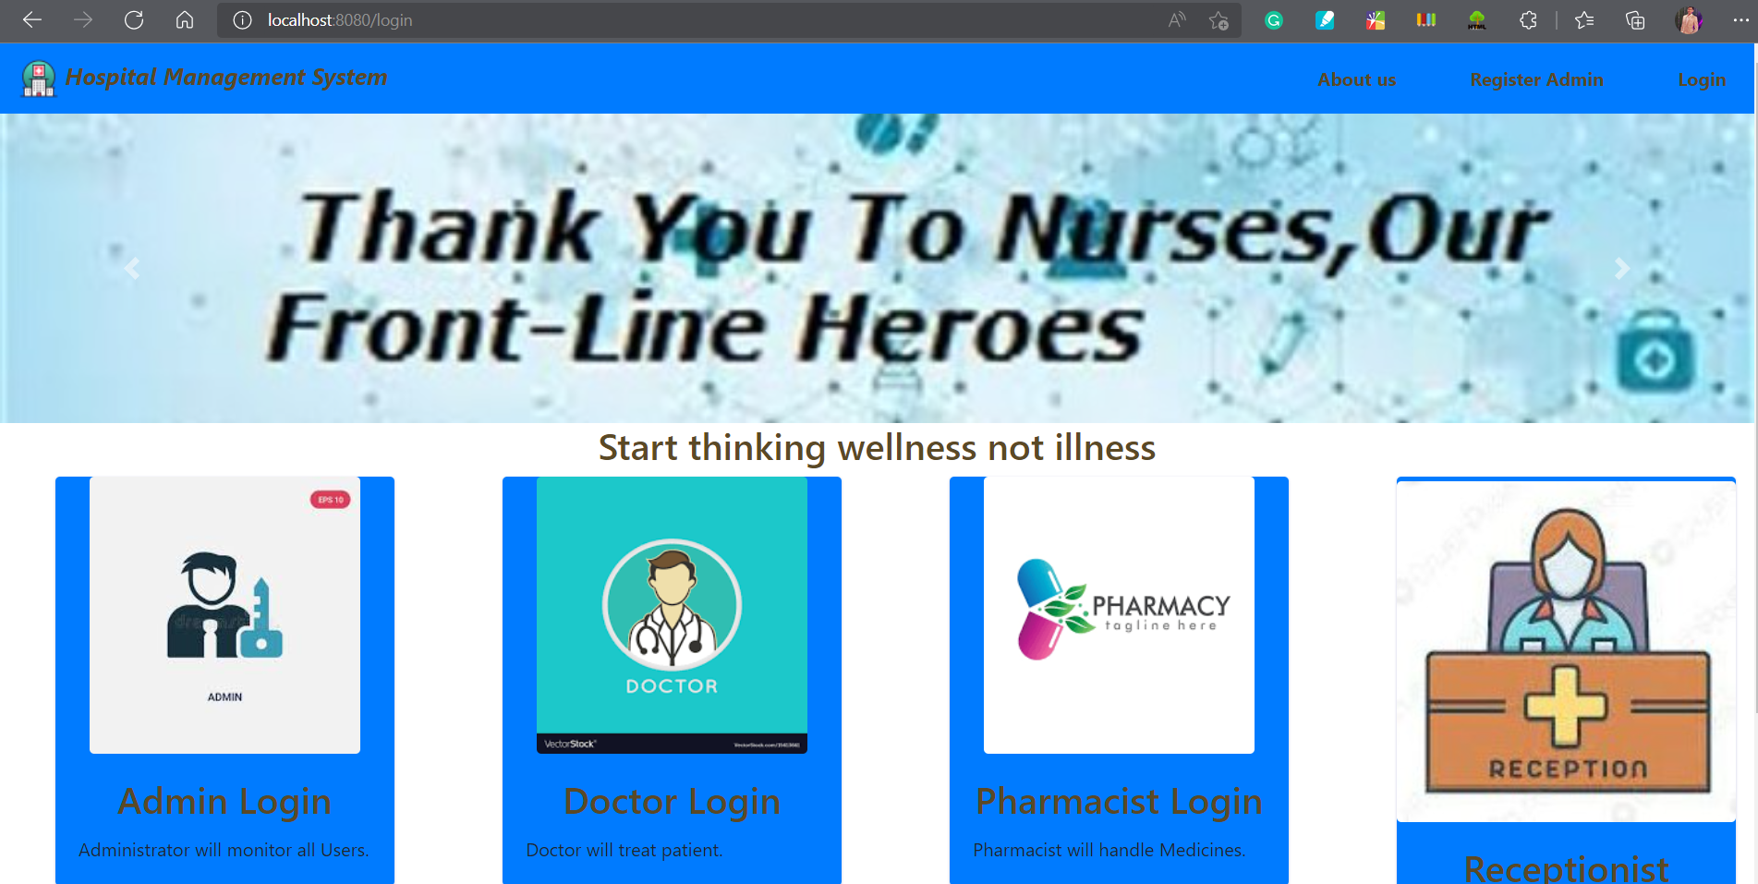

22

Hospital Management System

- Add Patients

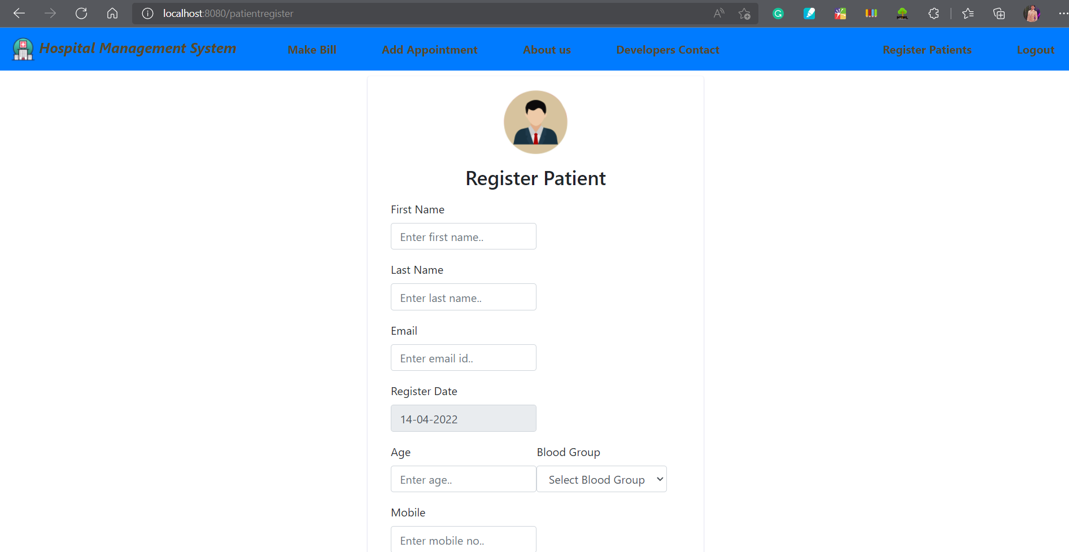

- Add Appointment

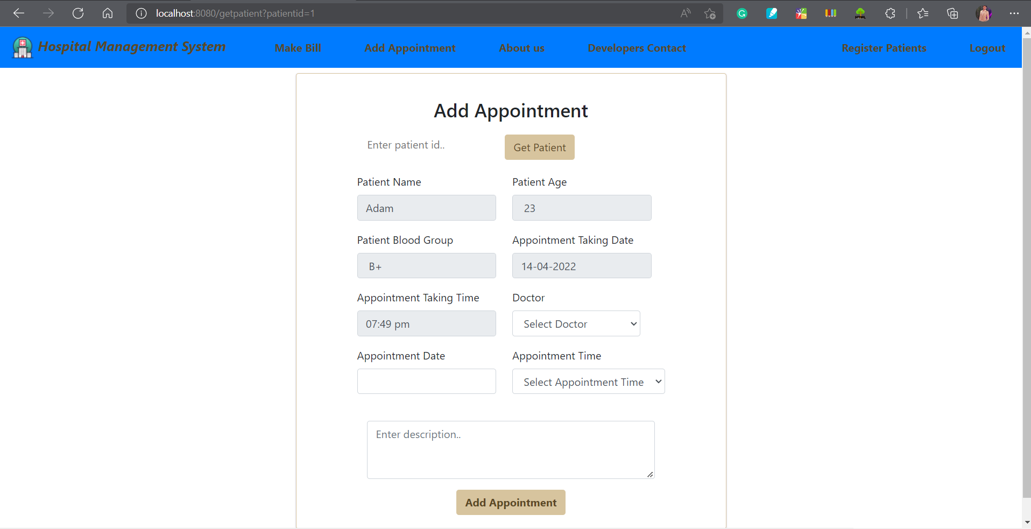

- Make Bill

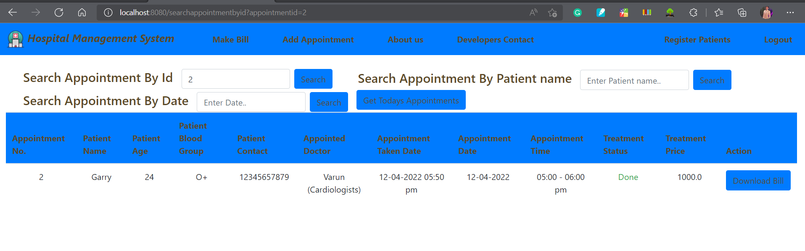

23

Hospital Management System

- Futures Scope

Future Scope of this project is betterment of the software.

- Adding the functionality for maintaining the records of ongoing surgeries, or operations and X-Ray, MRI facilities.

- A feature of 'blood bank' for the patients can be added to the system.

- The system can also be made directly accessible to the patients in the future for them to view their ongoing treatments, medicines registered for them and many more..

- References

1.www.w3school.com

Conclusion

This software reduces the amount of manual data entry and gives greater efficiency. The User Interface of it is very friendly and can be easily used by anyone. It also decreases the amount of time taken to write details .Well-tuned hospital management workflow involves lots of important decisions that should be made in the most efficient and quick way. Nowadays it is hard to implement it without the distinct hospital management system. In this app, we’ll explore what is HMS software, what functions it performs and how it helps the healthcare industry be more effective.

